Final Assignment

Title: Final Assessment of DLD
Course title: Digital Logic Design
Course code: CSE-253
2nd Year 2nd Semester Examination 2025

Date of Submission: 05/ 09/2026



Submitted to-
Dr. Md. Golam Moazzam
Professor
Department of Computer Science and Engineering
Jahangirnagar University
Savar, Dhaka-1342

Sl | Class Roll | Name
01 | 360 | MD ASHIKUR RAHMAN
02 | 361 | MONIRUZZAMAN MONIR

Contents

Q1. State the role of digital circuit technology in modern communication... 4
Q2. Compare analog and digital circuits, highlighting their advantages... 4
Q3. Analyze the impact of logic minimization on circuit cost, speed, and... 5
Q4. Is minimizing the number of logic gates always the best optimization... 6
Q5. Design a logic circuit with inputs P, Q, R so that output is high... 6
Q6. Design a logic circuit with four inputs (A, B, C, D) and output Y, such... 7
Q7. Design a logic circuit that accepts a 3-bit number and generates an... 9
Q8. Design a logic circuit that accepts a 4-bit number and generates the 2's... 11
Q9. Compare combinational and sequential logic circuits with respect to... 13
Q10. Design and explain the circuit to add the bits 1011 and 1100 using a... 13
Q11. A standard 8-to-3 encoder receives two active inputs simultaneously... 14
Q12. Implement a 1-to-16 demultiplexer using only 2-to-4 decoders with enable... 16
Q13. Design a logic circuit that compares two 4-bit numbers, A and B, to... 18
Q14. Explain how a multiplexer can be used as a universal logic circuit. 19
Q15. Design a circuit to distribute a serial input to four different outputs... 22
Q16. Give a real-life application where a priority encoder is preferred over... 23
Q17. Compare a decoder with a demultiplexer. Under what conditions can a... 24
Q18. A logic circuit is defined by f1 = A'B + ABC', f2 = A' + B, f3 = AB +... 25
Q19. Under what conditions would you choose a D flip-flop instead of a JK... 26
Q20. Compare SR, JK, D, and T flip-flops in terms of functionality... 27
Q21. Compare edge-triggered and level-triggered flip-flops. Which is more... 28
Q22. Is a JK flip-flop always a better choice because it is more versatile?... 29
Q23. Under what circumstances would you choose a synchronous design over an... 29
Q24. Under what circumstances would an asynchronous counter be a better... 31
Q25. Why are synchronous counters preferred in modern high-speed processors? 32
Q26. Why are synchronous counters generally preferred over asynchronous... 33
Q27. Compare ripple counters and synchronous counters in terms of speed... 35
Q28. Which type of counter would you recommend for a high-speed communication... 36
Q29. Design a counter that counts only even numbers from 0 to 14. 37
Q30. Explain a 4-bit asynchronous binary counter with timing diagram. If each... 39
Q31. A certain memory has a capacity of 16K × 32. How many words does it... 41
Q32. How many address inputs, data inputs, and data outputs are required for... 43
Q33. a) How many 32Kx8 RAM chips are needed to provide a memory capacity of... 44
Q34. Construct a 64 × 8 memory unit using 16 × 4 memory chips. 47
Q36. Analyze the advantages of programmable logic over fixed-function digital... 51
Q37. Compare CRC and Hamming code. Under what conditions is CRC preferred... 53
Q38. Why is CRC preferred over a simple parity check? 54
Q39. Under what conditions can a parity checker indicate that data is correct... 55
Q40. Design a sequential circuit with two D flip flops and two inputs, P and... 56
Q41. (a) Draw a logic circuit that accepts a 3-bit input number A(A2, A1, A0)... 57
Q42. a) Design a circuit that counts the number of 1s in a 3-bit input... 60
Q43. (a) Draw the truth table for the function f=x’y+x’z+xy’z’ 63
Q44. (a). Draw the truth table for a full-adder. 65
Q45. Design a circuit that tests if a 4-bit binary number is a prime number... 67
Q46. An 8x1 multiplexer has inputs A, B and C connected to the selection... 72

Q1. State the role of digital circuit technology in modern communication systems.
Answer:
Digital circuit technology changes information like voice, video, and text into binary code, which is just a stream of 0s and 1s. This simple change gives huge benefits to modern communication systems:
- Noise resistance: A digital signal only needs to be read as a 0 or a 1. Small noise on the wire does not change the meaning, so the message stays clear even over long distance.
- Error detection and correction: Digital data can carry extra check bits (like parity bits or checksums) so the receiver can find and even fix mistakes caused by noise.
- Easy to store and process: Digital data can be saved in memory chips and processed by computers and microprocessors, which are themselves built from digital circuits.
- Encryption and security: Digital data is easy to scramble (encrypt) and unscramble (decrypt), keeping communication safe from hackers.
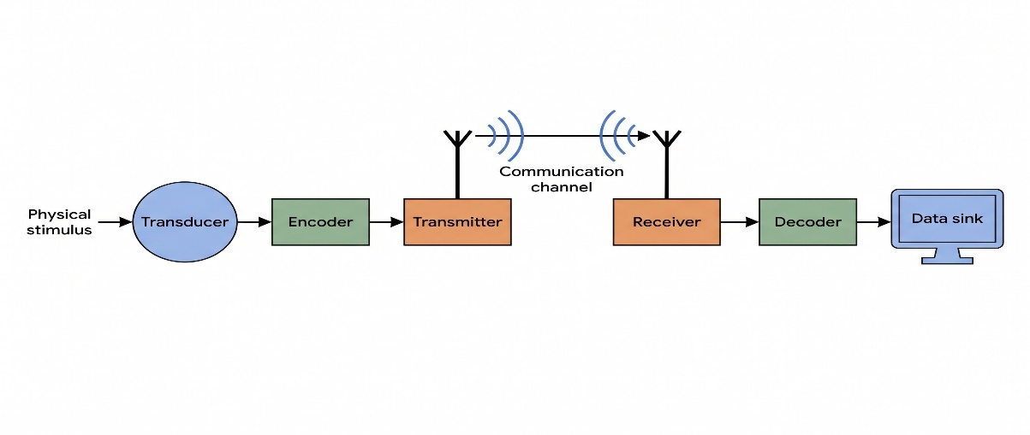
- Multiplexing: Many digital signals (calls, videos, data) can be mixed together and sent on one single channel, then separated again at the other end. This saves bandwidth and cost.
- Compression: Digital data can be compressed to a smaller size before sending, which saves time and bandwidth (for example, MP3 for audio, JPEG for images).

Because of these benefits, almost every modern communication system — mobile networks, the Internet, satellite links, fibre-optic cables, and Wi-Fi — is built using digital circuit technology instead of old analog technology.

Q2. Compare analog and digital circuits, highlighting their advantages, disadvantages, and practical applications.
Answer:
An analog circuit works with signals that can take any value in a continuous range (like a smooth wave). A digital circuit works with signals that only take two fixed values, usually called 0 (LOW) and 1 (HIGH).
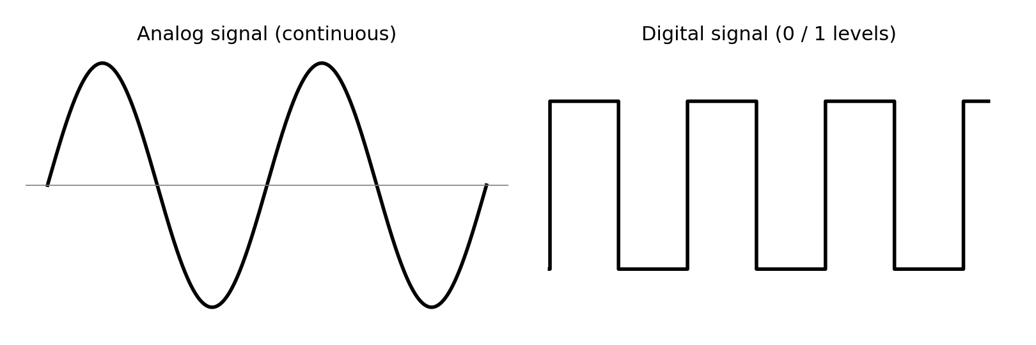

Point | Analog Circuit | Digital Circuit
Signal type | Continuous (infinite values) | Discrete (only 0 and 1)
Noise effect | Noise easily changes the signal and causes errors | Very resistant to noise; small noise is ignored
Accuracy | Can lose accuracy over long distance | Stays accurate even over long distance, with error correction
Design complexity | Often simpler for basic signal processing (e.g. amplifiers) | Needs more components (gates, flip-flops) but design is systematic
Storage | Hard to store without loss (e.g. old cassette tapes) | Easy to store perfectly in memory chips
Cost at scale | Can be cheaper for very simple tasks | Cheaper and easier to mass produce using ICs (integrated circuits)
Power | Can be more power efficient for pure analog tasks like small sensors | May use more power switching many gates, but modern low-power design fixes this
Applications | Microphones, old radios, sensors, audio amplifiers | Computers, mobile phones, digital TV, calculators, digital cameras

In short: analog circuits are good for capturing real-world signals directly (like sound from a microphone), while digital circuits are better for storing, processing, transmitting, and protecting that information without losing quality. Most modern devices use analog circuits only at the sensor/input stage and convert the signal to digital as fast as possible using an ADC (Analog-to-Digital Converter).

Q3. Analyze the impact of logic minimization on circuit cost, speed, and power consumption.
Answer:
Logic minimization means simplifying a Boolean expression so that it uses fewer gates and fewer literals (variable terms), usually done using Boolean algebra or a K-map.
- Cost: Fewer gates means fewer transistors on the chip, so the chip uses less silicon area. Less area means more chips can be produced from one silicon wafer, which lowers the manufacturing cost.
- Speed: Every gate a signal passes through adds a small delay, called propagation delay. If minimization removes gates from the longest path (critical path), the signal reaches the output faster, so the circuit can run at a higher clock speed.
- Power consumption: Every time a gate switches from 0 to 1 or 1 to 0, it uses a small amount of dynamic power. Fewer gates, and fewer switching events, directly lowers the total power used, which is very important for battery-powered devices.
However, minimization is not always simply better in every case (see Question 4) — sometimes reducing the gate count increases the number of inputs on one gate (called fan-in), and gates with many inputs can actually be slower or harder to build than a slightly larger circuit made of small, fast gates. So a good designer balances gate count, fan-in, and wiring length together, not just the raw number of gates.

Q4. Is minimizing the number of logic gates always the best optimization strategy? Explain with examples.
Answer:
No, minimizing the number of gates is not always the best strategy. Sometimes a smaller gate count creates other problems that make the circuit worse overall. Here are two examples:
- Example 1 — High fan-in problem: Suppose Boolean simplification produces one single AND gate with 8 inputs, instead of a small tree of 2-input AND gates. The single 8-input gate may look 'smaller' on paper, but in real hardware, gates with very high fan-in switch more slowly and need bigger transistors. A tree made from several small 2-input gates (more gates, but each one fast) can actually give a quicker output.
- Example 2 — Same gate type for manufacturing ease: A NAND-only design (like in Question 5) may need slightly more gates than a mixed AND-OR-NOT design, but using only one gate type makes the chip layout simpler, cheaper to fabricate, and easier to test. So designers often prefer more NAND gates over fewer mixed gates.
- Example 3 — Wiring and routing: Minimizing gates can sometimes force long wires to connect far-apart parts of the chip. Long wires add their own delay and can pick up noise. A design with a few more gates but shorter, local wiring can perform better in practice.
So the real goal of a designer is to balance gate count, speed (propagation delay), power, fan-in/fan-out limits, and ease of manufacturing — not just to chase the lowest possible gate count.

Q5. Design a logic circuit with inputs P, Q, R so that output is high whenever P is 0 or whenever Q=R=1. Use NAND gates only.
Answer:
Given, output, F is HIGH whenever P = 0, or whenever Q = R = 1. Using NAND gates only.
Step 1 — Boolean expression:
F is high when P = 0 (i.e. P̅) OR when Q = R = 1 (i.e. QR).
So F = P̅ + QR.
Step 2 — Convert to NAND form:
By De Morgan’s theorem, P̅ + QR = NAND(P, NAND(Q, R)).
The inner gate NAND(Q, R) produces the complement of the product (Q·R); the outer NAND(P, …) then yields P̅ + QR.
Result: only two NAND gates are needed — Gate 1 = NAND(Q, R) producing the complement of Q·R, and Gate 2 = NAND(P, that signal) producing F = P̅ + QR.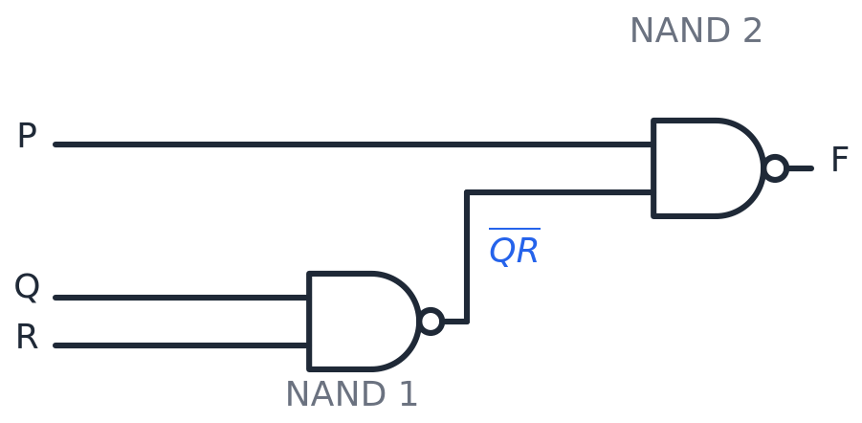
Figure 1. Two-NAND-gate realization of F = P̅ + QR.

Truth table
P | Q | R | P̅ | QR | F = P̅+QR
0 | 0 | 0 | 1 | 0 | 1
0 | 0 | 1 | 1 | 0 | 1
0 | 1 | 0 | 1 | 0 | 1
0 | 1 | 1 | 1 | 1 | 1
1 | 0 | 0 | 0 | 0 | 0
1 | 0 | 1 | 0 | 0 | 0
1 | 1 | 0 | 0 | 0 | 0
1 | 1 | 1 | 0 | 1 | 1
Output is HIGH (blue) for the four cases with P = 0, plus the case Q = R = 1 (last row) — exactly as required.

6. Design a logic circuit with four inputs (A, B, C, D) and output Y, such that Y = 1 whenever the decimal value of (ABCD)2 is divisible by 3 or 5.
Answer:
Step 1 — List the minterms. The 4-bit input ABCD can represent decimal numbers 0 to 15. The numbers divisible by 3 are: 0, 3, 6, 9, 12, 15. The numbers divisible by 5 are: 0, 5, 10, 15. Combining both lists (union, removing repeats) gives:

Truth table
Dec | A | B | C | D | Div 3/5 | Y
0 | 0 | 0 | 0 | 0 | yes | 1
1 | 0 | 0 | 0 | 1 | no | 0
2 | 0 | 0 | 1 | 0 | no | 0
3 | 0 | 0 | 1 | 1 | yes | 1
4 | 0 | 1 | 0 | 0 | no | 0
5 | 0 | 1 | 0 | 1 | yes | 1
6 | 0 | 1 | 1 | 0 | yes | 1
7 | 0 | 1 | 1 | 1 | no | 0
8 | 1 | 0 | 0 | 0 | no | 0
9 | 1 | 0 | 0 | 1 | yes | 1
10 | 1 | 0 | 1 | 0 | yes | 1
11 | 1 | 0 | 1 | 1 | no | 0
12 | 1 | 1 | 0 | 0 | yes | 1
13 | 1 | 1 | 0 | 1 | no | 0
14 | 1 | 1 | 1 | 0 | no | 0
15 | 1 | 1 | 1 | 1 | yes | 1

Y = 1 for minterms: 0, 3, 5, 6, 9, 10, 12, 15
Step 2 — Draw the K-map.
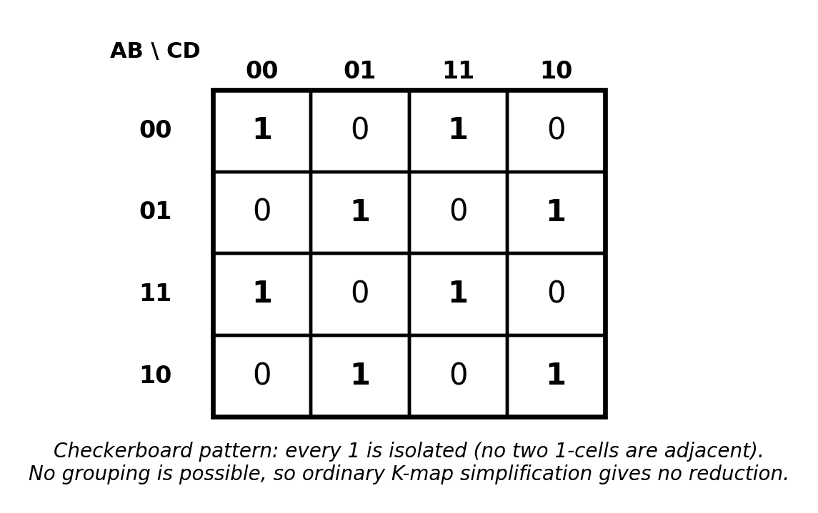
Step 3 — Try to simplify. Looking at the map, every single '1' cell has only '0' cells directly next to it (up, down, left, right). This is called a checkerboard pattern. In a checkerboard pattern, no two 1-cells are adjacent, so no pairs, quads, or larger groups can ever be formed. This means normal K-map grouping gives zero reduction — every minterm would need its own separate AND term, which is very wasteful (8 different 4-input AND gates).
Step 4 — Spot the pattern instead. If we count the number of 1-bits in each qualifying number's binary code, every single one of them (0000, 0011, 0101, 0110, 1001, 1010, 1100, 1111) has an even number of 1-bits. This is exactly the even-parity condition. So instead of a big sum-of-products circuit, we can build a much smaller and smarter circuit using XOR gates:
Y = (A ⊕ B ⊕ C ⊕ D)' (this is 1 exactly when the number of 1-bits in ABCD is even)
This uses only 3 XOR gates and 1 NOT gate — far fewer than 8 separate AND-OR terms, and it is also easier to extend to more bits.

Circuit
Implement with three XOR/XNOR gates: G1 = A XOR B, G2 = C XOR D, then Y = XNOR(G1, G2). (Equivalently, three XORs followed by one inverter.)
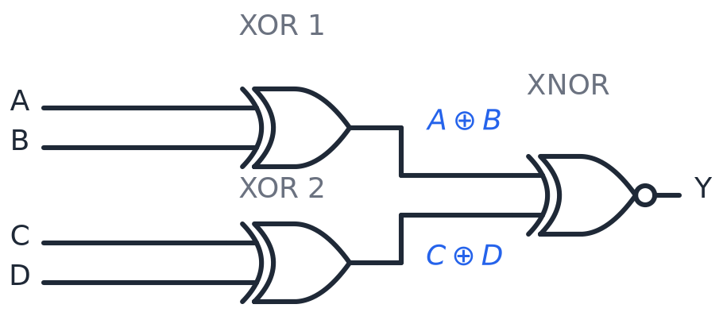
Figure 2. Even-parity (XNOR-tree) realization: Y = complement of (A XOR B XOR C XOR D).

Q7. Design a logic circuit that accepts a 3-bit number and generates an output binary number equal to the square of the input number.
Answer:
Let input: A, B, C. Since the maximum 3-bit number is 7, its square is 7² = 49 = (110001)₂. Therefore the output requires 6 bits: Y₅Y₄Y₃Y₂Y₁Y₀.
Truth table:
A | B | C | Decimal | Square | Y5 | Y4 | Y3 | Y2 | Y1 | Y0
0 | 0 | 0 | 0 | 0 | 0 | 0 | 0 | 0 | 0 | 0
0 | 0 | 1 | 1 | 1 | 0 | 0 | 0 | 0 | 0 | 1
0 | 1 | 0 | 2 | 4 | 0 | 0 | 0 | 1 | 0 | 0
0 | 1 | 1 | 3 | 9 | 0 | 0 | 1 | 0 | 0 | 1
1 | 0 | 0 | 4 | 16 | 0 | 1 | 0 | 0 | 0 | 0
1 | 0 | 1 | 5 | 25 | 0 | 1 | 1 | 0 | 0 | 1
1 | 1 | 0 | 6 | 36 | 1 | 0 | 0 | 1 | 0 | 0
1 | 1 | 1 | 7 | 49 | 1 | 1 | 0 | 0 | 0 | 1

Simplified Boolean Expressions from the truth table:

A\BC | 00 | 01 | 11 | 10
0 | 0 | 1 | 1 | 0
1 | 0 | 1 | 1 | 0
𝑌 = 𝐶
0

A\BC | 00 | 01 | 11 | 10
0 | 0 | 0 | 0 | 0
1 | 0 | 0 | 0 | 0

𝑌1 = 0

A\BC | 00 | 01 | 11 | 10
0 | 0 | 0 | 0 | 1
1 | 0 | 0 | 0 | 1
𝑌 = 𝐵𝐶'
2

A\BC | 00 | 01 | 11 | 10
0 | 0 | 0 | 1 | 0
1 | 0 | 1 | 0 | 0

𝑌 = 𝐶(𝐴 ⊕ 𝐵)
3

A\BC | 00 | 01 | 11 | 10
0 | 0 | 0 | 0 | 0
1 | 1 | 1 | 1 | 0

𝑌 = 𝐴𝐵'
4

A\BC | 00 | 01 | 11 | 10
0 | 0 | 0 | 0 | 0
1 | 0 | 0 | 1 | 1

𝑌5 = 𝐴𝐵

Simplified Boolean Expressions (from K-maps):
Y0 = C
Y1 = 0
Y2 = BC′
Y3 = C(A ⊕ B)
Y4 = AB′
Y5 = AB

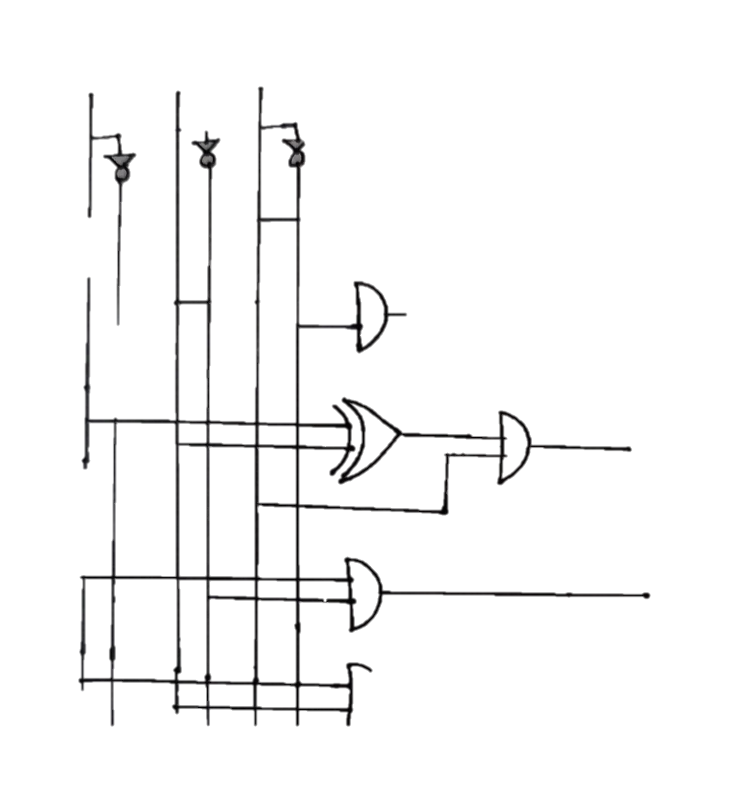
Now implement the simplified expression:
Figure 3:

Q8. Design a logic circuit that accepts a 4-bit number and generates the 2's complement of the input number.
Answer:
The 2’s complement of an N-bit binary number is obtained by: (1) inverting all bits (1’s complement), and (2) adding 1 to the result.
Let 4 inputs: A, B, C, D; 4 outputs: Y₃, Y₂, Y₁, Y₀.
Truth table:
A | B | C | D | Decimal | 2’s Comp | Y3 | Y2 | Y1 | Y0
0 | 0 | 0 | 0 | 0 | 0 | 0 | 0 | 0 | 0
0 | 0 | 0 | 1 | 1 | 15 | 1 | 1 | 1 | 1
0 | 0 | 1 | 0 | 2 | 14 | 1 | 1 | 1 | 0
0 | 0 | 1 | 1 | 3 | 13 | 1 | 1 | 0 | 1
0 | 1 | 0 | 0 | 4 | 12 | 1 | 1 | 0 | 0
0 | 1 | 0 | 1 | 5 | 11 | 1 | 0 | 1 | 1
0 | 1 | 1 | 0 | 6 | 10 | 1 | 0 | 1 | 0
0 | 1 | 1 | 1 | 7 | 9 | 1 | 0 | 0 | 1
1 | 0 | 0 | 0 | 8 | 8 | 1 | 0 | 0 | 0
1 | 0 | 0 | 1 | 9 | 7 | 0 | 1 | 1 | 1
1 | 0 | 1 | 0 | 10 | 6 | 0 | 1 | 1 | 0
1 | 0 | 1 | 1 | 11 | 5 | 0 | 1 | 0 | 1
1 | 1 | 0 | 0 | 12 | 4 | 0 | 1 | 0 | 0
1 | 1 | 0 | 1 | 13 | 3 | 0 | 0 | 1 | 1
1 | 1 | 1 | 0 | 14 | 2 | 0 | 0 | 1 | 0
1 | 1 | 1 | 1 | 15 | 1 | 0 | 0 | 0 | 1
Simplified Boolean Expressions:
Y0 = D
Y1 = C ⊕ D
Y2 = B′ ⊕ (C′D′)
Y3 = A′ ⊕ (B′C′D′)
Implementation: The four outputs are realized using XOR gates with inverters on the appropriate input lines, following the expressions above.
Now implement the simplified expression:
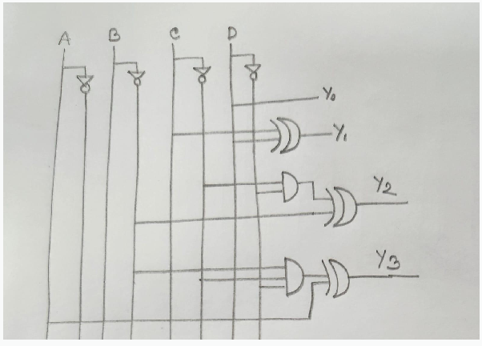
Figure 4:

Q9. Compare combinational and sequential logic circuits with respect to design, operation, and applications.
Answer:
Point | Combinational Circuit | Sequential Circuit
Definition | Output depends only on the present input values | Output depends on present input AND the past state (memory)
Memory element | No memory element used | Uses memory elements such as flip-flops or latches
Clock signal | Usually does not need a clock | Often needs a clock signal to control state changes
Building blocks | AND, OR, NOT, NAND, NOR, XOR, decoders, multiplexers | Flip-flops, registers, counters, built on top of combinational gates
Design method | Truth table, Boolean algebra, K-map | State diagram, state table, excitation table, then gate design
Feedback path | No feedback path | Has a feedback path from output back to input
Applications | Adders, encoders, decoders, multiplexers, comparators | Counters, registers, memories, FSMs (finite state machines), sequence detectors
In short, a combinational circuit is like a simple calculator step: same input always gives the same output right away. A sequential circuit is like a diary: it remembers what happened before, so the same input can give a different output depending on the current state.
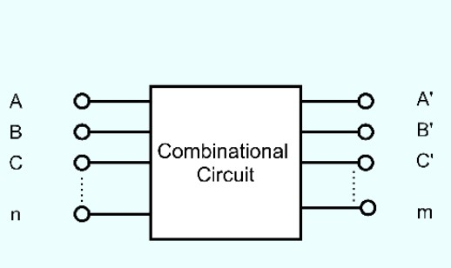
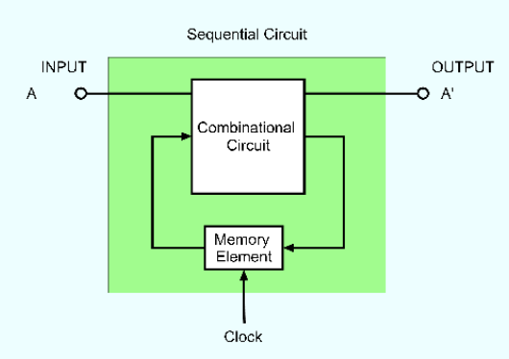
Figure 5:

Q10. Design and explain the circuit to add the bits 1011 and 1100 using a block diagram.
Answer:
To add two 4-bit binary numbers, 1011 and 1100, we use a 4-bit parallel binary adder. It can be implemented using four Full Adders (FA) connected in cascade.
Given, A = 1011
B = 1100
Initial carry: 𝐶 = 0
0

Block Diagram:
The four Full Adders are connected from the LSB to the MSB:
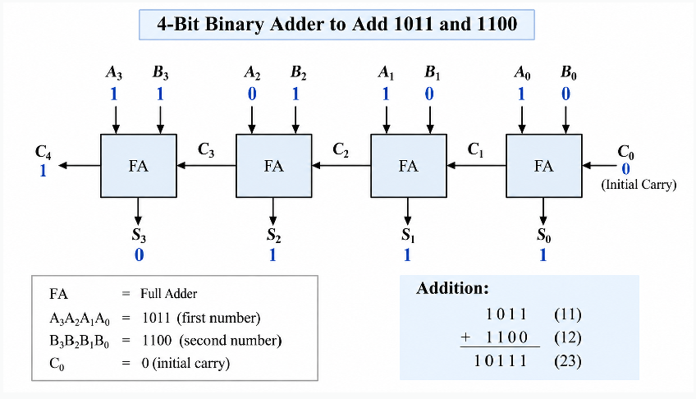
Figure 6:

Thus, the ﬁnal output is:𝐶 𝑆 𝑆 𝑆 𝑆 = 10111
4 3 2 1 0

Q11. A standard 8-to-3 encoder receives two active inputs simultaneously. What output will it produce? Why is this a problem?
Answer:
A standard (non-priority) 8-to-3 encoder is built with simple OR gates, assuming that only one of its 8 input lines is active (HIGH) at any given time. Each output bit is just the OR of the input lines whose position has a 1 in that bit position.
If two inputs become active at the same time, for example input D3 (011) and input D5 (101) are both HIGH together, the encoder OR-gates simply combine both codes bit by bit, producing 011 OR 101 = 111, which is the code for 7. But 7 was never actually pressed or activated — this output is completely wrong and does not represent either of the real active inputs.
This is a problem because:
- The output code is ambiguous — it does not match the true active input, and there is no way for the next circuit to know that an error happened.
- Important information can be silently lost or corrupted, which is dangerous in real systems like keyboards or interrupt controllers.
This exact problem is why priority encoders were invented: a priority encoder has a defined rule (for example, 'the highest-numbered active input wins') so that even when multiple inputs are active together, it always produces one sensible, predictable, correct output code.
Suppose:
Inputs | 𝑌  2 | 𝑌  1 | 𝑌  0
𝐼  0 | 0 | 0 | 0
𝐼  1 | 0 | 0 | 1
𝐼  2 | 0 | 1 | 0
𝐼  3 | 0 | 1 | 1
𝐼  4 | 1 | 0 | 0
𝐼  5 | 1 | 0 | 1
𝐼  6 | 1 | 1 | 0
𝐼  7 | 1 | 1 | 1
𝑌0 = 𝐼1 + 𝐼3 + 𝐼5 + 𝐼7
𝑌1 = 𝐼2 + 𝐼3 + 𝐼6 + 𝐼7
𝑌 = 𝐼 + 𝐼 + 𝐼 + 𝐼
2 4 5 6 7

When two inputs are active simultaneously in a standard 8-to-3 encoder, the output will be the bitwise OR of the binary codes of both active inputs.
Example : If 𝐼(011) 𝑎𝑛𝑑 𝐼(101) are active:
3 5

Output Bit | Expression | Value
𝑌 = 𝐼 + 𝐼 + 𝐼 + 𝐼  0 1 3 5 7 | 0+1+1+0 | 1
𝑌 = 𝐼 + 𝐼 + 𝐼 + 𝐼  1 2 3 6 7 | 0+1+0+0 | 1
𝑌 = 𝐼 + 𝐼 + 𝐼 + 𝐼  2 4 5 6 7 | 0+1+0+0 | 1

Output = 111 (which is binary 7) - an incorrect output.

Problem | Explanation
Ambiguous Output | The output 111 doesn't represent either I₃  (011) or I₅ (101) → Meaningless result
Loss of Information | Same output (111) is produced for I₇ alone, so we can't distinguish between I₃+I₅ and I₇
Data Corruption | In real applications (keyboards, interrupt controllers), this causes wrong codes/addresses

Q12. Implement a 1-to-16 demultiplexer using only 2-to-4 decoders with enable inputs and no other logic gates. Clearly label all inputs, pins, and outputs.
Answer:
A 2-to-4 decoder with an Enable pin can act like a small 1-to-4 demultiplexer: the 2 select lines choose which output line is active, and the Enable pin acts as the data input — whatever value is put on Enable is copied through to the one selected output, and all other outputs stay 0.
To build a bigger 1-to-16 demultiplexer, we arrange 5 decoders (2-to-4 each) in two levels:
- Level 1 (one decoder): Its select lines are the two most-significant select bits S3, S2 of the whole system. Its Enable pin is fed by the actual data input D. Its 4 outputs (E0, E1, E2, E3) go on to enable the 4 Level-2 decoders — only one of these 4 lines becomes active (equal to D) at a time, depending on S3S2.
- Level 2 (four decoders): All four of them share the same two select lines, S1 and S0 (the least-significant select bits). Each Level-2 decoder's Enable pin is connected to one output line from the Level-1 decoder. So only the one Level-2 decoder that is enabled will actually pass data through; the other three stay completely disabled (all outputs 0).
- Together, the 4 outputs of each of the 4 Level-2 decoders give 16 total output lines Y0 to Y15. Only one of these 16 lines will ever carry the data D, decided by the full 4-bit select code S3S2S1S0.

Example: if S3S2S1S0 = 1011 (decimal 11), the Level-1 decoder activates its E2 output (since S3S2=10 selects the third decoder), which enables Level-2 decoder L2-2; then S1S0=11 makes that decoder route D to its last output, which is overall output Y11. Every other output stays LOW.
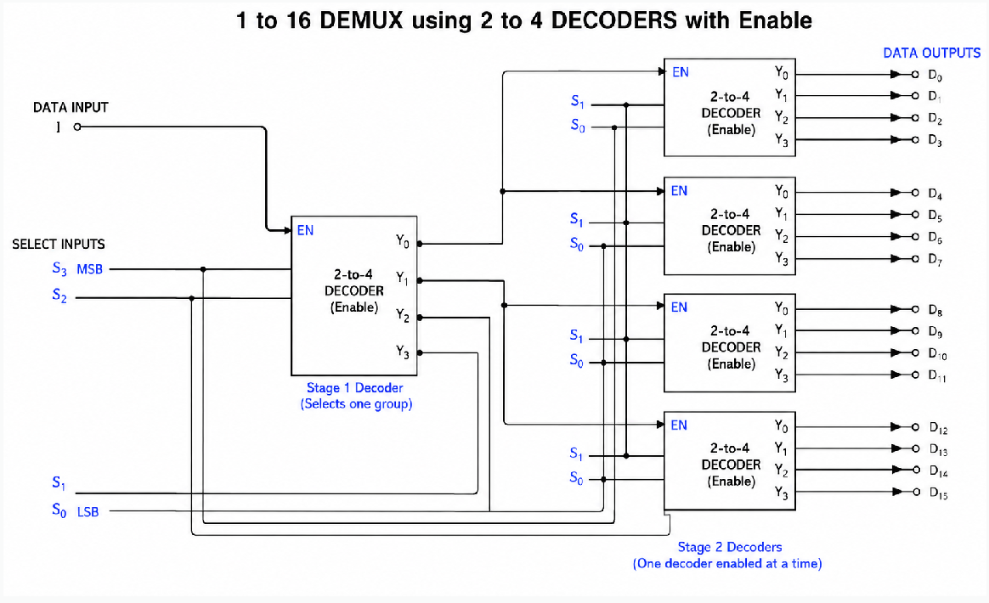
Figure 6:

Q13. Design a logic circuit that compares two 4-bit numbers, A and B, to check if they are equal. Output x = 1 if A = B, and x = 0 if A ≠ B.
Answer:
Let the two 4-bit numbers be:
𝐴 = 𝐴 𝐴 𝐴 𝐴
3 2 1 0

𝐵 = 𝐵 𝐵 𝐵 𝐵
3 2 1 0

The circuit has one output X such that:
X =1 , 𝐴 = 𝐵
𝑋 = 0, 𝐴 ≠ 𝐵
For A and B to be equal, all four corresponding bits must be equal:
𝐴 = 𝐵 , 𝐴 = 𝐵 , 𝐴 = 𝐵 , 𝐴 = 𝐵
3 3 2 2 1 1 0 0

We can compare each pair using an XNOR gate. XNOR gives:
- Same bits→ 1
- Different bits→ 0

Boolean Expression :
For each bit:
𝐸 = 𝐴 ⊙ 𝐵
3 3 3

𝐸 = 𝐴 ⊙ 𝐵
2 2 2
𝐸 = 𝐴 ⊙ 𝐵
1 1
1

𝐸 = 𝐴 ⊙ 𝐵
0 0 0

Then,𝑋 = 𝐸 𝐸 𝐸 𝐸
3 2 1 0

Therefore,𝑋 = (𝐴 ⊙ 𝐵 )(𝐴 ⊙ 𝐵 )(𝐴 ⊙ 𝐵 )( 𝐴 ⊙ 𝐵 )
3 3 2 2 1 1 0 0

Circuit Implementation:
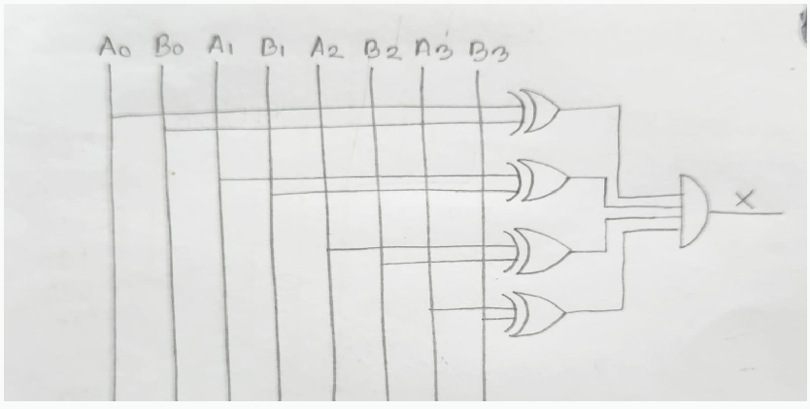
Figure 7:

Q14. Explain how a multiplexer can be used as a universal logic circuit.
Answer:
A multiplexer (MUX) is called a universal logic element because a MUX with n select lines can be wired to implement ANY Boolean function of (n+1) variables, just by connecting the right constant (0 or 1) or the right variable to each data input line — with no other gates needed.
The method is simple:
- Choose (n-1) of the function's input variables to connect to the MUX select lines.
- Write out the truth table of the function, and group the rows by the values of those chosen select variables.
- For each group (each data input line of the MUX), work out what the output should be in terms of the one remaining variable: it will always simplify to one of just four possibilities — always 0, always 1, equal to the remaining variable, or equal to the complement of the remaining variable.
- Connect each data input pin of the MUX to whichever of those four values (0, 1, variable, or variable') is correct for that row group.
Example: To build the function F(A,B,C) = A'B + BC using a 4-to-1 MUX, connect A and B to the select lines, and work out the required value on each data input as either 0, 1, C, or C'. Once wired this way, the MUX behaves exactly like the original function, with no separate AND/OR gates required. This is why a MUX (especially one with enough select lines) can replace almost any combinational logic block, earning it the name 'universal logic circuit'.
A multiplexer is a combinational circuit that:
- Has multiple inputs (2ⁿ) and one output
- Selects one input to pass to the output based on n select lines
- Acts like a data selector or rotary switch Structure: 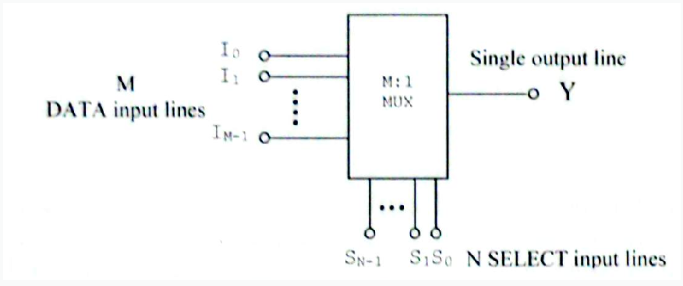
Figure 8:

A multiplexer is considered universal because:
- Any Boolean function can be implemented using only multiplexers
- It can replace AND, OR, NOT, NAND, NOR, XOR gates
- It serves as a complete logic family by itself
- Can implement combinational circuits without using basic gates NOT Gate using 2:1 MUX
select(s) | 𝐼  0 | 𝐼  1 | Output(Y)
S=A | 1 | 0 | Y=A’
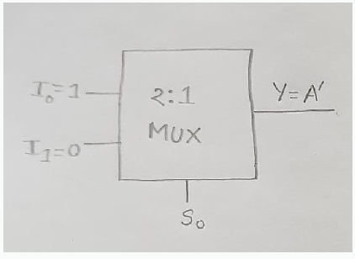
Working:
  - When A = 0 → S = 0 → Y = I₀ = 1 = A'
  - When A = 1 → S = 1 → Y = I₁ = 0 = A'

AND Gate using 2:1 MUX
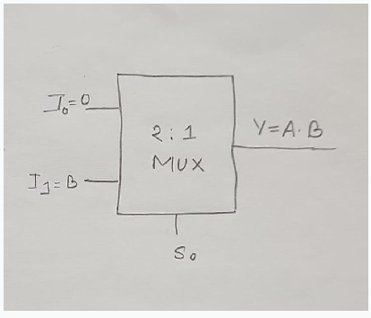
select(s) | 𝐼  0 | 𝐼  1 | Output(Y)
S=A | 0 | B | Y=A.B
Working:
  - When A = 0 → Y = I₀ = 0 = A·B
  - When A = 1 → Y = I₁ = B = A·B

OR Gate using 2:1 MUX

select(s) | 𝐼  0 | 𝐼  1 | Output(Y)
S=A | B | 1 | Y = A+B
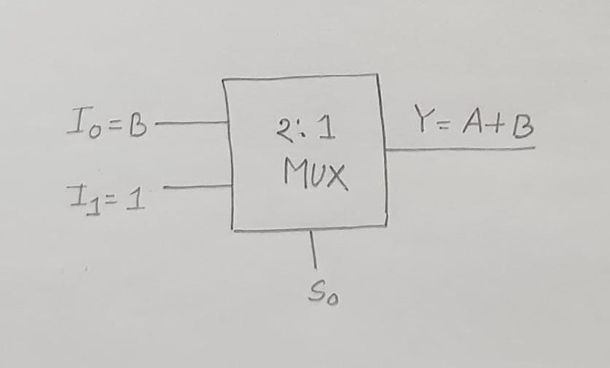
Working:
  - When A = 0 → Y = I₀ = B = A+B
  - When A = 1 → Y = I₁ = 1 = A+B

Q15. Design a circuit to distribute a serial input to four different outputs using a DEMUX.
Answer:
A Demultiplexer (DEMUX) is a combinational circuit that takes one data input and routes it to one of several outputs according to the values of the select inputs.
For distributing one serial input to four different outputs, we use a 1-to-4 DEMUX. Circuit Diagram:
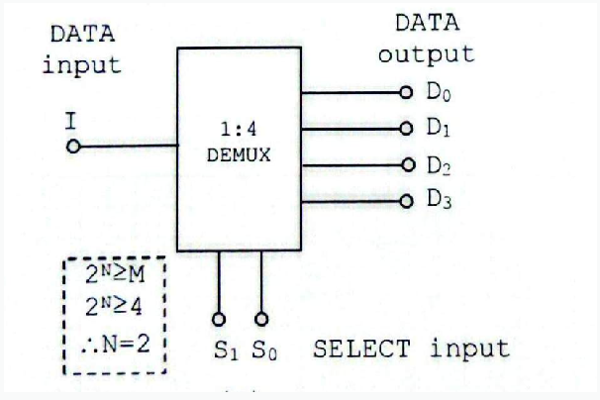
Figure 9:

Truth Table:
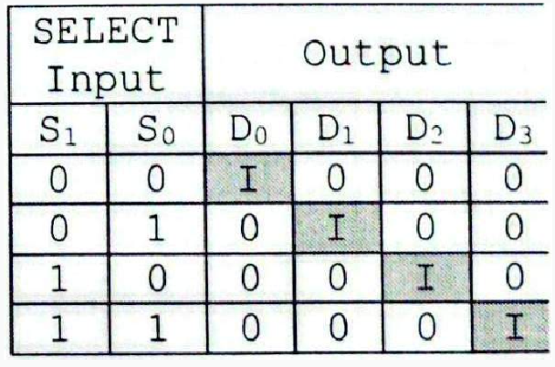
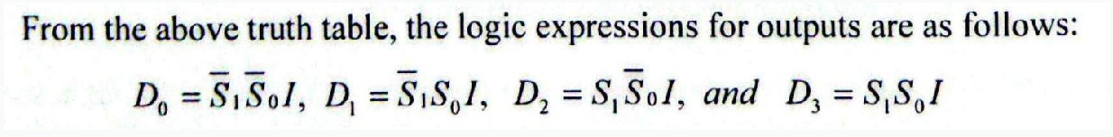

At any moment, only one AND gate has all of its select-line inputs equal to 1 (matched to S1S0), so only that one gate passes D through to its output; the other three gates always have at least one select input equal to 0, forcing their outputs to stay LOW. By changing S1S0 over time, the same serial input D can be sent to a different output line at each moment — this is exactly how a demultiplexer 'distributes' one input to many outputs.

Q16. Give a real-life application where a priority encoder is preferred over a standard encoder.
Answer:
A very common real example is a computer keyboard.
When you press a key, the keyboard circuit must send a code representing which key was pressed. But sometimes a person accidentally presses two keys at almost the same time (for example, pressing Shift and a letter key together, or simply pressing two keys close in time due to fast typing). A standard encoder would get confused, because it assumes only one input is active, and it would output a wrong, meaningless code if two inputs are active together (as explained in Question 11).
A priority encoder solves this cleanly: it is designed so that if more than one key is pressed at the same time, it always outputs the code for whichever key has the highest defined priority (for example, the physically highest-priority key line), and it simply ignores the lower-priority key for that moment. This gives predictable, correct behaviour even when multiple inputs happen together.
Another common real example is an interrupt controller inside a computer processor (CPU): many devices (keyboard, mouse, timer, disk) can each raise an interrupt request at the same time, and a priority encoder decides which interrupt the CPU should handle first, based on a fixed priority ranking
Another way,
A priority encoder is preferred over a standard encoder when more than one input may become active at the same time and the system must decide which input has higher priority. Example: Interrupt handling in a computer system. In a computer, several devices such as the keyboard, mouse, printer, and network card may request the CPU's attention at the same time.
A priority encoder can assign a priority to each interrupt:
- Highest priority → Critical device
- Medium priority → Network device
- Lower priority → Keyboard
- Lowest priority → Printer
If multiple devices send interrupt requests simultaneously, the priority encoder selects the highest-priority request and sends its binary code to the CPU.
A standard encoder assumes that only one input is active at a time. If multiple inputs are active simultaneously, its output may be ambiguous or invalid.
Therefore:
- Priority encoders are preferred in interrupt handling systems because they can correctly handle multiple simultaneous inputs by selecting the highest-priority one.

Q17. Compare a decoder with a demultiplexer. Under what conditions can a decoder function as a demultiplexer?
Answer: Both a decoder and a demultiplexer (DEMUX) use select inputs to activate one of several output lines, but their purposes are different.
Feature | Decoder | Demultiplexer
Main function | Converts binary input into one active output. | Routes one data input to one selected output.
Data input | Usually has n input lines. | Has 1 data input.
Select inputs | n input bits act as selection. | n select lines.
Number of outputs | 2ⁿ | 2ⁿ
Data routing | Does not route data. | Routes data.
Example | 2-to-4 decoder | 1-to-4 DEMUX
A decoder can function as a demultiplexer when one of its inputs is used as the data input (enable input), while the remaining inputs are used as select lines.
For example, consider a 2-to-4 decoder with an Enable (E) input:
- E → Data input
- S1, S0 → Select inputs
- Y0, Y1, Y2, Y3 → Outputs
The outputs can be represented as:
Y0 = E(S1S0)′, Y1 = ES′1S0, Y2 = ES1S′0, Y3 = ES1S0
These are exactly the same expressions as a 1-to-4 DEMUX.

Q18. A logic circuit is defined by f1 = A'B + ABC', f2 = A' + B, f3 = AB + A'B'. Draw the circuit with a decoder and external gates.
Answer:
The functions have 3 inputs (A, B, C), so we need a 3-to-8 decoder. A 3-to-8 decoder produces 8 min terms:
 | Inputs |  | Outputs
A | B | C
0 | 0 | 0 | 𝐷 = 𝐴'𝐵'𝐶'  0
0 | 0 | 1 | 𝐷 = 𝐴'𝐵'𝐶  1
0 | 1 | 0 | 𝐷 = 𝐴'𝐵𝐶'  2
0 | 1 | 1 | 𝐷 = 𝐴'𝐵𝐶  3
1 | 0 | 0 | 𝐷 = 𝐴𝐵'𝐶'  4
1 | 0 | 1 | 𝐷 = 𝐴𝐵'𝐶  5
1 | 1 | 0 | 𝐷 = 𝐴𝐵𝐶'  6
1 | 1 | 1 | 𝐷 = 𝐴𝐵𝐶  7

Expand Each Function into Minterms
𝑓 = 𝐴'𝐵' + 𝐴𝐵𝐶' = 𝐴'𝐵'(𝐶 + 𝐶') + 𝐴𝐵𝐶' = 𝐴'𝐵'𝐶 + 𝐴'𝐵'𝐶' + 𝐴𝐵𝐶' = 𝐷 + 𝐷 + 𝐷
1 0 1 6

𝑓 = 𝐴' + 𝐵 = 𝐴'(𝐵 + 𝐵')(𝐶 + 𝐶') + 𝐵(𝐴 + 𝐴')(𝐶 + 𝐶')
2

=𝐴'𝐵𝐶 + 𝐴'𝐵𝐶' + 𝐴'𝐵'𝐶 + 𝐴'𝐵'𝐶' + 𝐴𝐵𝐶 + 𝐴𝐵𝐶' + 𝐴'𝐵𝐶 + 𝐴'𝐵𝐶'

= 𝐷 + 𝐷 + 𝐷 + 𝐷 + 𝐷 + 𝐷
0 1 2 3 6 7

𝑓 = 𝐴𝐵 + 𝐴'𝐵'
3
= 𝐴𝐵(𝐶 + 𝐶') + 𝐴'𝐵'(𝐶 + 𝐶')

= 𝐷 + 𝐷 + 𝐷 + 𝐷
0 1 6 7

Circuit Diagram:
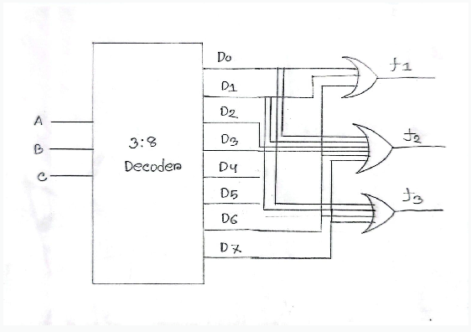

Q19. Under what conditions would you choose a D flip-flop instead of a JK flip-flop? Justify your answer.
Answer:
A D ﬂip-ﬂop should be chosen over a JK ﬂip-ﬂop when the main requirement is to store or transfer a single bit of data and a simple circuit is preferred.

Conditions
We choose a D ﬂip-ﬂop when:
  - Data storage is the main purpose
A D ﬂip-ﬂop directly stores the value of the D input at the active clock edge.
  - A simple circuit is required
A D ﬂip-ﬂop has only one data input, D, making the circuit simpler than a JK ﬂip-ﬂop.
  - No toggle or reset/set behavior is required through the data inputs
JK ﬂip-ﬂops are useful when we need set, reset, hold, and toggle operations. If these features are unnecessary, D ﬂip-ﬂop is more appropriate.
  - Registers or data transfer circuits are being designed
D ﬂip-ﬂops are commonly used in registers, shift registers, and data storage systems.

Justiﬁcation:
For a D ﬂip-ﬂop:
𝑄 =D
𝑛𝑒𝑥𝑡
So, whatever value is present at D is transferred directly to Q on the active clock edge.
For a JK ﬂip-ﬂop, two inputs J and K must be considered, and it provides additional operations such as toggling:
𝐽 = 𝐾 = 1 ⇒ 𝑄 = 𝑄'
𝑛𝑒𝑥𝑡
Therefore, using a JK ﬂip-ﬂop when only simple data storage is needed would add unnecessary complexity.

Q20. Compare SR, JK, D, and T flip-flops in terms of functionality, complexity, and typical applications.
Feature | SR Flip-Flop | JK Flip-Flop | D Flip-Flop | T Flip-Flop
Inputs | S, R | J, K | D | T
Main Function | Set and Reset | Set, Reset and Toggle | Data storage | Toggle
Hold | S=0, R=0 | J=0, K=0 | D retains  previous value | T=0
Set | S=1, R=0 | J=1, K=0 | D=1 | Not directly
Reset | S=0, R=1 | J=0, K=1 | D=0 | Not directly
Toggle | Not available | J=K=1 | Not directly | T=1
Invalid condition | S=R=1 | No invalid condition | None | None
Complexity | Simple | More complex | Simple | Simple
Typical Applications | Basic memory circuits,  Control circuits  ,Switch  debouncing | Counters, Frequency division,  Sequential  control circuits | Registers,  Shift registers, Data storage, Data transfer circuits | Binary counters, Frequency dividers,  Toggle circuits
In general, SR is the most basic building block but has a forbidden state; JK fixes that problem and adds toggle ability, making it the most flexible; D is the easiest to use for simple data storage; and T is the easiest to use when only toggling is needed, like in counters.

Q21. Compare edge-triggered and level-triggered flip-flops. Which is more suitable for high-speed applications, and why?
Answer: Comparison Between Edge-Triggered and Level-Triggered Flip-Flops:

Feature | Edge-Triggered | Level-Triggered
Operation | Changes only at a clock edge | Changes during a  particular clock level
Triggering | Rising edge (↑) or falling edge (↓) | HIGH level or LOW level
Input response | Responds at one instant | Responds throughout the active clock level
Speed | Suitable for high-speed systems | Less suitable for very high-speed systems
Timing control | More precise | Less precise
Race-through problem | Generally avoided | Can occur in some designs
Complexity | Usually more complex | Usually simpler
Applications | High-speed processors, registers, synchronous systems | Simple control circuits, latches, low-speed systems
Edge-triggered ﬂip-ﬂop is more suitable for high-speed applications.Reason:It samples the input only at a speciﬁc clock edge. This provides better timing control, prevents unwanted changes during the clock period, and reduces race-through problems, making it more suitable for high-speed synchronous digital systems.

Q22. Is a JK flip-flop always a better choice because it is more versatile? Defend your answer.
Answer:
No. A JK flip-flop is not always the better choice, even though it is more versatile.
A JK flip-flop can perform hold, set, reset, and toggle operations:
J | K | Operation
0 | 0 | Hold
0 | 1 | Reset
1 | 0 | Set
1 | 1 | Toggle
Because of this versatility, it can perform the functions of other flip-flops with suitable connections. However, more functionality does not always mean a better choice — the added inputs increase complexity, wiring, and power consumption, and for applications that only need data storage (registers, shift registers), a simpler D flip-flop is the more appropriate and efficient choice.

Q23. Under what circumstances would you choose a synchronous design over an asynchronous design? Justify your answer.
Answer:
A synchronous design is preferred when predictable timing, reliable operation and easy coordination between circuit components are important. Although asynchronous designs can respond faster because they do not wait for a clock, they are more sensitive to propagation delays, race conditions, and timing problems.
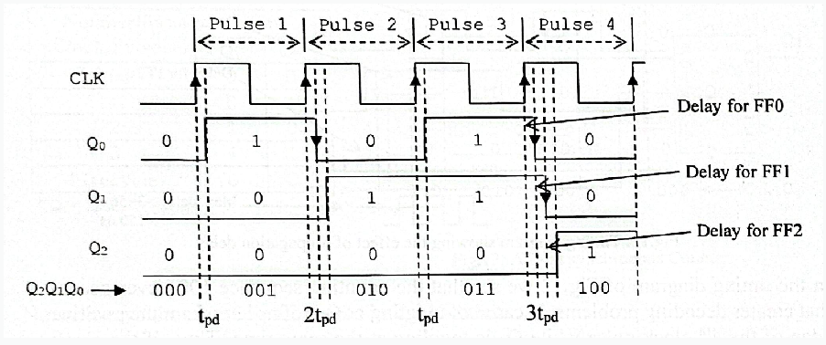
In an asynchronous design, the ﬂip-ﬂops do not receive the clock simultaneously. The output of one ﬂip-ﬂop triggers the next ﬂip-ﬂop. Therefore, propagation delays
accumulate from one stage to another.
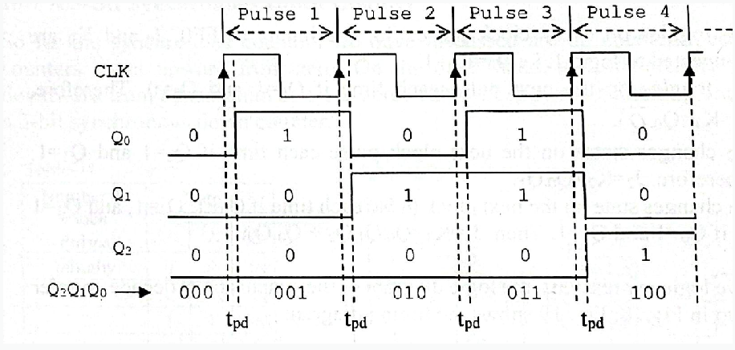

In a synchronous design, all ﬂip-ﬂops receive the same clock signal simultaneously.
Therefore, the circuit has better timing control and less accumulated propagation delay.
So, for high-speed applications, synchronous design is preferred because all ﬂip-ﬂops are triggered by the same clock, reducing cumulative propagation delay and providing more predictable timing.

Q24. Under what circumstances would an asynchronous counter be a better choice than a synchronous counter?
Answer:
An asynchronous counter (ripple counter) can be a better choice when simplicity, low hardware cost, and low-speed operation are more important than high speed.

Circumstances
- Low-speed applications
When the counting frequency is low, the propagation delay is usually not a major problem.
- Simple circuit is required
In an asynchronous counter, only the ﬁrst ﬂip-ﬂop receives the external clock. The remaining ﬂip-ﬂops are triggered by the outputs of previous ﬂip-ﬂops, so the
circuit is relatively simple.
- Low hardware cost is desired
It requires less additional logic, making it cheaper and easier to implement.
- Small number of counting stages
For a small number of ﬂip-ﬂops, the accumulated propagation delay may be acceptable.
- Simple frequency division is needed
Asynchronous counters are commonly used as frequency dividers.
In an asynchronous counter, the clock does not reach all ﬂip-ﬂops simultaneously. Therefore, a propagation delay occurs from one ﬂip-ﬂop to the next:
𝑡 ≈ 𝑛 × 𝑡
𝑡𝑜𝑡𝑎𝑙 𝑝𝑑

where n is the number of ﬂip-ﬂops.

For high-speed applications, this delay becomes a problem. But for low-speed and simple applications, the advantages of lower complexity and cost can make an
asynchronous counter preferable.

Example

An asynchronous counter can be used in a simple digital frequency divider or a low-speed event counter where very high counting speed is not required.

Q25. Why are synchronous counters preferred in modern high-speed processors?
Answer:
Synchronous counters are preferred in modern high-speed processors for these key reasons:
- No ripple delay: every flip-flop in a synchronous counter receives the same clock signal at the same time and changes state together, instead of waiting for the previous stage like in a ripple (asynchronous) counter. This means the total delay does not add up across many stages.
- Higher maximum speed: because there is no build-up of propagation delay, a synchronous counter can run at a much higher clock frequency than an asynchronous counter with the same number of bits.
- Glitch-free, predictable output: all output bits change at (almost) the same instant, so there are no brief incorrect in-between states (glitches) appearing on the output during counting, which is very important when other parts of the processor are reading the counter value at high speed.
- Easier integration with other synchronous logic: since the rest of a modern processor (registers, pipelines, ALU) is also built with a single shared clock, using synchronous counters keeps the whole system's timing consistent and easy to analyze.
Because processors today run at very high clock speeds and need extremely reliable, predictable timing everywhere, synchronous counters are the standard choice, even though they need a little more logic (extra gates to generate the next-state equations for every flip-flop at once) compared to simple asynchronous counters.

Q26. Why are synchronous counters generally preferred over asynchronous counters in high-speed digital systems? Discuss the trade-offs involved.
Answer:
Asynchronous counter (Ripple counter): An asynchronous counter is a counter in which the output of one flip-flop is connected to the clock input of the next flip-flop. Therefore, the output changes propagate from one flip-flop to the next in sequence. This sequential propagation is called a ripple.
Synchronous counter: A synchronous counter is a counter in which all flip-flops are driven by the same clock signal. All flip-flops receive the active clock edge simultaneously, and their outputs change together after a small propagation delay.

Why Synchronous Counters Are Preferred at High Speed
Synchronous counters are generally preferred in high-speed digital systems because they provide faster and more predictable operation.

Lower cumulative propagation delay
In an asynchronous counter, the transition of one flip-flop must propagate through the following flip-flops. For an n-bit ripple counter, the worst-case total delay is approximately:
ttotal = n × tpd
where t_{pd} is the propagation delay of one flip-flop.
Thus, as the number of flip-flops increases, the total delay also increases. This limits the maximum clock frequency.
In a synchronous counter, all flip-flops are clocked at the same instant. The delay depends mainly on the propagation delay of a flip-flop and the delay of the com-binational logic used to generate the next state. It does not accumulate stage by stage in the same way as a ripple counter.

More predictable timing
In a synchronous counter, all outputs update after the same clock edge. This makes timing analysis easier and more reliable.
In a ripple counter, output bits change at different times. During a transition, temporary or invalid binary states may appear before the final count is reached.

Reduced glitches in decoded outputs
When a ripple counter changes state, its bits do not change simultaneously. For example, a transition from 0111 to 1000 may temporarily pass through several unwanted states. If the counter output is connected to a decoder, these temporary states can produce glitches.

Synchronous counters significantly reduce such problems because the outputs change almost simultaneously.

Better integration with modern digital system
Most high-speed digital systems, including processors, communication circuits, and FPGA-based systems, are synchronous. Synchronous counters work naturally with a common system clock and are easier to integrate with registers, state machines, and control logic.

Trade-offs
Circuit complexity: Synchronous counters require additional combinational logic to determine which flip-flops should toggle or what their next states should be. Ripple counters require fewer connections and less logic.
Power consumption: Synchronous counters may consume more dynamic power because several flip-flops and combinational gates may switch at the same time. Ripple counters often use fewer logic gates, although the ripple transitions also consume power.
Design effort: Ripple counters are easier to design for small and low-speed appli-cations. Synchronous counters need more careful design but are much more suitable for high-speed and large-scale systems.

Therefore, synchronous counters are preferred for high-speed digital systems because they offer high operating speed, predictable timing, reduced output glitches, and better compatibility with synchronous digital circuits. Their main disadvantages are increased logic complexity and potentially higher power consumption.

Q27. Compare ripple counters and synchronous counters in terms of speed, complexity, power consumption, and applications.
Answer:
Comparison Ripple Counter vs Synchronous Counter
Feature | Ripple (Asynchronous) Counter | Synchronous Counter
Speed | Slower because propagation delay accumulates from one flip-flop to the next. | Faster because all flip-flops are triggered by the same clock.
Complexity | Simple circuit; requires fewer logic gates. | More complex; requires additional logic gates.
Power Consumption | Generally lower power consumption. | Generally higher power consumption due to additional logic
Propagation Delay | High; delay increases as the number of flip-flops increases. | Low; propagation delay is much smaller and does not ripple through all stages.
Accuracy/Timing | Less suitable for high-speed timing because outputs do not change simultaneously. | Better timing performance because outputs change in a coordinated manner.
Applications | Low-speed counters, frequency dividers, simple counting circuits. | High-speed digital systems, processors, digital clocks, communication systems.
Cost | Cheaper and easier to implement. | More expensive due to additional hardware.

Summary:
Ripple counters are simple and economical for low-speed applications. However, syn-chronous counters are faster, more reliable, and better suited for high-speed systems where timing accuracy is important.

Q28. Which type of counter would you recommend for a high-speed communication system? Justify your an-swer.

Answer:
For a high-speed communication system, a synchronous counter is recommended.

Justification

High operating frequency
Communication systems often operate at high clock rates. A synchronous counter can operate at a higher frequency because all flip-flops receive the clock signal simultaneously. The delay does not ripple through the entire chain of flip-flops.

Reliable timing
In a communication system, accurate timing is required for data framing, synchro-nization, bit counting, packet transmission, and baud-rate generation. Synchronous counters provide deterministic timing because all bits update with a common clock edge.

Reduced output glitches
Ripple counters can generate temporary intermediate states while counting. These unwanted states may cause incorrect decoding or false control signals. In high-speed communication equipment, such errors may lead to data loss or synchronization problems.

Compatibility with synchronous circuits
Communication systems usually contain registers, shift registers, state machines, and processors that are controlled by a common system clock. A synchronous counter can be integrated easily with these circuits.

Conclusion
Although a synchronous counter needs more logic gates than a ripple counter, it is the best choice for high-speed communication systems because of its higher speed, accurate timing, low glitch probability, and reliable operation.

Q29. Design a counter that counts only even numbers from 0 to 14.

Required Counting Sequence
The required sequence is:
0, 2, 4, 6, 8, 10, 12, 14, 0, 2, . . .
The corresponding 4-bit binary sequence is shown below.
Table 2: Required sequence for an even-number counter

Decimal Number | Binary Output | Next State
0 | 0000 | 0010
2 | 0010 | 0100
4 | 0100 | 0110
6 | 0110 | 1000
8 | 1000 | 1010
10 | 1010 | 1100
12 | 1100 | 1110
14 | 1110 | 0000

Design Idea:
All even binary numbers have the least significant bit equal to zero. Therefore:
Q₀ = 0
The remaining three bits, Q₃Q₂Q₁, count from 000 to 111. Thus, a 3-bit binary syn-chronous up-counter can be used for Q₃, Q₂, and Q₁, while Q₀ is permanently connected to logic 0.

D Flip-Flop Equations:

For a 3-bit synchronous binary up-counter using D flip-flops:
D₁ = Q₁
D₂ = Q₂ ⊕ Q₁
D₃ = Q₃ ⊕ (Q₂ · Q₁)
Q₀ = 0
where:

Q₁ is the least significant changing bit,
Q₂ is the middle bit,
Q₃ is the most significant bit,
Q₀ remains permanently equal to 0.

Circuit Diagram
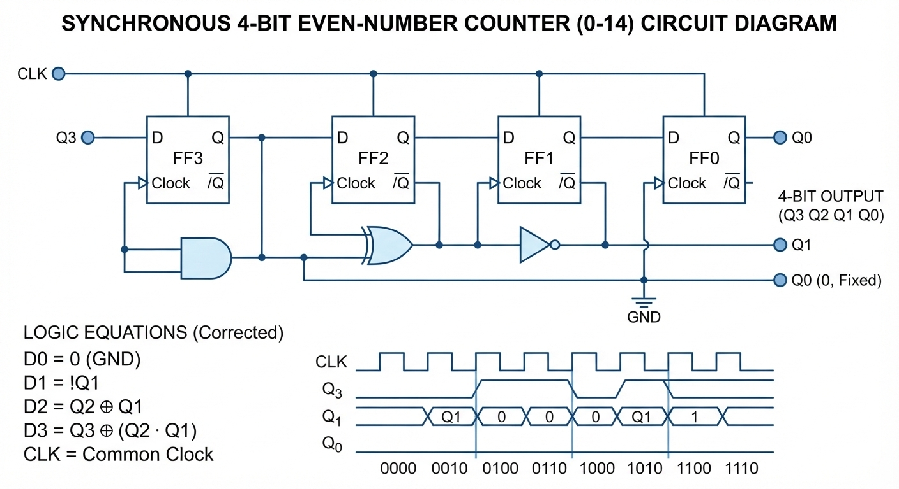Figure : Conceptual circuit diagram of the counter that counts even numbers from 0 to 14.

Result
The counter produces the following repeating output sequence:

0000 → 0010 → 0100 → 0110 → 1000 → 1010 → 1100 → 1110 → 0000
Therefore, it counts only the even decimal numbers from 0 to 14.

Q30. Explain a 4-bit asynchronous binary counter with timing diagram. If each flip-flop has a propagation delay of 10 ns, determine the total propagation delay time and maximum clock frequency at which the counter can be operated.

Answer:
A 4-bit asynchronous binary counter is also called a 4-bit ripple counter. It consists of four flip-flops connected in cascade. The external clock is applied only to the first flip-flop. Each subsequent flip-flop is triggered by the output of the preceding flip-flop.
Let the flip-flop outputs be Q₀, Q₁, Q₂, and Q₃, where:
Q₀ is the least significant bit (LSB),
Q₃ is the most significant bit (MSB).
The counter counts from 0000 to 1111, which represents decimal values 0 to 15.

Circuit Diagram
T Flip-Flop
T = 1 Q₃
T Flip-Flop
T = 1 Q₂
T Flip-Flop
T = 1 Q₁

T Flip-Flop
T = 1

CLK

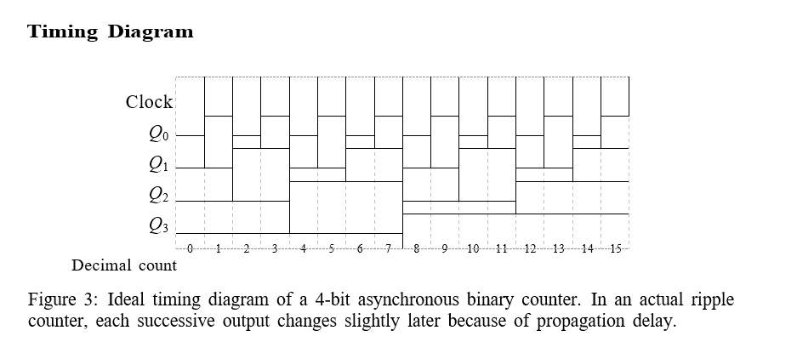
Q₀ Q₁ Q₂
Q₀ Q₁ Q₂ Q₃
Figure 2: 4-bit asynchronous (ripple) binary counter using T flip-flops.

Propagation Delay Calculation
Given:
t_{pd} = 10 ns
Number of flip-flops: n = 4
In the worst-case transition, the change must propagate through all four flip-flops. For example, during the transition:
0111 → 1000
all four flip-flops may change sequentially.
Therefore, total propagation delay is:
ttotal = n × tpd t_{total} = 4 × 10 ns

Maximum Clock Frequency
- Total propagation delay:
$$t_{total}=n×t_{pd}=4×10\text{ ns}=40 \text{ns}$$
- Minimum clock period:
$$T_{min}=t_{total}=40\text{ ns}$$
- Maximum clock frequency:
$$f_{max}=\frac{1}{T_{min}}=\frac{1}{40×{10}^{-9}}=25\text{ MHz}$$

Final Answer
Total propagation delay:
40 ns
Maximum clock frequency:
25 MHz

Q31. A certain memory has a capacity of 16K × 32. How many words does it store? What is the number of bits per word? How many different addresses are required by the memory?
The memory specification is: 16K × 32
This notation means that the memory contains 16K words, and each word contains 32 bits.

Number of Words
Since:

1K = 2¹⁰ = 1024
Then:

16K = 16 × 1024

16K = 16384
Therefore, the memory stores:
16, 384 words

Number of Bits per Word
The second number in the memory specification represents the number of bits in each word:
32 bits per word

Number of Different Addresses
Each memory word requires a unique address. Since the memory contains 16,384 words, it requires 16,384 unique addresses:
16, 384 different addresses

The number of address lines is found as follows:

2^{n} = 16384
Since:

16384 = 2¹⁴

n = 14
Therefore, the memory requires:
14 address lines

Table 3: Memory analysis for 16K × 32 memory

Quantity Result

Number of words 16,384 words Bits per word 32 bits
Different addresses 16,384 addresses Address lines required 14 address lines

Q32. How many address inputs, data inputs, and data out-puts are required for a 16K × 12 memory?
Answer:
The memory specification is: 16K × 12
This indicates that the memory contains 16K words, and each word has 12 bits.
The number of words is: 16K = 16 × 1024 = 16384
The number of address input lines is found from: 2^{n} = 16384
Since: 16384 = 2¹⁴
Therefore:
14 address inputs

Number of Data Inputs
Each word contains 12 bits. During a write operation, all 12 bits of a word must be supplied to the memory.
Therefore:
12 data inputs

Number of Data Outputs
During a read operation, the memory provides all 12 bits of the selected word at its output.
Therefore: 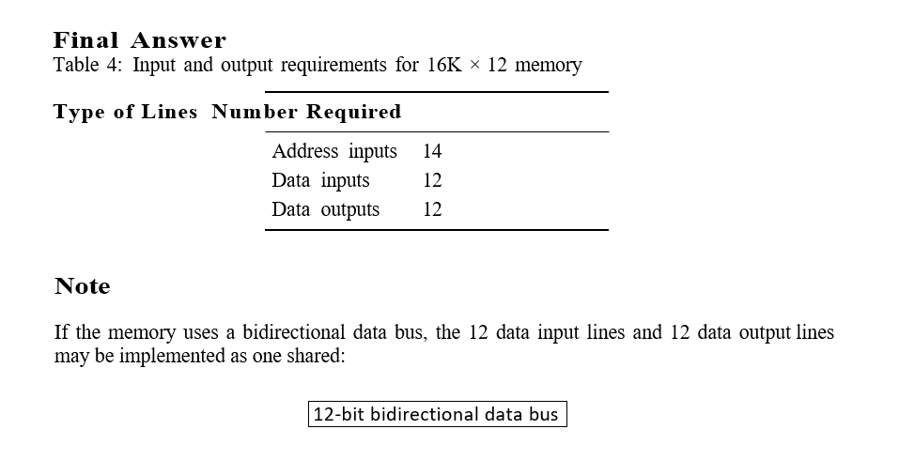
12 data outputs

Q33. a) How many 32Kx8 RAM chips are needed to provide a memory capacity of 256K bytes?
b) How many lines of the address must be used to access 256K bytes? How many of these lines are connected to the address inputs of all chips?
c) How many lines must be decoded for the chip select inputs? Specify the size of the decoder.
Answer: Given Information
A 32K × 8 RAM chip contains:

32K = 32 × 1024 = 32768 = 2¹⁵
memory locations. Each location stores 8 bits, which is equal to one byte. Therefore, one chip has a capacity of:
32K bytes The required total memory capacity is:
256K bytes

Number of RAM Chips Required
The number of chips required is:

Number of chips =

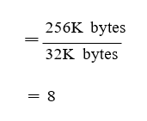
Required memory capacity Capacity of one chi

Address Lines Required
The total memory capacity is:
256K bytes = 256 × 1024 = 262144 bytes
Since:
262144 = 2¹⁸
the total number of address lines required is:
18 address lines
Let the address lines be: A₁₇, A₁₆, A₁₅, . . . , A₁, A₀
Each individual 32K × 8 RAM chip has:
32K = 2¹⁵
locations. Therefore, each chip requires:
15 address input lines
These lower-order address lines are connected in parallel to the address inputs of all chips:
A₀ to A₁₄
The remaining upper-order address lines are:
A₁₅, A₁₆, and A₁₇
These three lines are used to select one of the eight RAM chips.

Decoder Requirement for Chip Select
There are eight RAM chips. To select one chip out of eight chips: 8 = 2³
Therefore, three address lines must be decoded:
A17, A16, A15
A decoder with three inputs and eight outputs is required:
3-to-8 decoder
Each decoder output is connected to the chip-select input of one RAM chip

Final Answer

Table 5: Summary for the 256K-byte RAM design

Requirement Result

RAM chips required 8 chips
Total memory capacity 256K bytes Total address lines required 18 address lines
Address lines connected to all chips 15 lines: A₀ to A₁₄ Address lines decoded for chip select 3 lines: A₁₅, A₁₆, A₁₇ Decoder size 3-to-8 decode
Q34. Construct a 64 × 8 memory unit using 16 × 4 memory chips.
i) How many chips are required? ii) Show the external connections necessary to construct the memory unit.
Answer: Given,
Available RAM chips = 16 × 4
Required memory = 64 × 8

i) Number of chips required :

A single chip has: 16 × 4
The required memory is: 64 × 8
We need to increase both the number of locations and the number of bits per location.

Step 1: Increase word size from 4 bits to 8 bits
Two 16 × 4 chips connected in parallel give: 16 × 8
So, 2 chips are needed to make one 16 × 8 block.

Step 2: Increase locations from 16 to 64
We need:
$\frac{64}{16}=4$
So, we need 4 such blocks.
Therefore: 2×4 = 8 chips

ii) External connections
A 16×4 chip has:
- 4 data lines $D_{0}-D_{3}$
- 4 address lines, because 16=2416=2^4
The required 64×8 memory needs: 64=2^6
So, we need 6 address lines: $A_{0}$, $A_{1}$,$A_{2}$,$A_{3}$,$A_{4}{,A}_{5}$

Connections:
1. Address lines $A_{0}-A_{3}$:
Connect these 4 lower address lines to all 8 chips. They select one of the 16 locations inside a chip.
2. Address lines $A_{4}-A_{5}$:
These two higher address lines are used to select one of the four pairs of chips.
Therefore, use a 2-to-4 decoder
The decoder outputs control the Chip Select (CS) inputs.
3. Data lines:
For each pair:
- First chip → $D_{0}-D_{3}$
- Second chip → $D_{4}-D_{7}$
Thus, each pair provides 16×8 and four pairs together provide 64×8

Connection diagram:

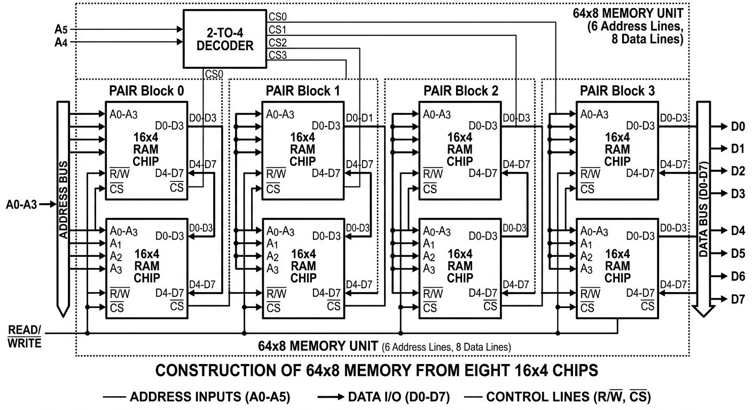

Q34. Construct a 128 × 8 ROM using four 32 × 8 ROM chips and a decoder.

Given Information
Available ROM chip: 32 × 8
Required ROM capacity: 128 × 8
Each available ROM chip contains 32 words of 8 bits each.

Number of Chips
The number of required words is 128, whereas one chip contains 32 words.
128
= 4
32
Therefore:
4 ROM chips are required

Since every chip already provides 8 output bits, no width expansion is required. Only memory-depth expansion is needed.

Address Lines
The required ROM has 128 words: 128 = 2⁷
Therefore, the complete ROM requires:
7 address lines
Let these address lines be: A₆, A₅, A₄, A₃, A₂, A₁, A₀
Each 32 × 8 ROM contains: 2 = 2⁵
locations, so it needs five address inputs:
A₀ to A₄
These five lower-order address lines are connected to every ROM chip. The remaining two address lines are:
A₅ and A₆
They are connected to a 2-to-4 decoder. The four outputs of the decoder are connected to the enable inputs of the four ROM chips.

External Connection Diagram:
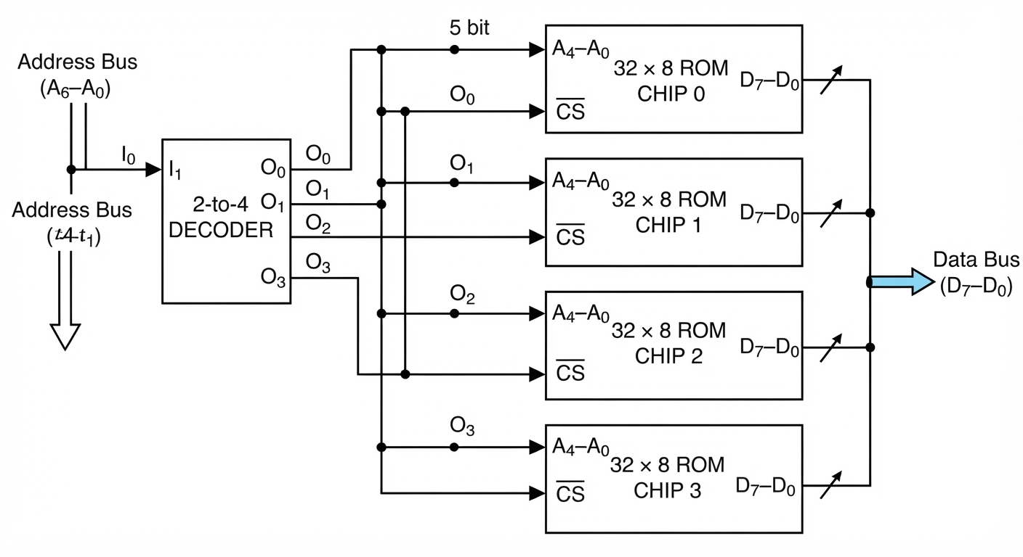
Figure 6: Construction of a 128 × 8 ROM using four 32 × 8 ROM chips and a 2-to-4 decoder.

Operation
Address lines A₀ to A₄ select one of the 32 locations inside each ROM chip.
Address lines A₆ and A₅ are decoded to enable exactly one ROM chip.
Only the enabled ROM chip places its 8-bit data on the common output bus.
The combined circuit provides 128 words of 8 bits each.

Final Answer
Use four 32 × 8 ROM chips and one 2-to-4 decoder.
A₀ to A₄ connect to all chips; A₅, A₆ select the enabled chip.

Q36. Analyze the advantages of programmable logic over fixed-function digital circuits.
A fixed-function digital circuit is designed to perform one specific task. Its logic connections are permanently determined during manufacturing or physical implemen-tation. Examples include circuits built from individual logic gates, dedicated counters, fixed decoders, and application-specific integrated circuits.
Programmable logic refers to digital devices whose logic behavior can be configured by the designer after manufacturing. Examples include Programmable Logic Arrays (PLAs), Programmable Array Logic (PAL) devices, Complex Programmable Logic De-vices (CPLDs), and Field-Programmable Gate Arrays (FPGAs).

Advantages of Programmable Logic

Flexibility and reconfigurability
The greatest advantage of programmable logic is that its functionality can be changed by modifying the program or hardware description. A circuit can be up-dated without physically replacing logic gates or redesigning the complete hardware.
For example, an FPGA configured as a counter can later be reconfigured as a communication controller, arithmetic unit, or state machine.

Reduced development time
Fixed-function circuits require schematic redesign, physical wiring changes, fabri-cation, and testing when modifications are needed. Programmable devices can be modified and tested quickly through software.
This significantly reduces prototype-development time.

Lower cost for low- and medium-volume production
Producing a custom integrated circuit can be expensive because of fabrication masks, design verification, and manufacturing setup costs. A programmable de-vice avoids most of these initial costs.
Therefore, programmable logic is very useful when the number of units produced is small or when a design may change frequently.

Easy correction of design errors
If an error is found in fixed hardware, the circuit board may need to be rewired or redesigned. In programmable logic, the designer can correct the logic description and reprogram the device.

High integration
A single FPGA or CPLD can replace many individual gates, flip-flops, multiplexers, counters, decoders, and registers. This reduces the number of separate integrated circuits on a circuit board.

Smaller physical size
Replacing many fixed-function chips with one programmable device reduces board area, wiring complexity, and the number of external connections.

Improved reliability
Fewer physical components and fewer wiring connections generally reduce the pos-sibility of hardware failure. The overall system can become more reliable.

Support for complex digital systems
Programmable logic devices can implement large and complicated systems, includ-ing processors, memory controllers, communication interfaces, digital signal pro-cessing blocks, and control units.

Parallel operation
Unlike a software program running sequentially on a processor, programmable hard-ware can implement many logic functions operating simultaneously. This gives excellent performance for tasks that require parallel processing.

Comparison Table

Table 6: Programmable logic compared with fixed-function digital circuits

Feature Programmable Logic Fixed-Function Circuit

Functionality Can be changed by reprogramming the device.
Design modification Easy; modify the design file and
program the device again.
Usually permanent after hardware implementation.
Difficult; may require rewiring, redesign, or replacement of hardware.

Prototype development Fast and convenient. Usually slower because physical
hardware changes are required.

Initial development cost Generally low for prototypes
and small production runs.
Hardware integration Many functions can be
combined in one FPGA, CPLD, PLA, or PAL.
Reliability Usually higher because fewer components and connections are used.
Best use Systems that may change, require upgrades, or contain complex logic.
Can be high, especially for custom integrated circuits.
Often requires several separate logic chips and more wiring.

May be lower when many individual chips and wires are required.
Very high-volume products with stable, optimized functionality.

Therefore, Programmable logic provides flexibility, reusability, easier debugging, rapid prototyping, and high integration. Fixed-function circuits may still be preferred when a design is completely stable and extremely low cost or maximum optimization is needed for very high-volume manufacturing. However, programmable logic is generally more practical for modern digital-system design.

Q37. Compare CRC and Hamming code.Under what con-ditions is CRC preferred, and when is Hamming code more suitable?
Answer:
CRC and Hamming code are both techniques used to improve the reliability of digital data. However, their primary purposes are different.
Answer:
Comparison: CRC vs. Hamming Code
Feature | Cyclic Redundancy Check(CRC) | Hamming Code
Primary Function | Error detection only | Error Detection & Correction
Error Handling Capability | Detects single, multiple, and burst errors (contiguous sequence of corrupted bits). Cannot correct errors. | Corrects single-bit errors (SEC) and detects double-bit errors (DED with an extra parity bit).
Mathematical Basis | Polynomial division (modulo-2 arithmetic). | Parity bit placement based on powers of 2 ($2^{k}$).
Data Block Size | Operates over variable-length frames or large data blocks. | Operates over small, fixed-length data blocks (e.g., 4-bit, 8-bit, 64-bit words).
Redundancy Overhead | Very Low: Adds a fixed-size checksum (e.g., 16 or 32 bits) regardless of large frame sizes. | Moderate to High: Overhead grows with word length (e.g., 3 parity bits for 4 data bits = 75% overhead).
Recovery Mechanism | Relies on retransmission (e.g., ARQ protocols). | Self-correcting directly in hardware without needing retransmission.

When CRC is Preferred
- High-Noise / Communication Channels (Ethernet, Wi-Fi, Cellular):
Network noise often causes continuous noise spikes (burst errors). CRC can reliably catch long burst errors across entire packets.
- Variable or Large Data Payloads:
When transmitting large files, disk blocks, or network packets, a fixed 32-bit CRC adds minimal overhead while offering near-100% error detection over thousands of bytes.
- Systems with Retransmission Capabilities:
If a fast, bidirectional link exists, it is cheaper to simply drop a corrupted frame and request a retransmission than to compute onboard error correction.

When Hamming Code is More Suitable
- Real-Time Memory Systems (ECC RAM, Cache, Flash Memory): RAM demands ultra-low latency. Retransmitting or re-reading data from CPU registers is impossible, making instant, hardware-level single-bit correction essential.
- Simplex / One-Way Communication Links: When data travels over a unidirectional channel (e.g., deep-space probes, satellite broadcasts) where retransmission is either impossible or introduces unusable latency.
- Low-Noise Channels with Isolated Bit Flips: In environments where electrical interference rarely corrupts more than one bit at a time, Hamming code restores data integrity on the fly without halting execution.

Q38. Why is CRC preferred over a simple parity check?
Answer:
A simple parity check adds one parity bit to a data unit. The parity bit makes the total number of 1s either even or odd. Although parity checking is simple and inexpensive, it provides very limited error-detection capability.
CRC is generally preferred because it gives much stronger error detection, especially for multi-bit and burst errors.
CRC (Cyclic Redundancy Check) is preferred over a simple parity check because it provides more reliable and powerful error detection during data transmission.
A simple parity check adds one extra bit to the data. It can detect an odd number of bit errors, but it cannot reliably detect an even number of bit errors. For example, if two bits change during transmission, the parity may remain unchanged, so the error can go undetected.
CRC, on the other hand, uses polynomial division to generate a check value. It can detect:
- Single-bit errors
- Multiple-bit errors
- Burst errors
- Many types of errors that a simple parity check may miss
CRC is particularly effective for detecting burst errors, where several consecutive bits are corrupted. This makes CRC much more suitable for computer networks, storage devices, and digital communication systems.
Another advantage is that CRC provides a much stronger level of error detection while adding only a relatively small amount of extra data.
Comparison:
Feature | Parity Check | CRC
Single-bit error | Detects | Detects
Even number of errors | May not detect | Usually detects
Multiple-bit errors | Limited | Much better detection
Burst errors | Poor | Excellent
Reliability | Low | High
complexity | simple | More complex

Q39. Under what conditions can a parity checker indicate that data is correct even though transmission errors occurred? Justify your answer.
Answer:
A parity checker can indicate that data is correct even though transmission errors occurred when an even number of bits change during transmission.
This happens because a parity checker only verifies whether the total number of 1s is even or odd. If an even number of bits is altered, the overall parity remains unchanged.
Therefore, the parity checker cannot detect the error. Again,
A parity checker will indicate that data is correct despite transmission errors whenever an even number of bit errors occurs within the same data block.
This happens because parity checking operates entirely on the total count of 1-bits (parity) rather than bit positions or contents:
- Even Parity: Requires an even total number of 1s (0, 2, 4, ...).
- Odd Parity: Requires an odd total number of 1s (1, 3, 5, ...).

Justification:
When an error occurs, a bit flips either from 0 to 1 or from 1 to 0.
- Single Bit Error (Detected): Flips one bit, changing the total count of 1-bits from even to odd (or vice versa). The parity bit no longer matches, and the error is caught.
- Double Bit Error (Undetected): Flips two bits. Three possible sub-cases occur:
  - Two 0s become 1s: The count of 1-bits increases by 2. Parity remains unchanged (even stays even, odd stays odd).
  - Two 1s become 0s: The count of 1-bits decreases by 2. Parity remains unchanged.
  - One 0 becomes 1 and one 1 becomes 0: The total count of 1-bits stays exactly the same.
- General Even-Bit Errors (2k Errors): Any even number of flipped bits (2, 4, 6, 8, ….) causes the parities of individual flips to cancel each other out (+1 -1 = 0, or +1 + 1 = +2). The resulting bit pattern maintains the expected parity, making the receiver's checker register the data as valid.

Concrete Example:
Consider transmitting the 7-bit byte 1010100 using Even Parity:
- Original Data: 1010100 (Three 1s-> append parity bit 1 to make it even)
- Transmitted Frame: 1010100 1 (Total 1-bits = 4, which is even)
Scenario A: 2-Bit Error (Undetected)
- Noise flips bit 1 and bit 3 during transmission: 0000100 1
- Receiver counts the 1s: Two 1s present-> Even parity matches!
- Result: The receiver marks the data as correct, even though two bits are corrupted.
Scenario B: 4-Bit Error (Undetected)
- Noise flips four bits: 0101011 1
- Receiver counts the 1s: Six 1s present -> Even parity matches!
- Result: The receiver accepts heavily corrupted data as valid.
Q40.. Design a sequential circuit with two D flip flops and two inputs, P and Q. If P = 0, the circuit remains in the same state regardless of the value of Q. When P = 1 and Q = 1, the circuit goes through the state transitions from 00 to 01 to 10 back to 00, and repeats. When P = 1and Q = 0, the circuit goes through the state transitions from 00 to 10 to 01 back to 00, and repeats, The circuit is to be designed by treating the unused state(s) as don’t care condition(s).
Answer:
Let the two D flip-flop outputs be A and B. Therefore, the present state is represented by AB.
There are two inputs: P, Q
The required operation is:
- If P=0, the circuit remains in the same state.
- If P=1,Q=1:
00→01→10→00
- If P=1,Q=0:
00→10→01→00
- State 1111 is unused, so it is treated as a don’t-care state.
State Table:
Present State AB | P | Q | Next State , $A^{+}B^{+}$
00 | 0 | 0 | 00
00 | 0 | 1 | 00
00 | 1 | 0 | 10
00 | 1 | 1 | 01
01 | 0 | 0 | 01
01 | 0 | 1 | 01
01 | 1 | 0 | 00
01 | 1 | 1 | 10
10 | 0 | 0 | 10
10 | 0 | 1 | 10
10 | 1 | 0 | 01
10 | 1 | 1 | 00
11 | × | × | ××

For a D flip-flop, $D_{A}=A^{+}$ and, $D_{B}=B^{+}$
Using Karnaugh maps and treating state 11 as don’t care, the simplified input equations are:
$D_{A}=AP^{'}+BPQ+PA'B'Q'$
And
$D_{A}=BP^{'}+APQ^{'}+PQAB'$

Circuit Connection:
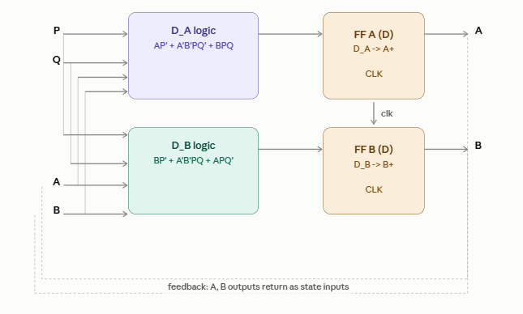

Q41. (a) Draw a logic circuit that accepts a 3-bit input number A(A2,A1,A0) and outputs a 2-bit number B(B1,B0) the is equal to the number of 1’s that appear in the input A. For example, A=101 contains two 1’s, so B=10. Also A=111 contains three 1’s, so B=11. You are allowed to use only one 3-8, two OR gates, and one 4-2 encoder. Label all inputs, pins and outputs. (b)Explain your solution.

Answer:

Logic Circuit
The easiest way is:
3-bit input → 3-to-8 decoder → group minterms according to number of 1s → 4-to-2 encoder → 2-bit output
The circuit is:
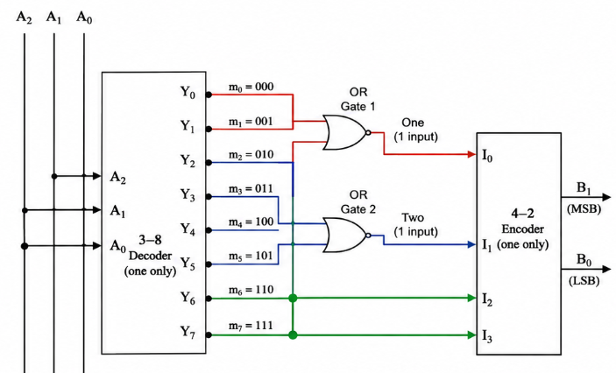
(b) Explanation:
The 3-to-8 decoder takes: A2, A1, A0
and produces 8 outputs Y0 to Y7, where only one output is 1 for each input combination.
Now group the decoder outputs according to how many 1s are present in the input.
Number of 1s | Input combinations | Decoder outputs | Encoder input
0 | 000 | Y0 | I0 = Y0
1 | 001,010,100 | Y1,Y2,Y4 | I1 = Y1+Y2+Y4
2 | 011,101,110 | Y3,Y5,Y6 | I2 = Y3+Y5+Y6
3 | 111 | Y7 | I3 = Y7
So we need only two OR gates: $I_{1}=Y_{1}+Y_{2}+Y_{4}$
$I_{1}=Y_{1}+Y_{2}+Y_{4}$
And directly: I0 = Y0, I3 = Y7
These four signals go into the 4-to-2 encoder.
The encoder produces:
I0→B1B0=00I
I1→B1B0=01
I2→B1B0=10
I3→B1B0=11
Therefore, the output B1B0 directly represents the number of 1s in A.

Example 1
If A=101 then there are two 1s.
So decoder activates: Y5=1
Since Y5goes to I2: I2 = 1
4-to-2 encoder gives: B1B0=10

Example 2
If A=111 there are three 1s.
Therefore: Y7=1→I3=1 and encoder gives: B1B0=11
So the required circuit uses exactly one 3-to-8 decoder, two OR gates, and one 4-to-2 encoder.

Q42. a) Design a circuit that counts the number of 1s in a 3-bit input word.(b)Explanation of the Design

The 3-to-8 decoder receives the three input bits A₂, A₁, and A₀. It activates exactly one decoder output line for each possible input combination.
For example:

If A₂A₁A₀ = 001, decoder output Y₁ becomes active. Since the input contains one 1, the circuit must produce: B₁B₀ = 01
If A₂A₁A₀ = 101, decoder output Y₅ becomes active. Since the input contains two 1s, the circuit must produce: B₁B₀ = 10
If A₂A₁A₀ = 111, decoder output Y₇ becomes active. Since the input contains three 1s, the circuit must produce: B₁B₀ = 11

The two OR gates combine decoder outputs that correspond to one 1 and two 1s, respec-tively: E₁ = Y₁ + Y₂ + Y₄
E₂ = Y₃ + Y₅ + Y₆
The four encoder inputs therefore represent the four possible counts:

I₀ = Y₀ for count 0 I₁ = E₁ for count 1 I₂ = E₂ for count 2
I₃ = Y₇ for count 3
The 4-to-2 encoder then converts the active input line into the required binary output:
B₁B₀ = number of 1s in A₂A₁A₀

Final Result
B₁ = A₂A₁ + A₂A₀ + A₁A₀

These Boolean equations are the direct mathematical result. However, the required hard-ware implementation uses a 3-to-8 decoder, two OR gates, and a 4-to-2 encoder as shown in the circuit diagram above.

Q42. (a) Draw a logic circuit that uses the 4-bit adder shown below and any other basic logic gates that you think. You might need to compute the equation P=3*Q+1. Assume that you have a 3-bit input Q(Q2,Q1,Q0) and a 5-bit output P( P4,P3,P2,P1,P0). Clearly label all inputs and outputs. (b) Explain your solution.

Answer:
The four-bit adder has inputs b₃b₂b₁b₀, a₃a₂a₁a₀, input carry C_{in}, outputs S₃S₂S₁S₀, and output carry C_{out}. We are given a three-bit input Q₂Q₁Q₀ and a five-bit output P₄P₃P₂P₁P₀. The required operation is P₃ = Q₃ + 1.
Since the statement uses Q₃ but supplies Q₂, Q₁, Q₀, this solution interprets the intended operation as the three-bit value Q₂Q₁Q₀ plus one. Thus,
P = Q + 1, Q = 4Q₂ + 2Q₁ + Q₀.
The resulting five-bit output is P₄P₃P₂P₁P₀ = 0000P₃P₂P₁P₀, with the upper bits in-cluded for a uniform five-bit output. If the original expression really is P₃ = Q₃ + 1, replace every Q₂, Q₁, Q₀ below by Q₃, Q₂, Q₁ and treat the remaining bit as specified by your instructor.

Adder connections
To add one, connect the first operand to zero and use the second operand as the input value. The least significant bit receives the constant one through C_{in}:
b₃b₂b₁b₀ = 0000, a₃a₂a₁a₀ = 0Q₂Q₁Q₀, C_{in} = 1.
Then the adder computes
S = (0Q₂Q₁Q₀) + 0000 + 1 = Q₂Q₁Q₀ + 1.
The output connections are:
P₀ = S₀, P₁ = S₁, P₂ = S₂, P₃ = S₃, P₄ = C_{out}.
B₀ = A₂ ⊕ A₁ ⊕ A₀

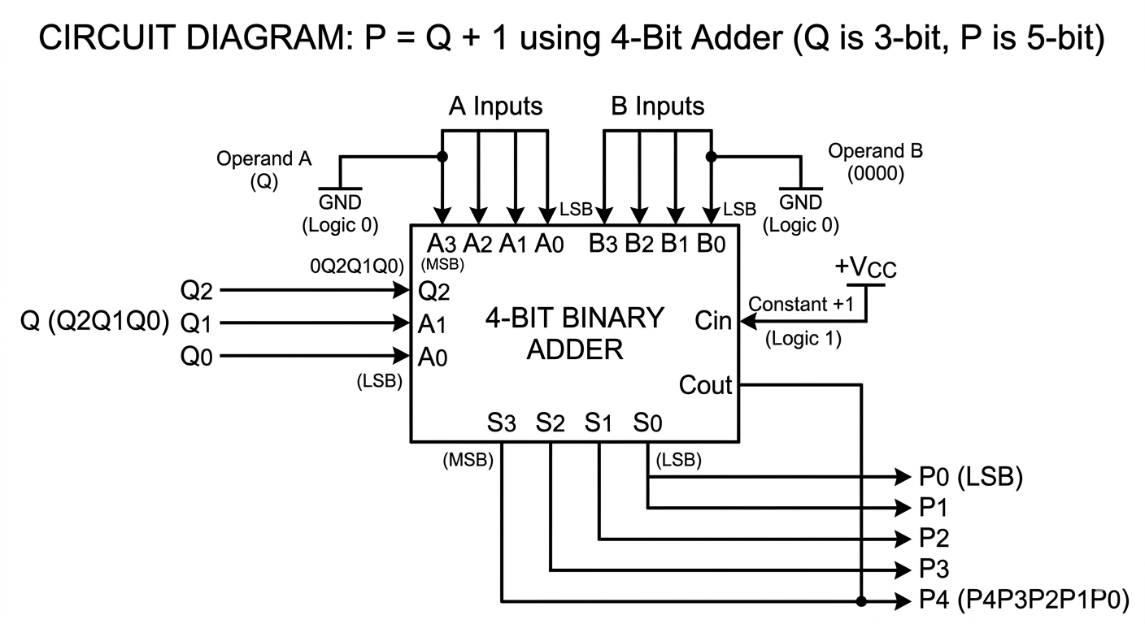Truth table and explanation

Table 12: Incrementer operation

Q₂Q₁Q₀ | Decimal Q | P = Q + 1
000 | 0 | 0001
001 | 1 | 0010
010 | 2 | 0011
011 | 3 | 0100
100 | 4 | 0101
101 | 5 | 0110
110 | 6 | 0111
111 | 7 | 1000
The carry output becomes one only for Q = 111. Thus, the four-bit sum output is sufficient for Q + 1. If a five-bit format is required, set P₄ = 0 because the maximum result is eight, represented as 01000 in five bits.

Q43. (a) Draw the truth table for the function f=x’y+x’z+xy’z’
(b) Implement this function using only 2-to-1 multiplexers and no other logic gates. The inputs to your circuits can be only the signals X, Y, and Z in their non-inverted form.
Answer:
- Truth Table:
Given, f=x’y+x’z+xy’z’
The truth table is:
x | y | z | x’y | x’z | xy’z’ | f=x’y+x’z+xy’z’
0 | 0 | 0 | 0 | 0 | 0 | 0
0 | 0 | 1 | 0 | 1 | 0 | 1
0 | 1 | 0 | 1 | 0 | 0 | 1
0 | 1 | 1 | 1 | 1 | 0 | 1
1 | 0 | 0 | 0 | 0 | 1 | 1
1 | 0 | 1 | 0 | 0 | 0 | 0
1 | 1 | 0 | 0 | 0 | 0 | 0
1 | 1 | 1 | 0 | 0 | 0 | 0
Therefore, f = ∑m(1,2,3,4)
(b).
Given, F = X'Y + X'Z + XY'Z'
Taking X' common from the first two terms, F = X'(Y + Z) + XY'Z'
Now consider the two possible values of X.
When X = 0: F = Y + Z
When X = 1: F = Y'Z'
Therefore,
F = X'(Y + Z) + X(Y'Z')
A 2-to-1 multiplexer has the Boolean expression: F = S'I0 + SI1
where S is the select input, I0 and I1 are the two data inputs.
Step 1: Generate Y + Z
Use the first 2-to-1 MUX with:
Select input,
S = Y
I0 = Z
I1 = 1
Then, M1 = Y'Z + Y(1)
M1 = Y'Z + Y
M1 = Y + Z
Therefore, M1 = Y + Z
Step 2: Generate Z'
Since only the non-inverted inputs X, Y, and Z can be used as external inputs, Z' must be generated using a MUX.
Use the second 2-to-1 MUX with:
Select input,
S = Z
I0 = 1
I1 = 0
Then,
M2 = Z'(1) + Z(0)
Therefore, M2 = Z'
Step 3: Generate Y'Z'
Use the third 2-to-1 MUX with:
Select input,
S = Y
I0 = M2 = Z'
I1 = 0
Then, M3 = Y'Z' + Y(0)
Therefore, M3 = Y'Z'
Step 4: Generate the final output F
From the earlier derivation,
When X = 0, F = Y + Z = M1
When X = 1, F = Y'Z' = M3
Therefore, use the fourth 2-to-1 MUX with:
Select input,
S = X
I0 = M1 = Y + Z
I1 = M3 = Y'Z'
The output of the final MUX is: F = X'M1 + XM3
Substituting the values of M1 and M3, F = X'(Y + Z) + X(Y'Z')
Expanding,
F = X'Y + X'Z + XY'Z'
Thus, the required Boolean function is obtained.
MUX Requirements:
- MUX 1: S = Y, I0 = Z, I1 = 1, Output = Y + Z
- MUX 2: S = Z, I0 = 1, I1 = 0, Output = Z'
- MUX 3: S = Y, I0 = Z', I1 = 0, Output = Y'Z'
- MUX 4: S = X, I0 = Y + Z, I1 = Y'Z', Output = F
Circuit Diagram:
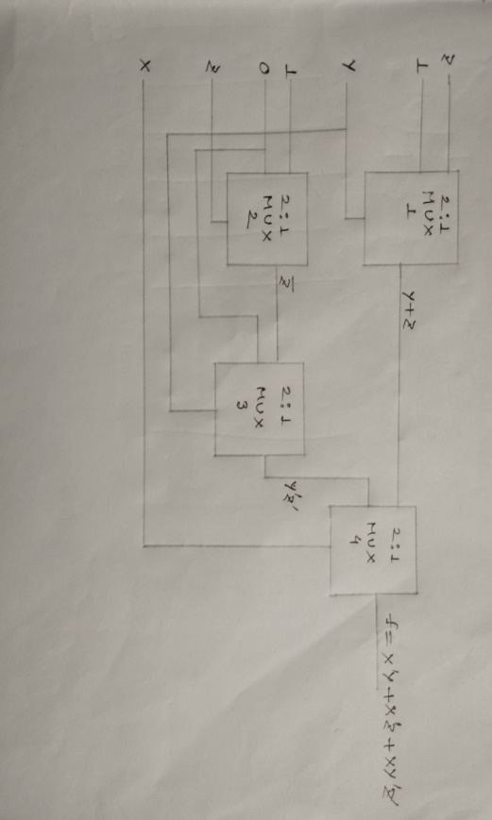

Q44. (a). Draw the truth table for a full-adder.
(b). Implement full-adder circuit using one 3-to-8 decoder and a minimal number of basic logic gates. Clearly label all inputs, pins, and outputs of your circuit.
Answer:

(a). Truth Table for a Full-Adder
A full-adder adds three single-bit inputs: A, B, and $C_{in}$ (Carry-in), producing two outputs: S(Sum) and $C_{out}$ (Carry-out).
Input |  |  | Output
A | B | $$C_{in}$$ | S(sum) | $$C_{out}$$
0 | 0 | 0 | 0 | 0
0 | 0 | 1 | 1 | 0
0 | 1 | 0 | 1 | 0
0 | 1 | 1 | 0 | 1
1 | 0 | 0 | 1 | 0
1 | 0 | 1 | 0 | 1
1 | 1 | 0 | 0 | 1
1 | 1 | 1 | 1 | 1

(b) Implementation Using a 3-to-8 Decoder and Basic Gates
From the truth table, we can express S and C_out as a sum of minterms (∑m):
- Sum (S): Active on minterms 1, 2, 4, 7->S = ∑m(1,2,4,7)
- Carry-out (C_out): Active on minterms 3, 5, 6, 7-> C_out = ∑m(3,5,6,7)
A 3-to-8 decoder takes the 3 input bits (A, B, C_in) and generates all 8 minterms (Y0 through Y7). To form S and C_out, we pass the corresponding active minterm outputs into OR gates.

Circuit Components & Pin Connections:
- 3-to-8 Active-High Decoder:
  - Select/Data Inputs:
    - I2 = A (Most Significant Bit - MSB)
    - I1 = B
    - I0 = C_in(Least Significant Bit - LSB)
  - Enable Pin: E = 1(High / VCC to enable decoder)
  - Decoder Minterm Outputs (Y0 to Y7):
    - Y0 = A'B'C’_in
    - Y1 = A'B'C_in
    - Y2 = A'BC’_in
    - Y3 = A'BC_in
    - Y4 = AB'C’_in
    - Y5 = AB'C_in
    - Y6 = ABC’_in
    - Y7 = ABC_in
- Basic Gates Required: Two 4-input OR gates (or equivalent 2-input OR trees).
  - Gate 1 (Sum OR Gate): Connect inputs Y1, Y2, Y4, Y7 -> Output = S
  - Gate 2 (Carry-out OR Gate): Connect inputs Y3, Y5, Y6, Y7 Output = C_out
Block Diagram:
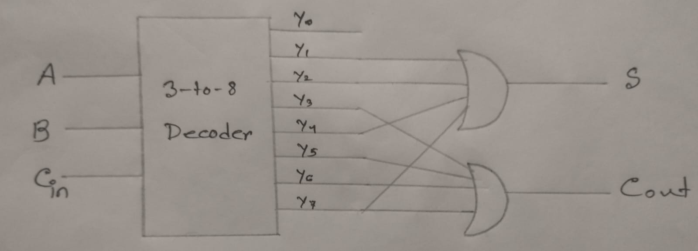

45.Design a circuit that tests if a 4-bit binary number is a prime number in the decimal system. Assume that the input is represented by the signals a, b, c, and d (where a is the most significant bit and d is the least significant bit) and the output is called f. Hint: 0 and 1 are not prime.
(a) Draw the truth table for the function f(a, b, c, d).
(b) Implement the function f using one 8-to-1 multiplexer and a minimal number of extra AND, OR, and NOT gates. Clearly label all inputs, pins, and outputs.
(c) Draw the truth table for the function f again on this page. Now, implement f using one 4-to-1 multiplexer and a minimal number of extra AND, OR, and NOT gates. Clearly label all inputs, pins, and outputs.
Answer:
Let the 4-bit input be represented by a, b, c, and d, where a is the most significant bit (MSB) and d is the least significant bit (LSB). The output is denoted by f.
The 4-bit binary numbers represent decimal numbers from 0 to 15.
The prime numbers between 0 and 15 are:
2, 3, 5, 7, 11, 13
Therefore, f = 1 for these numbers and f = 0 for all other numbers.
Note that 0 and 1 are not prime numbers.
Truth Table
a | b | c | d | Decimal Value | F
0 | 0 | 0 | 0 | 0 | 0
0 | 0 | 0 | 1 | 1 | 0
0 | 0 | 1 | 0 | 2 | 1
0 | 0 | 1 | 1 | 3 | 1
0 | 1 | 0 | 0 | 4 | 0
0 | 1 | 0 | 1 | 5 | 1
0 | 1 | 1 | 0 | 6 | 0
0 | 1 | 1 | 1 | 7 | 1
1 | 0 | 0 | 0 | 8 | 0
1 | 0 | 0 | 1 | 9 | 0
1 | 0 | 1 | 0 | 10 | 0
1 | 0 | 1 | 1 | 11 | 1
1 | 1 | 0 | 0 | 12 | 0
1 | 1 | 0 | 1 | 13 | 1
1 | 1 | 1 | 0 | 14 | 0
1 | 1 | 1 | 1 | 15 | 0

Thus, the function is 1 for minterms 2, 3, 5, 7, 11, and 13.
Therefore,
f(a,b,c,d) = Σm(2, 3, 5, 7, 11, 13)
(b) Implementation Using One 8-to-1 Multiplexer
Use a single 8-to-1 multiplexer.
Choose a, b, and c as the selection inputs:
- S2 = a
- S1 = b
- S0 = c
The remaining variable d will be connected to the data inputs where necessary.
For each combination of a, b, and c, examine the corresponding two decimal numbers obtained when d = 0 and d = 1
a | b | c | d = 0 | D = 1 | Required MUX Input
0 | 0 | 0 | 0→f=0 | 1→f=0 | I0 = 0
0 | 0 | 1 | 2→f=1 | 3→f=1 | I1 = 1
0 | 1 | 0 | 4→f=0 | 5→f=1 | I2 = d
0 | 1 | 1 | 6→f=0 | 7→f=1 | I3 = d
1 | 0 | 0 | 8→f=0 | 9→f=0 | I4 = 0
1 | 0 | 1 | 10→f=0 | 11→f=1 | I5 = d
1 | 1 | 0 | 12→f=0 | 13→f=1 | I6 = d
1 | 1 | 1 | 14→f=0 | 15→f=0 | I7 = 0

T1herefore, the data inputs of the 8-to-1 multiplexer are:
- I0 = 0
- I1 = 1
- I2 = d
- I3 = d
- I4 = 0
- I5 = d
- I6 = d
- I7 = 0
MUX Connections
Selection inputs:
- S2 = a
- S1 = b
- S0 = c
Data inputs:
- I0 = 0
- I1 = 1
- I2 = d
- I3 = d
- I4 = 0
- I5 = d
- I6 = d
- I7 = 0
MUX output:
f = Output
Boolean Verification:
The output of an 8-to-1 MUX is
f = I0a'b'c' + I1a'b'c + I2a'bc' + I3a'bc + I4ab'c' + I5ab'c + I6abc' + I7abc
Substituting the data inputs:
f = 0(a'b'c') + 1(a'b'c) + d(a'bc') + d(a'bc) + 0(ab'c') + d(ab'c) + d(abc') + 0(abc)
Therefore, f = a'b'c + a'bc'd + a'bcd + ab'cd + abcd' + abcd
This represents the prime numbers 2, 3, 5, 7, 11, and 13.
Hence, f = Σm(2,3,5,7,11,13)
No additional AND, OR, or NOT gates are required.
Therefore, the implementation requires:
- 1 × 8-to-1 Multiplexer
- 0 × AND gates
- 0 × OR gates
- 0 × NOT gates
Circuit Diagram:
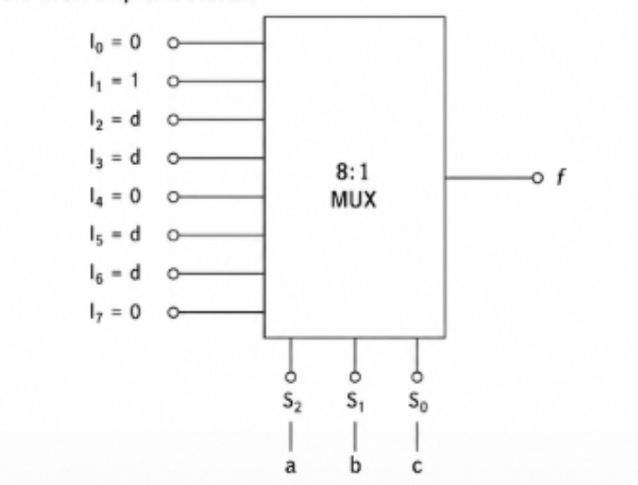
(c) Implementation Using One 4-to-1 Multiplexer
For the 4-to-1 multiplexer, choose a and b as the selection inputs.
- S1 = a
- S0 = b
The remaining variables are c and d. We determine the required data input for each combination of a and b.

a | b | Corresponding Decimal Numbers | Required Data Input
0 | 0 | 0, 1, 2, 3 | I0 = c
0 | 1 | 4, 5, 6, 7 | I1 = c
1 | 0 | 8, 9, 10, 11 | I2 = cd’
1 | 1 | 12, 13, 14, 15 | I3 = cd’

Explanation
For a = 0 and b = 0, the numbers are 0, 1, 2, and 3. Only 2 and 3 are prime. Both have c = 1.
Therefore, I0 = c
For a = 0 and b = 1, the numbers are 4, 5, 6, and 7.
Only 5 and 7 are prime. Both have c = 1.
Therefore, I1 = c
For a = 1 and b = 0, the numbers are 8, 9, 10, and 11.
Only 11 is prime. For 11:
a = 1, b = 0, c = 1, d = 1
Therefore, I2 = cd
For a = 1 and b = 1, the numbers are 12, 13, 14, and 15.
Only 13 is prime. For 13:
a = 1, b = 1, c = 1, d = 0
Therefore, I3 = cd'
Required Connections
Selection inputs:
- S1 = a
- S0 = b
Data inputs:
- I0 = c
- I1 = c
- I2 = cd
- I3 = cd'
The output of the 4-to-1 MUX is f.
Extra Logic Gates To generate I2 = cd:
One 2-input AND gate is required. To generate I3 = cd':
First, d' must be generated using one NOT gate. Then c and d' are connected to a 2-input AND gate.
Therefore, the extra gates required are:
- 1 × NOT gate
- 2 × AND gates
- 0 × OR gates
Circuit Diagram:
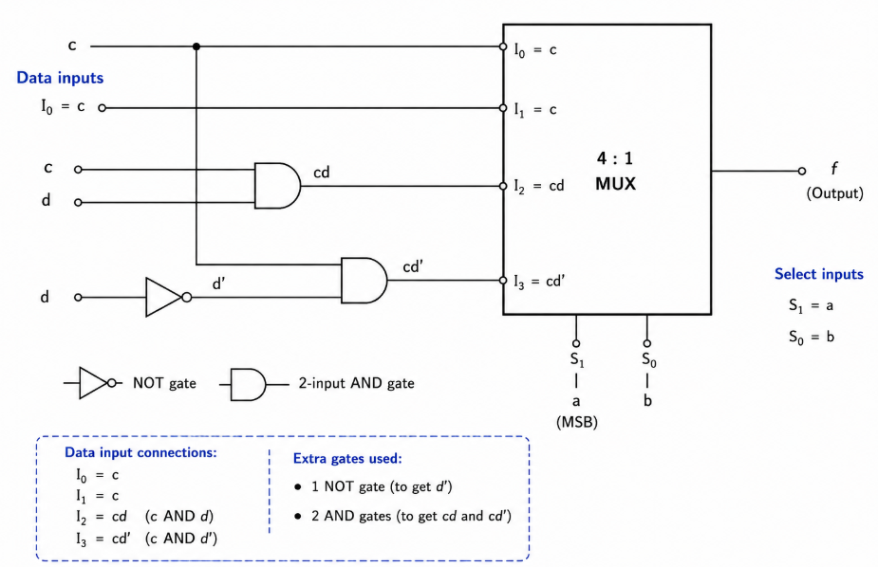

46. An 8x1 multiplexer has inputs A, B and C connected to the selection inputs S2, S1, and S0 respectively. The data inputs I0 to I7 are as follows:
I1=I2=I7=0; I3=I5=1; I0=I4= D and I6= D'
(a) Show the multiplexer implementation.
(b) Determine the Boolean function that the multiplexer implements.
Answer:
(a) Multiplexer Implementation.
Given,
S2 = A
S1 = B
S0 = C
The data inputs of the 8×1 multiplexer are connected as follows:
I0 = D
I1 = 0
I2 = 0
- I3 = 1
- I4 = D
- I5 = 1
- I6 = D'
- I7 = 0
Therefore, the multiplexer implementation consists of an 8×1 MUX with:
Selection inputs:
- S2 = A
- S1 = B
- S0 = C
Data inputs:
- I0 = D
- I1 = 0
- I2 = 0
- I3 = 1
- I4 = D
- I5 = 1
- I6 = D'
- I7 = 0
The output of the multiplexer is denoted by F.
Circuit Diagram:
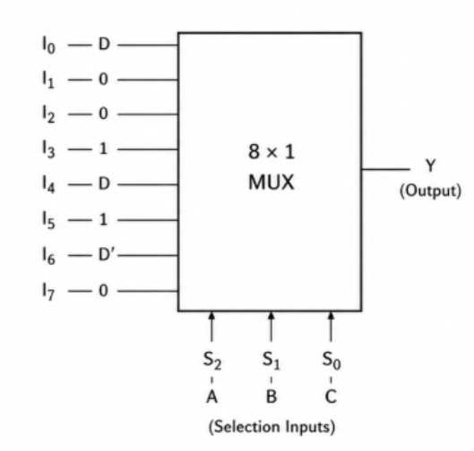

(b) Determine the Boolean function implemented by the multiplexer.
For an 8×1 multiplexer, the output equation is:
F = I0A'B'C' + I1A'B'C + I2A'BC' + I3A'BC + I4AB'C' + I5AB'C + I6ABC' + I7ABC
Substituting the given data inputs:
F = DA'B'C' + 0(A'B'C) + 0(A'BC')+ 1(A'BC) + DAB'C' + 1(AB'C)+ D'ABC' + 0(ABC)
Therefore,F = DA'B'C' + A'BC + DAB'C' + AB'C + D'ABC'
Now, simplify the expression.
F = DB'C'(A' + A) + C(A'B + AB') + D'ABC'
Since, A' + A = 1 and A'B + AB' = A XOR B
we get: F = DB'C' + C(A XOR B) + D'ABC'
Therefore, the Boolean function implemented by the multiplexer is:
F = DB'C' + C(A XOR B) + D'ABC'
Verification Using the MUX Selection Table
A | B | C | S2S1S0 | Selected input | Output F
0 | 0 | 0 | 000 | I0 = D | D
0 | 0 | 1 | 001 | I1 = 0 | 0
0 | 1 | 0 | 010 | I2 = 0 | 0
0 | 1 | 1 | 011 | I3 = 1 | 1
1 | 0 | 0 | 100 | I4 = D | D
1 | 0 | 1 | 101 | I5 = 1 | 1
1 | 1 | 0 | 110 | I6 = D’ | D’
1 | 1 | 1 | 111 | I7 = 0 | 0

Hence, the 8×1 multiplexer implements the Boolean function:
F = DB'C' + C(A XOR B) + D'ABC'
Equivalently, in minterm form with respect to A, B, C:
F = Σm(0, 3, 4, 5, 6)
where the data variable D determines the output for the cases in which the selected input is D or D'.

