

**Tribhuvan University**

**Faculty of Humanities and Social Sciences**

**A Proposal Report on**

**SKILLS SCOUT**

**Submitted to**

**Department of Computer Applications**

**Nepal Kasthamandap College**

***In the partial fulfilment of the requirement for bachelor’s in computer application***

Submitted By

Ambhoj Adhikari (6-2-144-01-2020)

Mukesh Nepali Pariyar (6-2-144-13-2020)

June 2024

**Table of Contents**

**Chapter 1 Introduction** 1

**1.1** **Introduction** 1

**1.2** **Problem Statement** 1

**1.3** **Objectives** 1

**1.4** **Scope and Limitations** 2

**1.4.1 Scopes** 2

**1.4.2 Limitations** 2

**Chapter 2 Background Study and Literature Review** 3

**2.1 Background Study** 3

**2.2 Literature Review** 3

**Chapter 3 Methodology** 5

**3.1 Requirement Identification** 5

**3.1.1 Requirement Analysis** 5

**3.2 Feasibility Study** 6

**3.3 High Level Design of System** 7

**3.3.1 Methodology and Working Mechanism** 7

**3.3.2 Flowchart** 8

**3.3.3 Data Modelling: ER Diagram** 9

**3.3.4 Data Flow Diagram (DFD)** 10

**3.3.5 Gantt Chart** 11

**Chapter 4 Expected Outcome** 12

**References**

**List of figures**

**Figure 1: Agile Development Model for Skills Scout** 7

**Figure 2: Flowchart of User/Worker for Skills Scout** 8

**Figure 3: Flowchart of Admin for Skills Scout** 9

**Figure 4: ER Diagram for Skills Scout** 10

**Figure 5: Level 0 DFD for Skills Scout** 11

**List of Tables**

**Table 3.1: Gantt Chart Table for Skills Scout** 11

**List of Abbreviation**

CSS : Cascading Style Sheet

HTML : Hypertext Mark-up Language

MERN : MongoDB, Express.js, React and Node.js

PHP : Hypertext Pre-processor

# **Chapter 1 Introduction**

## **Introduction**

In a world where expertise makes all the difference,” Skill scout” emerges as your premier platform for connecting with skilled professionals across a variety of essential services. Whether you're in urgent need of a plumber to fix a leak, an electrician to resolve wiring issues, a reliable driver for your transportation needs, or a proficient mechanic to service your vehicle, “Skill scout” is here to simplify your search.

Our platform is designed to match you with verified professionals who are adapt in their respective fields. Whether you're a homeowner, a business owner, or simply someone in need of skilled assistance, “Skill scout” is committed to facilitating connections that meet your exact requirements. Workers such as plumber, mechanics, and electricians are hired for temporary jobs.

## **Problem Statement**

In the context of Nepal the people have to face many problems.

* Difficulty in finding reliable professionals for essential services like plumbing, electrical work, driving, and mechanics.
* Frustration due to inconsistent availability and responsiveness of service providers.
* Workers could not reach in time.
* Websites not available for all districts.
* To contact workers a long process is done.

## **Objectives**

The main object of this project is to provide information about the essential and suitable job for the seekers.

* To provide platform forskilled worker.
* To recommend the worker available in the area.
* To make it available for 77 district.

## **Scope and Limitations**

### **1.4.1 Scopes**

* It provides various workers of different categories.
* It provides user friendly environment.
* Any user can use this system.

### **1.4.2 Limitations**

* There are no different folders for workers.
* No email alerts are send.
* Username should be different.

# **Chapter 2 Background Study and Literature Review**

## **2.1 Background Study**

In today's world the use and access to the internet is so high that internet has connected so many people from one place to another or from person to person. The internet has provided many platforms like Social media, E-Commerce, Content, App stores etc.

So in the generation of competition we are trying to give platform to workers like Plumber, Mechanics, Electricians, Drivers, etc. through Skill Scout which main motive is to find worker to necessary user.

Our website presents you a user-friendly interface where user can find the different category worker with typical skills where the platform provides worker’s Name, Phone Number, Address, and their working experience.

In the context of Nepal there are rare platform like this which are only provided for companies in which only permanent workers are available for companies where most of the workers are unemployed. That’s why our website is targeted for unemployed workers where they can upload their skills and wait for the response.

## **2.2 Literature Review**

As the development in the software and internet where it has become so common in today's generation. It has provided many platform like entertainment, social media, E-commerce, Content etc. As we were researching we've found platform like Sajilo Sewa, Kathmandu maintenance, Smart Home sewa, Homeplex Nepal, Skill Sewa etc.

The website we are designing is to match with verified professions who are adaptive in their respective fields. Whereas we are trying to reduce the complexity to operate it so that any person with basic technological knowledge can use it efficiently however sometimes it might get complex to user to use it perfectly in the time of system down or with any updates.

Sajilo Sewa, founded in 2017, is an innovative online service marketplace headquartered in Lalitpur, Patan. The platform allows homeowners and businesses to effortlessly request and book home services from multiple certified service providers. As a privately held company within the IT Services and IT consulting industry, Sajilo Sewa has carved a niche by providing a wide range of services including plumbing, electrical work, computer and networking services, carpentry, maintenance, and repair. [1]

Kathmandu Maintenance, renowned for its prompt and reliable service, has over a decade of global industry experience and expanded into Nepal in 2022. Specializing in electrical and electronics maintenance, the company serves the Kathmandu area with a range of services, including the repair and maintenance of fridges, air conditioners, water pumps, motors, and washing machines, alongside electrical wiring and plumbing services. Their skilled technicians ensure top-quality service, establishing a reputation for excellence. [2]

Service platforms like Smart Home Sewa have become essential in the home maintenance and repair industry, offering a "one-call solution" for various needs. These platforms are trusted for their reliability and affordability, catering to owners who find it challenging to locate reputable service providers. As noted in studies like those by Sundararajan (2016) and Katz and Krueger (2019), such platforms enhance service accessibility and trust by vetting contractors and ensuring consistent quality. Smart Home Sewa has distinguished itself through its commitment to excellence, earning recognition and a solid reputation in the industry by providing a broad range of maintenance and repair solutions that focus on customer satisfaction. [3]

Integrated service platforms like Homeplex provide a comprehensive solution for various home-related needs, combining repair, maintenance, construction, and inspection services under one umbrella. As indicated by research on the integration of technology in service delivery (e.g., Chesbrough, 2010; Baines et al., 2017), platforms such as Homeplex stand out due to their use of advanced tools and well-coordinated teams. This technological integration and organizational efficiency allow for high standards and precise execution in service provision, from minor repairs to major construction projects. Homeplex’s approach aligns with trends in the service sector that emphasize customer-centric models and the seamless delivery of diverse services. The company’s commitment to excellence and customer support is consistent with findings by Gronroos (2020), who highlights the importance of customer interaction and satisfaction in service excellence. This dedication to high-quality service and professional expertise ensures that Homeplex meets the needs of modern homeowners effectively. [4]

Skill Sewa is the Home Inspection Service”. Skill Sewa is a one stop solution to your daily problems at affordable price with professional technicians. We provide free home inspection under certain limitation plus attractive packages regarding different services and maintenance issues.Skilled Sewa will help you in taking away the pain of finding the trusted electricians and plumbers to cater to your needs, right at the comfort of your home. Moreover, we have facilities of every service that you wish to have around you at one call or one click. [5]

# **Chapter 3 Methodology**

## **3.1 Requirement Identification**

For this project, we researched and reviewed some of the related websites and applications. Throughout the research, we get to find out that there are very few websites or applications related to on daily basis job. Some of the related websites are LinkedIn, Freelancing, Guru, etc. have the features in which most of the users cannot access to it likewise to access these website user have to pay monthly premium to show that they are eligible to use the platform.

For the other website the workers need to give an interview for the job whereas in our website there is no mandatory for interview. The user can communicate the workers through phone number on the website.

### **3.1.1 Requirement Analysis**

Requirements analysis is a crucial step for determining the success of a system or software project. Requirements are generally split into two types.

1. Functional requirements
2. Non-functional requirements

The system needs to fulfil those requirements.

1. **Functional Requirement**

This section provides the requirement overview of the system. Various modules implemented by the system are:

* **User**
* User can view the detail of worker after register and login.
* User can find worker and they can contact them.
* User can logout from the system.
* **Worker**
* Worker can register and login the system.
* Worker can upload their details.
* Worker can logout from the system.
* **Admin**
* Admin can login the system.
* Admin can view the registered accounts.
* Admin can delete the users and workers account.
* Admin can logout from the system.

1. **Non-Functional Requirement**
2. **Availability**

It will be available as a website. The system works on multiple web browsers like Chrome, Mozilla Firefox and Opera.

1. **Security**

The system has accounts for its users and only authorized users can access the system with username and password. The register system contains form validations so that non-authorized user cannot access.

1. **Performance**

This system will be designed for smooth performance with optimization and good response.

## **3.2 Feasibility Study**

A feasibility study is a way to evaluate whether or not a project plan could be successful or not. In Nepal, finding reliable professionals for services such as plumbing, electrical work, driving, and mechanics can be challenging. This feasibility study aims to assess the practicality and potential success of developing the "Skill Scout" platform.

1. **Technical feasibility**

The platform will be built using a combination of front-end and back-end technologies. Where the programming language like MERN, CSS, PHP, HTML are used to provide user friendly interface so that the website can run successfully. The platform will feature a user-friendly interface that makes it easy for users to find workers. This includes search filters.

1. **Operational feasibility**

Operational feasibility involves analysing the practicality of implementing the project within the current business environment and determining how it will impact daily operations. The system provides the user friendly interface whereas in existing system as mentioned above needs premium to have full function and the skill scout system doesn't need premium to operate.

1. **Economic feasibility**

As per the research, system doesn’t need any funding while it is being developed. However to build the system it needs software like Visual Studio Code which is free on website.

## **3.3 High Level Design of System**

There are many development models like Waterfall model, Agile Model, Iterative Model, Big Bang Model, RAD model and many more. To develop our system we study some of the developing models. After studying the models, “Agile Model” is suitable for the system that is going to be used to develop the system.

## **3.3.1 Methodology and Working Mechanism**

The Agile methodology will be used for our system because in “Agile method” the task breaks into smaller iterations, or parts do not directly involve long term planning. In agile method we can change requirements, even in later stages and we can keep things simple as possible.

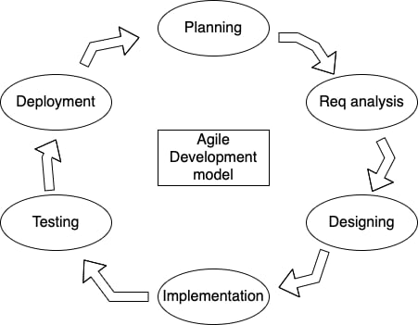

**Figure 1: Agile Development Model for Skills Scout**

### **3.3.2 Flowchart**

A flowchart is used in our system to show the diagram that displays how the data flows through the system and how decisions affected this process. There are two flowcharts in this system.

**User/Worker (Flowchart)**

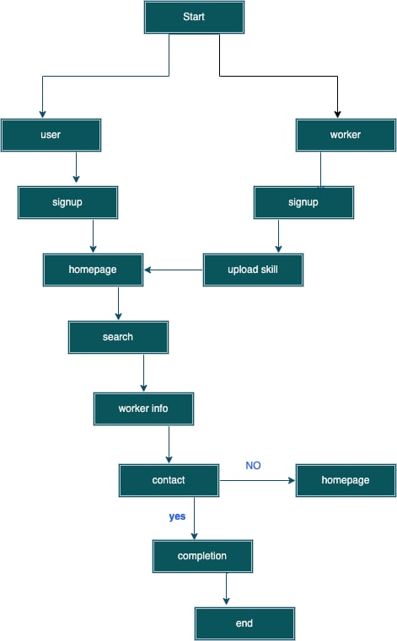

**Figure 2: Flowchart of User/Worker for Skills Scout**

**Admin (Flowchart)**

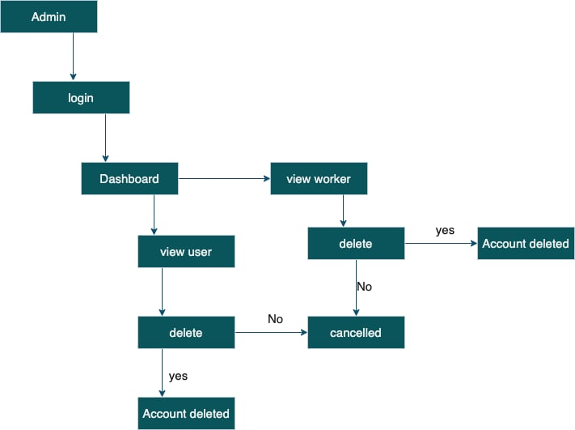

**Figure 3: Flowchart of Admin for Skills Scout**

### **3.3.3 Data Modelling: ER Diagram**

For Entity Relational Diagram we have four entities and four relations for our system. The entities are User, Worker, Admin and Categories. The user entity have attribute “u.id, username, password, contact no, location”, similarly worker, category and admin have attributes to represent their role in system.

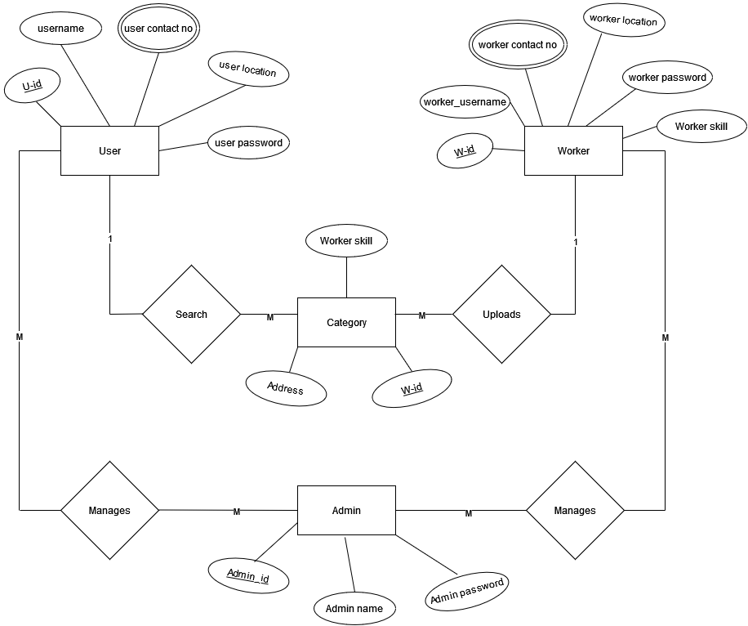

**Figure 4: ER Diagram for Skills Scout**

### **3.3.4 Data Flow Diagram (DFD)**

The Data Flow Diagram in the system shows the relation between Users, Worker and Admin through the system. It shows how the system response to different accounts differently. Data flow diagram provides a visual representation of our system.

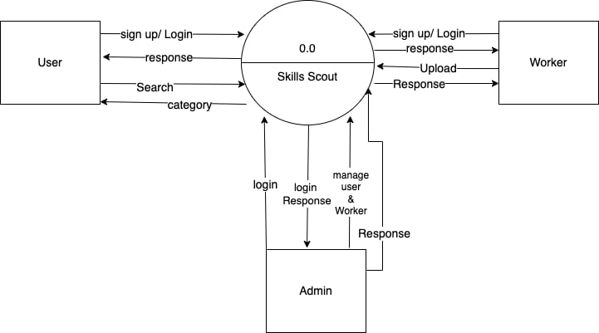

**Figure 5: Level 0 DFD for Skills Scout**

### **3.3.5 Gantt Chart**

Gantt chart is used in our system to show time period of our work. The Gantt chart is used for showing what work done on a specific time period. The Gantt chart contains planning, research, design, implementation, follow up and documentation. The Gantt chart were created using Microsoft Word in our system as seen in the table below.

**Table 3.1: Gantt chart Table for Skills Scout**

|  |  |  |  |  |  |  |  |  |
| --- | --- | --- | --- | --- | --- | --- | --- | --- |
| Task | June  01 | June  20 | July  15 | July  26 | Aug  27 | Sept  3 | Sept  15 | Estimation |
| Planning |  | |  |  |  |  |  | 20 days |
| Research |  |  | |  |  |  |  | 15 days |
| Design |  |  |  | |  |  |  | 25 days |
| Implementation |  |  |  |  | |  |  | 35 days |
| Testing |  |  |  |  |  | |  | 25 days |
| Documentation |  | | | | | | | 120 days |

# **Chapter 4 Expected Outcome**

After the completion of the system, it provides a user friendly interface where the user and worker can interact with each other. When the project is completed the user and worker will be able to register and login into the system. User will be able to search the profession or skilled that has been uploaded by worker. And they will be in contact with each other so that the system function is completed.

# **References**

|  |  |
| --- | --- |
| [1] | S. Shrestha, “Sajilo Sewa,” 2017. [Online]. Available: https://www.sajilosewa.com. |
| [2] | “Kathmandu Maintenance,” 2022. [Online]. Available: https://kathmandumaintenance.com/. |
| [3] | Sundararajan, “Smarthome Sewa,” 2019. [Online]. Available: https://www.smarthomesewa.com/. |
| [4] | Chesbrough, “Homeplex Nepal,” 2020. [Online]. Available: https://homeplexnepal.com/. |
| [5] | M. Timilsina, “Skill Sewa,” 2021. [Online]. Available: https://www.skillsewa.com/. |