**BAT ASSIGNMENT 1**

**K190257 || M. Tuaha Ajaz**

**ANSWER_1**

**Stage_1: Signup/Login**

Signup:

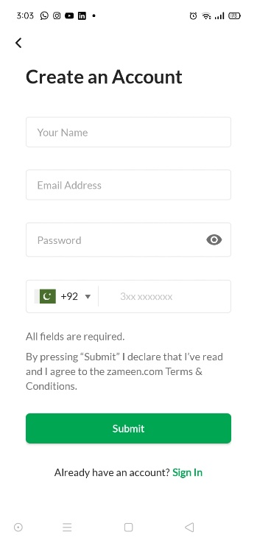

Login:

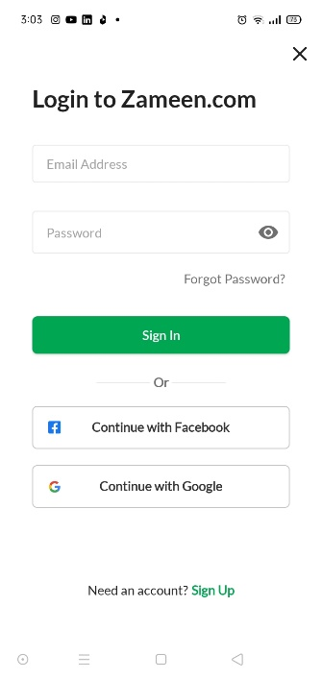

**Stage_2: Find a property**

Search by a specific category:

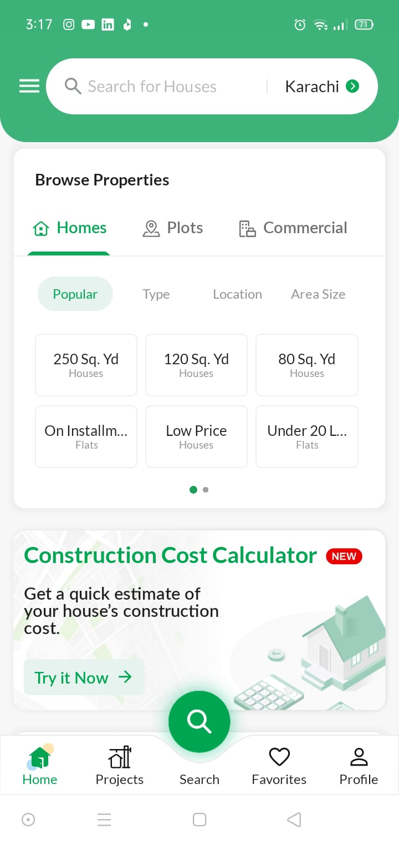

New Properties:

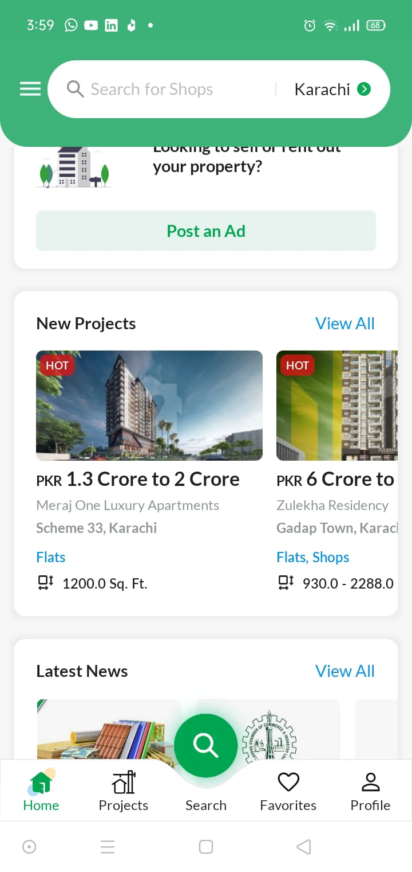

Search by multiple filters:

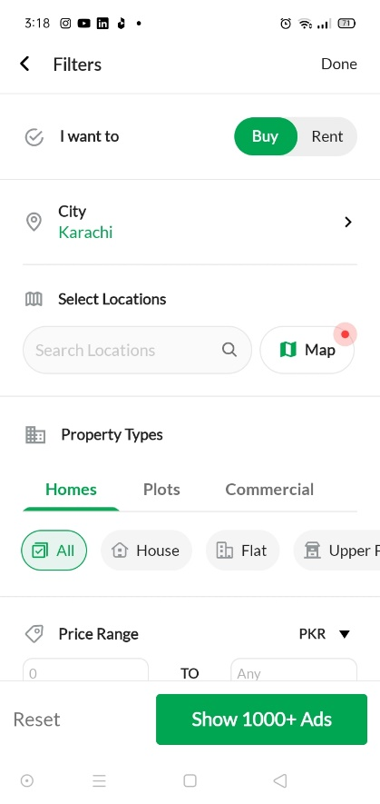

Search Results:

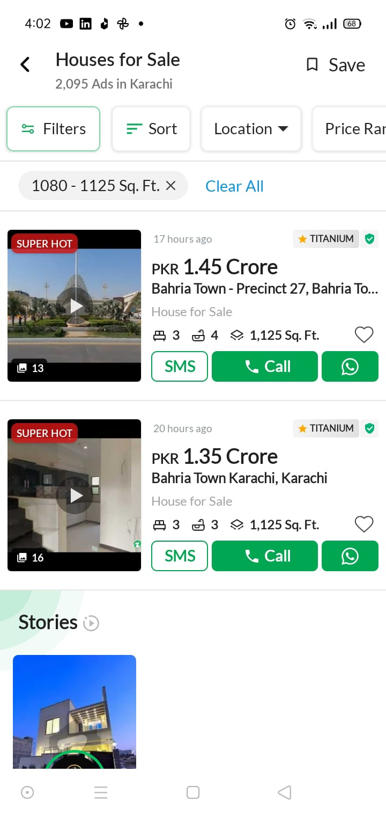

**Stage_3: Viewing property details**

Property Detail Page:

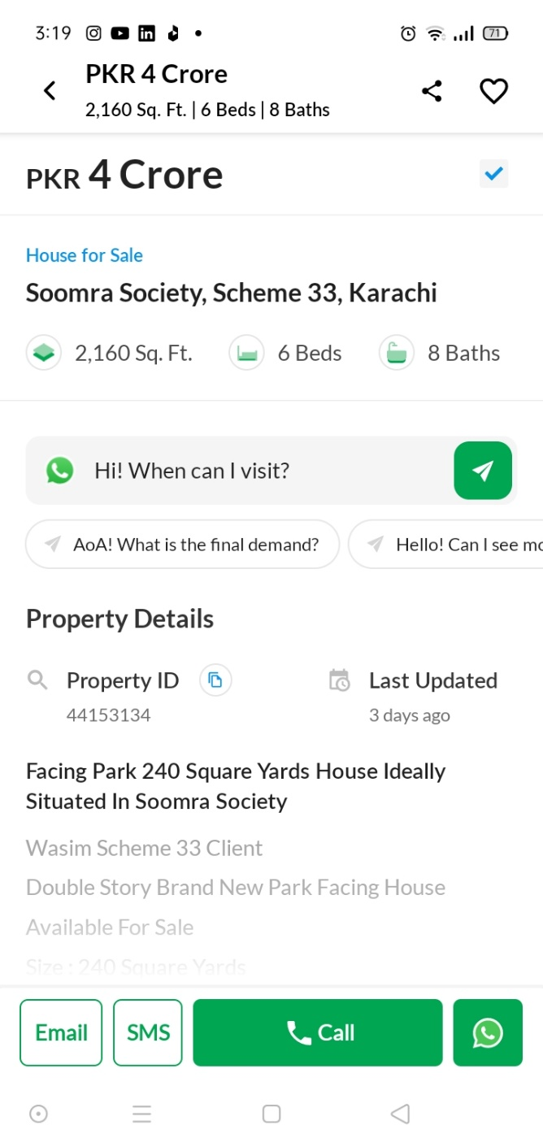

**Stage_4: Add your own property**

Property adding page

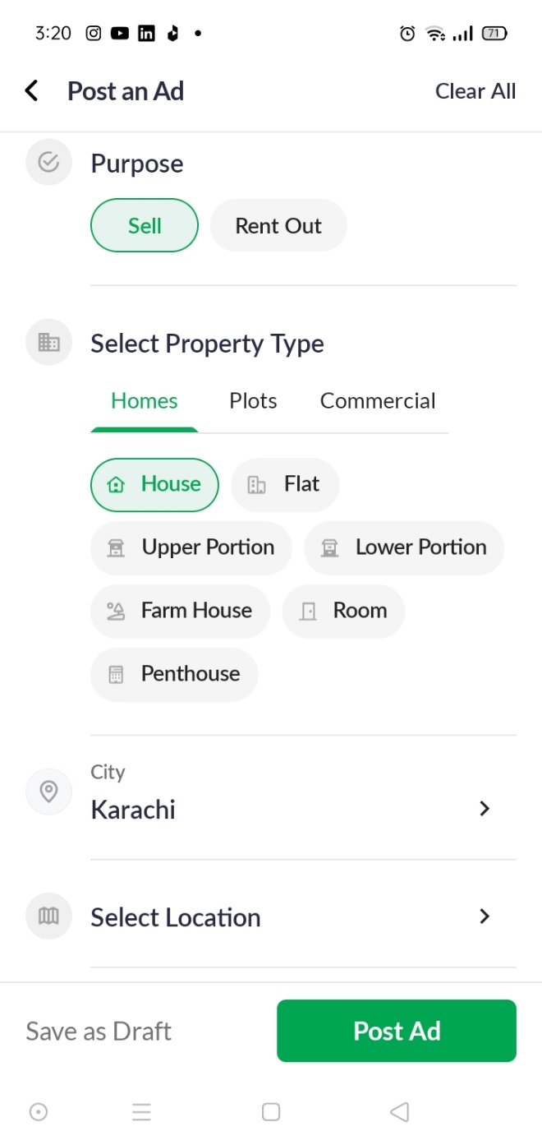

**ANSWER_2**

**Process Flow Diagram**

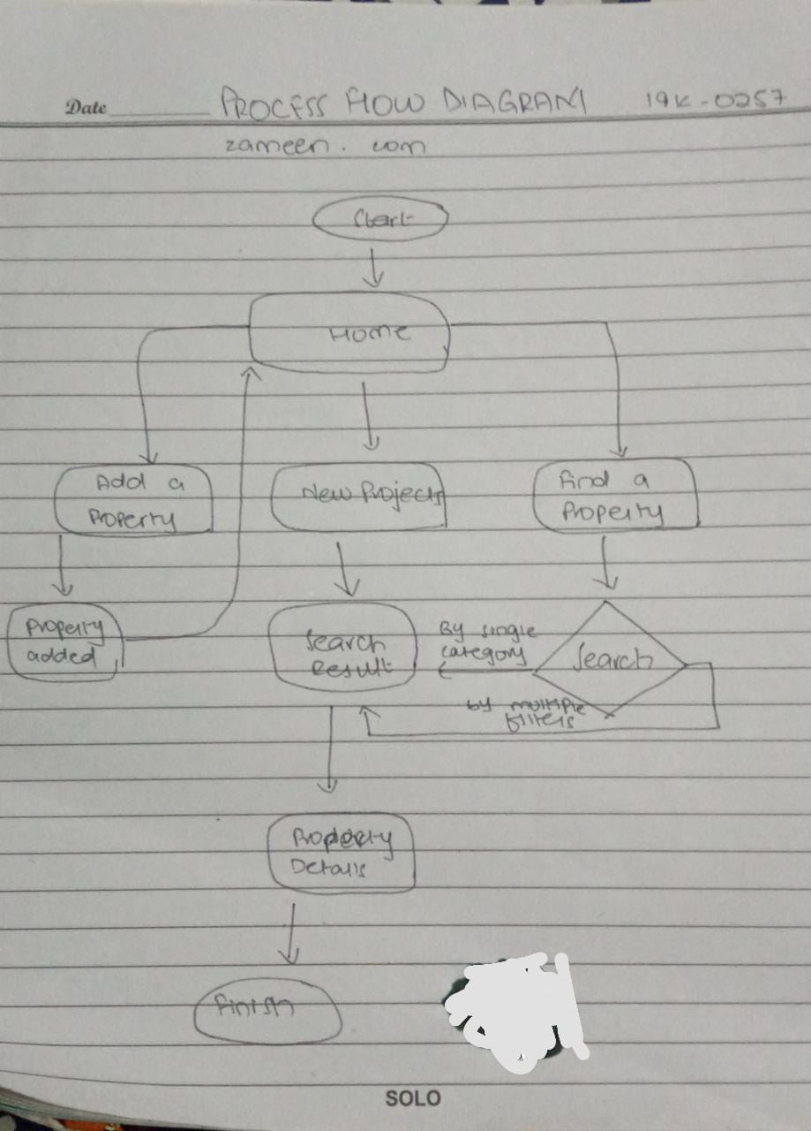

**State Transition Diagram:**

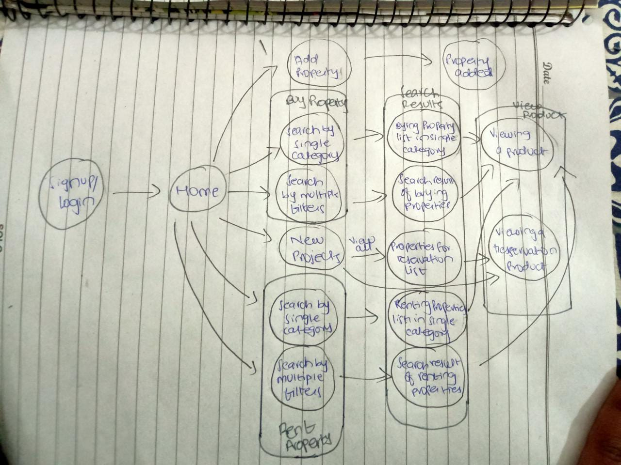

**ANSWER_3**

**Engagement Metrics**

Hypothesis:

* Seamless Signup and Sign in improves engagement.  
  Metric: Seamless Signup/Sign In
* Time required to register any property is inversely proportional to engagement.  
  Metric: Property Registration Time
* Search results accuracy is a sign of engagement.  
  Metric: Search results accuracy
* Time spend on the search result page is inversely proportional to engagement.  
  Metric: Search result average page time.
* Bouncing back from the search result page is bad for engagement.  
  Metric: Bounce-back rate from search results.
* Bouncing back from the property details page is bad for engagement.  
  Metric: Bounce-back rate from property details page.
* Time spent on the property details page is directly proportional to engagement.  
  Metric: Property details page-time
* User should move to contacting property owner.  
  Metric: Number of times user contacted property owner.

Variables:

|  |  |
| --- | --- |
| Metrics | Variables |

|  |  |  |  |  |
| --- | --- | --- | --- | --- |
| Seamless Signup/Signin | Successful  Signup  count | Not successful  Signup count | Successful Sign  in count | Not Successful  Sign in count |
| Property Registration Time | Time spent contemplating (doing nothing) on registration page. |  |  |  |
| Search results accuracy | Choosing from the top 3 results | No. of additional filters added |  |  |
| Search result page time | Micro view of search result page | Choosing a property that is not within the starting 5 results | Count of scroll  up/down on  search result |  |
| Bounce-back rate from search results | Count  Bounces  back from  Search Results |  |  |  |
| Bounce-back rate from property details page | Count  Bounces  back from  Details page |  |  |  |
| Property details page-time | Micro view of Property details page | Count of scroll  up/down on  Property details |  |  |
| Number of times user contacted property owner | Number of times user clicked on any of the three contact buttons |  |  |  |