Problem Description

A pet feeding system, which can dispense food and monitor the food consumed by the pets to alert someone nearby of any issue during the feeding process.

# Probable Inputs

* **Feeding Schedule** – Time to dispense pet food
* **Weight of the food tub** – Calculate weight to identify food consumption and food dispense amount
* **Current System Time** – Real-time clock to identify the feeding time

# **Probable Output**

* **Servo Motor Control** - Turns on the servo motor
* **Alert LED Signal** – Warn pet store staff about unconsumed food

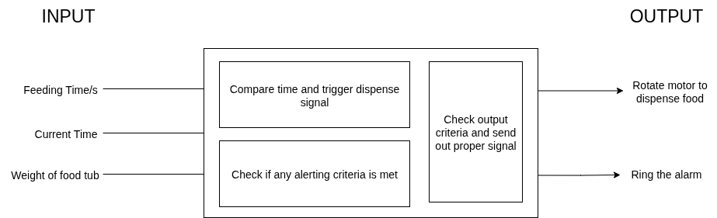Figure 1: Expected System Working

# Assumptions

* System will use basic and low-cost components (like servo motor)
* Only dry pet food used
* The device can be helpful for feeding either dog’s or cat’s
* Alert may be sent to staff using local or offline method, such as Alarm or LED
* The system can operate on very minimal storage equivalent to 128MB