**QUESTION BANK FOR Module 1 & 2**

**Subject name: BEE**

**Subject code: BTEE- 101-18**

**Syllabus:**

**Module – 1: DC Circuits**

Electrical circuit elements (R, L and C), voltage and current sources, Kirchoff’s current and voltage laws, analysis of simple circuits with dc excitation. Superposition, Thevenin’s and Norton’s Theorems. Time-domain analysis of first-order RL and RC circuits

**Unit – 2: AC Circuits**

Representation of sinusoidal waveforms, peak and rms values, phasor representation, real power, reactive power, apparent power, power factor. Analysis of single-phase ac circuits consisting of R, L, C, RL, RC, RLC combinations (series), resonance, Three-phase balanced circuits, voltage and current relations in star and delta connections. .

**Short Answer Type Questions (2 Marks)**

1. State Ohm’s law and its limitations.
2. Differentiate between Ideal and practical voltage sources.
3. How will you differentiate between Linear and Non Linear elements?
4. Differentiate between active and passive components
5. State superposition theorem.
6. What do you mean by time domain analysis? Discuss
7. State Thevenin’s Theorem
8. If a 30 V source can force 1.5 A through a certain linear circuit, how much current can 10 V force through the same circuit?
9. Define Ideal and practical current sources.
10. A wire of length 1 m has a resistance of 2 ohms. Obtain the resistance if specific resistance is double, the diameter is double and the length is made three times the first.
11. Differentiate between rms value and average value.
12. Differentiate phase and phasor difference with example.
13. Write the mathematical expression for 50Hz sinusoidal voltage supplied for domestic purposes at 230V
14. Draw the power triangle and define various types of power
15. The equation of alternating current is I = 42.42 Sin 628t. Determine (a) Maximum value (b) Frequency (c) RMS value (d) Average value.
16. How will you differentiate between AC and DC circuit..
17. Define Form Factor and Power Factor.
18. Describe the advantage of three –phase system over single phase system.
19. Discuss the significance of phasor diagram in electrical engineering.
20. What do you mean by resonance? Explain.

**Long Answer Type Questions (4 Marks)**

1. By using Norton’s Theorem, find current 1KΩ resistor of network as shown in figure below

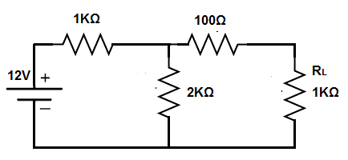

1. What are transients? Discuss the voltage response of RL series circuit.
2. Find the current through 10Ω resistance in the given network by using superposition theorem.

[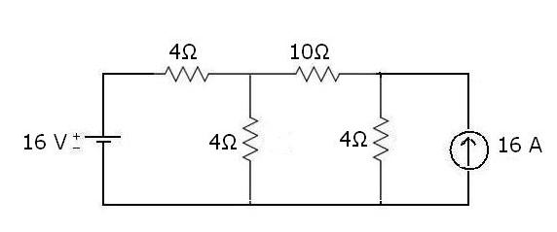](https://1.bp.blogspot.com/-NX6b7Oc-95E/UDC9R4uOD3I/AAAAAAAAAPg/iJ2L4FxlNyQ/s1600/super-example-1.JPG)

1. State and explain Kirchhoff’s law.
2. By using Thevenin’s Theorem, find current in 15Ω resistor of network as shown in figure below.

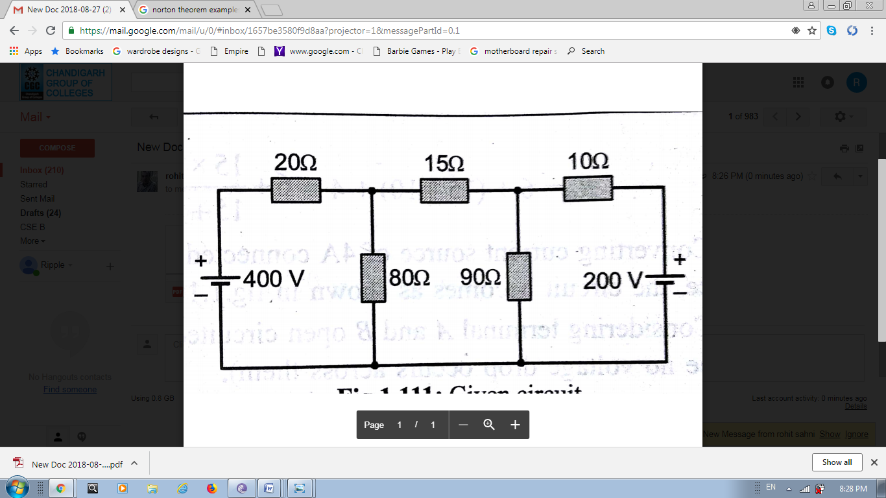

1. Define the r.m.s value of alternating current having sine wave and derive its expression.
2. Explain RLC series circuits. What happens when RLC series circuit is at resonance?
3. Derive the relation between phase and line voltages and currents for a balanced 3 phase- Delta connected system.
4. A resistance of 15Ω and capacitor of 150mF capacitance are connected in series acrossa 230V, 50Hz supply. Calculate
5. Impedance of the circuit
6. Current flowing through the circuit
7. Power factor and phase angle
8. Power consumed in the circuit.
9. Explain the operation of series RL circuit with single phase AC supply.
10. A resistance of 12Ω, inductance of 0.1H and a capacitor of 100µF capacitance are connected in series across a 220V, 100Hz supply. Calculate
11. Impedance of the circuit
12. Current flowing through the circuit
13. Power factor and phase angle
14. Power consumed in the circuit.
15. A d.c voltage V is applied across a circuit consisting of resistance R ohms in series with a capacitance C farads. Derive expression for variation of voltage across C with time.