

OOPS Lab Project Report

Track and Trigger Application

# Group-47:

### Rahul Mehndiratta-2017A7PS1479H

### Atharva Pagar-2019A7PS0085H

### Jatin Mangla-2019A7PS0122H

* + 1. Ankur Kanungo-2019A7PS0125H

# Problem Statement:

In modern household, due to hectic work schedules, it is quite difficult to remember as well as manage the availability of mandatory commodities in an urban home. Not only working professionals, homemakers, job-seekers, and others fail to keep track of their inventories or scheduled meetings which in turn either delay or terminate their regular duties. Sometimes, most of the people forget that they already have sufficient stock of certain item, and end up re-buying the same stuff again (toothpaste, soap, face wash, etc.) as a result lose money and time. The inability of efficiently managing the home inventories will not only impacts work schedules, but also causes stress, anger, and impatience. An automated application is proposed and intended to develop in order to keep track of the regular activities and aid people in managing the daily home inventories.

We present **Pixel FireNotes** which is an answer for all above mentioned issues.

# Pixel FireNotes:

Quickly capture what’s on your mind and get a reminder later at the right place or time. Speak a voice memo on the go and have it automatically transcribed. Grab a photo of a poster, receipt or document and easily organize or find it later in search. FireNotes makes it easy to capture a thought or list for yourself, and share it with friends and family.

# Capture what’s on your mind

 • Add notes, lists and photos to FireNotes.Pressed for time? Record a voice memo and FireNotes will transcribe it so you can find it later.

# Share ideas with friends and family.

  • Easily plan that surprise party by sharing your FireNotes with others and collaborating on them in real time.

# Find what you need, fast

 • Color and add labels to code notes to quickly organize and get on with your life. If you need to find something you saved, a simple search will turn it up.

# Always within reach

 • Pixel FireNotes works on all your Android wearables. Everything you add syncs across all of your devices so your thoughts are always with you.

**The Right note at the right time**

 • Need to remember to pick up some groceries? Set a inventory-based reminder to pull up your grocery list right when you get to the store.

# Permissions Notice:

 Camera: This is used to attach images to notes in FireNotes.

 Contacts: This is used to share notes to contacts.

 Microphone: This is used to attach audio to notes.(Coming Soon)

 Storage: This is used to add attachments from storage to their notes.

 Data : This is used to sync the notes and reminders with google account.

## Future Additions:

We intend to provide our users with everything they need to organise their

commodities and schedules within one application .That is why we will keep on updating FireNotes with exciting new features. Few of them are:

1.)Voice Memo: Pressed for time? Record a voice memo and FireNotes will transcribe it so you can find it later.

2.)Share App: Like what we do? Give us a star rating and help us grow.

# Functionalities and Screenshots

## Register:

User has to enter his mobile number for OTP Verification.

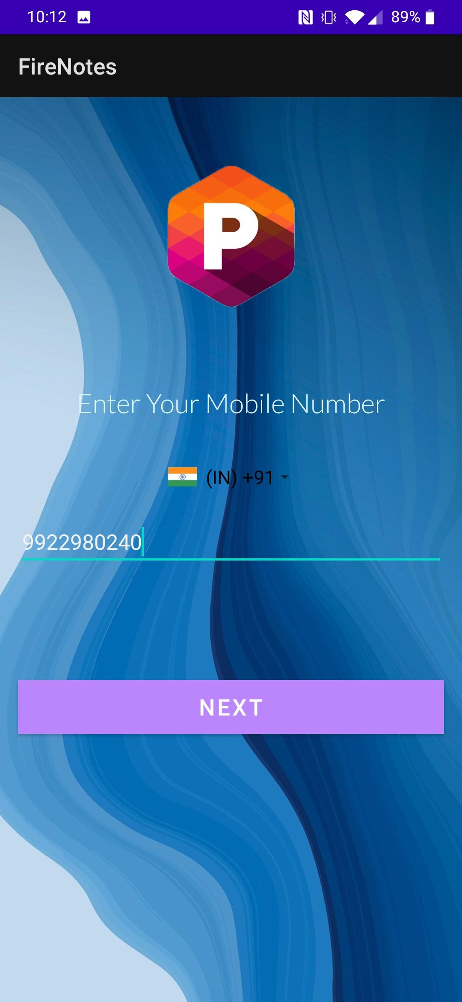 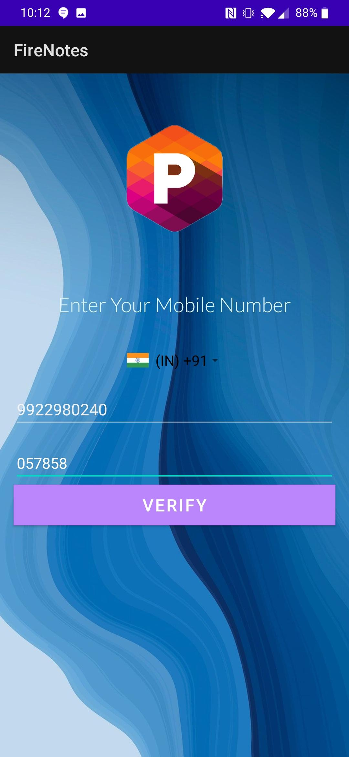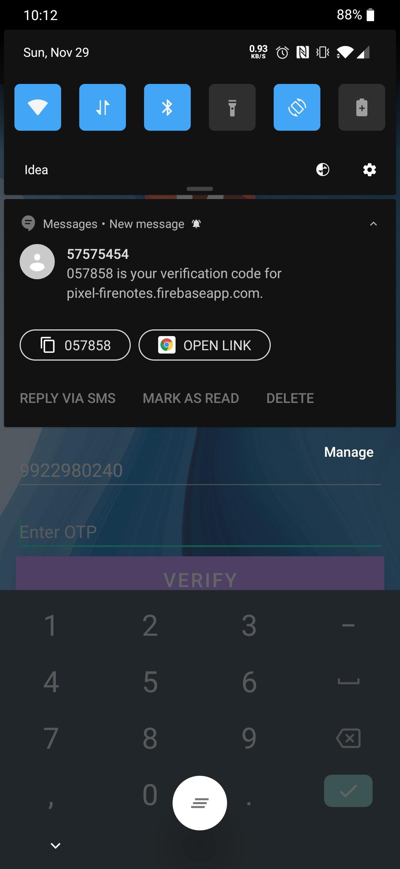 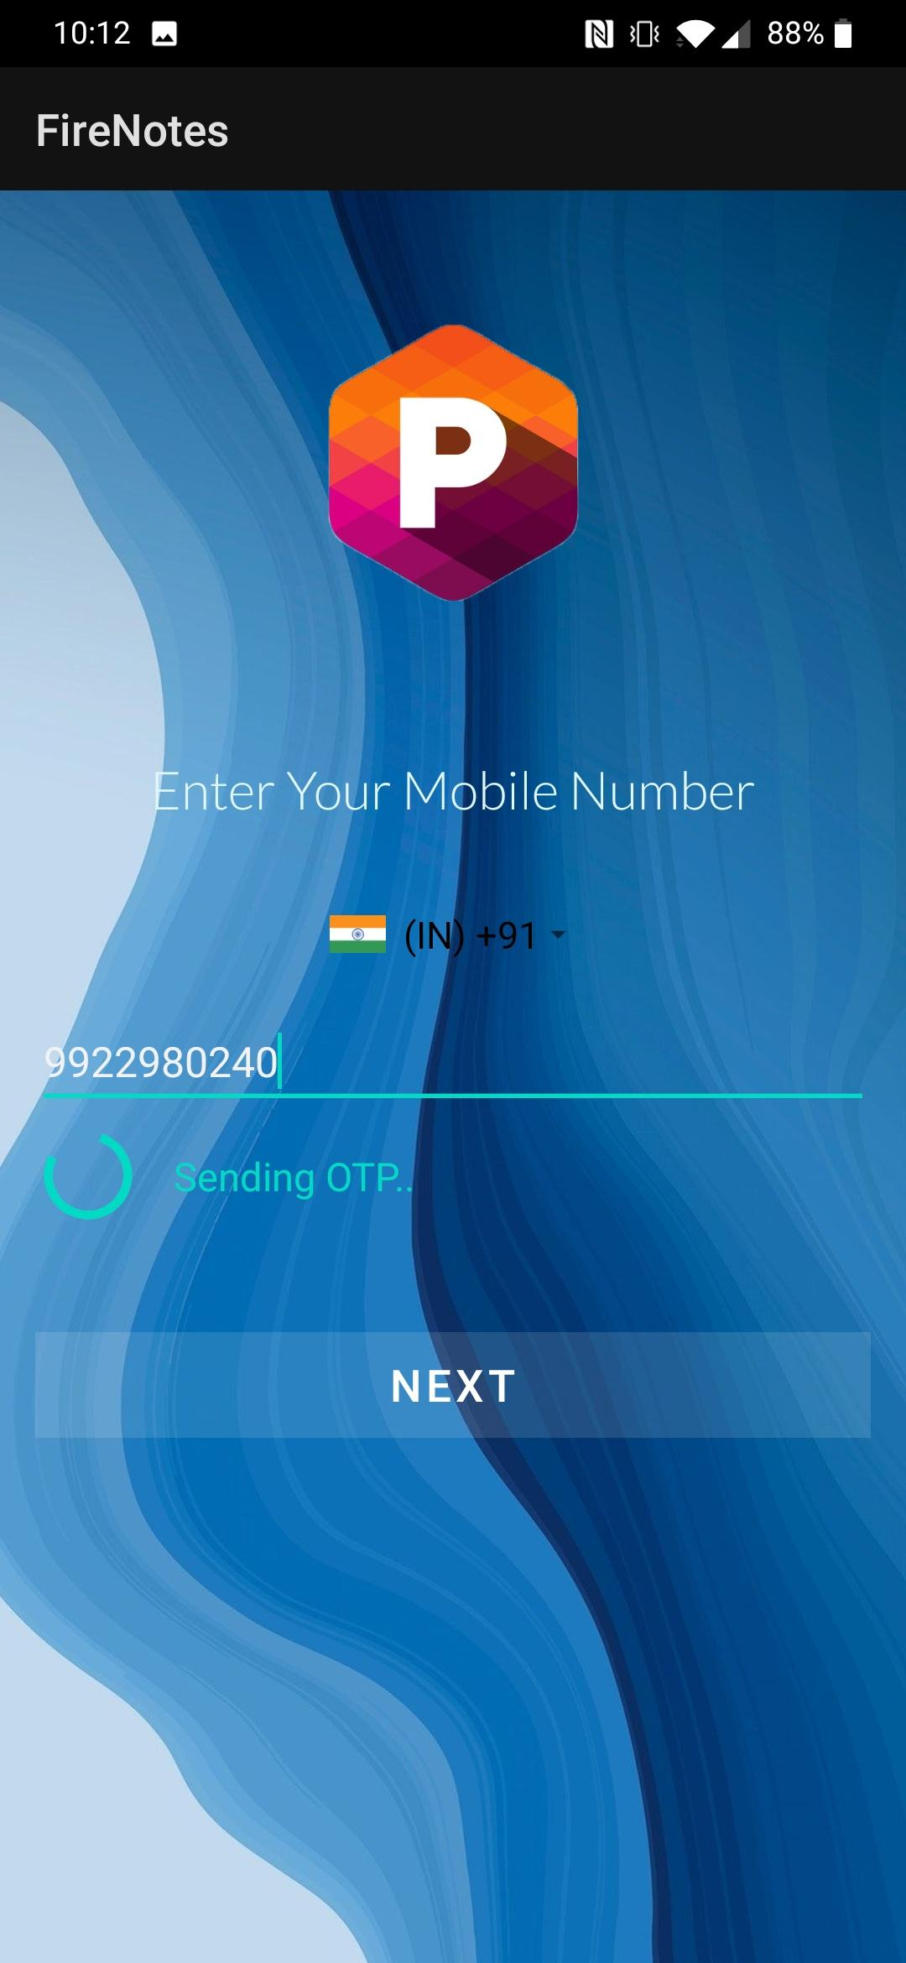

After the OTP Verification user is directed to a page which asks for First Name, Last Name and Email Address.

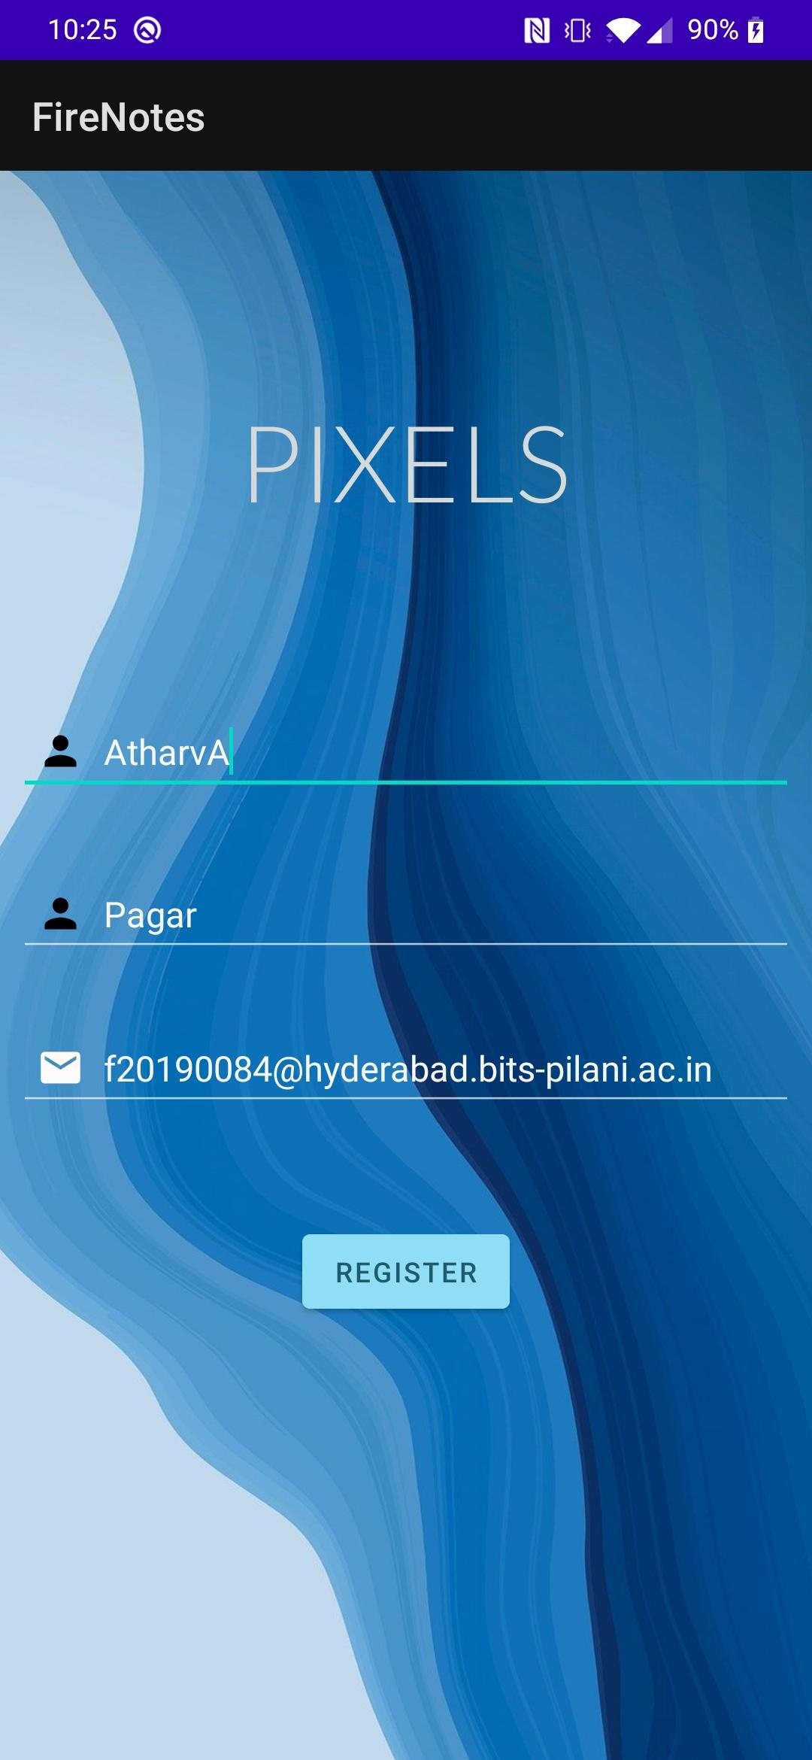

Once the user successfully logs in he is directed towards the MainActivity Area which consists of all the existing notes the user has created and options to add note and add an event using calendar.

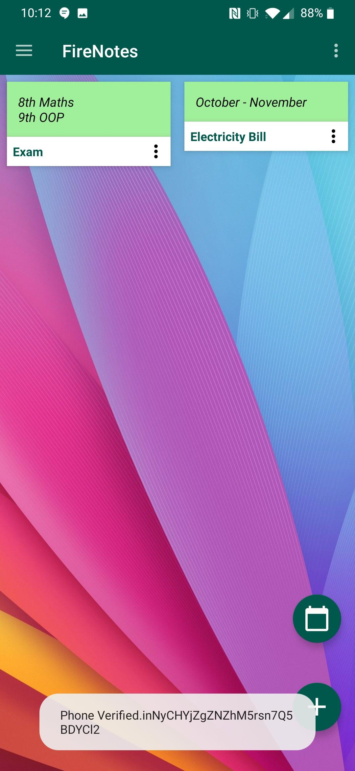

The notes that are being added can also be edited,deleted and shared via mail, Whatsapp, Messages etc.

# Options Available in MainActivityArea:

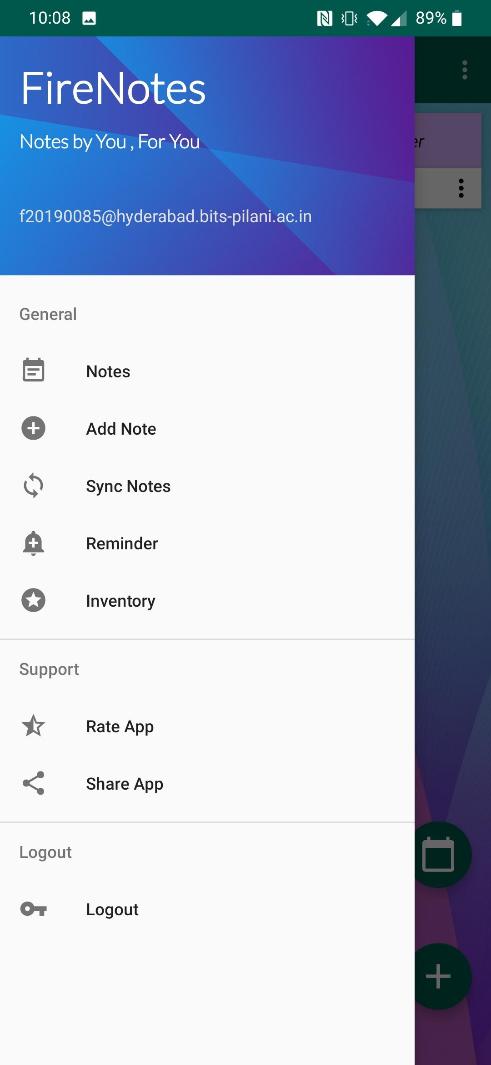

# DashBoard:

App provides predefined categories:

1.HouseHold

2.Work

3.Educational

4.Groceries

5.Stationary

6.Others

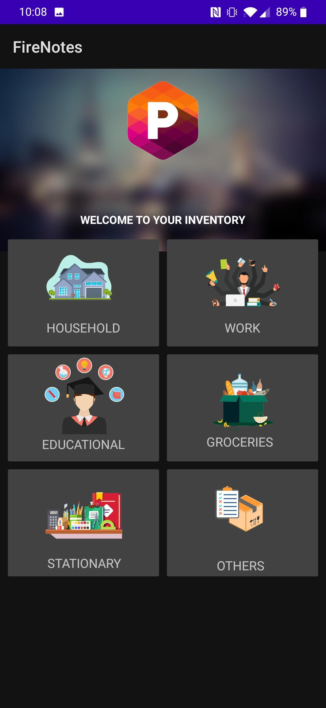 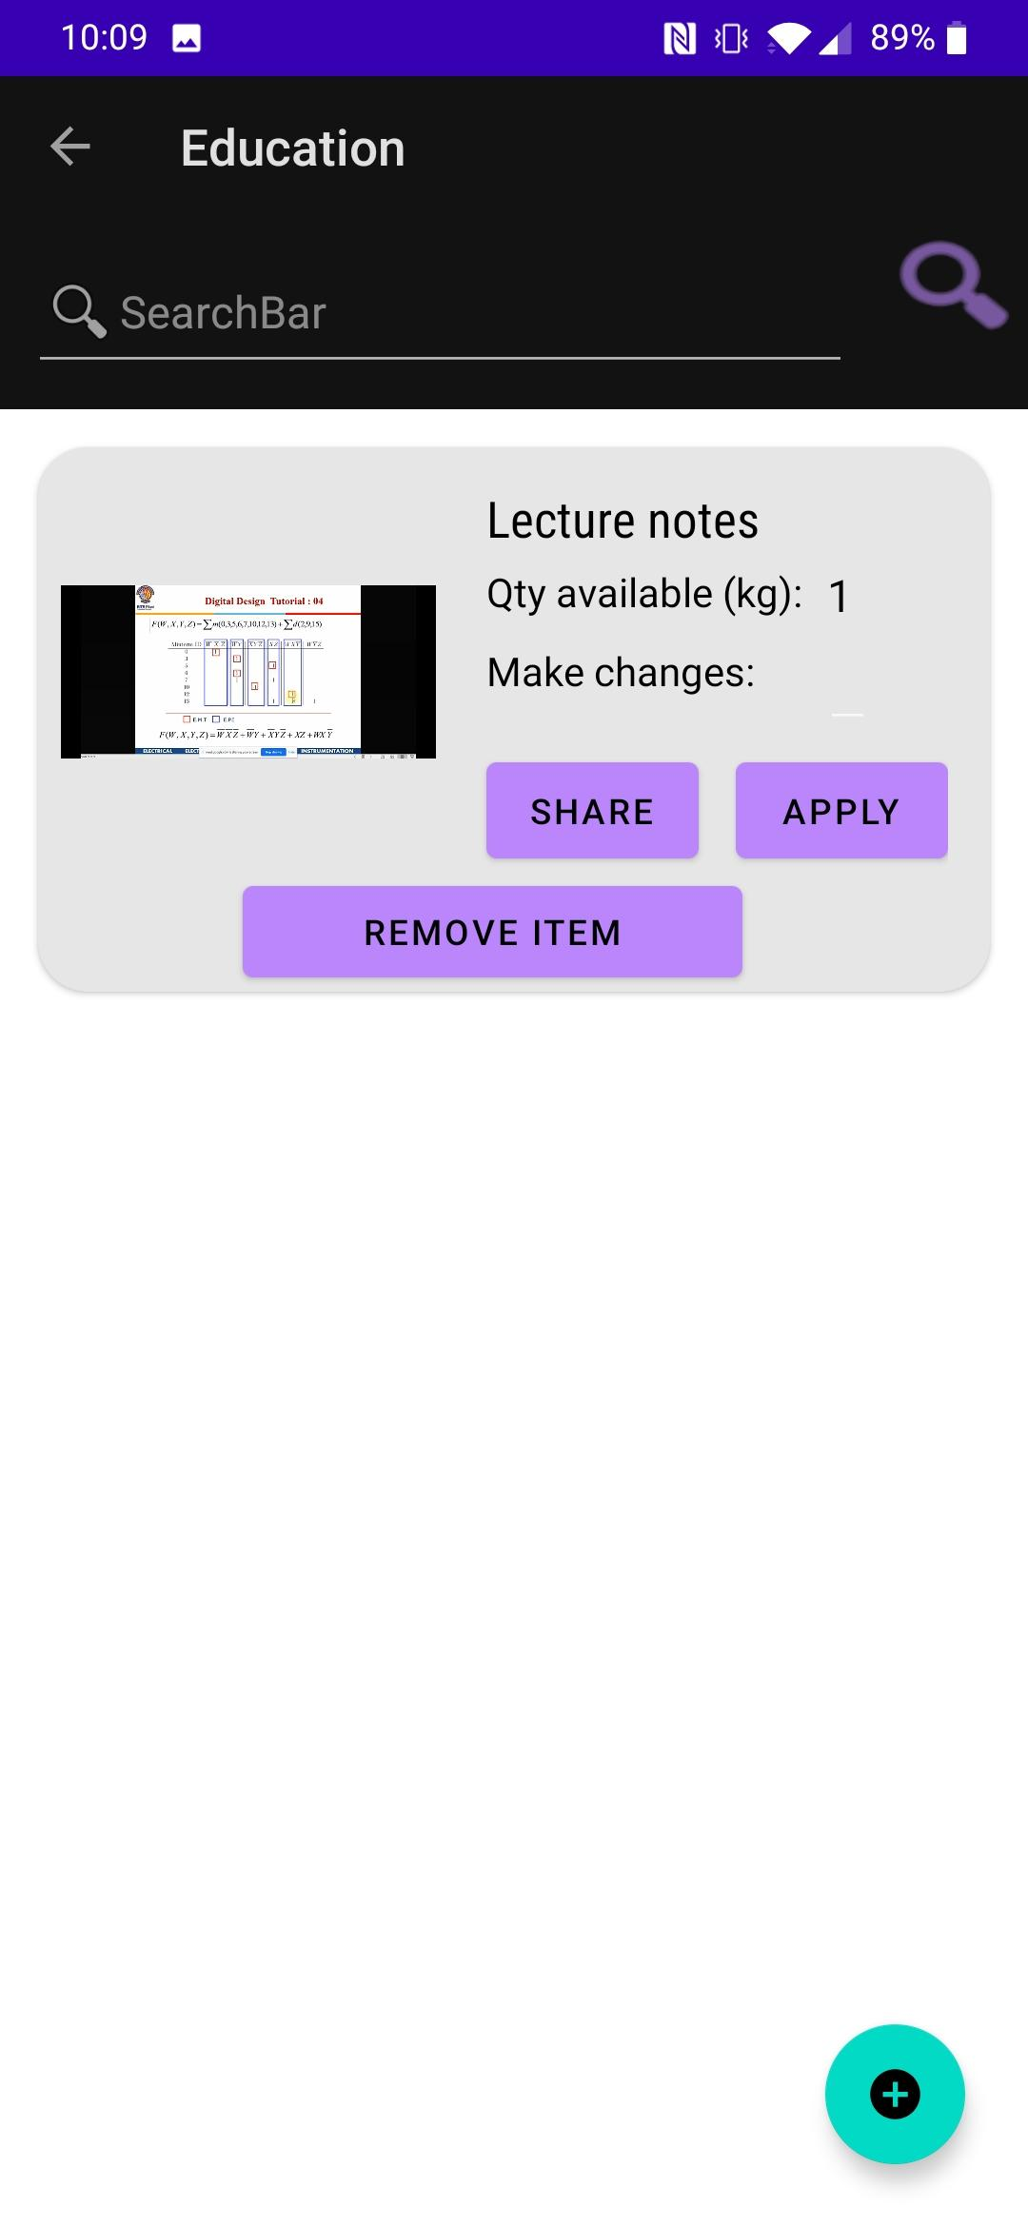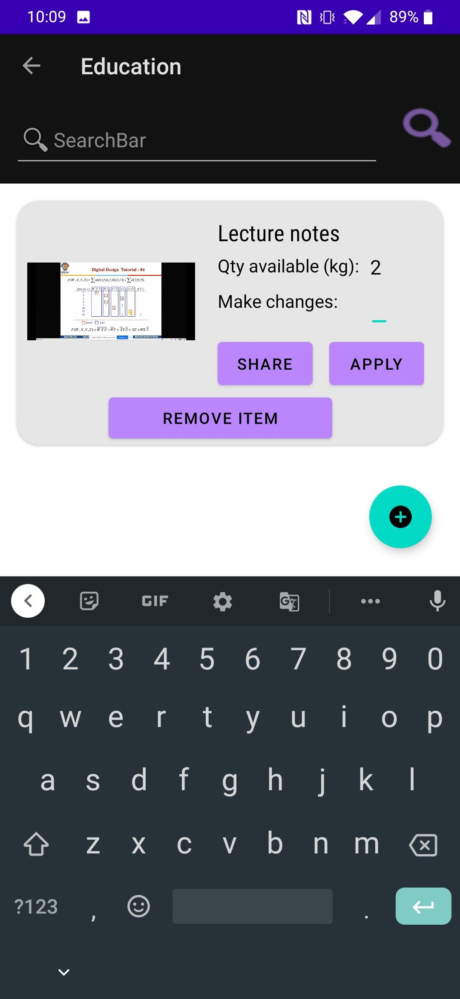 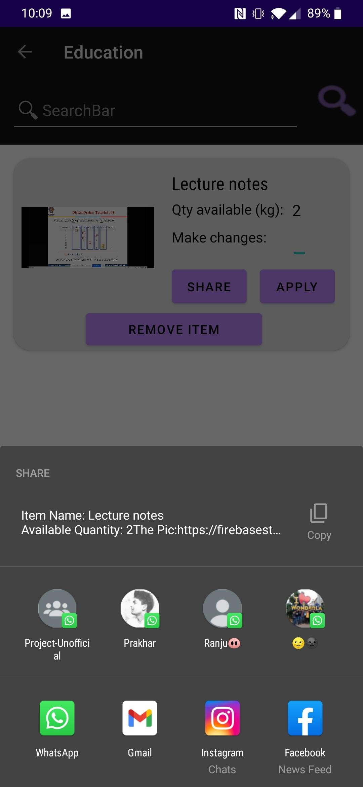

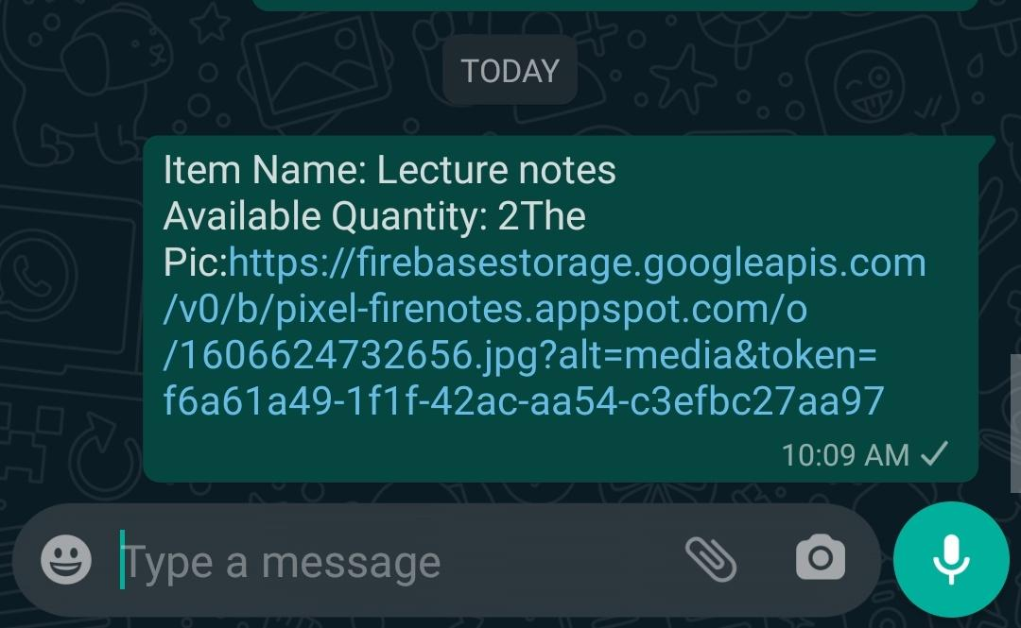

Users Data is also maintained in FireStore Database:

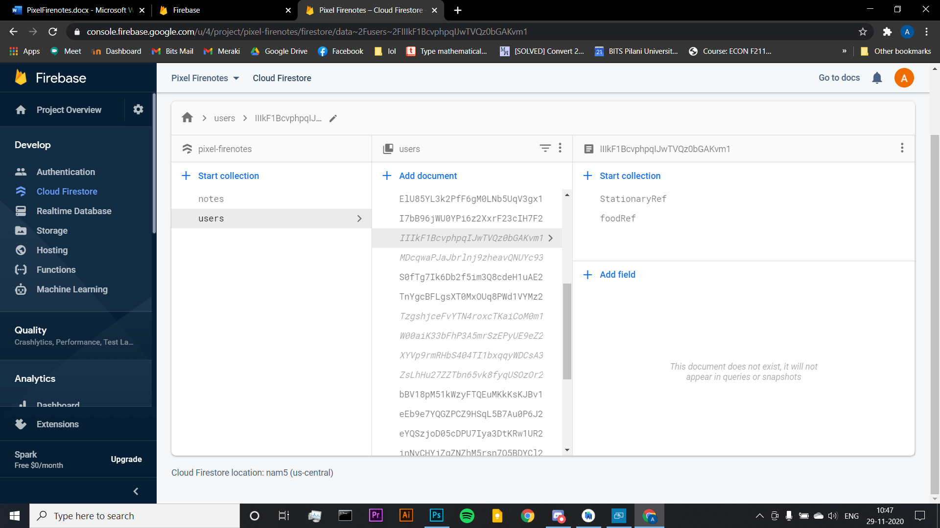

# Inventory:

The user can keep track of their items in the inventory by adding the quantities, images and even sharing it. It can update the current Number of items thus Making it a tracker

 

# Trigger:

The user can schedule reminders for important tasks at a desired time.

They will be notified with a push notification even if the app is closed.

For Reminder user have the option to Set Date, Time, Repetition Interval and Type of Repetition.

 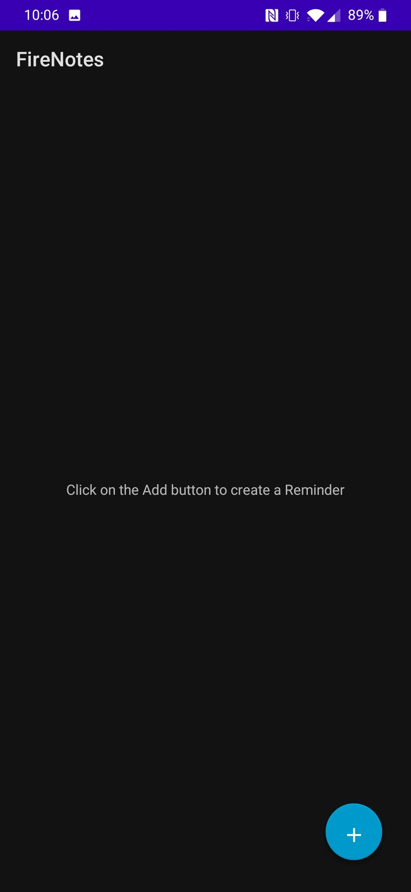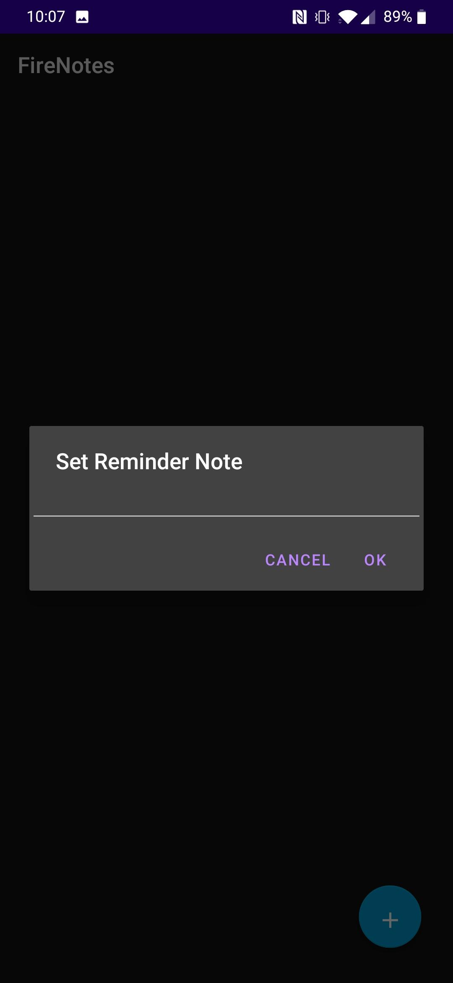 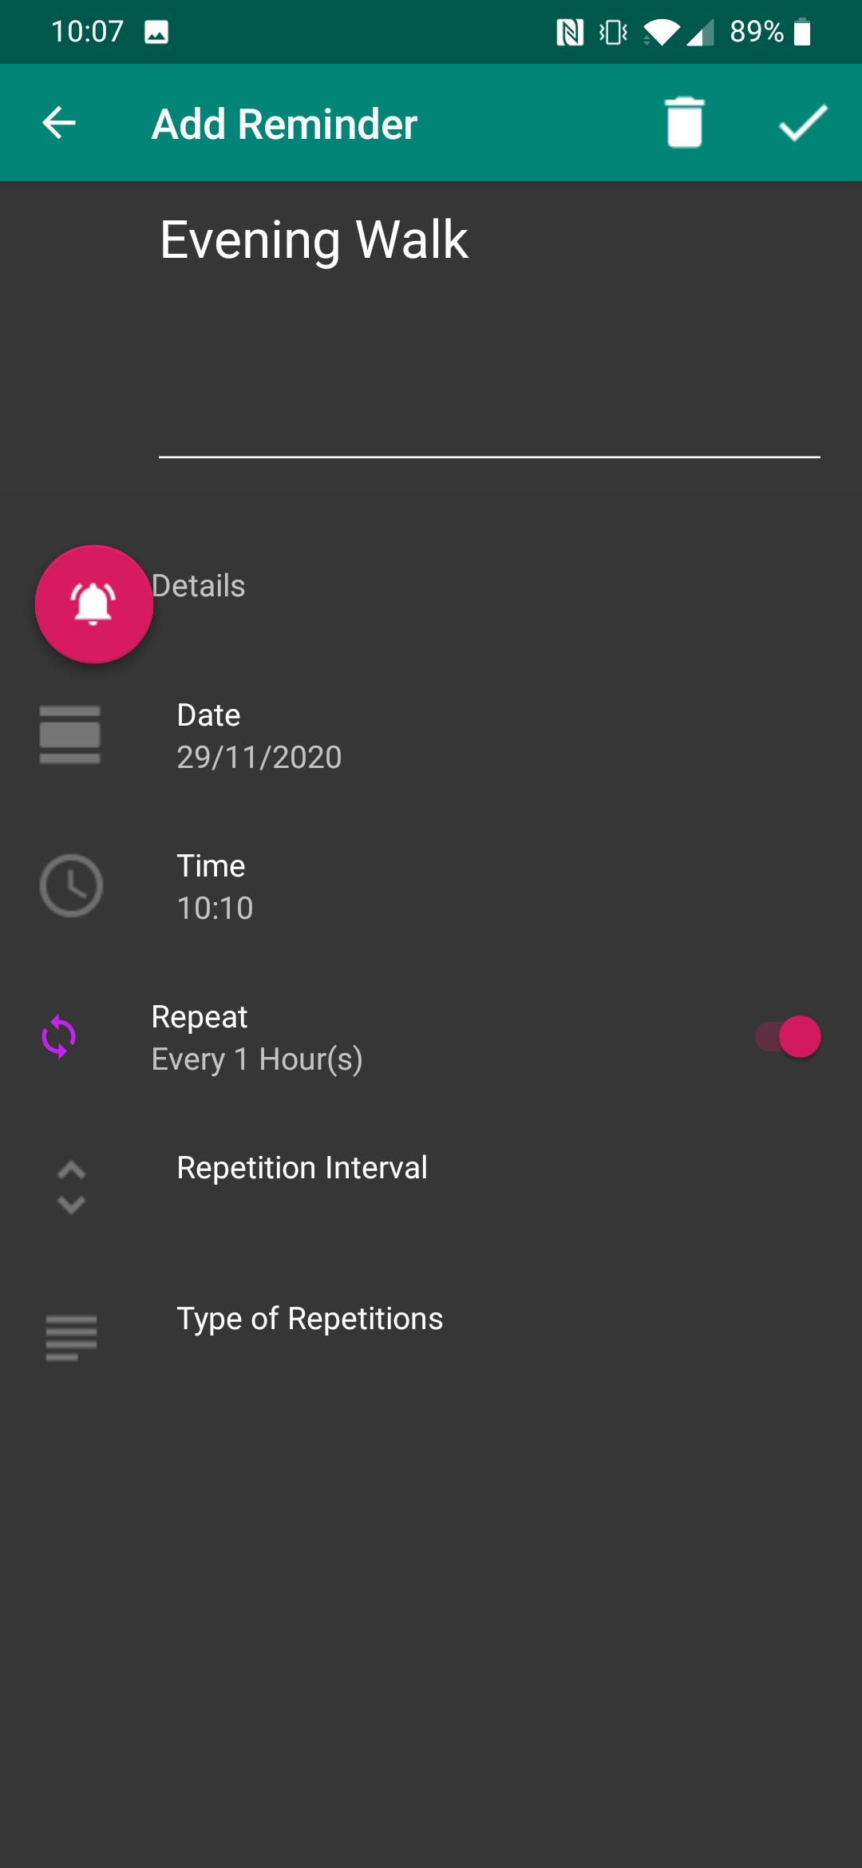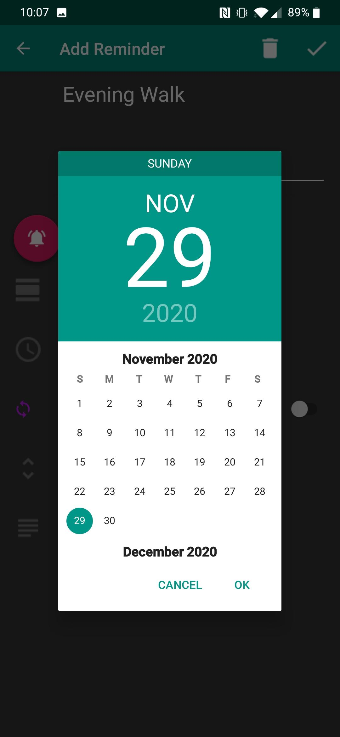 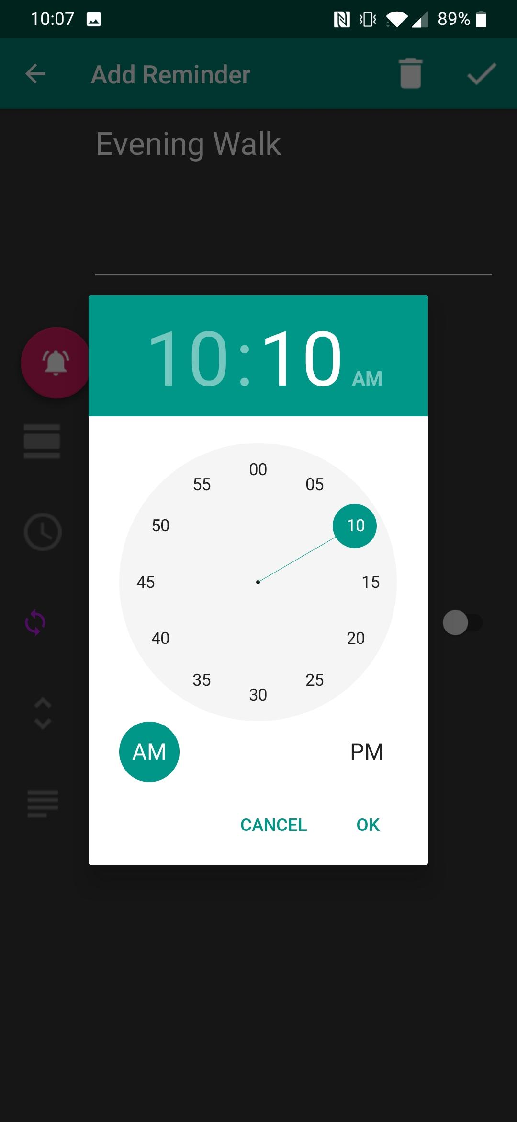

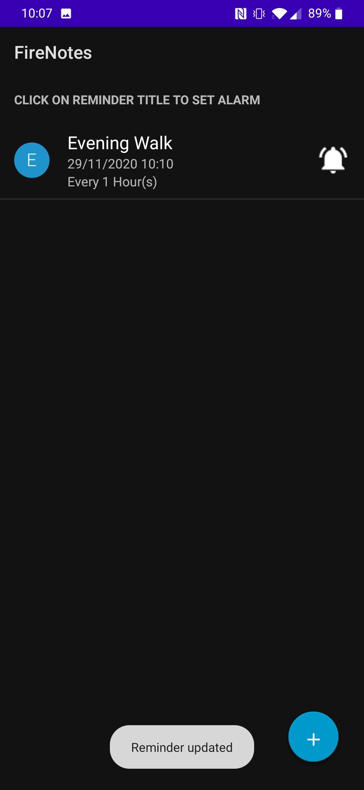

# Rating the App:

The feedback can be given by the user in Rate App Section

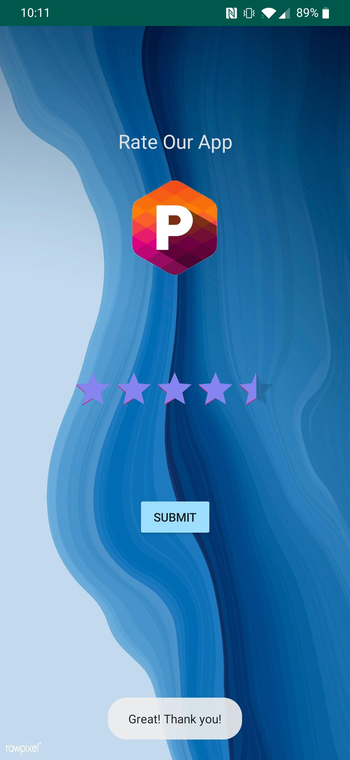

# Extra Features:

Add Calendar Event-





