DESIGN AND VERIFICATION OF A
4-BIT UNIVERSAL SHIFT REGISTER
Transistor-Level Design Using Tanner S-Edit and T-Spice

Abstract
This project documents a 4-bit universal shift-register design developed with hierarchical transistor-level logic in Tanner S-Edit and intended for transient analysis in T-Spice. The intended modes are hold, shift right, shift left, and parallel load. Four 4-to-1 multiplexers select the next data value for four storage elements. This report describes the architecture, subcircuits, expected behavior, and verification process, with reserved spaces for schematic and waveform screenshots. Actual simulation success is not claimed here; the results section should be completed using the user's own simulation evidence.

1. Introduction
A shift register is a sequential digital circuit that stores binary data and moves it between bit positions. A universal shift register combines parallel loading with left and right shifting and a hold mode. This project uses modular SPICE subcircuits so that logic blocks can be designed and tested individually before integration.

2. Objectives
- Design a 4-bit register with outputs Q3, Q2, Q1, and Q0.
- Use one 4-to-1 MUX per bit to select the next-state input.
- Build reusable inverter, logic-gate, MUX, and storage subcircuits.
- Use T-Spice transient analysis to inspect responses to data, clock, and select inputs.
- Document the design with schematic and transient-simulation figures.

3. Architecture and Signal Mapping
The top-level netlist contains four 4-to-1 MUXes and four storage-element instances. Each MUX output feeds the associated storage element's data input. The register outputs are fed back into the MUX network to implement hold and shifting. The posted netlist connects logic zero to the two serial-entry positions, so the current design uses zero-fill shifting rather than externally selectable serial inputs.
Bit | MUX inputs (I0, I1, I2, I3) | Intended role
Q3 | Q3, 0, Q2, D3 | Hold, right shift, left shift, parallel load
Q2 | Q2, Q3, Q1, D2 | Hold, right shift, left shift, parallel load
Q1 | Q1, Q2, Q0, D1 | Hold, right shift, left shift, parallel load
Q0 | Q0, Q1, 0, D0 | Hold, right shift, left shift, parallel load

Assuming the 4:1 MUX uses S0 to select within each pair and S1 to select between pair outputs, the intended mode table is:
S1 | S0 | Operation
0 | 0 | Hold
0 | 1 | Shift right (zero-fill)
1 | 0 | Shift left (zero-fill)
1 | 1 | Parallel load

[ FIGURE 1 — TOP-LEVEL SHIFTER SCHEMATIC ]
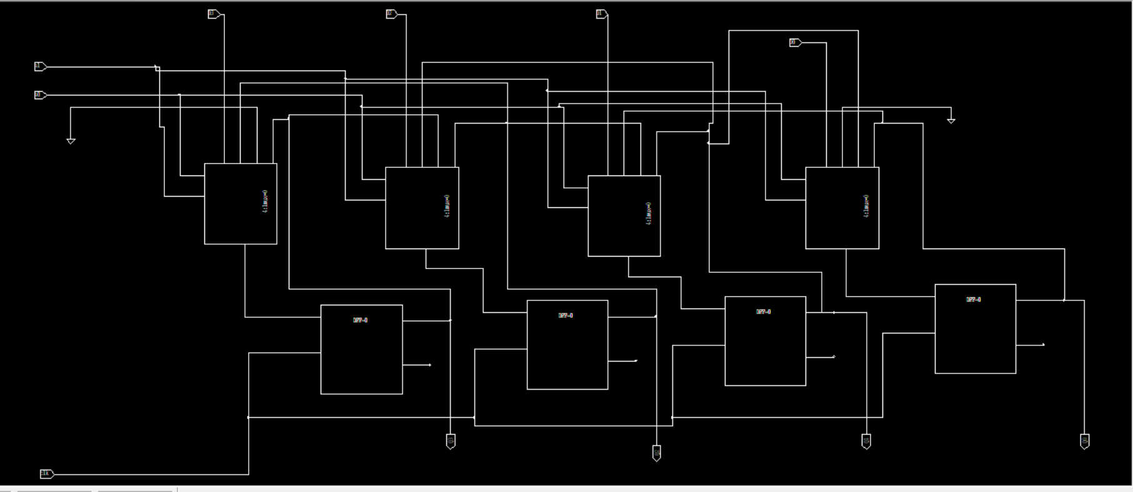
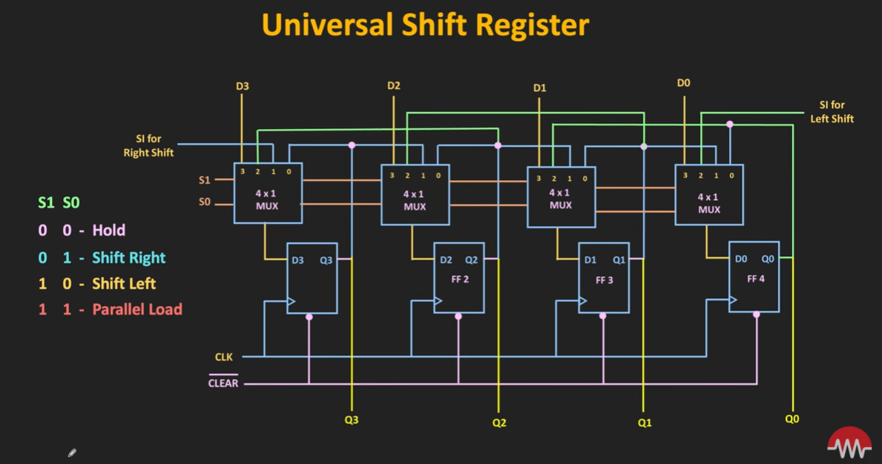
Without the CLEAR signal

TRANSIENT RESPONSE
Select lines:
00 -> 11 -> 10 -> 01 -> 00
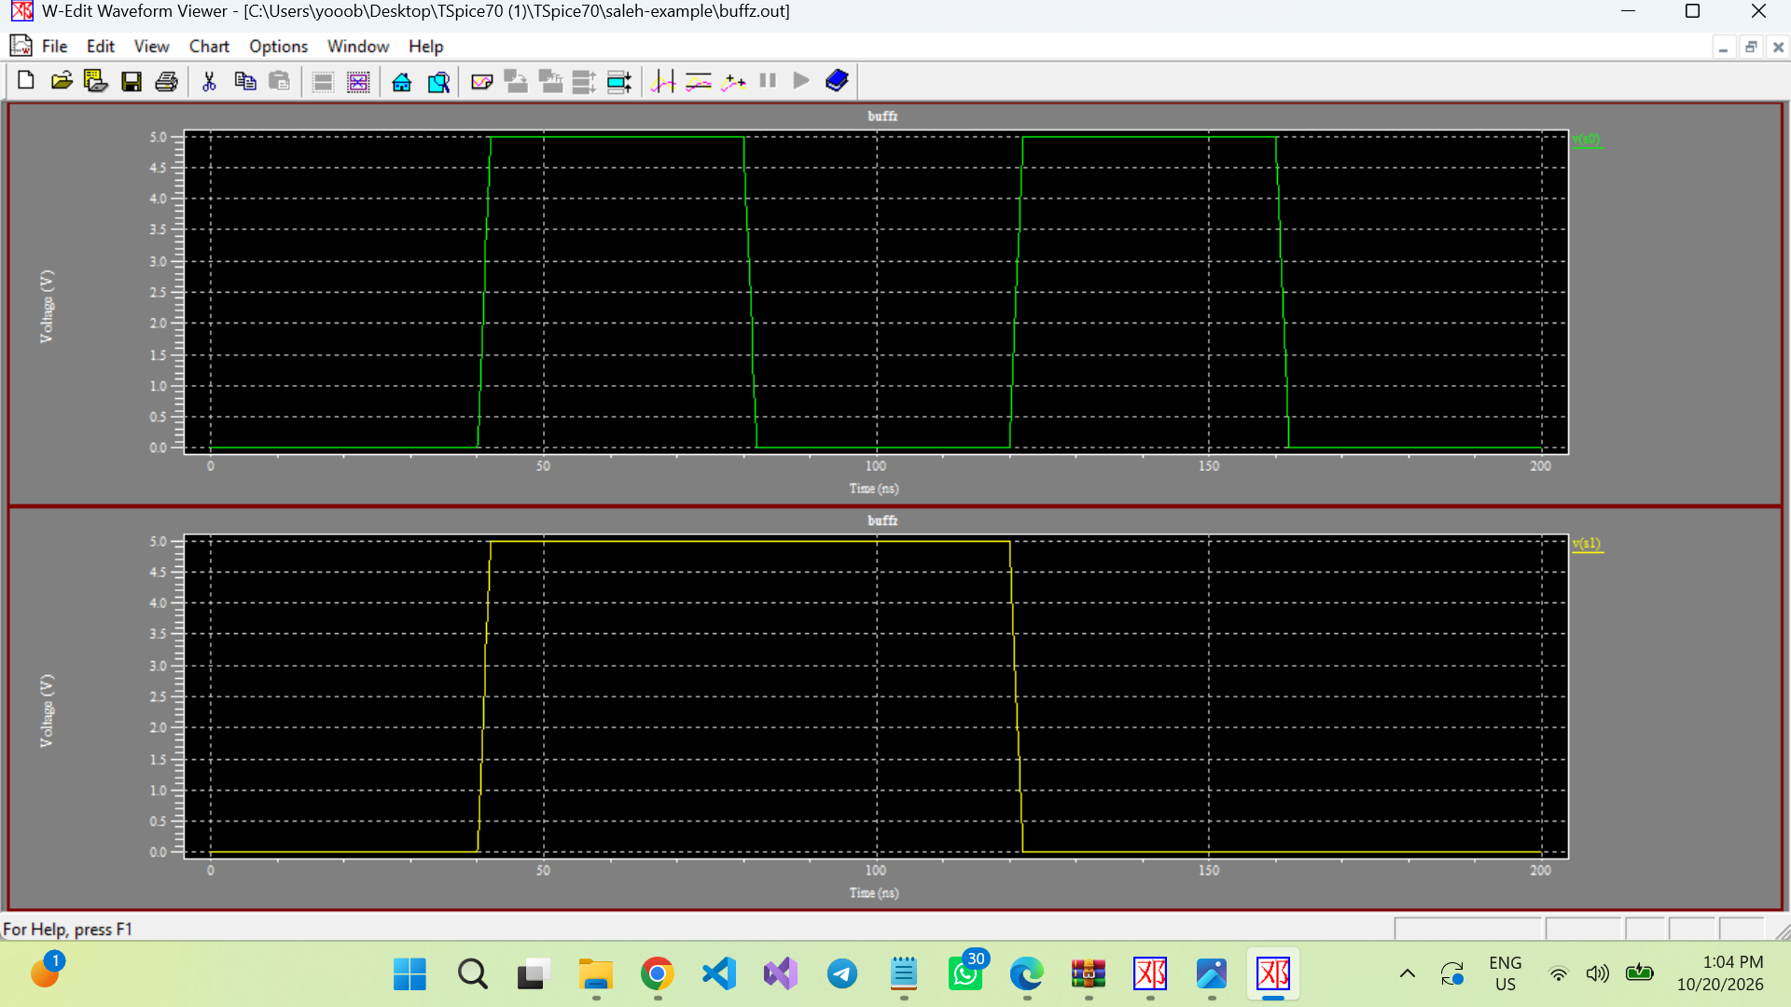

Input: 0000 -> 1101 -> 0110 -> 1001
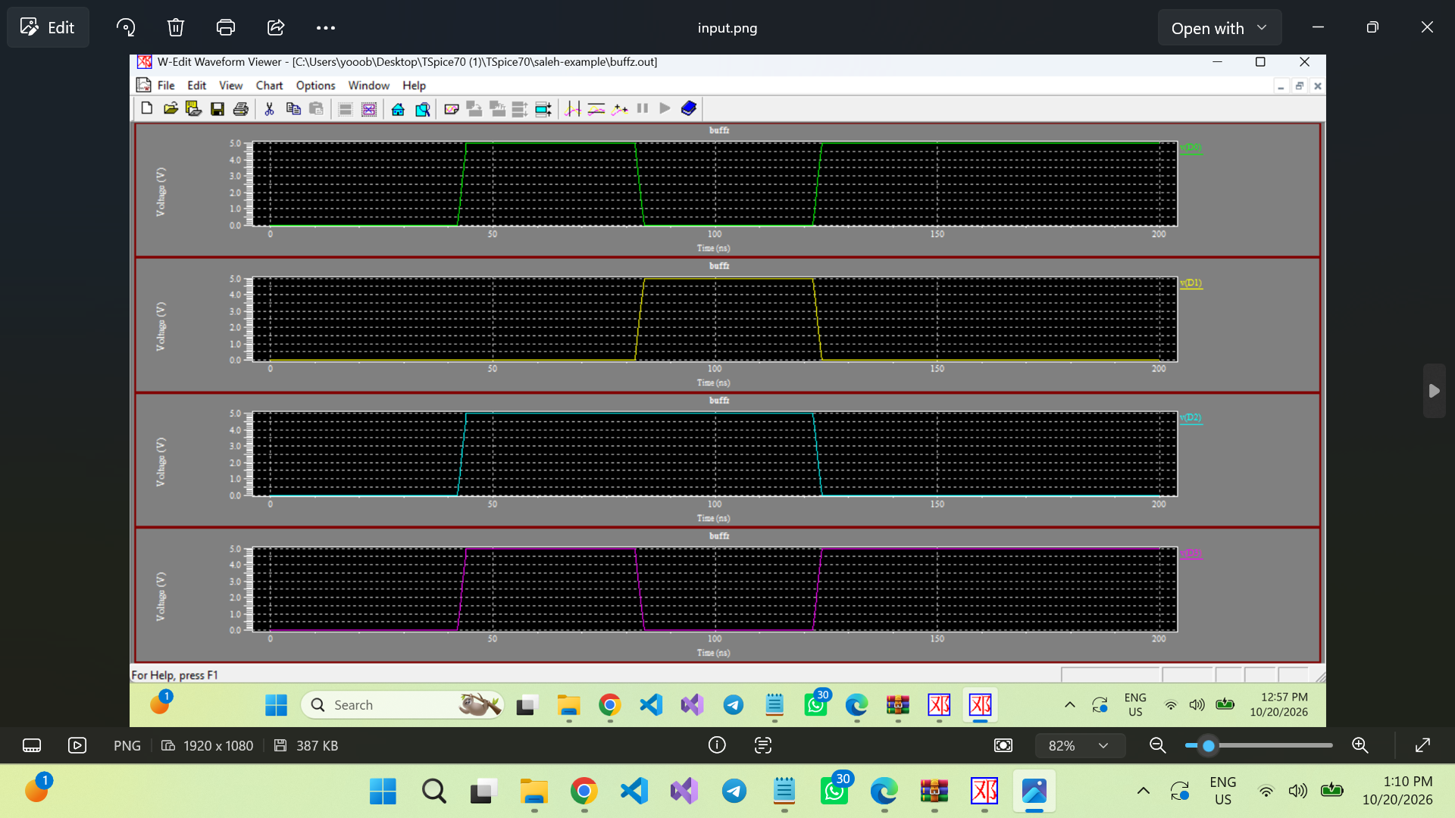

Output:
0000 then load the input = 1101 then shift left = 1010
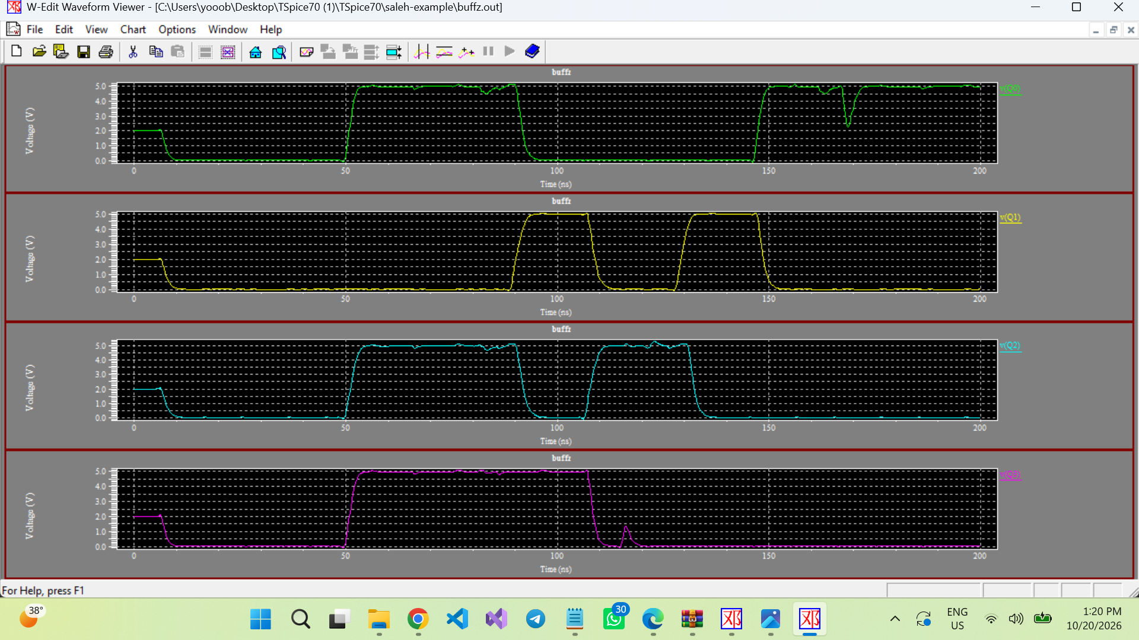

4. Logic Blocks

4.1 CMOS inverter
contains a PMOS and an NMOS transistor. Their gates share the input, while their drain connections form the output. The PMOS pulls the output toward VDD when the input is low; the NMOS pulls it toward ground when the input is high.
[ FIGURE 2 — INVERTER SCHEMATIC ]
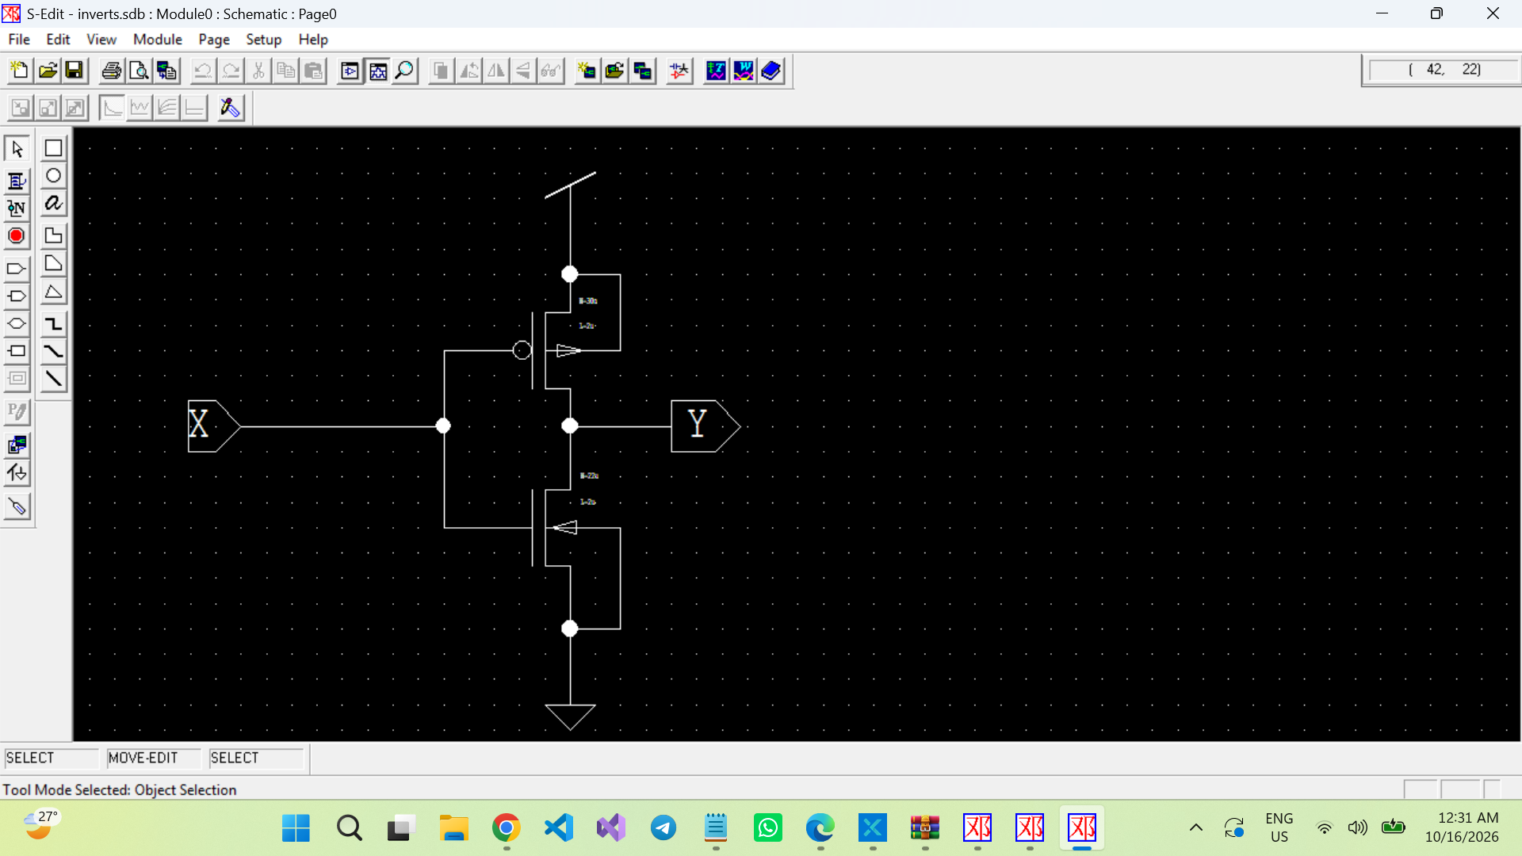

[ FIGURE 3 — INVERTER TRANSIENT RESPONSE ]
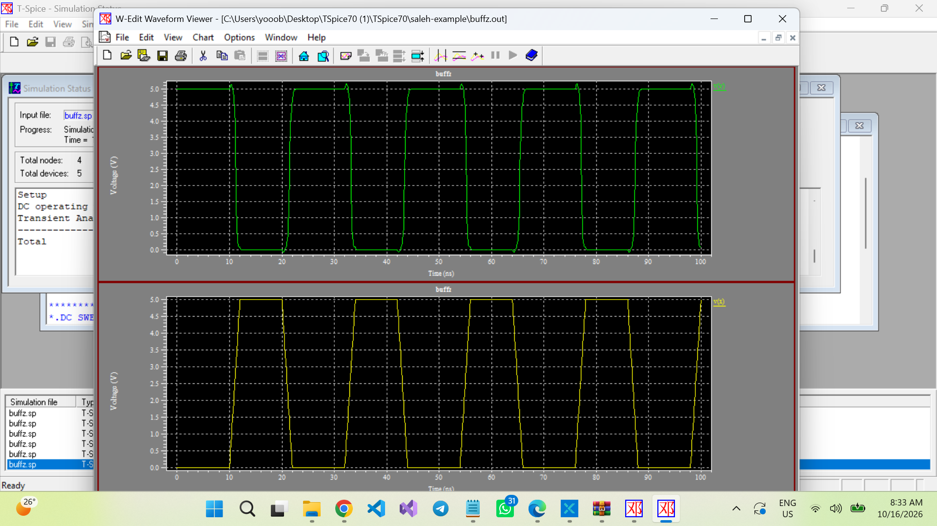

4.2 AND and OR gates
The and1 and or1 subcircuits implement two-input logic functions used by the MUX. Verify each gate with all four combinations of its inputs and compare the output to its truth table.
[ FIGURE 4 — AND GATE SCHEMATIC AND TRANSIENT RESULT ]
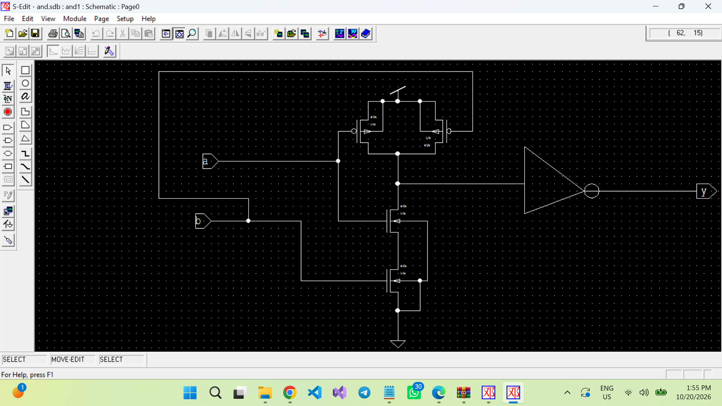

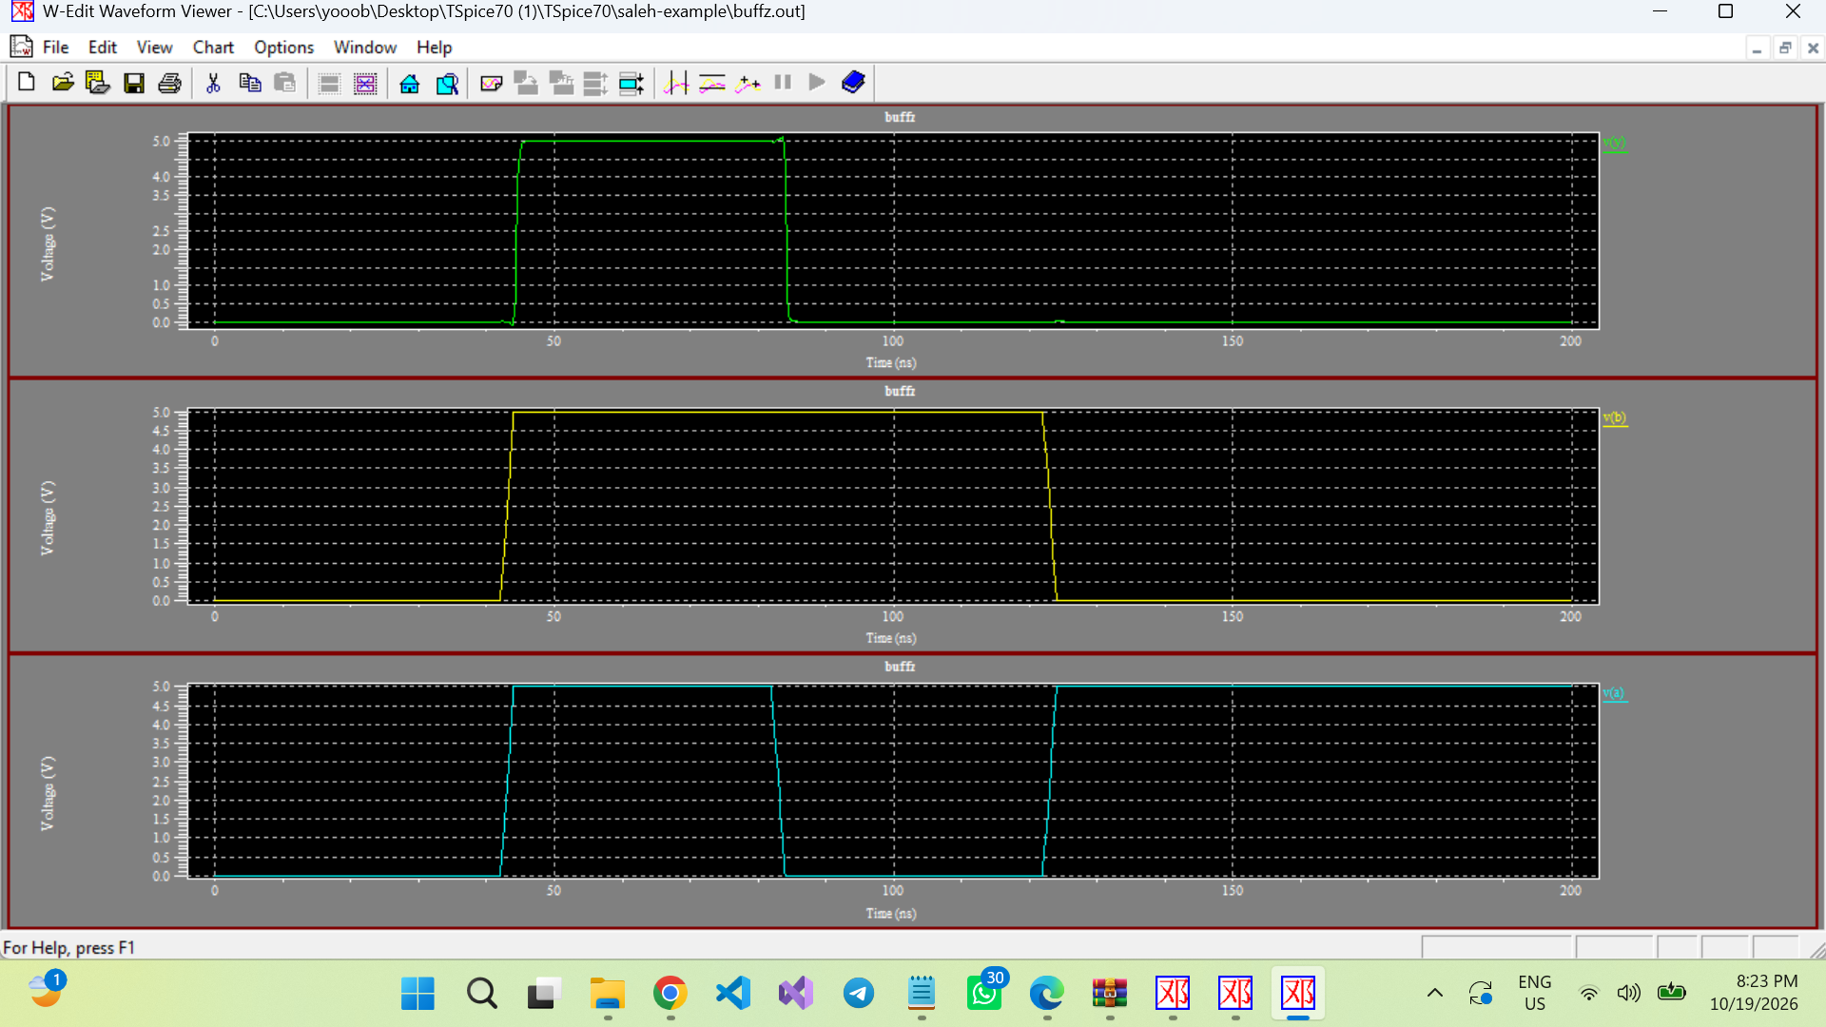

[ FIGURE 5 — OR GATE SCHEMATIC AND TRANSIENT RESULT ]
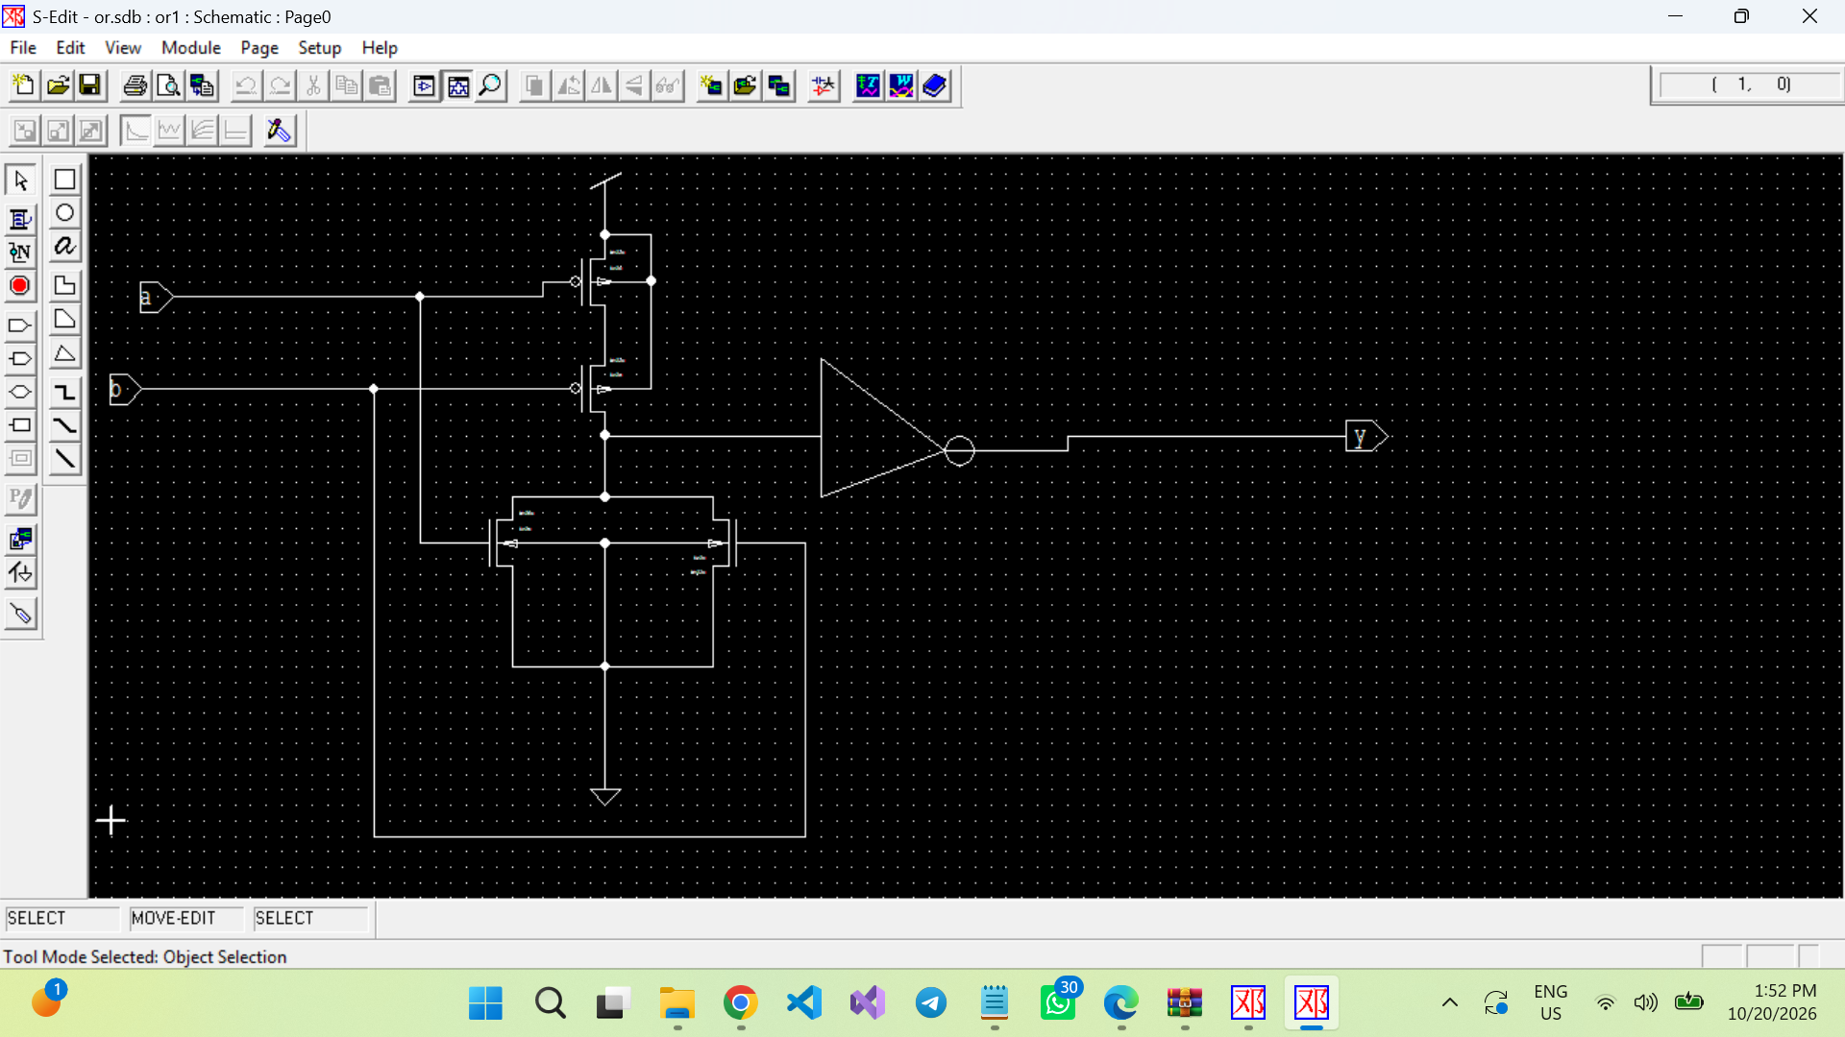

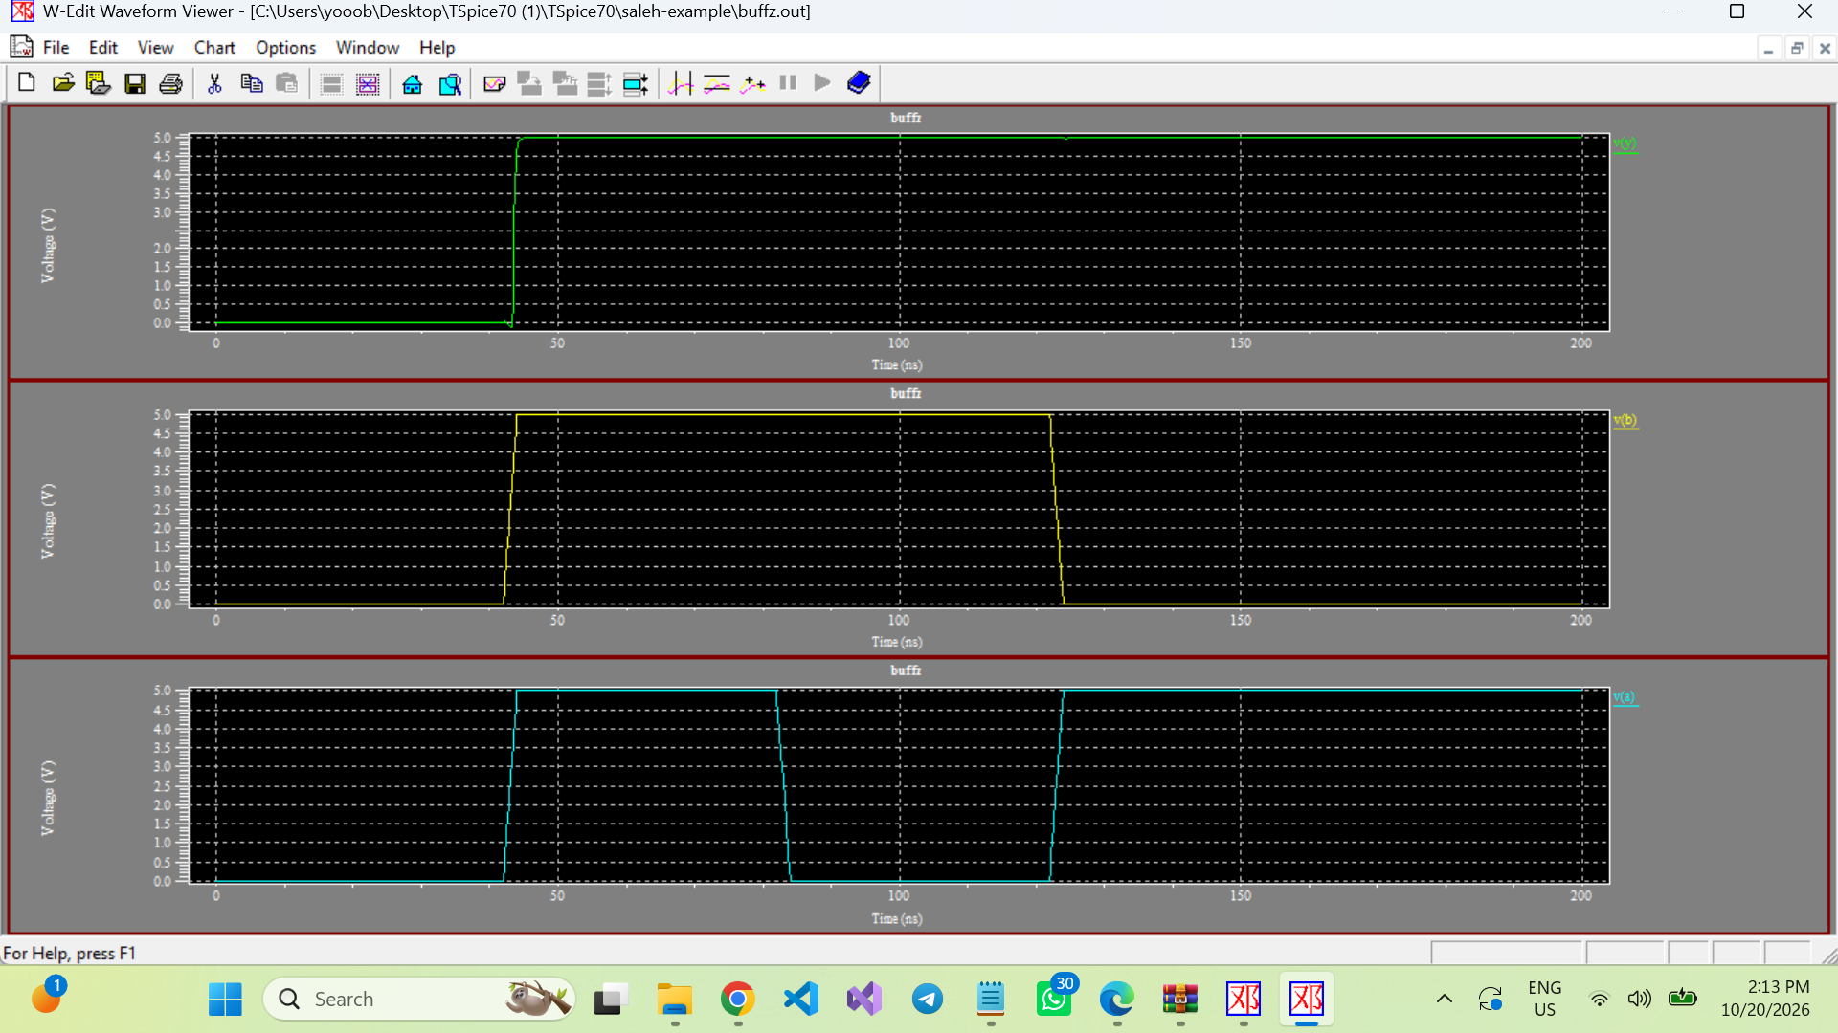

4.3 2:1 and 4:1 multiplexers
The 2:1 MUX implements Y = (NOT S0 AND I0) OR (S0 AND I1). Three 2:1 MUXes form one 4:1 MUX. The select signals choose one of four candidate data inputs.
[ FIGURE 6 — 2:1 MUX SCHEMATIC AND TRANSIENT SIMULATION ]
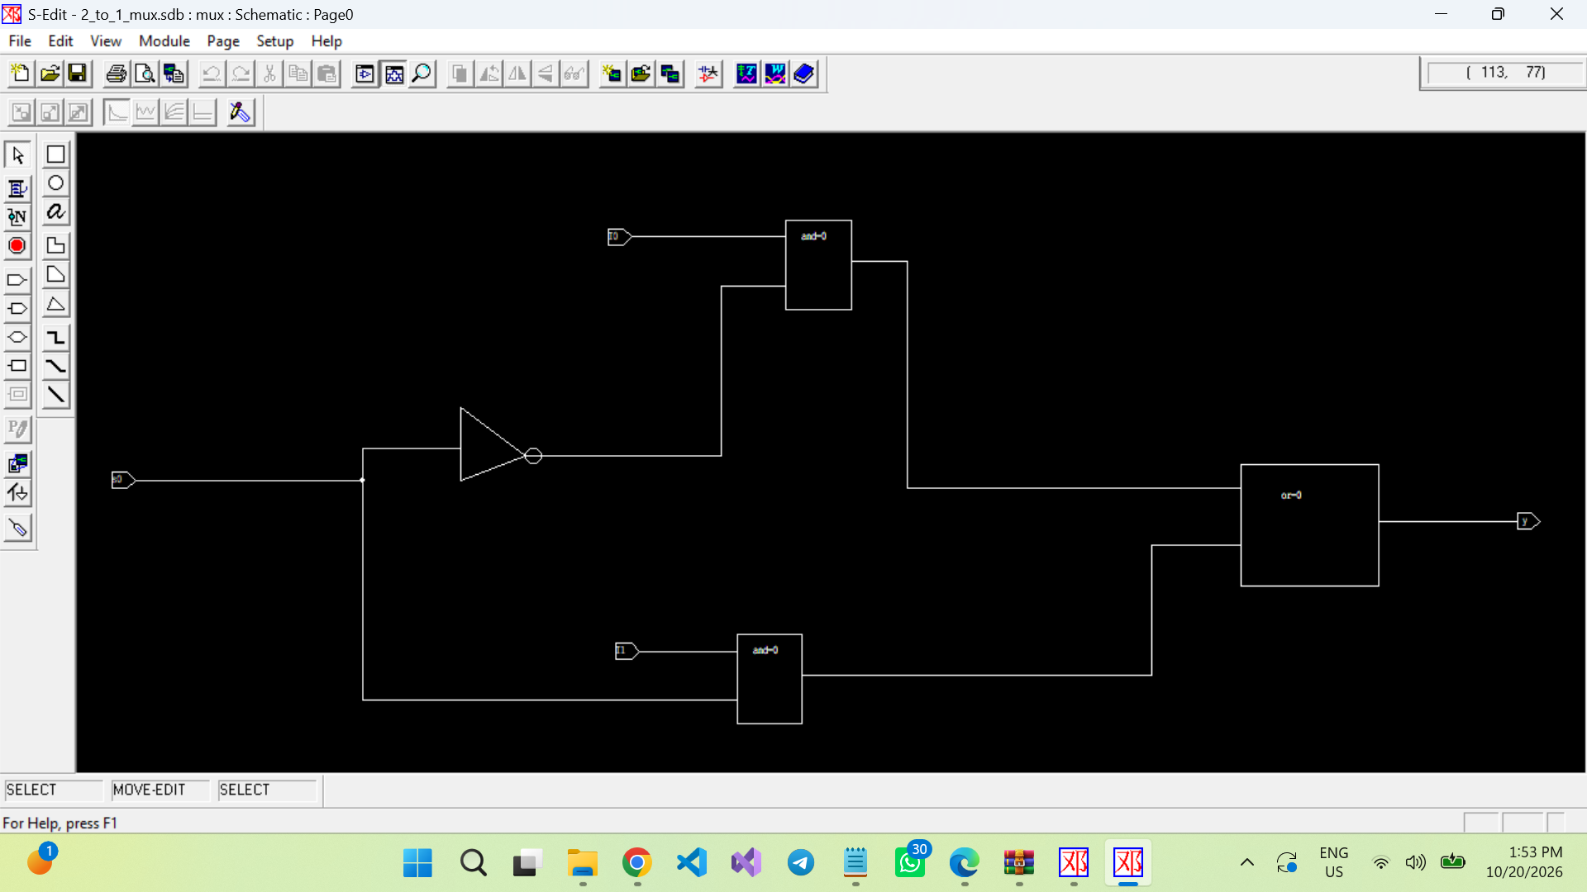

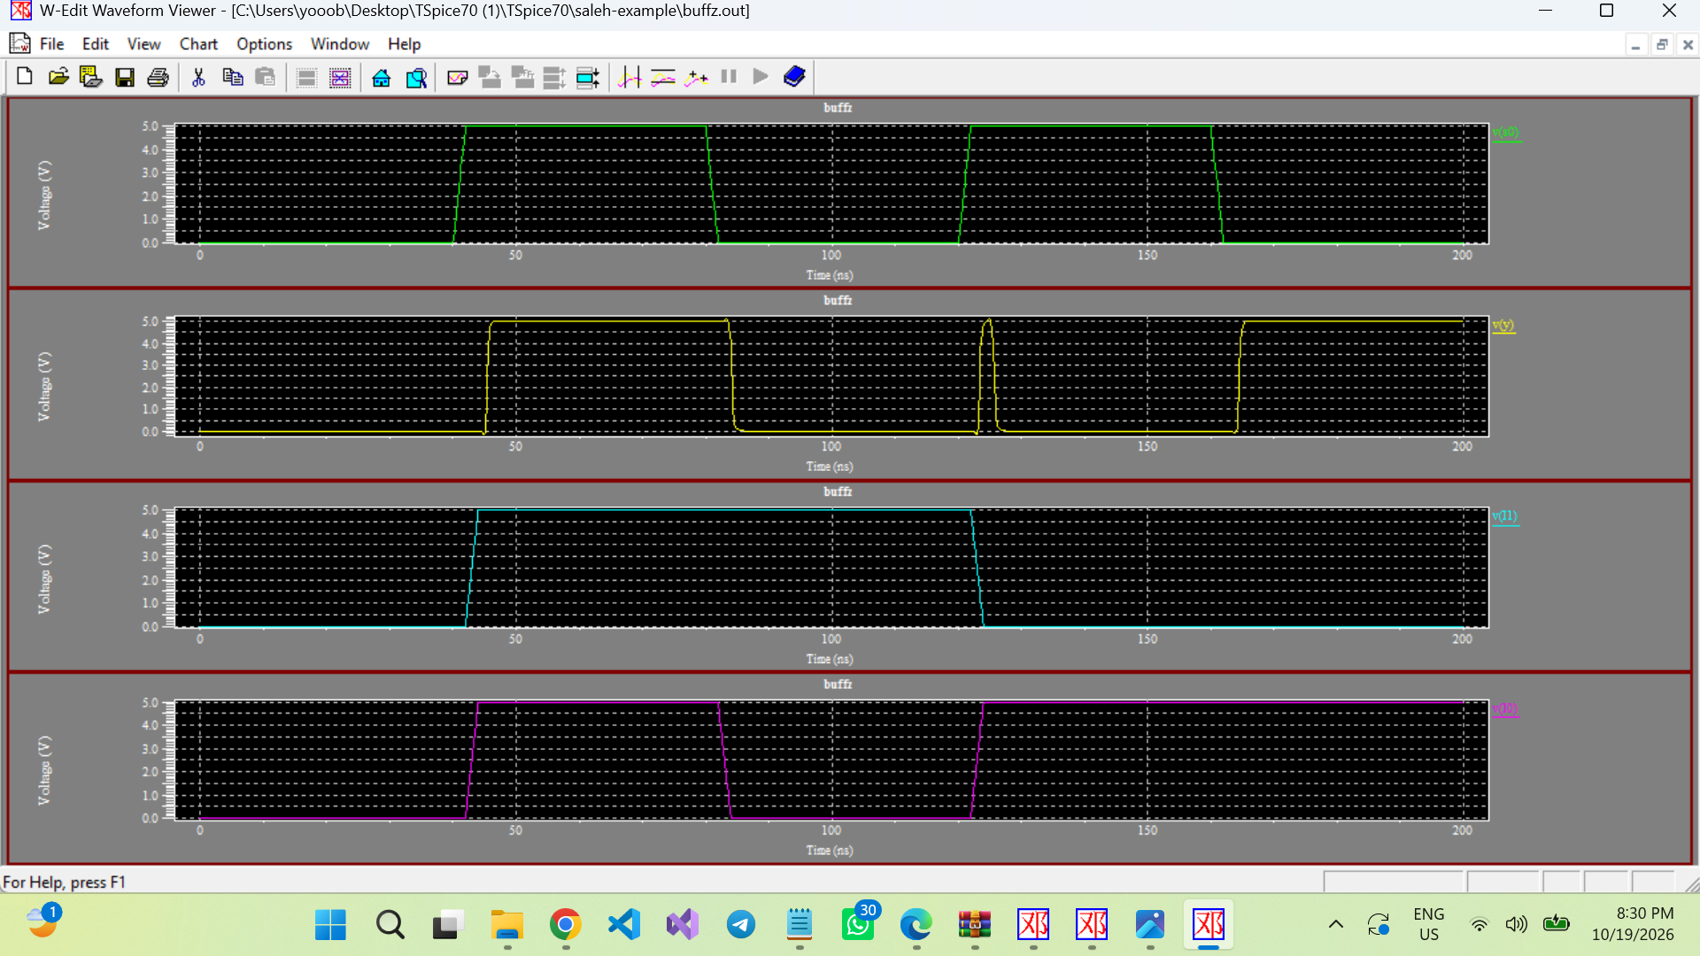
[ FIGURE 7 — 4:1 MUX SCHEMATIC]
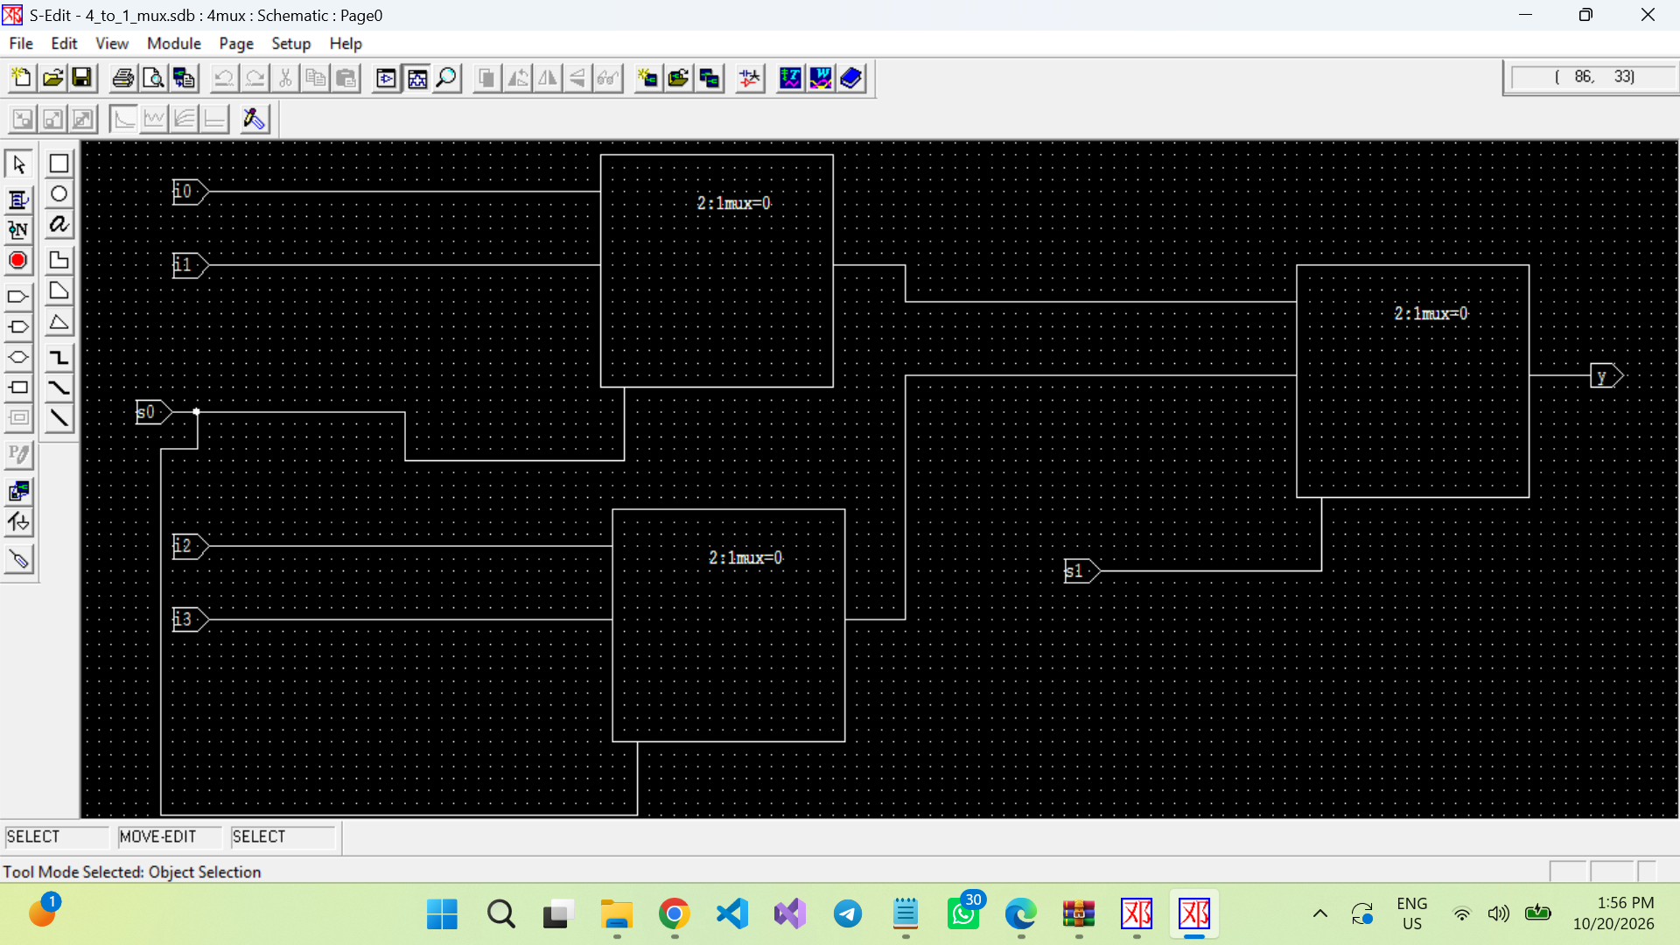

4.4 Storage element
The posted DFF_mod uses an inverter and NAND-based feedback. From the connections provided, it appears to implement a level-sensitive D latch rather than a confirmed edge-triggered D flip-flop. This distinction matters: while a latch is transparent, data can pass through as the clock level is active, potentially causing race-through in a multi-bit shifting circuit. Verify or replace this block if the required register must update only on a clock edge.
[ FIGURE 8 — STORAGE ELEMENT SCHEMATIC ]
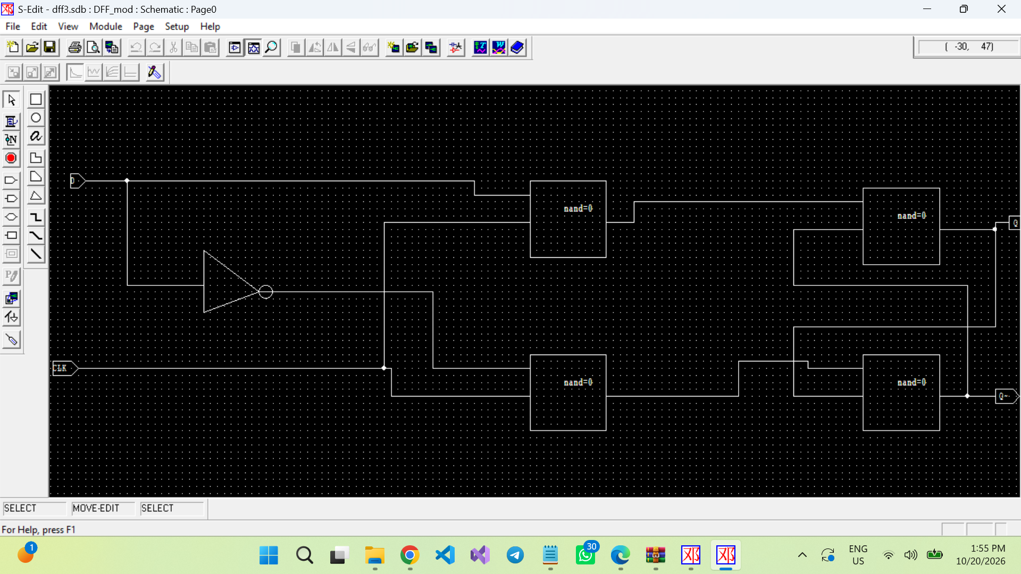

[ FIGURE 9 — STORAGE ELEMENT TRANSIENT SIMULATION ]
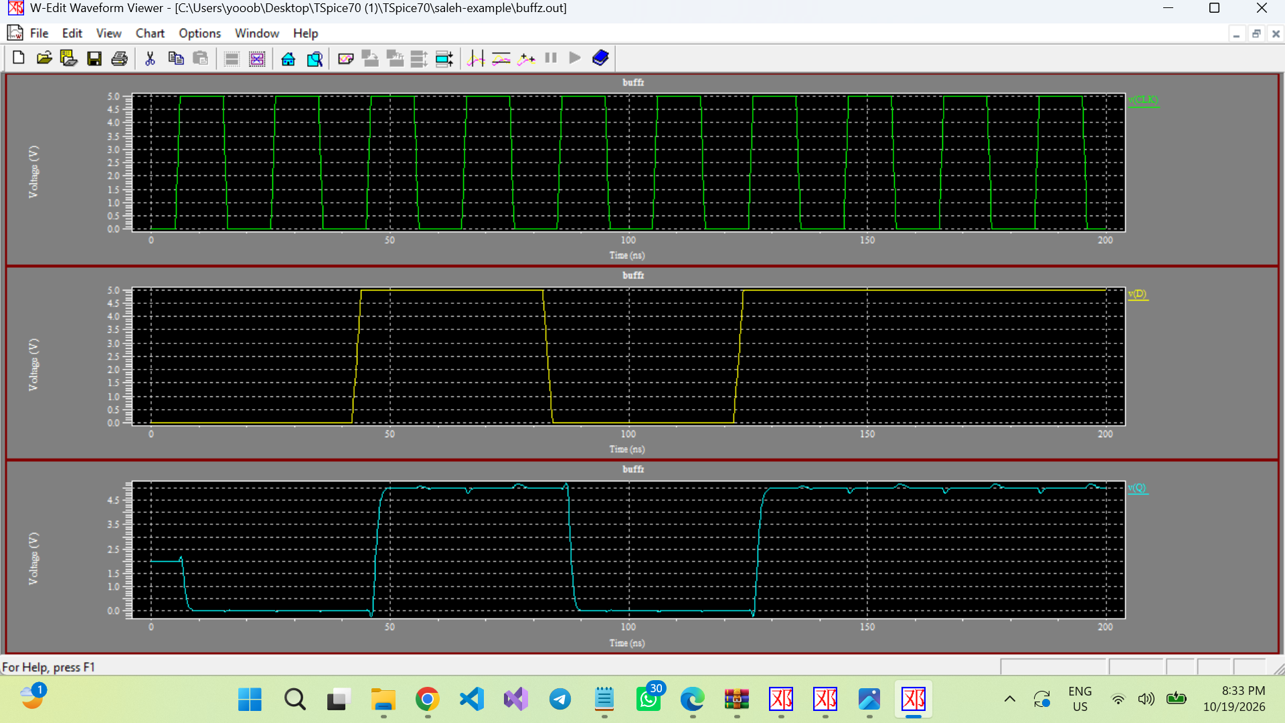

5. Expected Functional Behavior
Assuming the MUX pin order and select mapping described above, the intended next-state behavior is:
S1 S0 | Mode | Expected next state
00 | Hold | Q(next) = Q(current)
01 | Shift right | Q3 gets 0; Q2 gets old Q3; Q1 gets old Q2; Q0 gets old Q1
10 | Shift left | Q3 gets old Q2; Q2 gets old Q1; Q1 gets old Q0; Q0 gets 0
11 | Parallel load | Q(next) = D3 D2 D1 D0

Example: starting from Q = 1010, a zero-fill right shift should produce 0101, and a zero-fill left shift should produce 0100. Parallel load should copy D3–D0 to Q3–Q0 after the storage element responds. Hold should preserve the current state.

9. Conclusion
The design organizes a 4-bit register around four 4-to-1 MUXes and four storage elements, with feedback paths supporting hold and shifting and parallel inputs supporting load mode. Hierarchical subcircuits make the circuit modular and suitable for staged testing. Final functional claims should be based on the actual T-Spice waveforms. Particular attention should be given to the storage element because the supplied DFF_mod connections appear level-sensitive rather than edge-triggered.

