RAYMOND JOSEPH P. GALUPE WD-202

Github link: https://github.com/iBOTx07/School-Works.git

firstexpress.js

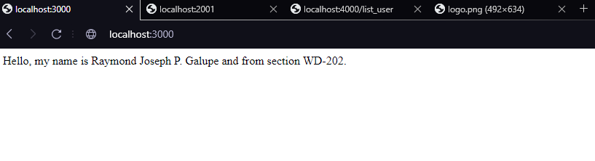

secondexpress.js

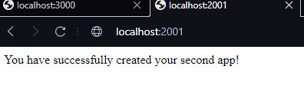

server.js

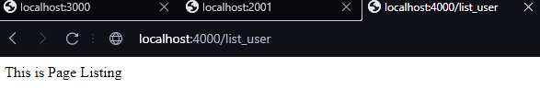

server.js -ROUNTING

