AWS PT Final Project
Prepared by: Ido Boker
Email: Ido.boker@walla.co.il
Date: 08/02/2026

Abstract:
In an era where digital transformation is reshaping industries and businesses, the secure management of cloud resources is of paramount importance. This document presents the culmination of our efforts during the AWS Cloud Security course at ITSafe College. Our final project delves into the intricacies of securing AWS cloud infrastructure, showcasing our understanding of fundamental security concepts, best practices, and hands-on implementation within the Amazon Web Services (AWS) ecosystem.

Acknowledgments:
We extend our gratitude to our instructors at ITSafe College for their guidance and support throughout this course. Their expertise has been invaluable in shaping our understanding of cloud security.

Note:
This document is a culmination of our in-depth exploration of AWS cloud security. The following pages will provide a comprehensive overview of our project, including the objectives, methodologies, and outcomes. Our primary aim is to demonstrate our ability to design and implement a secure AWS environment while adhering to industry best practices.
The project was carried out on the website Cloud Goat & flAWS.cloud

table of content
Introduction 3
Scope 3
AWS Cloud Infrastructure 3
Conclusions 3
Scenarios 4
1. SNS_SECRETS - EASY 6
Description and Execution Demonstration 6
2. iam_privesc_by_rollback - EASY 10
Description and Execution Demonstration 10
3. ec2_ssrf - MEDIUM 13
Execution Demonstration 13
4. iam_privesc_by_attachment - MEDIUM 17
Execution Demonstration 17
5. vulnerable_cognito - MEDIUM 24
Execution Demonstration 24
6. secrets_in_the_cloud 30
Execution Demonstration 30
7. rce_web_app 37
Execution Demonstration 37

Cloud Goat

Introduction
The penetration testing of Cloud Goat and flAWS.cloud has been extended to include an assessment of its AWS Cloud infrastructure. To improve data protection and general security, this thorough test tries to find and fix any weaknesses in the AWS environment. ITSafe understands how crucial it is to protect its cloud infrastructure from any assaults.
The AWS Cloud infrastructure underwent a grey box security assessment with the goal of assessing its resistance to different threats and bolstering data protection mechanisms.

Scope

AWS Cloud Infrastructure
The scope of penetration testing encompasses the entire AWS Cloud infrastructure of Cloud Goat and flAWS.cloud, with limited prior knowledge of the specific AWS services and configurations in use. The assessment includes but is not limited to:
- Assessing the AWS environment for vulnerabilities related to injection attacks, including both client and server-side vulnerabilities.
- Evaluating adherence to AWS best practices in areas such as Identity and Access Management (IAM), network security, and resource configurations.
- Inspecting how sensitive data is managed within the AWS environment, including storage, encryption, and access controls.
- Assessing the risk of unauthorized information disclosure within the AWS infrastructure.
- Conducting tests against advanced cloud-specific attacks, such as privilege escalation, data exfiltration, and cloud misconfigurations.
- Evaluating the effectiveness of AWS Identity and Access Management policies and roles in ensuring proper authorization and access control.
This penetration test aims to provide information that may be used to strengthen security protocols in the cloud environment. The results will aid in the company's defense against potential attacks and weaknesses in its AWS infrastructure.

Conclusions
2 – Easy
3 – Moderate
2 - Hard

Scenarios
No. | Test Type | Risk Level | General Explanation
1 | sns_secrets | Easy | Starting as the IAM user, the attacker explores the services SNS and API-Gateway. From the service SNS an API-Gateway Key was acquired, and by API-Gateway permissions enumeration of that service was possible, leading to data dump of the content in the API-Gateway. That content includes sensitive information and the flag for the challenge.
2 | Iam_privesc_by_  rollback | Easy | Starting as the IAM user, permissions to enumerate the policy were available, leading to finding older version of the policy which include high administrative permissions. As the permission “SetDefaultPolicyVersion” was enabled, the supplied IAM user was able to revert the policy back to an older version, leading to administrative access on the cloud.
3 | ec2_ssrf | Moderate | In this scenario, I was provided with low-privileged user which is allowed to list the lambda functions. The lambda function contained credentials that allowed me to escalate privileges to another user. That user had access to an EC2 instance with SSRF vulnerability, this allowed me to gain the credentials for user with S3 bucket permissions. The S3 bucket contained another user credentials with granted me access to Invoke the lambda function and complete the challenge.
4 | Iam_privesc_by_  attachment | Moderate | In this scenario, the provided user had sufficient privileges to execute powerful commands, for example attaching/detaching roles from InstancesProfiles, creating a new key-pair, and enumerating information about the VPC and instances. With this information I was able to create a new EC2 instance, provide the relevant VPC information and attach a “mighty” role, allowing me to execute administrative actions on the cloud.
5 | vulnerable_cognito | Moderate | In this scenario, I was provided with an API-Gateway URL. The application allowed to login/signup and required to use “@evilcorp.com” email to signup but validated this only on the client side. The SourceCode of the application contained a lot of information that allowed me to signup via AWS CLI and bypass the restrictions on the client-side. After gaining access to the webpage, I grabbed the JWT from the Local Storage and used the CLI to change the attribute of my user “custom:access” from “reader” to “admin”. After gaining admin access on the webpage, a response packet contained admin credentials which allowed me to access via AWS CLI.
6 | secrets_in_the_cloud | hard | In this scenario, I was provided with a user, after enumerating the S3 buckets I’ve gained a URL which requested an API KEY that was found after listing the “Lambda” functions. This supplied me with a Token that was used to access “HashiCorp” on port 8200, gaining “id_rsa” private key. Using this key, I was able to connect via SSH to the instance and enumerate information via the “meta-data”. After enumeration I’ve accessed “DynamoDB” and gained credentials for admin user which could access “secretsmanager” service and get the “secret_passcode”.
7 | rce_web_app | hard | In this scenario I was provided with user “McDuck” which could list the S3 bucket service, gaining OpenSSH private key. Then, I’ve listed the EC2 instances and connected “ubuntu” instance via SSH using the private key. After downloading AWS CLI and accessing the S3 buckets from the instance, I acquired credentials for DB on postgres. Connecting to the database I retrieved the “VICTORY” flag.

SNS_SECRETS - EASY

Description and Execution Demonstration
In the following challenge, I was granted a low-privileged user for the AWS service.
Preforming User Enumeration, I had access to list and subscribe to SNS topics on the machine, and by subscribing to a certain topic, I’ve gained an API Gateway Key.
After receiving the key I’ve enumerated the “apigateway” service, enumerating the following information: get-rest-apis, get-resources, and get-stages.
This information allows me to access the API Gateway, but the access is forbidden.
By using the acquired API KEY, I’ve managed to access the API GATEWAY via the “intended way” meaning I’ve accessed the API using a legitimate KEY and the API Gateway dumped the information it held, including sensitive information.

By dumping the content of the API I’ve acquired the following SENSITIVE information
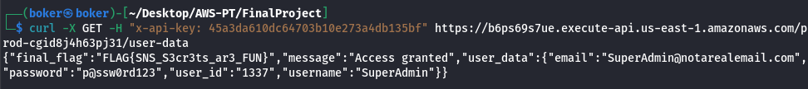

After deploying this scenario, I’ve gained access_keys to low-privileged user.
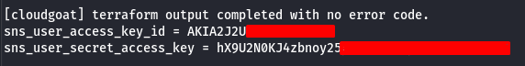
Using the tool “Pacu” to enumerate the permissions of the user, the following permissions are marked under “Allow”:
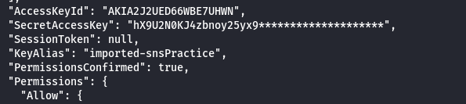
"sns:receive": {"Resources": ["*"]}, "apigateway:get": {"Resources": ["*"]},
"iam:listgroupsforuser": {"Resources": ["*"]}, "sns:listsubscriptionsbytopic": {"Resources":["*"]},
"sns:listtopics": {"Resources": ["*"]}, "sns:gettopicattributes": {"Resources": ["*"]},
"iam:listuserpolicies": {"Resources": ["*"]}, "iam:listattacheduserpolicies": {"Resources": ["*"]},
"iam:getuserpolicy": {"Resources": ["*"]}, "sns:subscribe": {"Resources": ["*"]}

Using the allowed command “list-topics” on the “sns” service, I’ve enumerated the sns on the machine:
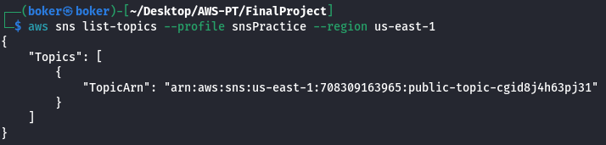

Using the module “sns__subscribe” via “Pacu”, I’ve successfully subscribed to the topic by providing the topic’s ARN and providing a temporary email for confirmation:
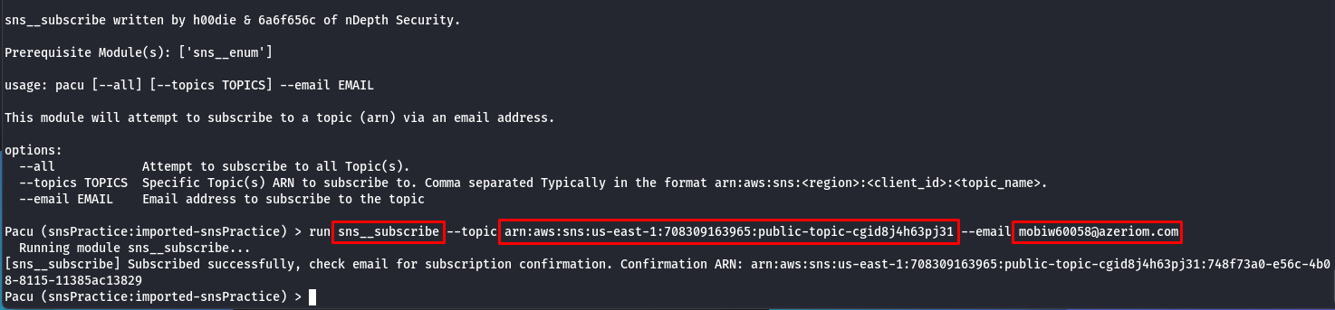

After a short while, I’ve received a notification from the service to my mail, this email contains an “API GATEWAY KEY: 45a3da610dc64703b10e273a4db135bf” for debug purposes: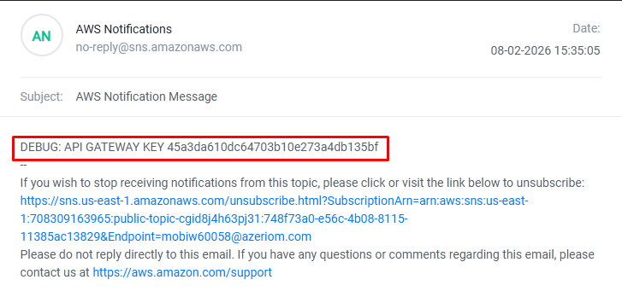

As the following permission is allowed: "apigateway:get": {"Resources": ["*"]}, I can enumerate the existing API Gateways on the machine: This gave a large amount of information about the API Gateway, for example: ID, Description, endpointConfiguration, etc…
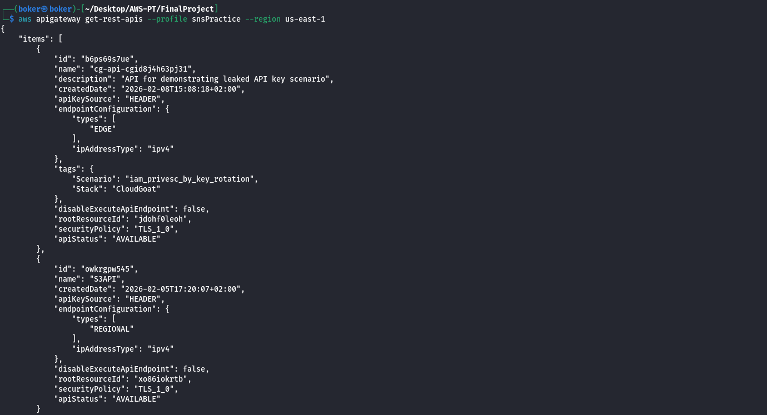

Using the information from the from the previous enumeration on the API Gateway, I now can enumerate the resources of the API Gateway:
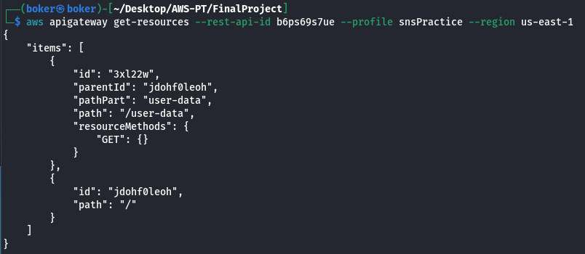

The only missing part for attacking is the stage name, using the following command to get the stage name of the API Gateway:
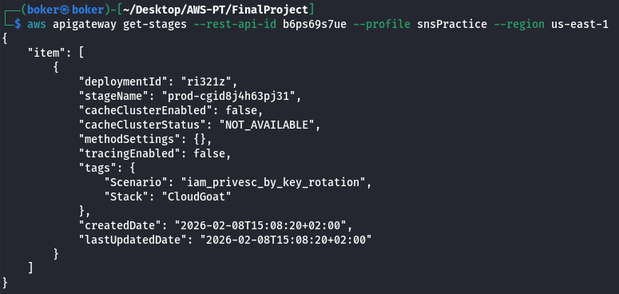

Now I’ve acquired all the relevant information to carry an attack against the API Gateway, this includes the API Key, API Gateway ID, Method, Path, and Stage. Using the following curl command I interact with the API Gateway, using the GET method that is allowed, and providing the API GATEWAY KEY I’ve received in the mail from SNS, this allows me to access the API Gateway as a legitimate user, and provide me with sensitive “user_data” information, and also the flag for completing the challenge.

iam_privesc_by_rollback - EASY

Description and Execution Demonstration
In the following scenario I was provided with a user that has the following relevant permissions: “iam:listpolicies","iam:getpolicyversion","iam:setdefaultpolicyversion".
Those permissions allows the user to list previous versions of the policy, and revert to those versions setting the selected version.
One of the versions provides fall admin access, and by reverting to it using Pacu’s “iam__privesc_scan” module, it’s possible to gain full admin access as proved by the “iam:CreateUser” permission being allowed.

After deploying this scenario, I’ve gained access_keys to low-privileged user.
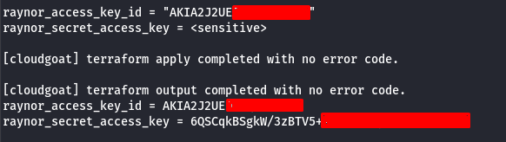

Using the tool “Pacu” to enumerate the permissions of the granted user, the user has large amount of permissions, so I’ll mention the relevant ones when I use them.
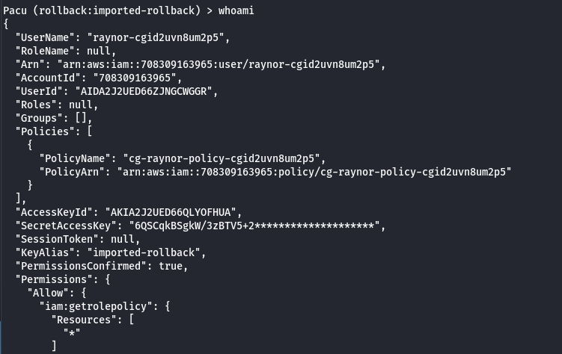
The user has access to multiple iam permissions including the following:
"iam:getrolepolicy", "iam:listpolicies", "iam:listgrouppolicies", "iam:listrolepolicies", "iam:getpolicyversion", "iam:listpoliciesgrantingserviceaccess", "iam:setdefaultpolicyversion", and more including policy related and others.
Because of the big number of permissions, I’ve ran the module “iam__privesc_scan” to enumerate what privilege escalation vectors I have on the machine.
Using this scan I’m able to also see previous policy versions due to the “iam:getpolicyversion” permission:
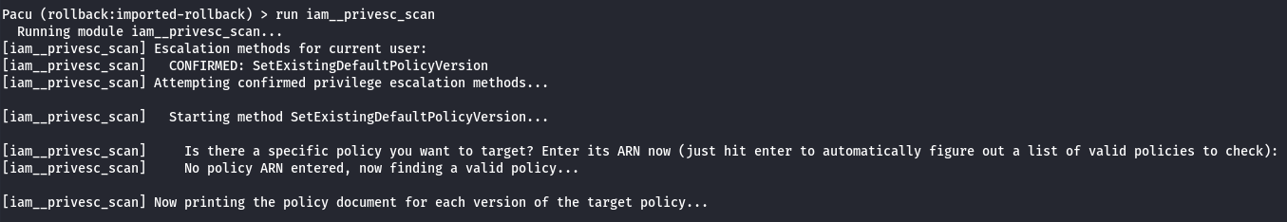

There are 5 versions of the policy, after examining them “v3” have full administrative access:
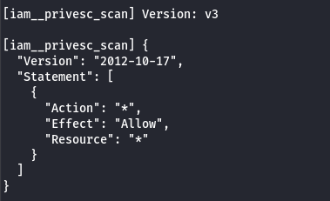

Due to the permission "iam:setdefaultpolicyversion", it’s possible to set another policy version as the default using the “iam__privesc_scan” module:
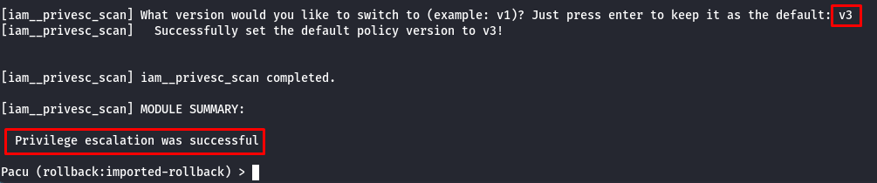

To verify I have administrative access I’ve run the following command to verify I can for example create an IAM user, which requires admin permissions. This action is allowed proving I’ve gained administrative permissions by reverting to previous version of the policy.
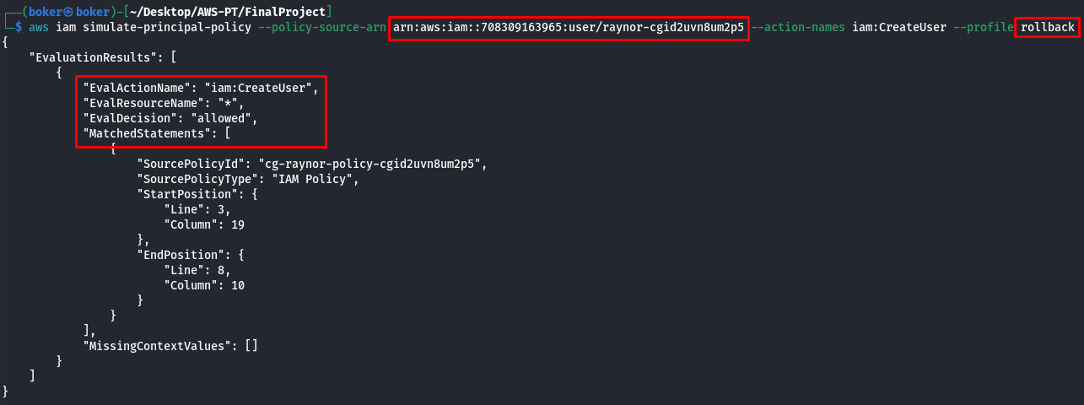

ec2_ssrf - MEDIUM

Execution Demonstration
In this scenario I was provided with a low-privileged user, the user couldn’t map the allowed permissions but using trial and error, and manual enumeration I was able to list the lambda functions on the cloud.
I couldn’t Invoke the function, but the function included access_keys labeled “EC2_ACCESS_KEYS”, using those keys I was able to access another user which could list the EC2 instances. The instance included public IPv4 and could be accessed via the web.
The EC2 instance website was vulnerable to SSRF attack, and by accessing the IMDS I was able to gain role credentials that were used by the instance.
After acquiring the credentials for the role, I had access to the s3 service, I was able to list the existing buckets, and access the content inside, leading to credentials to another user.
This user was able to Invoke the lambda function, leading to “You win!” message and completing the scenario.

Upon starting the scenario, I’m provided with the access_keys for user “solus”:
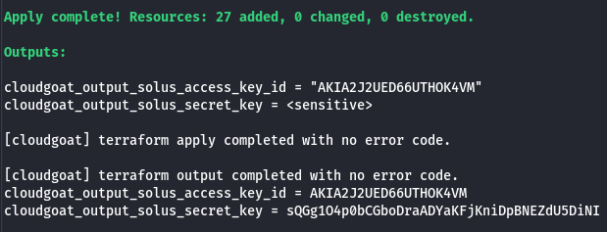

The provided user doesn’t have permissions to read permissions over IAM:
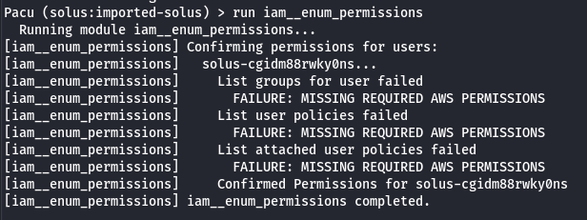
Checking for services manually, mainly EC2, S3 and Lambda, I’m allowed to list the functions on lambda service, revealing the following function but I don’t have permission to invoke. Using the credentials found in this function to configure a new user and check his permissions:
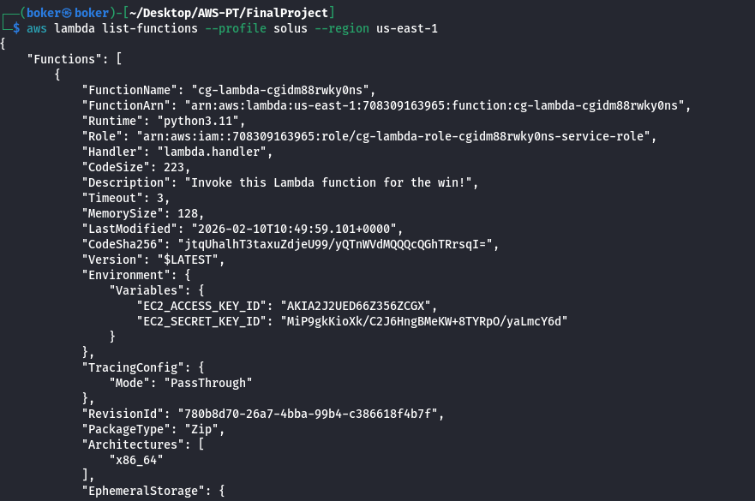

As the key is “EC2_ACCESS_KEY”, I’ve enumerated the EC2 service. Using the command “describe-instances” to list all the instances, the following instance was found. The name indicates it’s indeed connected to CloudGoat (cg), and the public IP is available:
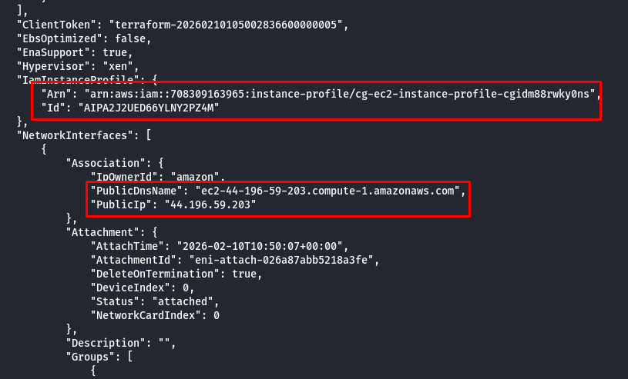

The public page of the EC2 instance presents the following message, and nothing in the SourceCode:
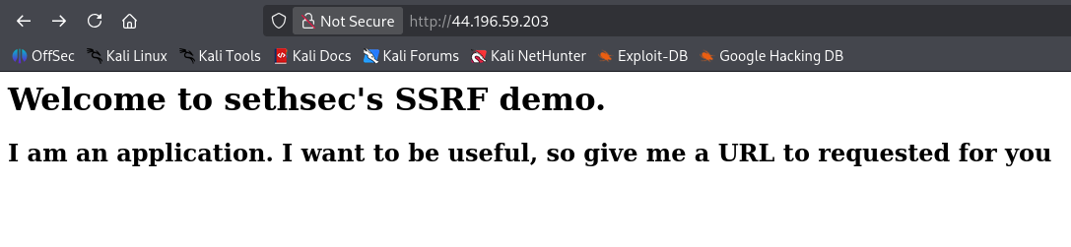

As the website requests a URL, I’ve provided a URL using the “?url=” parameter. As a test I’ve provided “google” to see what happens and google is presented within the website:
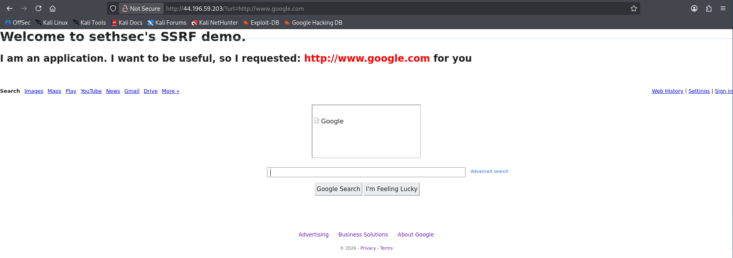

After some exploration, I’ve found the IMDS which is the Instance MetaData Service. This service provides data and credentials to software running on the instance. Visiting the official AWS site I’ve found the following article that helped me access the metadata of the instance:
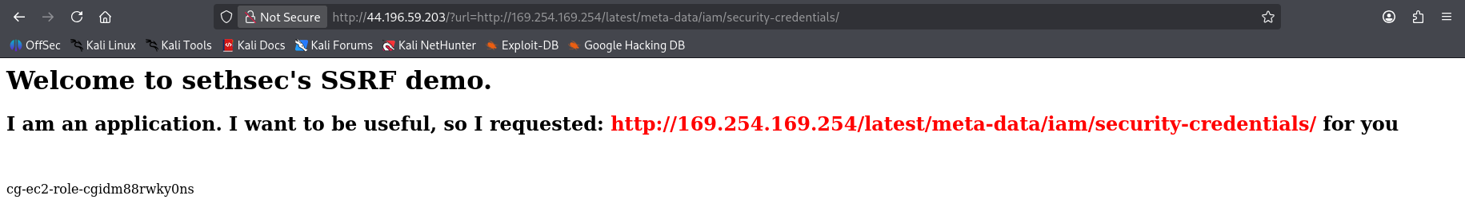

After acquiring the name of the ec2 role, I achieved the credentials for that role:
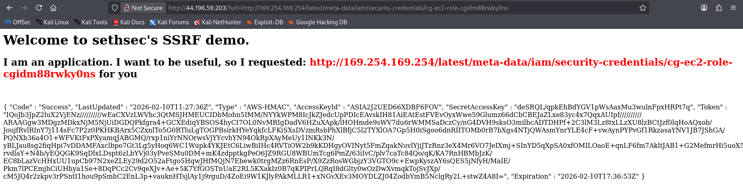
After acquiring the AccessKeyID, AccessSecretKeyID, and SessionToken, I’ve gained access to this higher privileged role user. Enumerating the services with that user I was able to list s3 buckets and the following bucket was presented:
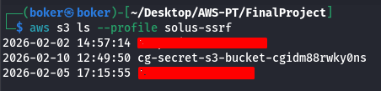

Further enumeration reveals the path “s3://[bucketName]/aws/credentials”:
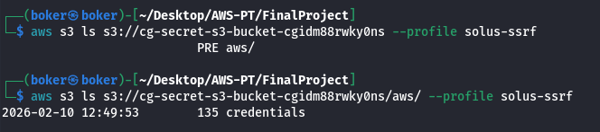

This file contains credentials for a user:
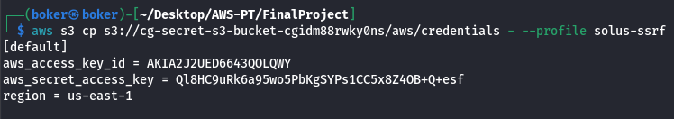

As the lambda function seen earlier had the description “Invoke to win” I tried to invoke that function. Invoke was successful and I got the output text “You win!”, completing this scenario.
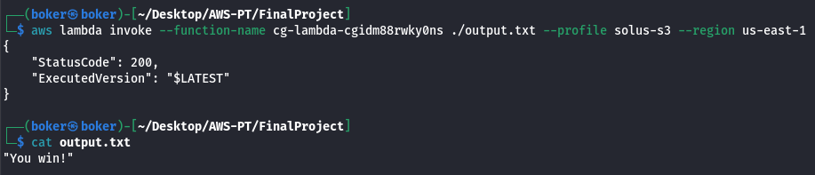

iam_privesc_by_attachment - MEDIUM

Execution Demonstration
In this scenario I was supplied with a user “Kerrigan”. This user cannot access the EC2 instance, but able to change the roles on the InstanceProfile. Changing the role from “meek…” to “mighty…”.
My user was able to create new key-pair and a new instance. Also, the user was able to obtain the relevant subnet-id of the VPC, and the Security Group. After acquiring this information, I’ve created a new EC2 instance, attached the “mighty” policy to it, and connected via SSH.
From the instance I’ve created with the “mighty” InstanceProfile, I was able to delete the “Super-Critical…” instance, completing the scenario.

As most scenarios, I’ve been granted access_keys to user “kerrigan”:
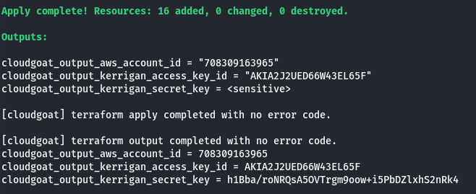

This user has no permission to enumerate IAM so I’ve continued manual enumeration. Listing the existing instances the following instance stands out. This instance have public IP which isn’t accessible with the current user.
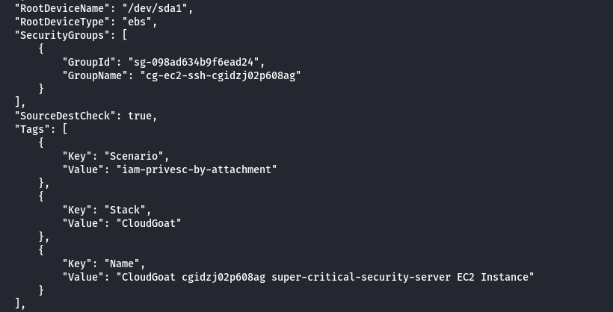

Because there’s an EC2 Instance which isn’t accessible with my user, I will enumerate Instances-Profiles and Roles with the goal of finding a privilege escalation vector.
Listing the InstancesProfiles, the following InstanceProfile is presented with an assigned role:
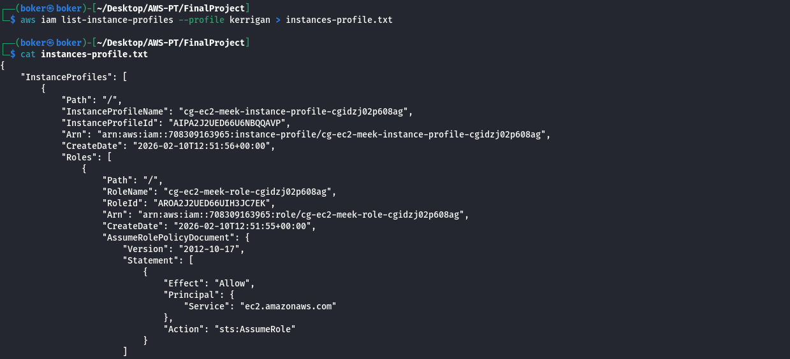

Listing the roles, the same assigned role is presented, and underneath another role. One of the roles is named “meek” and the other “mighty”, so I can deduct the “mighty” role have mightier privileges:
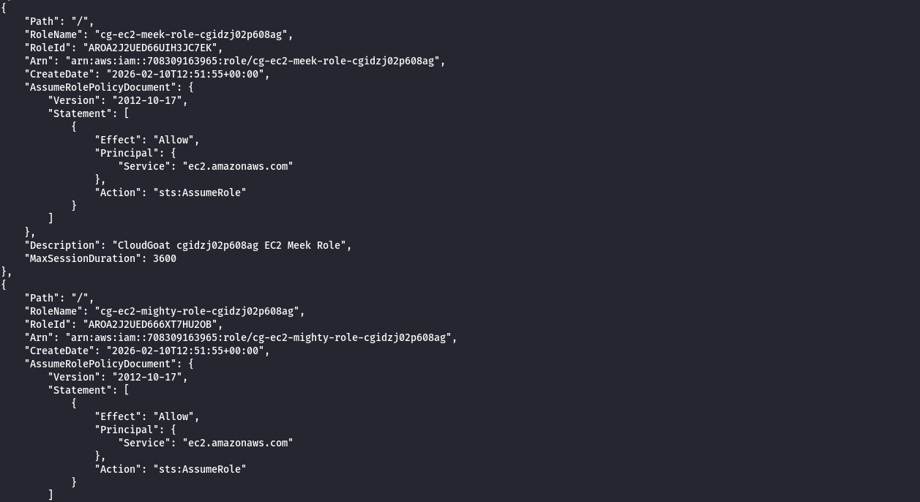

An instance-profile can contain only one role at a time, so I’ll try to detach the existing “meek” role and attach the “mighty” role, if successful I’ll enumerate what the new permissions grants me. Using the following commands to remove the “meek” role, and attach the new one:

Verifying that the role changed on the instance-profile:
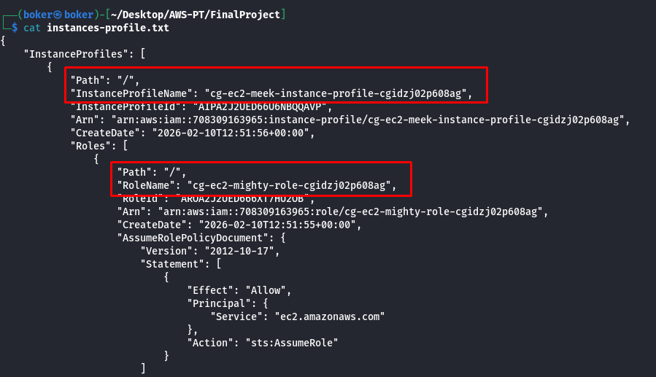
As my user can change roles on Instance-Profiles, and I’ve attached a more powerful role to the profile instance, now I’ll try to create an EC2 instance, attach the instance-profile to it and gain a shell on the cloud via SSH.
I’ll start by trying to create a new key-pair, if successful this is the correct attack vector. I was able to create a private key, and the public key is stored on aws:
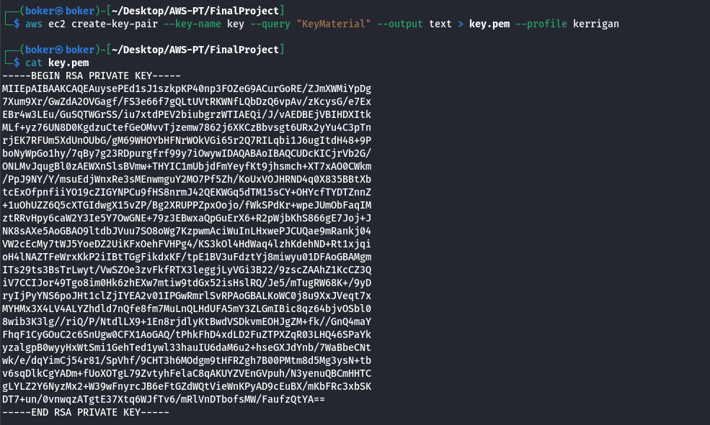

To run the instance, I’ll need to enumerate some more information. Enumerating the Subnets using the following command:
aws ec2 describe-subnets --profile kerrigan
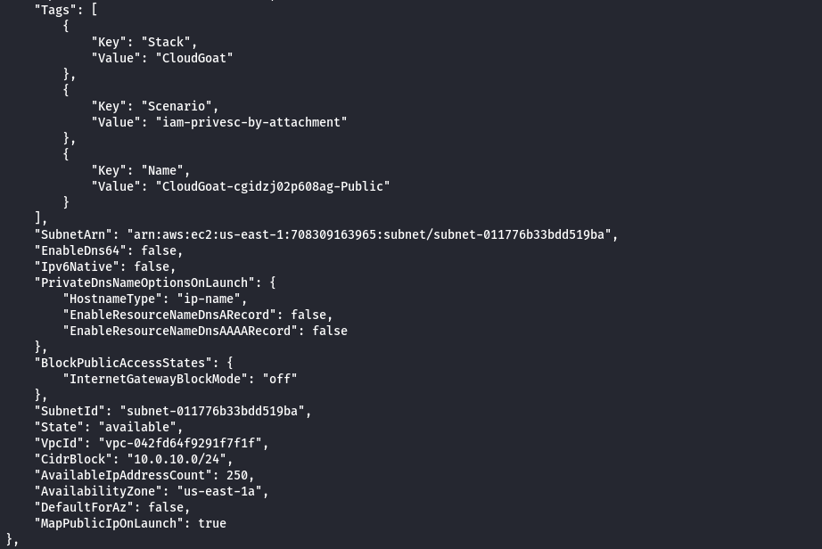

Enumerating the SecurityGroup using the following command:
aws ec2 describe-security-groups --profile kerrigan
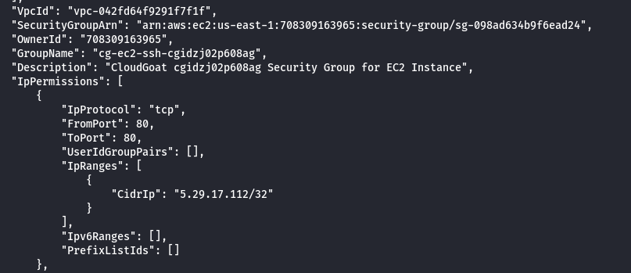

Now I’m able to build the EC2 instance. The following command does the following:
- Creates an instance and uses the image provided, and the instance type.
- Then I’ve attached the “mighty” instance-profile (still named “meek”).
- I’ve provided the key-pair I’ve generated.
- Provided the subnet-id of the VPC.
- Provided the Security Group.
Providing all this information allowed me to create an EC2 instance with the “instance-profile” attached, and now I can connect via SSH.
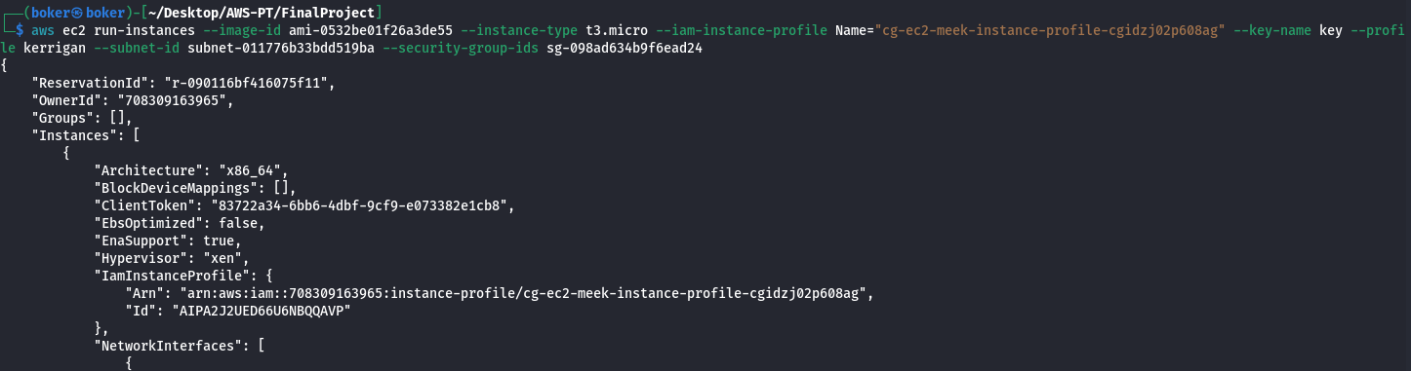

After a while the instance finished launching, I’ve enumerated it again and gained the PublicDNS: “ec2-3-239-78-238.compute-1.amazonaws.com”. Now I’m able to connect to the EC2 instance via SSH using the key I’ve generated and the default username for new instances “ec2-user”:
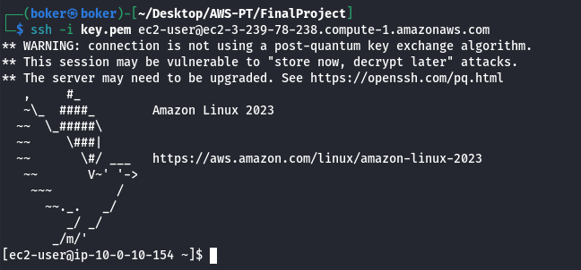

From the instance I’ve downloaded the AWS-CLI:
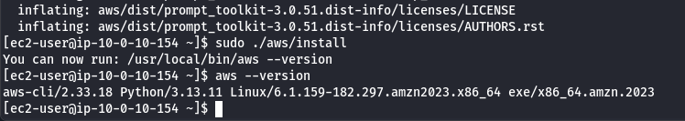

Now I’m able to delete the “super-critical” instance:
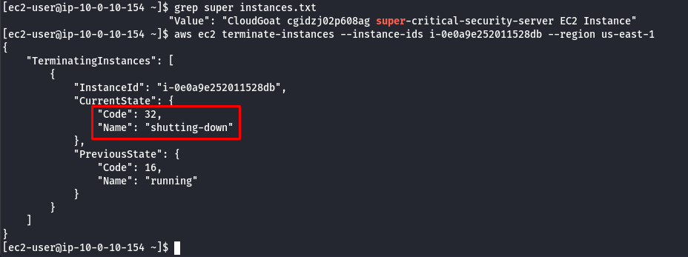

To verify, I’ve listed the instances again, the instance is indeed terminated and the challenge is completed:
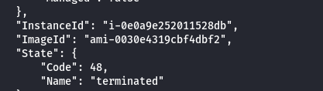

vulnerable_cognito - MEDIUM

Execution Demonstration
In this scenario I was provided with API-Gateway URL which contained login and signup form. Trying to signup to the service, I’m required to have “@ecorp.com” email, but reading the SourceCode the server validate this via the web script by the client side.
The SourceCode contains “poolData” containing “ClientID” and “UserPoolID” are available in the SourceCode, allowing me to create an account via the AWS CLI and bypassing the client-side restrictions.
By creating a user and supplying the required attributes, which are also available in the SourceCode, I’m able to create an account and login to the service.
Upon login, a JWT Token is available via Local Storage. Using the JWT Token I’m able to list the attributes of my current user, and the attribute “custom:access” isn’t default and set to “reader”. Using the command “update-user-attributes” I’m able to change this attribute from “reader” to “admin” and gain admin access on the webpage.
After gaining admin access on the webpage, I’ve found access_keys in the response of a packet that was sent to the webpage, and with that was able to login to an administrator user on the cloud, accessing and manipulating the content of the bucket hosting the webpage.

Deploying the scenario, I’m provided with API-Gateway URL:
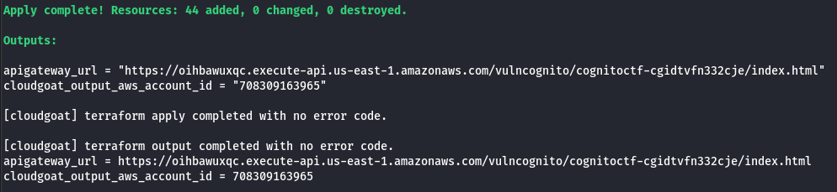

The webpage presents a login form and a signup, trying to signup I get the following message:
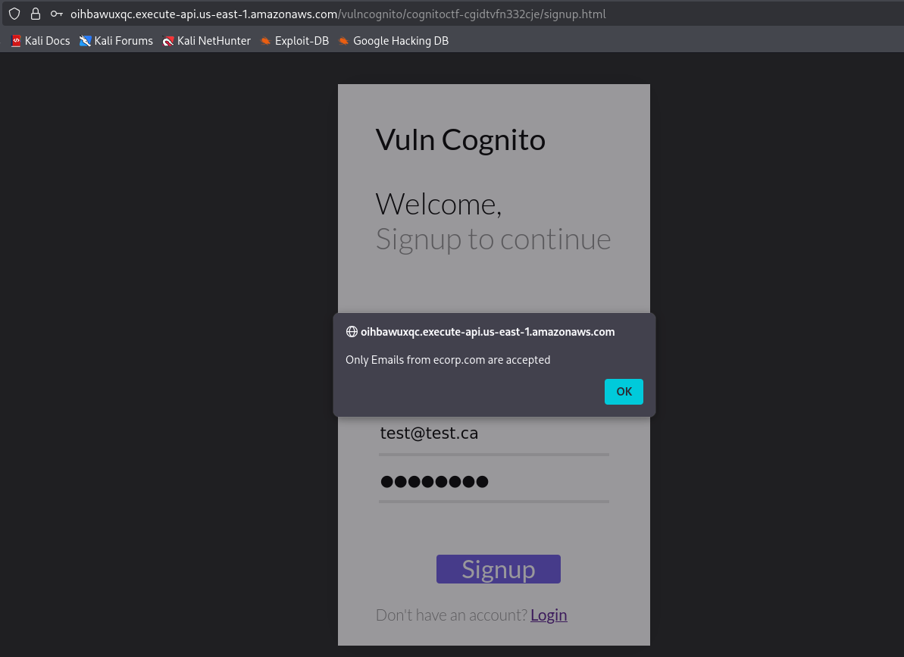

Reviewing the SourceCode of the signup page, the website checks for “XXXX@ecorp.com” mail, but the “poolData” is presented with the UserPoolId and ClientId, this may allow me to create a user from the CLI and bypass the client side restriction on the email:
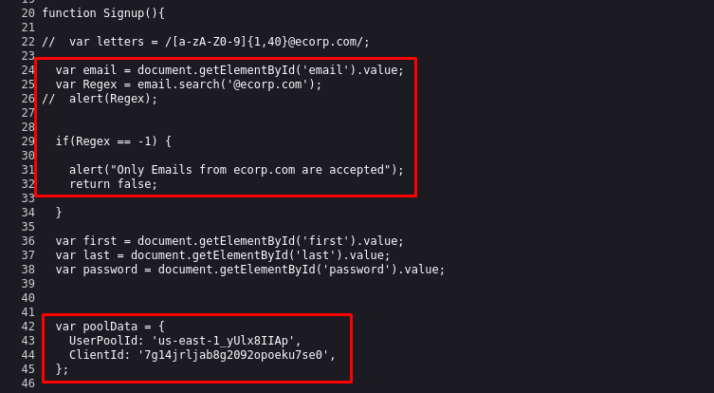
Using the CLI and providing the attributes from the SourceCode, the app tells me what is required to create a user. Adapting the signup to the restrictions I’ve successfully created a user with a temporary email address and bypassed the Client-Side restcitions:
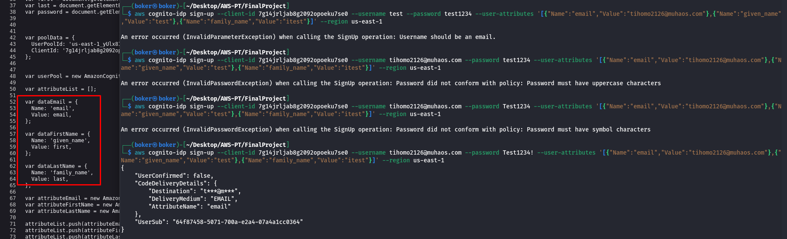

I’ve received a confirmation code in the temporary mail, using the CLI to also confirm the account. No error meaning the account created successfully:

Logging to the account I’ve created successfully, I’m redirected to the following page with only this message presented, also checked the SourceCode but no information there:
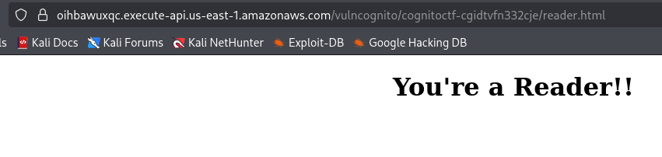

Examination of the website, the LocalStorage holds an “accessToken”:
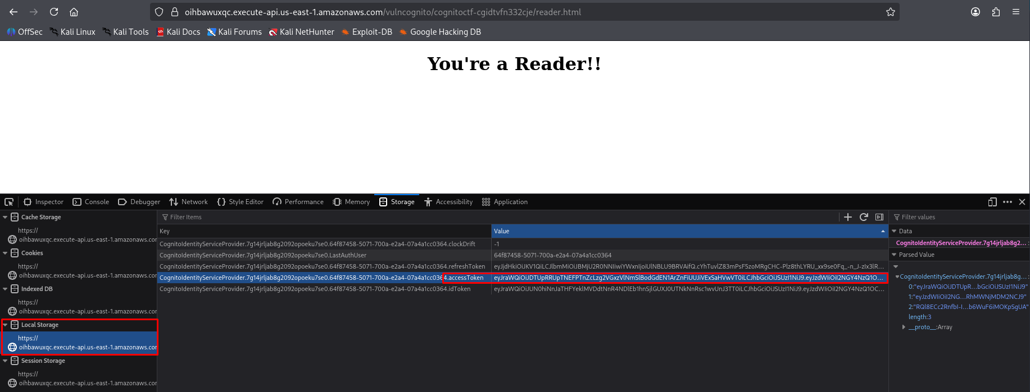
Decrypting the token using JWT.io, the following information is retrieved:
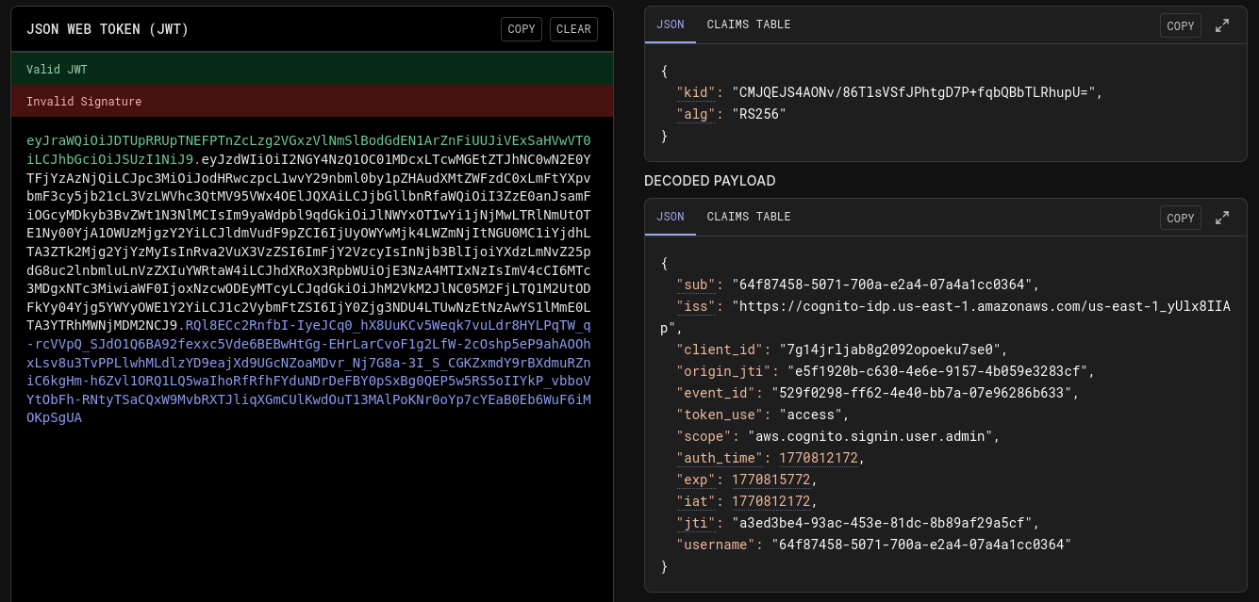

Searching for what commands I can use with the accessToken, the following “get-user” command allows me to get information about the user. By entering this command with the accessToken, I’m presented with the attributes of the user. One attribute instantly caught my eye, “custom:access” “reader”, as it’s a custom attribute, and this provides “reader” permissions as seen in the webpage when I logged in.
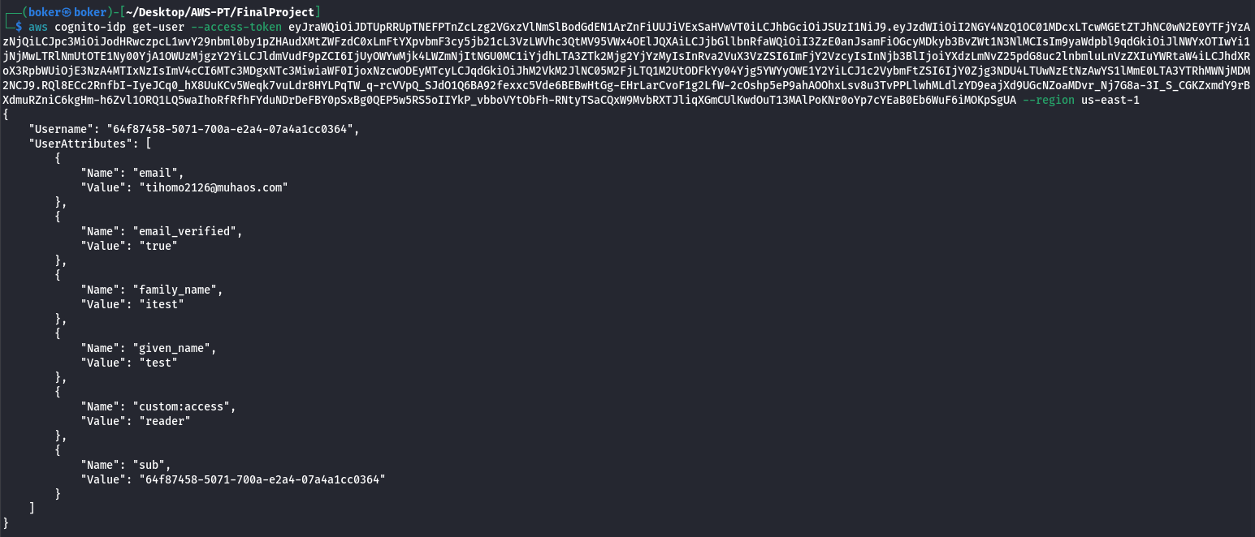

Some more searching I’ve found the command “update-user-attributes” that allows me to update this attribute. I’ll try to escalate this attribute from “reader” to “admin”. No error presented:
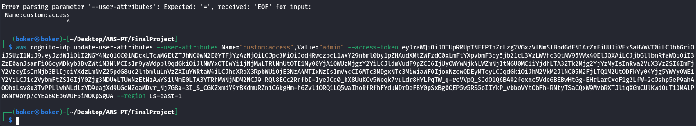

Verifying the attribute changed to “admin”:
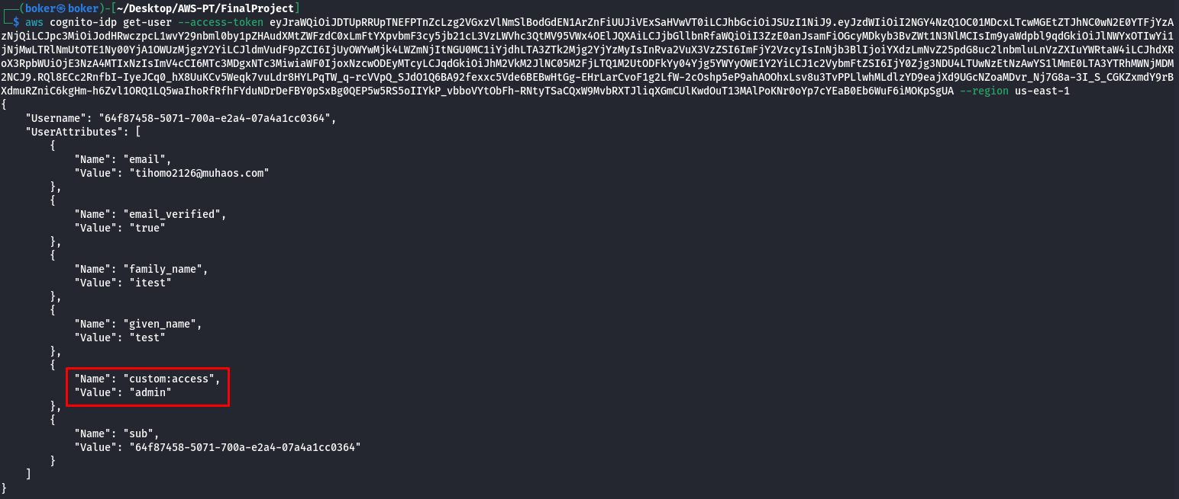

Back on the website, I’ve changed the URL to “admin.html” instead of “reader.html” and the following message is presented. Examining the requests and responses on this webpage, the following respond contains credentials for AWS CLI, most likely for an admin user:
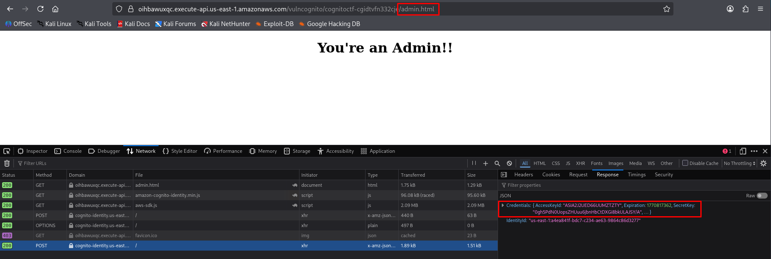

Configuring the user and checking services, I have access to the S3 bucket which holds the website:
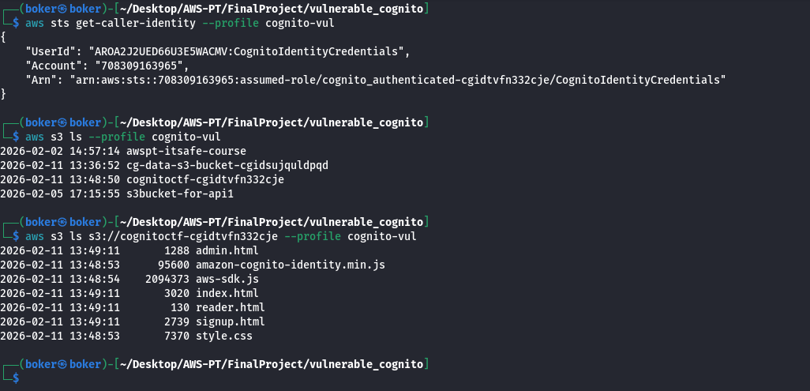

Verifying I can interact with the content of the bucket, successfully completing the scenario.
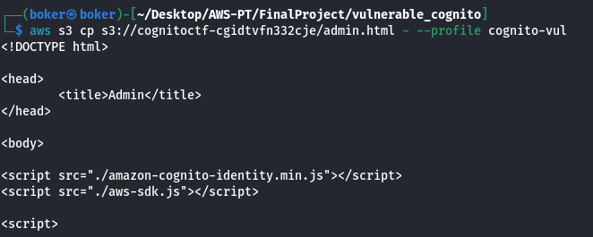

secrets_in_the_cloud

Execution Demonstration
In this scenario I was provided with a user, and I was able to list the S3 buckets on the cloud. A text file in the bucket revealed a website with “/admin” panel that requested an API KEY.
I was also able to list the “Lambda” functions, and the function revealed an API KEY. Supplying this API KEY provided a Token
In the SourceCode of “/admin” there’s a comment by “Jeff” talking about “HashiCorp”, which the default port for this service is “:8200”. Accessing this service requires a token which is acquired in the previous step. Accessing the dashboard an “id_rsa” private key is available.
Connecting via SSH with the private key I’ve accessed the instance with default username “ec2-user”.
The login message showed an error loading the “.bash_profile” file, reading this file there’s a note from “Jeff” saying IMDSv2 is enabled on the server. This allows me to generate a token from AWS magic IP and then access the “meta-data” of “/iam” with the magic IP and token. Accessing this I’ve gained the information that DynamoDB is in use by the InstanceProfile.
Accessing the DynamoDB database, I’ve acquired user’s credentials under the name “secrets_manager_...”. Using this user, I’ve accessed the “secretsmanager” service, and completed the scenario.

Starting this scenario, I’m supplied with access_keys:
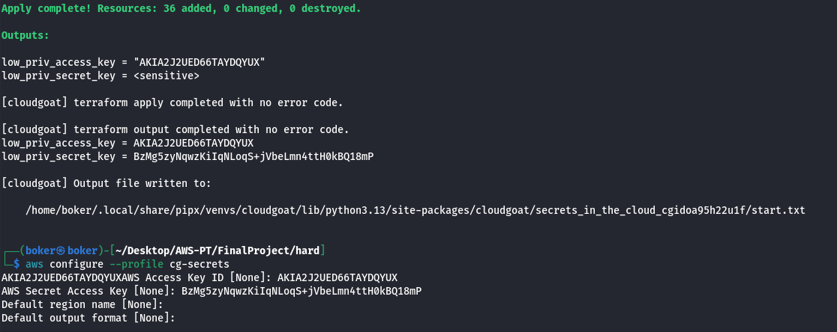

Enumerating the S3 service, I’ve found the following note that includes a URL:
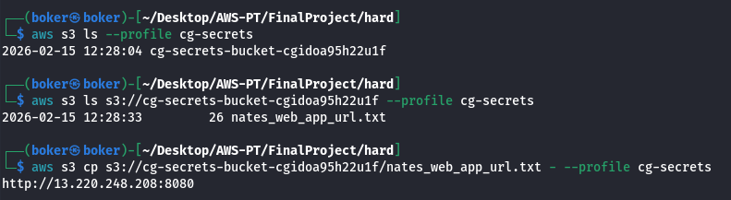

In this URL main page there’s an “href” to “/admin”, and inside admin I’m required to provide an API Key:
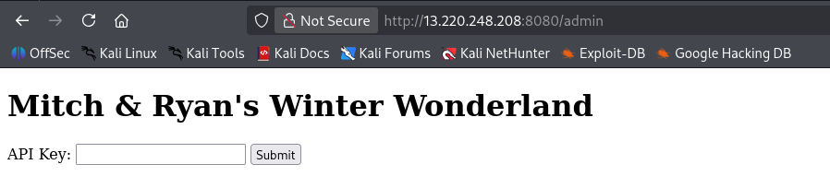

Reading the SourceCode of the “/admin” page, it contains the following comment. This comment talks about “HashiCorp endpoint”, and after some research, I’ve found this is an “API paths used by Vault to manage AWS resources or by Terraform to interact with AWS services.

The default port of “HashiCorp” is 8200, visiting this port via web redirects to the following login form:
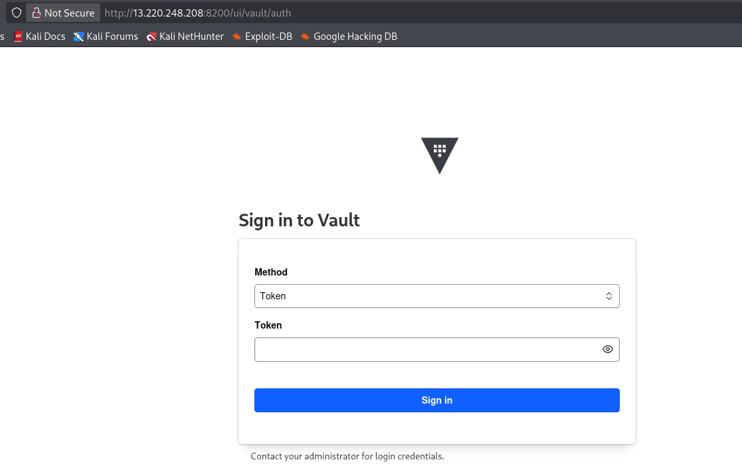

As I need to supply a token and I didn’t manage to find any other information, I’ve decided to continue with enumeration. After listing the lambda functions, I’ve found the following containing an API Key:
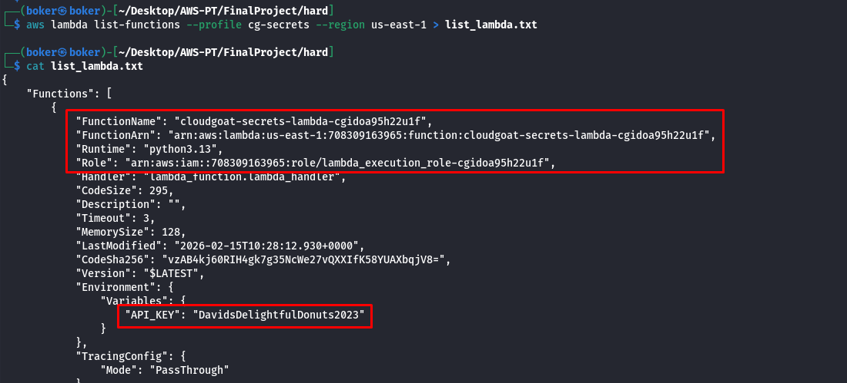
Supplying the API Key to the admin panel, I’ve gained a Vault Token:
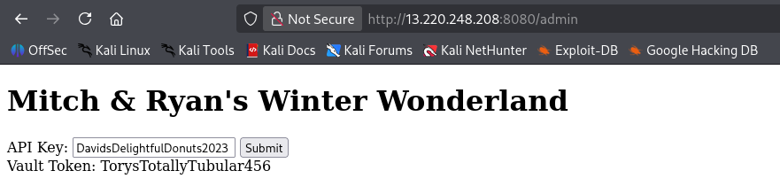

Using the Vault Token on the Vault (port 8200), I’ve gained access to the dashboard:
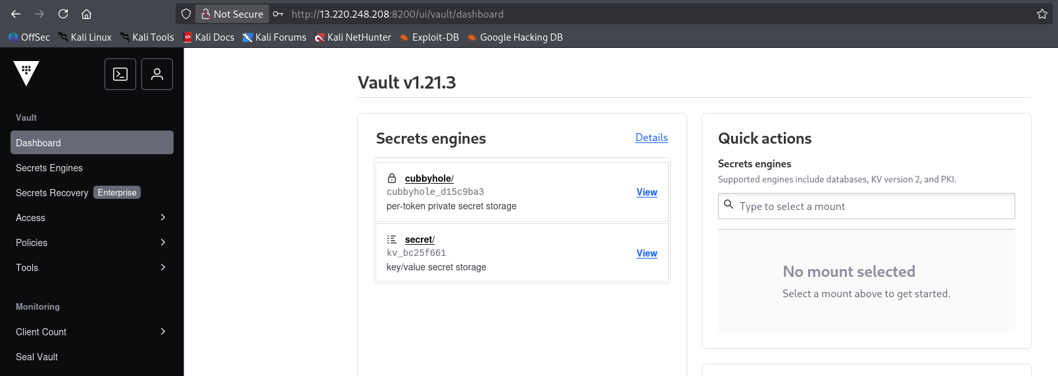

In the Vault I’ve found the following files, I can use the id_rsa to login to the instance via SSH:
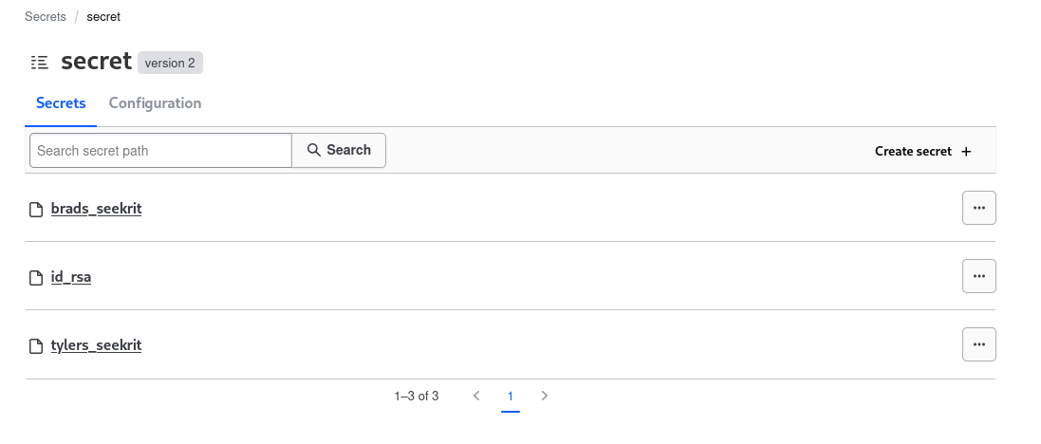

Using the “id_rsa” private key, I’ve gained access to the instance via SSH. The “.bash_profile” file presents an error, leading me to think it may have been tampered with:
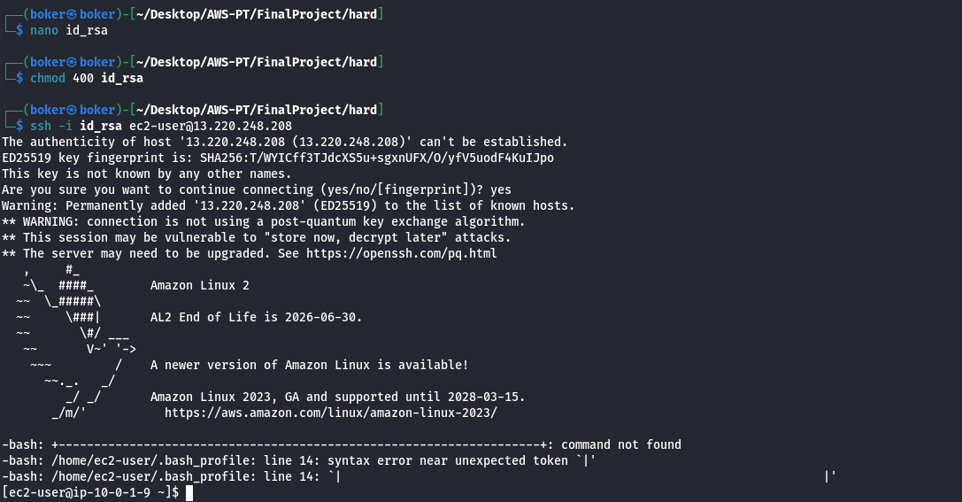

In the “.bash_profile” file “Jeff” left a message about the “IMDSv2” being enabled on the server The IMDSv2 service is a “session-oriented, token-based security enhancement for accessing EC2 instance metadata, designed to mitigate SSRF (Server-Side Request Forgery) vulnerabilities”
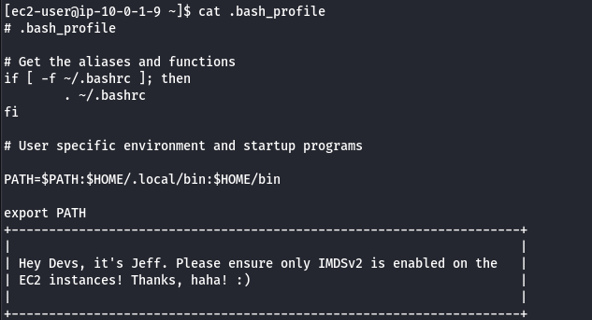

After understanding the usage of IMDSv2, I need to use the following commands:
The first command creates a variable “TOKEN”, curls to the magic IP of AWS and a specific path, uses “PUT” method, as this is required by AWS to prevent SSRF attacks, and provides a header that set the TTL of the token to 6 hours:
TOKEN=$(curl -X PUT http://169.254.169.254/latest/api/token \
-H "X-aws-ec2-metadata-token-ttl-seconds: 21600")
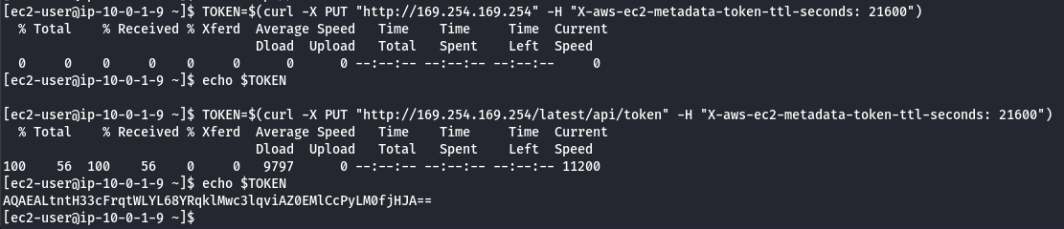

Now I can use the “$TOKEN” variable to access the magic IP of AWS.
Accessing the meta-data, the “security-credentials” contain credentials for the following user:
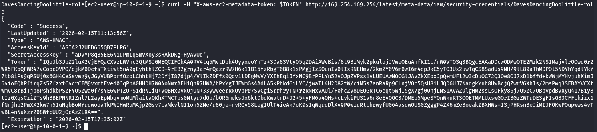

I’ve also found the following information of the InstanceProfile “dynamodb-instance-profile”, this means my current session via SSH have the InstanceProfile permissions, and as it named “dynamodb” I’ll enumerate this service first before trying to use the credentials:
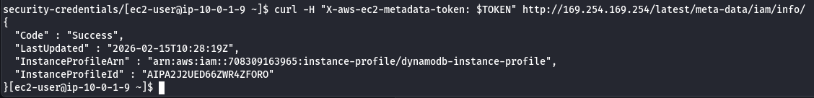

Listing the existing databases and then using “scan” to read the content of the table, I’ve acquired access_keys to a user:
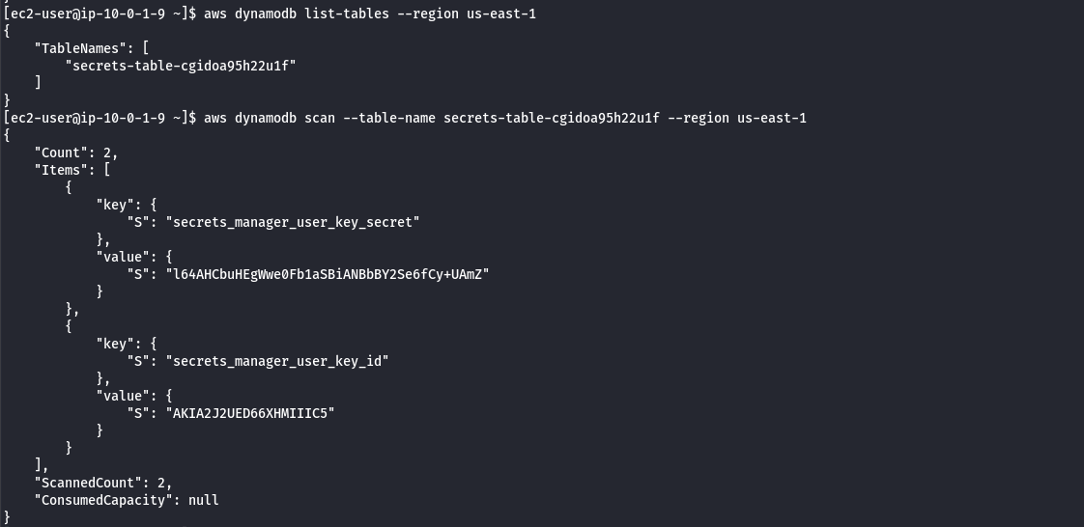

As the name in the database is “secret_manager_user…” I tried to enumerate the “secretsmanager” service:
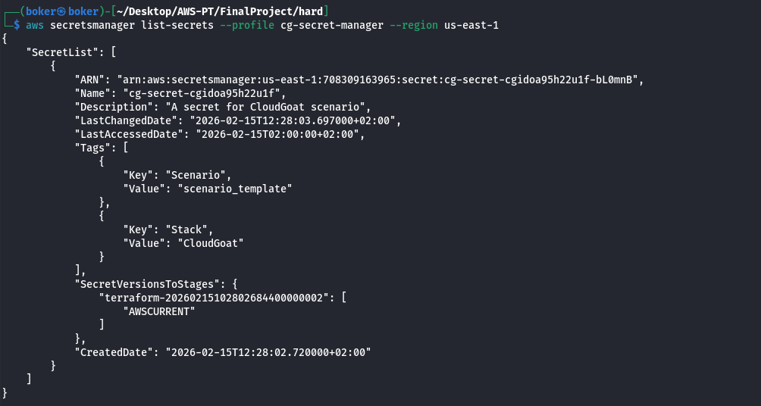

Getting the value of the secret, I’ve successfully completed this scenario:
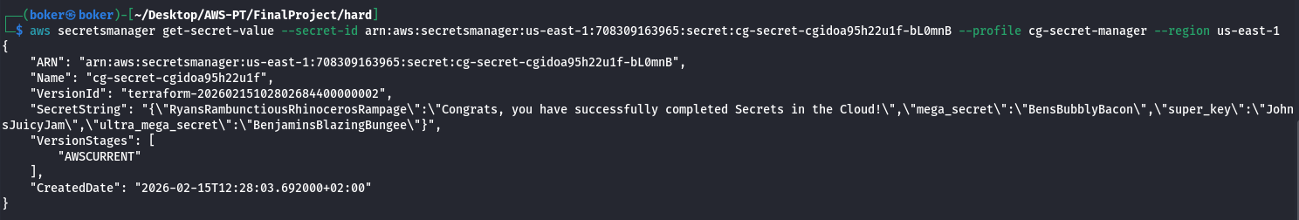

rce_web_app

Execution Demonstration
In this scenario I was provided with 2 users, “McDuck” and “Lara”, I’ve completed the scenario via user “McDuck”.
User “McDuck” is permitted to list s3 bucket, finding the bucket “cg-keystore…” containing OpenSSH private and public key.
“McDuck” is also permitted to list EC2 instances on the cloud, finding an “ubuntu” instance available. Using the OpenSSH private key, and the default username “ubuntu” I’m able to connect to the EC2 instance via SSH.
After accessing the instance, I’ve downloaded AWS CLI and from the instance and most likely due to roles I’m able to access the S3 bucket “cg-secret…” containing credentials and DB name for RDS.
Connecting to the RDS via “psql”, I’ve grabbed the secret passcode from the “sensitive_information” table and completed the scenario.

Deploying this scenario, I’ve been given 2 users, Lara and McDuck:
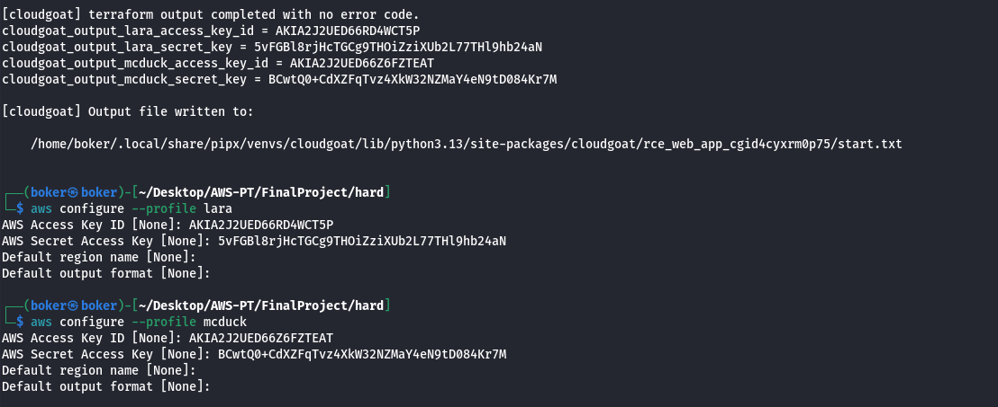

Starting with exploring the user McDuck (Purely due to the awesome name), this user can list s3 buckets. This user isn’t authorized to view the bucket “cg-logs…” or “cg-secret…” but have access to bucket “cg-keystore…” that contains OpenSSH private key and public key:
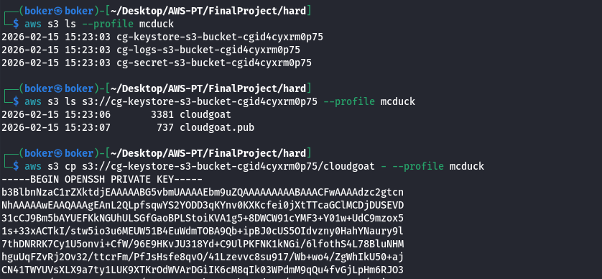

Using the “ec2 describe-instances” command, 2 instances are available. The following includes the “KeyName”: “cg-ec2-key-pair-cgid4cyxrm0p75” which lead me to try login via the private OpenSSH key I’ve acquired from the S3 bucket:
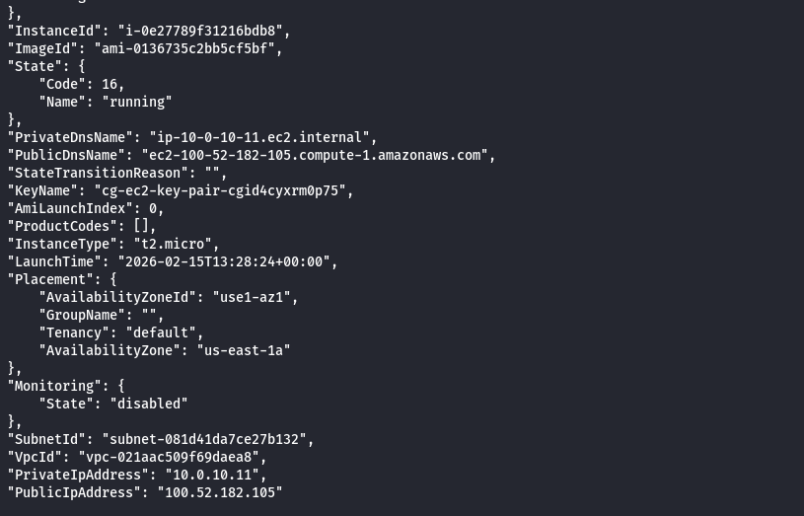

The tags of the instance reveal it’s an “ubuntu” instance:
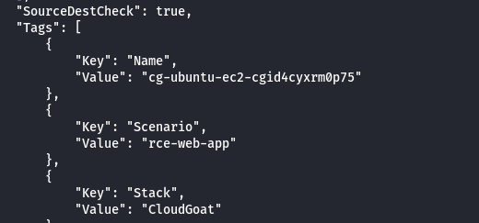

Using the following article to determine what the default username for ubuntu ec2 AMI’s, the username “ubuntu” is the default. Using this username with the private key, I’ve gained access to the machine via SSH:
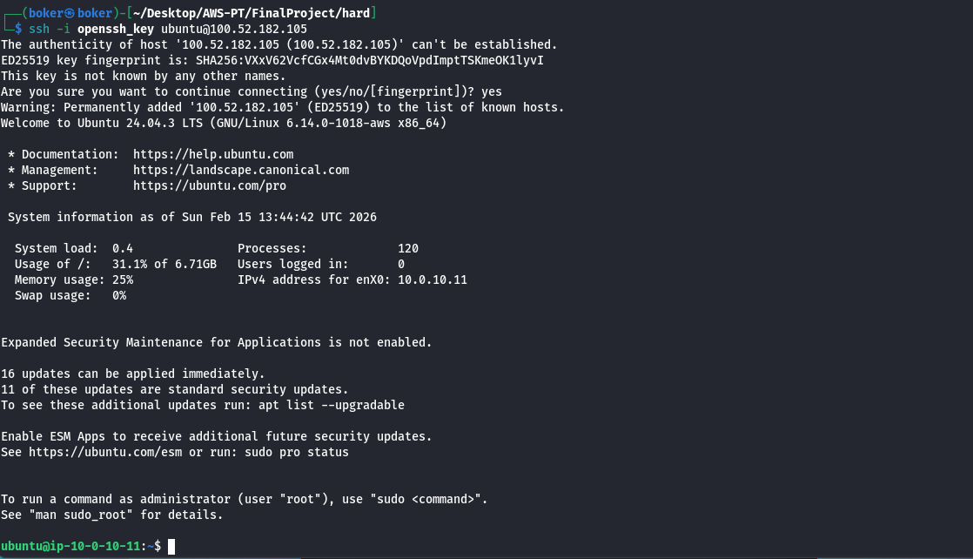

After enumerating the machine without any interesting files, I’ve decided to continue enumerating AWS as the instance may hold higher-privileged roles than my user. There’s no AWS CLI on the machine, but I’m able to “privesc” to root user, and download the AWS CLI from the following link:
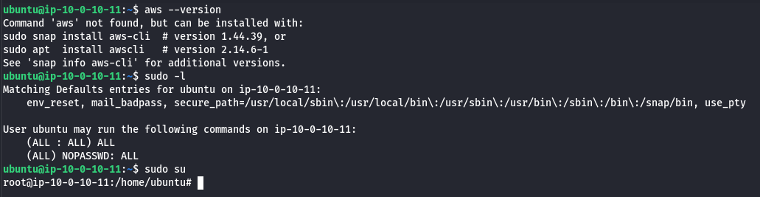

Successfully downloading AWS CLI on the EC2:
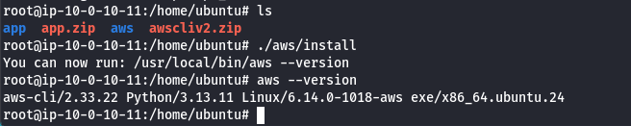

From this EC2 instance I have access to the the bucket “cg-secret…”. This bucket have the file “db.txt” which contains credentials, and db name.
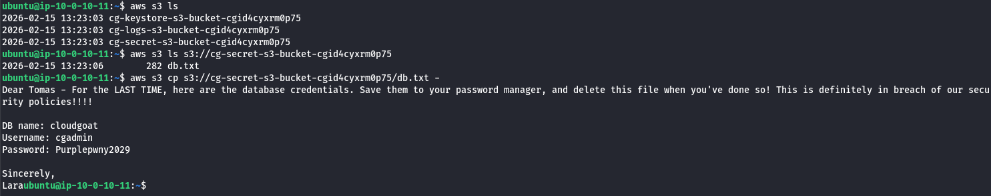

A db instance is available, and it uses “postgres”:
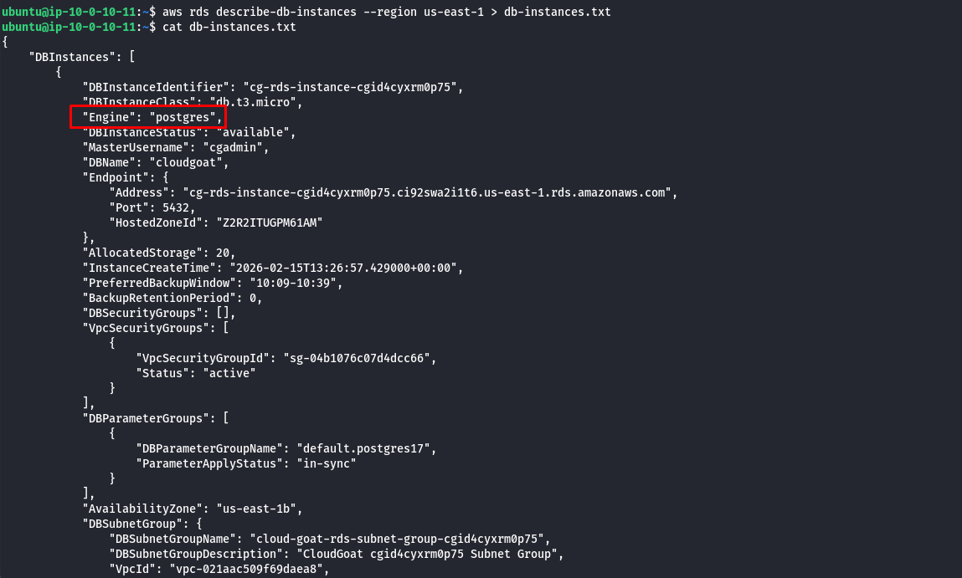

Because the db uses “postgres”, I’ll connect via “psql” with the following command:
psql -h <Endpoint> -U <MasterUsername> -d <DatabaseName>
I’ve successfully connected to the database:
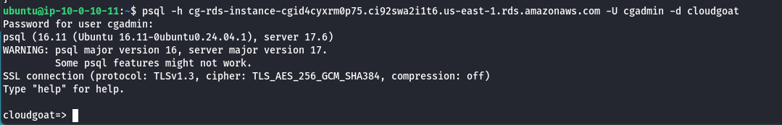

The database contains a table “sensitive_information”, retrieving the content of it reveals “Super-secret-passcode”, completing the scenario.
