**To**

The Management,

IIMT College of Management,

Greater Noida, UP – 201308

Date: 26th April 2023

Subject: Correction of Date of Birth in my College Documents

Dear Sir, I am Ankush Kumar Gupta, from BCA (2nd Semester) department of section ‘A’. I filled my 2nd Semester exam form and found that my Date of Birth Year is wrong. I want it to be corrected as soon as possible.

I hereby request you to please correct my Date of Birth on all my College documents including my Exam Form. Otherwise, I’ll face issues in the future regarding any college paperwork. “**Original DOB: 2nd August 2004**”

I also have inserted my Aadhar Card copy with this letter for proof of my original Date of Birth.

Thanks!

Yours Sincerely,

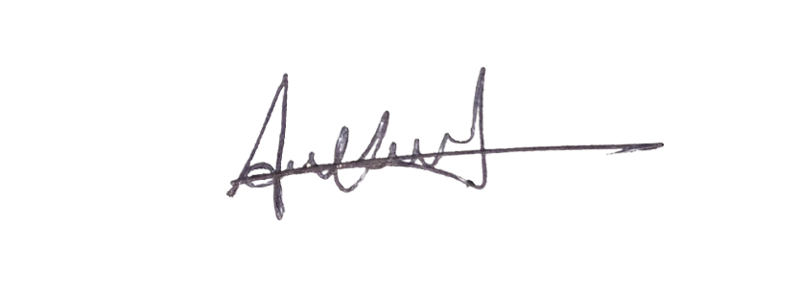

Ankush Kumar Gupta

***Signature***