Practical No:-17
Interfaces, nested interfaces and use of extending interfaces
Interfaces:-
Code->

interface Gne{
public void print();
}
class It implements Gne{
@Override
public void print(){
System.out.println("Guru Nanak Dev Engineering College");
}
}

public class Interfaces {
public static void main(String[] args) {
It a = new It();
a.print();
}
}

Output:-

Nested Interfaces:-
Code->
interface Mahindra{
interface Thar{
public void print();
}
}
class Testing implements Mahindra.Thar{
@Override
public void print(){
System.out.println("Thar is a car model launched by Mahindra");
}
}

public class NestedInterface {
public static void main(String[] args) {
Mahindra.Thar obj;
Testing t = new Testing();
obj = t;
obj.print();

}
}

Output->

Practical No:-18
Exception Handling - using predefined exception
Code->

public class PredefinedException {
public static void main(String args[]) {
try {
int a = 30, b = 0;
int c = a / b; // cannot divide by zero
System.out.println("Result = " + c);
} catch (ArithmeticException e) {
System.out.println("Can't divide a number by 0");
}
}
}

Output:-

Practical No:-19
Exception Handling - creating user defined exceptions
Code->
// Java program to demonstrate user defined exception
// This program throws an exception whenever balance
// amount is below Rs 1000
public class Myexceptions extends Exception {
// store account information
private static int accno[] = { 1001, 1002, 1003, 1004 };

private static String name[] = { "Nish", "Shubh", "Sush", "Abhi", "Akash" };

private static double bal[] = { 10000.00, 12000.00, 5600.0, 999.00, 1100.55 };

// default constructor
Myexceptions() {
}

// parameterized constructor
Myexceptions(String str) {
super(str);
}

// write main()
public static void main(String[] args) {
try {
// display the heading for the table
System.out.println("ACCNO" + "\t" + "CUSTOMER" +
"\t" + "BALANCE");

// display the actual account information
for (int i = 0; i < 5; i++) {
System.out.println(accno[i] + "\t" + name[i] +
"\t" + bal[i]);

// display own exception if balance < 1000
if (bal[i] < 1000) {
Myexceptions me = new Myexceptions("Balance is less than 1000");
throw me;
}
}
} // end of try

catch (Myexceptions e) {
e.printStackTrace();
}
}
}

Output:-
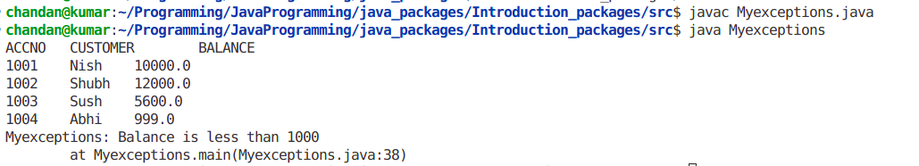

Practical No:- 20
Multithreading by extending Thread Class
Code->
class Test extends Thread {
public void run() {
System.out.println("inside run thread");
}
}

public class ExtendingThread {

public static void main(String[] args) {
Test t = new Test();
t.start();
System.out.println("inside main thread");

}
}

Output:-

Practical No:-21
Multithreading by implementing Runnable Interface

Code->
class Test implements Runnable {
public void run() {
System.out.println("inside test thread");
}
}

public class UsingRunnable {
public static void main(String[] args) {
Test t = new Test();
Thread d = new Thread(t);
d.start();
System.out.println("inside main thread");
}
}

Output:-

Practical No:-22
Thread life cycle
Code->
// Java program to demonstrate thread states
class thread implements Runnable {
public void run()
{
// moving thread2 to timed waiting state
try {
Thread.sleep(1500);
}
catch (InterruptedException e) {
e.printStackTrace();
}

System.out.println(
"State of thread1 while it called join() method on thread2 -"
+ ThreadLife.thread1.getState());
try {
Thread.sleep(200);
}
catch (InterruptedException e) {
e.printStackTrace();
}
}
}

public class ThreadLife implements Runnable {
public static Thread thread1;
public static ThreadLife obj;

public static void main(String[] args)
{
obj = new ThreadLife();
thread1 = new Thread(obj);

// thread1 created and is currently in the NEW
// state.
System.out.println(
"State of thread1 after creating it - "
+ thread1.getState());
thread1.start();

// thread1 moved to Runnable state
System.out.println(
"State of thread1 after calling .start() method on it - "
+ thread1.getState());
}

public void run()
{
thread myThread = new thread();
Thread thread2 = new Thread(myThread);

// thread1 created and is currently in the NEW
// state.
System.out.println(
"State of thread2 after creating it - "
+ thread2.getState());
thread2.start();

// thread2 moved to Runnable state
System.out.println(
"State of thread2 after calling .start() method on it - "
+ thread2.getState());

// moving thread1 to timed waiting state
try {
// moving thread1 to timed waiting state
Thread.sleep(200);
}
catch (InterruptedException e) {
e.printStackTrace();
}
System.out.println(
"State of thread2 after calling .sleep() method on it - "
+ thread2.getState());

try {
// waiting for thread2 to die
thread2.join();
}
catch (InterruptedException e) {
e.printStackTrace();
}
System.out.println(
"State of thread2 when it has finished it's execution - "
+ thread2.getState());
}
}

Output:-
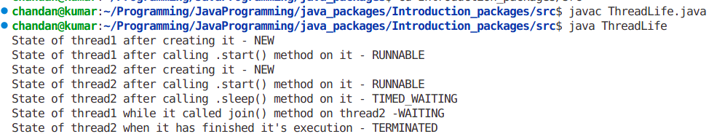

Practical No:-23
Applet life cycle
Code->

// Java Program to Illustrate Insertion of HTML File in
// Applet As Commands

// Importing required classes
import java.applet.*;
import java.awt.*;

// Note: Insertion of HTM:L file as comments

/* <applet code = AppletDemo width=400 height=500>
</applet>*/

// Java Program

// Class extending Applet
public class MyApplet extends Applet {
public void init()
{
setBackground(Color.black);
setForeground(Color.yellow);
}
public void paint(Graphics g)
{
g.drawString("Welcome to Applets", 50, 50);
}
}

Output:-
