

Assignment: Summer Term Internship
School Name: Computer Science and Engineering
Course: DSA FOR PLACEMENTS

PATH FINDING VISUALIZER
Project Report
C++ | HTML | CSS | Data Structures / JavaScript

Submitted by: Name Registration No.
Chirag 12409735
Ishan Walia 12412548

Academic session:2026-27 Submitted to: Sudha Shanker Prasad

ACKNOWLEDGEMENT

We express our sincere gratitude to our respected mentor Mr. Sudha Shanker Prasad for his constant guidance, motivation, and valuable suggestions throughout the duration of our Summer Training Course titled " DSA FOR PLACEMENTS."
His technical knowledge, practical insights, and continuous encouragement enabled us to successfully complete this project. We learned how theoretical concepts of data structures can be effectively implemented in real-world applications.
We are also thankful to Lovely Professional University for providing us with the opportunity to participate in this training program, which significantly enhanced our programming and problem-solving skills.
Finally, we extend our gratitude to our teammates for their cooperation, dedication, and teamwork throughout the development of the Library Management System.

Team Members:
Chirag

Ishan Walia

1. Introduction
The Path Finding Visualizer is an interactive application that demonstrates how different pathfinding algorithms find the shortest path between two locations. It provides a Google Maps-inspired graphical interface where users can place a Start Node, End Node, walls (obstacles), and weighted cells to observe the behavior of different algorithms in real time.
The project is developed using C++ for implementing graph algorithms and HTML, CSS, and JavaScript for designing an interactive and responsive user interface. The visualization helps students understand graph traversal techniques through animations and live statistics.

2. Modules of the Project
• Home Dashboard
• Algorithm Selection
• Grid Visualization
• Start & End Node Placement
• Wall (Obstacle) Drawing
• Weighted Node Placement
• Path Visualization
• Maze Generator
• Statistics Panel
• Reset & Clear Board
• Animation Speed Controller

3. Working of the Library Management System
The working of the system is divided into the following steps.
Step 1: Launch Application
• User opens the application.
• The visualization dashboard appears.
• A grid is generated automatically.

Step 2: Select Algorithm
The user selects one of the following algorithms:
• Breadth First Search (BFS)
• Depth First Search (DFS)
• Dijkstra's Algorithm
• A* Search Algorithm
• Greedy Best First Search (Optional)

Step 3: Place Start & End Nodes
The user places:
• Start Node (Green)
• End Node (Red)
The algorithm will find the shortest path between these two points.

Step 4: Draw Walls (Obstacles)
The user can draw walls on the grid.
• Walls block the path.
• The algorithm searches for an alternative route.
• Walls cannot be crossed.

Step 5: Add Weighted Nodes
Weighted nodes increase the travel cost.
Only weighted algorithms like:
• Dijkstra
• A*
consider these costs while finding the shortest path.

Step 6: Visualize Algorithm
When the Visualize button is clicked:
• The selected algorithm starts searching.
• Visited nodes are highlighted.
• The search process is animated step by step.
• Once the destination is found, the shortest path is displayed.

Step 7: Statistics Panel
The application displays:
• Number of Visited Nodes
• Shortest Path Length
• Execution Time
• Memory Usage
• Time Complexity

Step 8: Reset Board
The Reset button clears:
• Start Node
• End Node
• Walls
• Weights
• Previous Visualization
A fresh grid is created for the next simulation.

4. Architecture of the Library Management System

Working Flow

5. Data Structures & Algorithms Used
The Smart Library Management System uses several data structures to improve efficiency.
1. Graph
The entire grid is represented as a graph.
Each cell represents one node.
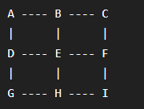
Purpose
• Represent map
• Connect neigh boring nodes
• Traverse paths

2. Queue
Queue is used in BFS.
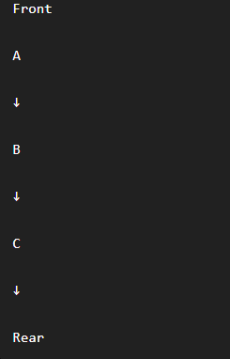
Operations
• Enqueue
• Dequeue
FIFO (First In First Out)

3. Stack
Stack is used in DFS.
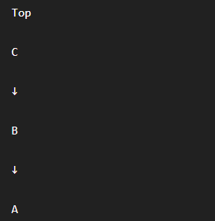
Operations
• Push
• Pop
LIFO (Last In First Out)

4. Priority Queue
Priority Queue is used in:
• Dijkstra
• A*
The node having the minimum cost is selected first.

Algorithms Used
The project implements:
- Breadth First Search (BFS)
- Depth First Search (DFS)
- Dijkstra's Algorithm
- A* Search Algorithm
- Greedy Best First Search (Optional)
- Maze Generation Algorithm
- Shortest Path Reconstruction Algorithm
- Grid Traversal Algorithm

Time Complexity
Algorithm | Time Complexity
BFS | O(V + E)
DFS | O(V + E)
Dijkstra | O(E log V)
A* Search | O(E log V) (Average)

6. Conclusion
The Path Finding Visualizer successfully demonstrates how different pathfinding algorithms work through an interactive and animated interface. The project combines C++ algorithms with a modern HTML, CSS, and JavaScript frontend to help users understand graph traversal and shortest path concepts.
It provides a practical learning platform for Data Structures and Algorithms while showcasing real-world applications such as Google Maps, GPS navigation, robotics, and game development. The project improves problem-solving skills, algorithm analysis, and visualization techniques, making it an excellent educational and portfolio project.

Project Outcomes:
