
UL Research Information System
User Manual

Introduction 2
5 Step Quick Start Guide 3
More detailed information on each screen 8
The Dashboard 8
General information 9
Research 11
Publications 12
Professional activities 20
Editing and publishing your profile 22
Logout 23
Change Password 23
Frequently asked questions 24

Introduction

What is the UL Research Information System?
The UL Research Information System (ULRIS) is a user-friendly, intuitive, web-based system that provides functionality for academics to create, update and maintain their own web profiles. Designed in conjunction with 200 academics, sysem supplier Vidatum has created an online Researcher Profile publishing and collaboration system that is used to showcase academic and research achievements to a global audience and has been instrumental in the measurement and improvement of research output.

Getting help with ULRIS
Although ULRIS has been designed with ease of use in mind, this manual is provided to assist new users in getting started with creating their web profiles while also providing more in depth information of the system functionality.

On screen help
Help buttons ( ) are at the top of each screen as shown below:
Clicking on the help button displays page sensitive information on what the screen is for and definitions of the data fields on the screen.

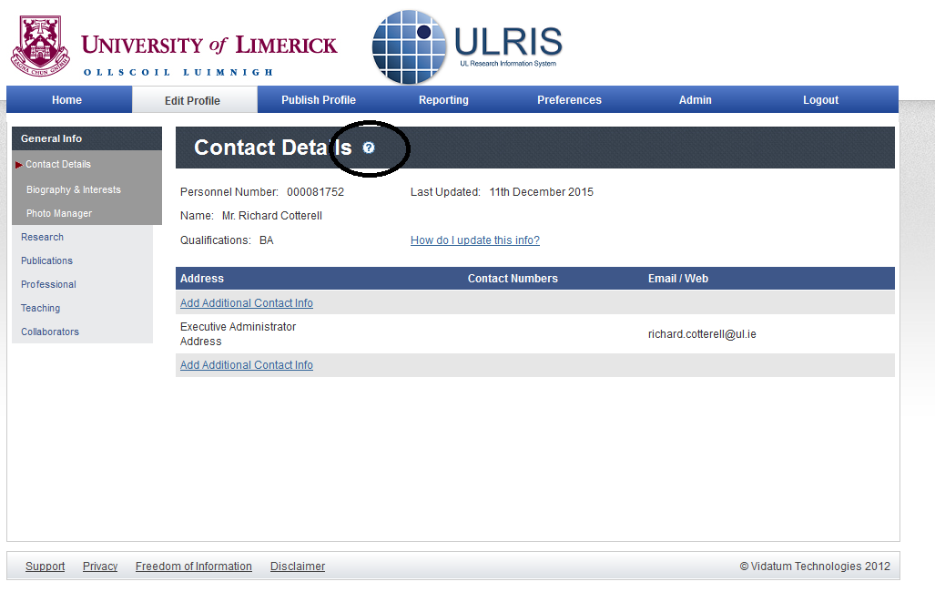

5 Step Quick Start Guide
Login to the system for the first time
Update your publishing alias(es)
Enter your biography
Claim your publications
Review and Publish your profile

Logging in
The URL (web address) for the system is http://ulris.ul.ie/live You log in with your UL e-mail address and password.
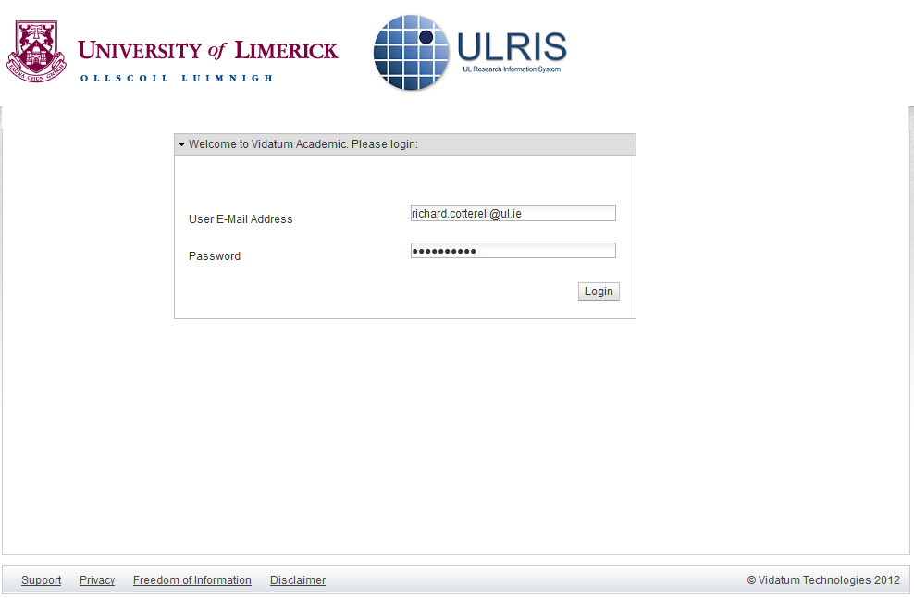

Updating your Publishing Alias
When you login to the system you will be brought to the homepage, see next page, this screen contains a summary of your research profile.

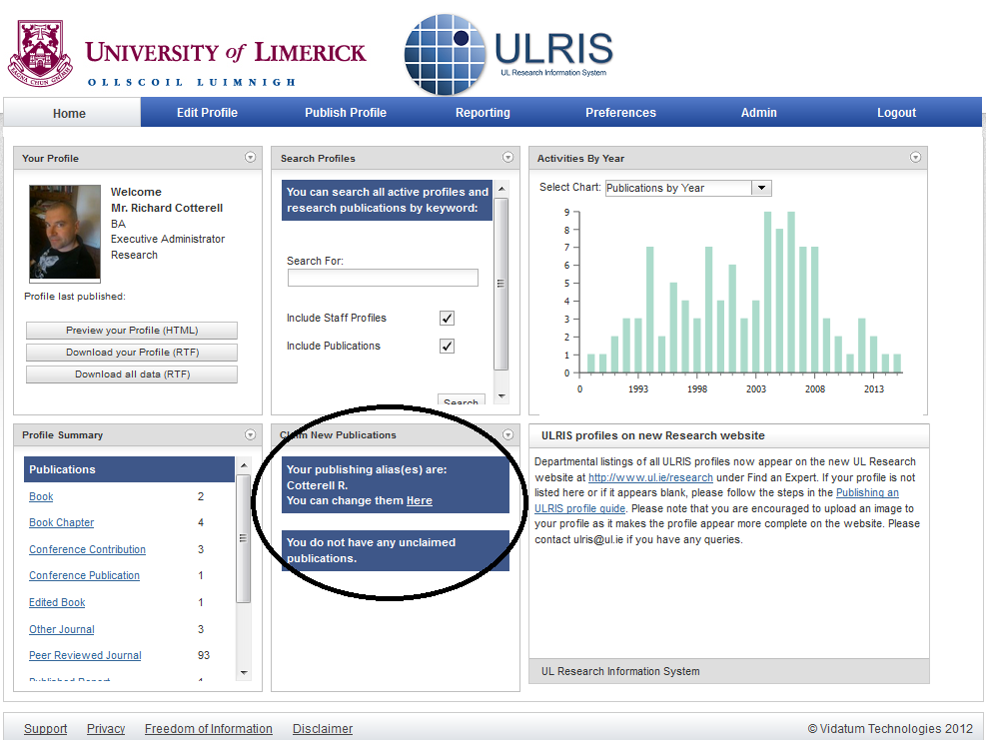

Before entering any new publications, you need to record your Author Name and Keywords in the user preference. These settings allow the system to match publications from the Web of Science, PubMed and from colleague’s profiles for addition to your profile.
You can do this by either clicking on the linked circled in the screenshot above or by clicking on the Preferences link in the main menu bar, and then enter all the variants of your name and initials that are used by your publisher and journals (see below).

Only use your surname and initials, separated by spaces. Do not add any punctuation. Click on the Add button to add each entry.
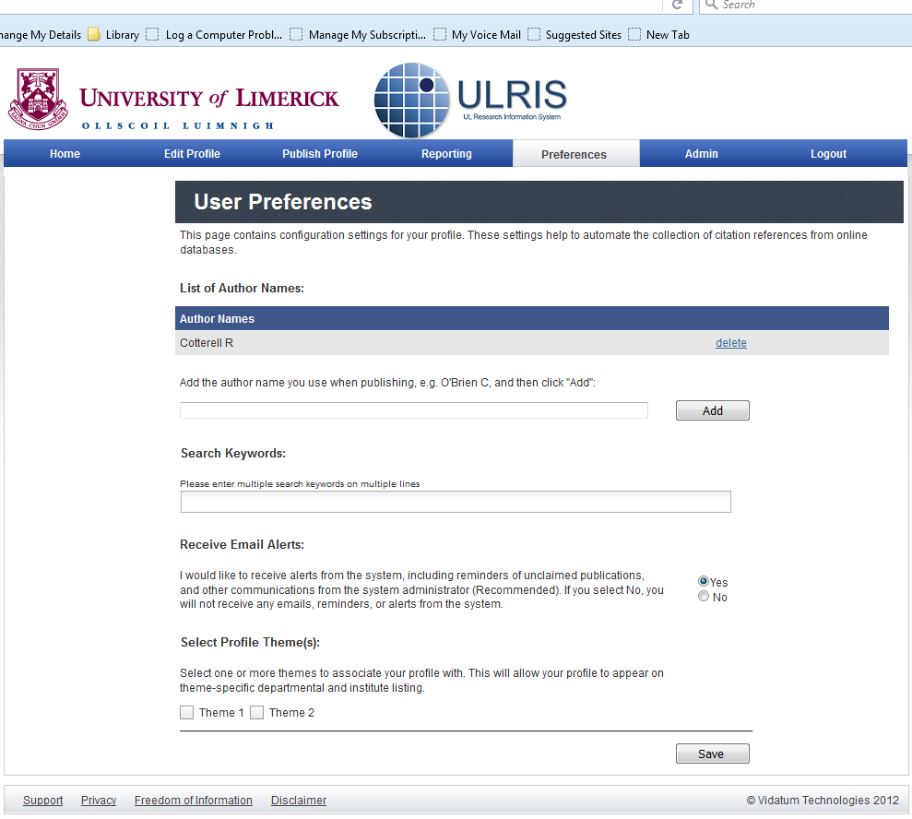

When you have finished remember to click Save.

Updating Your Profile
Click on the ‘Edit Profile’ tab in the main navigation bar to begin editing. Your web profile is stored under several categories:
General Information: This contains your main contact details, biography, and photograph.
Research: This contains your general research information such as your Research Interests, your Research Projects , and your Research Proposals?
Publications: contains all publications authored and co-authored by you. They are split up into a different publication types such as books, chapters, journals, and so on.
Professional Details: This contains a history of your professional qualifications, such as committee work, patents, languages, education record, previous employment record and so on.
Teaching: This is a summary of your teaching qualifications, including teaching interests, recent, and current students, and modules taught.
Collaborators: This allows you to record detail of interaction with internal and external research and academic collaborators.

Note: When copying and pasting text, use the “paste-as-text” icon on the text editor menu . This removes unwanted formatting.

Adding Publications
The system is initially pre-populated with all your publication from Web of Science & Scopus where possible. You should initially review these publications for completeness and accuracy. Previous publications from InfoEd are contained in the Claim area for each researcher.
The system automatically downloads all the latest publications associated with the university from online sources such as PubMed and the Web of Science. The system attempts to match those downloaded publications to your profile based on the publishing alias mentioned earlier, but you must still claim those publications.

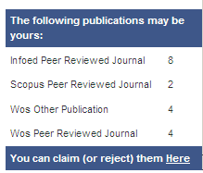
The Claim Publications box is on the homepage and shows all publications that you have not claimed or rejected yet.

Publications matching your preferred Author Name which have not yet been assigned to your profile are shown in the Claim Area at the top. This may include some existing entries from InfoEd, PubMed, Web of Science or manually entered items by other university research or academic staff.

To claim a publication
CLcik on the link in ‘You can claim (or reject) them Here’ as above. This will then bring you to the cliam area showing thedifferent categories of publications that may be yours. Click in the checkbox at the right of the entry, and then click on the “Add Selected Publications“ button at the bottom of the page to claim the publication

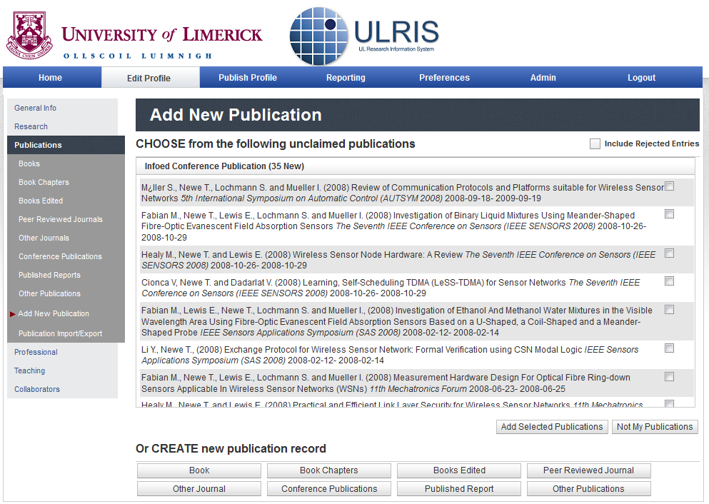.

To disclaim a publication
If there are publications shown which are not yours (for example, wrong matches for your name from online databases), you can disclaim them by clicking the checkbox at the right of the entry, and then clicking on the Not my publications button at the bottom of the page.

You can find additional details of this process (such as reversing claims or disclaims) in the Publications section.

Publishing Your CV

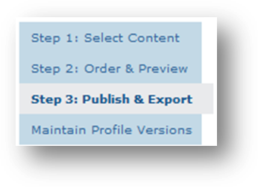
Once you have completed editing your profile, you will then be able to publish your web profile/CV. Clicking on “Publish Profile”will bring you to the CV publishing area of the system. There are 3 main steps in this process:
- First, you must select the content that you want included in your CV.
- Second, you can (optionally) change the order of items and sections in your CV.
- Third, you publish your CV.
Your CV is split into several sections, closely mirroring the sections under “Edit Profile”. You will have sections called Home, Research, Publications, Professional, Teaching, and Collaborators. You do not have to have content in ALL of those sections to publish your CV.
Go to each of the above section, and tick the boxes that you want to appear in your CV. Make sure you press CV once for each section before you move onto the next one.
After you have finished adding items to your CV, you can click on “Step 2: Order and Preview” on the left-hand menu. This is not a mandatory step. If you do not do this, your details will be listed in reverse chronological order (newest first).
Finally, click on “Step 3: Publish and Export”. Click on Publish my Profile to Web. After that, you may click on “Review Published Profile (HTML)” to see the CV that you have just created.

More detailed information on each screen

The Dashboard
The dashboard is the “Homepage” of the Research Information System, a summary of your activities and profile. All organised in tabs following a natural continuation of the publishing/reporting/research process.
Along with shortcuts for easy access to most of the functions of the Research Information System, it contains a number of useful shortcuts to other parts of the system, and includes information, alerts, and other important pieces of information.
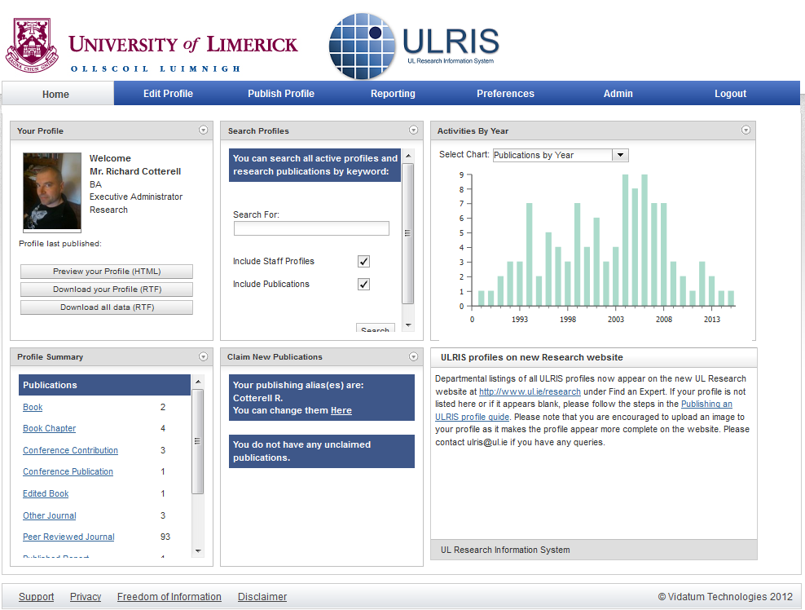

General information
Your basic general information is located under Edit Profile tab and is automatically fed into the system by the university Human Resources Information System.
This includes:
- Contact details
- Biography & Interests
- Photo Manager
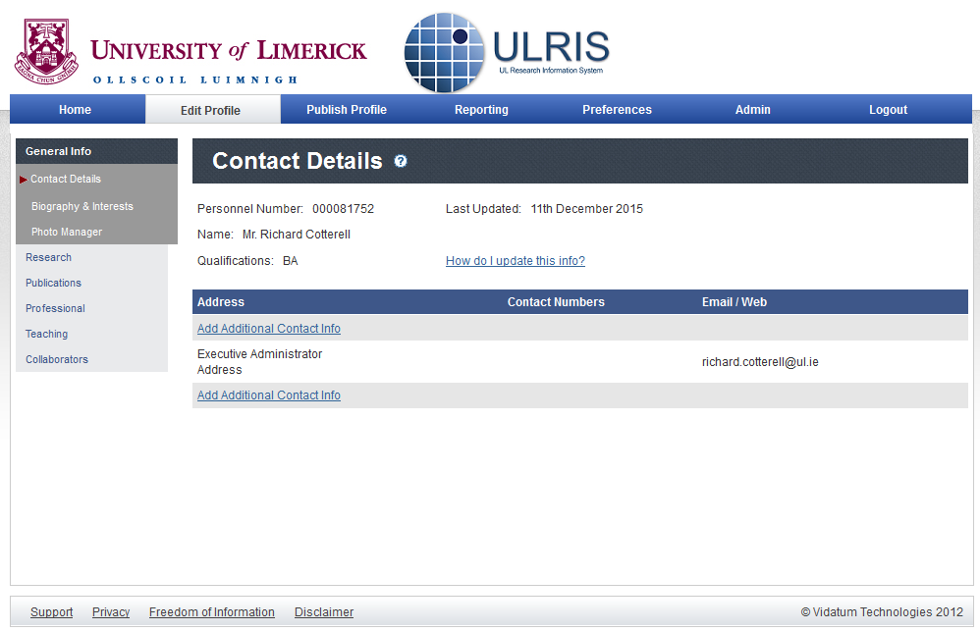
This information is shown as it is known in UL’s human resources database. You cannot amend this information yourself: if there are errors to your qualifications, please see the link to How do I update this info? To have it updated.

Contact details
- your Staff Number
- your Name
- your principal Qualification[s]
You can freely add multiple fully editable blocks of contact information. There is an Edit link to the right of each block which opens an editing screen where you can update the information (see below). There is a Delete link to allow you to delete a block.
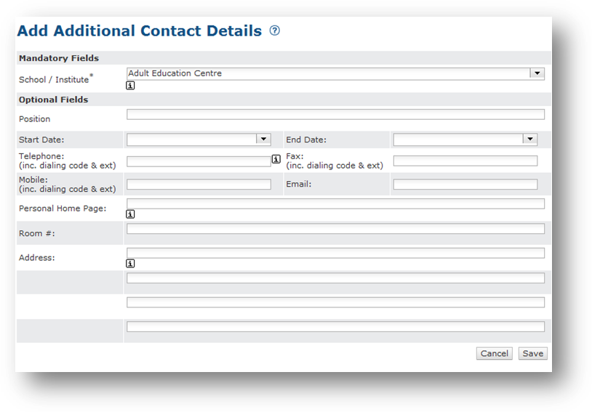
The School/Institute field is mandatory, and you need to pick a value from the drop-down menu. This contains all the official names of Schools, Departments, and Offices within the University. You cannot type your own text here.
The remaining fields are for you to include whatever relevant contact information you wish to supply. When entering your Start Date and Finish Date, a drop down calendar appears in the fields to ensure that dates are entered in the correct format.
When you have finished entering or editing the contact information, click on the Save button at the bottom of the window. If you want to cancel your edits, click on the Cancel button instead. When it comes to publishing your profile, you can choose which Contact Details block to publish; so if the HR-supplied data is not up to date you can select an alternative you have created yourself.

Biography and interests
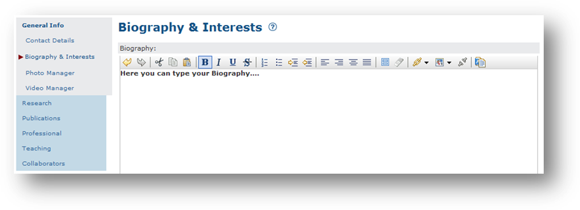
This section provides a mini word-processor window where you can enter your biographical details. Click the Save button when you are finished.
When pasting text (here or anywhere else) which you have copied from your word processor or web browser or other office application, use the “Remove Formatting” button to ensure the text is cleaned up properly.
If you do not remove formatting, you risk transferring all kinds of extraneous formatting garbage which may mess up your profile.

Photo Manager
You will find the Photo Manager in the General Information section. To add an image simply click on Browse, locate the file of yourself that you have already on your computer disk (copied from your camera or elsewhere) and click the Save button.
Images must be in JPG or GIF format (JPG is preferred for photographs) and the file size must be less than 500Kb. This means that you need scale down any megapixel images from a digital camera. You can do this with any normal image-editing software: you do not need to buy anything, as you can download several image-editing programs for free (e.g. GIMP).

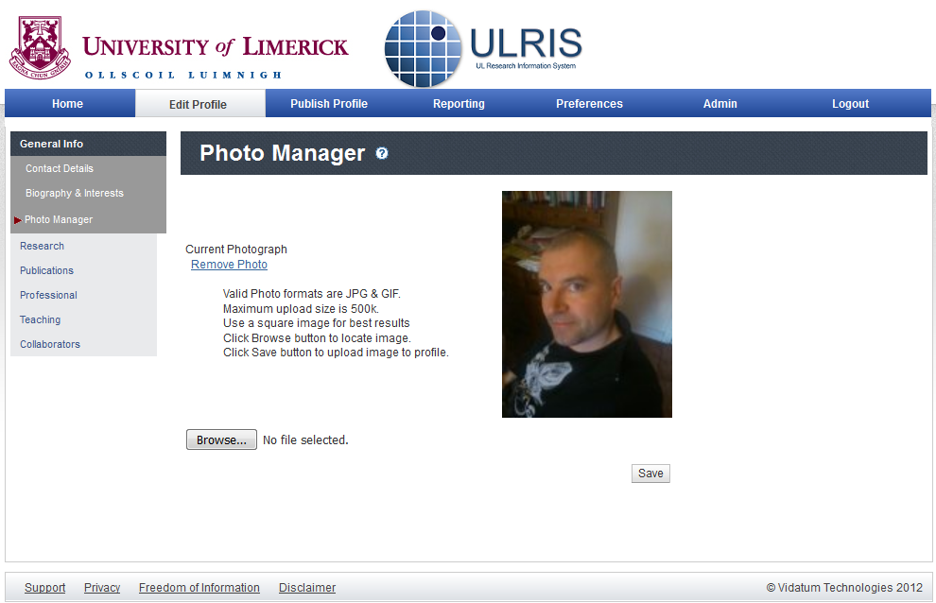

Research
In the Research Interests section you can write your own description of research you are (or have been) involved with, using the mini word-processor window provided. Click the Save button when you are finished.
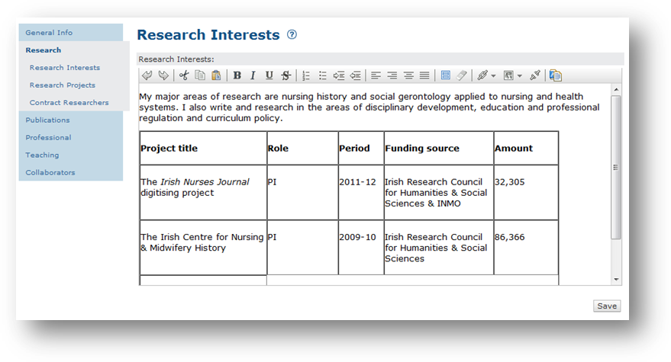

Research Projects
This screen lists your registered grants. This screen is not live at present.

Publications
This section contains your bibliography. All your previously recorded publications will have been transferred here, along with any other relevant publication entered by other members of staff, or downloaded from bibliographic databases such as PubMed and Web of KnowledgeSM.
In the Publications section you will be able to:
- review references uploaded to your profile
- claim references which the system has matched against your name
- manually add references to your profile
- import references from personal bibliographic databases such as EndNote, Refworks, Zotero etc. and export references from your profile to personal bibliographic databases
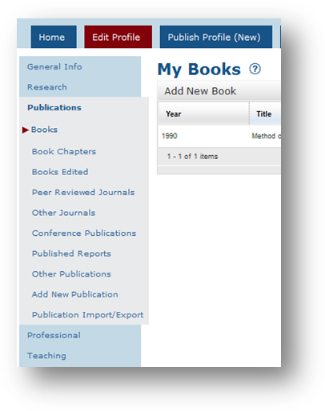
- upload the full text of your publications to your university institutional repository (optional).

Review your publications
A data entry team has uploaded references to your profile by using the following sources and cross-checking these against your recorded profile:

- Data migrated from your profile inInfoEd
- Data matching your profile from the bibliographic databases - Web of KnowledgeSM.
- Data matching your profile uploaded to the Research Information System by your university co-authors
Please review all publications that were uploaded against your profile to ensure that the right information is in the right fields.
These references were then categorised into the following publication types:

- Books
- Book Chapters
- Books Edited
- Peer Reviewed Journals
- Other Journals
- Conference Publications
- Published Reports
- Other Publications

You can navigate through these sections to review works that have been pre-populated to your profile.

Adding New Publication - Claim area
Please note that your author name and aliases have to be correctly recorded in order for this to work. Please see the Quick Start Guide section of this document for more details.
Click on Add New Publication to see the Claim Area. This is shown below and is found immediately underneath the heading ‘CHOOSE from the following unclaimed publications’.
Publications matching your preferred Author Name which have not yet been loaded against your profile are shown in the Claim Area at the top. This may include some existing entries from the
old Research Information System, PubMed, Web of Science or manually entered items by other university research or academic staff.

To claim a publication
Click in the checkbox at the right of the entry, and then click on the “Add Selected Publications“ button at the bottom of the page.

To disclaim a publication
If there are publications shown which are not yours (for example, wrong matches for your name from online databases), you can disclaim them by clicking the checkbox at the right of
the entry, and then clicking on the Not my publications button at the bottom of the page.

Disclaimed a publication in error?
If you had previously disclaimed a publication in error, tick the box labelled “Include Rejected Items”. This will show all previously disclaimed publications, marked with a strikethrough. You will be then able to select those publications and then click on “Add Selected Publication”

Empty claim area
If no claimable publications are shown, then there are no outstanding entries to be claimed, or your author name as recorded in “Preferences” is incorrect. Please see the Quick Start Guide for details on how to set your author name.

Adding new publications manually
You can add new publications yourself in two ways:
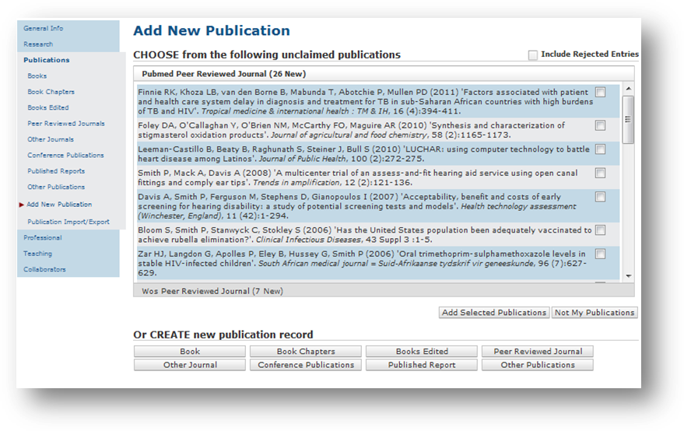
by uploading them from your existing personal bibliographic database (see below Publication import/export), (e.g. BIBTEX, JabRef, Zotero, EndNote, ProCite, Reference Manager, etc.) For further instructions, see the Publication Import/Export section below.
by clicking on one of the links under ‘CREATE a new publication’ at the foot of the page for the relevant type of publication , and adding the entry in the form provided

The publication categories are as follows:
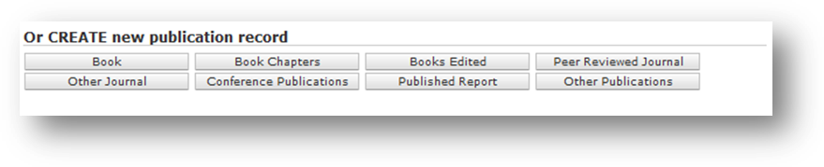
- Book
- Book Chapters
- Books Edited
- Peer Reviewed Journal
- Other Journal
- Conference Publication
- Published Report
- Other Publications

The Other Publications link provides access to a drop-down submenu in the form with dozens of other publication types not shown here for reasons of space. If a specific type of publication that you need is not shown, please email your system administrator to ask for it to be added.
The ‘new publications’ form is slightly different for some types of publication because they have different requirements: Most of the fields are self-explanatory, but a few require foreknowledge, which is noted in the list below.

All types
Author and Editor names: please read the online help (click the beside the Author field). Multiple authors must be separated by a semicolon
Month is currently compulsory, if you do not know the month please enter select unknown.
Titles must be given in full and without enclosing quotes.
"Laughter and Language in 'Romeo and Juliet'"
Laughter and Language in 'Romeo and Juliet'
Embedded quotes around cited titles should remain. There is no provision for italics, bold, or equations (TEX mark-up can be used for mathematics).

Books
See the general comments in All types above.

Book chapters
If your chapter is untitled, just give the chapter number.

Books edited
See the general comments in All types above.

Peer-reviewed journals

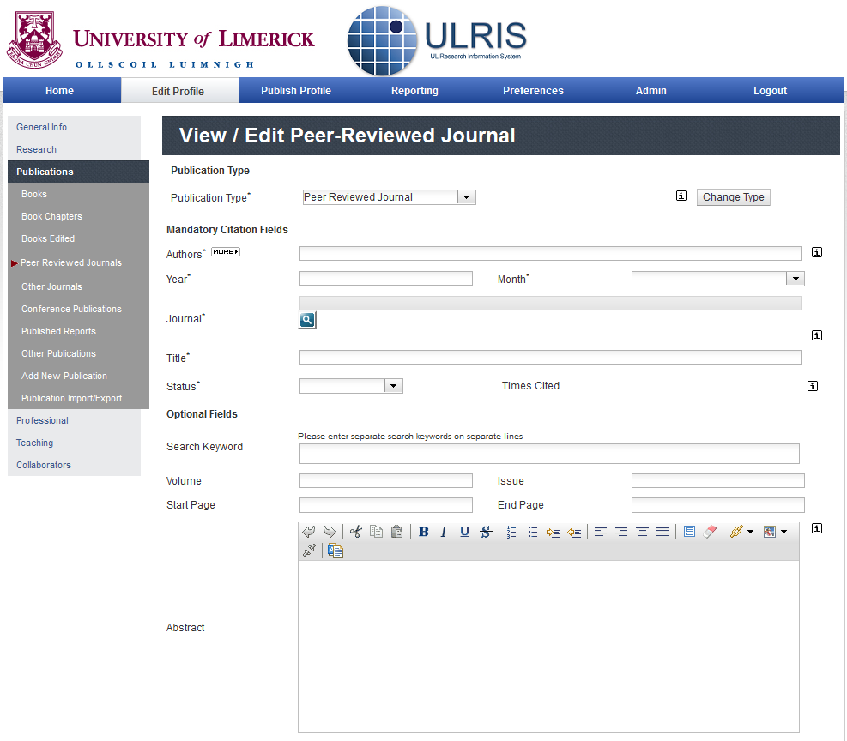
The list of journal titles is held separately in an Authority list maintained by the Sytems Administrator.
If the title of your peer-reviewed journal is not shown, email ulris@ul.ie and ask for it to be added.

Other journals
For these journals, give the full journal name.

Conference publications
This type is for papers published in a volume of Proceedings. Other forms of conference presentation which have been published can be loaded in the ‘Conference Contribution’ type under ‘More Publications’.
Conference presentations and other contributions which have not been published go in the ‘Professional’ section under ‘Conference Contribution’.

Published reports
See the general comments in All types above.

More publications
This section provides access to a much longer menu of more publication types covering
(at the time of writing):
Abstract, Aggregated Database, Ancient Text, Annotations/Encodings, Artwork, Audio visual material, Bill/Resolution, Blog, Book Review, Case, Catalogue, Chart or Table,
Classical Works, Computer Program, Conference Paper, Dictionary Entry, Documentary,
Edited Book, Editorial, Electronic Article, Electronic Book, Electronic Journal, Electronic
Source, Encyclopaedia Entry, Equation, Fact Sheet, Field Guide, Figure, Film or
Broadcast, Foreword, Generic, Government Document, Grant, Guest Lectures, Guest
Speaker, Hearing, In Press, Index, Internet Communication, Invited Lectures, Invited
Review Articles, Invited Seminars, Invited papers, Legal Rule/Regulation, Magazine article, Manual, Manuscript, Map, Music score, Newsletter, Newspaper Articles, Online
Database, Online Multimedia, Pamphlet, Performance, Personal communication,
Poems, Policy Contribution, Presentation, Presented Papers, Programme Note,
Published Review Articles, Serial, Serial (Book, Monograph), Slide, Sound recording, Standard,
Statute, Technical Publication, Thesis/Dissertation, Translation, Unpublished Reports,
Unpublished work, Video recording / TV, Web Page or Working Paper. If there is a further type of publication you need which is not in the list, please e-mail your local Research office or helpdesk and ask for it to be added.

Published Profiles
The entries you select to be published in your Profile will be formatted based on the fields you use to enter them. Please ensure that the right information is in the right place.
See particularly the warning Temporary fix for conference papers published in journals in the list in this section above about the special use of the Location and Conference Title fields for Conference Publications to get around a temporary deficiency in the fields available.
The grouping ‘More publications’ is only used here to save menu space because the list is very long.
When your profile is published to the web, each publication type is presented separately, and the heading ‘More Publications’ is not used.

Publication import/export
This section allows you to upload existing publications from a personal bibliographic database such as BIBTEX, Zotero, JabRef, EndNote, ProCite, Reference Manager, etc.; and to import entries from online databases of publications. 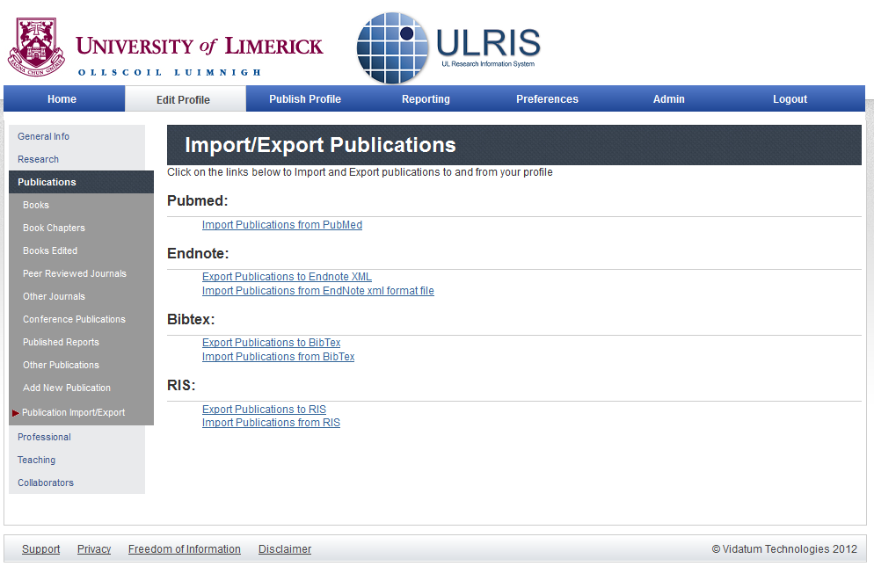

Pubmed
Click on Import Publications from PubMed and type in suitable keywords, or the PubMed ID (PMID), and click on Import. You can also enter a % (percent) sign in the Keywords field to act as a wildcard.
If there are matching publications, they will be shown in the same Claim/Disclaim format used below for you to claim or reject. The other three sources are for personal bibliographic databases. ULRIS can import your existing entries and also export selections (or all) of your stored entries from your profile. In the following sections we deal only with importing (uploading).

File formats
Whatever the type of personal bibliographic database you use, you must provide your entries in one of the three compatible formats: EndNote-XML, BIBTEX, or RIS. All known personal bibliographic databases are capable of saving your entries in one of these forms, and you must do this before uploading them.

Endnote
Click on Import Publications from EndNote xml format file and then click on Browse to select your .xml file of entries from your computer disk. Note that you must already have saved the entries from EndNote, ProCite, Reference Manager, or other system into EndNote-
XML format beforehand, using the FileExport menu in your personal bibliographic database.
When you have located your exported .xml file with the Browse button, click on Import to upload and import the entries.

BIBTEX
Users of LATEX, ConTEX t, and other TEX systems using BIBTEX: click on Import Publications from
BIBTeX and then click on Browse to select your .bib file. Click on Import to upload and import the entries.

RIS
The RIS format (Research Information Systems) can be used as an export and import format
by most personal bibliographic database systems. Click on Browse to select your .ris file.
Click on Import to upload and import the entries.
Save time by using journal, book, and library sites
If your publications are listed in online sources, you can save yourself a lot of typing or copying-and-pasting by using the ‘Download Citation’ function on these types of web site: the numerous bibliographic and full text databases accessible from the Library website.

- your publisher's or journal's web site
- your university library catalogue or other library catalogues such as the British Library or Library of Congress.
You can also use Zotero to extract and record the information from those web sites, and then save it in BIBTEX or RIS format ready for uploading and importing into ULRIS.
Zotero is a free plugin for the Firefox browser. Details of how to use it are in Reference Information software/Zotero.

Professional activities
In this section you can enter activities which do not usually result in formal publication but is important to present them on your CV. Each subsection is laid out in the same way.
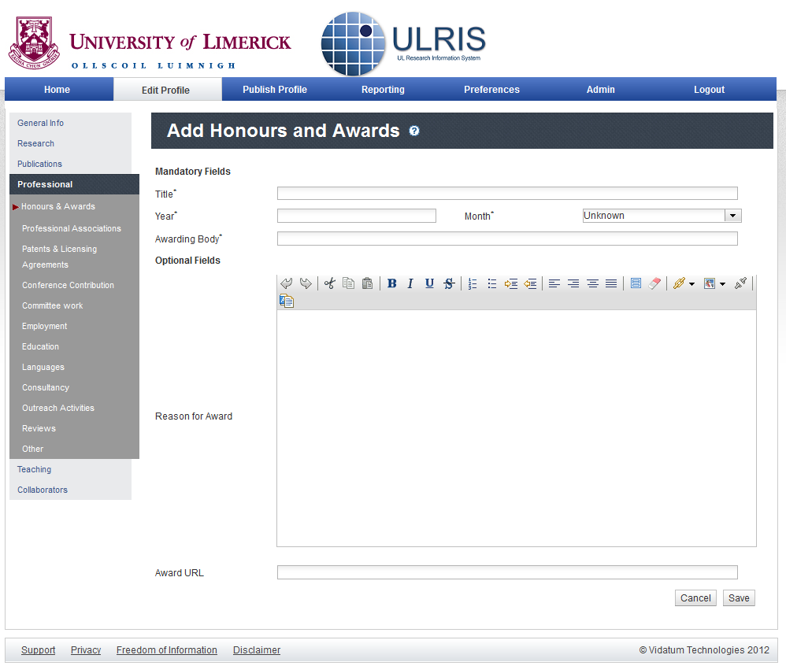Click on one of the subsections listed (Honours & Awards, Professional Associations, Patents & Licensing Agreements, Conference Contribution, Committee work, Employment, Education, Languages, Consultancy, Outreach Activities, Reviews, or Other) to show or amend your entries.
To add an activity, click the Add New link above or below the list of entries to bring up the fields for that section.

Teaching activities
This section covers your teaching and supervisory activities. Each subsection is laid out in the same way.
Click on one of the subsections listed (Teaching Interests, Recent Postgraduates Students, Current Postgraduate Students or Modules) to show your relevant details on those areas.
The first two subsections use a mini word-processor window like those in Research and Biography and interests where you can enter the details.
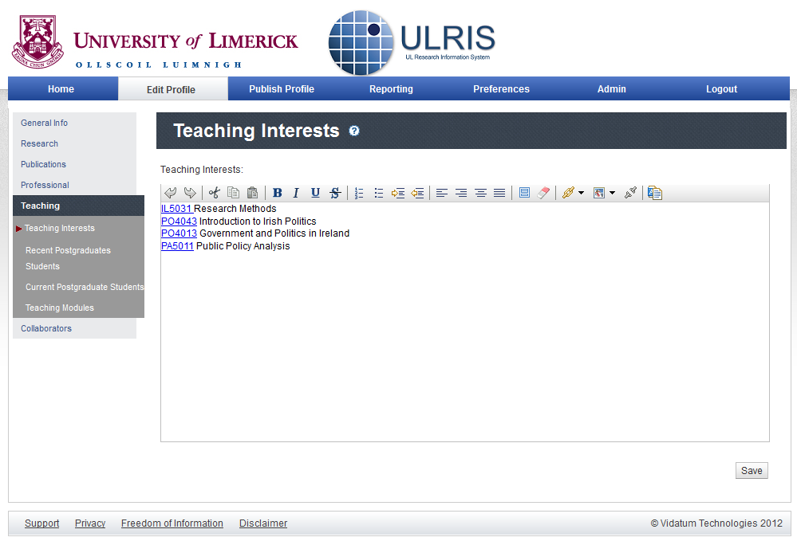Click the SAVE button when you are finished.
The Current Postgraduate Students section is automatically populated from the University’s Student Information System to reflect the latest graduate students that are assigned to you (this functionality will be available in the upcoming upgrade in early 2016).
The Teaching Modules section contains a listing of the modules which you teach in the university.

Collaborators
Each entry uses a mini word-processor window like those in Teaching interests where you can enter the details for both Internal and External collaborators. Click the SAVE button when you are finished.

Editing and publishing your profile
To select information for publishing in your Profile or for generating a CV, click on the Publish
Profile link in the blue menu bar towards the top of the window. There are three steps to the process:

1. Select Content
In this step you can select what you want to appear in your Profile by clicking the checkbox at the right of the entry within the sections listed in the second blue menu bar.
These correspond to the sections listed in the Edit Profile menu, explained in Updating your profile above, namely Home, Research, Publications, Professional, Teaching, and Collaborators.
If you want to select all the entries in a section, click on the Select All button; otherwise click the checkbox at the right of the entry. As you finish each section, click on the SAVE button to add the selected entries to your Profile.

2. Order and Preview
This step lets you preview what will be published, and it allows you to re-order the subsections within the Home, Publications, Professional, Modules, and Collaborators sections.
Use the Up and Down arrows after the title of each section to raise or lower them in the order. In Publications you can also re-order the individual publications using the Up and Down arrows beside the sequence number at the end of each citation.
Note that you cannot change the order of the major sections Home, Research, Publications,
Professional, Teaching, and Collaborators themselves, only the order of the subsections within them.

3. Publish/Export
The final step is to publish your Profile to the your university web site. This will appear in the Staff
Profiles section of the web pages for your department, school, faculty, college, or project.

Publish to web
To publish your Profile to the web site, click on the Publish My Profile to Web button.

Download to word processor
You can also generate a CV in a format that can be edited with a word processor such as Microsoft
Word or Open Office so that you can tailor it to specific purposes such as inclusion in a funding bid, and application for a position, or participation in a consortium.

To download your profile to Microsoft Word click on the Download Profile data to Word button.

This generates an RTF file which can be edited in any word processor. It includes only the selection
of data that you have chosen to publish to the web.

To download your entire Profile hit the Download All Profile data to Word button.

This option includes all the information in your Profile, not just the selection you chose to publish to the web.

Logout
When you are finished work, please remember to log out. Click the Logout link on the last tab.

Frequently asked questions

Who do I contact if I cannot login to the system?
Please contact Ulris@ul.ie

What are the Benefits of the system for Researchers?
The Research Information System will save both time and effort by enabling you to maintain your research profile in an easy-to-use, web-based application. The data can then be downloaded in multiple formats to meet your information requirements or, when published, is available for viewing via your Department/School/Institute website.
Once published, your profile will allow your colleagues and others to more easily cite your publications in referencing
An up to date web profile helps to:
Win new research awards by profiling research expertise and by providing consistent CVs for inclusion in proposals;
Find collaborators with similar research goals;
Get publications cited by presenting their work online and linking their profiles to online repositories of research publications. This in turn helps to enhance their personal reputation and that of the university.

Does the system works from home?
Yes, as the Research Information System is a web based programme it is fully accessible off campus and worldwide.

How do I Edit My Profile?
When you first login to the profiles system you will be brought to the homepage. Click on the Edit Profile tab in navigation bar to begin editing.
You can select the section of your profile to edit using the navigation bar on the left-hand side of the page.

Tips for Updating Your Profile
Help specific to each individual page is available by clicking on the question mark icon on the top right of the page.
Before entering any peer reviewed journals, check, if applicable, whether they are available from the Pubmed or Web of knowledge list by clicking into the “claim area”

Will It Take A Lot of Time to Use?
It may take some time to validate your information at the start. After that, though, it will be easy to make changes and add new information. Moreover, you will always be able to produce a new CV or report on demand in only a few clicks.

Also, it's worth considering that the time you spend entering data now will be time you don't have to spend filling out annual report submissions and grant applications later. Vidatum Academic can save you time and energy in the long run.

How do I Export my Data to MS Word?
By navigating to the CV Builder in Step 3 you can export your data to MS Word.

How do I Publish My Profile?
Click on the Publish Profile tab in navigation bar to begin publishing.
Step 1
Select Content Select the content you want to include form each section of your profile using the checkboxes.
Step 2
Order and Preview Rank and Order the content in each section using the arrows to move items up or down the list.
Step 3
Publish or Export Select one of the publishing or export options from the list.
- Use Publish My Profile to Web to update your webpage.
- Use Review Web Profile to get a preview of what your webpage will look like.
- Use Export Profile to Word to generate your profile in MS Word

I Have Made Amendments To My Profile But I Don’t See Them In My Published Profile?
Once you have made any amendments, you need to select the content and republish your profile to the web for the changes to take effect.

If I Have a Problem Who Can I Contact?
All issues can be reported to Ulris@ul.ie

Does the system conform to standard data protection legislation?
As a general principle the system is self-service in nature and all data entered is at the discretion and the full control of the end user. Specific rules from the Data Protection Act are addressed under the following headings:
- Fair Obtaining & Purpose Specification
Through-out the collaborative development of the Research Information System the rationale behind the Researcher Portal has been communicated to all the stakeholders. The forum for these communications were at Focus Group meetings, User Acceptance Testing, Academic Seminars, a specially designed Research Portal information leaflet and also on this site in the FAQ section.
- Use and Disclosure of Information
The use and disclosure policy has been outlined in the help files in the system and also in the research Portal information leaflet.
- Security
The system is delivered by a secure web site and maintained according to standard internet security standards.
- Adequate, relevant and not excessive
The system is designed to be of benefit to the academic users. Certain fields of information when entering publication, professional or other records are optional with only the minimum amount of mandatory fields. The mandatory fields were determined using international standards for citation references. In the case of professional activities the mandatory fields were determined by referencing other leading academic profile systems.

- Accurate and up-to-date
Accuracy is facilitated by, where possible, external validated data feeds from systems such as the Personnel System, Student Information System, Web of Knowledge and Office of Funded Research. Where data is entered manually by an academic a check is performed by an administrator at School level on the publicly available information.

- Retention Time
The retention time of the data is at the discretion of the end user.

- The Right of Access
The system administration controls access and user levels within the system. Access to the data within the system is tightly controlled to ensure access is limited to those of authority.

