单机K8S环境安装

指导手册

作者：彭朝辉@湖南真视通

日期：2018年09月15日

目 录

1 前期准备 2

1.1 安装CentOS7.6 Minimal 2

1.1.1 设置桥接网络，启动网卡 2

1.1.2 启动XShell，远程登录 3

1.2 配置虚拟机环境 3

1.2.1 修改主机名 3

1.2.2 禁止防火墙 3

1.2.3 关闭selinux 3

1.2.4 关闭swap 3

2 安装Kubernetes 4

2.1 设置yum源 4

2.2 安装Docker-ce 4

2.3 安装Kubernetes 4

2.3.1 安装azk8spull 4

2.3.2 安装kubeadm 5

2.3.3 启动kubernetes集群 5

2.3.4 启动kubernetes集群 5

2.4 安装Kubernetes Dashboard 5

2.4.1 安装Kubernetes Dashboard 5

2.4.2 获取secret 6

2.4.3 创建kube-dashboard管理员 6

# 前期准备

## 安装CentOS7.6 Minimal

默认帐户：root/root, peter/peter.peng

### 设置桥接网络，启动网卡

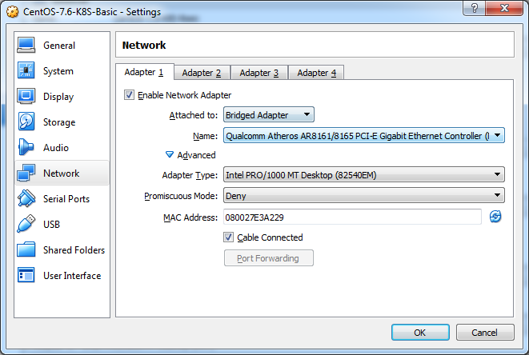

$ cd /etc/sysconfig/network-scripts/

$ vi ifcfg-XXXX

***修改noboot=no 为 noboot=yes，并重启虚拟机***

$ ip addr show | grep ‘inet’

$ ifconfig | grep ‘inet’

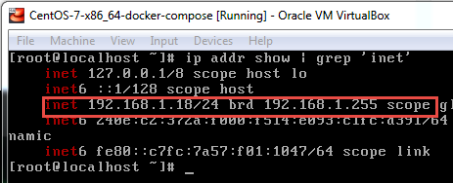

参考资料：[Centos7安装完毕后无法联网的解决方法](https://blog.csdn.net/lijie18/article/details/54706438)

$ service docker stop

$ mv /var/lib/docker /data/docker

$ ln -s /data/docker /var/lib/docker

$ systemctl daemon-reload

$ systemctl restart docker

$ systemctl enable docker

参考资料：[Docker: 如何修改 Docker 的镜像存储位置](https://www.cnblogs.com/csharpsharper/p/5685263.html)

### 启动XShell，远程登录

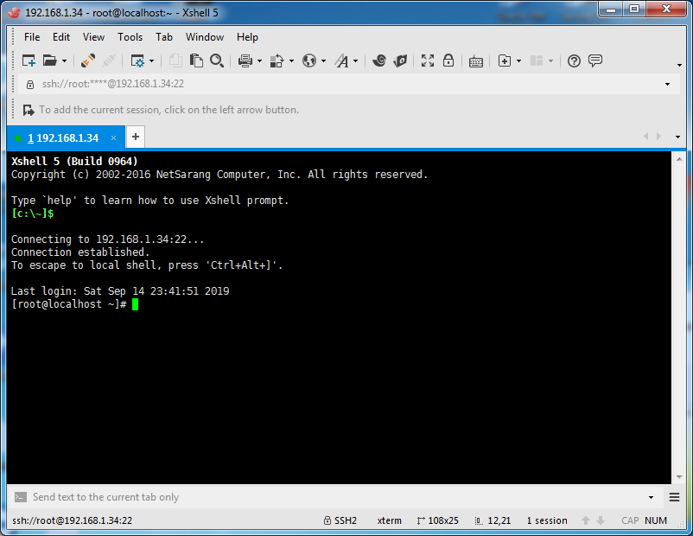

## 配置虚拟机环境

### 修改主机名

$ hostnamectl set-hostname k8smaster

$ hostname

参考资料：[centos修改主机名的正确方法](https://www.cnblogs.com/zhaojiedi1992/p/zhaojiedi_linux_043_hostname.html)

### 禁止防火墙

$ systemctl disable firewalld

$ systemctl stop firewalld

$ firewall-cmd --state

### 关闭selinux

$ vi /etc/selinux/config

将SELINUX=enforcing改为SELINUX=disabled

或 sed -i 's/SELINUX=enforcing/SELINUX=disabled/g' /etc/selinux/config

### 关闭swap

$ swapoff -a

$ vi /etc/fstab

注释 #/dev/mapper/rhel-swap   swap                    swap    defaults        0 0

$ free -m

参考资料：[centOS7 关闭swap](https://www.cnblogs.com/silgogo/p/10684370.html)

# 安装Kubernetes

## 设置yum源

$ yum install -y curl wget git

$ cd /etc/yum.repos.d/

$ curl -o CentOS-Base.repo http://mirrors.aliyun.com/repo/Centos-7.repo

$ curl -o docker-ce.repo <https://download.docker.com/linux/centos/docker-ce.repo>

$ cat <<EOF > /etc/yum.repos.d/kubernetes.repo

[kubernetes]

name=Kubernetes

baseurl=http://mirrors.aliyun.com/kubernetes/yum/repos/kubernetes-el7-x86_64

enabled=1

gpgcheck=0

repo_gpgcheck=0

gpgkey=http://mirrors.aliyun.com/kubernetes/yum/doc/yum-key.gpg

http://mirrors.aliyun.com/kubernetes/yum/doc/rpm-package-key.gpg

EOF

$ yum clean all

$ yum makecache

$ yum repolist

参考资料：[使用kubeadm快速搭建单机kubernetes 1.13集群](https://www.jianshu.com/p/70efa1b853f5)

## 安装Docker-ce

$ yum list docker-ce --showduplicates | sort -r

$ yum install -y docker-ce

$ systemctl start docker

$ systemctl enable docker

$ docker info

## 安装Kubernetes

### 安装azk8spull

$ cd /tmp

$ git clone https://github.com/xuxinkun/littleTools.git

$ cd littleTools

$ chmod +x *.sh

$ source /tmp/littleTools/azk8spull.sh

$ source /tmp/littleTools/docker-tools.sh

$ source /tmp/littleTools/kube-tools.sh

参考资料：[docker/kubernetes国内源/镜像源解决方式](https://www.cnblogs.com/xuxinkun/p/11025020.html)

### 安装kubeadm

$ yum install -y kubeadm

$ systemctl enable kubelet.service

$ echo "1" >/proc/sys/net/bridge/bridge-nf-call-iptables

$ azk8spull k8s.gcr.io/kube-apiserver:v1.15.3

$ azk8spull k8s.gcr.io/kube-controller-manager:v1.15.3

$ azk8spull k8s.gcr.io/kube-scheduler:v1.15.3

$ azk8spull k8s.gcr.io/kube-proxy:v1.15.3

$ azk8spull k8s.gcr.io/pause:3.1

$ azk8spull k8s.gcr.io/etcd:3.3.10

$ azk8spull k8s.gcr.io/coredns:1.3.1

$ kubeadm init --pod-network-cidr=10.244.0.0/16

### 启动kubernetes集群

$ mkdir -p $HOME/.kube

$ sudo cp -i /etc/kubernetes/admin.conf $HOME/.kube/config

$ sudo chown $(id -u):$(id -g) $HOME/.kube/config

$ kubectl get node

### 启动kubernetes集群

$ cd /etc/kubernetes/manifests

$ ps -ef|grep containerd

$ kubectl get pods -n kube-system

$ wget https://raw.githubusercontent.com/coreos/flannel/bc79dd1505b0c8681ece4de4c0d86c5cd2643275/Documentation/kube-flannel.yml

$ kubectl apply -f kube-flannel.yml

$ kubectl get componentstatus

$ kubectl get node

$ kubectl taint nodes --all node-role.kubernetes.io/master-

## 安装Kubernetes Dashboard

### 安装Kubernetes Dashboard

$ cd /etc/kubernetes/manifests

$ wget <https://raw.githubusercontent.com/kubernetes/dashboard/v1.10.1/src/deploy/recommended/kubernetes-dashboard.yaml>

$ azk8spull k8s.gcr.io/kubernetes-dashboard-amd64:v1.10.1

$ kubectl create -f kubernetes-dashboard.yaml

$ kubectl -n kube-system edit svc kubernetes-dashboard

找到type字段，将ClusterIP，修改为NodePort

$ kubectl -n kube-system get svc

$ curl -k https://192.168.1.34:32586/

参考资料：[Kubernetes Dashboard的安装与坑](https://www.jianshu.com/p/c6d560d12d50)

### 获取secret

$ kubectl describe secret kubernetes-dashboard -n kube-system

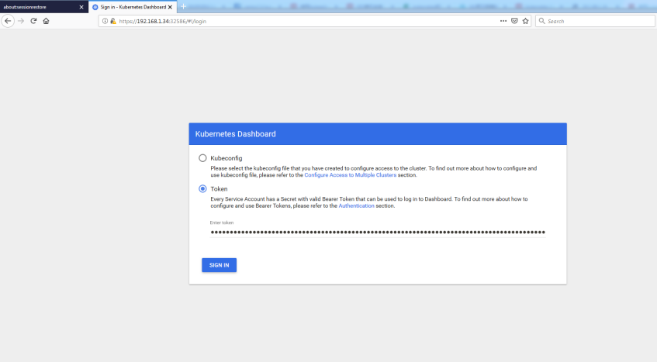

### 创建kube-dashboard管理员

$ cd /etc/kubernetes/manifests

$ touch admin-sa.yaml

$ cat <<EOF > admin-sa.yaml

kind: ClusterRoleBinding

apiVersion: rbac.authorization.k8s.io/v1beta1

metadata:

name: admin

annotations:

rbac.authorization.kubernetes.io/autoupdate: "true"

roleRef:

kind: ClusterRole

name: cluster-admin

apiGroup: rbac.authorization.k8s.io

subjects:

- kind: ServiceAccount

name: admin

namespace: kube-system

---

apiVersion: v1

kind: ServiceAccount

metadata:

name: admin

namespace: kube-system

labels:

kubernetes.io/cluster-service: "true"

addonmanager.kubernetes.io/mode: Reconcile

EOF

$ kubectl create -f admin-sa.yaml

$ kubectl get secret -n kube-system|grep admin

$ kubectl get secret admin-token-mf8ch -o jsonpath={.data.token} -n kube-system |base64 -d

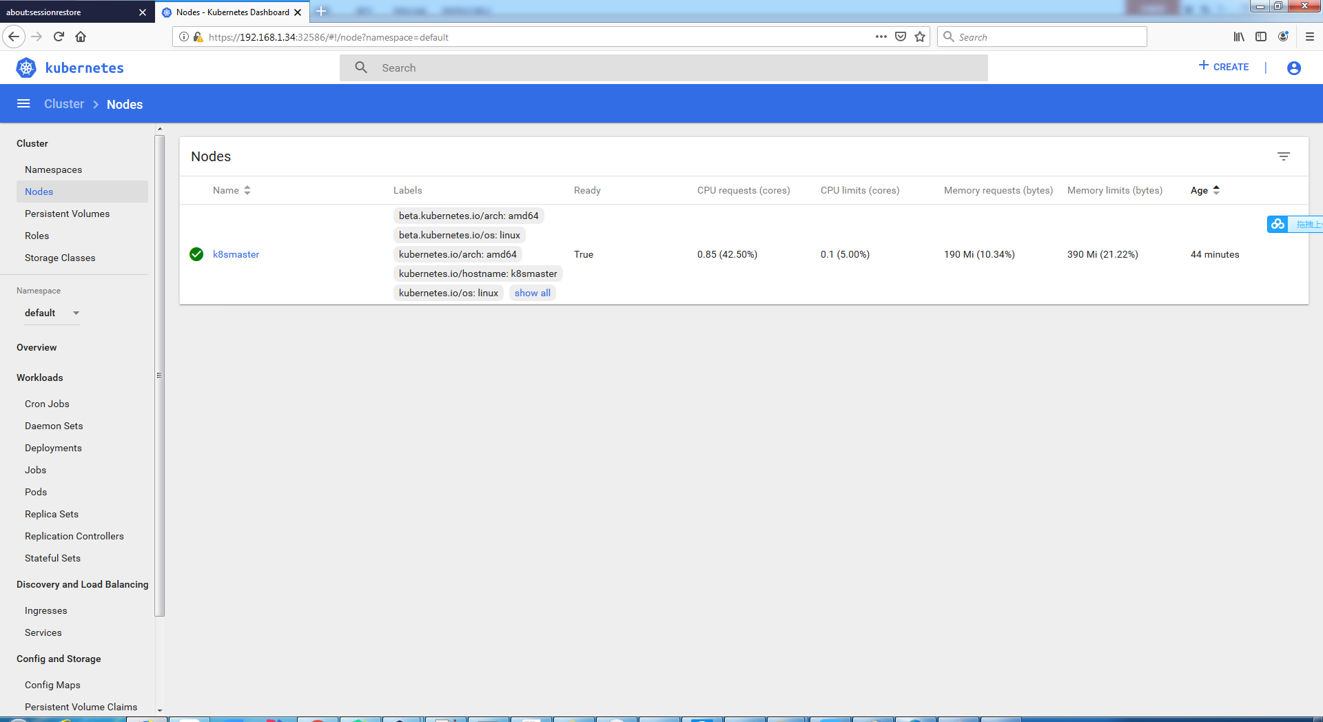

注意：使用Firefox浏览器

参考资料：[创建kube-dashboard管理员](https://www.jianshu.com/p/fca995761d3e)

### 重新生成证书，确保在Google Chrome浏览器中也可访问

$ mkdir -p /opt/k8s/certs && cd /opt/k8s/certs

$ openssl genrsa -out dashboard.key 2048

$ openssl req -new -out dashboard.csr -key dashboard.key -subj '/CN=192.168.1.34'

$ openssl x509 -req -in dashboard.csr -signkey dashboard.key -out dashboard.crt

$ kubectl delete secret kubernetes-dashboard-certs -n kube-system

$ kubectl create secret generic kubernetes-dashboard-certs --from-file=dashboard.key --from-file=dashboard.crt -n kube-system

$ kubectl get pod -n kube-system

$ kubectl delete pod kubernetes-dashboard-7d75c474bb-qprqx -n kube-system

# 安装Helm

## 常见命令：

### 重启kubelet服务

$ systemctl daemon-reload

$ systemctl restart kubelet

### 查看集群信息

$ kubectl cluster-info

$ kubectl get pods --all-namespaces

### 查看日志:

$ journalctl -u kubelet -f

$ systemctl status kubelet