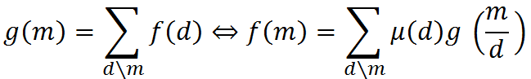

IMG_256

IMG_256

**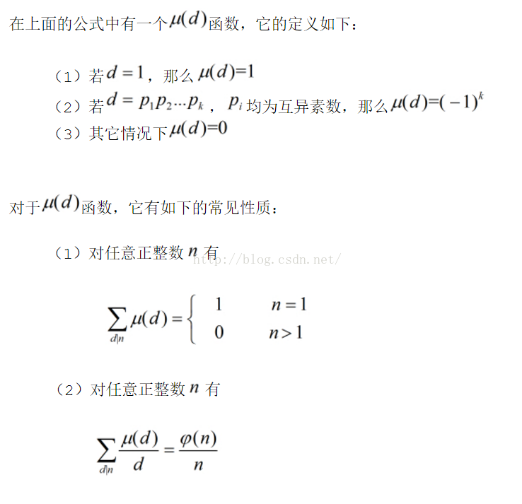**

1. **u(a∗b)=u(a)∗u(b)(积性函数)**