**COMPUTER SCIENCE PROJECT (C++)**



**Submitted To: Mr. Nadeem Salmani**

**Submitted By: Ishan Sang, Neepam Goel**

**Admission No: 2012/0276, 2011/0183**

**Year: 2016-17**

**CERTIFICATE**

**ACKNOWLEDGEMENTS**

We wish to express our most sincere gratitude towards our Computer Science mentor Mr. Nadeem Salmani, for his wilful support, able guidance and encouragement, without which this project would not have come forth.

We would extend our sincere thanks towards our parents for their valuable suggestions and unconditional support throughout the preparation of the project.

We would also like to express our whole-hearted appreciation to our friend Parth Gupta, for his dynamic assistance in this project.

**INDEX**

|  |  |  |
| --- | --- | --- |
| S.No. | Topic | Page No. |
| 1. | Contents | 5. |
| 2. | Introduction | 7. |
| 3. | Code | 8. |
| 4. | Screenshots | 40. |
| 5. | Bibliography | 68. |

**CONTENTS**

* Header Files Used:
* iostream.h
* stdlib.h
* conio.h
* graphics.h
* math.h
* stdio.h
* dos.h
* User-Defined Functions:
* slowtype()
* slowtype2()
* push()
* pop()
* cd()
* get_y_poly_function()
* get_y_conic_pos()
* get_y_conic_neg()
* start_screen()
* graph()
* graphinput()
* menu()
* again()
* special_graphs()
* help()
* about()

**INTRODUCTION**

* ‘Grapher’ is a C++ program which helps us to plot the graphs of polynomial functions, conic sections (circle, parabola, ellipse, hyperbola or pair of straight lines) and some special graphs (sin(x), tan(x), greatest integer function, etc.)
* The program takes certain values from the user like coefficients, scale, precision, etc. as input and for this, some knowledge of basic geometry is required
* During execution of program, zooming in and zooming out are possible which helps the user to understand the nature of the curve better
* Overall, this program is sure to be a student’s delight where he can play along in the world of graphs

**CODE**

/*header files*/

#include<iostream.h>

#include<stdlib.h>

#include<conio.h>

#include<graphics.h>

#include<math.h>

#include<stdio.h>

#include<dos.h>

typedef long double ld;

/*global variables*/

ld s,l,len,p,xmax,ymax;

int i,j,m;

char ch,chg[20];

/*function for typing slow*/

void slowtype(char a[])

{

for(i=0;a[i]!='\0';i++)

{

cout<<a[i];

delay(16);

}

}

/*function for typing faster*/

void slowtype2(char a[])

{

for(i=0;a[i]!='\0';i++)

{

cout<<a[i];

delay(8);

}

}

/*structure for linked list*/

struct term

{

ld c;

term *next;

term *prev;

};

term *top,*rear,*tmp;

/*function to push coefficients into linked list*/

void push(int j, int n)

{

tmp = new term;

slowtype2("Enter the co-efficient of x^");

cout<<j<<": ";

cin>>tmp->c;

if(top==NULL)

{

top=tmp;

rear=tmp;

}

else

{

rear->next=tmp;

rear=tmp;

}

if(j==n)

{

rear->next=top;

}

else

{

rear->next=NULL;

}

}

/*function to pop coefficients out of linked list*/

ld pop(int n)

{

ld p;

tmp=top;

for(int i=0;i<n;i++)

{

tmp=tmp->next;

}

p=tmp->c;

return p;

}

/*function to clear the screen completely*/

void cd()

{

clrscr();

cleardevice();

}

/*function to get values of y for each x in polynomial function*/

ld get_y_poly_function(ld x,int n)

{

ld y=0;

int k=0;

for(int i=0;i<=n;i++)

{

k=pop(i);

y+=k*pow(x,i);

}

return y;

}

/*function to get +ve values of y for each x in conic section*/

ld get_y_conic_section_pos(ld x,ld a, ld h, ld b, ld g, ld f, ld c)

{

ld y=0;

if((((h/2)*(h/2)-a*b)*(x*x)+2*((h/2)*(f/2)-b*(g/2))*x+((f/2)*(f/2)-b*c))>=0&&b!=0)

{

y=(-(((h/2)*x)+(f/2))+sqrt(((h/2)*(h/2)-a*b)*(x*x)+2*((h/2)*(f/2)-b*(g/2))*x+((f/2)*(f/2)-b*c)))/b;

}

else if(b==0)

{

y = -(a*x*x+g*x+c)/(h*x+f);

}

else

{

return 2016.2017; //treated as a garbage value

}

return y;

}

/*function to get -ve values of y for each x in conic section*/

ld get_y_conic_section_neg(ld x,ld a, ld h, ld b, ld g, ld f, ld c)

{

ld y=0;

if((((h/2)*(h/2)-a*b)*(x*x)+2*((h/2)*(f/2)-b*(g/2))*x+((f/2)*(f/2)-b*c))>=0&&b!=0)

{

y=(-(((h/2)*x)+(f/2))-sqrt(((h/2)*(h/2)-a*b)*(x*x)+2*((h/2)*(f/2)-b*(g/2))*x+((f/2)*(f/2)-b*c)))/b;

}

else if(b==0)

{

y = -(a*x*x+g*x+c)/(h*x+f);

}

else

{

return 2016.2017;

}

return y;

}

/*function to show the start screen*/

void start_screen()

{

setcolor(GREEN);

settextstyle(0,0,8);

outtextxy(xmax/2-216,ymax/2-30,"GRAPHER");

int i;

rectangle(xmax/2-250,ymax/2+150,xmax/2+250,ymax/2+160);

setcolor(GREEN);

for(i=-250;i<=250;i++)

{

delay(5);

rectangle(xmax/2-250,ymax/2+150,xmax/2+i,ymax/2+160);

setfillstyle(1,GREEN);

if(i!=-250)

{

floodfill(xmax/2-249,ymax/2+151,GREEN);

}

if(i==250)

{

settextstyle(2,0,5);

setcolor(BLACK);

outtextxy(xmax/2-90,ymax/2+146,"Press any key to continue...");

getch();

cd();

}

}

}

/*function to show the base of the graph*/

void graph()

{

settextstyle(2,0,6);

setcolor(WHITE);

outtextxy(xmax/2-3,ymax/2-10,"O");

for(i=ymax/2;i<=ymax;i+=s) //vertical line divisions(M-B)

{

setcolor(CYAN);

setlinestyle(1,1,1);

line(0,i,xmax,i);

setlinestyle(0,1,1);

line(xmax/2-l,i,xmax/2+l,i);

for(m=1;m<=ymax/(2*s);m++)

{

setcolor(WHITE);

settextstyle(2,0,3);

sprintf(chg,"%d",m*-1);

outtextxy(xmax/2-l-10,ymax/2+m*s,chg);

}

}

for(i=ymax/2;i>=0;i-=s) //vertical line divisions(M-T)

{

setcolor(CYAN);

setlinestyle(1,1,1);

line(0,i,xmax,i);

setlinestyle(0,1,1);

line(xmax/2-l,i,xmax/2+l,i);

for(m=-1;m>=-ymax/(2*s);m--)

{

setcolor(WHITE);

settextstyle(2,0,3);

sprintf(chg,"%d",m*-1);

outtextxy(xmax/2-l-5,ymax/2+m*s,chg);

}

}

for(j=xmax/2;j<=xmax;j+=s) //horizontal line divisions(M-R)

{

setcolor(CYAN);

setlinestyle(1,1,1);

line(j,0,j,ymax);

setlinestyle(0,1,1);

line(j,ymax/2-l,j,ymax/2+l);

for(m=1;m<=xmax/(2*s);m++)

{

setcolor(WHITE);

settextstyle(2,0,3);

sprintf(chg,"%d",m);

outtextxy(xmax/2+m*s,ymax/2+l+5,chg);

}

}

for(j=xmax/2;j>=0;j-=s) //horizontal line divisions(M-L)

{

setcolor(CYAN);

setlinestyle(1,1,1);

line(j,0,j,ymax);

setlinestyle(0,1,1);

line(j,ymax/2-l,j,ymax/2+l);

for(m=-1;m>=-xmax/(2*s);m--)

{

setcolor(WHITE);

settextstyle(2,0,3);

sprintf(chg,"%d",m);

outtextxy(xmax/2+m*s-5,ymax/2+l+5,chg);

}

}

setcolor(GREEN);

setlinestyle(0,1,1);

line(xmax/2,0,xmax/2,ymax); //vertical line

line(0,ymax/2,xmax,ymax/2); //horizontal line

setcolor(YELLOW);

settextstyle(2,0,6);

outtextxy(10,10,"Graph is: ");

outtextxy(xmax-200,5,"Press '+' to zoom in");

outtextxy(xmax-200,25,"Press '-' to zoom out");

outtextxy(xmax-215,ymax-20,"Press key 'e' to exit...");

}

/*function to take values regarding graph plotting*/

void graphinput()

{

cout<<"\n";

slowtype2("Enter the scale(recommended15-60): ");

cin>>s;

//s is the distance between each division

cout<<"\n";

slowtype2("Enter the length(recommended6-12): ");

cin>>len;

//len is the length of each division

l=len/2;

cout<<"\n";

slowtype2("Enter the precision level(recommended0.0001-0.01): ");

cin>>p;

cd();

graph();

}

void menu();

/*function to ask the user to run program again*/

void again()

{

settextstyle(0,0,2);

setcolor(GREEN);

outtextxy(xmax/2-240,ymax/2-10,"Press any key to go to main menu");

getch();

cd();

menu();

}

/*function to plot some special graphs*/

void special_graphs()

{

int r=0,z=0;

ld x,y,a;

slowtype("Select the graph you want to plot: ");

cout<<"\n\n";

slowtype2("01. sin(x)");

cout<<"\n";

slowtype2("02. cos(x)");

cout<<"\n";

slowtype2("03. tan(x)");

cout<<"\n";

slowtype2("04. cosec(x)");

cout<<"\n";

slowtype2("05. sec(x)");

cout<<"\n";

slowtype2("06. cot(x)");

cout<<"\n";

slowtype2("07. modulus (|x|)");

cout<<"\n";

slowtype2("08. greatest integer ([x])");

cout<<"\n";

slowtype2("09. fractional part ({x})");

cout<<"\n";

slowtype2("10. logarithmic (log(a)(x))");

cout<<"\n";

slowtype2("11. exponential (a^x)");

cout<<"\n\n";

slowtype2("Enter your choice: ");

cin>>r;

if(r==10)

{

cout<<"\n";

slowtype2("Enter the base(greater than 0 and not equal to 1): ");

cin>>a;

}

else if(r==11)

{

cout<<"\n";

slowtype2("Enter the base(greater than 0): ");

cin>>a;

}

if(r>=1&&r<=11)

{

graphinput();

}

while(z==0)

{

for(x=-xmax/(2*s);x<=xmax/(2*s)&&z==0;x+=p)

{

switch(r)

{

case 1:

{

y=sin(x);

break;

}

case 2:

{

y=cos(x);

break;

}

case 3:

{

y=tan(x);

break;

}

case 4:

{

y=1/sin(x);

break;

}

case 5:

{

y=1/cos(x);

break;

}

case 6:

{

y=1/tan(x);

break;

}

case 7:

{

if(x>=0)

{

y=x;

}

else

{

y=-1*x;

}

break;

}

case 8:

{

y=floor(x);

break;

}

case 9:

{

y=x-floor(x);

break;

}

case 10:

{

if(x<0)

{

y=2016.2017;

}

if(x>0)

{

y=log10(x)/log10(a);

}

break;

}

case 11:

{

y=pow(a,x);

break;

}

default:

{

cd();

slowtype("Invalid choice...");

getch();

cd();

z=1;

}

}

if(xmax/2+(x*s)>xmax||xmax/2+(x*s)<0||ymax/2-(y*s)>ymax||ymax/2-(y*s)<0)

{

continue;

}

putpixel(xmax/2+(x*s),ymax/2-(y*s),LIGHTRED);

}

if(z==0)

{

ch=getch();

if(ch=='-')

{

s--;

cd();

graph();

}

else if(ch=='+')

{

s++;

cd();

graph();

}

else if(ch=='e')

{

break;

}

}

}

}

/*function to display help page*/

void help()

{

//Page 1

cd();

setcolor(CYAN);

settextstyle(0,0,3);

outtextxy(xmax/2-60,20,"HELP");

settextstyle(6,0,1);

outtextxy(0,60,"*The main menu icons perform the following tasks: ");

outtextxy(20,90,"1. 'Let's Plot' starts the grapher");

outtextxy(20,120,"2. 'Help' helps to understand the functioning of program");

outtextxy(20,150,"3. 'About' gives the information about the programmers");

outtextxy(20,180,"4. 'Exit' exits the program");

outtextxy(0,210,"*The program's main motive is to plot a graph");

outtextxy(0,240,"*It can make graphs of polynomial functions,conic sections and some special");

outtextxy(8,270,"graphs");

outtextxy(0,300,"*For making the graphs the program takes following as input: ");

outtextxy(20,330,"1. Scale i.e. the number of pixels/unit");

outtextxy(20,360,"2. Length i.e. the size of each division on the x and y axes");

outtextxy(20,390,"3. Precision level i.e. the number of pixels to be skipped in each iteration");

outtextxy(0,420,"*For best results,enter the recommended values (given in brackets) of the above");

settextstyle(0,0,1);

outtextxy(xmax/2+30,470,"Press any key to go to next page...");

getch();

cd();

//Page 2

settextstyle(0,0,3);

outtextxy(xmax/2-60,20,"HELP");

settextstyle(6,0,1);

outtextxy(0,60,"*If it takes too much time to plot the graph then the problems could be: ");

outtextxy(20,90,"1. Precision is very low");

outtextxy(20,120,"2. No graph is possible for the entered equation");

outtextxy(20,150,"3. Graph is plotted but is not visible at the present scale");

outtextxy(0,180,"*If the graph pixels become scattered then the problems could be: ");

outtextxy(20,210,"1. Precision is very high");

outtextxy(20,240,"2. The change in values of y with change in x is too much -- in this case");

outtextxy(45,270,"the correct graph formation is out of scope for the program");

outtextxy(0,300,"*After plotting is done,pressing '+' will zoom in and pressing '-' will zoom out");

outtextxy(0,390,"*Enjoy graphing!!");

settextstyle(0,0,1);

outtextxy(xmax/2+30,470,"Press any key to go to main menu...");

getch();

cd();

menu();

}

/*function to display about page*/

void about()

{

cd();

setcolor(MAGENTA);

settextstyle(0,0,3);

outtextxy(xmax/2-60,20,"ABOUT");

settextstyle(6,0,1);

outtextxy(0,60,"*The project has been developed by: ");

outtextxy(10,90,"1. Ishan Sang");

outtextxy(10,120,"2. Neepam Goel");

outtextxy(8,150,"Class XII");

outtextxy(8,180,"Delhi Public School,Ranipur");

settextstyle(0,0,1);

outtextxy(xmax/2+30,470,"Press any key to go to main menu...");

getch();

cd();

menu();

}

void menu()

{

int num;

setcolor(GREEN);

settextstyle(0,0,4);

outtextxy(xmax/2-110,50,"GRAPHER");

setcolor(WHITE);

settextstyle(0,0,2);

outtextxy(xmax/2-110,150,"1. Let's Plot");

setcolor(CYAN);

settextstyle(0,0,2);

outtextxy(xmax/2-110,200,"2. Help");

setcolor(MAGENTA);

settextstyle(0,0,2);

outtextxy(xmax/2-110,250,"3. About");

setcolor(YELLOW);

settextstyle(0,0,2);

outtextxy(xmax/2-110,300,"4. Exit");

setcolor(GREEN);

settextstyle(0,0,2);

settextstyle(0,0,1);

outtextxy(xmax-50,450,"v2.0");

cout<<"\n\n\n\n\n\n\n\n\n\n\n\n\n\n\n\n\n\n\n\n\n\n\n\n\t\t\t\t\t ";

outtextxy(xmax/2-110,388,"Enter your choice: ");

cin>>num;

switch(num)

{

case 1:

{

break;

}

case 2:

{

help();

break;

}

case 3:

{

about();

break;

}

case 4:

{

cd();

exit(0);

}

default:

{

cd();

outtextxy(10,50,"Well, you have to press-> ");

outtextxy(10,90,"1 to start the program");

outtextxy(10,120,"2 to open help page");

outtextxy(10,150,"3 to open about page");

outtextxy(10,180,"4 to exit the program");

outtextxy(10,240,"Try Again!!");

outtextxy(xmax/2+30,470,"Press any key to go to main menu...");

getch();

cd();

menu();

break;

}

}

}

void main()

{

int gdriver=DETECT, gmode, errorcode;

int n,choice;

ld x,y;

ld a,b,h,g,f,c;

srand(time(NULL));

initgraph(&gdriver, &gmode, "C:\\TURBOC3\\BGI");

xmax=getmaxx(); //xmax=639

ymax=getmaxy(); //ymax=479

cd();

start_screen();

menu();

cd();

char go_ahead='y';

while(go_ahead=='y')

{

cd();

slowtype("Press 1 to plot a polynomial function");

cout<<"\n\n";

slowtype("Press 2 to plot a conic section");

cout<<"\n\n";

slowtype("Press 3 to plot some special graphs");

cout<<"\n\n";

slowtype("Enter your choice: ");

cin>>choice;

cd();

switch(choice)

{

case 1:

{

slowtype("Polynomial Function");

cout<<"\n\n";

slowtype2("Enter the degree of polynomial function (an integer greater than 0): ");

cin>>n;

cout<<"\n";

for(int j=0;j<=n;j++)

{

push(j,n);

}

graphinput();

while(1)

{

//loop1 to plot the points

for(x=-xmax/(2*s);x<=xmax/(2*s);x+=p)

{

y=get_y_poly_function(x,n);

if(xmax/2+(x*s)>xmax||xmax/2+(x*s)<0||ymax/2-(y*s)>ymax||ymax/2-(y*s)<0)

{

continue;

}

putpixel(xmax/2+(x*s),ymax/2-(y*s),LIGHTRED);

}

ch=getch();

if(ch=='-')

{

s--;

cd();

graph();

}

else if(ch=='+')

{

s++;

cd();

graph();

}

else if(ch=='e')

{

break;

}

}

top=NULL;

break;

}

case 2:

{

slowtype("Conic Section");

cout<<"\n\n";

slowtype2("Enter the coefficient of x^2: ");

cin>>a;

slowtype2("Enter the coefficient of xy: ");

cin>>h;

slowtype2("Enter the coefficient of y^2: ");

cin>>b;

slowtype2("Enter the coefficient of x: ");

cin>>g;

slowtype2("Enter the coefficient of y: ");

cin>>f;

slowtype2("Enter the constant: ");

cin>>c;

graphinput();

//loop2 to plot the points

while(1)

{

for(x=-xmax/(2*s);x<=xmax/(2*s);x+=p)

{

y=get_y_conic_section_pos(x,a,h,b,g,f,c);

putpixel(xmax/2+(x*s),ymax/2-(y*s),LIGHTRED);

y=get_y_conic_section_neg(x,a,h,b,g,f,c);

putpixel(xmax/2+(x*s),ymax/2-(y*s),LIGHTRED);

}

ch=getch();

if(ch=='-')

{

s--;

cd();

graph();

}

else if(ch=='+')

{

s++;

cd();

graph();

}

else if(ch=='e')

{

break;

}

}

break;

}

case 3:

{

slowtype("Special Graphs");

cout<<"\n\n";

special_graphs();

break;

}

default:

{

slowtype("Invalid choice...");

getch();

}

}

cd();

again();

}

}

**SCREENSHOTS**

Loading Screen

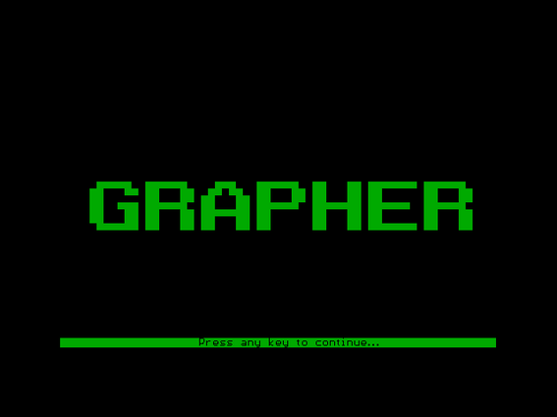

Main Menu

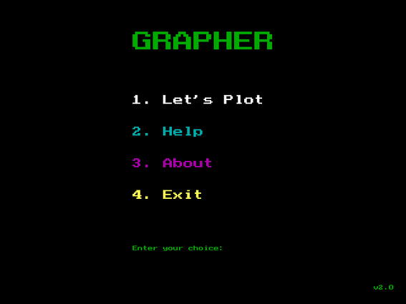

Let’s Plot

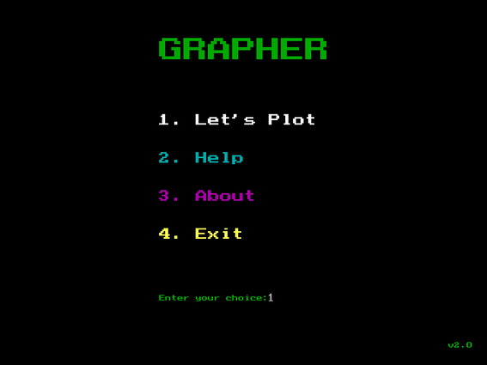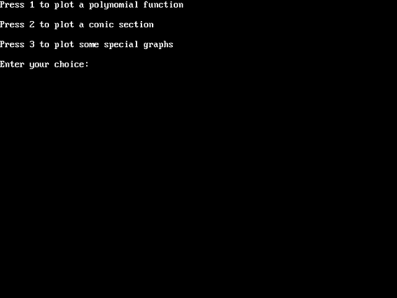

Polynomial Function

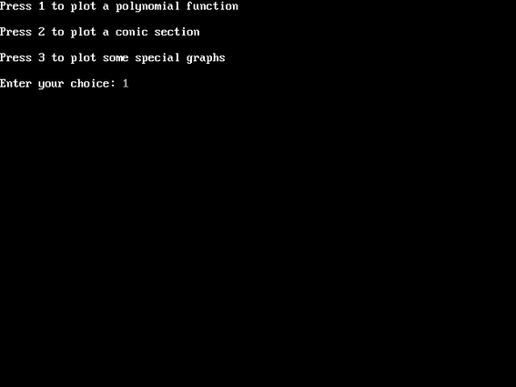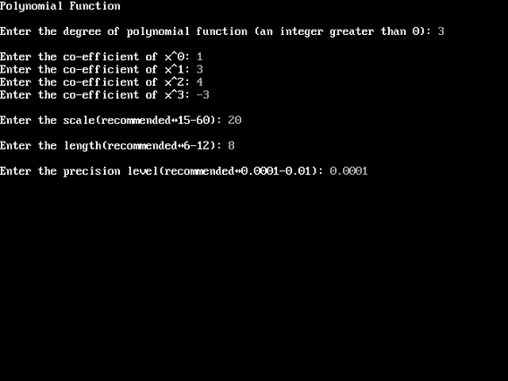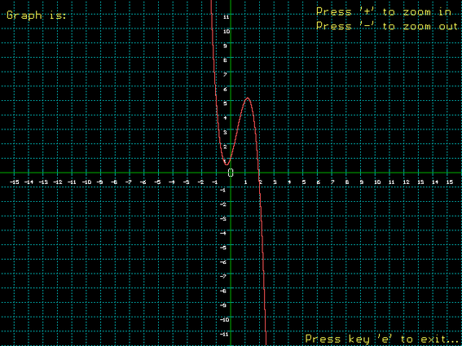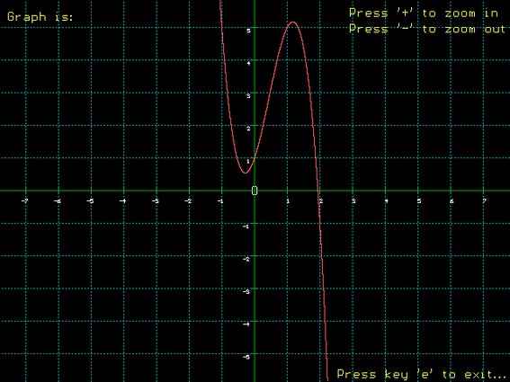

Conic Sections

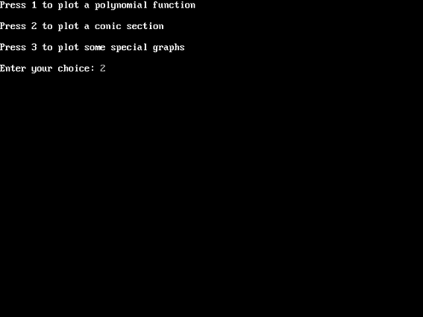

Circle

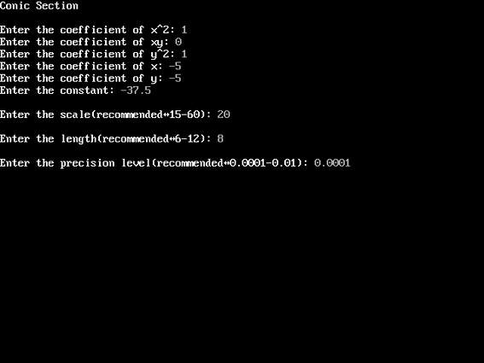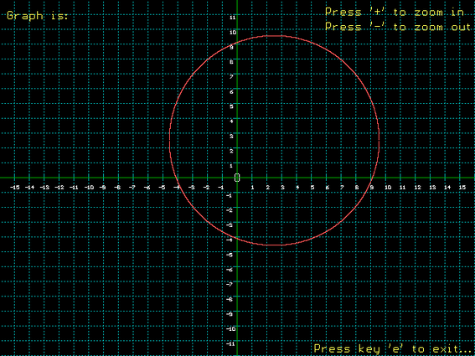

Parabola

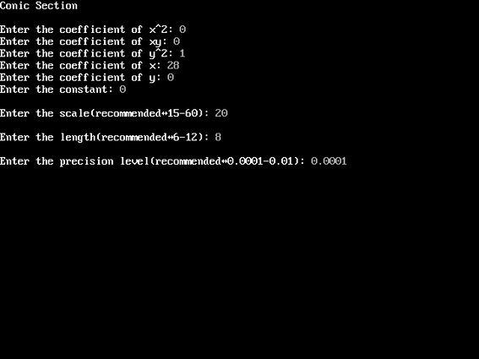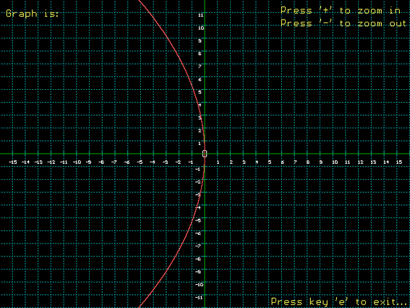

Ellipse

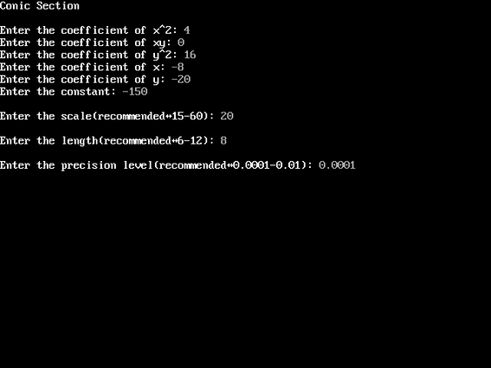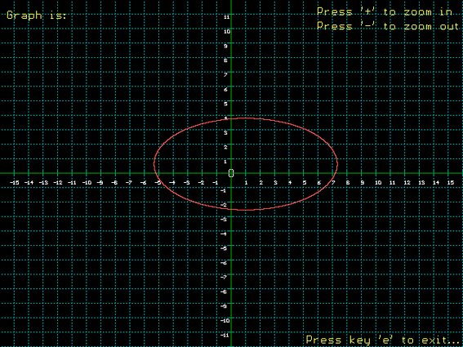

Hyperbola

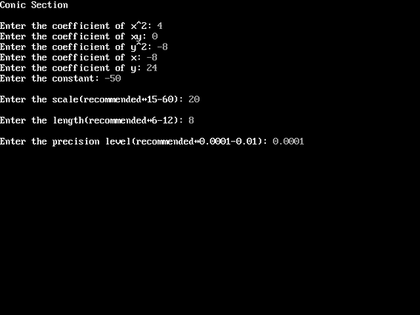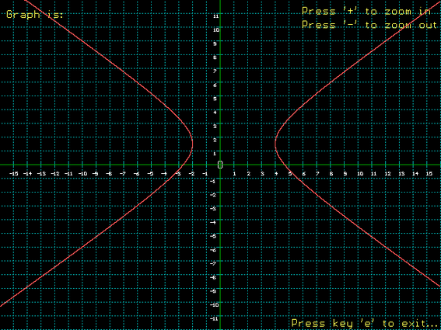

Pair of Straight Lines

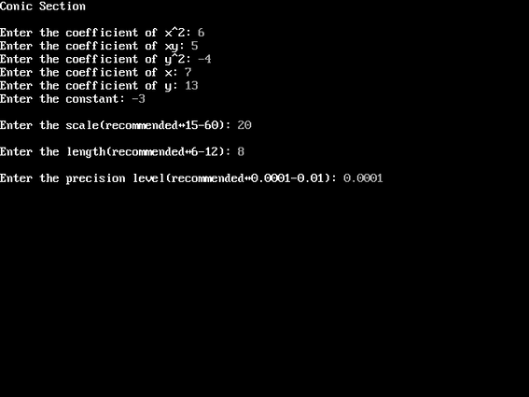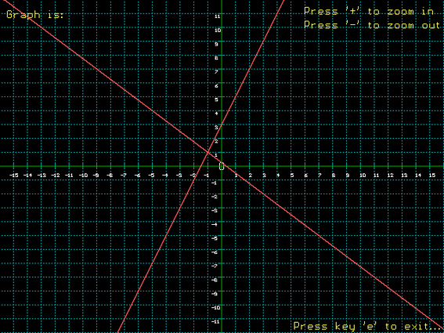

Special Graphs

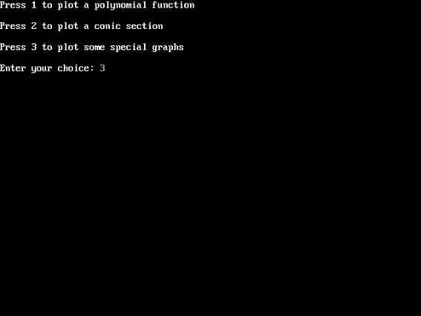

sin(x)

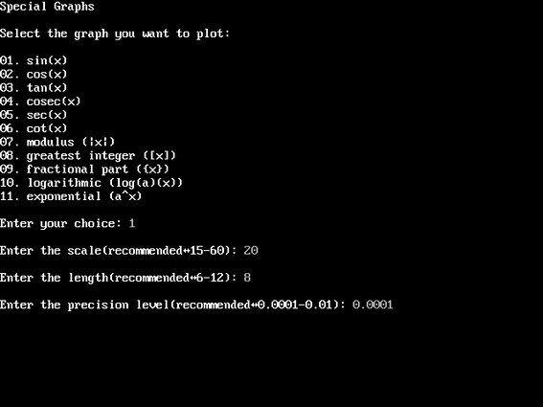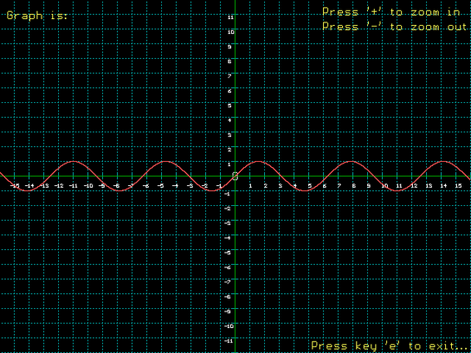

cos(x)

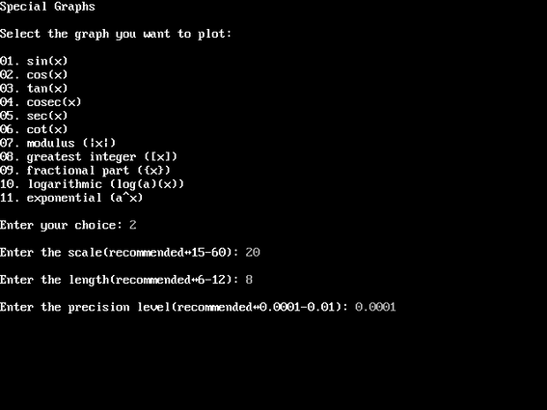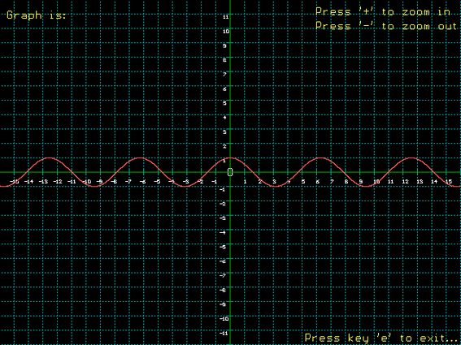

tan(x)

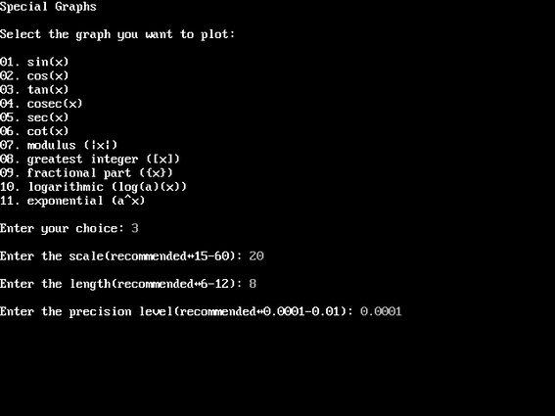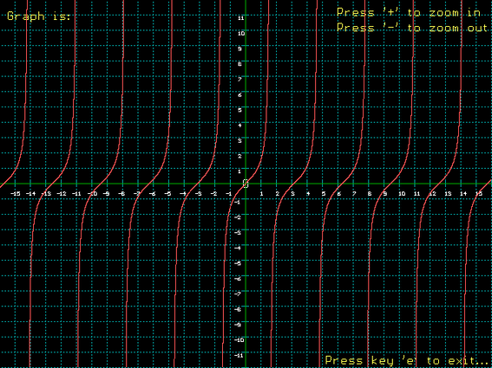

cosec(x)

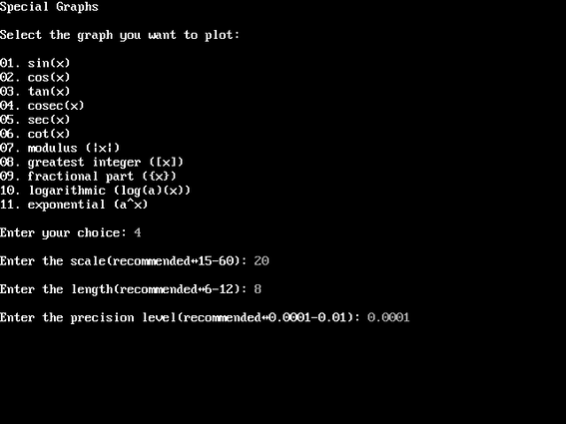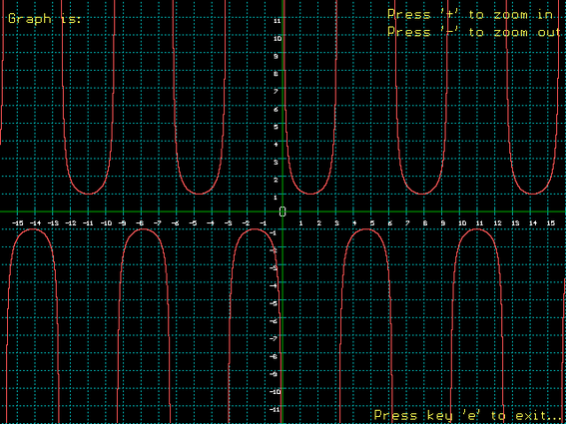

sec(x)

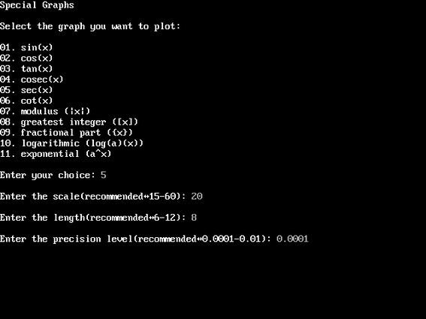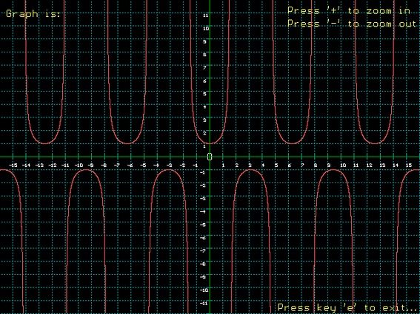

cot(x)

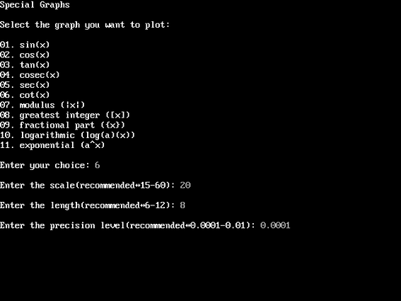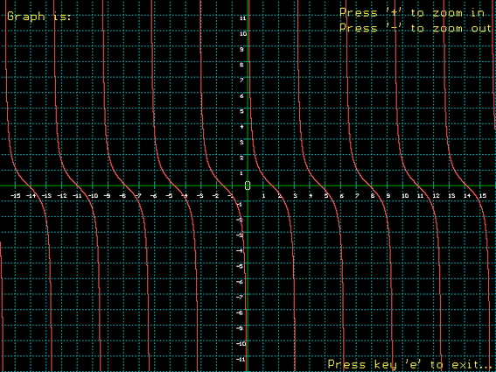

modulus(x)

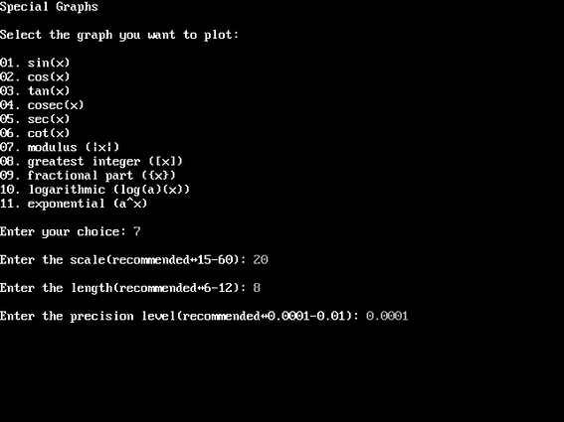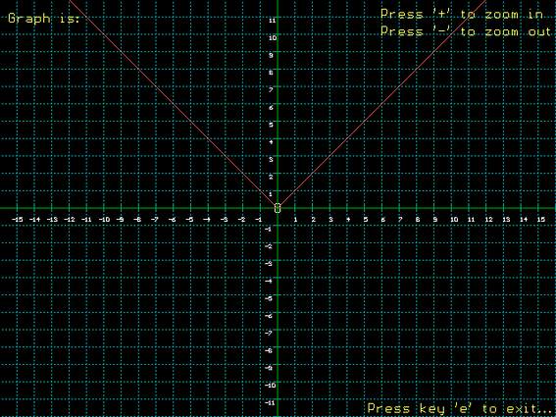

greatest integer(x)

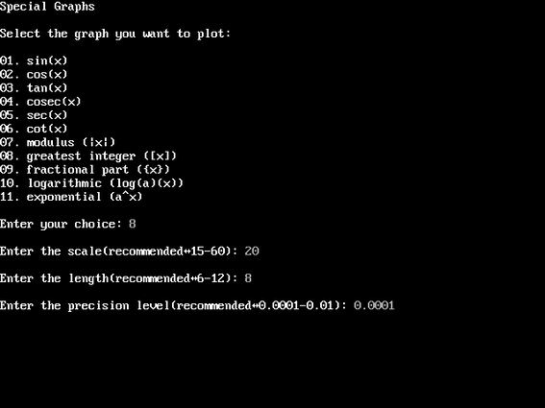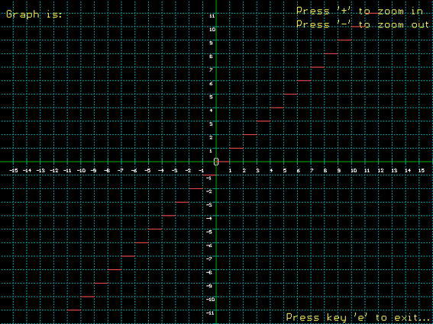

fractional part(x)

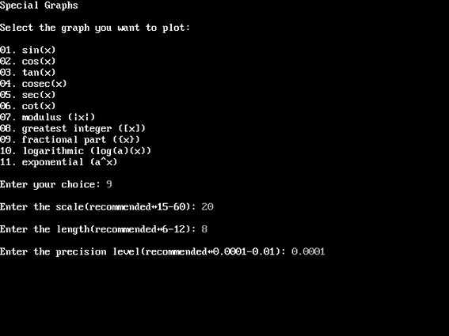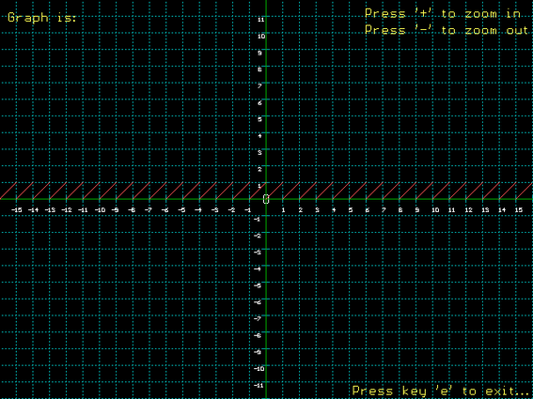

logarithmic(x)

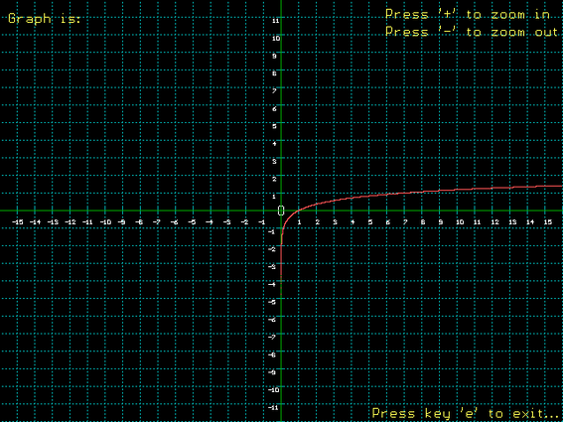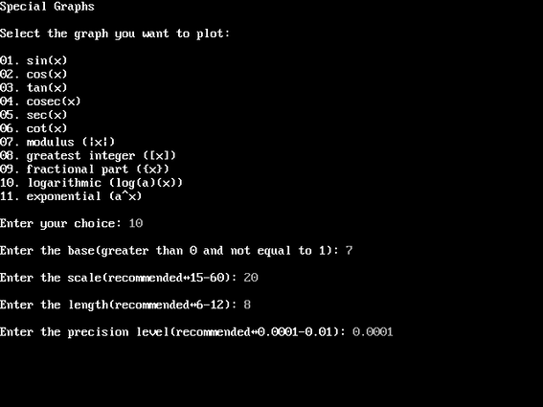

exponential(x)

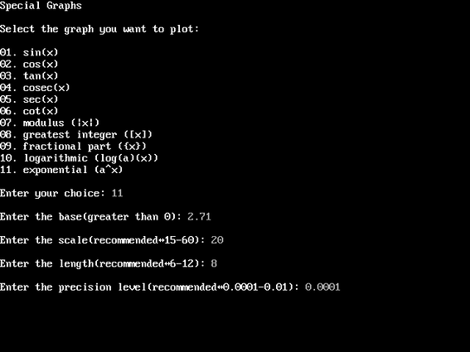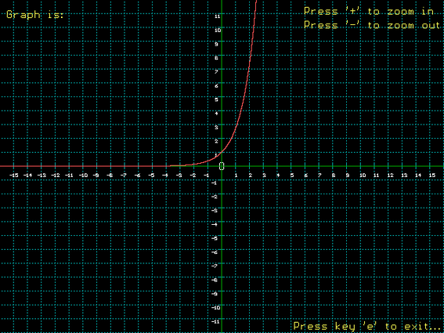

Help

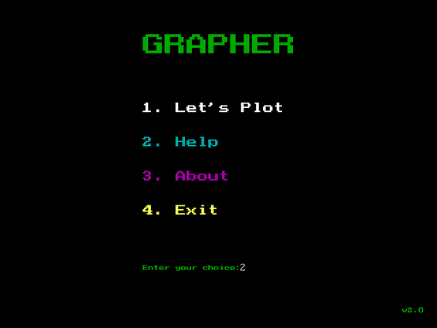

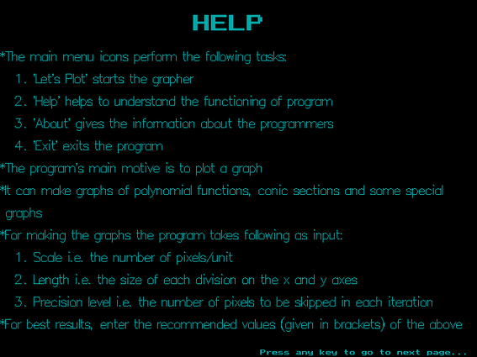

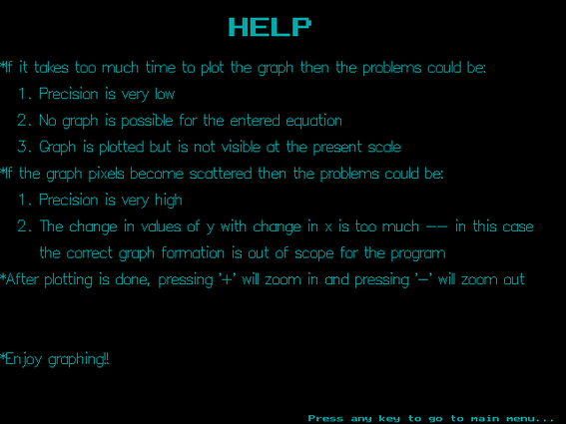

About

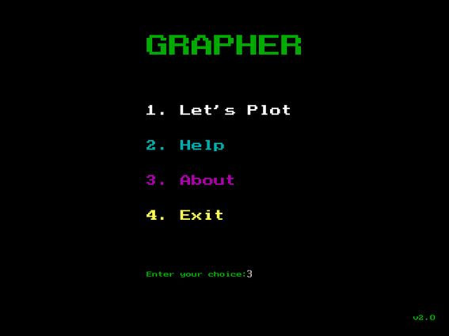

Again

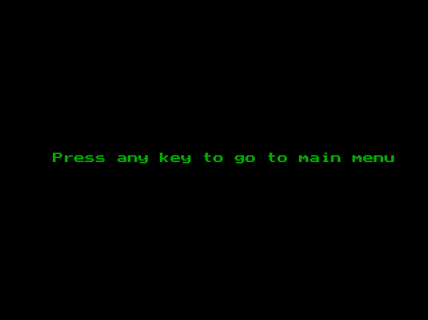

Exit

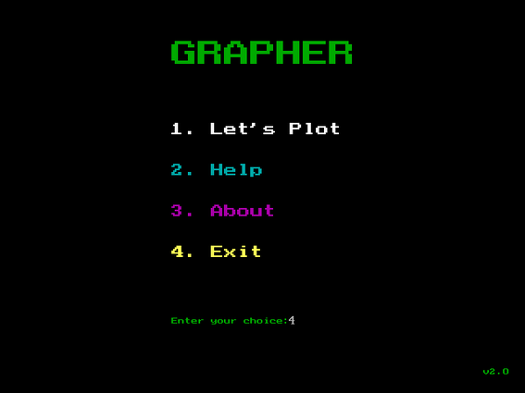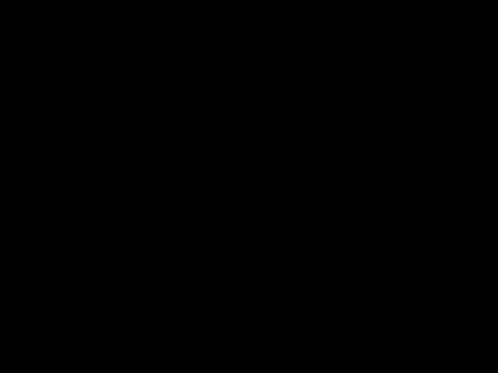

**BIBLIOGRAPHY**