ALI - Test Protocol

2024-06-24 12:11:36 - - 645096_ac_adapter_12V.docx **-- SUCCESS --**

|  |  |
| --- | --- |
| testString | patternFound |
| 036012 | True |
| 120 | True |
| 30 | True |
| 1002630REV01 | True |
| 15A | True |

assets/train/images/ac_adapter_12V.jpg

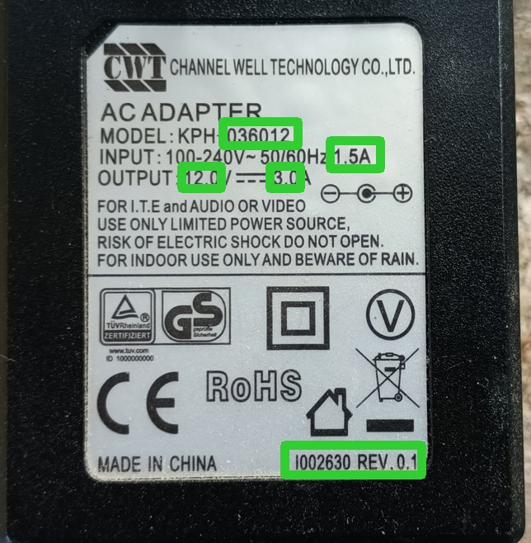

Paddle OCR Result

