F1 PREDICTOR PROJECT
Complete Technical Project Document
Front End | Back End | Machine Learning | Diagrams
Live race visualizer, RandomForest podium predictor and race-replay desktop application, built on the OpenF1 API and FastF1

Repository: github.com/iDare-Hacker/f1-predictor-project
Document version: 2.0 (updated with dependency and ignore-file evidence)
Date: 16 October 2026
Basis: README, requirements.txt and .gitignore; source folders blocked (see Section 1.2, Appendix G)

Document Control
Table 63: Document control
Item | Detail
Title | F1 Predictor Project: Complete Technical Project Document (v2)
Version / status | 2.0 / Draft for review
Date | 16 October 2026
Project owner | iDare-Hacker (GitHub)
Evidence basis | Public README, pinned requirements.txt and .gitignore. Source folders (ml, live_visualizer, f1-race-replay, openf1, computed_data) could not be retrieved. Statements are tagged [V] verified, [I] inferred, [P] proposed.
Diagrams included | 26 figures: context, architecture, repository, front-end modules, UI wireframe, sequence diagrams (front end, training, prediction, replay), state machines, ER, class, deployment, use-case, activity, security, testing, CI/CD, roadmap, feature importance
Next review | After the source-code verification pass in Appendix G

Table of Contents
If the table below is empty or out of date, right-click it in Word and choose Update Field, then Update entire table.

1. Introduction

1.1 Purpose of this document
This document is the complete technical project document for the F1 Predictor Project, a collection of three cooperating tools built around Formula 1 data: a browser-based live race visualizer, a machine-learning pipeline that predicts podium finishers, and a desktop race-replay application. It describes what the system does, why it is designed the way it is, how each component works internally, how the components exchange data, and how the system should be set up, tested, secured, operated and extended.
The document is intended to serve several purposes at the same time. For new contributors it is an onboarding guide that explains the repository layout and the mental model behind each component. For maintainers it is a design record that captures architectural decisions and their rationale. For reviewers, instructors or stakeholders it is a formal description of the system suitable for assessment. For future development it is a baseline against which proposed changes can be compared.

1.2 How to read the evidence tags
The author of this document had access to the project's public README, the root requirements.txt (60 pinned packages) and the .gitignore, which together state the repository structure, the technology stack, the training data scope, the cross-validated model score, the feature importances and the run commands. The individual source files (app.js, train_model.py, predict.py, main.py and the helper folders) could not be retrieved because GitHub blocks automated access to those pages, so they were not inspected. To keep the document honest, every technical statement is tagged with one of three evidence levels so that readers can tell fact from inference.
Table 1: Evidence tags used throughout this document
Tag | Meaning | How to treat it
[V] Verified | Stated directly in the README, requirements.txt or .gitignore (for example: the folder layout, the 0.935 AUC, the 500 calls/hour limit, the pinned versions in requirements.txt). | Reliable. Quote freely.
[I] Inferred | A design detail that follows logically from the README and from how the named libraries normally work (for example: RandomForest is a classifier because AUC is reported; the visualizer polls because it is a pure browser client). | Probably correct. Confirm against the code before relying on it.
[P] Proposed | A recommendation, extension or good-practice item that is not claimed to exist in the repository (for example: a CI pipeline, a Dockerfile, a unit-test suite). | A design suggestion. Not part of the current system.

Verify against source: Wherever a function name, class name or variable name appears in a diagram or table and is not listed in the README, it is a logical name chosen to explain responsibilities, not a literal identifier. Appendix G lists the open questions that should be checked against the real source files, so that this document can be promoted from inferred to verified status in a single review pass.

1.3 Project overview
Formula 1 is one of the most data-rich sports in the world. During a race weekend, timing systems, GPS units and on-car sensors stream thousands of values per second. Two community projects expose that data to developers: the OpenF1 API, a free REST service providing live and historical session data, and FastF1, a Python library that downloads, caches and structures timing and telemetry data for analysis. [V]
The F1 Predictor Project builds on both. Its first tool, the Live Visualizer, runs entirely in the browser with no backend, connects to the public OpenF1 API and shows live driver positions, telemetry, race-control messages and pit stops during an active session. [V] Its second tool, the ML Podium Predictor, is a Python pipeline that trains a RandomForest model on 2021–2024 race data (about 1,679 race entries) and predicts podium probabilities for any championship round with a single command. [V] Its third tool, the Race Replay application, is a desktop program (documented as Tkinter-based; see Section 6.1 for a discrepancy with the dependency list) that replays historical sessions with telemetry overlays. [V]
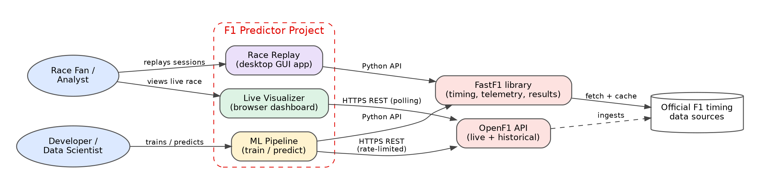
Figure 1: System context diagram: users, the three tools and the external data providers

1.4 Goals and objectives
- Provide a zero-install, zero-backend live dashboard for following an F1 session in real time.
- Provide a reproducible, well-documented machine-learning workflow that predicts which drivers finish on the podium, and that can be retrained as new seasons are added.
- Provide an offline-capable replay tool for studying historical sessions with telemetry.
- Keep the setup path short for new contributors: clone, create a virtual environment, install dependencies, run.
- Respect the rate limits and usage terms of upstream data providers through caching and throttling.
- Make the system easy to extend with new features, models and visualizations.

1.5 Non-goals
- The project is not a betting or gambling product; predictions are probabilistic and educational.
- The project does not attempt sub-second, broadcast-grade latency; the live dashboard is as fresh as the OpenF1 API and its polling interval allow. [I]
- The project does not host user accounts, payments or any personal data. [I]
- The project does not redistribute raw F1 timing data; it caches data locally for the individual developer. [I]

1.6 Scope
In scope are the three components listed above, the Python dependencies declared in the root requirements.txt, the pre-trained model artifacts (model.pkl, features.json) and the local caches (.fastf1-cache, computed_data). Out of scope are the upstream services themselves, the operating system and browser environment, and any commercial licensing of F1 content.

1.7 Audience
Table 2: Audience guide
Audience | What they need from this document | Start with
New contributor | Where things live, how to run them, how the pieces talk to each other | Chapters 4, 5, 12
Front-end developer | Dashboard modules, data flow, UI states, API usage, performance | Chapter 5, Chapter 11
Back-end / data engineer | Data acquisition, caching, rate limits, storage formats | Chapters 7, 10
Data scientist | Features, labels, validation, metrics, limitations, improvement ideas | Chapters 8, 9, 14
Reviewer / instructor | Requirements, architecture, quality attributes, risks | Chapters 3, 4, 15, 16
Operator / DevOps | Environments, deployment options, observability, security | Chapters 12, 13, 15

1.8 Document conventions
File and folder names appear in monospace. Commands appear in shaded code blocks. Figures and tables are numbered consecutively across the document. Time is expressed in UTC unless stated otherwise because OpenF1 timestamps are UTC. [I] Racing terminology is explained in Chapter 2 and in the glossary in Appendix A.

1.9 Document structure
Table 3: Chapter overview
Chapter | Title | Summary
1 | Introduction | Purpose, goals, scope, conventions
2 | Domain and Technology Background | F1 weekend format, data sources, ML concepts
3 | Requirements | Functional, non-functional, constraints, use cases
4 | System Architecture | Context, layers, repository, stack, decisions
5 | Front-End Design: Live Visualizer | Modules, UI, data flow, states, API use
6 | Front-End Design: Race Replay | Desktop GUI architecture, playback model
7 | Back-End Design: Data Acquisition | OpenF1, FastF1, caching, rate limiting
8 | Back-End Design: ML Pipeline | Features, training, validation, metrics
9 | Back-End Design: Prediction Service | CLI, inference flow, output, limitations
10 | Data Model and Storage | Entities, files, schemas
11 | Interfaces and Reference | OpenF1 endpoints, CLI, file contracts
12 | Deployment and Environment | Setup, environments, hosting, containers
13 | Security and Compliance | Threats, mitigations, licensing
14 | Testing and Quality Assurance | Strategy, test cases, ML validation
15 | Performance, Reliability and Observability | Budgets, failure modes, logging
16 | Maintenance, Risks and Roadmap | Risk register, evolution plan
App. | Appendices A–G | Glossary, cheat sheet, code, checklists, open questions

2. Domain and Technology Background

2.1 The Formula 1 race weekend
A Grand Prix weekend is a sequence of sessions. Understanding them matters because the project's prediction target and its live display both depend on session semantics.
Table 4: Race-weekend sessions and their role
Session | Purpose | Relevance to this project
Free Practice (FP1–FP3) | Teams tune car set-up and tyre strategy; no points. | Not used by the model as a feature. [I] Telemetry is available in the visualizer and replay.
Qualifying (Q1, Q2, Q3) | Sets the starting grid through knockout sessions; fastest Q3 lap earns pole position. | Source of quali delta to pole, the second most important feature. [V]
Sprint (some rounds) | Short race with reduced points, with its own shoot-out qualifying. | Treated as a separate session type in the live visualizer. [I]
Race | Main event. Top three finishers take the podium; top ten score points. | Source of podium label and of rolling-average-finish features. [V]

2.2 Why a podium is a good prediction target
Predicting the exact finishing order of twenty cars is a hard ranking problem with a very large outcome space. Predicting whether a given driver reaches the top three is a binary classification problem: for each race entry the label is 1 if the driver finished first, second or third, and 0 otherwise. With roughly twenty entries per race and three podium places, about fifteen percent of the training rows are positive. [I] That class imbalance is moderate, which is why the project reports ROC AUC, a ranking-quality metric that is insensitive to the decision threshold, rather than plain accuracy. [I]
Binary framing also gives a natural output: a probability per driver. Sorting the probabilities and taking the highest three yields a predicted podium, while the probabilities themselves express uncertainty, for example when two drivers are nearly tied for third.

2.3 Data sources

2.3.1 OpenF1 API
OpenF1 is an open-source API exposing real-time and historical Formula 1 data as JSON (and optionally CSV) over HTTPS. Data is organised by meetings (a Grand Prix weekend) and sessions (a single practice, qualifying, sprint or race). Individual endpoints return time-stamped samples such as car telemetry, positions, pit-stop records and race-control messages. Requests are filtered with query-string parameters such as session_key, driver_number and date comparisons. The project's README states that the free tier is limited to 500 calls per hour, a limit that directly shapes the training workflow. [V]

2.3.2 FastF1
FastF1 is a Python package that downloads F1 timing, telemetry, session results and schedule data, merges them into pandas data frames, and caches downloads on disk. Typical use is to request a session by year, event and session identifier, call load(), and then access laps, results and per-driver telemetry. The repository contains a .fastf1-cache folder, which is the library's on-disk cache so that a session is downloaded only once. [V]
Table 5: Comparison of the two data sources
Aspect | OpenF1 API | FastF1 library
Access style | REST over HTTPS, language-agnostic | Python package, pandas objects
Strength | Live data; usable straight from browser JavaScript | Rich historical analysis; built-in caching and merging
Used by | Live Visualizer; ML pipeline [V] | ML pipeline; Race Replay; .fastf1-cache [V]
Rate limiting | 500 calls/hour on free tier [V] | Bounded by upstream sources; mitigated by local cache
Offline use | No | Yes, once a session is cached

2.4 Machine-learning concepts used

2.4.1 RandomForest
A random forest is an ensemble of decision trees. Each tree is trained on a bootstrap sample of the rows and considers a random subset of features at each split. Predictions are produced by averaging the trees' votes, which for a classifier gives a probability estimate. Random forests handle mixed numeric and encoded categorical features, need little scaling, resist over-fitting better than a single tree, and expose feature importances that make the model easy to explain. These properties make it a sound first choice for a tabular problem of about 1,700 rows. [V for algorithm choice, I for rationale]

2.4.2 ROC AUC and cross-validation
The receiver operating characteristic curve plots true-positive rate against false-positive rate across all thresholds. The area under it (AUC) equals the probability that a randomly chosen positive example receives a higher score than a randomly chosen negative one. A value of 0.5 is chance and 1.0 is perfect ranking. The project reports 0.935 ± 0.016 from cross-validation, meaning the mean score across folds and its spread. [V] A small spread suggests stable behaviour across folds, although Section 14.5 explains why random folds can be optimistic for time-ordered racing data.

2.4.3 Rolling averages as form indicators
The model uses the rolling average finishing position of the driver and of the constructor (team). A rolling average summarises recent form without needing explicit car-performance data: a team that has recently finished near the front is likely to be quick. Because the window must only contain past races, correct implementation requires care to avoid leaking the current race result into its own feature. This is discussed in Chapter 8 and Chapter 14.

2.5 Technology overview
Table 6: Technology inventory
Technology | Role | Evidence
HTML / CSS / JavaScript | Live Visualizer front end (index.html, app.js, style.css) | [V]
Python 3 + venv | Runtime for ML pipeline and replay app | [V]
pandas | Data cleaning and feature tables | [V]
scikit-learn | RandomForest training, cross-validation, AUC | [V]
fastf1 | Historical data and telemetry | [V]
requests, requests-cache | API calls with HTTP-level caching | [V]
Tkinter | Race Replay GUI toolkit as stated in the README | [V] statement
arcade 3.3.3, pyglet, pymunk, pytiled_parser | OpenGL game and graphics library pinned in requirements.txt; most likely the replay window renderer | [V] pinned; [I] role
PySide6 6.11.2 (+ Addons, Essentials, shiboken6) | Qt for Python; likely secondary GUI windows | [V] pinned; [I] role
questionary, rich, prompt_toolkit | Interactive terminal menus and formatting | [V] pinned; [I] role
signalrcore, websockets | SignalR and WebSocket clients for live-timing connectivity (normally pulled in by FastF1) | [V] pinned; [I] role
matplotlib, scipy, numpy | Plotting and numerical routines | [V] pinned
cryptography, PyJWT, pydantic | Security and validation libraries (probably transitive) | [V] pinned; [I] transitive
pickle file (model.pkl) | Model persistence format | [I] (extension indicates pickle/joblib)
JSON (features.json) | Ordered feature list contract between training and prediction | [V]
CSV (historical_data.csv) | Cached training table | [V]
python3 -m http.server | Static file server for local dashboard use | [V]

3. Requirements

3.1 Stakeholders
Table 7: Stakeholders and interests
Stakeholder | Interest
Race fans | Follow a live race with more detail than a standard broadcast overlay; curiosity about predictions.
Developers / contributors | Understandable code, quick setup, reliable local runs.
Data scientists / students | A clear example of an end-to-end sports-analytics ML pipeline.
Data providers (OpenF1, FastF1) | Fair use: caching, rate-limit compliance, attribution.
Project owner | Maintainable, extensible, documented project.

3.2 Use cases
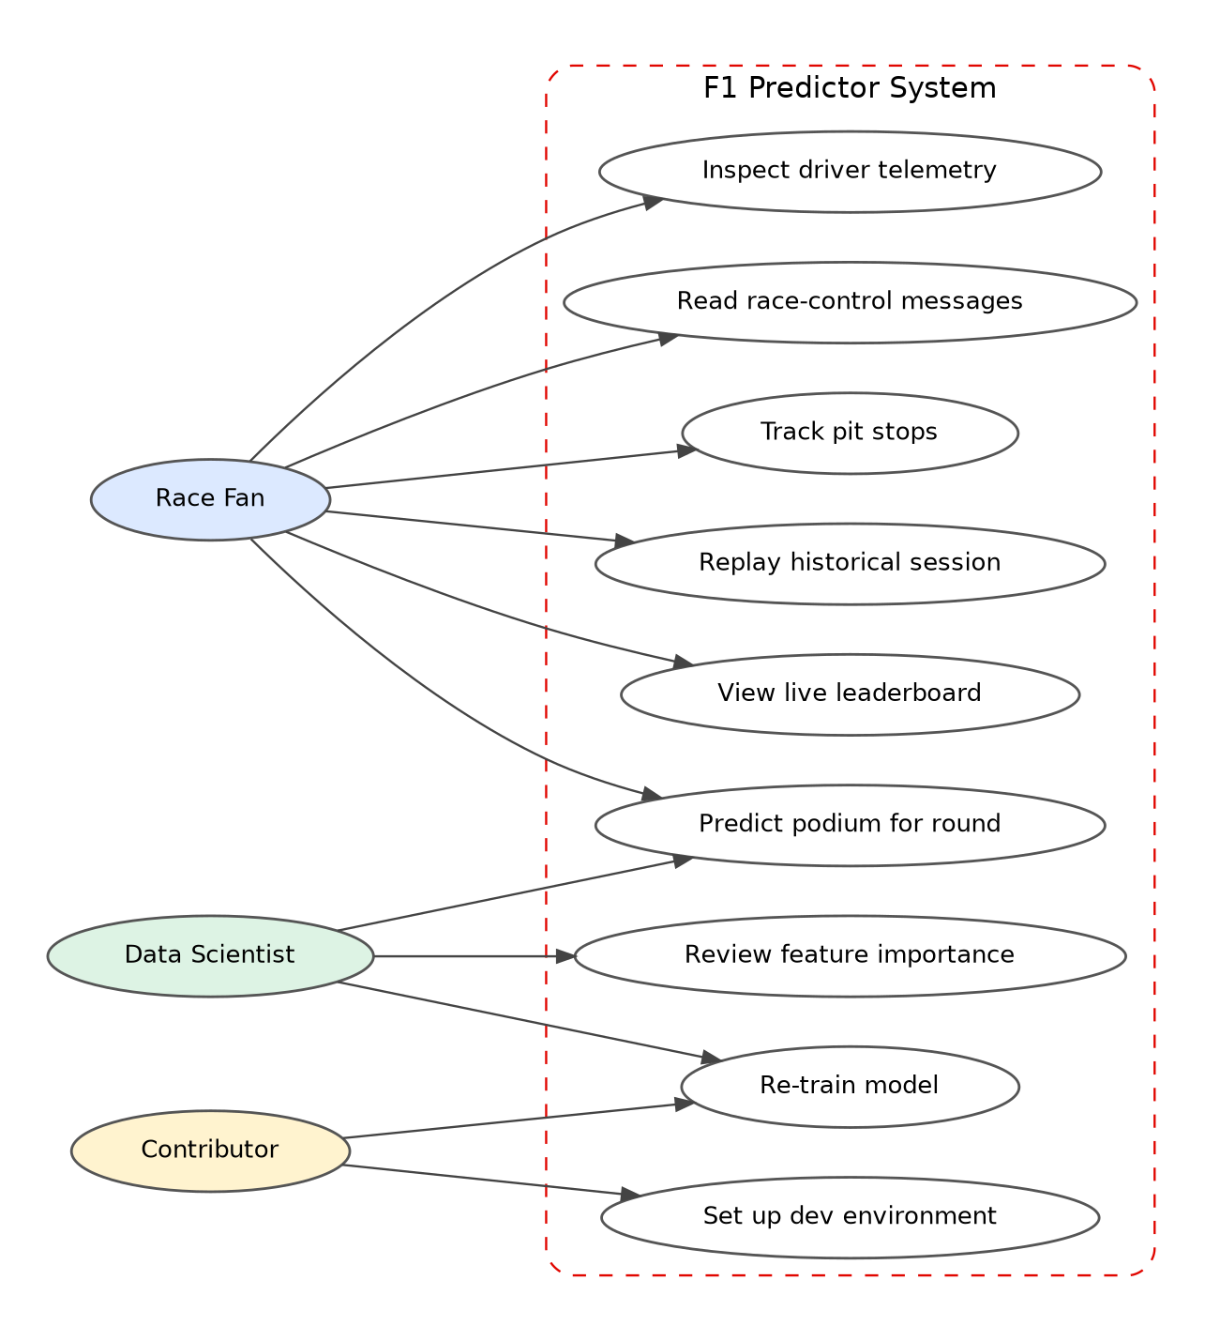
Figure 2: Use-case diagram showing actors and the features they use
Table 8: Use-case catalogue
ID | Use case | Actor | Main flow
UC-01 | View live leaderboard | Race fan | Open dashboard during session; see ordered drivers updating.
UC-02 | Inspect driver telemetry | Race fan | Select a driver; see speed, throttle, brake, gear, DRS.
UC-03 | Read race-control messages | Race fan | Scroll feed of flags, safety-car and steward messages.
UC-04 | Track pit stops | Race fan | See stop laps and durations as they occur.
UC-05 | Replay historical session | Fan | Choose session in desktop app; press play; seek and change speed.
UC-06 | Predict podium | Fan / data scientist | Run predict.py --year Y --round R; read ranked probabilities.
UC-07 | Re-train model | Data scientist / contributor | Remove cached CSV; run train_model.py; wait ~30 minutes.
UC-08 | Review feature importance | Data scientist | Read printed importances or README table.
UC-09 | Set up dev environment | Contributor | Clone; create venv; pip install -r requirements.txt.

3.3 Functional requirements: Live Visualizer
Table 9: Live Visualizer functional requirements
ID | Requirement | Priority | Evidence
FR-LV-01 | The dashboard shall run as static files without a back-end server. | Must | [V]
FR-LV-02 | The dashboard shall retrieve data from the public OpenF1 API. | Must | [V]
FR-LV-03 | The dashboard shall display live driver positions. | Must | [V]
FR-LV-04 | The dashboard shall display driver telemetry. | Must | [V]
FR-LV-05 | The dashboard shall display race-control messages. | Must | [V]
FR-LV-06 | The dashboard shall display pit-stop information. | Must | [V]
FR-LV-07 | The dashboard shall refresh data periodically while a session is active. | Must | [I]
FR-LV-08 | The dashboard shall show a clear message when no session is live. | Should | [P]
FR-LV-09 | The dashboard shall colour-code drivers by team colour. | Should | [I]
FR-LV-10 | The dashboard shall back off and recover after API errors. | Should | [P]
FR-LV-11 | The dashboard shall allow selecting a past session for demonstration. | Could | [P]

3.4 Functional requirements: ML pipeline
Table 10: ML pipeline functional requirements
ID | Requirement | Priority | Evidence
FR-ML-01 | The trainer shall use 2021–2024 historical race data. | Must | [V]
FR-ML-02 | The trainer shall build features: grid position, quali delta to pole, constructor and driver rolling average finish, team and driver encoding. | Must | [V]
FR-ML-03 | The trainer shall train a RandomForest model and report cross-validated AUC. | Must | [V]
FR-ML-04 | The trainer shall persist the model to ml/model.pkl and the feature list to ml/features.json. | Must | [V]
FR-ML-05 | The trainer shall cache collected data in ml/historical_data.csv and reuse it if present. | Must | [V]
FR-ML-06 | The predictor shall accept --year and --round arguments. | Must | [V]
FR-ML-07 | The predictor shall load the pre-trained model without re-training. | Must | [V]
FR-ML-08 | The predictor shall output per-driver podium probability and a predicted podium. | Must | [I]
FR-ML-09 | The data collector shall stay within the 500 calls/hour limit. | Must | [V]
FR-ML-10 | The predictor shall validate that features match features.json order. | Should | [P]

3.5 Functional requirements: Race Replay
Table 11: Race Replay functional requirements
ID | Requirement | Priority | Evidence
FR-RR-01 | The application shall be a desktop GUI (README: Tkinter; dependency list: Arcade and PySide6). | Must | [V]
FR-RR-02 | The application shall replay historical F1 sessions. | Must | [V]
FR-RR-03 | The application shall show telemetry overlays. | Must | [V]
FR-RR-04 | The application shall run via python main.py from f1-race-replay. | Must | [V]
FR-RR-05 | The application shall offer play, pause, speed control and seeking. | Should | [I]
FR-RR-06 | The application shall reuse FastF1's on-disk cache to avoid repeated downloads. | Should | [I]

3.6 Non-functional requirements
Table 12: Non-functional requirements
ID | Category | Requirement | Target
NFR-01 | Usability | A new contributor shall run any component within 15 minutes of cloning. | ≤ 15 min
NFR-02 | Performance (UI) | Dashboard updates shall not block the main thread for more than 50 ms per tick. | ≤ 50 ms
NFR-03 | Performance (predict) | A prediction for a cached round shall complete within a few seconds. | < 5 s
NFR-04 | Reliability | API failures shall not crash the dashboard or the predictor. | No unhandled exceptions
NFR-05 | Compatibility | Dashboard shall work in current Chrome, Firefox, Edge and Safari. | Evergreen browsers
NFR-06 | Portability | Python components shall run on Windows, macOS and Linux. | 3 OS families
NFR-07 | Maintainability | Features and model shall be reproducible from the repository. | Deterministic with fixed seed
NFR-08 | Compliance | Usage shall respect provider rate limits and terms. | 0 limit violations
NFR-09 | Security | No secrets stored in the repository; model loaded only from trusted source. | 0 secrets
NFR-10 | Explainability | Model behaviour shall be explainable through feature importances. | Importances reported

3.7 Constraints and assumptions
Table 13: Constraints and assumptions
Type | Statement
Constraint | Free-tier OpenF1 access is limited to 500 calls per hour, so full re-training takes about 30 minutes. [V]
Constraint | Race Replay requires a desktop environment with a graphical display (README: Tkinter GUI). [V]
Constraint | The dashboard has no backend, so all data fetching, parsing and rendering occur in the browser. [V]
Constraint | Training data covers 2021–2024 only; behaviour on regulation changes outside that window is unvalidated. [V]
Assumption | OpenF1 continues to provide the endpoints and field names currently used. [I]
Assumption | Users have Python 3 with venv and pip available. [V]
Assumption | Users run the dashboard through a local HTTP server rather than opening the HTML file directly, because modern browsers restrict some features on file://. [I]

3.8 Requirements traceability
The matrix below links requirement groups to the architecture components that satisfy them and to the test areas that verify them. It lets maintainers see at a glance which component must be re-tested when a requirement changes.
Table 14: Traceability matrix
Requirement group | Satisfied by | Verified by (Chapter 14)
FR-LV-* | live_visualizer/ modules (Chapter 5) | Front-end functional tests, manual live session test
FR-ML-01..05 | ml/train_model.py, data layer (Chapters 7, 8) | Data-quality checks, training smoke test, CV regression test
FR-ML-06..10 | ml/predict.py (Chapter 9) | CLI tests, golden-output test
FR-RR-* | f1-race-replay/main.py (Chapter 6) | Manual GUI test, loader unit tests
NFR-04, NFR-08 | Cache, back-off, throttle (Chapter 7) | Fault-injection tests
NFR-09 | Security controls (Chapter 13) | Dependency scan, artifact checksum check

4. System Architecture

4.1 Architectural overview
The system is a modular monorepo: three independently runnable tools share one repository, one root dependency file and a common set of upstream data providers. There is no shared runtime process, no database server and no message bus. Each tool is launched by the user, does its work, and reads or writes plain files. This keeps the system simple to understand and to run on a laptop, at the cost of tools sharing data only through files and through the upstream APIs. [V/I]
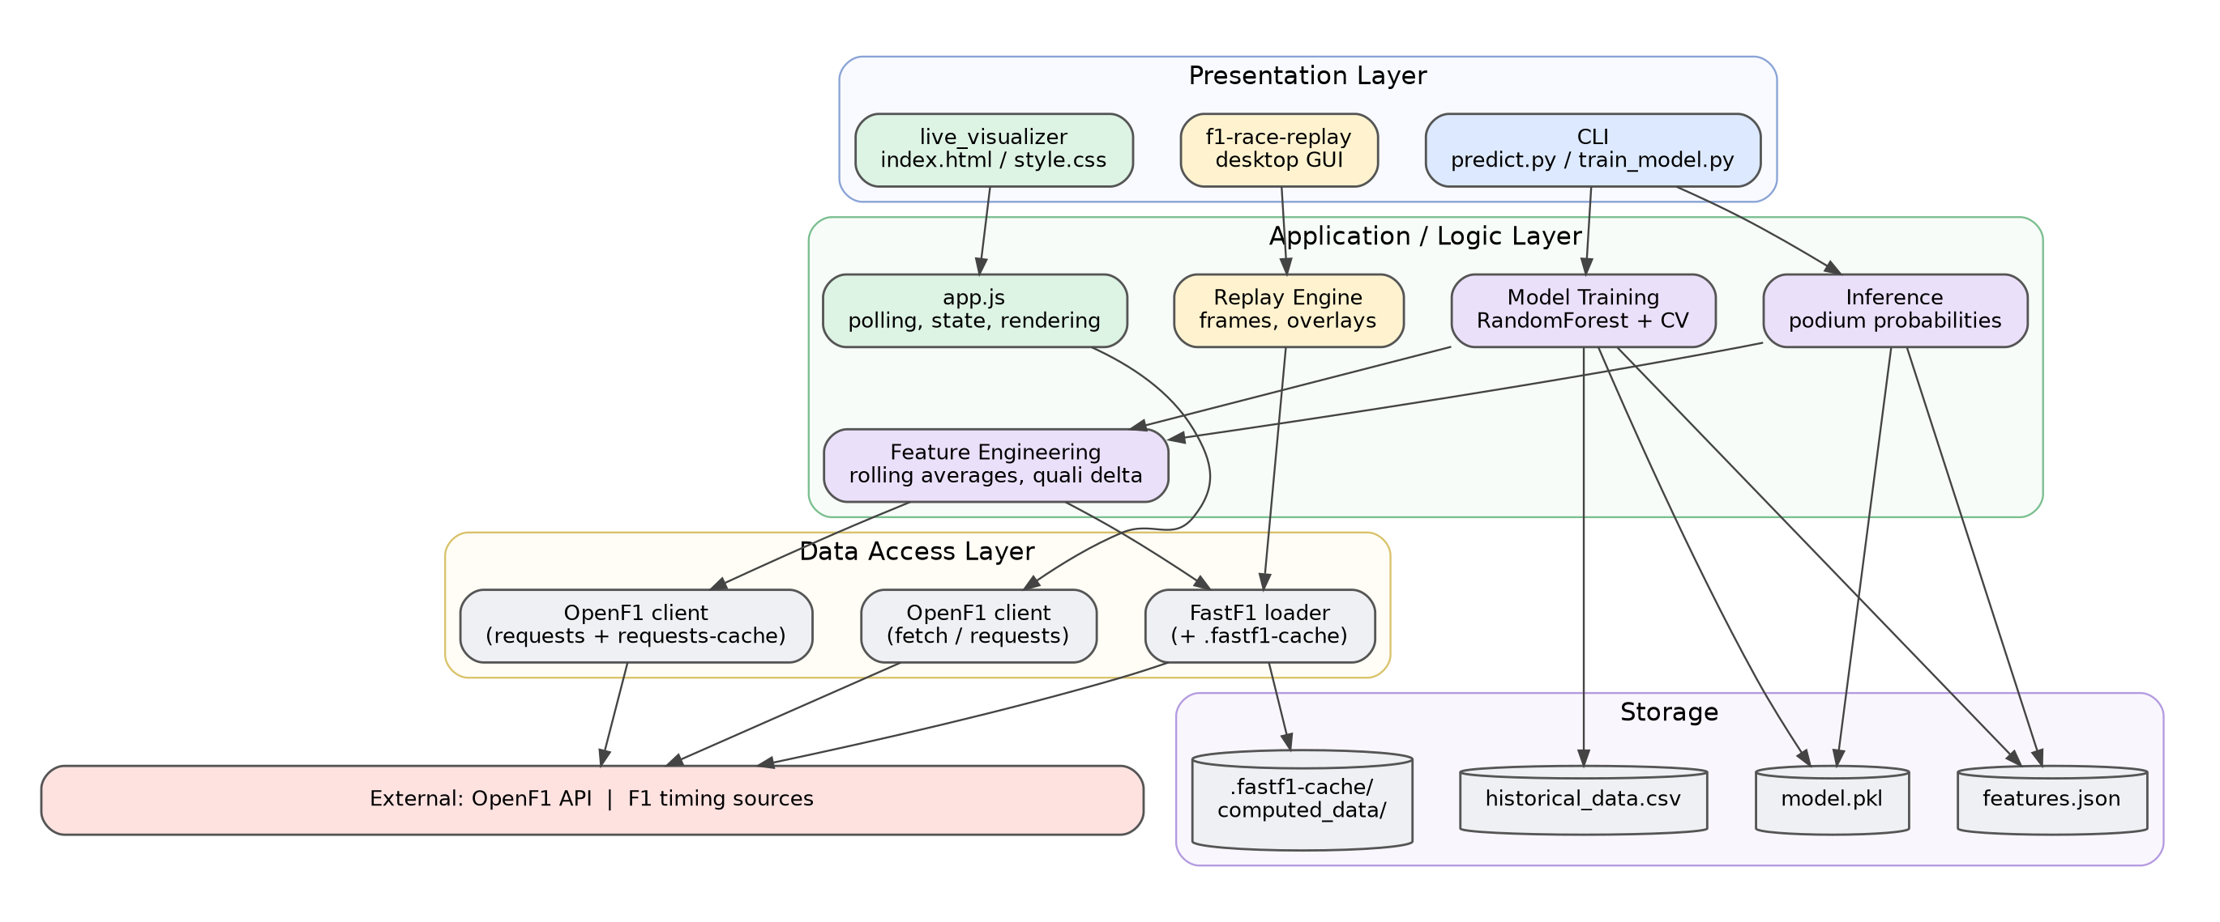
Figure 3: Layered architecture showing presentation, logic, data-access and storage layers
The layered view groups responsibilities rather than processes. The presentation layer contains everything the user touches: the HTML dashboard, the desktop replay window and the two command-line entry points. The logic layer holds the polling and rendering code of the dashboard, the feature engineering, training and inference code of the ML pipeline, and the frame-building and playback code of the replay tool. The data-access layer isolates the details of talking to OpenF1 and FastF1, including caching. The storage layer is the file system: the serialized model, the feature list, the cached training CSV, FastF1's cache and the computed_data folder.

4.2 Repository structure
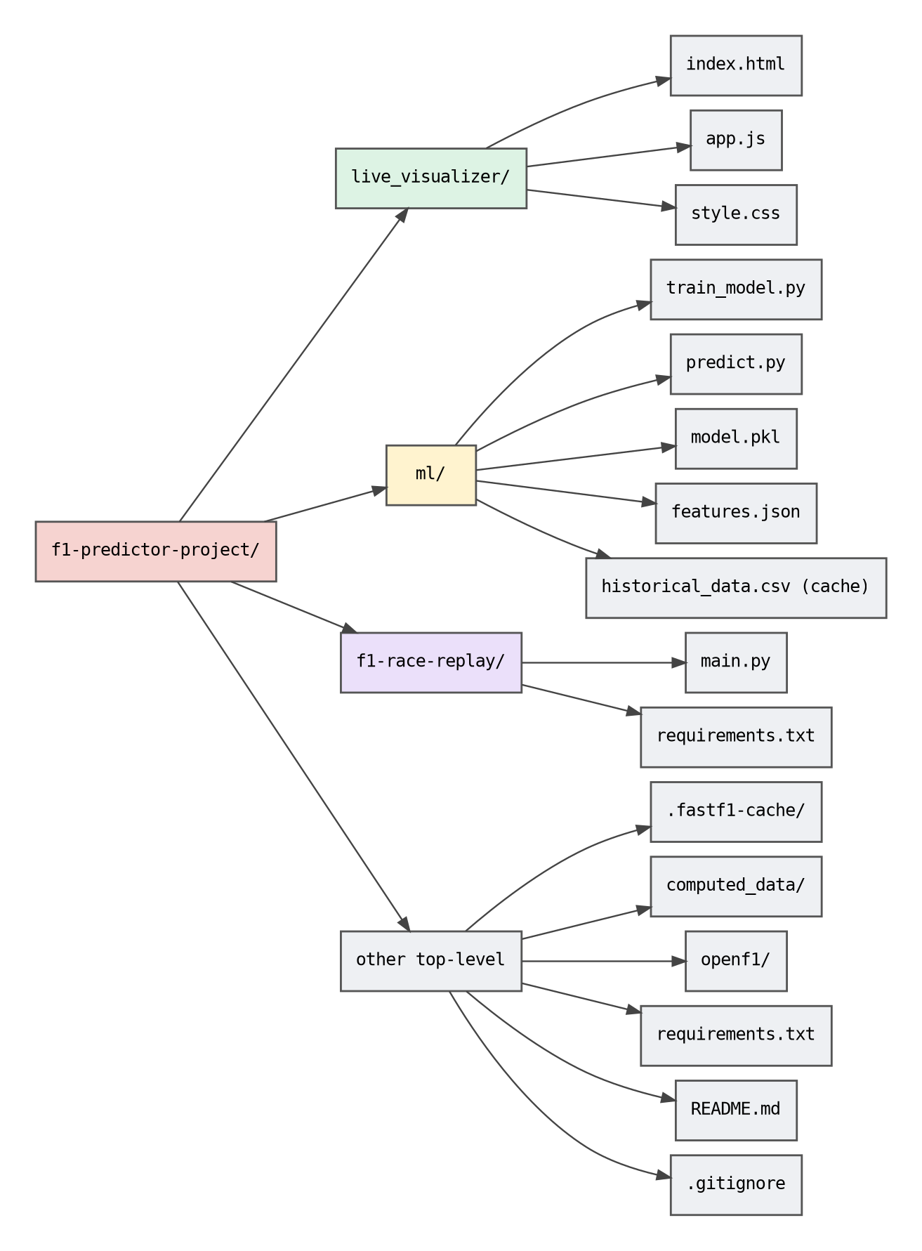
Figure 4: Repository structure
Table 15: Repository inventory
Path | Responsibility | Evidence
live_visualizer/index.html | Page skeleton: containers for leaderboard, telemetry, race control, pit stops; loads script and stylesheet. | [V] file exists; [I] contents
live_visualizer/app.js | All dashboard behaviour: API calls, polling loop, state, DOM rendering. | [V] / [I]
live_visualizer/style.css | Visual design, layout, colours. | [V] / [I]
ml/train_model.py | Collects 2021–2024 data, builds features, cross-validates, trains and saves the model. | [V]
ml/predict.py | Loads model and features; produces podium prediction for --year, --round. | [V]
ml/model.pkl | Pre-trained RandomForest. | [V]
ml/features.json | Ordered list of feature names used by the model. | [V]
f1-race-replay/main.py | Desktop replay application entry point (GUI toolkit: see Section 6.1). | [V]
f1-race-replay/requirements.txt | Replay-specific dependencies. | [V]
requirements.txt | Root-level Python dependencies: a fully pinned, 60-line pip freeze-style list (see Section 4.8). | [V]
.fastf1-cache/ | FastF1 download cache. Listed in .gitignore, yet visible at the repository root. | [V]
computed_data/ | Derived data produced by the tools (for example processed telemetry or intermediate tables). | [V] folder; [I] purpose
openf1/ | Helper material for OpenF1 access (for example client code or notes). | [V] folder; [I] purpose
.gitignore | Excludes .venv/, venv/, env/, __pycache__/, .fastf1-cache/, ml/fastf1_cache/, ml/historical_data.csv and OS files; explicitly re-includes ml/model.pkl and ml/features.json. | [V]

4.2.1 Verified repository facts
Table 16: Repository facts
Fact | Value | Source
Visibility / branch | Public, default branch main | Repository page [V]
Commit count | 10 commits | Repository page [V]
Stars / forks / watchers | 0 / 0 / 0 | Repository page [V]
Description and topics | None set on GitHub | Repository page [V]
Releases and packages | None published | Repository page [V]
Licence file | None at repository root | Root listing [V]
Root entries | .fastf1-cache, computed_data, f1-race-replay, live_visualizer, ml, openf1, .gitignore, README.md, requirements.txt | Root listing [V]
Dependency manifest | 60 lines, 1.04 KB, every package pinned with == | requirements.txt [V]
Repo blurb in search index | 'This project uses OpenF1 API, and F1 Race Replay.' | Search-engine snippet [V]; suggests f1-race-replay/ is derived from the open-source F1 Race Replay project [I]

4.3 Component responsibilities
Table 17: Component summary
Component | Primary responsibility | Inputs | Outputs | Runtime
Live Visualizer | Real-time presentation of a live session | OpenF1 JSON | Rendered dashboard | Browser
Training pipeline | Produce a validated model | Historical data (OpenF1/FastF1) | model.pkl, features.json, CSV cache, console metrics | Python CLI
Prediction CLI | Score a given race | Model, features, round data | Ranked podium table | Python CLI
Race Replay | Interactive historical playback | FastF1 sessions | GUI window | Python + desktop GUI toolkit

4.4 Technology stack by tier
Table 18: Technology by tier
Tier | Front end | Back end / data science
Language | JavaScript (ES6+), HTML5, CSS3 [I] | Python 3 [V]
Frameworks | None required; vanilla DOM [I] | scikit-learn, pandas [V]
Networking | fetch to OpenF1 [I] | requests + requests-cache; FastF1 [V]
GUI | Browser | Tkinter per README; Arcade and PySide6 per requirements.txt [V]
Packaging | Static files + http.server [V] | venv + requirements.txt [V]
Persistence | In-memory only [I] | pickle, JSON, CSV, FastF1 cache [V/I]

4.5 Key design principles
- Simplicity first. No servers to deploy for the dashboard; no database for the ML pipeline.
- Data providers are black boxes. All upstream access is funnelled through caching and throttling so that provider outages or limits do not corrupt local state.
- Reproducibility. The feature list is persisted next to the model so that training and prediction cannot silently diverge.
- Fail soft. If the live feed is empty or a request fails, the UI shows state, not a crash.
- Explainable models. A RandomForest with a short, meaningful feature list is preferred over a more opaque model for this data size.
- Separation of concerns. Presentation, data access and modelling live in separate folders and can be developed independently.

4.6 Architecture decision records
The following records summarise the important decisions, the alternatives considered, and the consequences. Decisions tagged [I] are reconstructed from the evident design and should be confirmed by the author.
Table 19: Architecture decision records
ADR | Decision | Alternatives | Rationale / consequence
ADR-1 | Dashboard is a pure client-side app calling OpenF1 directly. [V] | Node/Python proxy server | No hosting cost, trivial setup. Consequence: API rate limits apply per user and no server-side caching or key hiding.
ADR-2 | Use RandomForest. [V] | Logistic regression, gradient boosting, neural nets | Strong baseline on small tabular data, built-in importances, little tuning.
ADR-3 | Binary podium target. [I] | Predict full order, regress finishing position | Simpler labels, probability output, matches AUC reporting.
ADR-4 | Persist feature list in JSON. [V] | Hard-code features in both scripts | Guards against column-order mismatch between train and predict.
ADR-5 | Pre-trained model committed to repo. [V] | Train on first run | Instant predictions; avoids a 30-minute wait caused by API limits.
ADR-6 | Cache raw training data to CSV. [V] | Refetch every time | Re-training without re-downloading; respects rate limits.
ADR-7 | Native desktop GUI for replay (README: Tkinter; manifest: Arcade + PySide6). [V] | Browser-based replay; Tkinter only | Smooth local rendering and no hosting. Consequence: heavy GUI dependencies in the shared environment, desktop-only use.
ADR-8 | Use FastF1 for historical data and OpenF1 for live. [V/I] | Single source for both | Each is strongest in its niche.

4.7 Quality attributes and tactics
Table 20: Quality attribute tactics
Quality attribute | Tactics used or recommended
Availability / resilience | Caching (requests-cache, FastF1 cache), retry with back-off [P], graceful empty states.
Performance | Incremental polling with date filters [P], batched DOM updates, cached features.
Modifiability | Folder-per-component, JSON feature contract, small scripts.
Testability | Pure feature functions [P], recorded API fixtures [P], deterministic random seed [P].
Security | Trusted-source model files, pinned dependencies [P], no secrets.
Usability | One-line commands in README; self-explanatory UI panels.

4.8 Dependency analysis (from requirements.txt)
The root requirements.txt is the most informative verified artifact about the implementation. It has 60 lines and pins every package to an exact version with ==, including transitive dependencies such as urllib3, six and pycparser. That layout is characteristic of a pip freeze export from a single virtual environment rather than a hand-curated list of direct dependencies. [V for content, I for interpretation]
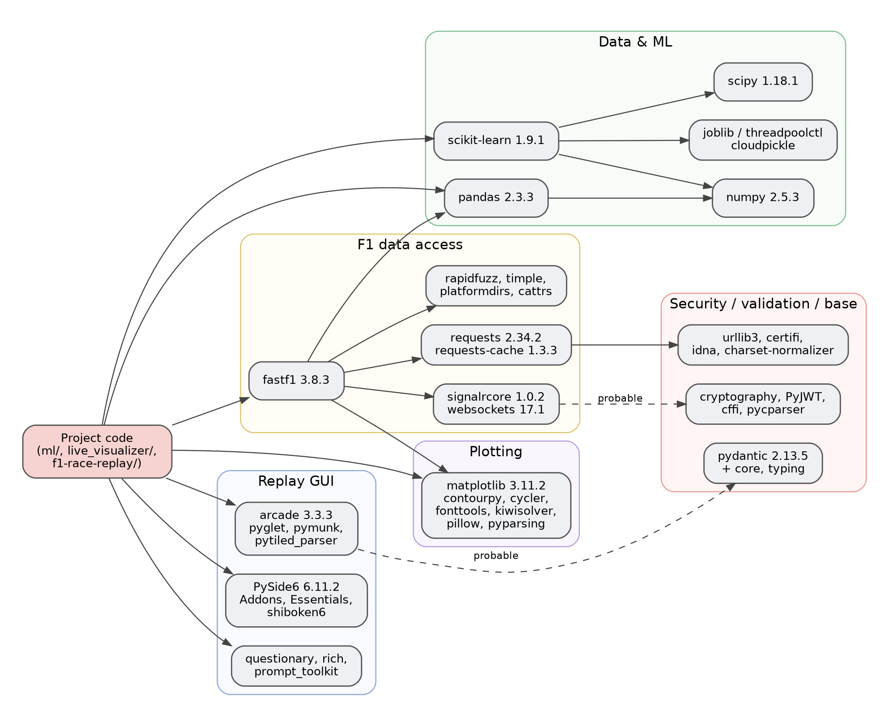
Figure 5: Dependency map derived from the pinned packages
Table 21: Dependency groups
Group | Packages (pinned version) | Likely role | Evidence
Data and ML | pandas 2.3.3, numpy 2.5.3, scipy 1.18.1, scikit-learn 1.9.1, joblib 1.6.0, threadpoolctl 3.7.0, cloudpickle 3.1.2 | Feature tables, RandomForest, model persistence | [V] pins; [I] roles
F1 data access | fastf1 3.8.3, requests 2.34.2, requests-cache 1.3.3, cattrs 26.2.0, attrs 26.1.0, url-normalize 3.0.0, rapidfuzz 3.14.6, timple 0.1.8, platformdirs 4.11.11 | Session loading, HTTP caching, name matching | [V] pins; [I] roles
Live connectivity | signalrcore 1.0.2, websockets 17.1, msgpack 1.1.2 | SignalR/WebSocket live-timing client (FastF1 dependency) | [V] pins; [I] role
Replay GUI | arcade 3.3.3, pyglet 2.1.16, pymunk 6.9.0, pytiled_parser 2.2.9, PySide6 6.11.2 (+ Addons, Essentials), shiboken6 6.11.2 | OpenGL window and Qt windows | [V] pins; [I] roles
Terminal UX | questionary 2.1.1, prompt_toolkit 3.0.53, rich 15.0.0, Pygments 2.21.0, markdown-it-py 4.2.0, mdurl 0.1.2, wcwidth 0.8.4 | Interactive menus, coloured output | [V] pins; [I] roles
Plotting | matplotlib 3.11.2, contourpy 1.4.0, cycler 0.12.1, fonttools 4.65.0, kiwisolver 1.5.1, pillow 11.3.0, pyparsing 3.3.3 | Charts (FastF1 and analysis) | [V] pins; [I] roles
Security and validation | cryptography 50.0.1, cffi 2.1.1, pycparser 3.0, PyJWT 2.14.0, pydantic 2.13.5, pydantic_core 2.46.5, annotated-types 0.8.0, typing-inspection 0.4.4, typing_extensions 4.16.0 | Probably transitive (TLS, auth tokens, models) | [V] pins; [I] transitive
HTTP and base | certifi, charset-normalizer, idna, urllib3, six, python-dateutil, pytz, tzdata, packaging, narwhals | Foundation libraries | [V] pins

4.8.1 What the dependency list tells us
- The replay GUI toolkit is unresolved. The README says Tkinter, but the pinned set contains Arcade and PySide6 and no entry for Tkinter (which would not appear anyway, because it ships with Python). Chapter 6 treats this as an open discrepancy.
- There is no web-server framework. No Flask, FastAPI or Django appears, which confirms the README statement that the dashboard needs no backend. [V]
- Model compatibility is pinned. scikit-learn==1.9.1, numpy==2.5.3 and pandas==2.3.3 are the versions in which model.pkl should be loaded. A pickled estimator from a different scikit-learn release can fail or warn. [V pins, I consequence]
- The environment is heavy. PySide6 and its Qt payload plus Arcade, pyglet and matplotlib make a large install. Someone who only wants predictions must still install the full GUI stack. Splitting requirements into ML-only and replay-only files would cut install size and time. [P]
- There are no test or lint tools. No pytest, ruff, flake8 or black appears, which matches the absence of an automated quality gate. [V absence in this file]
- Supply-chain surface is wide. Sixty packages including cryptography and PyJWT mean more exposure to advisories; pip-audit should run regularly. [P]
- Version numbers are recent. The pins use very current releases; if any pinned version is yanked or unavailable for an older Python, installation will fail. State the supported Python versions in the README. [P]

5. Front-End Design: Live Visualizer

5.1 Overview
The Live Visualizer is the project's front end. It lives in live_visualizer/ as three files, index.html, app.js and style.css, and is served as static content. The README instructs users to start a trivial server with python3 -m http.server 8000 and open http://localhost:8000. [V] The dashboard connects to the public OpenF1 API and shows live driver positions, telemetry, race-control messages and pit stops during an active session. [V] Because there is no back end, the browser itself performs every network request, parses the JSON, maintains application state and updates the page.

5.2 Frontend architecture
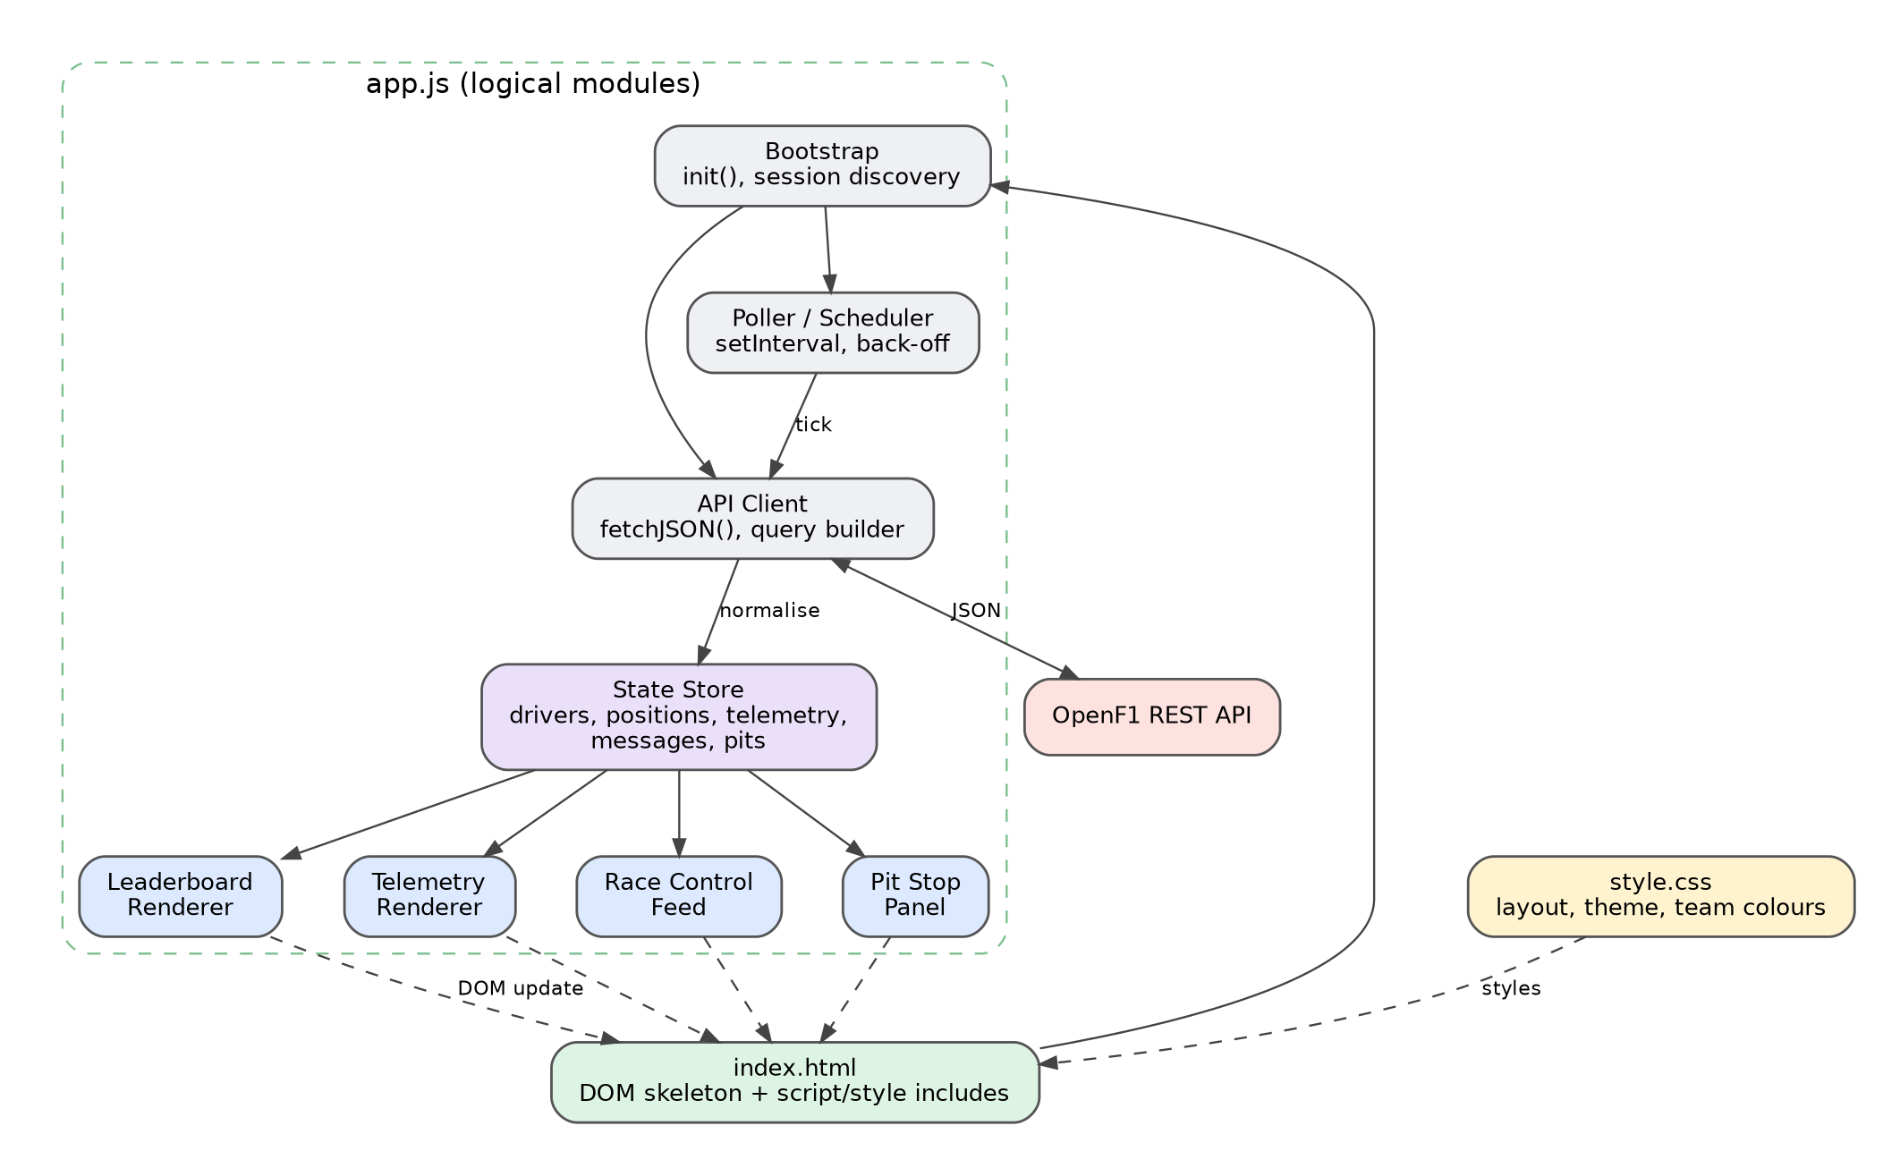
Figure 6: Logical module architecture of the dashboard (app.js)
Although app.js is a single file, it is best understood as six cooperating responsibilities. [I]
Table 22: Dashboard modules
Module | Responsibility | Typical functions (logical)
Bootstrap | Runs on page load; discovers the active (or latest) session; fetches driver list; starts the poller. | init(), loadSession(), loadDrivers()
API client | Builds URLs, performs fetch, checks status, parses JSON, throws or returns typed errors. | fetchJSON(endpoint, params)
Poller / scheduler | Calls the API client on a timer; handles back-off, pause when the tab is hidden, and re-checking when no session is live. | startPolling(), tick()
State store | Holds the latest drivers, positions, telemetry, race-control messages and pit stops; offers read access to renderers. | state object
Renderers | Translate state into DOM: leaderboard rows, telemetry gauges, message list, pit table. | renderLeaderboard(), renderTelemetry(), renderMessages(), renderPits()
Utilities | Time formatting, colour handling, small helpers. | fmtTime(), teamColour()

5.3 User interface design
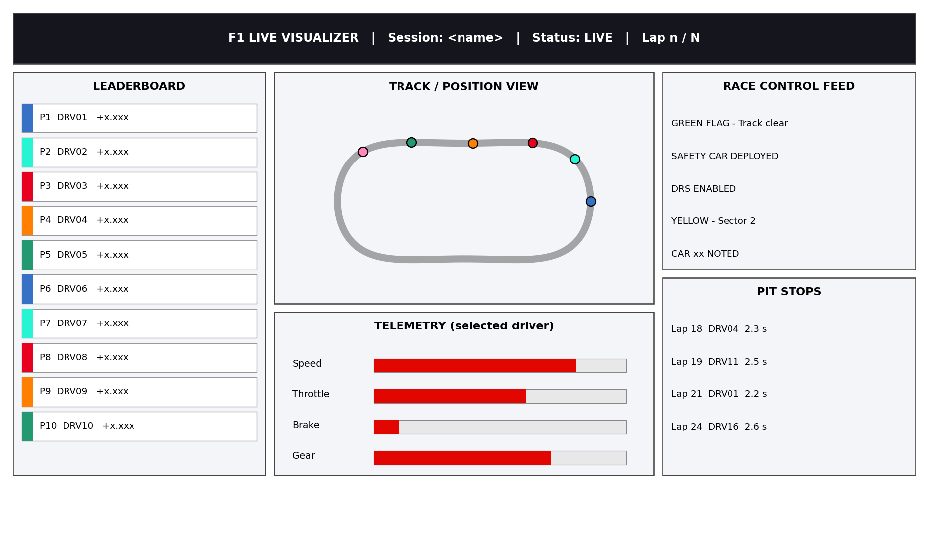
Figure 7: Conceptual UI wireframe of the dashboard (illustrative layout)
The wireframe shows the intended information architecture. A header bar identifies the session and its status. A leaderboard column on the left lists drivers in running order with a team-colour stripe. A central region contains the track or position view above a telemetry panel for the selected driver. A right-hand column holds the race-control feed and the pit-stop panel. This arrangement follows the common broadcast-timing pattern: the order is always visible, while contextual detail surrounds it. [I]
Table 23: Dashboard panels
Panel | Content | Update rate (suggested) | Interaction
Header | Session name, live/offline badge, lap counter | Every tick | None
Leaderboard | Position, driver acronym, team colour, gap or interval | 1–5 s | Click row to select driver
Track / position view | Cars plotted on a track outline or a simple position list | 1–2 s | Hover for driver name
Telemetry | Speed, throttle, brake, gear, RPM, DRS for the selected driver | 1–2 s | Driver selection
Race control | Chronological flags and messages, newest first | 5–10 s | Scroll
Pit stops | Lap number, driver, stop duration | 10 s | Scroll

5.4 Data flow and interaction sequence
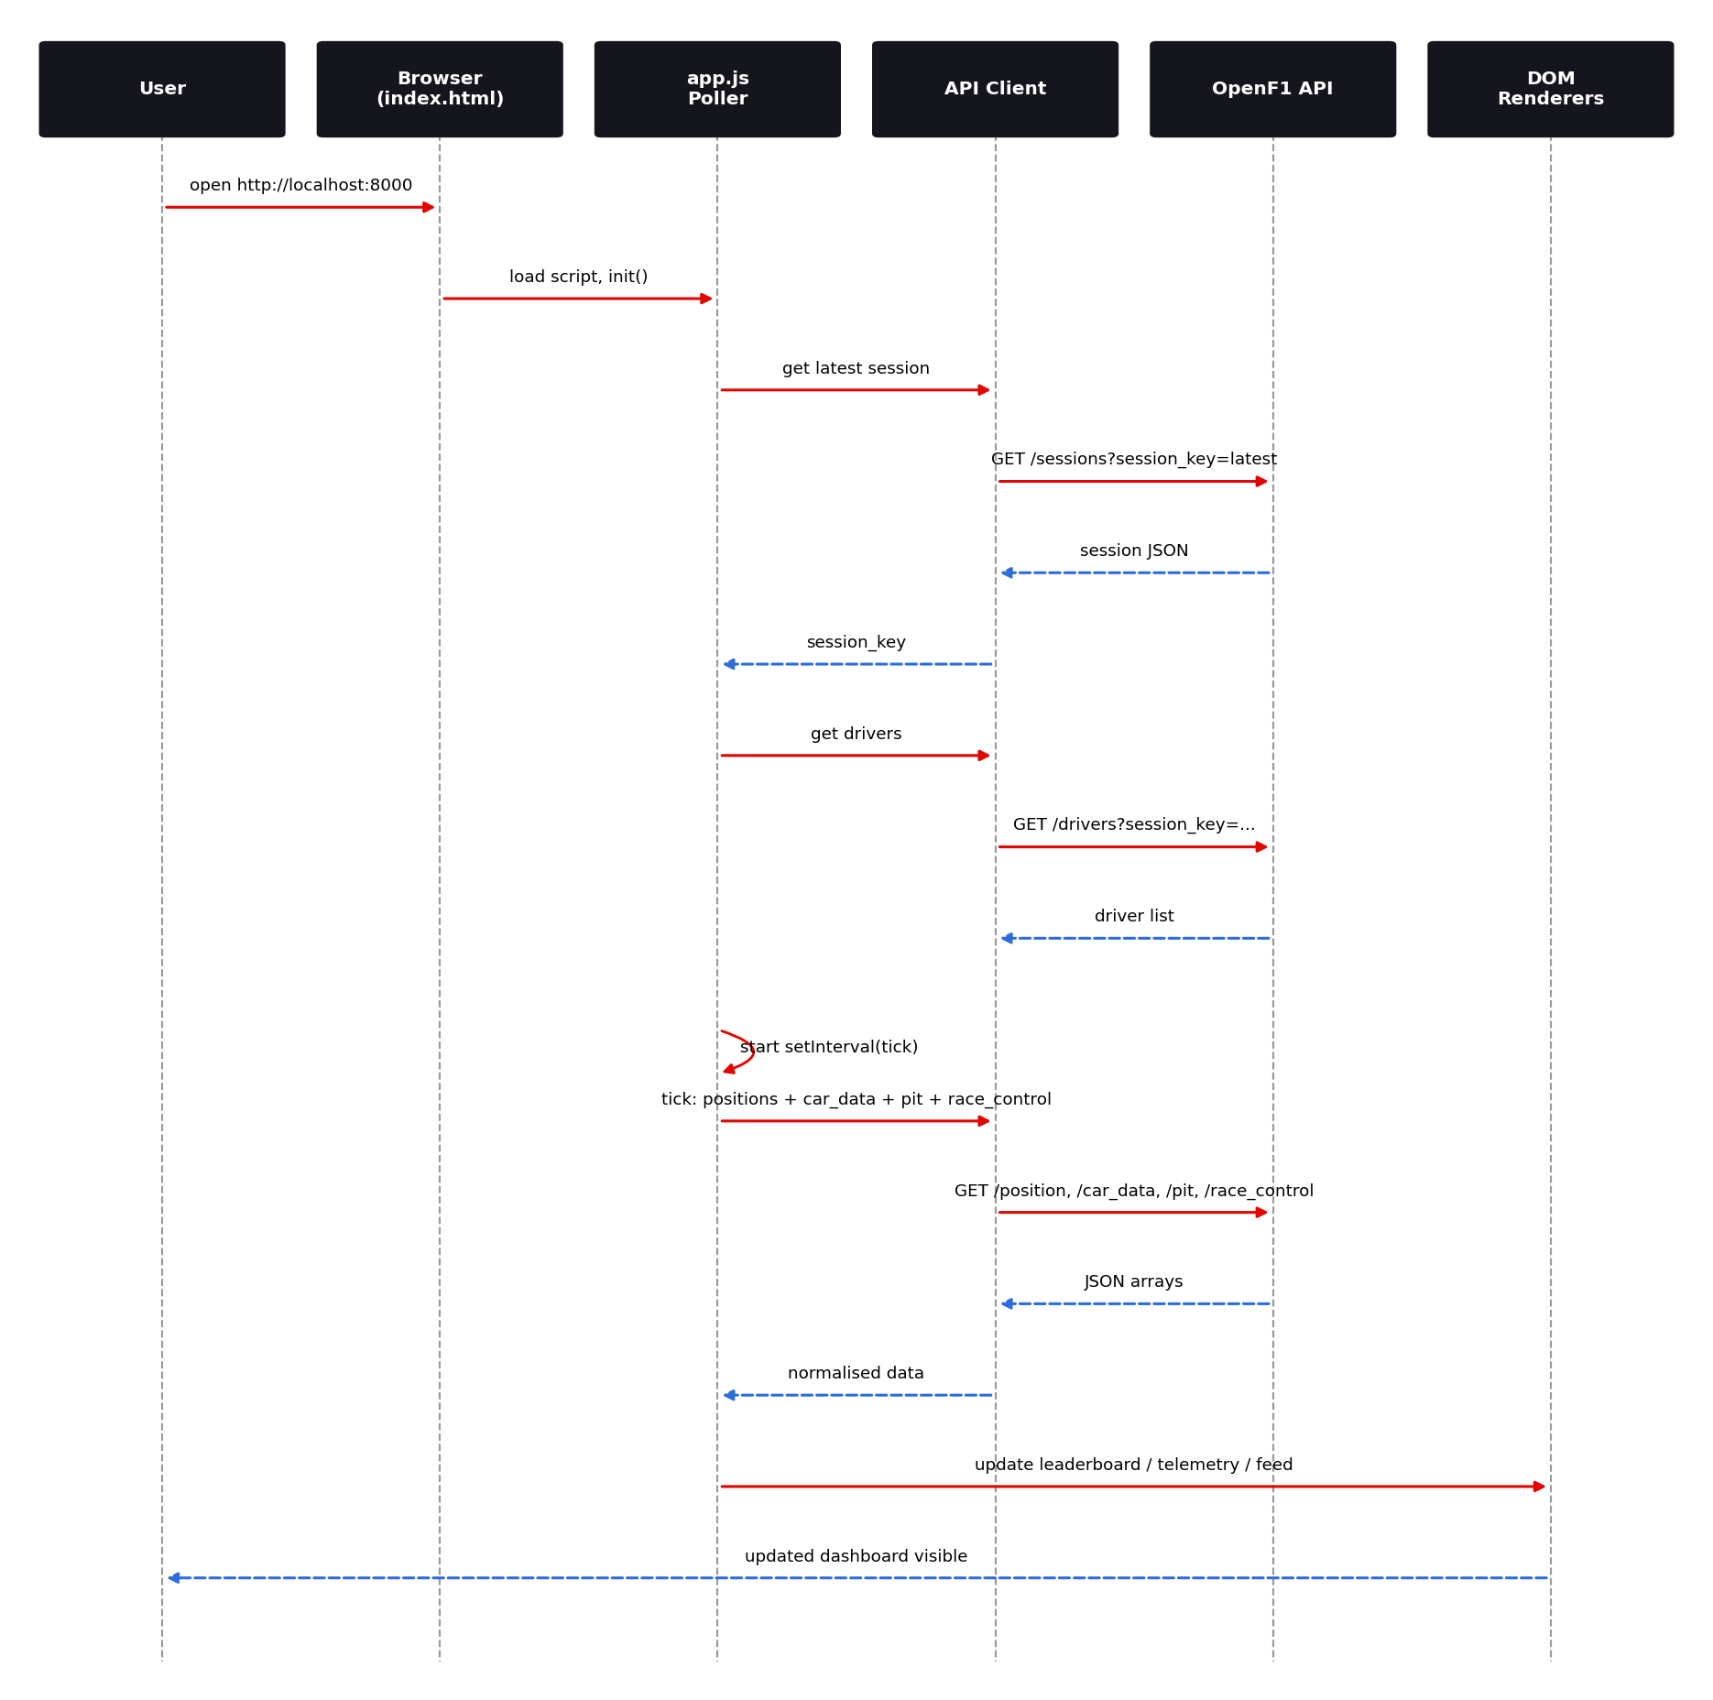
Figure 8: Initialisation and polling sequence between the user, the dashboard code and OpenF1
When the page loads, the bootstrap code asks OpenF1 for the latest session. OpenF1 supports a special session_key=latest filter for this purpose. [I] Once the session key is known, the drivers endpoint provides the grid of drivers with numbers, acronyms and team colours. The poller then starts a timer. At every tick the API client requests fresh position, telemetry, pit and race-control data for the session, normalises it into the state store and asks the renderers to update the DOM.

5.4.1 Efficient incremental fetching
OpenF1 endpoints return time-stamped samples and support date filters using comparison operators in the query string. A robust poller remembers the timestamp of the last sample it received per endpoint and asks only for newer samples on the next tick, rather than refetching the whole session. This reduces payload size dramatically for car_data, which can contain several samples per second per driver. [P]
// Proposed pattern: incremental polling with a per-endpoint cursor
const cursor = { position: null, car_data: null, race_control: null, pit: null };

async function pull(endpoint, sessionKey) {
const params = new URLSearchParams({ session_key: sessionKey });
let url = `https://api.openf1.org/v1/${endpoint}?${params}`;
if (cursor[endpoint]) url += `&date>${encodeURIComponent(cursor[endpoint])}`;
const res = await fetch(url);
if (!res.ok) throw new Error(`${endpoint} HTTP ${res.status}`);
const rows = await res.json();
if (rows.length) cursor[endpoint] = rows[rows.length - 1].date;
return rows;
}

5.5 UI state machine
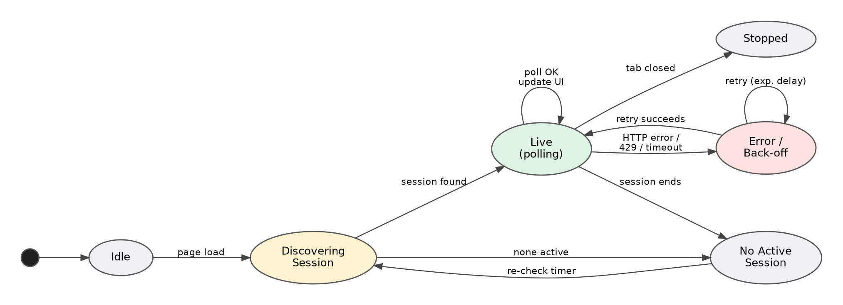
Figure 9: Dashboard lifecycle states and transitions
Table 24: Dashboard states
State | Entry condition | UI behaviour | Exit
Idle | Page opened | Skeleton panels, 'Loading…' | Automatic
Discovering session | Page load or re-check timer | Spinner in header | Session found / none active
Live (polling) | Active session found | Panels update every tick; LIVE badge | Error, session end, tab closed
No active session | No live session returned | Clear message; optionally show latest completed session | Timer re-check
Error / back-off | HTTP error, timeout or 429 | Non-blocking banner; retry delay doubles up to a cap | Retry succeeds
Stopped | Tab closed or polling paused | No activity | —

5.6 OpenF1 endpoints used
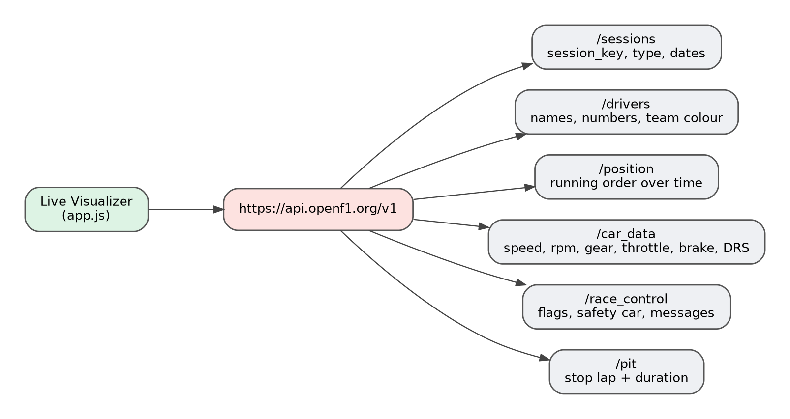
Figure 10: OpenF1 endpoints relevant to the dashboard
The README names four live data categories: driver positions, telemetry, race-control messages and pit stops. [V] These map to the OpenF1 endpoints position, car_data, race_control and pit, supported by sessions and drivers for context. [I] Chapter 11 provides a detailed reference.

5.7 Rendering strategy
DOM updates are the most expensive part of a live dashboard. The recommended rendering pattern is to build the structure of each panel once and update only text and style values on later ticks, instead of replacing innerHTML wholesale. For the leaderboard, one row element per driver is created at start-up and re-ordered by changing its CSS order or by re-appending rows; each tick updates only the changed fields. This avoids layout thrashing and preserves scroll position and hover state. [P]
- Batch all DOM writes for a tick inside one requestAnimationFrame callback.
- Use textContent rather than innerHTML for API-provided strings to avoid injection (see Section 13.3).
- Cap the race-control list (for example, 200 items) to keep memory bounded.
- Use CSS transitions for position changes so reordering is visually clear.
- Throttle telemetry updates to the human-visible rate; plotting every raw sample adds cost with no visual benefit.

5.8 Styling and theming
style.css provides layout and appearance. A dark theme with high-contrast accents is conventional for timing screens and reduces glare. Team colours are provided by OpenF1 as hexadecimal values in the drivers endpoint, so the stripe beside each leaderboard row can be driven directly by data rather than a hard-coded palette. [I]
Table 25: Suggested design tokens [P]
Design token | Suggested value | Use
Background | #15151E | Page background
Surface | #1F1F2B | Panel background
Accent | #E10600 | Headings, live badge, highlights
Text primary | #FFFFFF | Body text
Text secondary | #B0B4BE | Labels, gaps
Positive / negative | #2E9A5B / #E80020 | Delta colouring, flags

5.9 Responsiveness and accessibility
- Use CSS grid with named areas; collapse to a single column below about 900 px so the dashboard is usable on tablets and phones. [P]
- Provide text equivalents for colour-only information (for example, a flag name next to the flag colour).
- Ensure a contrast ratio of at least 4.5:1 for body text.
- Make driver selection reachable by keyboard (rows as button or with tabindex and key handlers).
- Announce important race-control messages through an aria-live="polite" region.

5.10 Error handling and resilience
A live dashboard must treat the network as unreliable. The recommended behaviour is: wrap every fetch in try/catch; treat non-2xx statuses as errors; on HTTP 429 or 5xx increase the polling interval using exponential back-off with jitter up to a maximum such as 30 seconds; show a small banner instead of blocking the UI; keep showing the last good data while retrying; and reset the interval after a success. [P]
let delay = 2000; // base interval (ms)
const MAX_DELAY = 30000;

async function loop() {
try {
await tick(); // fetch + update state + render
delay = 2000; // success: reset
hideBanner();
} catch (err) {
showBanner('Connection problem, retrying…');
delay = Math.min(delay * 2, MAX_DELAY) + Math.random() * 500;
} finally {
setTimeout(loop, delay); // schedule next run
}
}

5.11 Performance considerations
Table 26: Front-end performance risks and mitigations
Concern | Risk | Mitigation
Large car_data payloads | High bandwidth and parse time | Incremental date cursor; limit to selected driver for telemetry
Many DOM updates | Jank, high CPU | Update in place; batch with requestAnimationFrame
Background tab polling | Wasted calls and rate-limit use | Pause on visibilitychange; resume with fresh fetch
Memory growth | Unbounded arrays over a 2-hour race | Ring buffers or time windows for telemetry history
Many simultaneous viewers | Per-user API limits | Document limits; offer optional proxy with shared cache [P]

5.12 Browser compatibility and hosting
The dashboard relies only on standard web APIs (fetch, URLSearchParams, DOM, CSS grid) available in all evergreen browsers. [I] It must be served over HTTP rather than opened as a file:// URL so that cross-origin requests behave consistently. [I] The static folder can be hosted on any static host such as GitHub Pages, Netlify or an object-storage bucket without server code. [P]

5.13 Front-end configuration points
Table 27: Suggested configuration constants [P]
Setting | Purpose | Typical value
BASE_URL | OpenF1 API root | https://api.openf1.org/v1
POLL_INTERVAL_MS | Base refresh period | 2000–5000
MAX_BACKOFF_MS | Back-off ceiling | 30000
MAX_MESSAGES | Race-control list cap | 200
SESSION_KEY | Override to a fixed session for demos | latest

5.14 Front-end evolution options
- Introduce ES modules (type="module") to split app.js into files without a build step.
- Add a lightweight framework (Preact, Svelte or React) if the state and view logic grows.
- Add a track map using circuit coordinates from the location endpoint.
- Embed the ML podium prediction as a panel by exposing predictions as a JSON file produced by predict.py.
- Add a service worker for offline shell and asset caching.

6. Front-End Design: Race Replay Desktop Application

6.1 Overview and the GUI-toolkit discrepancy
f1-race-replay/ contains a standalone desktop application started with python main.py. It replays historical F1 sessions with telemetry overlays, has its own requirements.txt, and needs a desktop environment. [V] The README describes it as using a Tkinter GUI. [V]
The pinned dependency list in the root requirements.txt points somewhere else. It contains arcade 3.3.3 with its companions pyglet, pymunk and pytiled_parser, and PySide6 6.11.2 with PySide6_Addons, PySide6_Essentials and shiboken6, together with questionary, rich and prompt_toolkit. Tkinter ships with Python and would never appear in a requirements file, so its absence proves nothing, but the presence of Arcade and PySide6 strongly suggests that the replay window is drawn with Arcade (OpenGL), that Qt windows are used for secondary panels, and that a terminal menu built with questionary lets the user choose a session. [V for packages, I for interpretation] A search-engine snippet of the repository page also describes the project as using the OpenF1 API 'and F1 Race Replay', which hints that this folder is derived from the open-source F1 Race Replay project. [V snippet, I derivation]
Verify against source: The GUI toolkit is an open question. The README says Tkinter; the dependency manifest suggests Arcade and PySide6. Both statements can be true: the README may predate a rewrite, or the folder may be imported from an upstream project whose own requirements were merged into the root freeze. Check the import lines at the top of f1-race-replay/main.py and update the README so the two agree.

Table 28: GUI toolkit candidates
Candidate toolkit | How it renders | Main loop and timers | Implications for this app
Tkinter (README) | Canvas widgets; CPU-drawn items | mainloop(), after(ms, fn) | No extra install; limited performance with many moving items
Arcade (requirements.txt) | OpenGL through pyglet; sprites and shape lists | on_update(dt) and on_draw() driven by the window loop | Smooth 60 fps playback; needs a GPU driver; a natural fit for a game-style replay
PySide6 (requirements.txt) | Qt widgets and QPainter or Qt Quick | QTimer, QThread, signals and slots | Rich widgets for menus and insight windows; large install

The rest of this chapter is therefore written in a toolkit-neutral way. Wherever behaviour differs, the table above gives the mapping.

6.2 Architecture
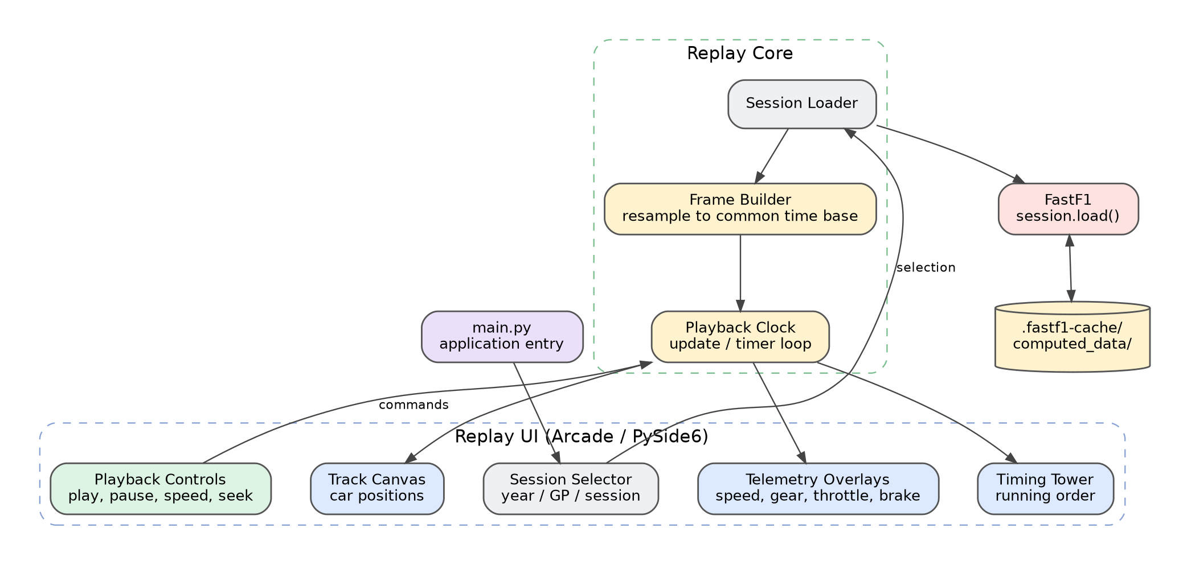
Figure 11: Race Replay architecture: UI, replay core and data layer
Table 29: Replay components [I]
Component | Role (logical)
Session selector | Lets the user choose season, Grand Prix and session type. With questionary in the dependency list this is probably an interactive terminal menu. [I]
Session loader | Calls FastF1 to load the session; uses the on-disk cache for repeat loads.
Frame builder | Resamples every driver's position and telemetry onto a common time base so that each frame contains all cars at one instant.
Playback clock | Advances the current frame index from the framework's update loop or timer, scaled by playback speed.
Track view | Draws the circuit outline and car markers.
Telemetry overlays | Shows speed, gear, throttle and brake for selected drivers.
Timing tower | Shows running order and gaps.
Computed-data store | The repository's computed_data/ folder is the natural place for resampled frames and derived telemetry that are expensive to rebuild. [I]

6.3 Playback model
Replay is a discrete-time simulation. After loading, the application holds an ordered list of frames spaced at a fixed interval of session time (for example 0.04 s for 25 frames per second of data). The playback clock keeps a floating-point session time and a speed multiplier. On every update tick it adds the elapsed wall-clock delta multiplied by the speed, clamps the result to the end of the data, converts the time into a frame index, and the draw routine renders that frame. Seeking sets the time directly; pausing stops the addition. This design makes play, pause, seek and speed change trivial and independent of data size. [I]
# Toolkit-neutral playback clock
class Clock:
def __init__(self, n_frames, dt_frame):
self.t = 0.0; self.speed = 1.0; self.playing = False
self.t_end = (n_frames - 1) * dt_frame; self.dt_frame = dt_frame

def update(self, delta): # called by the framework each tick
if self.playing:
self.t = min(self.t + delta * self.speed, self.t_end)
if self.t >= self.t_end: self.playing = False

@property
def frame(self):
return int(self.t / self.dt_frame)

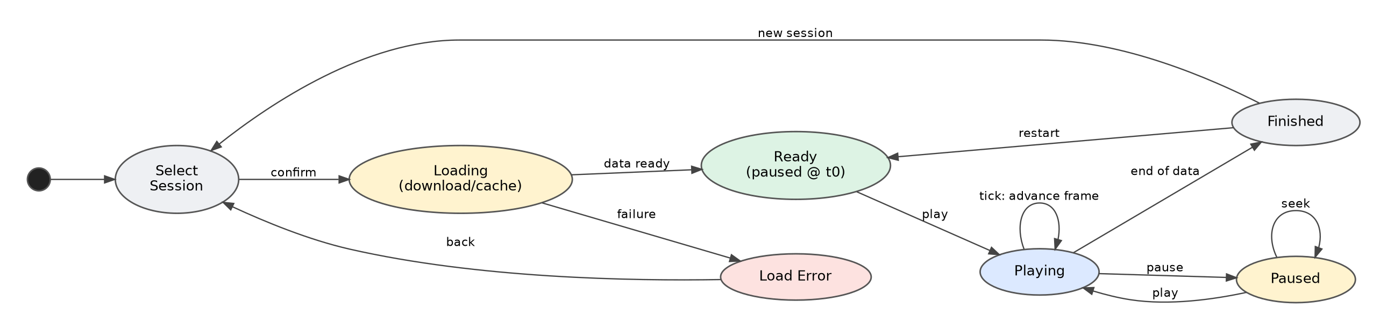
Figure 12: Replay lifecycle state machine
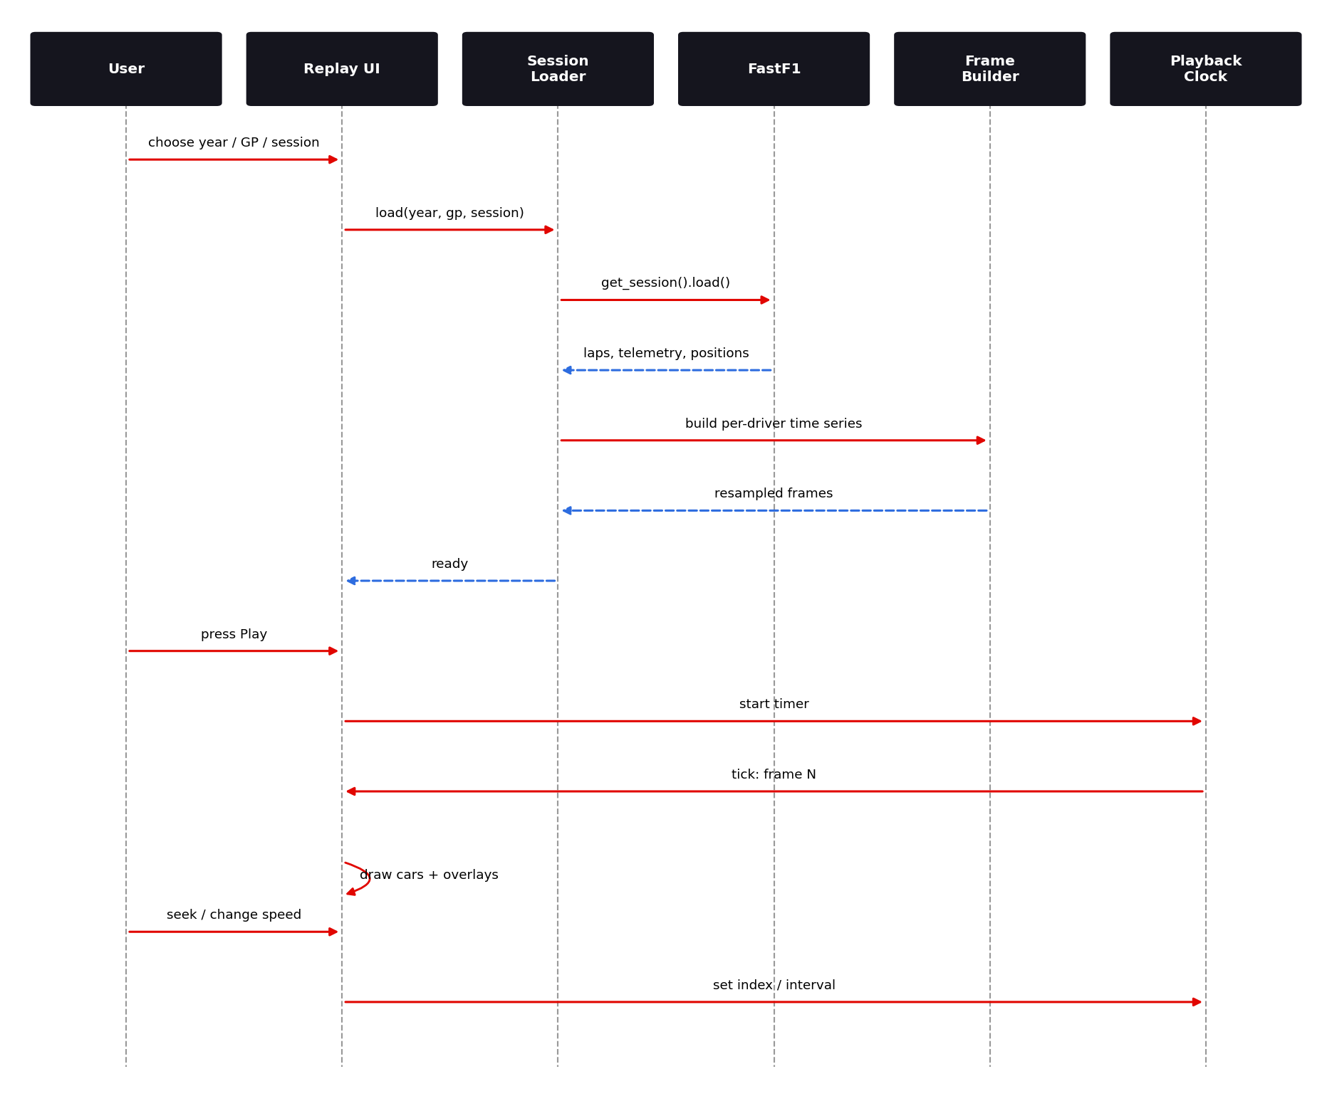
Figure 13: Replay load and playback sequence

6.4 Threading and responsiveness
Every toolkit named above requires drawing and widget updates to happen on the main thread. Long operations such as downloading and resampling a session must run elsewhere, or the window freezes and the operating system may flag it as not responding. The portable pattern is a worker thread that places its result on a queue.Queue, with the main loop polling the queue from a timer. In Qt the native equivalent is a QThread or QRunnable emitting a signal; in Arcade the polling happens inside on_update. A progress message must be shown while loading. [P]
import threading, queue
q = queue.Queue()

def load_worker(year, gp, kind):
try:
q.put(("ok", build_frames(year, gp, kind))) # FastF1 load + resample
except Exception as e:
q.put(("err", e))

def poll_queue(on_ok, on_err): # call from update loop / timer
try:
status, payload = q.get_nowait()
except queue.Empty:
return
(on_ok if status == "ok" else on_err)(payload)

threading.Thread(target=load_worker, args=(2024, "Monza", "R"), daemon=True).start()

6.5 Performance considerations
- Create drawing objects once (sprites, shape lists or canvas items) and move them each frame instead of destroying and recreating them.
- Precompute frames into NumPy arrays; convert to Python objects only when drawing.
- Cache built frames (for example under computed_data/) so a repeated session skips resampling. [I]
- Cap overlay redraw at about 30 frames per second; text rendering is usually the most expensive part of a frame.
- Skip frames when the draw time exceeds the tick time, so playback speed stays correct on slow machines.

6.6 Dependency footprint and packaging
Because the root requirements.txt merges the ML, FastF1 and GUI stacks, a contributor who only wants podium predictions must install Arcade, PySide6 and their native dependencies. PySide6 alone ships a large Qt payload. The sensible fix is a split: requirements-ml.txt (pandas, numpy, scikit-learn, fastf1, requests, requests-cache) and the existing f1-race-replay/requirements.txt for the GUI. Packaging the replay as a single executable (for example with PyInstaller) is a later option for non-developers. [P]

6.7 Limitations
- Desktop-only; not usable in a headless server or most CI environments. [V]
- First load of a session requires internet access and can take a while, depending on FastF1 downloads. [I]
- GPU and Qt platform libraries are needed if the Arcade/PySide6 reading is correct, which can fail on remote desktops and minimal Linux installs. [I]
- Documentation and dependencies disagree about the GUI toolkit (Section 6.1).

7. Back-End Design: Data Acquisition

7.1 Role of the data layer
The project has no traditional web back end. Its back end is a Python data and modelling layer that acquires historical data, transforms it into features, trains and stores a model, and serves predictions through a command-line interface. This chapter covers the first responsibility: obtaining data reliably while respecting provider limits.

7.2 Data acquisition overview
Table 30: Back-end data sources
Source | Accessed through | Used for | Cache
OpenF1 API | requests with requests-cache [V] | Session, qualifying and result data for training and prediction [I] | HTTP-level cache from requests-cache [V]
FastF1 | fastf1 Python API [V] | Results, laps, telemetry, schedule | .fastf1-cache/ [V]
Derived tables | pandas | Feature table | ml/historical_data.csv [V]
Derived artifacts | Python | Processed data | computed_data/ [V]

7.3 Rate limiting and caching
The README warns that re-training takes about 30 minutes because of API rate limits of 500 calls per hour on the free tier. [V] The training collector must therefore (a) avoid duplicate requests, (b) persist what it has already fetched, and (c) slow down when it approaches the limit. The project addresses (a) and (b) with requests-cache and with the CSV cache, and instructs users to delete ml/historical_data.csv to force a fresh collection. [V]
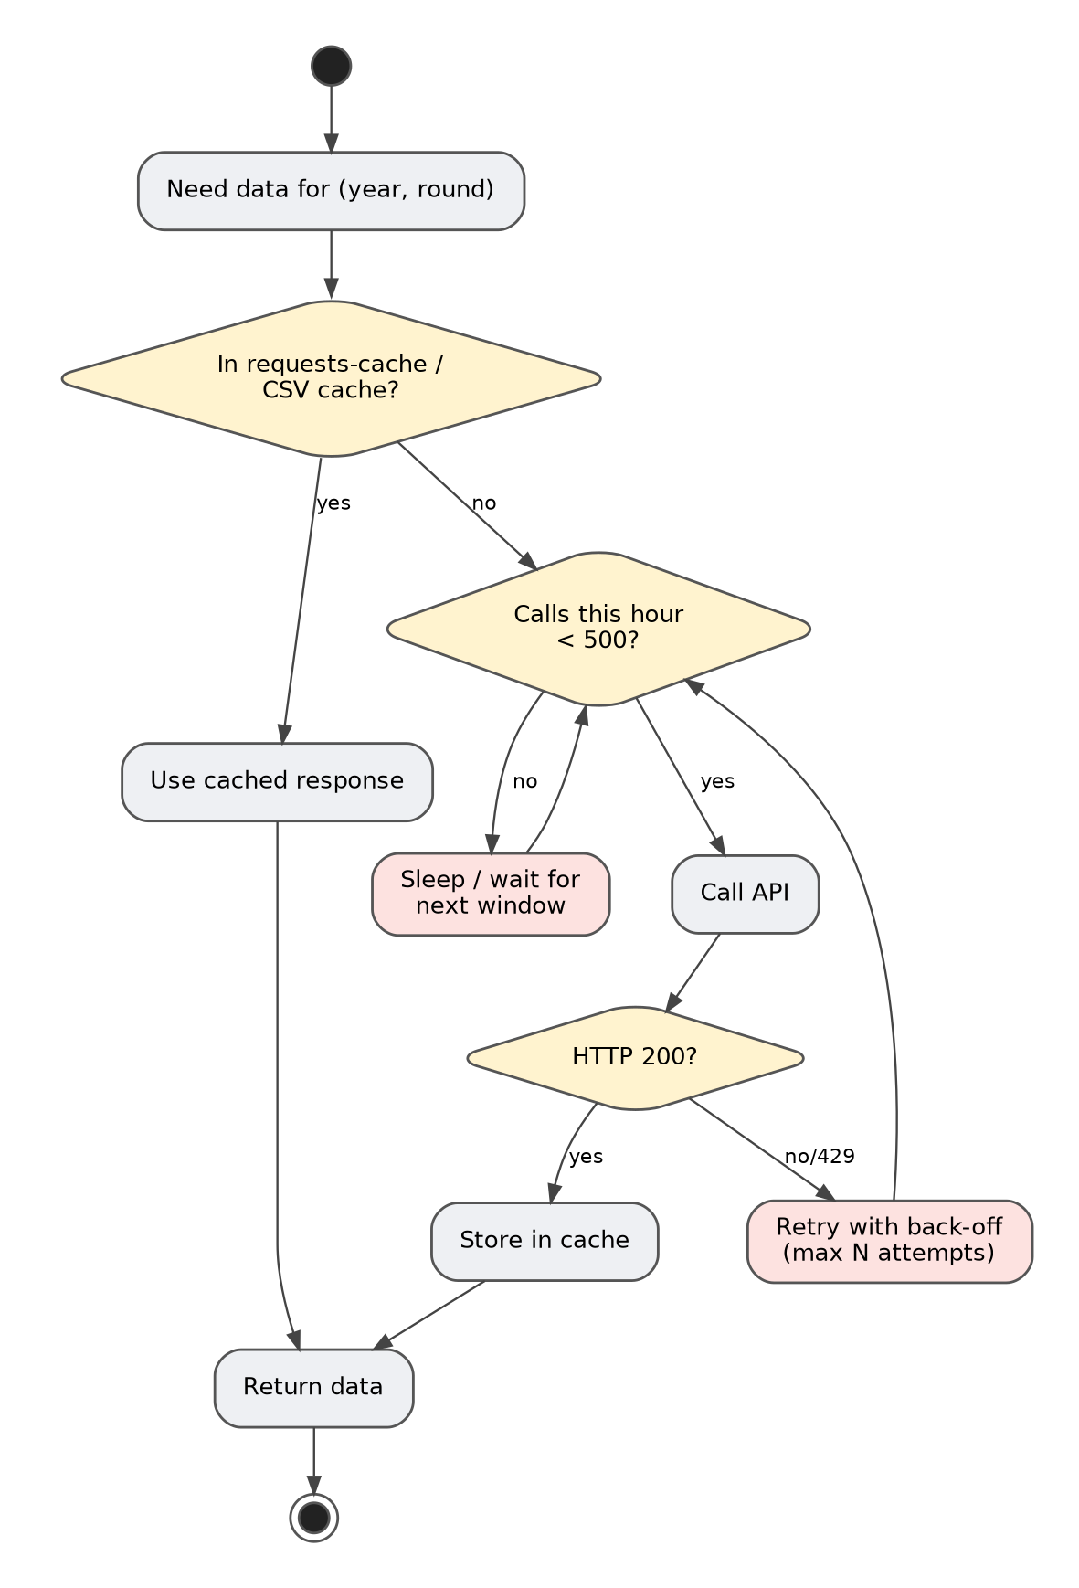
Figure 14: Activity diagram: cache lookup, rate-limit gate, retry and storage
The diagram shows the intended logic for every data request. A request is first answered from cache if possible. If not, a rate-limit gate checks the number of calls made in the current hour; when the budget is exhausted the collector sleeps until the next window. A successful response is stored in the cache before being returned. Failures, including HTTP 429, trigger a retry with back-off up to a maximum number of attempts. [I/P]

7.3.1 Request budget estimate
The budget can be estimated from the dataset size. Four seasons of about 22–24 rounds each give roughly 90–95 races. If each race needs a handful of calls (qualifying, race results, driver info, sessions), the total is a few hundred to a thousand calls, consistent with the 30-minute collection time once rate-limit waits are included. [I] The exact number should be measured and recorded after the first instrumented run (see Section 15.5).
Table 31: Data volume and budget
Quantity | Estimate | Basis
Seasons | 4 (2021–2024) | [V]
Races (approx.) | ≈ 88–96 | Calendar sizes of 22–24 rounds [I]
Entries | ≈ 1,679 | [V]
Entries per race | ≈ 18–20 | Grid size, with some DNS/DSQ [I]
Rate limit | 500 calls/h | [V]
Full collection time | ≈ 30 min | [V]

7.4 Recommended client design
A thin API client centralises URL construction, caching, throttling and retries so the rest of the code never calls requests directly. [P]
import time, requests, requests_cache
from collections import deque

class ApiClient:
def __init__(self, base="https://api.openf1.org/v1", per_hour=500):
self.base = base
self.s = requests_cache.CachedSession("openf1_cache", expire_after=None)
self.per_hour = per_hour
self.calls = deque() # timestamps of live (non-cached) calls

def _throttle(self):
now = time.time()
while self.calls and now - self.calls[0] > 3600:
self.calls.popleft()
if len(self.calls) >= self.per_hour:
time.sleep(3600 - (now - self.calls[0]) + 1)

def get(self, endpoint, **params):
for attempt in range(5):
self._throttle()
r = self.s.get(f"{self.base}/{endpoint}", params=params, timeout=30)
if not getattr(r, "from_cache", False):
self.calls.append(time.time())
if r.status_code == 200:
return r.json()
time.sleep(2 ** attempt) # back-off for 429 / 5xx
r.raise_for_status()

7.5 FastF1 usage pattern
FastF1 requires the cache to be enabled before any session is loaded. Sessions are identified by year, event (name or round number) and session code (FP1, FP2, FP3, Q, S, R). After load(), results, laps and telemetry are available as pandas objects. [I]
import fastf1
fastf1.Cache.enable_cache(".fastf1-cache")

ses = fastf1.get_session(2024, 18, "R") # year, round, session
ses.load(telemetry=False, weather=False) # lighter load for results
results = ses.results[["DriverNumber", "Abbreviation", "TeamName",
"GridPosition", "Position"]]

7.6 Data quality challenges
Table 32: Data quality issues and handling
Issue | Example | Handling strategy
Missing qualifying time | Driver eliminated early or no time set | Use best available session time; or maximum delta; flag with indicator [P]
Grid penalties / pit-lane starts | Grid position 0 or 20+ | Normalise to numeric; treat pit-lane start as last
DNS / DNF / DSQ | No classified finishing position | Assign position after last classified; podium label = 0
Team renames | Alfa Romeo → Kick Sauber; AlphaTauri → RB | Map to canonical constructor id before rolling averages [P]
Driver transfers | Mid-season team change | Compute constructor rolling average per team, driver rolling average per driver
Rookie drivers | No history | Use fallback average (for example mid-grid) [P]
API schema drift | Field renamed or removed | Defensive parsing; schema check test [P]

8. Back-End Design: ML Pipeline

8.1 Pipeline overview
Figure 15: End-to-end ML pipeline from data collection to prediction
The pipeline has eight stages. Collect gathers raw results and qualifying data for 2021–2024 from OpenF1 and FastF1. Cache persists the assembled table to ml/historical_data.csv. Clean repairs missing values and handles non-classified finishers. Engineer features computes the model inputs. Label marks podium finishers. Train and cross-validate fits a RandomForest and measures AUC. Persist writes model.pkl and features.json. Predict loads both and scores a requested round. [V for stages and artifacts; I for internal cleaning details]

8.2 Training data
Table 33: Training dataset facts
Property | Value | Evidence
Seasons | 2021, 2022, 2023, 2024 | [V]
Rows (race entries) | ≈ 1,679 | [V]
Unit of observation | One driver in one race | [I]
Target | Podium (1) vs not podium (0) | [I]
Positive rate | ≈ 15% (3 of ~20 entries) | [I]
Cache file | ml/historical_data.csv | [V]
Collection time | ≈ 30 minutes | [V]

8.3 Feature engineering
The model uses a deliberately small, interpretable feature set. The README lists five feature groups with their importances. [V]
Table 34: Feature catalogue (importances from README)
Feature | Definition (logical) | Why it matters | Importance
Grid position | Starting slot after qualifying and penalties | Track position at the start is the strongest single predictor of finishing position, especially on circuits where overtaking is difficult. | 36%
Quali delta to pole | Driver's best qualifying time minus pole time (seconds or percent) | Measures raw pace relative to the best, finer than grid slot. | 24%
Constructor rolling avg finish | Mean finishing position of the team's cars over the previous N races | Captures car performance and current development trend. | 16%
Driver rolling avg finish | Mean finishing position of the driver over the previous N races | Captures driver form and consistency. | 12%
Team & driver encoding | Numeric codes for team and driver identity | Lets the forest learn identity effects not captured by form. | 7%

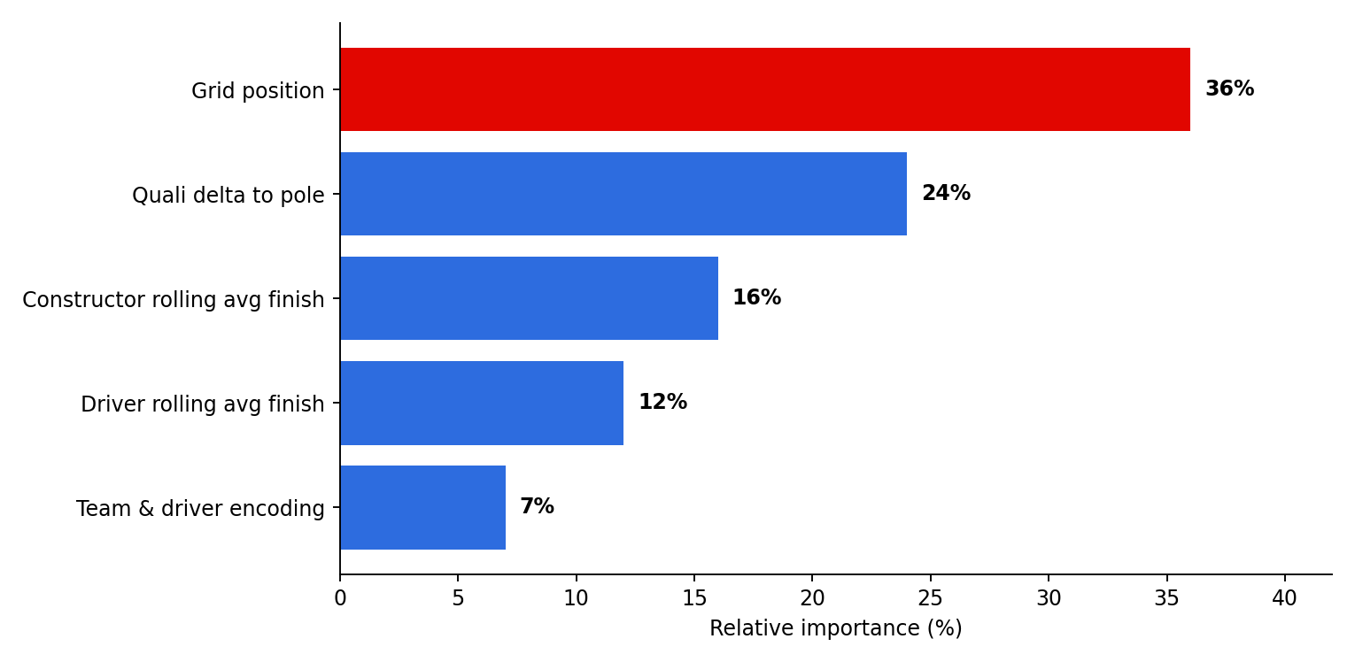
Figure 16: Feature importance of the trained RandomForest

8.3.1 Interpreting the importances
Grid position and quali delta together account for 60% of the model's decisions. This is intuitive: both describe where the car is relative to the field before the race starts. The two rolling-average features together contribute 28% and act as a prior on team and driver strength. Identity encodings contribute only 7%, which is reassuring, because it indicates the model is not memorising names. A caveat applies to every impurity-based importance: it can over-state high-cardinality or correlated features. Grid position and quali delta are strongly correlated, so their split of importance should not be read as exact. Permutation importance is a more reliable cross-check. [P]

8.3.2 Avoiding target leakage
A rolling average of finishing position must be computed from races that occurred before the race being predicted. If the current race result is included, the feature secretly contains the label. The pandas pattern for this is to sort chronologically, group by driver (or constructor), and apply shift(1) before rolling(N).mean(). [P]
df = df.sort_values(["year", "round"])
df["driver_roll_finish"] = (
df.groupby("driver")["finish_pos"]
.transform(lambda s: s.shift(1).rolling(5, min_periods=1).mean())
)
df["team_roll_finish"] = (
df.groupby("team")["finish_pos"]
.transform(lambda s: s.shift(1).rolling(10, min_periods=1).mean())
)

Verify against source: The window sizes (5 and 10 above) are illustrative. The real values live in train_model.py and should be recorded in Appendix G once confirmed.

8.4 Model selection and configuration
The README identifies the model as a RandomForest. [V] Because AUC is reported, the estimator is a classifier producing probabilities, i.e. scikit-learn's RandomForestClassifier. [I] The table lists typical hyper-parameters and the reasoning for the values a project of this size would normally use.
Table 35: Typical RandomForest configuration [I]
Hyper-parameter | Typical value | Reason
n_estimators | 200–500 | Enough trees for stable probabilities; diminishing returns beyond
max_depth | 8–15 or None with min_samples_leaf | Limits over-fitting on ~1.7k rows
min_samples_leaf | 3–10 | Smooths probability estimates
class_weight | balanced or balanced_subsample | Compensates for ~15% positive class
random_state | Fixed integer | Reproducibility
n_jobs | -1 | Use all CPU cores

8.5 Validation and metrics
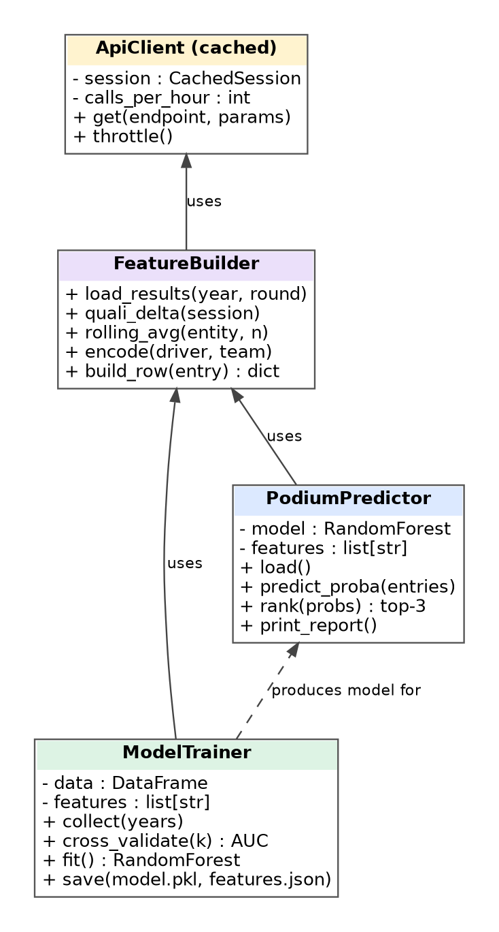
Figure 17: Logical class diagram of the ML back end (responsibilities, not literal classes)
The cross-validated ROC AUC is 0.935 ± 0.016. [V] The value indicates strong ranking quality: for a random podium finisher and a random non-podium finisher, the model scores the podium finisher higher about 93.5% of the time. The ±0.016 spread suggests low variance across folds. Two cautions apply. First, AUC measures ranking, not calibration: a probability of 0.40 may not mean a 40% real-world frequency. Second, grid position alone is already highly predictive in F1, so the improvement of the model over a simple baseline should be reported (Section 14.5).
Table 36: Evaluation metrics
Metric | Purpose | Status
ROC AUC (cross-validated) | Ranking quality across all thresholds | 0.935 ± 0.016 [V]
Top-3 hit rate per race | Of the three predicted drivers, how many actually finish top three | Recommended [P]
Exact podium match rate | Predicted set equals actual set | Recommended [P]
Brier score / calibration curve | Quality of probability values | Recommended [P]
Baseline AUC (grid only) | Proves the model adds value | Recommended [P]

8.6 Training sequence
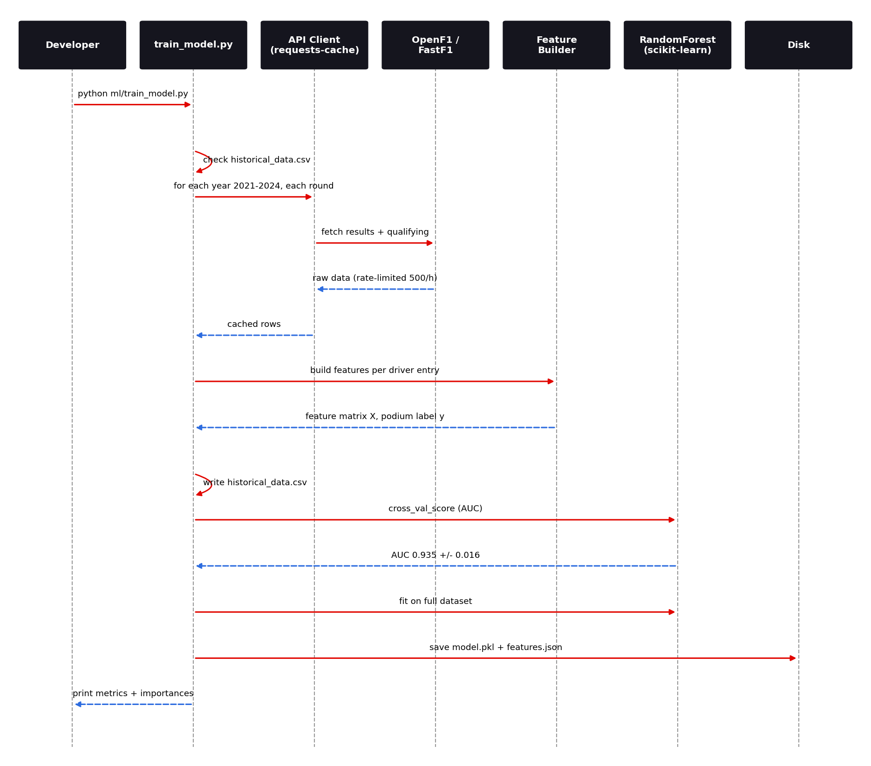
Figure 18: Training sequence

8.7 Persistence and the feature contract
Two files are written after training. model.pkl contains the serialized fitted estimator. features.json contains the ordered list of feature names. Tree models index columns by position, not name, so if predict.py builds its feature matrix in a different column order than training did, predictions would be silently wrong. Persisting the list next to the model, and having the predictor re-order columns by it, removes this failure mode. [V for files; I for rationale]
# training side
import json, pickle
pickle.dump(model, open("ml/model.pkl", "wb"))
json.dump(FEATURES, open("ml/features.json", "w"), indent=2)

# prediction side
FEATURES = json.load(open("ml/features.json"))
model = pickle.load(open("ml/model.pkl", "rb"))
X = rows[FEATURES] # enforce column order
proba = model.predict_proba(X)[:, 1]

8.8 Reproducibility and versioning
- Fix random_state for the forest and for the cross-validation splitter.
- Record library versions with the model: scikit-learn, pandas, numpy. Pickles are sensitive to scikit-learn version. [P]
- Verified pins: requirements.txt pins scikit-learn==1.9.1, numpy==2.5.3, pandas==2.3.3, scipy==1.18.1 and joblib==1.6.0. Load model.pkl under these versions, or expect warnings or errors. [V]
- Store metadata alongside the model: training date, years covered, row count, CV AUC, git commit. [P]
- Tag releases when a new model is committed so that model and code versions match.

8.9 Improvement opportunities
Table 37: Model improvement backlog [P]
Idea | Expected benefit | Effort
Time-aware cross-validation (train on past seasons, test on next) | More honest performance estimate | Low
Add circuit characteristics (overtaking difficulty, pole-to-win rate) | Better use of grid position | Medium
Add practice long-run pace | Race-pace signal not visible in qualifying | High
Add weather and tyre-strategy indicators | Captures wet races and strategy variance | High
Gradient boosting (XGBoost / LightGBM) comparison | Possible AUC gain | Medium
Probability calibration (isotonic / Platt) | More trustworthy probabilities | Low
Per-race normalisation so that exactly three podiums are predicted | Consistent output | Low

9. Back-End Design: Prediction Service

9.1 Command-line interface
Prediction is exposed as a command-line program. The README gives the canonical invocation: [V]
python ml/predict.py --year 2025 --round 18

Table 38: CLI arguments
Argument | Type | Meaning | Required
--year | int | Championship season | Yes [V]
--round | int | Round number within the season | Yes [V]

9.2 Inference flow
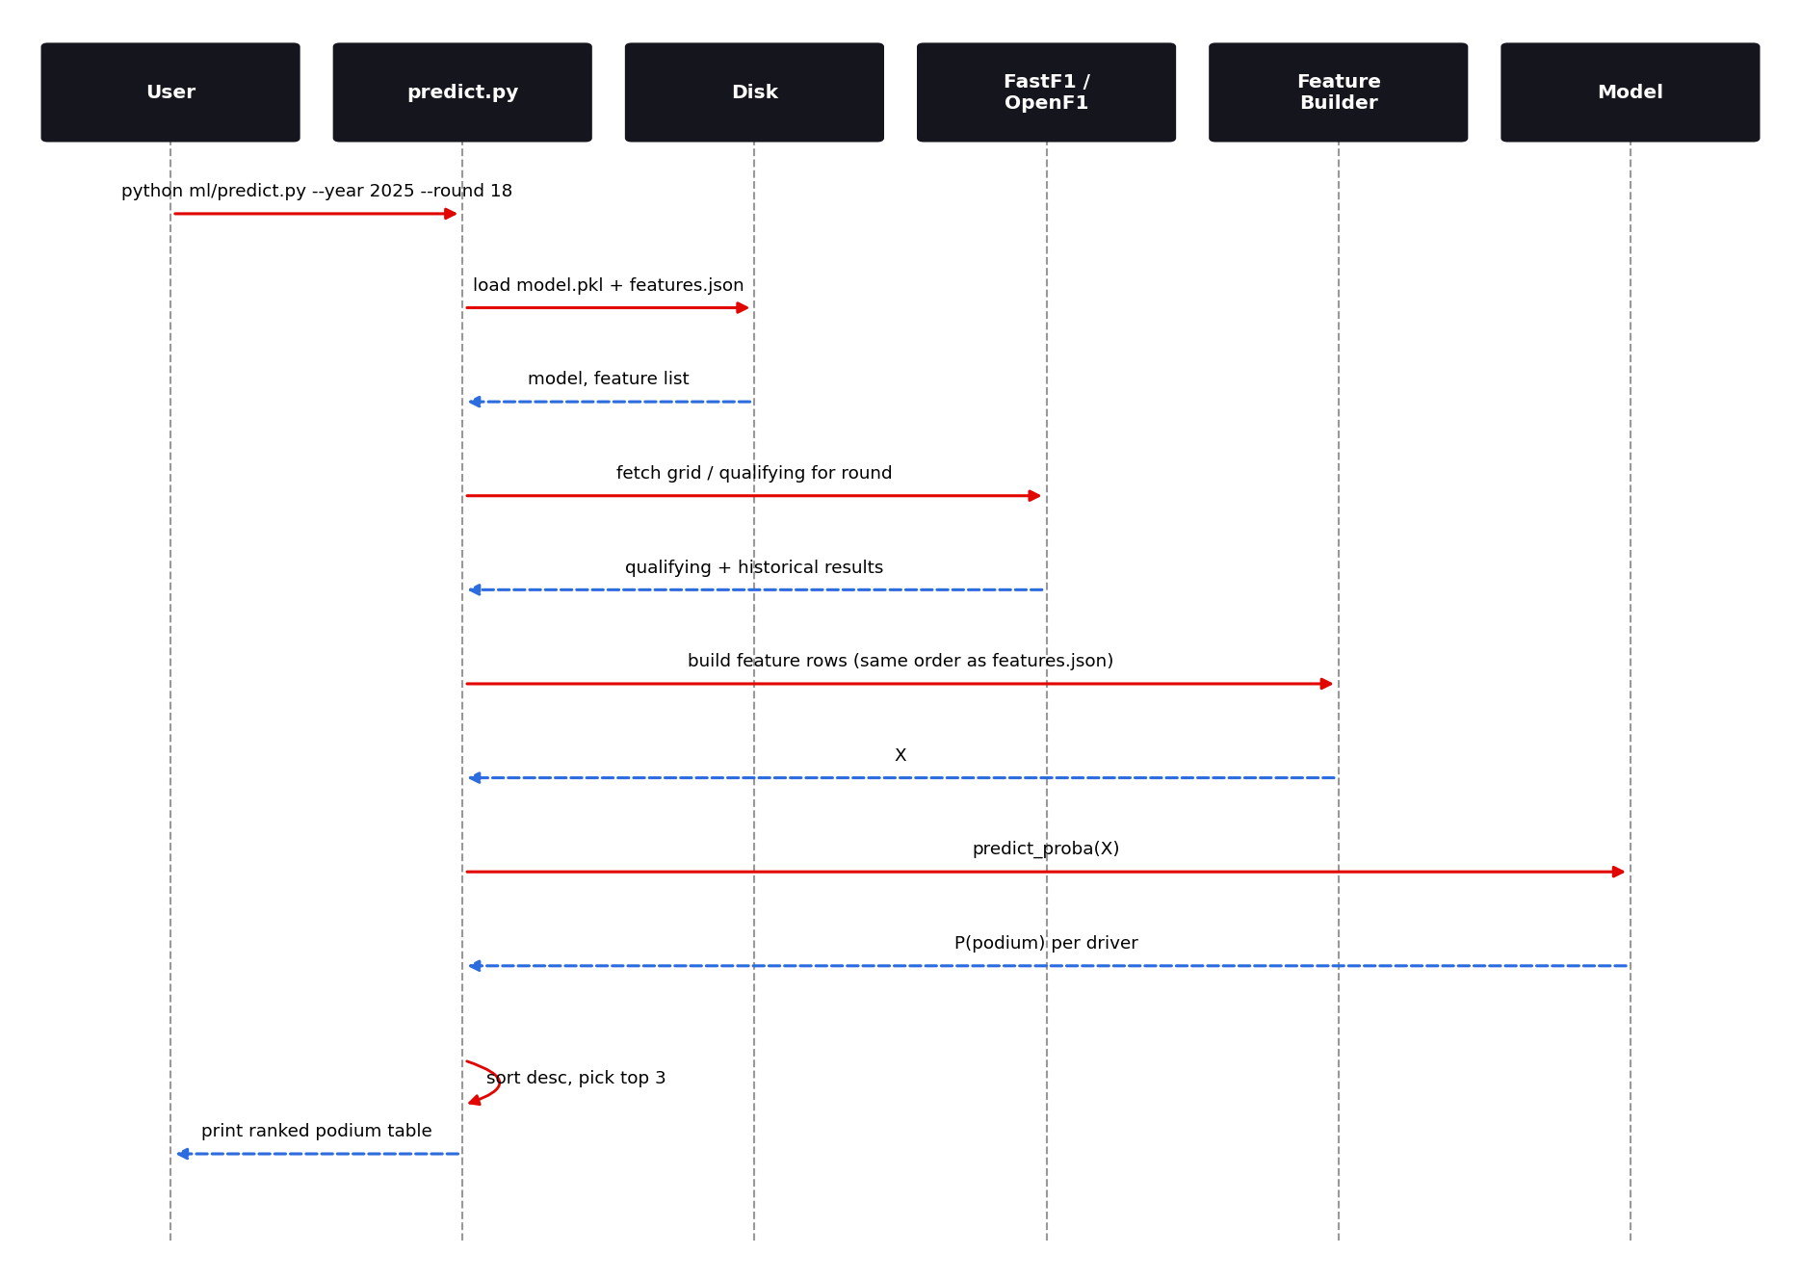
Figure 19: Prediction sequence
At start-up the script loads the model and the feature list. It then obtains the data needed for the requested round: the qualifying result (and hence grid and quali delta) and the historical results needed for the rolling averages. It builds one feature row per driver, selects and orders the columns by features.json, calls predict_proba, sorts by probability and prints the ranking. [I]

9.3 Output design
A clear console table is the natural output. A suggested layout shows the predicted order, driver, team, grid position and probability. Showing the grid position beside the probability helps the reader judge whether the model is mostly following the grid or deviating from it. [P]
Round 18, 2025 - Predicted podium probabilities
# Driver Team Grid P(podium)
1 XXX Team A 1 0.82
2 YYY Team B 2 0.71
3 ZZZ Team A 4 0.55
4 ...

9.4 Pre-race versus post-race use
The model can only be used after qualifying, because grid position and quali delta are its two strongest features. [I] Running it before qualifying would require substituting expected values, which the current design does not do. For completed races the same command can be used as a back-test: compare the printed prediction with the real podium.

9.5 Interpreting probabilities
- Probabilities from a random forest are averages of tree votes and tend to be under-confident at the extremes. Calibration improves interpretability. [P]
- Probabilities across drivers need not sum to three. If a strictly consistent podium is desired, normalise the probabilities so they sum to three or choose the top three only.
- A close third and fourth place indicate genuine uncertainty. Report both rather than a hard cut-off.

9.6 Error handling
Table 39: Prediction failure handling [P]
Failure | Cause | Desired behaviour
Missing model file | model.pkl absent or wrong path | Clear message advising to run train_model.py or restore the file [P]
Round not available | Future round or API gap | Explain that data is not yet available
Network error | No connectivity or HTTP 429 | Retry with back-off; fall back to cached data
Feature mismatch | Columns differ from features.json | Fail fast with the list of missing columns
Version mismatch | Pickle created with another scikit-learn version | Warn and advise re-training

9.7 Limitations of the prediction model
- Trained on 2021–2024 only; the regulation change expected in 2026 may reduce accuracy until retrained. [I]
- Does not know about in-race events such as safety cars, red flags, mechanical failures or first-lap incidents, which strongly affect outcomes.
- Does not know car upgrades introduced mid-season except through rolling averages that lag behind.
- Rolling averages for new drivers or teams are weak.
- Predictions are probabilistic and must not be used for wagering.

10. Data Model and Storage

10.1 Logical data model
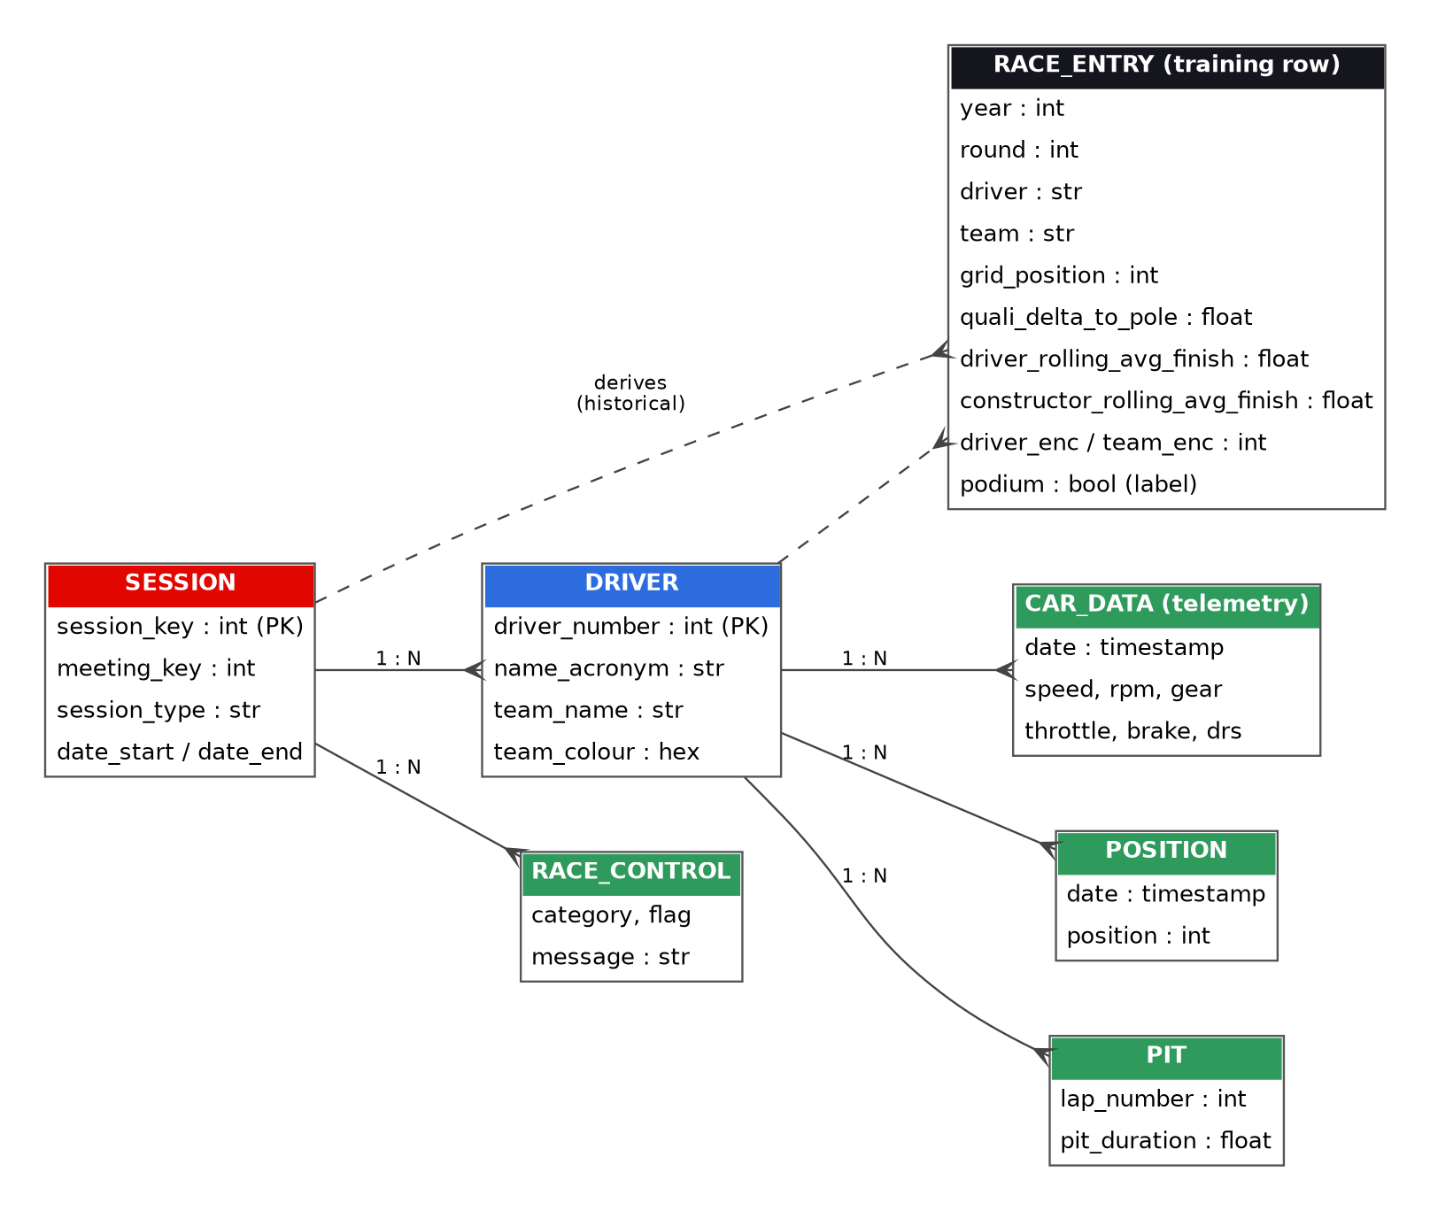
Figure 20: Entity-relationship view of API data and the derived training row
The diagram has two parts. The green entities are time-series and event records exposed by OpenF1 for a session. The dark RACE_ENTRY entity is the derived training row, built by joining session, driver, qualifying and historical results. This is the only table the model sees. Field names for the OpenF1 entities follow the public API; the RACE_ENTRY field names are logical. [I]

10.2 File-based storage
Table 40: Storage artifacts
Artifact | Format | Written by | Read by | Size class | Tracked in Git?
ml/model.pkl | pickle | train_model.py | predict.py | MB | Yes [V]
ml/features.json | JSON | train_model.py | predict.py | < 1 KB | Yes [V]
ml/historical_data.csv | CSV | train_model.py | train_model.py | ≈ 1,679 rows | No: ignored in .gitignore [V]
.fastf1-cache/ | FastF1 internal | fastf1 | fastf1 | 10s–100s MB | Ignored in .gitignore [V], yet folder visible in repo tree [V]
computed_data/ | Implementation-specific | Tools | Tools | Varies | [V] folder exists
requests-cache DB | SQLite | requests-cache | requests-cache | MB | No [I]

Caution: .gitignore already excludes .fastf1-cache/, ml/fastf1_cache/ and ml/historical_data.csv, yet .fastf1-cache is visible at the repository root. Git keeps tracking files that were committed before an ignore rule was added, so the folder was most likely committed earlier. [I] Remove it from tracking with git rm -r --cached .fastf1-cache and commit; contents stay on disk. Note also that the .gitignore repeats the FastF1 cache block twice and that the negation lines !ml/model.pkl and !ml/features.json are harmless but redundant, because no rule ignores those files.

10.3 Training table schema (logical)
Table 41: Training table schema [I]
Column | Type | Description | Nullable
year | int | Season | No
round | int | Round number | No
driver | string | Driver code or number | No
team | string | Constructor name (canonical) | No
grid_position | int | Starting position | No
quali_delta_to_pole | float | Gap to pole in seconds or percent | Imputed
driver_rolling_avg_finish | float | Prior N-race mean finish | Imputed for rookies
constructor_rolling_avg_finish | float | Prior N-race team mean finish | Imputed
driver_enc | int | Encoded driver identity | No
team_enc | int | Encoded team identity | No
finish_position | int | Classified finishing position | Training only
podium | int (0/1) | Label | Training only

10.4 `features.json` contract
[
"grid_position",
"quali_delta_to_pole",
"constructor_rolling_avg_finish",
"driver_rolling_avg_finish",
"team_enc",
"driver_enc"
]

The array above is illustrative. The real file defines the authoritative order. The only rule is that prediction must build columns in exactly this order. [V for concept]

10.5 Encoding strategy
Team and driver identities are encoded as integers. Integer label encoding is acceptable for tree models because splits can isolate individual codes, but the mapping from names to integers must be saved or deterministic; otherwise the same driver could receive different codes at training and at prediction. Sorting the unique names alphabetically, or persisting an encoder dictionary alongside the model, solves this. [P]

10.6 Data retention and size management
- Keep the cache folders out of Git.
- Provide a make clean-cache or equivalent command that removes .fastf1-cache and requests-cache files.
- Record in the README how large the caches grow after a full training run.
- Archive old models with version tags instead of overwriting history silently.

11. Interfaces and Reference

11.1 OpenF1 REST interface
All endpoints are under https://api.openf1.org/v1/. They accept GET requests and return arrays of JSON objects. Filters are provided through the query string; numeric and date fields support comparison operators written inline (for example date>2025-01-01T00:00:00). [I] The list below covers the endpoints relevant to this project.
Table 42: OpenF1 endpoint reference (public API; subset)
Endpoint | Description | Key filters | Key fields | Used by
/sessions | Sessions (practice, qualifying, sprint, race) | year, session_type, session_key | session_key, meeting_key, session_name, date_start, date_end | Dashboard, ML
/meetings | Grand Prix weekends | year, meeting_key | meeting_name, circuit_short_name, country_name | Dashboard, ML
/drivers | Drivers in a session | session_key, driver_number | driver_number, name_acronym, team_name, team_colour | Dashboard
/position | Running order over time | session_key, driver_number, date | date, driver_number, position | Dashboard
/car_data | Telemetry samples | session_key, driver_number, speed>, date | speed, rpm, n_gear, throttle, brake, drs | Dashboard
/race_control | Flags, safety car, steward messages | session_key, category, flag | date, category, flag, message, lap_number | Dashboard
/pit | Pit-stop events | session_key, driver_number | lap_number, pit_duration, date | Dashboard
/laps | Lap times and sectors | session_key, driver_number, lap_number | lap_duration, duration_sector_1..3 | Possible extension
/session_result | Final classification (where available) | session_key | position, driver_number | ML (possible)

Verify against source: Endpoint names and fields are reproduced from general knowledge of the public OpenF1 API and may change. Consult https://openf1.org for the authoritative, current specification before relying on any field.

11.2 Command-line reference
Table 43: Command reference
Command | Purpose | Notes
git clone <repo-url> | Get the code | [V]
python3 -m venv .venv | Create virtual environment | [V]
source .venv/bin/activate / .venv\Scripts\activate | Activate (Unix / Windows) | [V]
pip install -r requirements.txt | Install dependencies | [V]
cd live_visualizer && python3 -m http.server 8000 | Serve dashboard | [V]
python ml/predict.py --year 2025 --round 18 | Run prediction | [V]
rm ml/historical_data.csv && python ml/train_model.py | Fresh re-train (~30 min) | [V]
cd f1-race-replay && pip install -r requirements.txt && python main.py | Run replay GUI | [V]

11.3 File interface contracts
Table 44: Internal contracts
Contract | Producer → Consumer | Rule
Feature order | train_model.py → predict.py | Prediction must select columns by features.json order.
Model compatibility | train_model.py → predict.py | Model must be loaded with a compatible scikit-learn version.
Cache validity | historical_data.csv → train_model.py | If file exists it is trusted; delete to refresh.
Team/driver encoding | Training ↔ prediction | Same mapping at both stages.

11.4 Suggested JSON export for dashboard integration [P]
To display predictions inside the live dashboard without adding a server, predict.py could write a small JSON file that the static front end can fetch. This keeps the architecture serverless.
{
"year": 2025,
"round": 18,
"generated_at": "2025-10-04T12:30:00Z",
"model": { "type": "RandomForest", "cv_auc": 0.935 },
"predictions": [
{ "driver": "XXX", "team": "Team A", "grid": 1, "p_podium": 0.82 },
{ "driver": "YYY", "team": "Team B", "grid": 2, "p_podium": 0.71 }
]
}

12. Deployment and Environment

12.1 Deployment model
The project is designed for local execution. There is no production server. Each user clones the repository, creates a Python virtual environment, installs dependencies and runs the component they need. The only network service started locally is the static file server for the dashboard. [V]
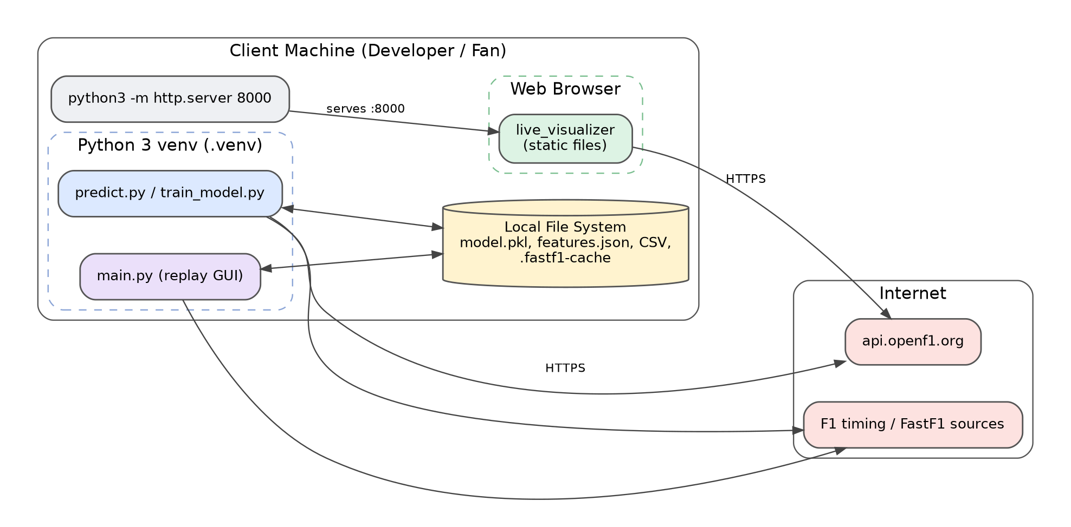
Figure 21: Deployment view: local machine components and external services

12.2 Prerequisites
Table 45: Prerequisites
Requirement | Version / note | Needed for
Python | 3.9 or newer recommended [I] | ML, replay
pip and venv | Bundled with Python | Dependency management
Graphics stack | OpenGL-capable graphics driver (Arcade/pyglet) and Qt platform libraries (PySide6) [I]; the README also mentions Tkinter | Race Replay
Modern browser | Chrome, Firefox, Edge, Safari | Dashboard
Internet access | OpenF1 and FastF1 sources | All components (first run)
Disk space | Several hundred MB for caches | FastF1, requests-cache
Git | Any recent version | Cloning

12.3 Step-by-step setup
- Clone the repository: git clone https://github.com/iDare-Hacker/f1-predictor-project then cd f1-predictor-project.
- Create a virtual environment: python3 -m venv .venv.
- Activate it: source .venv/bin/activate (macOS/Linux) or .venv\Scripts\activate (Windows).
- Install dependencies: pip install -r requirements.txt.
- Run the component you need (see Sections 12.4–12.6).

12.4 Running the Live Visualizer
cd live_visualizer
python3 -m http.server 8000
# open http://localhost:8000 in a browser

The dashboard shows live data only while a real F1 session is in progress. Outside session times it has little to show, which is why a demo mode with a fixed past session key is a worthwhile addition. [P]

12.5 Running predictions and training
# Predict (uses pre-trained model)
python ml/predict.py --year 2025 --round 18

# Retrain (about 30 minutes; API rate limits)
rm ml/historical_data.csv
python ml/train_model.py

12.6 Running the Race Replay
cd f1-race-replay
pip install -r requirements.txt
python main.py

12.7 Troubleshooting guide
Table 46: Troubleshooting
Symptom | Likely cause | Fix
ModuleNotFoundError | Virtual environment not active or dependencies missing | Activate .venv; run pip install -r requirements.txt
Replay window fails to open (OpenGL or Qt platform error) | Missing OpenGL/Qt libraries, headless or remote session | Update graphics drivers; install Qt platform dependencies; run in a desktop session
Dashboard shows nothing | No live session, blocked request, or API error | Check the browser console and network tab; try during a session
CORS or mixed-content error | Opening via file:// or using non-HTTPS endpoint | Serve through http.server; use HTTPS endpoint
HTTP 429 during training | Exceeded 500 calls/hour | Wait; keep the cache; avoid parallel runs
Pickle warning / error | scikit-learn version mismatch | Install the version used in training, or re-train
Replay hangs on load | Large download on GUI thread | Wait for first download; later loads use cache
Prediction for unknown round | Round not yet run or not in data source | Choose a completed round

12.8 Optional: hosting the dashboard
Because the dashboard is static, any static host works. GitHub Pages is the simplest option for a public repository: publish the live_visualizer folder (or copy it to a docs/ folder) and enable Pages in the repository settings. Netlify, Cloudflare Pages or an S3-compatible bucket with static-website hosting are equivalent. Ensure the site is served over HTTPS so that calls to the HTTPS API are not blocked as mixed content. [P]

12.9 Optional: containerising the Python tools [P]
FROM python:3.11-slim
WORKDIR /app
COPY requirements.txt .
RUN pip install --no-cache-dir -r requirements.txt
COPY ml ./ml
ENV PYTHONUNBUFFERED=1
ENTRYPOINT ["python", "ml/predict.py"]
# usage: docker run --rm f1-predictor --year 2025 --round 18

The replay GUI is not a good container candidate because it needs a display server. The training job is a good candidate, especially with a mounted volume for the caches so that the 30-minute collection is not repeated.

12.10 Environment matrix
Table 47: Environments
Environment | Purpose | Data | Model
Developer laptop | Day-to-day work | Local caches | Committed model or local retrain
CI runner [P] | Lint, tests, smoke | Recorded fixtures only | Committed model
Static host [P] | Public dashboard | Live OpenF1 calls | Optional exported JSON
Training job [P] | Periodic retrain | Fresh collection with throttle | Candidate model with version tag

13. Security and Compliance

13.1 Security posture overview
The system handles no user accounts, no payments and no personal data, which removes most conventional web-application risks. [I] Its remaining risks come from three places: running code obtained from third parties (dependencies, pickled models), rendering data received from an external API in the browser, and consuming third-party services under their terms.
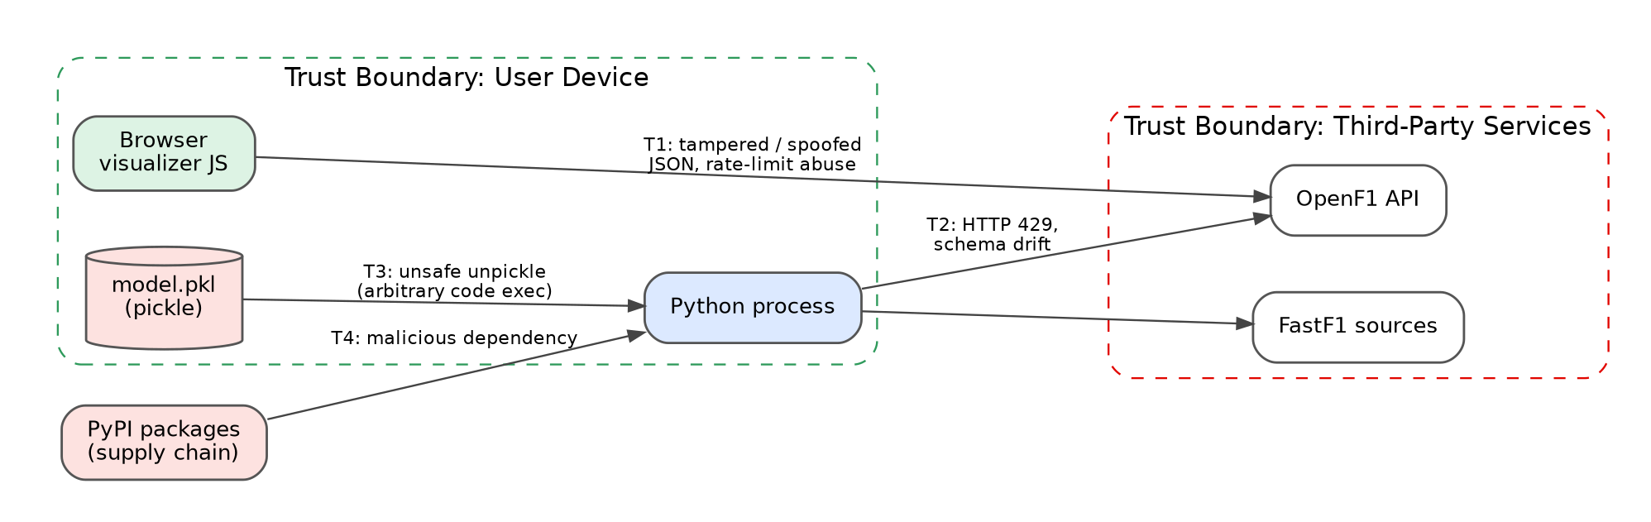
Figure 22: Trust boundaries and principal threats

13.2 Threat register
Table 48: Threat register
ID | Threat | Asset | Likelihood | Impact | Mitigation
T1 | Malicious or malformed API data rendered in the DOM (XSS) | Browser session | Low | Medium | Use textContent; never inject API strings via innerHTML; validate types
T2 | Rate-limit exhaustion or provider outage | Availability | High | Low | Cache, back-off, document limits, fall back to cached data
T3 | Unsafe deserialisation of model.pkl (pickle executes code on load) | Developer machine | Low–Medium | High | Only load models from the trusted repo; verify checksum; consider skops or ONNX [P]
T4 | Malicious or compromised dependency | Developer machine | Low | High | Pin versions, use a lock file, run pip-audit, review updates [P]
T5 | Secret leakage (API keys, tokens) | Credentials | Low | Medium | Keep secrets out of the repo; use environment variables; secret scanning
T6 | Cache poisoning of local caches | Data integrity | Low | Low | Use HTTPS; clear caches if results look wrong
T7 | Committing large caches or personal files | Repository hygiene | Medium | Low | Ignore rules exist; untrack .fastf1-cache with git rm -r --cached; add pre-commit size check

13.3 Front-end security guidance
- Treat all API fields as untrusted text. Render with textContent or by creating elements and assigning text.
- If HTML formatting is ever required for race-control messages, sanitise with a vetted library.
- Add a Content-Security-Policy meta tag that restricts connect-src to https://api.openf1.org and script-src to 'self'. [P]
- Do not place secrets in front-end code; anything shipped to the browser is public.
- Use Subresource Integrity (SRI) hashes when loading any third-party script from a CDN.
<meta http-equiv="Content-Security-Policy"
content="default-src 'self';
connect-src 'self' https://api.openf1.org;
img-src 'self' data:;
style-src 'self' 'unsafe-inline'">

13.4 Back-end security guidance
- Pickle risk. Loading a pickle can execute arbitrary code. Because model.pkl is committed to the repository, it is as trustworthy as the repository itself. Contributors should review changes to binary files carefully and publish a SHA-256 checksum with each release.
- Dependency hygiene. Pin exact versions in requirements.txt (or generate a requirements.lock), and run pip-audit in CI.
- Least privilege. The tools need no administrator rights and no write access outside the project folder and caches.
- Input validation. Validate --year and --round as integers within plausible ranges before building URLs.

13.5 Compliance and licensing
Table 49: Compliance checklist
Topic | Guidance
OpenF1 terms | Respect rate limits; review the provider's current terms and any attribution request.
FastF1 licence | Open source; follow its licence and cite it.
F1 trademarks and data | Formula 1 names, logos and timing data belong to their owners; this project is unofficial and should say so in its README. [P]
Project licence | No licence file exists at the repository root. [V] Add one (for example MIT or Apache-2.0) so that others know how they may use the code. [P]
Betting disclaimer | State clearly that predictions are for education and entertainment. [P]

13.6 Privacy
No personal data is collected or stored. The browser sends standard HTTP request metadata (IP address, user-agent) to the OpenF1 service, as with any web request. If the project later adds analytics, accounts or hosted components, a privacy review should precede the change.

14. Testing and Quality Assurance

14.1 Test strategy
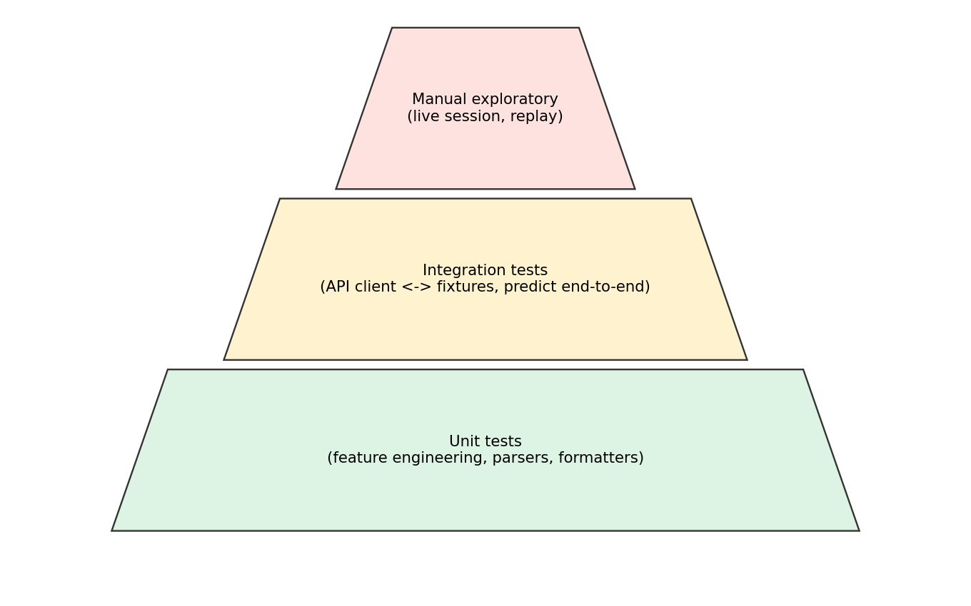
Figure 23: Proposed testing pyramid
A balanced strategy relies on many fast unit tests for pure logic, a smaller number of integration tests with recorded API responses, and a limited set of manual exploratory checks for the live and GUI parts that are hard to automate. Automated tests must never call live APIs, both to respect rate limits and to remain deterministic. [P]

14.2 Test levels and scope
Table 50: Test levels
Level | Scope | Tools | Data
Unit (Python) | Feature functions, parsers, encoders, CLI argument validation | pytest | Small hand-made frames
Unit (JavaScript) | Formatters, normalisers, back-off function | vitest or jest | Fixture JSON
Integration | API client with responses or recorded HTTP; predict.py end-to-end | pytest, requests-mock | Recorded fixtures
Model regression | Re-compute CV AUC on cached CSV; compare to stored value | pytest | historical_data.csv
UI smoke | Dashboard loads, renders skeleton, handles empty API | Playwright [P] | Mocked network
Manual | Live race session; replay GUI playback | Checklist | Real

14.3 Test case catalogue
Table 51: Test cases
ID | Area | Test | Expected
TC-01 | Features | Rolling average excludes current race | Value equals mean of prior N races
TC-02 | Features | Quali delta for pole driver | Zero
TC-03 | Features | Driver without history | Fallback value, no NaN
TC-04 | Features | Team rename mapping | Rolling average continuous across rename
TC-05 | Predict | --year missing | Usage message, non-zero exit
TC-06 | Predict | Feature order shuffled in input frame | Output identical to ordered input
TC-07 | Predict | Missing model.pkl | Clear message, non-zero exit
TC-08 | API client | HTTP 429 then 200 | Retries, returns data
TC-09 | API client | Cached response | No network call made
TC-10 | API client | 500 calls in hour | Throttle waits
TC-11 | Dashboard | Empty API array | 'No active session' state shown
TC-12 | Dashboard | HTTP 500 on tick | Banner shown; last data kept; back-off grows
TC-13 | Dashboard | Message containing <script> | Rendered as text, not executed
TC-14 | Dashboard | Tab hidden for 60 s | Polling paused; resumes on visible
TC-15 | Replay | Load invalid session | Error dialog, return to selector
TC-16 | Replay | Seek to end | State becomes Finished
TC-17 | Model | CV AUC on cached CSV | Within ±0.02 of 0.935
TC-18 | Model | Grid-only baseline AUC | Lower than full model

14.4 Example automated tests [P]
# tests/test_features.py
import pandas as pd
from ml.features import add_rolling_features # logical module name

def test_rolling_excludes_current_race():
df = pd.DataFrame({
"year":[2024]*4, "round":[1,2,3,4],
"driver":["A"]*4, "team":["T"]*4,
"finish_pos":[1,3,5,7],
})
out = add_rolling_features(df, window=2)
# round 3 uses rounds 1-2 only: (1+3)/2 = 2.0
assert out.loc[out["round"] == 3, "driver_roll_finish"].iloc[0] == 2.0

14.5 ML-specific validation

14.5.1 Time-aware validation
Random k-fold cross-validation mixes races from all seasons in both training and validation folds. Because teams and drivers have persistent strength within a season, rows from the same season are correlated, so random folds can give an optimistic estimate. A more honest design trains on earlier seasons and tests on a later one (for example train on 2021–2023, test on 2024), or uses scikit-learn's TimeSeriesSplit after ordering rows chronologically. The reported 0.935 ± 0.016 is a useful figure but should be complemented with a forward-chaining result. [P]

14.5.2 Baselines
Table 52: Baselines to report
Baseline | Description | Purpose
Grid-only | Score = −grid position | Shows how much of the AUC is explained by starting slot
Pole-to-podium heuristic | Predict top three on the grid | Intuitive benchmark
Constructor form | Rank by team rolling average | Shows contribution of car performance

14.5.3 Data-leakage checklist
- No race-day outcomes (finishing position, race laps) in any feature for the same race.
- Rolling windows use shift(1).
- Encoders are fitted without looking at validation labels (or are deterministic).
- Scaling or imputation statistics, if used, are computed on training folds only (use a scikit-learn Pipeline).
- Qualifying-derived features use only information available at the start of the race.

14.6 Manual test checklist (live session)
- Start the local server and open the dashboard 15 minutes before a session.
- Confirm the header shows the correct session and a LIVE status when the session starts.
- Verify the leaderboard matches the official timing screen for the first five positions.
- Select a driver and confirm telemetry values move plausibly (speed rising on straights, brake spikes).
- Trigger or wait for a flag message and confirm it appears in the feed within one polling interval.
- Observe a pit stop and verify the lap number and duration appear.
- Disconnect the network for 30 seconds; confirm a banner appears and recovery occurs on reconnection.
- Leave the tab in the background for 5 minutes; confirm no excessive requests are made.

14.7 Quality gates [P]
Table 53: CI quality gates
Gate | Threshold
Lint (ruff / eslint) | 0 errors
Unit test pass rate | 100%
Line coverage on feature code | ≥ 80%
Model regression AUC drop | ≤ 0.02 versus stored baseline
Dependency audit | No known high-severity vulnerabilities

14.8 Continuous integration pipeline [P]
Figure 24: Proposed CI/CD pipeline
# .github/workflows/ci.yml (proposed)
name: ci
on: [push, pull_request]
jobs:
python:
runs-on: ubuntu-latest
steps:
- uses: actions/checkout@v4
- uses: actions/setup-python@v5
with: { python-version: "3.11" }
- run: pip install -r requirements.txt pytest ruff pip-audit
- run: ruff check .
- run: pytest -q
- run: pip-audit -r requirements.txt

15. Performance, Reliability and Observability

15.1 Performance budgets
Table 54: Performance budgets
Operation | Budget | Notes
Dashboard tick (fetch + render) | < 500 ms on broadband; render < 50 ms | Incremental fetch; DOM updates in place
Dashboard first paint | < 1 s | Static files only
Prediction (cached round) | < 5 s | Dominated by data load and pickle load
Prediction (uncached round) | < 30 s | Network bound
Full re-train | ≈ 30 min [V] | Rate-limit bound; CPU time for forest is seconds
Replay session load (cold) | ≈ 0.5–3 min [I] | FastF1 download
Replay session load (warm) | < 15 s | Cache hit

15.2 Reliability and failure modes
Table 55: Failure mode analysis
Failure mode | Effect | Detection | Recovery
OpenF1 unavailable | Dashboard empty; training stalls | HTTP errors, timeouts | Back-off; use cache; retry later
Provider schema change | Parsing errors | Schema tests; exceptions | Update parser; pin API behaviour in fixtures
Corrupt cache | Odd or missing data | Checksum / sanity tests | Delete cache and refetch
Stale model | Degraded accuracy | Back-test metrics | Re-train; version the model
Replay UI freeze | GUI unresponsive | User report | Move loading to worker thread
Browser throttles background tab | Delayed updates | Timestamps in UI | Refresh on visibilitychange

15.3 Observability
The project is small, but a little structured logging pays for itself during the 30-minute training run and during live sessions.
- Python: use the logging module with levels (INFO for progress such as 'Fetched 2023 round 7', WARNING for retries, ERROR for failures). Log cache hit ratio and total live calls per hour. [P]
- Browser: log poll duration, error count and current back-off to the console behind a DEBUG flag, and display a discreet 'last updated' timestamp in the UI. [P]
- Model: write a model_card.json with CV metrics, feature importances and training date each time the model is trained. [P]

15.4 Capacity and scalability
The system is designed for a single user per machine, so server-side scalability is not a concern. The only scale risk is many people running the dashboard at once, each polling the public API. If the dashboard became popular, a small caching proxy that polls OpenF1 once and serves many viewers would reduce load and protect the rate limits. That change would break the pure no-backend design and should be taken only if demand justifies it. [P]

15.5 Measurements to record
Table 56: Metrics to record
Metric | How to obtain | Why
Live API calls per full training run | Counter in ApiClient | Validate the 500/hour budget
Cache hit ratio | requests-cache statistics | Tune caching
Dashboard polls per minute | Console counter | Confirm throttling
Pickle size and load time | Timing in predict.py | Track model growth
Per-race top-3 hit rate | Back-test script | Track real-world accuracy

16. Maintenance, Risks and Roadmap

16.1 Maintenance plan
Table 57: Maintenance schedule
Activity | Frequency | Owner | Notes
Add the latest season to training data and re-train | Once per season (after the final race) [P] | Maintainer | Re-run back-tests; tag release
Review API endpoint changes | Quarterly | Maintainer | Check OpenF1 changelog
Update dependencies | Monthly | Maintainer | Run tests and pip-audit
Verify dashboard in a live session | Each season start | Maintainer | Use manual checklist
Prune caches in repository | As needed | Contributors | Keep repository small

16.2 Risk register
Table 58: Risk register
ID | Risk | Probability | Impact | Mitigation | Owner
R1 | Upstream API changes or shuts down | Medium | High | Fixtures, abstraction layer, alternative sources (FastF1) | Maintainer
R2 | Regulation changes reduce model accuracy | High (2026) | Medium | Add new data quickly; time-aware validation; monitor hit rate | Data scientist
R3 | Rate-limit changes make training impractical | Medium | Medium | Persistent caches; paid tier; use FastF1 for bulk historical data | Maintainer
R4 | Pickle incompatibility across versions | Medium | Medium | Pin versions; store metadata; alternative serialisation | Maintainer
R5 | Single maintainer / knowledge loss | Medium | High | This document; tests; README | Owner
R6 | Legal or trademark complaint | Low | Medium | Unofficial disclaimer; no redistribution of raw data | Owner
R7 | Repository bloat from caches | High | Low | Untrack .fastf1-cache; dedupe .gitignore; Git LFS if artifacts required | Contributors

16.3 Roadmap
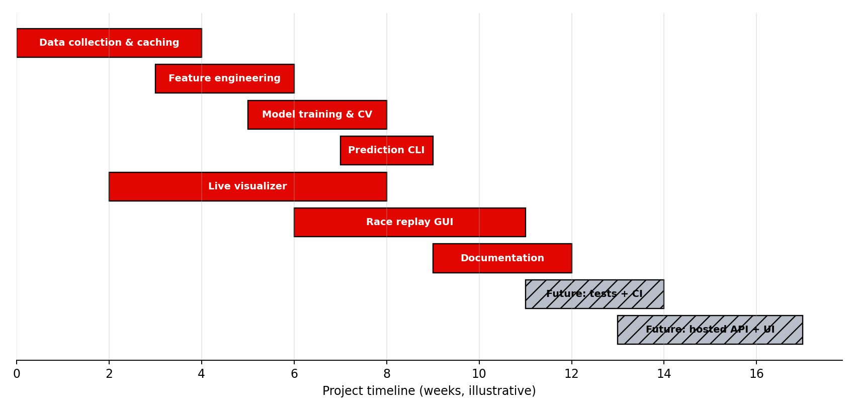
Figure 25: Illustrative project timeline: delivered scope and proposed future work
Table 59: Roadmap phases
Phase | Deliverables | Status
Phase 1: Foundations | Data collection, caching, repository structure | Delivered [V]
Phase 2: Model | Feature engineering, RandomForest, CV AUC 0.935, saved artifacts | Delivered [V]
Phase 3: Tools | Prediction CLI, live visualizer, race replay GUI | Delivered [V]
Phase 4: Quality | Tests, CI, untrack committed caches, licence, requirements split, model card | Proposed [P]
Phase 5: Integration | Show predictions in dashboard; demo mode for past sessions | Proposed [P]
Phase 6: Model v2 | Time-aware validation, calibration, more features, 2025 data | Proposed [P]
Phase 7: Hosting | Static hosting; optional caching proxy | Proposed [P]

16.4 Definition of done for future changes
- Code reviewed and merged through a pull request.
- Unit tests added or updated; CI green.
- Documentation updated (README and the relevant chapter of this document).
- For model changes: CV AUC, baseline comparison and model card recorded.
- For front-end changes: manual checklist items affected have been re-run.
- No new secrets, large binaries or caches committed.

16.5 Conclusion
The F1 Predictor Project combines three pragmatic tools around two open data sources. Its strengths are its simplicity, its short setup path, its explainable model with a strong cross-validated AUC and its serverless live dashboard. Its main opportunities lie in strengthening validation (time-aware splits and baselines), adding automated tests and CI, cleaning repository hygiene around caches, and connecting the prediction output to the live dashboard. With those additions the project can evolve from a capable prototype into a durable, maintainable analytics platform.

Appendix A. Glossary
Table 60: Glossary
Term | Definition
AUC (ROC AUC) | Area under the ROC curve; probability that a random positive is ranked above a random negative.
Back-off | Increasing the wait between retries after failures.
Binary classification | Predicting one of two classes, here podium or not.
Cache | Local storage of previously fetched data to avoid repeat requests.
Constructor | An F1 team as a championship entrant.
Cross-validation | Repeatedly splitting data into training and validation parts to estimate performance.
DNF / DNS / DSQ | Did not finish / did not start / disqualified.
DRS | Drag Reduction System; a movable rear-wing flap that reduces drag when enabled.
FastF1 | Python library for F1 data and telemetry.
Feature | An input variable to a model.
Feature importance | Measure of how much a feature contributes to a model's predictions.
Grid position | Starting slot in the race.
Leakage | Information from outside the training set (or from the future) that makes validation unrealistically good.
Meeting (OpenF1) | A Grand Prix weekend.
OpenF1 | Open REST API for F1 data.
Pickle | Python's object-serialisation format.
Podium | The top three finishing positions.
Polling | Repeatedly requesting data at an interval.
Pole position | First place on the grid; fastest in qualifying.
Quali delta | Difference between a driver's qualifying time and pole time.
RandomForest | Ensemble of decision trees averaging their predictions.
Rate limit | Cap on number of API calls in a time window.
Rolling average | Average over a moving window of recent observations.
Session (OpenF1) | A single practice, qualifying, sprint or race.
Telemetry | Sensor data from the car such as speed, throttle, brake and gear.
Arcade | Python library for 2D graphics and games built on pyglet and OpenGL.
PySide6 | Official Qt for Python bindings.
SignalR | Real-time messaging protocol used by F1 live timing.
Tkinter | Python's standard GUI toolkit (named in the README).
venv | Python virtual environment for isolated dependencies.

Appendix B. Command Cheat Sheet
# one-time setup
git clone <repo-url> && cd f1-predictor-project
python3 -m venv .venv
source .venv/bin/activate # Windows: .venv\Scripts\activate
pip install -r requirements.txt

# live dashboard
cd live_visualizer && python3 -m http.server 8000 # http://localhost:8000

# predictions
python ml/predict.py --year 2025 --round 18

# retrain (about 30 minutes)
rm ml/historical_data.csv
python ml/train_model.py

# race replay (desktop)
cd f1-race-replay && pip install -r requirements.txt && python main.py

Appendix C. Proposed Utility Code

C.1 Back-test script [P]
A back-test compares predicted podiums with real podiums for completed rounds and reports the top-3 hit rate.
import json, pickle, numpy as np, pandas as pd

FEATURES = json.load(open("ml/features.json"))
model = pickle.load(open("ml/model.pkl", "rb"))
df = pd.read_csv("ml/historical_data.csv")

hits, races = 0, 0
for (y, r), g in df.groupby(["year", "round"]):
p = model.predict_proba(g[FEATURES])[:, 1]
pred = set(g.iloc[np.argsort(-p)[:3]].index)
actual = set(g[g["podium"] == 1].index)
hits += len(pred & actual); races += 1

print(f"Top-3 hit rate: {hits / (3 * races):.3f} over {races} races")

Note that back-testing on the training set is optimistic. Use it for tracking regressions, and use time-aware validation for honest estimates.

C.2 Permutation importance [P]
from sklearn.inspection import permutation_importance
res = permutation_importance(model, X_valid, y_valid,
scoring="roc_auc", n_repeats=20, random_state=0)
for name, m in sorted(zip(FEATURES, res.importances_mean), key=lambda t: -t[1]):
print(f"{name:35s} {m:.4f}")

C.3 Model card [P]
{
"model": "RandomForestClassifier",
"trained_at": "YYYY-MM-DD",
"years": [2021, 2022, 2023, 2024],
"rows": 1679,
"cv_auc_mean": 0.935,
"cv_auc_std": 0.016,
"features": ["grid_position", "..."],
"sklearn_version": "x.y.z",
"git_commit": "<sha>"
}

Appendix D. Documentation Checklists

D.1 README improvements [P]
- Add a project description and topic tags on the GitHub repository page.
- Add a licence file and an 'unofficial project' disclaimer.
- Add screenshots of the dashboard and the replay GUI.
- Add a 'Known limitations' section (see Section 9.7).
- Link to this document from the README.

D.2 Pre-release checklist [P]
- All tests and linters pass.
- Model re-trained if data changed; metrics recorded.
- Dependencies audited and pinned.
- Caches excluded from the commit.
- README and this document updated.
- Release tag created; model checksum published.

Appendix E. Requirements Quick Reference
Table 61: Requirement counts by priority
Area | Count | Must | Should | Could
Live Visualizer (FR-LV) | 11 | 7 | 3 | 1
ML pipeline (FR-ML) | 10 | 9 | 1 | 0
Race Replay (FR-RR) | 6 | 4 | 2 | 0
Non-functional (NFR) | 10 | — | — | —

Appendix F. References
- Project repository: https://github.com/iDare-Hacker/f1-predictor-project
- OpenF1 API: https://openf1.org
- FastF1 documentation: https://docs.fastf1.dev
- scikit-learn User Guide: RandomForestClassifier, model evaluation, permutation importance: https://scikit-learn.org
- pandas documentation: https://pandas.pydata.org
- requests-cache documentation: https://requests-cache.readthedocs.io
- Arcade documentation: https://api.arcade.academy
- Qt for Python (PySide6): https://doc.qt.io/qtforpython-6
- Python tkinter documentation: https://docs.python.org/3/library/tkinter.html
- MDN Web Docs: Fetch API, Content-Security-Policy: https://developer.mozilla.org

Appendix G. Open Questions to Verify Against the Source Code
The items below could not be confirmed from the README and should be checked once, so that [I] tags can be upgraded to [V] and this document becomes fully authoritative.
Table 62: Open questions
# | Question | Where to look | Affects
1 | What are the exact function names, structure and polling interval in app.js? | live_visualizer/app.js | Ch. 5
2 | Does the dashboard have a session selector or only 'latest'? | app.js, index.html | Sec. 5.5
3 | Which OpenF1 endpoints and parameters are actually used? | app.js, openf1/ | Sec. 5.6, 11.1
4 | Rolling-window sizes and imputation rules for the two average features | ml/train_model.py | Sec. 8.3
5 | RandomForest hyper-parameters, random_state, number of CV folds | ml/train_model.py | Sec. 8.4–8.5
6 | How quali_delta_to_pole is defined (seconds or percent; which session part) | ml/train_model.py | Sec. 8.3
7 | How team and driver encodings are built and stored | train_model.py, predict.py | Sec. 10.5
8 | Exact output format of predict.py | ml/predict.py | Sec. 9.3
9 | Contents and purpose of computed_data/ and openf1/ | Folders | Sec. 4.2, 10.2
10 | What the replay GUI draws and which controls it offers | f1-race-replay/main.py | Ch. 6
11 | Why does .fastf1-cache appear at the root although .gitignore lists it? | Git history | Sec. 10.2
12 | Which Python version was used (library pins are known, interpreter is not)? | Developer, CI | Sec. 8.8, 12.2
13 | Which GUI toolkit does main.py import: tkinter, arcade or PySide6? | f1-race-replay/main.py | Ch. 6
14 | Is f1-race-replay/ derived from the open-source F1 Race Replay project (and under what licence)? | Folder, upstream repo | Sec. 13.5

