DATA ANALYTICS | MODULE 1 | IN-CLASS LAB
Digital Storytelling Exercise 1
Turning Retail Sales Data into Business Insights
Item | Details
Duration | 30 minutes (timed in five parts)
Format | Individual or pairs; optional group share-out
Tools | Microsoft Excel (Tables, SUMIFS or PivotTables, Charts)
Dataset | digital_storytelling_sales_dataset.xlsx (120 orders, January–April 2025)
Deliverables | Completed answer sheet, 3 charts, and a one-paragraph data story with a recommendation

Learning Objectives
By the end of this exercise, you will be able to:
- Validate a calculated field and prepare a dataset for analysis.
- Summarize sales by dimension (region, product, category, customer) using SUMIFS or PivotTables.
- Select appropriate chart types and write headline-style chart titles that state the insight.
- Structure a data story: business question, evidence, insight, and recommendation.
- Communicate a data-driven recommendation to a non-technical audience in under 90 seconds.

The Scenario
Client brief: Summit Lane Retail (fictional company)
You are a junior data analyst at Summit Lane Retail, a national retailer that sells technology and office furniture through four regional divisions: North, South, East and West.
Dana Brooks, VP of Sales, is preparing for next quarter’s planning meeting. She has a fixed marketing budget and must decide where to focus it: which regions, which products, and which customer accounts. She has sent you the January–April 2025 order data with this message:
“I don’t need a spreadsheet, I need a story. Tell me what is driving our sales and where I should put next quarter’s marketing dollars. I have 30 minutes before the leadership meeting.”
Your job: analyze the data, build three clear charts, and deliver a short, evidence-based recommendation.

Business Question
What is driving Summit Lane’s sales, and where should marketing investment be focused next quarter?

Data Dictionary
Field | Type | Description
Order ID | Number | Unique order identifier (1001–1120)
Date | Date | Order date (January 2 – April 28, 2025)
Region | Text | Sales region: North, South, East, West
Product | Text | Laptop, Phone, Tablet, Monitor, Printer, Desk, Chair, Bookshelf
Category | Text | Technology or Furniture
Customer | Text | Customer account (last name)
Units Sold | Number | Quantity purchased on the order
Unit Price | Currency | Price per unit in USD
Total Sales | Currency | Order revenue = Units Sold × Unit Price

30-Minute Agenda
Time | Part | Output
0:00–0:03 | Read the scenario | Restate the business question in your own words
0:03–0:06 | Part 1: Data preparation | Validated, formatted Excel Table
0:06–0:14 | Part 2: Analysis | Five answers recorded on the answer sheet
0:14–0:21 | Part 3: Visualizations | Three charts with headline titles
0:21–0:27 | Part 4: Build the data story | Completed story template
0:27–0:30 | Part 5: Share | 60–90 second pitch to a partner or the class

Part 1 – Data Preparation (3 minutes)
Analysts never trust a calculated field without checking it. The dataset already contains a Total Sales column; your first task is to verify it.
- Open the dataset and convert the range to an Excel Table: click any cell and press Ctrl + T. Name the table SalesData (Table Design > Table Name).
- Add a column named Check Sales with the formula =[@[Units Sold]]*[@[Unit Price]] (or =G2*H2).
- Add a column named Match with =[@[Check Sales]]=[@[Total Sales]] and confirm every row returns TRUE.
- Format Unit Price, Total Sales and Check Sales as Currency with no decimals.

Why this matters
Data validation is the first step of every credible analysis. If the numbers behind your story are wrong, the story is wrong, no matter how good the charts look.

Part 2 – Data Analysis (8 minutes)
Answer each question using SUMIFS, COUNTIFS or a PivotTable (Insert > PivotTable). Record your answers in the right-hand column.
# | Question | Suggested Excel method | Your answer
1 | What is the company’s total revenue? | =SUM(SalesData[Total Sales]) | Total revenue is $221,060
2 | What are total sales by region? Which region is highest? | PivotTable: Rows = Region, Values = Sum of Total Sales | East Region - $49,560  North Region - $56,690  South Region - $55,200  West Region - $59,610
3 | Which product generates the most revenue? | PivotTable: Rows = Product; sort largest to smallest | Laptop generates the most revenue
4 | What are total sales by category, and what share is each? | PivotTable: Values shown as % of Grand Total | Funiture Values – 23.66%  Technology Values –  76.34%
5 | Who is the top customer by sales? | PivotTable: Rows = Customer; Top 10 filter | Top customer is Taylor at $20,350

Stretch question (if you finish early)
Which region has the highest average order value (Total Sales ÷ number of orders)? Does it match the region with the highest total sales? What might explain the difference?

Part 3 – Create Visualizations (7 minutes)
Create the three charts below. Each chart title should be a headline that states the insight, not just a label.
# | Chart | Recommended type | Design checklist
1 | Sales by Region | Bar chart | Sort largest to smallest; highlight the top region in a darker color
2 | Sales by Product | Column chart | Sort descending; add data labels; remove gridlines
3 | Sales by Category | Pie or doughnut chart | Show percentages; a pie works here because there are only two slices

Weak title (label) | Strong title (headline)
Sales by Region | West leads all regions in revenue
Product Sales | Laptops generate the most revenue of any product

Design tips: remove chart junk (3-D effects, heavy borders, unnecessary legends), use one accent color to draw the eye to the key bar, and label values directly instead of relying on the axis.

Part 4 – Build the Data Story (6 minutes)
Use the template below. A strong data story moves from question to evidence to action. Keep each section to one or two sentences.
Story element | Your response
1. Business question | What is driving our sales? Where should we put next quarter’s marketing dollars?
2. Context (the big number) | Our company's current total revenue sits at $221,060.
3. Key insight #1 (region) | Out of all the regions the West takes the lead. The West region produces $59,610 out of our total revenue.
4. Key insight #2 (product) | Laptops are our leading product item right before phones. Bringing a total of $61,200.
5. Key insight #3 (category or customer) | Our number 1 customer is Taylor who spends a total of $20,350 on our products. With technology being our highest producing category bringing in a whooping 76.34% of our revenue.
6. Recommendation (what to do) | I highly recommend we use next quarter’s marketing dollars on technology specifically laptops. If we could push the demand in our west region most to increase profit.
7. Next step / what to measure | Next steps are to look into which laptop sales are doing best and continue to advance in technology products.

Story Quality Checklist
- Does every insight include a specific number (dollar amount or percentage)?
- Does the recommendation follow logically from the evidence?
- Is the language plain enough for a non-analyst executive?
- Have you named any limitation in the data (for example, time period covered)?

Part 5 – Share Your Story (3 minutes)
Deliver a 60–90 second pitch to a partner (or to the class if time allows) covering:
- The business question
- One chart that best supports your recommendation
- Your top two or three insights
- Your recommendation and one next step

Assessment Rubric
Criterion | Excellent (4) | Proficient (3) | Developing (2) | Beginning (1)
Data preparation | Validated, formatted Table; all rows TRUE | Validated with minor formatting gaps | Partial validation | No validation
Analysis accuracy | All 5 answers correct | 4 correct | 2–3 correct | 0–1 correct
Visualizations | 3 sorted, clean charts with headline titles | 3 charts, mostly clean | Charts present but unclear | Fewer than 3 charts
Data story | Clear question, evidence-based insights with numbers | Insights mostly supported | Insights vague or unsupported | No clear story
Recommendation | Specific, actionable, linked to data | Actionable but general | Weakly linked to data | Missing

Solution Key
All figures below were calculated from the 120 orders in digital_storytelling_sales_dataset.xlsx. Remove this section before distributing the exercise to students.

Part 1 – Validation
All 120 rows return TRUE: Units Sold × Unit Price equals Total Sales for every order. Totals: 120 orders, 570 units, January 2 – April 28, 2025.

Part 2 – Answers at a Glance
# | Question | Answer
1 | Total revenue | $221,060 (120 orders; average order value $1,842)
2 | Highest region | West: $59,610 (27.0% of revenue)
3 | Top product | Laptop: $61,200 (27.7% of revenue)
4 | Sales by category | Technology $168,750 (76.3%); Furniture $52,310 (23.7%)
5 | Top customer | Taylor: $20,350 across 9 orders (Miller is a close second at $19,870)

Detailed Results
Sales by Region
Region | Total Sales | % of Total | Orders | Avg Order Value
West | $59,610 | 27.0% | 31 | $1,923
North | $56,690 | 25.6% | 33 | $1,718
South | $55,200 | 25.0% | 34 | $1,624
East | $49,560 | 22.4% | 22 | $2,253

Sales by Product
Product | Category | Total Sales | % of Total | Units
Laptop | Technology | $61,200 | 27.7% | 68
Phone | Technology | $43,200 | 19.5% | 72
Desk | Furniture | $29,750 | 13.5% | 85
Monitor | Technology | $24,000 | 10.9% | 80
Tablet | Technology | $21,600 | 9.8% | 54
Printer | Technology | $18,750 | 8.5% | 75
Bookshelf | Furniture | $15,600 | 7.1% | 78
Chair | Furniture | $6,960 | 3.1% | 58

Top 5 Customers
Customer | Total Sales | % of Total | Orders
Taylor | $20,350 | 9.2% | 9
Miller | $19,870 | 9.0% | 9
Gonzalez | $18,500 | 8.4% | 7
Davis | $18,050 | 8.2% | 8
Thomas | $17,920 | 8.1% | 7
Together, the top five customers account for $94,690, or 42.8% of revenue.

Stretch Question Answer
East has the lowest total sales ($49,560) but the highest average order value ($2,253) because it placed the fewest orders (22). East customers buy big when they buy, which points to an order-frequency opportunity rather than an order-size problem.

Part 3 – Model Charts
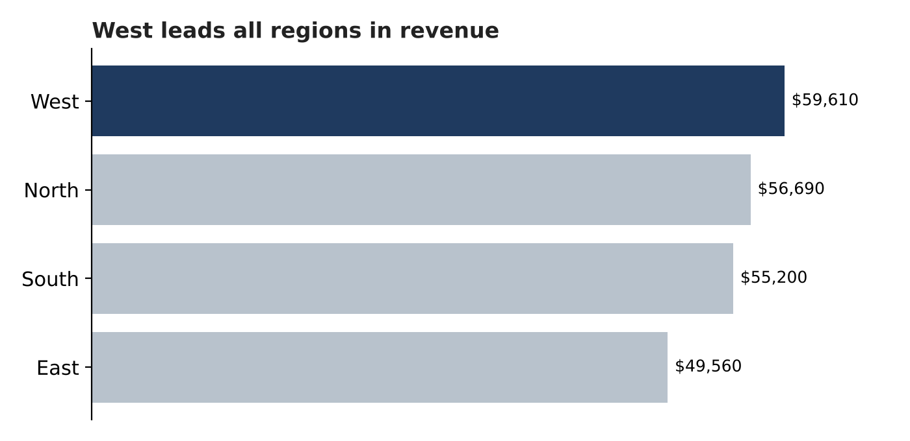
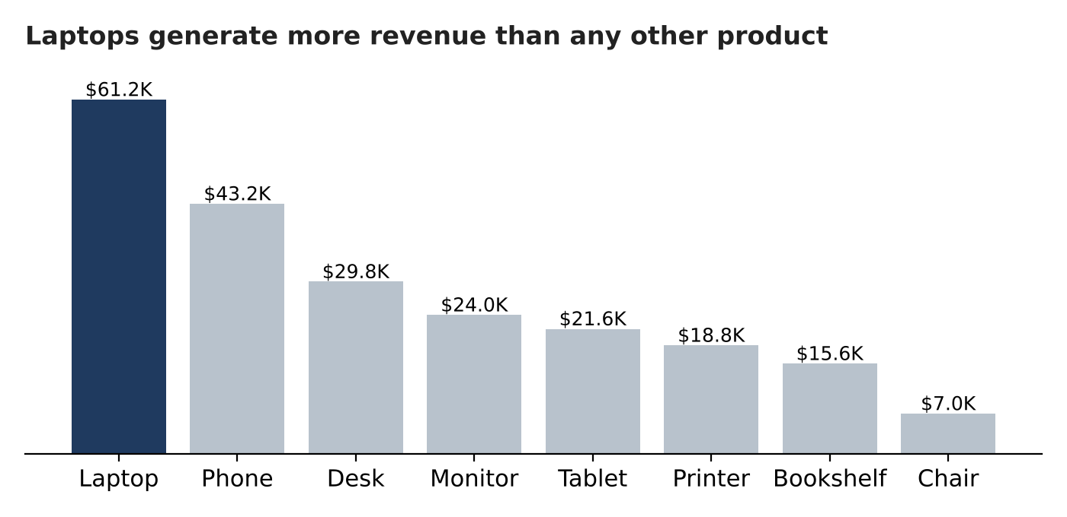
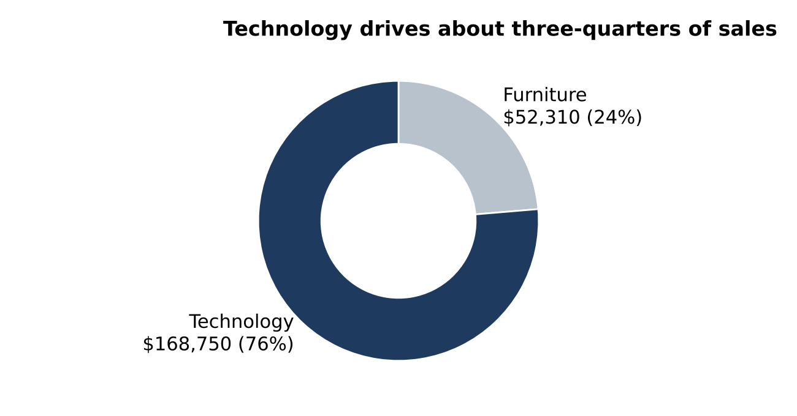

Part 4 – Model Data Story
Sample response
Business question: What is driving Summit Lane’s sales, and where should marketing be focused next quarter?
Context: From January to April 2025, Summit Lane generated $221,060 in revenue across 120 orders.
Insight 1: Technology drives the business, delivering 76% of revenue ($168,750). Laptops alone account for 28% ($61,200), and laptops plus phones together make up 47%.
Insight 2: West is the top region at $59,610 (27%), but regional performance is fairly balanced, with only about $10,000 separating first and last place.
Insight 3: East has the fewest orders (22) but the highest average order value ($2,253), so it is a frequency opportunity, not a demand problem.
Recommendation: Focus next quarter’s marketing on laptops and phones, and run a targeted re-engagement campaign in the East to increase order frequency among high-value buyers. Protect the top five accounts (43% of revenue) with a dedicated account-management program.
Next step: Track East order count and laptop/phone revenue monthly, and revisit once a full quarter of data (including all of April) is available.

Common Student Mistakes
- Using Count instead of Sum in the PivotTable value field, which ranks products by number of orders rather than revenue (Monitor would wrongly appear on top with 18 orders).
- Naming the top product by units sold (Desk, 85 units) instead of revenue (Laptop, $61,200).
- Writing insights without numbers (“West is the best region”) rather than quantified evidence.
- Recommending action on a single region without noting how close the four regions are.
- Drawing conclusions about an April decline without noting that April data ends on April 28, so the month is incomplete.

