Entity Relationship Diagram: Events and Venues
Idasha Lee and Thania Sta. Ana
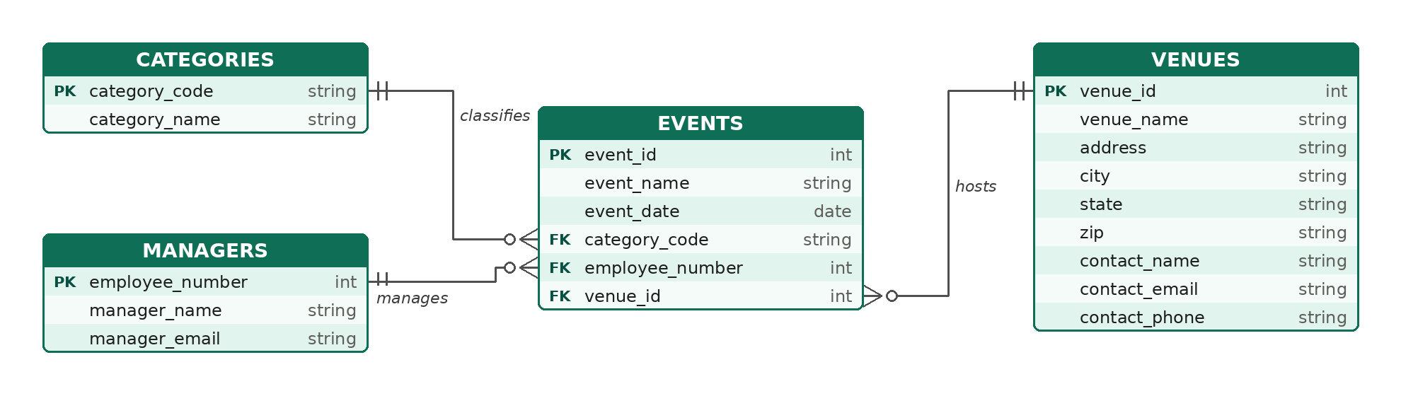
Key: PK = primary key, FK = foreign key. Two bars mean exactly one; the crow’s foot with a circle means zero or many. Each event has one category, one manager, and one venue.

