KoreaDoT

# Set-up:

1. Go to Project location

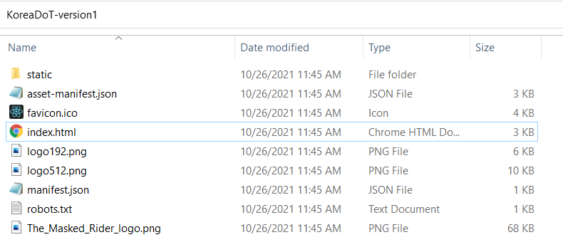

1. Run index.html with Firefox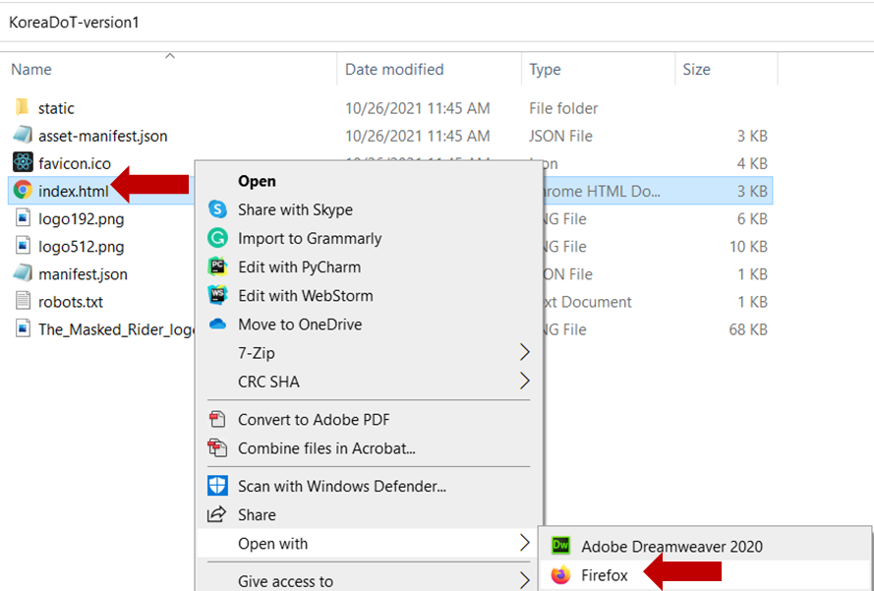
2. What should be show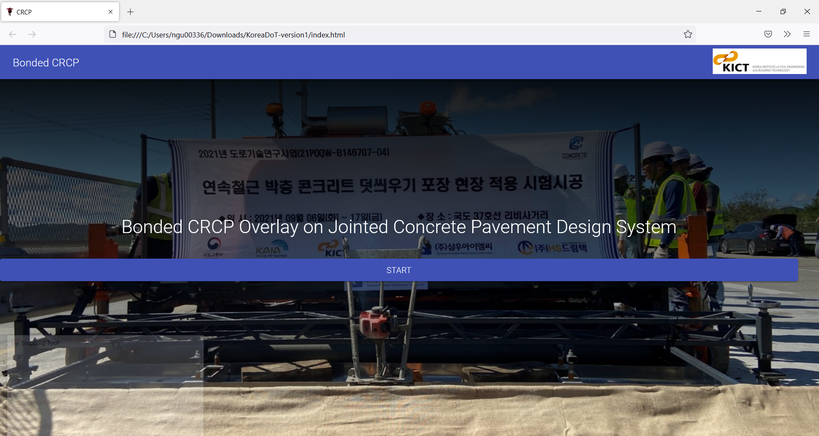

If you don’t see above result, the possible reason is : <https://developer.mozilla.org/en-US/docs/Web/HTTP/CORS/Errors/CORSRequestNotHttp> .

**To fix the issue:**

* 1. Open new tab on Firefox: (1.1) type **about:config** on search bar. (1.2) Click to **Accept the Rick and Continue** , if the option shows

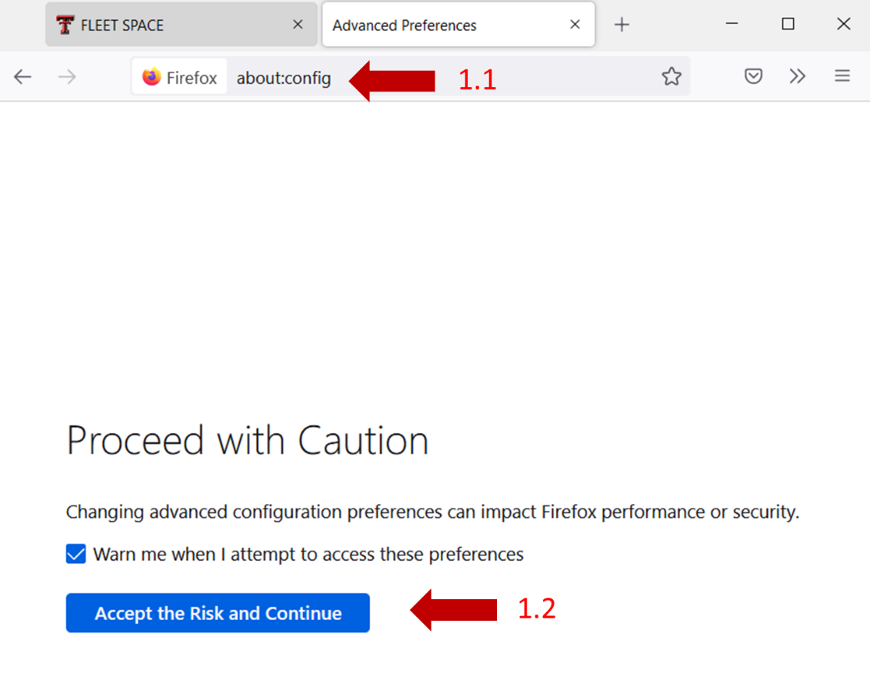

* 1. Change “**privacy.file_unique_origin**” to false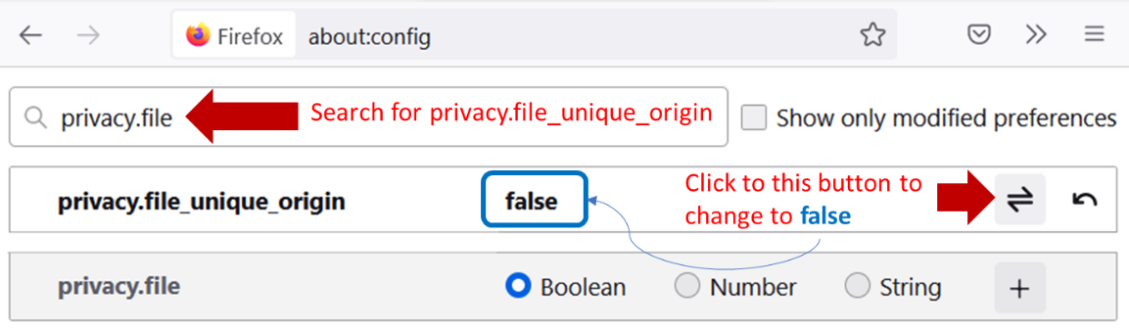
  2. Close Firefox
  3. Repeat Step 2 in Step-up