XtremWeb-HEP 10
“DaringGrid”
User Guide
Version 1.12.0

Table of Contents
1 Introduction 10
1.1 Audience 10
1.2 Software license agreement 10
1.3 Reading conventions 11
1.4 Middleware Versioning 11
1.5 Documentation Versioning 12
1.5.1 Version 1.0.0 12
1.5.2 Version 1.1.0 12
1.5.3 Version 1.2.0 12
1.5.4 Version 1.3.0 12
1.5.5 Version 1.3.1 12
1.5.6 Version 1.4.0 13
1.5.7 Version 1.4.1 13
1.5.8 Version 1.5.0 13
1.5.9 Version 1.6.0 13
1.5.10 Version 1.7.0 13
1.5.11 Version 1.8.0 13
1.5.12 Version 1.9.0 14
1.5.13 Version 1.10.0 14
1.5.14 Version 1.11.0 14
1.5.15 Version 1.12.0 14
1.5.16 Version 1.13.0 14
2 Introduction to XtremWeb-HEP middleware 15
3 Hardware and software requirements 15
4 Notification system 15
5 Installation and configuration of the Xtremweb-HEP client 16
5.1 Installation of the Xtremweb-HEP client 16
5.1.1 Linux RPM 16
5.1.2 Linux Debian 16
5.1.3 Mac OS X 16
5.1.4 Microsoft Windows 17
5.2 Removing the Xtremweb-HEP client 17
5.2.1 Linux RPM 17
5.2.2 Linux Debian 17
5.2.3 Mac OS X 17
5.2.4 Microsoft Windows 17
5.3 Configuration of the Xtremweb-HEP client 17
6 Usage of the Xtremweb-HEP client 19
6.1 Client options 19
6.2 Client online help 19
6.3 General purpose commands 19
6.3.1 Sending a heartbeat signal 20
6.3.2 Retrieving the middleware version 20
6.3.3 Opening the graphic interface 20
6.3.4 Testing the connection to the server 21
6.4 Data management 21
6.4.1 Data types 22
6.4.2 Register data 22
6.4.3 Update data 23
6.4.4 Change data access rights 23
6.4.5 Retrieve registered data 24
6.4.6 Download registered data 24
6.4.7 Remove data 24
6.5 Application management 25
6.5.1 Application types 25
6.5.2 Register application 26
6.5.3 Register a virtual machine 26
6.5.4 Register a container 27
6.5.5 Update application 28
6.5.6 Change application access rights 29
6.5.7 Retrieve registered application 29
6.5.8 Remove application 30
6.6 Manage bag of tasks 30
6.6.1 Register a bag of tasks 30
6.6.2 Update a bag of tasks 31
6.6.3 Retrieve bags of tasks 31
6.6.4 Retrieve jobs of a bag of tasks 31
6.6.5 Retrieve results of a bag of tasks 31
6.6.6 Remove a bag of tasks 32
6.7 Manage sessions 32
6.7.1 Register a session 32
6.7.2 Update a session 32
6.7.3 Retrieve sessions 32
6.7.4 Remove a session 32
6.8 Job management 32
6.8.1 Job definition 33
6.8.1.1 Referring a registered application. 33
6.8.1.2 Command line parameters. 33
6.8.1.3 Standard input file. 33
6.8.1.4 Working directory 34
6.8.1.5 Label. 34
6.8.1.6 Group of jobs 34
6.8.2 Submit a job 34
6.8.3 Wall Clock Time 35
6.8.4 Replication 35
6.8.5 Manage connect-able job 36
6.8.5.1 Port allocation 36
6.8.5.2 Submit a server like job 36
6.8.5.3 Connect to a server like job 38
6.8.5.4 Submit a client like job 39
6.8.6 Submit a virtual machine 40
6.8.7 Submit a bag of tasks 41
6.8.8 Update a job 41
6.8.9 Change job access rights 41
6.8.10 Retrieve submitted jobs 41
6.8.11 Download job results 42
6.8.12 Remove a job 43
6.9 Task management 43
6.9.1 Submit a task 43
6.9.2 Update a task 43
6.9.3 Change access rights of a task 43
6.9.4 Retrieve tasks 43
6.9.5 Remove a task 44
6.10 User management 44
6.10.1 Register user 44
6.10.2 Update user 45
6.10.3 Change user access rights 45
6.10.4 Retrieve registered user 45
6.10.5 Remove user 46
6.11 User group management 46
6.11.1 Register user group 46
6.11.2 Update user group 47
6.11.3 Change user group access rights 47
6.11.4 Retrieve registered user group 47
6.11.5 Remove user group 47
6.12 Worker management 48
6.12.1 Register a worker 48
6.12.2 Update a worker 48
6.12.3 Retrieve registered workers 48
6.12.4 Remove a worker 48
6.12.5 Activate a worker 48
6.13 Client daemon 49
7 Web Interface 50
7.1 Security considerations 50
7.1.1 Authenticate using an X509 certificate 54
7.1.2 Delegate authentication to an remote service 54
7.2 Introduction 54
7.3 Web workers 55
7.4 The Graphical User Interface 55
7.4.1 The header 55
7.4.2 The main buttons bar 55
7.4.3 The main window 56
7.5 Object management 56
7.5.1 Retrieving registered objects 56
7.5.2 Detailing an object 56
7.5.3 Sending an object 56
7.5.4 Deleting an object 57
7.6 Application management 57
7.6.1 Submit a job 57
7.7 Data management 57
7.7.1 Download data 58
7.7.2 Upload data 58
7.8 Job management 58
7.8.1 Send a job 58
7.8.2 Job submission 58
7.8.3 Group of jobs 59
7.8.4 Job result retrieval 59
7.8.5 Job removal 59
7.9 Group of jobs management 59
7.9.1 Group of jobs retrieval 59
7.9.2 Group of jobs removal 59
7.10 Errors and warnings 59
7.10.1 Warnings 59
7.10.2 Errors 59
8 REST interface 60
8.1 Security considerations 60
8.2 General purpose commands 60
8.2.1 Sending a heartbeat signal 60
8.2.2 Retrieving the middleware version 60
8.2.3 Testing the connection to the server 60
8.2.4 Change object access rights 61
8.2.5 Retrieve registered object 61
8.2.6 Remove object 61
8.3 Data management 61
8.3.1 Register data 61
8.3.2 Upload data 62
8.3.3 Change data access rights 62
8.3.4 Retrieve registered data 62
8.3.5 Remove data 63
8.4 Application management 63
8.4.1 Register application 63
8.4.2 Change access rights 63
8.4.3 Retrieve registered application 63
8.4.4 Remove application 63
8.5 Bag of tasks management 63
8.5.1 Register BoT 63
8.5.2 Change access rights 64
8.5.3 Retrieve registered BoT 64
8.5.4 Remove BoT 64
8.6 Sessions management 64
8.6.1 Register session 64
8.6.2 Change access rights 64
8.6.3 Retrieve registered session 65
8.6.4 Remove session 65
8.7 Job management 65
8.7.1 Submit job 65
8.7.2 Change access rights 65
8.7.3 Retrieve registered job 65
8.7.4 Remove job 65
8.8 Task management 66
8.8.1 Submit a task 66
8.8.2 Update a task 66
8.8.3 Change access rights of a task 66
8.8.4 Retrieve registered task 66
8.8.5 Remove task 66
8.9 User management 66
8.9.1 Register user 66
8.9.2 Change access rights 67
8.9.3 Retrieve registered user 67
8.9.4 Remove user 67
8.10 Worker management 67
8.11 Programmatically access the REST interface 67
9 List of commands and options 68
9.1 General purpose options 68
9.1.1 Available options 68
9.1.2 Help 69
9.1.3 Configuration file 71
9.1.4 Output format 71
9.1.5 Verbose mode 71
9.2 Available requests 72
9.2.1 List of available requests 72
9.2.2 Clean 73
9.2.3 Application management 73
9.2.3.1 Register new application 73
9.2.3.2 Retrieve applications 74
9.2.3.3 Retrieve an application 74
9.2.3.4 Remove application 75
9.2.3.5 Change application access rights 75
9.2.4 Data management 75
9.2.4.1 Register new data 75
9.2.4.2 Retrieve datas 76
9.2.4.3 Retrieve data 77
9.2.4.4 Retrieve data content 77
9.2.4.5 Change data access rights 77
9.2.4.6 Remove data 78
9.2.4.7 Change data access rights 78
9.2.5 Bag of tasks management 78
9.2.5.1 Register new BoT 78
9.2.5.2 Get BoT 79
9.2.5.3 Get BoT 79
9.2.5.4 Remove BoT 79
9.2.5.5 Change BoT access rights 80
9.2.6 Session management 80
9.2.6.1 Register new session 80
9.2.6.2 Get sessions 80
9.2.6.3 Get session 81
9.2.6.4 Remove session 81
9.2.6.5 Change session access rights 81
9.2.7 Job management 82
9.2.7.1 Submit new job 82
9.2.7.2 Update a job 83
9.2.7.3 Change job access rights 83
9.2.7.4 Get jobs 83
9.2.7.5 Get job 84
9.2.7.6 Retrieve job results 84
9.2.7.7 Remove job 85
9.2.8 Task management 85
9.2.8.1 Submit a task 85
9.2.8.2 Update a task 85
9.2.8.3 Change access rights of a task 85
9.2.8.4 Get tasks 86
9.2.8.5 Get task 86
9.2.8.6 Remove task 86
9.2.9 User management 86
9.2.9.1 Register user 87
9.2.9.2 Update user 87
9.2.9.3 Change user access rights 87
9.2.9.4 Retrieve registered users 87
9.2.9.5 Retrieve registered user 87
9.2.9.6 Remove user 88
9.2.10 User group management 88
9.2.10.1 Register user group 88
9.2.10.2 Update user group 89
9.2.10.3 Change user group access rights 89
9.2.10.4 Retrieve registered user groups 89
9.2.10.5 Retrieve registered user group 89
9.2.10.6 Remove user group 89
9.2.11 Worker management 90
9.2.11.1 Register a worker 90
9.2.11.2 Update a worker 90
9.2.11.2.1 Retrieve registered workers 90
9.2.11.3 Retrieve registered worker 90
9.2.11.4 Remove a worker 91
9.2.11.5 Activate a worker 91
10 Managing virtual machines using the XtremWeb-HEP scripts 92
10.1 Creating and running new virtual machines 92
10.2 Contextualizing a new virtual machine 94
10.3 Installing a new virtual machine 95
10.4 Running the VM 96
10.5 Connecting to the running VM 97
10.5.1 Linux and Mac OS X 97
10.6 Stopping the VM 98
10.7 Removing the VM 98
11 Provisioning virtual machines 98
11.1 Creating a new customized LiveCD 99
11.1.1 Generating new customized LiveCD 99
11.1.2 Retrieve the customized LiveCD 100
11.1.3 Stopping our VM 100
11.2 Creating a new customized LiveCD step by step 100
11.2.1 Create directory structure, mount virtual filesystems, configure yum 100
11.2.2 Install yum (please note the back slash at the end of lines) 101
11.2.3 Enable shadow passwords 101
11.2.4 Use yum to install some packages 101
11.2.5 Install system configuration files 102
11.2.6 Enter chroot 102
11.2.7 Install the build script 102
11.2.8 Customize the build process 103
11.2.9 Customize some more files 103
11.2.10 Define a “Message of the day” 104
11.2.11 Build the new LiveCD 104
11.2.12 Optional informations 104
12 Managing containers using the XtremWeb-HEP scripts 108
12.1 Creating and running new virtual machines 108
12.2 Contextualizing a new virtual machine 110
12.3 Installing a new virtual machine 111
12.4 Running the VM 115
12.5 Connecting to the running VM 116
12.5.1 Linux and Mac OS X 116
12.6 Stopping the VM 117
12.7 Removing the VM 117
13 Annexe 1: Virtual-Box usage 118
13.1 Creating a new VM with Scientific-Linux 5.5 118
13.1.1 Create a new virtual machine 118
13.1.2 Virtual machine name and OS 121
13.1.3 Setting the memory size 121
13.1.4 Setting up the virtual disk 122
13.1.5 Summary 124
13.2 Prepare media for the new virtual machine 126
13.2.1 Attach the DVD 126
13.2.2 Create a new hard drive. 129
13.2.3 Install Scientific Linux 5.5 131
13.3 Converting disk image 133
13.3.1 Converting to VDI 133
13.3.2 Converting from VDI 133
14 Annexe 2: virtual disk management 135
14.1 Mac OS X 136
14.2 Windows 7 136
14.2.1 Graphical User Interface 136
14.2.2 Command line tools 139
14.3 Linux 141
15 Annexe 3: provisioning electronic keys 143
15.1 Linux and Mac OS X 143
15.2 Windows 143
15.2.1 Import an electronic key pair 143
15.2.2 Generate a new electronic key pair 144
15.2.3 Save you key pair 148
16 List of constants 151
17 XML representations 151
18 Job state graph 151
19 Client attributes 152
19.1 Introduction 152
19.2 Properties list 152
20 Troubleshooting 159
20.1 Unknown host exception 159
20.2 Server configuration error 159
20.3 Connection error 159
20.4 Encryption error 160
20.5 X509 certificate errors 160
20.6 Access error 160
20.6.1 Object not found error 160
20.6.2 Access denied error 161
20.7 Data upload error 161
20.8 Result download error 161
21 Contacts 163
22 Third party libraries 163
23 Index 164

Index des illustrations
Illustration 1: Client Graphical User Interface 20
Figure 2: server like job submission 37
Figure 3: connection to a server like job running on volunteer resource 38
Figure 4: A job connecting to client 39
Illustration 5: Warning on untrusted connection 51
Illustration 6: Certificate details 51
Figure 7: Providing your X509 certificate to connect to the Web interface 52
Figure 8: the new VM is installed 96
Figure 9: the new VM is running 97
Figure 10: Virtual Box main window 108
Figure 11: Create a new Virtual Machine Wizard 109
Figure 12: Create a new VM; give name and OS type 109
Figure 13: Create a new VM; memory size 110
Figure 14: Create a new VM; virtual disc 110
Figure 15: Create a new VM; virtual disc warning 111
Figure 16: Create a new VM; summary 111
Figure 17: Virtual disc main window 112
Figure 18: Virtual disc : choose a DVD 113
Figure 19: Virtual disc: choose a DVD menu 113
Figure 20: Virtual disc: choose a DVD 114
Figure 21: Virtual disc : create a new virtual disc 115
Figure 22: Virtual disc: create a new virtual disc 115
Figure 23: Virtual disc : summary 116
Figure 24: Start VM 116
Figure 25: Create a new image disk 121
Figure 26: Open computer management tool 122
Figure 27: Create new virtual disk 122
Figure 28: The new VHD is created 123
Figure 29: Format the new VHD 123
Figure 30: New simple volume 124
Figure 31: VHD shown in file browser 124
Figure 32: VHD shown in file browser 126
Figure 33: Putty Key Generator icon 128
Figure 34: Putty: import key 129
Figure 35: Putty: generate a new key 130
Figure 36: Putty: export private key 130
Figure 37: Putty: save private key 131
Figure 38: Putty: copy public key 132

Introduction
This document is part of the XtremWeb-HEP middleware documentation which contains different documents: “XtremWeb-HEP Introduction”, “XtremWeb-HEP Administrator Guide”, “XtremWeb-HEP Resource Provider Guide”, “XtremWeb-HEP Programmer Guide” and this one, “XtremWeb-HEP User Guide”.

The name “XtremWeb-HEP” is shortened as “XWHEP”.
The XtremWeb-HEP version 8 is designated as “FlyingGrid ”
The XtremWeb-HEP version 9 is designated as “DiggingGrid ”

Please note that the documentation versioning is different from the middleware one.
On November 2014, the documentation is made of:
- “XtremWeb-HEP Introduction” 1.5.0;
- “XtremWeb-HEP Programmer Guide” 1.5.0;
- “XtremWeb-HEP Administrator Guide” 1.8.0;
- “XtremWeb-HEP User Guide” 1.10.0;
- “XtremWeb-HEP Resource Provider Guide” 1.5.0.

Audience
Anyone who would like to administrate or use the XtremWeb-HEP middleware should read this document.

The reader is invited to first read the “XtremWeb-HEP Introduction” documentation.

This document specifically introduces the client component of the XtremWeb-HEP middleware and details user interactions: how to insert datas, applications; how to submit jobs and retrieve results etc.
With this document, as user of the XtremWeb-HEP middleware, the reader will be able to use the distributed resources managed by an XtremWeb-HEP infrastructure.

Software license agreement
XtremWeb-HEP is an open source software provided under the GPL2 license (http://www.gnu.org/licenses/gpl-2.0.html).

BECAUSE THE PROGRAM IS LICENSED FREE OF CHARGE, THERE IS NO WARRANTY FOR THE PROGRAM, TO THE EXTENT PERMITTED BY APPLICABLE LAW. EXCEPT WHEN OTHERWISE STATED IN WRITING THE COPYRIGHT HOLDERS AND/OR OTHER PARTIES PROVIDE THE PROGRAM "AS IS" WITHOUT WARRANTY OF ANY KIND, EITHER EXPRESSED OR IMPLIED, INCLUDING, BUT NOT LIMITED TO, THE IMPLIED WARRANTIES OF MERCHANTABILITY AND FITNESS FOR A PARTICULAR PURPOSE. THE ENTIRE RISK AS TO THE QUALITY AND PERFORMANCE OF THE PROGRAM IS WITH YOU. SHOULD THE PROGRAM PROVE DEFECTIVE, YOU ASSUME THE COST OF ALL NECESSARY SERVICING, REPAIR OR CORRECTION.

IN NO EVENT UNLESS REQUIRED BY APPLICABLE LAW OR AGREED TO IN WRITING WILL ANY COPYRIGHT HOLDER, OR ANY OTHER PARTY WHO MAY MODIFY AND/OR REDISTRIBUTE THE PROGRAM AS PERMITTED ABOVE, BE LIABLE TO YOU FOR DAMAGES, INCLUDING ANY GENERAL, SPECIAL, INCIDENTAL OR CONSEQUENTIAL DAMAGES ARISING OUT OF THE USE OR INABILITY TO USE THE PROGRAM (INCLUDING BUT NOT LIMITED TO LOSS OF DATA OR DATA BEING RENDERED INACCURATE OR LOSSES SUSTAINED BY YOU OR THIRD PARTIES OR A FAILURE OF THE PROGRAM TO OPERATE WITH ANY OTHER PROGRAMS), EVEN IF SUCH HOLDER OR OTHER PARTY HAS BEEN ADVISED OF THE POSSIBILITY OF SUCH DAMAGES.

Reading conventions
Code examples appear in grey boxes
$> ./proxy-init.sh desktopgrid.vo.edges-grid.eu
Enter your private key passphrase:
Created VOMS proxy: O=GRID-FR,C=FR,O=CNRS,OU=LAL,CN=Oleg Lodygensky,CN=proxy
Proxy is valid until: Fri Nov 19 21:59:37 2010 CET
Proxy location: /var/folders/0R/0RQqVNNAEpqqeXUidaIL0++++TM/-Tmp-/x509up_u_mboleg

Variables appear in courier font, within '${' and '}', just as “${VARIABLE}”. They should be understood and replaced by their values.

Some variables used in this document:
${XWHEP_VERSION} is the current version of our middleware
${XWHEP_HOME} is the directory where the middleware is installed
${HOME} is the user home directory

Sometimes there are some inputs the reader must provide. These appear in courier font, within '<' and '>', just as “<your input>”.

Middleware Versioning
Middleware versioning is as follow
- X is the major part of the version
- Y is the minor part of the version
- Z is the micro part of the version

(*) X reports a very important change: for example the communication protocol changes or a major new feature is modified/introduced/removed
When X changes, backward compatibility is not ensured

(*) Y reports an important but not critical change: backward compatibility is ensured

(*) Z reports a minor change: bug correction, documentation changes etc.

In octobre 2013, the last version of XtremWeb-HEP is 8.3.1.
In this document we refer that version as the current version and refer it as ${XWHEP_VERSION}.

Documentation Versioning
Documentation versioning is as follow
- X is the major part of the version
- Y is the minor part of the version
- Z is the micro part of the version

Version 1.0.0
Date: Feb, 2011
Authors: O. Lodygensky
Reviewers: E. Urbah; S. Dadoun

- Initial document.

Version 1.1.0
Date: May 5th, 2011
Authors: O. Lodygensky
Reviewers:

- The introduction has been extracted to create a new document: “xwhep-intro.odt”.
- XML object description
- XML request description
- Web interface
- Client shell

Version 1.2.0
Date: May 25th, 2011
Authors: O. Lodygensky
Reviewers:

- XWHEP 7.5.0 introduces full certificate usage

Version 1.3.0
Date: Sept, 2011
Authors: O. Lodygensky
Reviewers: S. Dadoun

- XWHEP 7.6.0 introduces URI pass through to enable more than one file as job environment.

Version 1.3.1
Date: Dec, 2011
Authors: O. Lodygensky
Reviewers:

- Minor errors corrected in chapter 7.

Version 1.4.0
Date: July 17th, 2012
Authors: O. Lodygensky
Reviewers:

- Merging wit the “extended” document.

Version 1.4.1
Date: July 20th, 2012
Authors: O. Lodygensky
Reviewers:

- The login to connect to a run VM is “vmuser” and not “xwuser”.

Version 1.5.0
Date: December 3rd, 2012
Authors: O. Lodygensky
Reviewers:

- Introducing the capability to retrieve jobs given their status.
- Detailing REST interface usage

Version 1.6.0
Date: January 9th, 2013
Authors: O. Lodygensky
Reviewers:

- Introducing OpenId

Version 1.7.0
Date: February 26th, 2013
Authors: O. Lodygensky
Reviewers:

- Introducing programmatically accessing the REST interface

Version 1.8.0
Date: October 16th, 2013
Authors: O. Lodygensky
Reviewers:

- Introducing the smartsocketshubaddr configuration variable

Version 1.9.0
Date: June 18th, 2014
Authors: O. Lodygensky
Reviewers:

- Introducing XWHEP 9.

Version 1.10.0
Date: November 11th, 2014
Authors: O. Lodygensky
Reviewers:

Introducing XWHEP 10:
- Introducing notification system;
- client output file may be a directory (see chapters 6.4.6 and 6.8.11);
- introducing virtual machine shared file system;
- introducing OAuth;
- introducing work replication;
- introducing data driven scheduling.

Version 1.11.0
Date: Sept 21th, 2015
Authors: O. Lodygensky
Reviewers:

Some more details about job replication.

Version 1.12.0
Date: Feb 11th, 2016
Authors: O. Lodygensky
Reviewers:

Update the LiveCD creation process.

Version 1.13.0
Date: July 3rd, 2017
Authors: O. Lodygensky
Reviewers:

Introducing Docker container management.

Introduction to XtremWeb-HEP middleware
The XtremWeb-HEP middleware is introduced in the “XtremWeb-HEP Introduction” document. The reader is invited to refer to that document.

This document presents the client part of the middleware that aims to control and use a deployment. Using that client, one may insert, use or delete objects such as data, applications, jobs, users and more. Next chapters detail the installation, configuration and usage of the client provided within the middleware distribution.
One may also consider using the Web interface embedded in the server, described in chapter 8. This Web interface proposes most of the functionalities available in the client.

Hardware and software requirements
The XtremWeb-HEP middleware is written in Java 1.6 computing language.

To run any component of the middleware you need:
- a machine running Windows, or Linux or Mac OS X
- java runtime environment 1.6 or above

Notification system
A notification system has been introduced since XtremWeb-HEP 9.1.0.
Users receive an email each time an owned object is modified or deleted.

Installation and configuration of the Xtremweb-HEP client
This chapter details the XWHEP client configuration.

Installation of the Xtremweb-HEP client
You can find installation packages at this address:
http://www.xtremweb-hep.org/spip.php?article53

Usually, you would need administrator rights to install this package in your machine.
Packages install files in different directories:
- Mac OS X:
  - /Applications/xwhep.client/
- Linux:
  - /opt/xwhep-client-${XWHEP_VERSION}
- Windows:
  - c:\Program Files\CNRS\XWHEP\client

We refer the installation directory as ${XWHEP_HOME} until the end of this document.

Linux RPM
To install the client on an RPM box, please use the command:

$> rpm -i xwhep-client-${XWHEP_VERSION}-1.noarch.rpm

This installs:
- /opt/xwhep-client-${XWHEP_VERSION}

Linux Debian
To install the client on an Debian box, please use the command:

$> dpkg -i xwhep-client-${XWHEP_VERSION}.deb

This installs:
- /opt/xwhep-client-${XWHEP_VERSION}

Mac OS X
To install the client on an Mac OS X box, the easiest way is to double click on the package and follow the instructions. You can also use the command:

$> sudo installer -pkg xwhep-client-${XWHEP_VERSION}.mpkg -target /

This installs:
- /Applications/xwhep.client/

Microsoft Windows
To install the client on windows, please unzip xwhep-cilent-${XWHEP_VERSION}.zip
in any directory of your choice.

Removing the Xtremweb-HEP client
This section details how to remove the XtremWeb-HEP client from different platforms.

Linux RPM
To remove the client on an RPM box, please use the command:

$> rpm -e xwhep-client-${XWHEP_VERSION}

Linux Debian
To remove the client on an Debian box, please use the command:

$> dpkg -r xwhep-client-${XWHEP_VERSION}

Mac OS X
To remove the client on an Mac OS X box, please use the command:

$> sudo /Application/xwhep.client/bin/uninstall.sh

Microsoft Windows
To remove the client, delete the directory where you have installed it.

Configuration of the Xtremweb-HEP client
Running the client needs a configuration file. The client installation package has created a default one containing all necessary configuration attributes.
You should duplicate this file and store it in your own home directory.

The middleware includes a default configuration file that can be found there:
${XWHEP_HOME}/conf/xtremweb.client.conf

The default directory is: ${HOME}/.xtremweb directory (where ${HOME} is your home directory).
You should create this directory. Don't forget the heading dot: the directory name must be “.xtremweb” and not “xtremweb”.

Copy the default client configuration file provided within the client distribution to
${HOME}/.xtremweb/xtremweb.client.conf

If you have an X509 certificate, you don't need a login/password credential. The XtremWeb-HEP server may accept your certificate under certain security conditions (i.e. you must belong to a virtual organization recognized by the XtremWeb-HEP server).
In this case you must set the environment variables prior using the XWHEP client:
- usercert: the file containing your certificate;
- userkey: the file containing your private key;
- userkeypassword.: a string containing your private key password.

In this case you don't have to create your own configuration file (${HOME}/.xtremweb/xtremweb.client.conf), the middleware will use the default one (${XWHEP_HOME}/conf/xtremweb.client.conf).

If you can create an X509 proxy from your certificate (by using jLite for instance), you must set the environment variable X509_USER_PROXY.

In any case, if you have set any of the previous environment variables they will be used in place of the login/password credential.

If you don't have such an X509 certificate, you need to be registered on the XtremWeb-HEP server by the server administrator.
As soon as the administrator registers you, you will be provided a login/password credential.
You must then create your configuration file (${HOME}/.xtremweb/xtremweb.client.conf) and set your login and password parameters:

login=<your login>
password=<your password>

The configuration file contains several attributes. It is generally not necessary to modify them. Chapter 19 details all possible attributes.

Usage of the Xtremweb-HEP client
As soon as the client package has been installed and configured as described in chapter 5.3, one can use the client tool to manage and use the XtremWeb-HEP infrastructure.

Using the client, one can register users and applications, send datas, submit jobs for registered applications and retrieve job results.

Command results depend on user credentials as described in the “XtremWeb-HEP Introduction” document.

The XtremWeb-HEP client package has installed all commands in ${XWHEP_HOME}/bin.

Commands should not be run as administrator of the hosting system
where client package has been installed.

Client options
The client accepts a huge amount of command line arguments in order to allow necessary actions to use and manage a deployment. Some parameters are “requests” that uniquely identify the action to perform. Some others are “options” applied to the given request.
Following sections detail all requests and associated options. Please refer to chapter 9 for the complete list of requests and options.

Client online help
The user has easily access to online help.
Generally speaking, nearly all commands need parameters. If one call a command without any parameter, the command displays its help.
For example calling the command xwsenddata without any parameter gives the following output:

$> xwsenddata
+--------- XWHEP client 7.1.0-head -----------------------------------+
Error: java.text.ParseException: no param provided
Usage: --xwsenddata dataName [cpuType] [osName] [dataType] [accessRigths] [dataFile | dataURI | dataUID]: this sends data and uploads data if dataFile provided
+----------------------------------------------------------------------+

User can also user the –-xwhelp command line parameter to get the full list of available requests and options. This parameter applies to any command. Requests and options are detailed in chapter 9.

General purpose commands

The XtremWeb-HEP middleware manages several object types such as applications, datas and jobs.
Before detailing management of all these types of object in next chapters, we introduce here general purpose commands that do not apply to any specific object type, if at all.

Sending a heartbeat signal
In order to maintain up to date information about the state of the XtremWeb-HEP infrastructure, distributed components of the middleware send a heartbeat signal regularly (typically every five minutes). This is the way workers signal their status to the server. Among others, workers send their availability -if the resource owner policy allows computation or not- and the jobs they are computing.

A worker is considered “lost”, if the server does not receive three heartbeats from this worker (typically if there is no heartbeat within fifteen minutes). All jobs that could have been sent to that specific workers are then reinserted in the pending jobs queue on server side so that they have a chance to be rescheduled to another worker, if any.

In the middleware, this heartbeat signal is named the “alive” signal.

Even if clients don't need and should not send heartbeat signals, there is a way to do so using client commands. This is mainly for test purposes. Here is the command:

$> xwalive

Users should not use this command on a production platform since this registers the client resource within alive workers, on server side.

But, using this command does not affect the platform consistency. This makes the client resource to appear in workers list (see chapter 6.12). within alive period (typically fifteen minutes).

Retrieving the middleware version
There is a script to check if you client is up to date.
Here is the command and its output if your client is up to dated:

$> xwversion
Current version: 7.1.0-head

Here is the same command and its output if your client should update:

$> xwversion
Current version: 7.1.0-head
Server version: 7.2.0-head
********** ********** **********
You should upgrade your client
********** ********** **********

Opening the graphic interface
The client comes with a integrated graphic user interface (GUI). Here is the command to open the client graphic interface

$> xwgui

Figure 1 shows the main window of the XtremWeb-HEP client graphical user interface.
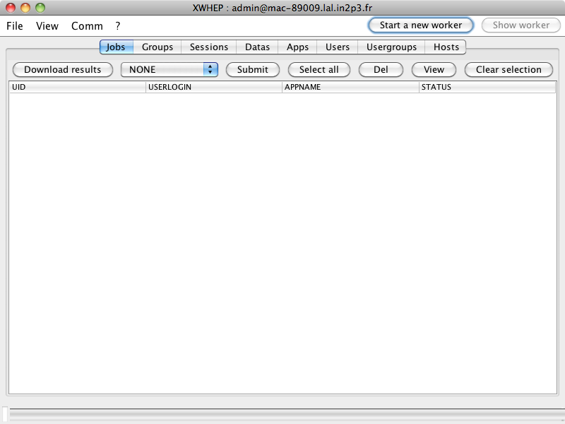Illustration 1: Client Graphical User Interface

The XtremWeb-Hep web site contains some video tutorials that show the usage of the client GUI. Please visit http://www.xtremweb-hep.org/spip.php?article34.

Testing the connection to the server
The xwping command aims to test connection to the XtremWeb-HEP server. This sends an empty command to the server (including credentials) and waits an empty answer from the server.

Here is the command to test connection to the XtremWeb-HEP server and its output:

$> xwping
Ping to xwservpub.lal.in2p3.fr:4326: time=560 ms
Ping to xwservpub.lal.in2p3.fr:4326: time=15 ms
Ping to xwservpub.lal.in2p3.fr:4326: time=14 ms
Ping to xwservpub.lal.in2p3.fr:4326: time=14 ms
Ping to xwservpub.lal.in2p3.fr:4326: time=12 ms

Data management
Data are detailed in the “XtremWeb-HEP programmer guide”.
The XtremWeb-HEP middleware manages data that may be referred by registered applications and submitted jobs. A data is an object referring a content available on the network through an URI and associating several attributes such as the name, the MD5 sum, the size, the owner and the access rights.
Data may also have an operating system, an architecture and a type. Please refer to the “XtremWeb- HEP Programmer's Guide”.
Any user can register its own data. The default data access rights is public. Please refer to the “XtremWeb-HEP Introduction” document.
The reader can find definition of data object in the “XtremWeb-HEP Programmer Guide”.

Chapter 9.2.4 details data management.

Data types
The middleware proposes different data types. You can retrieve known application types using the following command:
$> java -cp xtremweb.jar xtremweb.common.DataType
NONE
BINARY
ISO
VDI
VMDK
JAVA
TEXT
ZIP
URIPASSTHROUGH
SH
BAT
X509
UDPPACKET
STREAM

Register data
Registering a data is done using the command xwsenddata . This scripts needs one mandatory parameter:
- a uri, which may be a local file or an xwhep uri.
or
- --xwxml <xmlFile> where <xmlFile> contains a data XML representation.

Chapter 17 details XML representations.
The xwsenddata accepts some optional parameters:
- data name
- operating system
- cpu architecture
- data type (see chapter 6.4.1)
- associated work to start a data driven scheduling.

Data types are generally informational. The only data type that must be used at registration time is the “bat” one which defines Windows command script. Because the file name extension must be “.bat” and nothing else.

Chapter 9.2.4.1 details registering data.

For example, here is the command to register and upload a data which is stored in local disk space. The command displays the data URI as result:

$> xwsenddata /bin/ls
xw://mac-89009.lal.in2p3.fr:4321/fa9c6e5e-3017-4bd7-8f9c-dbde7e717a8d

The same example using XML representation.

This syntax may be used to register data
but can not be used to upload data content.

The command displays the data URI as result:

$> xwsenddata –xwxml <anXmlFile>
xw://mac-89009.lal.in2p3.fr:4321/fa9c6e5e-3017-4bd7-8f9c-dbde7e717a8d

Finally, here is the command to register a data to which we give the name LS, the Ma OS X operating system, the Intel 64 bits architecture, the binary type, and file located in local disk space. The command displays the data URI as result:

$> xwsenddata LS macosx x86_64 binary /bin/ls
xw://mac-89009.lal.in2p3.fr:4321/f0c7b6cb-26cd-4c3e-8e89-ddd0508f8b60

It is the end user responsibility to safely keep the resulted URI for further references (job submission, remove the data etc.)

Update data
The XtremWeb-HEP middleware does not allow data update.

Change data access rights
As explained in the “XtremWeb-HEP Introduction” document, all objects have access rights.
There is the xwchmod command to change an object access rights. The result of the command depends of the user authorization as explained the “XtremWeb-HEP Introduction” document.

The command displays no output. To check the result of the xwchmod command, you must retrieve the object as explained in chapter 6.4.5.

The xwchmod command expects two parameters:
- the new access rights in hexadecimal, starting with '0x';
- the object URI.

Chapter 9.2.4.7 details changing data access rights.

Here is an example to modify access rights:

$> xwchmod 0x700 xw://mac-89009.lal.in2p3.fr:4321/66baf2cc-f097-46ea-95b7-962a45593e89

You can change a data access rights using XML representation defining new access rights.

Retrieve registered data
You can retrieve registered data using the xwdatas command, providing data URIs as parameter.
Here is the command and its output:

$> xwdatas xw://mac-89009.lal.in2p3.fr:4321/fa9c6e5e-3017-4bd7-8f9c-dbde7e717a8d xw://mac-89009.lal.in2p3.fr:4321/f0c7b6cb-26cd-4c3e-8e89-ddd0508f8b60
UID='fa9c6e5e-3017-4bd7-8f9c-dbde7e717a8d', NAME='ChangeLog', STATUS='AVAILABLE'
UID='f0c7b6cb-26cd-4c3e-8e89-ddd0508f8b60', NAME='LS', STATUS='AVAILABLE'

You can also retrieve registered data using the xwdatas command without any URI. Here is the command and its output:

$> xwdatas
UID='fa9c6e5e-3017-4bd7-8f9c-dbde7e717a8d', NAME='ChangeLog', STATUS='AVAILABLE'
UID='f0c7b6cb-26cd-4c3e-8e89-ddd0508f8b60', NAME='LS', STATUS='AVAILABLE'

Some data may not be listed: this command returns a maximum of 1000 references.

Chapter 9.2.4.2 details retrieving data.

Download registered data
You can download registered data using the xwdownload command, providing data URIs as parameter.
Here is the command and its output:

$> xwdownload xw://mac-89009.lal.in2p3.fr:4321/fa9c6e5e-3017-4bd7-8f9c-dbde7e717a8d
UID='fa9c6e5e-3017-4bd7-8f9c-dbde7e717a8d', NAME='ChangeLog', STATUS='AVAILABLE'

This create a new file in the current directory. The name is uid_name., where uid is the UID of the registered data and name is the name of the registered data.
This command accepts the “--xwout” command line parameter to specify the output file name. If the provided file name denotes a directory, everything is stored in that directory.
It is the user responsibility to ensure files integrity (i.e. existing files are overwritten).

Remove data
You can remove a registered data using the xwrm command.
The xwrm command displays no result. To check the result of the xwrm command, you must retrieve registered object as explained in chapter 6.4.5.

$> xwrm xw://mac-89009.lal.in2p3.fr:4321/66baf2cc-f097-46ea-95b7-962a45593e89

One should note that data have a “links” attribute which is automatically updated by the server. When an object (job, application...) refer to a data, the data “links” attribute is incremented. When an object is removed from the platform, the server automatically decrements this object data “links” attribute.
Any job associated to the data -for data driven scheduling- is deleted.
When the “links” attribute is less or equal to zero, the data and its content is removed from the server.

Chapter 9.2.4.6 details data removal.

Application management
The XtremWeb-HEP middleware manages applications that are referred by submitted jobs.
An application is an objects referring binaries workers will execute on job computation. An application may contain several binaries for different operating systems and architectures (e.g a binary for Linux and Intel 32 bits; another for Linux and AMD 64 bits; another for Windows and Intel 32 bits; another for Mac OS X and Intel 64 bits etc.)

The XtremWeb-HEP middleware defines known operating systems and architecture types as enumerations. Please refer to the “XtremWeb-HEP programmer guide” document.
Any user can register its own applications, but the application access rights depends on the user credentials. Administrator rights are needed to register a public application accessible by all users. Standard user rights allow to register a private application accessible by its owner only. Please refer to the “XtremWeb-HEP Introduction” document.

The reader can find definition of application object in the “XtremWeb-HEP Programmer Guide”.

Chapter 9.2.3 details application management.

Application types
The middleware proposes different application types:
- deployable application: this denotes application that must be sent to computing resources.
- shared application: this denotes application shared by computing resources themselves.

You can retrieve known application types using the following command:
$> java -cp xtremweb.jar xtremweb.common.ApplicationType
NONE
DEPLOYABLE
SHARED
DOCKER
VIRTUALBOX

Register application
Registering an application is done using the command xwsendapp . This command requests some parameters:
- the application name;
- the application type (see chapter 6.5.1);
- the OS of the binary;
- the CPU of the binary;
- the binary file reference.
Or
- --xwxml <xmlFile> where <xmlFile> contains an application XML representation.

Chapter 17 details XML representations.

The application name must be unique in the XtremWeb-HEP platform.
Because the XtremWeb-HEP middleware uses the application name as primary key.

Registering an application expects an application type (see chapter 6.5.1). To register a non shared application, the deployable application type must be used. To register a shared application, its application type must be used. For example to register a virtual machine referring Virtual-Box as its shared application, the virtualbox application type must be used (see next chapter).
Here is the command to submit a deployable application which name is ls providing the binary file for Mac OS X and Intel 64 bits, which is stored in local disk space.
The command displays the application URI as result:

$> xwsendapp ls deployable macosx x86_64 /bin/ls
xw://mac-89009.lal.in2p3.fr:4321/66baf2cc-f097-46ea-95b7-962a45593e89

The same command using XML representation:

$> xwsendapp –-xwxml <anXmlFile>
xw://mac-89009.lal.in2p3.fr:4321/66baf2cc-f097-46ea-95b7-962a45593e89

Chapter 9.2.3.1 details registering application.

Register a virtual machine
Registering a virtual machine consists on registering a new shared application having:
- the virtualbox application type;
- no binary (since it is a shared application);
- the management scripts.
You don't have to write your own management scripts for VirtualBox shared application. The middleware provides them. These scripts are detailed in chapter 10.
There are two versions, one for Linux and Mac OS X, and one for Windows:
- ${XWHEP_HOME}/bin/xwstartvm.sh
- ${XWHEP_HOME}/bin/xwstartvm.bat

In the middleware source package these scripts are in:
- ${XWHEP_HOME}/src/script/

Finally, the middleware contains scripts to register new virtual machines:
- ${XWHEP_HOME}/bin/xwaddvbapp.sh
- ${XWHEP_HOME}/bin/xwaddvbapp.bat

In the middleware source package these scripts are in:
- ${XWHEP_HOME}/src/script/

The script requires some parameters and may display error messages on erroneous usage, like:

$> ./bin/xwaddvbapp.sh
- * !!!!!!!!!!!!!!!!!!!!!!!!!!!!!!!!!!!!!!!!!! * -
Fatal: you must provide a VirtualBox application name (please try --help)
- * !!!!!!!!!!!!!!!!!!!!!!!!!!!!!!!!!!!!!!!!!! * -

You can have access to the inline help:

$> ./bin/xwaddvbapp.sh --help
Usage: ./bin/xwaddvbapp.sh --name <app name> --hdauri <the disk URI or UID>

The script expects two command line parameters:
- --name <appName>. This is the name of the application to register;
- --hdauri <anURI>. This is an uri or uid of the bootable disk to be used to boot the virtual machine.

Register a container
Registering a container consists on registering a new shared application having:
- the docker application type;
- no binary (since it is a shared application);
- the management scripts.

You don't have to write your own management scripts for Docker shared application. The middleware provides them. These scripts are detailed in chapter 10.

There are two versions, one for Linux and Mac OS X, and one for Windows:
- ${XWHEP_HOME}/bin/xwstartdocker.sh
- ${XWHEP_HOME}/bin/xwstartdocker.bat

In the middleware source package these scripts are in:
- ${XWHEP_HOME}/src/script/

Finally, the middleware contains scripts to register new containers:
- ${XWHEP_HOME}/bin/xwadddockerapp.sh

In the middleware source package these scripts are in:
- ${XWHEP_HOME}/src/script/

The script requires some parameters and may display error messages on erroneous usage, like:

$> ./bin/xwadddockerapp.sh
- * !!!!!!!!!!!!!!!!!!!!!!!!!!!!!!!!!!!!!!!!!! * -
Fatal: you must provide a container name (please try --help)
- * !!!!!!!!!!!!!!!!!!!!!!!!!!!!!!!!!!!!!!!!!! * -

You can have access to the inline help:

$> ./bin/xwadddocerkapp.sh --help
Usage: ./bin/xwadddockerapp.sh --name <app name>

The script expects one command line parameter:
- --name <appName>. This is the name of the application to register;

Update application
Updating an application is especially useful to add several binaries.

To update an application, one can use the same xwsendapp command.
Using the same command with the same application name, update the application.

You can call as many times as necessary the same xwsendapp command.

For example, here is the command to update the previous application which name is ls providing the binary file for Mac OS X and Intel 32 bits, which is stored in local disk space.

The command displays the same application URI as result:

$> xwsendapp ls macosx ix86 /bin/ls
xw://mac-89009.lal.in2p3.fr:4321/66baf2cc-f097-46ea-95b7-962a45593e89

You can update an application using XML representation.

Change application access rights
As explained in “XtremWeb-HEP Introduction”, all objects have access rights.

There is the xwchmod command to change an object access rights. The result of the command depends of the user authorization as explained in “XtremWeb-HEP Introduction”.
The command displays no output. To check the result of the xwchmod command, you must retrieve the object as explained in chapter 6.5.7.

The xwchmod command expects two parameters:
- the new access rights in hexadecimal, starting with '0x';
- the object URI.

Here is the command to modify access rights of an application:

$> xwchmod 0x700 xw://mac-89009.lal.in2p3.fr:4321/66baf2cc-f097-46ea-95b7-962a45593e89

You can change an application access rights using XML representation defining new access rights.

Chapter 9.2.3.5 details changing application access rights.

Retrieve registered application
You can retrieve registered application using the xwapps command, providing application URIs or name as parameter. Here is the command and its output:

$> xwapps xw://mac-89009.lal.in2p3.fr:4321/66baf2cc-f097-46ea-95b7-962a45593e89
UID='66baf2cc-f097-46ea-95b7-962a45593e89', NAME='ls'

If you know the name of an application, you can provide that name to the xwapps command:

$> xwapps ls
UID='66baf2cc-f097-46ea-95b7-962a45593e89', NAME='ls'

Finally, you can retrieve registered applications using the xwapps command without any parameter. Here is the command and its output:

$> xwapps
UID='66baf2cc-f097-46ea-95b7-962a45593e89', NAME='ls'

Some applications may not be listed: this command returns a maximum of 1000 references.

Chapter 9.2.3.2 and 9.2.3.3 detail retrieving application.

Remove application
You can remove a registered application using the xwrm command.
The xwrm command displays no results. To check the result of the xwrm command, you must retrieve registered object as explained in chapter 6.5.7.

$> xwrm xw://mac-89009.lal.in2p3.fr:4321/66baf2cc-f097-46ea-95b7-962a45593e89

If successful, the object should not appear anymore in the output of the command detailed in chapter 6.5.7.

Please note that all data associated with the application are automatically removed too.

Chapter 9.2.3.4 details removing application.

Manage bag of tasks
The XtremWeb-HEP middleware can manage bag of tasks (BoT). The middleware introduces this notion as “group”.

Chapter 9.2.5 details BoT management.

Register a bag of tasks
Registering a new BoT is done using the xwsendgroup command as shown below; the command displays the new URI:

$> xwsendgroup <groupName> <sessionUID>
xw://xwserv:4321/3eacecb0-72d3-4513-b5ee-fc49afa29df4

The same command using bag of tasks XML representation:

$> xwsendgroup –-xwxml <anXmlFile>
xw://xwserv:4321/3eacecb0-72d3-4513-b5ee-fc49afa29df4

Chapter 17 details XML representations.

Chapter 9.2.5.1 details registering BoT.

Update a bag of tasks
The middleware does not allow updating BoT.

Retrieve bags of tasks
You can retrieve registered BoT using the xwgroups command, providing BoT URIs as parameter. Here is the command and its output:

$> xwgroups xw://mac-89009.lal.in2p3.fr:4321/66baf2cc-f097-46ea-95b7-962a45593e89
UID='66baf2cc-f097-46ea-95b7-962a45593e89', NAME='dummy'

You can also retrieve registered BoT using the xwgroups command without any URI. Here is the command and its output:

$> xwgroups
UID='66baf2cc-f097-46ea-95b7-962a45593e89', NAME='dummy'

Some BoT may not be listed: this command returns a maximum of 1000 references.

Chapter 9.2.5.2 details retrieving BoT.

Retrieve jobs of a bag of tasks
Retrieving jobs of a registered BoT is done using the xwgroupworks command, providing its UID or URI, as follow:

$> xwgroupworks <URI> | <UID> [ <URI> | <UID>...]

Retrieve results of a bag of tasks
Retrieving results of a registered BoT downloads job results. All job are deleted as soon as their results have been successfully downloaded.
Retrieving results of a registered BoT is done using the xwgroups command, providing its UID or URI, as follow:

$> xwgroupworks --xwdownload <URI> | <UID> [ <URI> | <UID>...]

Remove a bag of tasks
Removing a registered BoT removes all associated jobs.
Removing a registered BoT is done using the xwrm command, providing its UID or URI, as follow:

$> xwrm <URI> | <UID> [ <URI> | <UID>...]

Chapter 9.2.5.4 details removing BoT.

Manage sessions
As described in “XtremWeb-HEP introduction”, a session holds jobs during a client lifetime.
Session are then just unusable using the command line client tool; they are intended for developers only.

Chapter 9.2.6 details session management.

Register a session
There is no way to register a session using the command line client tool.
The xwsendsession command is provided for test purposes only and does nothing.

Chapter 17 details XML representations.

Chapter 9.2.6.1 details registering session.

Update a session
The middleware does not allow updating sessions.

Retrieve sessions
Retrieve sessions can be done programmatically only.
Chapter 9.2.6.2 details retrieving session.

Remove a session
Removing sessions can be done programmatically only.
Chapter 9.2.6.4 details removing sessions.

Job management
The XtremWeb-HEP middleware manages jobs. Any user can submit his/her own job.
A job references an application registered on server side. A job may contain command line parameters. A job may reference datas.

As described in the “XtremWeb Introduction” document, a job is described as a “work” by the middleware.

Generally speaking, one can submit a job as it would be done on a local batch system. By this, we basically mean that submitting job must definitely have no expectation.
One must keep in mind that submitted jobs are run on volunteer resources provided by citizens. The middleware has no way to control or manage in any manner these resources.

Typically, one must consider that submitted job must not:
- expect user interaction;
- make assumption about installed softwares and libraries on computing resource.

Typically one must consider that submitted job may not have:
- access to internet;
- access to some local resources (shared libraries etc.).

Chapter 9.2.7 details job management.

Job definition
Before submitting jobs, the reader must understand attributes that define a job.

A job is made of the several attributes. The only required one is the reference to a registered application. It is just not possible to submit a job without this registered application reference.
The attribute list is described as follow.

Referring a registered application.
On a local system you can call the “ls” program
$> ls
This can be reproduced by submitting a job to XtremWeb-HEP.
Here, if the “ls” application is registered on XtremWeb-HEP infrastructure, you could submit a job for the application, providing its reference.

Command line parameters.
On a local system you can call the “ls” program providing “-l” as command line parameter
$> ls -l
This can be reproduced by submitting a job to XtremWeb-HEP.
Here, if the “ls” application is registered on XtremWeb-HEP infrastructure, you could submit a job for the application, providing the application reference and “-l” as command line parameter. This command line parameter would then automatically be inserted in the definition of your job.

Standard input file.
On a local system you can call the “cat” program providing an input file.
$> cat < aTextFile
This can be reproduced by submitting a job to XtremWeb-HEP.
Here, if the “cat” application is registered on XtremWeb-HEP infrastructure, you could submit a job for the application, providing its reference and “aTextFile” as standard input. The text file would then be automatically inserted as a data of yours, referred by your job and automatically downloaded by the worker.

Working directory
On a local system you can call the “ls” program on a directory where the program can retrieve a hierarchy of needed files and directories.
$> ls -lR
This can be reproduced by submitting a job to XtremWeb-HEP.
Here, if the “ls” application is registered on XtremWeb-HEP infrastructure, you could submit a job for the application, providing its reference and a working directory. The working directory would then be automatically inserted as a data of yours, referred by your job and automatically downloaded by the worker. The worker would then automatically start your job using this data as the job working directory.

Label.
For conveniences, you can provide a label to your job.

Group of jobs
You can insert your job in a group of jobs. This facilitates job management by enabling management of all jobs at once.

You can define jobs with any subset of these attributes. The minimal subset must contains a reference of an application registered on the XtremWeb-HEP infrastructure.

Submit a job
Submitting a job consists on sending a job to the XtremWeb-HEP scheduler that will try to find a volunteer resource to compute the job.

One must clearly understand that a desktop grid will never compute anything. A desktop grid can only try to give something to compute to a resource that asks for a job. Because desktop grid does not control the computing resources since they are volunteer ones.
Another point is that there must also be a positive match making between referred application of the submitted job and resource attributes (CPU, OS, RAM...).

One can use the xwsubmit command to submit jobs. Another command is available, xwsendwork, which is just an alias to xwsubmit.

Let suppose the “ls” application is registered in the XtremWeb-HEP infrastructure.
If you would like to execute something similar on local host to:

$> ls -Rl

You should use the xwsubmit command. This displays the URI of you submitted job for further reference (get the job status, retrieve job results).

Here is an example of using xwsubmit and its output:

$> xwsubmit ls -lR –-xwenv .
xw://xwserv:4321/3eacecb0-72d3-4513-b5ee-fc49afa29df3

Where
- “ls” is the name of the referenced applications
- “-lR” is the command line parameters
- “--xwenv .” is the way to specify a working directory that must be copied and used to compute the job on the computing resource. In this example, “--xwenv” is the XWHEP client command line parameter and “.” (a single dot) represents the current directory. This command line parameter accepts a directory, a local file, an URI or an UID. On that last case, it must be an UID of a data registered on server side (by using the “xwsenddata” command).
Since XWHEP 7.6.0 “URI pass through mode” has been introduced in order to be able to copy several data to the job working directory. You can provide more than one “--xwenv” parameter. In this case, all data references must be URI. It is not possible to provide several local files or directories.

The same example using job XML representation:

$> xwsubmit –-xwxml <anXmlFile>
xw://xwserv:4321/3eacecb0-72d3-4513-b5ee-fc49afa29df3

Chapter 17 details XML representations.

Chapter 9.2.7.1 details registering application.

Wall Clock Time
Since XWHEP 8.2.0, the system introduces the notion of “Wall clock time”. It is the deployment administrator responsibility to set the default Wall Clock Time, defining the maximum allowed value for all jobs.
The job wall clock time may be set at submission time using the –-xwwallclocktime client parameter. This parameter expect a long integer variable expressing the value in seconds.
Next example shows how to set a one hour wall clock time:

$> ./bin/xwsubmit apptest --xwwallclocktime 3600

Replication
Since XWHEP 10.0.0 , the middleware proposes job replication so that a job may be computed several time.
Job replication needs two parameters: the total amount of expected replicas and the replica set size. That last defines the amount of job to run simultaneously. When a replica computation is completed, a new replica is automatically pushed in the scheduler queue if and only if the replica has completed correctly. This replication process ends as it reach the total amount of expected replicas.

Next example shows how to submit a new work to be replicated 100 times, by simultaneous packets of 10 jobs:

$> ./bin/xwsubmit apptest –-xwreplica 100 –xwreplicasize 10

Manage connect-able job
We denote server like job, job referring an application that listen to a port. We denote client like job, a job referring an application that wish to connect to a distributed service.
In this section, we use “JackRabbit” as server like application example; this software is an apache web server entirely written in Java programming language and self contained in a single java archive (JAR file). By default this software listens to port 8080. We use “wget” as client like application.

Port allocation
The middleware does not accept any job that wish to listen to privileged ports (ports under 1024). Your job listening port must be greater than 1024 on volunteer resource side. If your job requests a port lower than 1024, it is not run and its status set to error.

The middleware tries to use the provided port but chances are great that this port is already in use. The simplest case we may think about is running simultaneously two identical server like jobs that are finally run on a single volunteer resource at the same time. The first job will gain its port as described at submission time; the second job has no chance to use the same port.
If port as described at submission time is not available, the middleware automatically tries to allocate another non privileged port. We call “runtime port” the port finally allocated for the job.
The running job must used the runtime port to be connectable through the SmartSocket tunnel. The running job has a chance to retrieve its runtime port through the ${XWPORTS} environment variable automatically set by the middleware at runtime.

Submit a server like job
When submitting a server like job (a job listening to a local port), the middleware may create a tunnel to connect to that job, even if it is running behind a firewall or on a NATed resource.
To create this tunnel, you must provide the port that will be listened by your server like job on volunteer resource, providing the following XWHEP client command line parameter:
- --xwlistenport <portNumber>
Figure 2 shows an example of a JackRabbit job running on a volunteer resource. In this figure, we see a JackRabbit job running on volunteer resource denoted by the Apache icon. On the client side, we see an application -denoted by the FireFox icon- wishing to connect to that JackRabbit instance. It may be difficult or even impossible to make this connection since the job may be running and restarted on different volunteer resources. In top of that, the job and/or the client may certainly be behind a firewall on a NATed resource.
The middleware helps to solve this connection problem by creating a tunnel between the client and the volunteer resource. Thanks to SmartSocket service, they may have a chance to finally get a direct connection as follow: (1) the job (JackRabbit) registers on the SmartSocket hub; (2) the client side application retrieves the SmartSocket address of the job from the SmartSockets hub; and (3) the application makes the connection to the job.

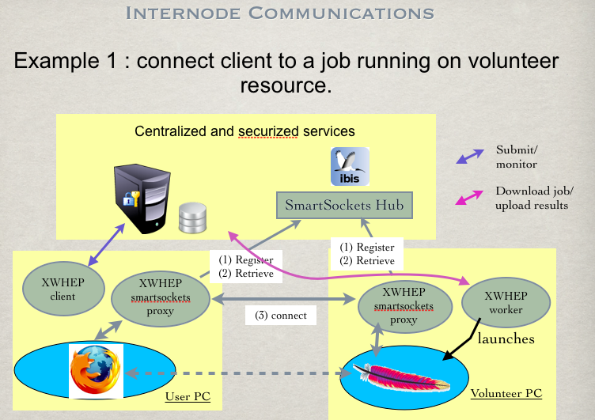Figure 2: server like job submission

In this example, supposing that “jackrabbit” is a registered application, we submit a job like this:

$> xwsubmit jackrabbit –-xwlistenport 8080
xw://whatever/f87da0c4-2324-4cb2-8622-ef81e30525a7

We can retrieve the listening port of the job (in red):

$> ./bin/xwworks --xwformat xml f87da0c4-2324-4cb2-8622-ef81e30525a7
<?xml version='1.0' encoding='UTF-8'?>
<get>
<work uid="f87da0c4-2324-4cb2-8622-ef81e30525a7" ... status="PENDING" listenport="8080" />
</get>

When the job is running on a volunteer resource, it has automatically be assigned a SmartSocket address (in red):

$> ./bin/xwworks --xwformat xml f87da0c4-2324-4cb2-8622-ef81e30525a7
<?xml version='1.0' encoding='UTF-8'?>
<get>
<work uid="f87da0c4-2324-4cb2-8622-ef81e30525a7" ... status="RUNNING" listenport="8080" smartsocketaddr="127.0.0.1-64349#02.9a.bc.39.10.7b.00.00.2f.71.6e.7f.8a.71.27.35:3000@127.0.0.1-4329#12.be.25.38.10.7b.00.00.7c.8b.7f.d1.c1.05.94.ce~root#" />
</get>

Connect to a server like job
The client part of the middleware allows to create a tunnel endpoint on client side using the “xwproxy” script. Please note the usage of the –-xwlistenport command line parameter to open a local port on client side the proxy will listen to:

$> ./bin/xwproxy f87da0c4-2324-4cb2-8622-ef81e30525a7 \
--xwlistenport 1234

Finally you can connect to your job running on volunteer resource using:
- address: localhost
- port: the client side proxy endpoint one; in our example: 1234

Figure 3 shows an example of using a web browser to connect to jackRabbit running on volunteer resource.

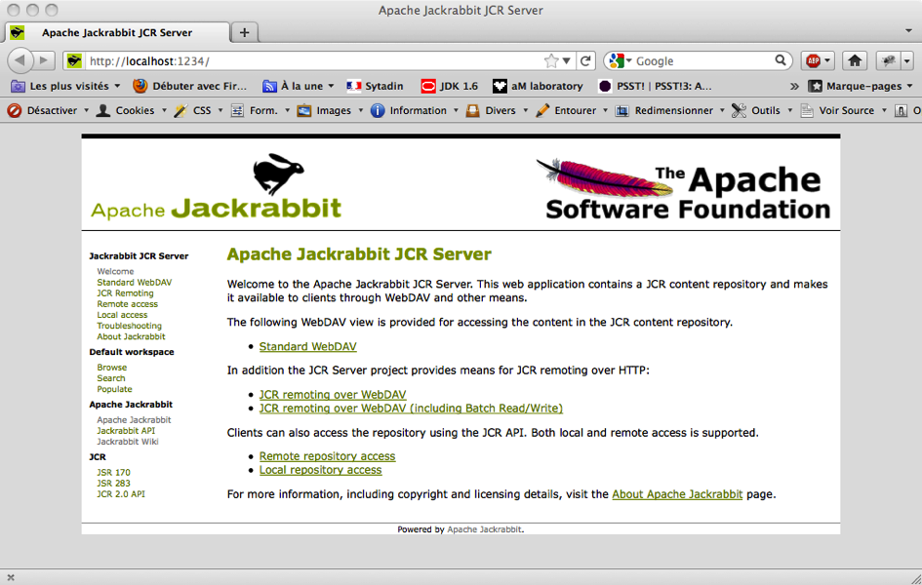Figure 3: connection to a server like job running on volunteer resource

Submit a client like job
We may also like to submit a job that will connect to an application running on client side. This may be particularly interesting if we run a data repository on client side. Figure 4 shows such a configuration. We can see the “data repository” -denoted by the Apache icon- running on client side and the application -denoted by the FireFox icon- willing to connect to that repository running on volunteer resource.
It may be difficult or even impossible to make this connection since the client is certainly behind a firewall on a NATed resource.
The middleware helps to solve this connection problem by creating a tunnel between the client and the volunteer resource. Thanks to SmartSocket service, they may have a chance to finally get a direct connection as follow: (1) register on a SmartSocket hub; (2) retrieve distributed part from the hub; and (3) make the connection.

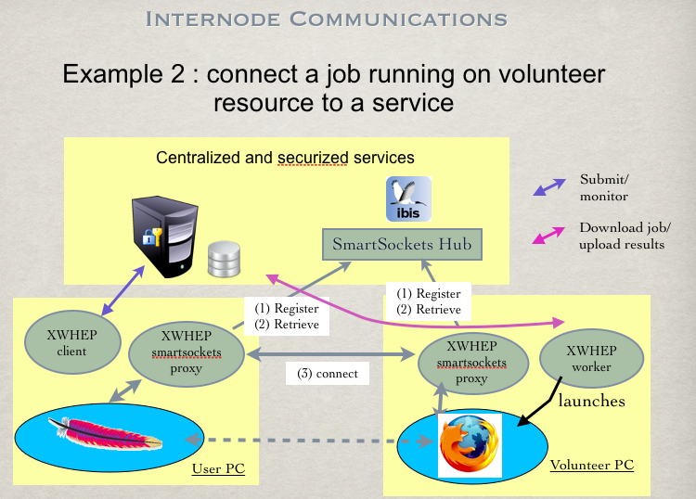Figure 4: A job connecting to client
You must first launch your repository on client side.
Then create a SmartSocket proxy on client side. The –-xwlistenport aims to indicate your proxy local port to which the tunnel must connect.
The following example shows how to create a tunnel on client side; we can see in red colour the created SmartSocket address.
This address will be passed to the job at submission time:
$> ./bin/xwproxy --xwlistenport 8080
Starting server proxy
SLF4J: This version of SLF4J requires log4j version 1.2.12 or later. See also http://www.slf4j.org/codes.html#log4j_version
log4j:WARN No appenders could be found for logger (ibis.smartsockets.properties).
log4j:WARN Please initialize the log4j system properly.
Proxy started on: 192.168.1.14-50163#32.1f.1b.46.10.7b.00.00.4c.1b.34.65.22.ff.be.ff:3000@192.168.1.14-4329#86.a4.19.46.10.7b.00.00.df.40.df.b0.c5.c9.69.08~root#

Supposing that “wget” is a registered application, next example shows a job submission that will connect to the repository running on client side.
There are several things to note here:
- the forward address is a comma separated value in the form:
- “client-SmartSocket-Address, port-number”
- we must provide the previous client SmartSocket address shown in red;
- the job must use the tunnel; hence we must provide http://localhost:aPort as address to connect to; in next example the port we use is shown in bold blue: we choose 1234;
- the same port is used to form the URL and the forward address;

$> ./bin/xwsubmit wget http://localhost:1234 --xwforwardaddresses "192.168.1.14-50163#32.1f.1b.46.10.7b.00.00.4c.1b.34.65.22.ff.be.ff:3000@192.168.1.14-4329#86.a4.19.46.10.7b.00.00.df.40.df.b0.c5.c9.69.08~root#,1234"
xw://new-host.home/a1d885ab-42e9-4d90-92a5-cac21448a0df

Submit a virtual machine
Submitting a virtual machine consists on submitting the “xwstartvm” script described in chapter 10.
Hence four parameter may be used at submission time:
- “--context”;
- “--sshport”;
- “--scratch”;
- “--sharedfs”.

Please refer to chapter 10 for virtual machine scripting details. You should also refer to chapter 14 for contextualization disk creation.
Following is a full example of a VM submission, supposing that “ubuntu” is a registered VM.
In this example we need four command line parameters where some may seem duplicated. These parameters must be understood as follow:
- --sshport 2022: is a parameter for the VM itself asking to open a SmartSocket tunnel on port 2022 that will be used on volunteer resource to forward ssh connection to port 22 in the VM;
- --context xwcontext_disk.vdi: is a parameter for the VM itself to mount the provided virtual disk on /context;
- --xwenv xwcontext_disk.vdi: is an XWHEP client parameter to upload the xwcontext_disk.vdi file to the server so that the volunteer resource will be able to download it at runtime; please refer to the “XtremWeb-HEP User Guide” document;
- --xwlistenport 2022: is an XWHEP client parameter to tell the volunteer resource to create a SmartSocket tunnel so that we will have a chance to connect to our running VM.

$> xwsubmit ubuntu –-sshport 2022 –-context xwcontext_disk.vdi \
–-xwlistenport 2022 –-xwenv xwcontext_disk.vdi

Submit a bag of tasks
Submitting bag of tasks is done the same way of job submission, providing the BoT URI.
Heres is the example of submitting a job for the ls application, in a BoT which URI is xw://xwserv:4321/9aacecb0-72d3-4513-b5ee-fc49afa29df3, using the xwsubmit:

$> xwsubmit ls -lR –-xwenv . –-xwgroup xw://xwserv:4321/9aacecb0-72d3-4513-b5ee-fc49afa29df3
xw://xwserv:4321/3eacecb0-72d3-4513-b5ee-fc49afa29df3

Where
- “ls” is the name of the referenced applications
- “-lR” is the command line parameters
- “--xwenv .” is the way to specify a working directory that must be copied and used to compute the job on the computing resource.

Chapter 9.2.7.1 details submitting BoT.

Update a job
It is impossible to update a submitted job.

Change job access rights
It is impossible to change the access rights of a submitted job.

Retrieve submitted jobs
You can retrieve submitted jobs using the xwworks command, providing job URIs as parameter. Here is the command and its output:

$> xwworks xw://mac-89009.lal.in2p3.fr:4321/01baf2cc-f097-46ea-95b7-962a45593e49
UID='01baf2cc-f097-46ea-95b7-962a45593e49', STATUS='COMPLETED'

You can also retrieve submitted jobs using the xwworks command without any URI. Here is the command and its output:

$> xwworks
UID='01baf2cc-f097-46ea-95b7-962a45593e49', STATUS='COMPLETED'

Some jobs may not be listed: this command returns a maximum of 1000 references.

Chapter 9.2.7.4 and 9.2.7.5 detail retrieving submitted jobs.

Download job results
Downloading job results removes the job from the server. There is no way to use a job, as soon its results have successfully been downloaded on client side.

You can download job results using the xwresults command, providing data URIs as parameter.
Here is the command and its output:

$> xwresults xw://mac-89009.lal.in2p3.fr:4321/fa9c6e5e-3017-4bd7-8f9c-dbde7e717a8e

One can also download all available job results at once:

$> xwresults

This create one new file per job in the current directory.

The name of the result file is
duid“_ResultsOf_”[wuid|wlabel],
where:
- duid is the job result UID (the UID of the data representing the result);
- “_ResultsOf_” is a characters string;
- wuid is the job UID;
- wlabel is the label of the job.

That last is used if the job has a label; the job UID is used otherwise.

This command accepts the “--xwout” command line parameter to specify the output file name. If the provided file name denotes a directory, everything is stored in that directory.
It is the user responsibility to ensure files integrity (i.e. existing files are overwritten).

Remove a job
You can remove a job providing its UID or URI, as follow:

$> xwrm <URI> | <UID> [ <URI> | <UID>...]

Associated objects (data, task...) are automatically removed, as well as all replica.

Chapter 9.2.7.7 details removing jobs.

Task management
The XtremWeb-HEP middleware associates job to computing resources to keep track of the jobs. Tasks are automatically created and managed by the server.

Is is important to note that a task has the UID of its job.

Chapter 9.2.8 details task management.

Submit a task
There is no way to submit a task since the management of that kind of object is entirely automated.

Update a task
There is no way to update a task since the management of that kind of object is entirely automated.

Change access rights of a task
There is no way to change access rights of a task since the management of that kind of object is entirely automated.

Retrieve tasks
You can retrieve registered data using the xwtasks command, providing task URIs as parameter. Here is the command and its output:

$> xwtasks xw://mac-89009.lal.in2p3.fr:4321/01baf2cc-f097-46ea-95b7-962a45593e49
UID='01baf2cc-f097-46ea-95b7-962a45593e49', STATUS='COMPLETED'

You can also retrieve submitted tasks using the xwtasks command without any URI. Here is the command and its output:

$> xwtasks
UID='01baf2cc-f097-46ea-95b7-962a45593e49', STATUS='COMPLETED'

Some tasks may not be listed: this command returns a maximum of 1000 references.

Chapter 9.2.8.4 details retrieving tasks.

Remove a task
You can remove a task providing its UID or URI, as follow:

$> xwrm <URI> | <UID> [ <URI> | <UID>...]

Associated work and data are automatically removed. Chapter 9.2.8.6 details removing tasks.

User management
The XtremWeb-HEP middleware manages users. A user is an identity that is associated to credentials, authorization and eventually a group of users.

The administrator authorization is needed to manage (insert, edit, delete) users. Chapter 9.2.9 details user management.

Register user
Registering an user is done using the command xwsenduser . This script needs three parameters:
- login
- password
- email
and two optional parameters:
- authorization (default is standard_user)
- user group (default is none)
Or
- --xwxml <xmlFile> where <xmlFile> contains an user XML representation.

Chapter 17 details XML representations.

The login must be unique in the XtremWeb-HEP platform.
Because the XtremWeb-HEP middleware uses the login as primary key.

The email address should be set to permit authentication delegation to an OpenId or OAuth server through the web interface.

For example, here is the command to register the user which login is guest, password is guestp , email is guest@gmail.com and authorization is standard_user.

The command displays the new user configuration:

$> xwsenduser guest guestp guest@gmail.com STANDARD_USER
# XWHEP client config file
# 7.1.0-head
# Role
xtremweb.role=CLIENT
# XWHEP server
dispatcher.servers=mac-89009.lal.in2p3.fr
# Login and password to connect to the server
login=guest
password=guestp
user.uid=f35f9600-8efd-4172-b951-cb7b9875c59f
# logger level
logger.level=INFO
# worker keystore
SSLKeyStore=/projects/DGHEP/XWHEP/tags/7.1.0/build/dist/xwhep-7.1.0/keystore/xwhepclient.keys

The same example using user XML representation.

$> xwsubmit –-xwxml <anXmlFile>
xw://xwserv:4321/3eacecb0-72d3-4513-b5ee-fc49afa29df3

Chapter 17 details XML representations. Chapter 9.2.9.1 details registering user.

It is the administrator responsibility to sent this configuration to the user.

Update user
The middleware does not permit to update an user.

Change user access rights
The middleware does not permit modify access rights of user.

Retrieve registered user
You can retrieve registered users using the xwusers command, providing users URIs or login as parameter. Here is the command and its output:

$> xwusers xw://mac-89009.lal.in2p3.fr:4321/01baf2cc-f097-46ea-9aa7-962a45593e49
UID='01baf2cc-f097-46ea-95b7-962a45593e49', LOGIN='guest'

If you know the login of an user, you can provide that login to the xwusers command:

$> xwusers guest
UID='01baf2cc-f097-46ea-95b7-962a45593e49', LOGIN='guest'

Finally, you can retrieve registered users using the xwusers command without any parameter. Here is the command and its output:

$> xwusers
UID='01baf2cc-f097-46ea-95b7-962a45593e49', LOGIN='guest'

Some users may not be listed: this command returns a maximum of 1000 references.

Chapter 9.2.9.4 details retrieving users.

Remove user
You can remove a registered user using the xwrm command. The xwrm command displays no results.

$> xwrm xw://mac-89009.lal.in2p3.fr:4321/66baf2cc-f097-46ea-95b7-962a45593e89

If successful, the object should not appear any more in the output of the command detailed in chapter 6.10.4. Chapter 9.2.9.6 details removing user.

User group management
The XtremWeb-HEP middleware manages users. User may belong to at most one group of users. The administrator authorization is needed to manage (insert, edit, delete) user groups. Chapter 9.2.10 details user group management.

Register user group
Registering an user is done using the command xwsendusergroup. This script needs four parameters:
- the user group label
- the user group administrator login
- the user group administrator password
- the user group administrator email address
Or
- --xwxml <xmlFile> where <xmlFile> contains an user group XML representation.

Chapter 17 details XML representations.

For example, here is the command to register the user group which label is “guestgroup”:

$> xwsendusergroup guestgroup guestadmin_login guestadmin_password guestadmin_email

The group is created; a new user is automatically created inside this new user group with advanced_user user rights. This user has enough rights to manage the group (insert users, apps etc.).

Chapter 9.2.10.1 details registering user group.

Update user group
The middleware does not permit to update an user group.

Change user group access rights
The middleware does not permit modify access rights of user group.

Retrieve registered user group
You can retrieve registered user group using the xwusergroups command, providing users URIs as parameter. Here is the command and its output:

$> xwusergroups xw://mac-89009.lal.in2p3.fr:4321/01baf2cc-f097-46ea-9aa7-962a45593e49
UID='01baf2cc-f097-46ea-95b7-962a45593e49', LABEL='guestgroup'

You can also retrieve registered user groups using the xwusergroups command without any URI. Here is the command and its output:

$> xwusergroups
UID='01baf2cc-f097-46ea-95b7-962a45593e49', LABEL='guestgroup'

Some user groups may not be listed: this command returns a maximum of 1000 references.

Chapter 9.2.10.4 details retrieving user group.

Remove user group
You can remove a registered user group using the xwrm command. The xwrm command displays no results.

$> xwrm xw://mac-89009.lal.in2p3.fr:4321/66baf2cc-f097-46ea-95b7-962a45593e89

If successful, the object should not appear any more in the output of the command detailed in chapter 6.11.4. Chapter 9.2.10.6 details removing user group.

Worker management
A worker is a distributed component aiming to aggregate volunteer resources and use their CPU idle time. Chapter 9.2.11 details worker management.

Register a worker
It is impossible to register a worker. Workers register themselves.

Update a worker
It is impossible to update a worker. Workers update themselves.

Retrieve registered workers
You can retrieve registered workers using the xwworkers command.
Here is the command and its output:

$> xwworkers
UID='b7fad928-0dff-489d-8be5-94d7ffdd5bb3', NAME='debiansqueeze'

Chapter 9.2.11.2.1 details retrieving worker.

Remove a worker
It is impossible to remove a worker.

Activate a worker
The XtremWeb-HEP scheduler sends jobs on worker job request to activated workers only. Deactivated workers never receive jobs.

All workers are activated by default.
A new worker joining a XtremWeb-HEP infrastructure is automatically activated.

The administrator of a XtremWeb-HEP infrastructure is the only one allowed to activate/deactivate workers. The administrator can activate and deactivate workers using the xwactivate command.
This command gives no output. Using xwworker helps to check workers status.

The administrator is the only one who can successfully execute this command.
This command requires:
- the activation status: on or off
- one or more worker UID as found from the xwworkers command output.

$> xwactivate on|off UID

Chapter 9.2.11.5 details activating worker.

Client daemon
The client can be used as daemon: a non interactive endless process. This mode can be specifically used if one has a lot of different requests to send to server. Using the client in daemon mode, one can dramatically reduce Java Virtual Machine launch overhead.

In this mode the client waits for socket incoming connection, read a request from the socket and forwards it to the server. The client waits for server answer and forwards it to the initiator of the communication.

The xwshell command aims to launch the client in daemon mode. The default port is 4327 and is configurable from the client configuration file.

$> xwshell
[29/Apr/2011:15:50:53 +0200] [xtremweb.client.Shell_Shell_12] INFO: started, listening on port: 4327

Next chapter introduces the server embedded web interface and details the available requests. All these requests are usable through the client daemon.
One can open a socket to connect to the client daemon and send requests as describe in next chapter.
The only difference is that the client does not expect an URI, but the request only.

For example, in next chapter, the URI is to retrieve the server version is:

https://xw.lri.fr:4326/?xwcommand=<version ><user login="..." password=".." /></version>

The client daemon expects the request part only:

<version ><user login="..." password=".." /></version>

Web Interface

June 20th, 2013: this interface does not work with Google Chrome.

The middleware proposes a Web interface that proposes most of the client functionalities described in chapter 6. One can access to this Web interface using its favourite Web browser.

The Web interface allows interacting to the server, using the HTTPS protocol, through appropriate URL. It is the user responsibility to use the proper URL to access the targeted XWHEP server.

Security considerations
As described in the “XtremWeb-HEP Introduction” document, the middleware ensures security at different levels:
- communications privacy is ensured by using TLS encryption;
- server authentication is implemented by the usage of an electronic key pair;
- client authentication is certified by the usage of valid credentials.

The Web interface accepts two different credentials types:
- X509 certificate credential;
- OpenId credential;
- OAuth credential.

So does the REST interface described in chapter8.

To connect to the Web interface, the XWHEP administrator must provide the public URL.
An example of such an URL may be:

https://xwservpub.lal.in2p3.fr:4326:4326/path?params

Where
- https is the secured schema
- xwservpub.lal.in2p3.fr:4326 is the server resolved name
- 4326 is the server port
- path is the URL path
- params are URL parameters

In all this chapter, we will use this URL as example.

The connection being secured by the TLS layer, one may encounter security warnings if using a web browser. This may result to a dialog shown in figure 5.
It is the end user responsibility to accept or to deny the connection. One may check the server identity by displaying the certificate details as shown in figure 6.
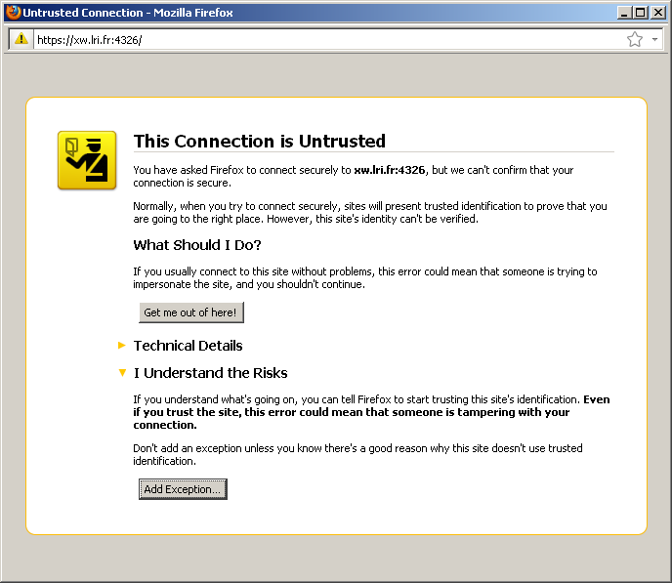Illustration 5: Warning on untrusted connection

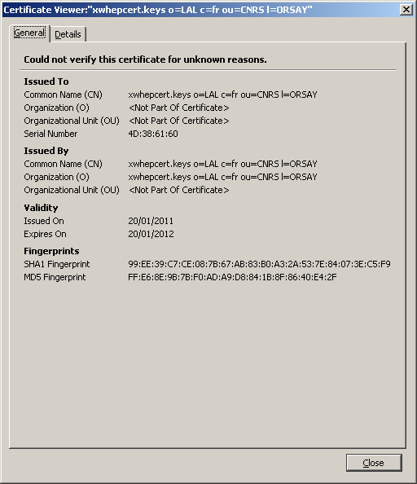Illustration 6: Certificate details

Authenticate using an X509 certificate
Using X509 certificate to connect, your web browser will show you a dialog box requesting you to select your certificate and displaying your certificate details. We can see an example in figure 7.

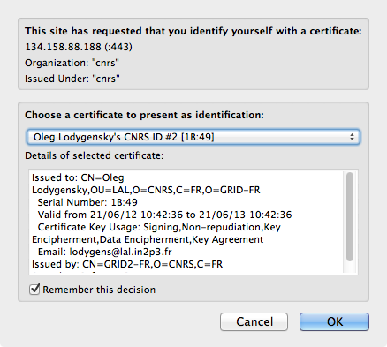Figure 7: Providing your X509 certificate to connect to the Web interface

Delegate authentication to an remote service
If you don't connect using your X509 certificate (or if you don't have such a certificate), you are automatically directed to the page referencing the server statistics page and the two default OpenId of OAuth servers you can use to delegate authentication. If you have an email address on google or on yahoo, or an account on facebook please click on the dedicated link and follow the instructions.

Clicking one of the proposed link redirects your browser to the remote server which ask you to accept the authentication for the XWHEP server.

If you accept to use your identity to connect to the XWHEP server, you are automatically redirected back to that last and have a chance to start using the XWHEP deployment.

Introduction
The web interface aims to use the platform. It helps to manage (register, delete...) objects as well as to submit jobs and retrieve their results.

This interface has been tested on Firefox 12 and Safari 5.1.5.
This interface uses:
- HTML 5
- CSS 3
- Ajax
- File, FileReader, FileList APIs

Web workers
Since HTML5, multi threading has been introducing in JavaScript, named as Web Worker. This new technology can dramatically improves performances. The drawback lies on the implementation by each browser.
Since XWHEP 8.2.0, the web interface integrates web workers to retrieve jobs from the XWHEP server. Their usage may be disabled by unselecting the “Web worker” check box in the interface.
This has been tested on Firefox 18 only. If you encounter any trouble (e.g. you can't retrieve all your jobs), please unselect the “Web worker” check box and try again.

The Graphical User Interface
The GUI is made of: the header made of a set of tabs to select and display the expected pane; each pane list objects of a given type; the main buttons bar that applies to objects; the main window containing the current pane.

The header
The header is made of six tabs to select the viewed pane.
The four first tabs are:
- "Application" to display the registered applications
- "Data" to display your registered data
- "Jobs" to display your registered jobs
- "Group of jobs" to display your registered group of jobs

The two last tabs are:
- "Help" to display the inline help
- "API" to access the Application Programming Interface. Please see chapter 8.

The main buttons bar
Buttons in the main buttons bar apply to any object selected in the main window (please refer to section 7.5). The main buttons bar contains the following buttons:
- "Refresh" to retrieve registered objects from server.
- "Send" to send (register) a new object; the object type is the one of the current tab
- "Details" to retrieve the selected object details
- "Delete" to remove (unregister) selected objects
- "Select all" to select all objects in the current pane
- "Unselect all" to unselect all objects in the current pane

Note that changing the viewed pane unselect all objects from pane.

The main window
The main window is a single area displaying the selected pane. Except for the "Help" and "API" tabs, the main window displays objects list retrieved form server, if any, where each row is composed of:
- a checkbox button to select/unselect the row
- an UID (1)
- a few columns summarising the row informations

Object management
This section describes management procedures applicable to any kind of object type. We refer this procedures as global. The global procedures are available in the main buttons bar (please refer to section 7.4.2).

Management actions dedicated to specific object types are not included in the main buttons bar; they appear in their pane only (e.g: "Submit a job" is a button in "Applications" pane only). Management actions dedicated to specific object types are described below in their respective section.

Retrieving registered objects
Retrieving registered objects retrieves all accessible objects from server.
In the main buttons bar, the "Refresh" action retrieves all accessible objects from server (i.e. objects which access rigths are granted to the user). The retrieved object type is the one of the selected pane. Retrieved objects are listed in the current pane.

Detailing an object
Detailing a registered object retrieves all objects parameters from server. To retrieve an object parameters, you must select it in its pane by clicking its checkbox button. You can detail one object at a time only. If you select more than one object in the list, you will get one object details only.
In the main buttons bar, the "Detail" action pops up a window where you can see all object parameters. These parameters depend on the object type.
Trying to detail an object which access is denied, pops up an error message window.

Sending an object
Sending a new object registers this object on server. In the main buttons bar, the "Send" action pops up a window where you have the opportunity to provide object parameters. These parameters depend on the object type.
You can send one object at a time only.
Please note that sending an object transfers the object meta data only. This does not upload any data content (please refer to the "upload data" section).

Deleting an object
Deleting registered objects removes them from server. To delete objects, you must select them in their pane by clicking their checkbox button.
In the main buttons bar, the "Delete" action removes all selected objects from server. Trying to delete an object which access is denied, pops up an error message window.

Application management
To manage applications, you must select the "Applications" tab.
Retrieving, detailing and deleting applications are detailed in section 7.5.

Submit a job
To submit a job, you must click the "Submit a job" button in the "Applications" tab.
For a better user experience, one should first refresh data and group of jobs in their respective pane. Doing so, the user does not have to manually enter data URI and group UID, but can use the GUI to select data and goup of jobs.
When clicking the submission button, a pop up window appears where several parameters may be filled:
label: is a free text to name the job.
group of jobs: must be an UID, if provided. If you have previously retrieved your group of jobs, you can click on "Select" button to pop up a window where you can select the expected group of jobs.
command line: is a free text that will be provide on the command line of the job at run time.
listen port: is an integer defining the port your job will listen.
smartsocket client: is a smartsocket virtual address your job may wish to connect to.
dirin: must be an URI, if provided. This must be an URI of a file that will automatically be installed in the working directory of the job. If you have previously retrieved your data, you can click on "Select" button to pop up a window where you can select the data.
stdin: must be an URI, if provided. This must be an URI of a file that will automatically be provided to the job as standard input. If you have previously retrieved your data, you can click on "Select" button to pop up a window where you can select the data.
env variables: is a free text in the form NAME=VALUE[, NAME=VALUE] that will be used to generate environment variables.

Data management
To manage data, you must select the "Data" tab.
Sending, detailing and deleting data are detailed in section 7.5.

Sending data content consists on uploading data (please refer to section 7.7.2). Retrieving data does not retrieve all accessible data. This retrieves data owned by the user only.

Download data
Download data consists on retrieving data content from the server. One can only download a data already registered on server. One data can be downloaded at a time only.
The user can click the data name link in its data list. Data which name is not a link, can not be downloaded.

Upload data
To upload data, you must open the “Data” tab, then select a data in the list and click the "Upload" button.
Uploading data consists on sending data content to the server. This must not be confused with sending data, which consists on sending the meta data only.
One can only upload a data already registered on server. Section 7.5.3 details how to register a data. One data can be uploaded at a time only.
The user must select one data in the data list and click the "Upload" button. This pops up a window where the user can select a data from its local file system. It is the user responsibility to provide the md5sum of its data content, sine there is, unfortunately, no way to calculate the md5sum of a local file.
Sending an erroneous md5sum pops up an error message window. In such a situation, the data status is set to ERROR.
Trying to upload data content which access rights does not grant write access pops up an error message window.

Job management
To manage jobs, you must select the "Jobs" tab. For a better user experience, one should first refresh applications and group of jobs in their respective pane. Doing so displays names of application and data referred by the jobs and not their UID. It also permits to sort jobs under their respective group in the "Group of jobs" pane.

Retrieving and detailing jobs are detailed in section 7.5.
Retrieving jobs does not retrieve all accessible jobs. This retrieves jobs owned by the user only.

Send a job
When trying to send a job, a pop up window invites the user to use the “Submit Button” in the applications pane.

Job submission
Please refer to section 7.6.1.

Group of jobs
Jobs can be managed by group of jobs. If the user has first retrieved its group of jobs before retrieving the jobs themselves, jobs are sorted, at retrieval time, in their respective group in the "Group of jobs" pane.
Known limitation: if you refresh jobs several times, they are duplicated in their group of jobs.

Job result retrieval
Retrieving job result consists on retrieving data content from the server. One result can be downloaded at a time only. The user can click the job status link in its jobs list. Job which status is not a link, can not be downloaded.

Job removal
Deleting jobs is detailed in section7.5.4. One must note that deleting a job deletes all its associated data. Hence, it is not possible to retrieve job results after job removal.

Group of jobs management
To manage group of jobs you must select the "Bag of jobs" tab. We refer to group of jobs as BoT.
Sending and retrieving Bot are detailed in section7.5.

Group of jobs retrieval
Retrieving group of jobs does not retrieve jobs, but groups only. To retrieve jobs of each group, please refresh jobs in the "Jobs" pane.

Group of jobs removal
Deleting group is detailed in section7.5. One must note that deleting a group of jobs deletes all its jobs. Hence, it is not possible to retrieve jobs of the group after group removal.

Errors and warnings

Warnings
If you selected a wrong number of rows, a warning is raised

Errors
If the server is not responding, a "connection error" is raised. On access rights violation, an "access rights error" is raised. On data upload, an "md5sum check error" may be raised.

REST interface
The middleware proposes a Web API, “à la” REST, embedded in the server. This REST interface proposes most of the client functionalities described in chapter 6 by implementing the “Application Programming Interface” (API). The API is described in the “XtremWeb-HEP Programmer Guide” document.

One can access to the REST interface using its favourite Web browser. The REST interface allows sending requests to the server, using the HTTPS protocol, through appropriate URL. It is the user responsibility to use the proper URL to access the targeted XWHEP server.

Security considerations
Please refer to chapter7.1.

General purpose commands

Sending a heartbeat signal
To send the heart beat signal, use the URL path /workalive as in:

https://xwservpub.lal.in2p3.fr:4326/workalive

The server answer is:

<xwhep></xwhep>

Retrieving the middleware version
To retrieve the server middleware version, use the URL path /version as in:

https://xwservpub.lal.in2p3.fr:4326/version

The server answer is:

<xwhep><Version branch="head" build="201406181213" version="9.0.0"/></xwhep>

Testing the connection to the server
To test the server connection, use the URL path /ping as in:

https://xwservpub.lal.in2p3.fr:4326/ping

The server answer is:

<xwhep><XMLVector SIZE="0"/></xwhep>

Change object access rights
To modify access rights, use the URL path /chmod/object_uid.
Required parameter:
- PARAMETER=<an access rights>.

Example, to set the access rights to 0x700 of an object which UID is object_uid:

https://xwservpub.lal.in2p3.fr:4326/chmod/object_uid?PARAMETER=0X700

The server answer is:

<?xml version='1.0' encoding='UTF-8'?><xwhep></xwhep>

Retrieve registered object
To retrieve an object, use the URL path /get/object_uid.

Example, to retrieve the object which UID is object_uid:

https://xwservpub.lal.in2p3.fr:4326/get/object_uid

In this example, if object_uid is the valid UID of a data; the server answer is:

<xwhep version="7.4.1-head"><data><accessrights>0x755</accessrights>...</data></xwhep>

Remove object
To remove an object, use the URL path /remove/object_uid.

Example, to remove the object which UID is object_uid:

https://xwservpub.lal.in2p3.fr:4326/remove/object_uid

The server answer is:

<xml version='1.0' encoding='UTF-8'?><xwhep></xwhep>

Data management
Data management is discussed in chapter 6.4. This section presents the Web interface for managing data.

Register data
To register a new data, use the URL path /send.

This does not upload data content.
Please refer to section8.3.2.

Required parameter:
- XMLDESC=<a data XML representation>.

Example, to send a data which name is “dummy”:

https://xwservpub.lal.in2p3.fr:4326/send?XMLDESC=<xwhep version="8.2.0-head”><data><name>dummy</name>...</data></xwhep>

The server answer is:

<?xml version='1.0' encoding='UTF-8'?><xwhep><XMLVector SIZE="0" ></XMLVector></xwhep>

Upload data
To upload content of data which UID is DATAUID, use the URL path /uploaddata/DATAUID.

One can only upload content for a registered data.
Please refer to section8.3.1.

Required parameters:
- DATASIZE=content size
- DATAMD5SUM=content MD5
- DATAFILE=content name
- the data content itself embedded in the correct Mime Type

Example using curl to upload content of the data which UID is YOUR_DATA_UID:

curl -F DATAFILE=@pools.txt https://xwservpub.lal.in2p3.fr:4326/uploaddata/65680689-3168-4e89-8768-be806c12d0cc?DATASIZE=9652&DATAMD5SUM=7b7eb86bf50c58cbf92dc12ff5adf7f4

The server answer is:

<?xml version='1.0' encoding='UTF-8'?><xwhep><XMLVector SIZE="0" ></XMLVector></xwhep>

Change data access rights
Please refer to section8.2.4.

Retrieve registered data
Please refer to section8.2.5.

Remove data
Please refer to section8.2.6.

Application management
Application management is discussed in chapter 6.5. This section presents the Web interface for managing applications.

Register application
To register a new application, use the URL path /send.

Required parameter:
- XMLDESC=<an application XML representation>.

Example, to send an application which name is “dummy”:

https://xwservpub.lal.in2p3.fr:4326/send?XMLDESC=<xwhep version="8.2.0-head”><app><name>dummy</name>...</app></xwhep>

The server answer is:

<?xml version='1.0' encoding='UTF-8'?><xwhep><XMLVector SIZE="0" ></XMLVector></xwhep>

Change access rights
Please refer to section8.2.4.

Retrieve registered application
Please refer to section8.2.5.

Remove application
Please refer to section8.2.6.

Bag of tasks management
The XtremWeb-HEP middleware can manage bag of tasks (BoT). The middleware introduces this notion as “group”.

Register BoT
To register a new Bot, use the URL path /send.

Required parameter:
- XMLDESC=<a group XML representation>.

Example, to send a group which label is “dummy”:

https://xwservpub.lal.in2p3.fr:4326/send?XMLDESC=<xwhep version="8.2.0-head”><group label="dummy” /></xwhep>

The server answer is:

<?xml version='1.0' encoding='UTF-8'?><xwhep><XMLVector SIZE="0" ></XMLVector></xwhep>

Change access rights
Please refer to section8.2.4.

Retrieve registered BoT
Please refer to section8.2.5.

Remove BoT
Please refer to section8.2.6.

Sessions management
The XtremWeb-HEP middleware can manage sessions.

Register session
To register a new session, use the URL path /send.

Required parameter:
- XMLDESC=<a session XML representation>.

Example, to send a session which name is “dummy”:

https://xwservpub.lal.in2p3.fr:4326/send?XMLDESC=<xwhep version="8.2.0-head”><session name="dummy” /></xwhep>

The server answer is:

<?xml version='1.0' encoding='UTF-8'?><xwhep><XMLVector SIZE="0" ></XMLVector></xwhep>

Change access rights
Please refer to section8.2.4.

Retrieve registered session
Please refer to section8.2.5.

Remove session
Please refer to section8.2.6.

Job management
Job management is discussed in chapter 6.8. This section presents the job management Web interface.

Submit job
To submit a new job, use the URL path /send.

Required parameter:
- XMLDESC=<a work XML representation>.

Example, to submit a job which application UID is “1234”:

https://xwservpub.lal.in2p3.fr:4326/send?XMLDESC=<xwhep version="8.2.0-head”><work appuid="1234” /></xwhep>

The server answer is:

<?xml version='1.0' encoding='UTF-8'?><xwhep><XMLVector SIZE="0" ></XMLVector></xwhep>

Change access rights
Please refer to section8.2.4.

Retrieve registered job
Please refer to section8.2.5.

Remove job
Please refer to section8.2.6.
Job removal also removes all associated tasks and data.

Task management
Task management is discussed in chapter 6.9. This section present the Web interface for task management.

Submit a task
There is no way to submit a task since the management of that kind of object is entirely automated.

Update a task
There is no way to update a task since the management of that kind of object is entirely automated.

Change access rights of a task
There is no way to change access rights of a task since the management of that kind of object is entirely automated.

Retrieve registered task
Please refer to section8.2.5.

Remove task
Please refer to section8.2.6.
Task removal also removes all associated jobs and data.

User management
User management is discussed in chapter 6.10. This section presents the Web interface for user management.

Register user
To register a new user, use the URL path /send.

Required parameter:
- XMLDESC=<an user XML representation>.

Example, to register a user which login is “dummy”:

https://xwservpub.lal.in2p3.fr:4326/send?XMLDESC=<xwhep version="8.2.0-head”><user><login>dummy</login>...</user></xwhep>

The server answer is:

<?xml version='1.0' encoding='UTF-8'?><xwhep><XMLVector SIZE="0" ></XMLVector></xwhep>

Change access rights
Please refer to section8.2.4.

Retrieve registered user
Please refer to section8.2.5.

Remove user
Please refer to section8.2.6.

Worker management
The middleware does not allow worker management through the Web interface.

Programmatically access the REST interface
Please refer to the “XtremWeb-HEP Programmer Guide” document.

List of commands and options
This chapter details client requests and options. Readers that want a quite simple introduction to the middleware do not need to read this chapter in order to use the platform. On the other hand, advanced users may find interests to read it.

One may note that all requests and options start are headed with “–-xw”. This ensures that client command line parameters can not be confused with others (e.g. job submission parameters).

In this chapter, requests and options are formatted as follow:

Request | Option name
Script : any | script name (found in ${xwhep_home}/bin)
any: applicable to any script
Command : Client command line parameter name
Parameter : Command Parameter
None | Parameter type (e.g. String, File, URI)
None: no parameter expected
Mandatory: expected parameter
Optional: optional parameter (this is the default if not specified)
Default : Parameter Default Value
None | default value (e.g. null)
None: No default value
Purpose : explanation
Deprecated : explanation

General purpose options
This section details general purpose options that may be applied to any request.

Available options
You can retrieve available options using the following command:
$> java -cp xtremweb.jar xtremweb.common.CommandLineOptions
NONE : does nothing
HELP : to get this help
STATUS <STATUS> : to specify a status (to get list: java -cp xtremweb.jar xtremweb.common.XWStatus)
MACRO <macro file name> : provide a macro file (a text file)
XML <macro file name> : provide a macro file (an XML file)
VERBOSE : verbose mode to get more details
NOVERBOSE : hide macro execution details
FORMAT [short | xml | csv | html] : to specify output format (default = short)
LABEL <label> : to provide a job label
SESSION <UID> : to provide a job session
GROUP <UID> : to provide a job group
CERT <URI | file name> : to provide an X.509 proxy for a job
EXPECTEDHOST <UID> : to specify the worker to run the job
ENV [URI | UID | dir name | file name | zip file name] : to provide a job environment file
STDIN [URI | UID | file name ] : to provide job stdin
CONFIG <config file name> : to provide a config file
DOWNLOAD download datas (this works with --xwgetdata and --xwgetwork to retrieve results)
UPDATEWORKERS [uids list] [on | off] : enable/disable workers
NOEXTRACT : to not extract the zip result file
DONTZIP : to not compress data
KEEPZIP : to not delete the zip result file
NOERASE : to keep a copy of result on server
OVERRIDE : this is not used
CLIENTLOOPDELAY : this is not used
WAIT : this is not used
WALLCLOCKTIME <anInteger >: to set the work wallclocktime
SHELL <portNumber> : to create an XWHEP proxy (default port 4327)
SMARTSOCKETSPROXY <portNumber: to create a SmartSockets proxy (default port 4329)
OUT <fileName> : to set output file name
LISTENPORT <portNumber> : to set the local port to listen to
FORWARDPORT <portNumber : to set the local port to forward to
FORWARDADDRESSES <smartSocketAddr> : to set the SmartSockets address to forward to
GUI : to display the GUI

Help
The client accepts help request to display its online help which is quite verbose.
help
Script : any
Command : --xwhelp
Parameter : None
Default : None
Purpose : this cancels any other request and displays the online help

Here is an example and its output:
(this example uses xwusers, but any other command would display the same result with that option)

$> xwusers --xwhelp

This is the XWHEP client to use and manage the platform (7.5.0-developments)
Available options:
--xwnone: do nothing
--xwhelp: get this help
--xwclean: cleans all client informations at start up (erase cache, get new UID...)
--xwmacro <macro file name>: provide a macro file (a text file)
--xwxml <macro file name>: provide a macro file (an xml file)
--xwverbose: verbose mode
--xwnoverbose: hide macro execution details
--xwformat [short | xml | csv | html]: specify output format (default = short)
--xwlabel <label>: provide a job label
--xwsession <UID>: provide a job session
--xwgroup <UID>: provide a job group
--xwcert <URI | file name>: provide an X.509 proxy for a job
--xwexpectedhost <UID>: specify the worker to run the job
--xwenv [URI | UID | directory | file name | zip file name]: provide a job environment file
--xwstdin [URI | UID | file name ]: provide job stdin
--xwconfig <config file name>: provide a config file
--xwdownload download datas (this works with --xwgetdata and --xwgetwork to retreive results)
--xwupdateworkers [uids list] [on | off]: enable/disable workers
--xwnoextract not expand zip result file
--xwrmzip delete zip result file
--xwnoerase keep result in server
--xwoverride override existing file on local disk
--xwclientloopdelay set a loop delay to get job status
--xwwait wait for job completion
--xwshell open a socket and wait for incoming connections (default port 4327)
--xwgui display GUI
--xwnull: this does nothing
--xwdisconnect: this disconnects
--xwversion: this retreives server version
--xwget URI | UID [URI | UID...]: this retrieves objects
--xwgettask URI | UID [ URI | UID...]: this retrieves tasks
--xwsend
--xwsendapp appName cpuType osName URI | UID: this sends/updates application; URI or UID points to binary file
--xwgetapps:this retrevies all application descriptions
--xwremove URI | UID [ URI | UID...]: this removes objects
--xwsendgroup groupName [sessionUID]: this sends/updates a group
--xwgetgroups: this retreives all group description
--xwgetgroupworks: this retreives all work UID for the group group
--xwsendhost: this is not usable by client
--xwgethosts: this retrevies all host description
--xwactivatehost: [on|off] hostUID [hostUID...]: this activate/deactivate host for computation
--xwsetworkersparameters: this is not usable by client
--xwgetworkersparameters: this is not usable by client
--xwsetworkersnb: this is not usable by client
--xwsendsession sessionName clientUID: this sends/updates a session
--xwgetsessions: this retreives all session description
--xwgetsessionworks: this retreives all session works UID
--xwsendtask: this is not usable by client
--xwgettasks: this retreives all task description
--xwsendtrace: this is not implemented
--xwgettraces: this is not implemented
--xwsendusergroup usergroupName groupAdminLogin groupAdminPassword groupAdminEmail: this sends an user group
--xwgetusergroups: this retreives an user group
--xwsenduser login password email rights [<a user group UID | URI> ]: this sends/updates a user
***java -cp <youLibDir>/xtremweb.jar xtremweb.common.UserRights to see available values
--xwgetuserbylogin userLogin [userLogin...]: this retrevies user description
--xwgetusers: this retrevies all user description
--xwsendwork <application name | URI | UID> [ --xwcert <X.509 cert or proxy> ] [ --xwenv <dirinFile | URI | UID> ] [ '<' <stdinFile> ] [--xwsession <UID | URI>] [--xwgroup <UID | URI>]
--xwbroadcastwork <application name | URI | UID> [ --xwcert <X.509 cert or proxy> ] [ --xwenv <dirinFile | URI | UID> ] [ '<' <stdinFile> ]
--xwworkrequest: this is not available from client
--xwgetworks: to retreive all works
--xwworkalivebyuid: this is not available from client
--xwworkalive: this is not available from client
--xwping: this pings server
--xwtactivitymonitor: this is not available from client
--xwgettrustedaddresses: this is not implemented
--xwaddtrustedaddress: this is not implemented
--xwremovetrustedaddress: this is not implemented
--xwtraceworkers: this is not available from client
--xwmount: this is not implemented
--xwumount: this is not implemented
--xwshutdown: this is not implemented
--xwsenddata dataName [cpuType] [osName] [dataType] [accessRigths] [dataFile | dataURI | dataUID]: this sends data and uploads data if dataFile provided
--xwgetdatas: to retreive all data descriptions
--xwchmod newAccessRights URI | UID [ URI | UID...]: to change access rights
>>>>>> java -cp <yourLibDir>/xtremweb.jar xtremweb.common.XWAccessRights to see available values
--xwuploaddata dataUID dataFile: to send data content to server
--xwdownloaddata dataUID: to retreive data content

Configuration file
The client accepts the –-xwconfig option to specify a configuration file.
This parameter must be provided to the client.
It is always automatically set by script found in ${XWHEP_HOME}/bin.

config
Script : any
Command : --xwconfig <file>
Parameter : Mandatory; <file> must be an xwhep client configuration file
Default : ${HOME}/.xtremweb/xtremweb.client.conf
Purpose : this sets the client configuration file

Output format
The client accepts the –-xwformat option to specify the output format.

format
Script : any
Command : --xwformat
Parameter : short | xml | html | csv
csv: comma separated values
html: web format
short: minimal information set
xml: xml format
Default : short
Purpose : this sets the client output format

Verbose mode
The client accepts the –-xwverbose option to write request details.
verbose
Script : any
Command : --xwverbose
Parameter : None
Default : None
Purpose : this details requested action

Using this option the client first displays, your login, the XWHEP server, the request to send to the server and its eventual parameters. The request and the rest of the output depends of the used request. Here is an example using this option with the request getworks:

$> ./bin/xwworks --xwformat xml --xwverbose
server = xwservpub.lal.in2p3.fr:4326
login = CN=Oleg_Lodygensky,OU=LAL,O=CNRS,C=FR,O=GRID-FR_CN=GRID2-FR,O=CNRS,C=FR
request = GETWORKS
params = null
<?xml version='1.0' encoding='UTF-8'?>
<get>
<work uid="831ee73e-994f-4fda-a727-a49263fbfd07" isservice="false" isdeleted="false" appuid="b72b79ec-4aa0-4741-866a-640647cbe289" owneruid="20bb9427-db2b-4266-950e-81ee2b72eaf0" accessrights="0x700" status="PENDING" returncode="0" cmdline="" dirinuri="xw://xwservpub.lal.in2p3.fr:4326/4edd9b39-da31-4174-80f5-6774aa759420" arrivaldate="2011-05-27 10:01:42" sendtoclient="false" local="true" active="true" replicated="false" maxretry="0" minmemory="0" mincpuspeed="0" />
</get>

Available requests
This section details requests to use, monitor and administrate a deployment.

List of available requests
You can retrieve available requests using the following command:
$> java -cp xtremweb.jar xtremweb.communications.IdRpc
NULL : does nothing
DISCONNECT : disconnects
VERSION : retrieves server version
GET UID | URI : retrieves an object
GETTASK UID | URI : retrieves a task
SEND : insert/update an object
SENDAPP appName appType cpuType osName URI | UID : inserts/updates an application; URI or UID points to binary file ; application name must be the first parameter
GETAPPS retrieves all applications
REMOVE URI | UID [ URI | UID...] : removes objects
SENDGROUP groupName [sessionUID] : sends/updates a group
GETGROUPS : retrieves all groups
GETGROUPWORKS UID | URI : retrieves all group works
SENDHOST : not available
GETHOSTS : retrevies all hosts
ACTIVATEHOST [on|off] hostUID [hostUID...] : activates/deactivates hosts
SETWORKERSPARAMETERS not available
GETWORKERSPARAMETERS not available
SETWORKERSNB not available
SENDSESSION sessionName clientUID : sends/updates a session
GETSESSIONS : retrieves all sessions
GETSESSIONWORKS : retrieves all session works
GETTASKS : retrieves all tasks
SENDTRACE : not available
GETTRACES : not available
SENDUSERGROUP usergroupName groupAdminLogin groupAdminPassword groupAdminEmail : sends/updates an user group
GETUSERGROUPS : retrieves all user groups
SENDUSER login password email rights [<a user group UID | URI> ] : sends/updates a user
GETUSERBYLOGIN userLogin [userLogin...] : retrevies users given their login
GETUSERS : retrevies all users
SENDWORK <application name | URI | UID> [ --xwcert <X.509 cert or proxy> ] [ --xwenv <dirinFile | URI | UID> ] [ '<' <stdinFile> ] [--xwsession <UID | URI>] [--xwgroup <UID | URI>]
BROADCASTWORK (same parameters as SENDWORK) : broadcast a work to all hosts
WORKREQUEST : not available
GETWORKS : retrieves all works
WORKALIVEBYUID : not available
WORKALIVE : sends the alive signal (for debugging purposes only)
PING : pings the server
TACTIVITYMONITOR : not available
GETTRUSTEDADDRESSES : not available
ADDTRUSTEDADDRESS : not available
REMOVETRUSTEDADDRESS : not available
TRACEWORKERS : not available
MOUNT : not available
UMOUNT : not available
SHUTDOWN : not available
SENDDATA dataName [cpuType] [osName] [dataType] [accessRigths] [dataFile | dataURI | dataUID] : sends data and uploads data if dataFile provided
GETDATAS : retrieves all data
CHMOD newAccessRights URI | UID [ URI | UID...] : changes access rights
GETHUBADDR : retrieves the SmartSockets hub address
UPLOADDATA UID file : sends data content from file to server
DOWNLOADDATA UID | URI : downloads data content from server

Clean
Since 7.4.1, this is deprecated, since the client uses in memory cache only and do not store its cache on local file system.
The client accepts the –-xwclean request to clean the local cache.
This request has no parameter.
clean
Script : xwclean
Command : --xwclean
Parameter : None
Default : None
Purpose : This erases local cache
Deprecated : since 7.4.1 the client uses in memory cache only

Application management
This section details requests to use, monitor and administrate applications.

Register new application
The client accepts the –-xwsendapp request to register a new application.
Registering a new application may be done by providing a name, os, cpu and binary file; or by providing an xml file.

sendapp
Script : xwsendapp
Command : --xwsendapp
Parameter : name os cpu uri [--xwxml <an xml file>]
- Mandatory; name: application name
- Mandatory; os: os name (please refer to “xtremweb-hep programmer guide”)
- Mandatory; cpu: cpu type (please refer to “xtremweb-hep programmer guide”)
- Mandatory; uri: a local (e.g /bin/ls) or remote (e.g. http://www.xtremweb-hep.org/index.html) file
or
- Mandatory; --xwxml <an xml file>: using this cancels other parameters; the xml file must contain an application xml representation (please refer to “xtremweb-hep programmer guide”)
Default : None
Purpose : this registers a new application

Retrieve applications
The client accepts the –-xwgetapps and request to retrieve registered applications.

getapps
Script : xwapps
Command : --xwgetapps
Parameter : [--xwformat ...]
- --xwformat (please refer to 9.1.4)
Default : None
Purpose : this retrieve the list of registered applications, if any. The list is limited to a thousand only

Some applications may not be listed: this request returns a maximum of 1000 references.

Retrieve an application
The client accepts the –-xwget request to retrieve a registered application.

get
Script : xwapps
Command : --xwget
Parameter : uid | uri [..] [--xwformat ...]
- Mandatory; a space separated list of uri or uid
- Optional: --xwformat (please refer to 9.1.4)
Default : None
Purpose : this retrieve the list of registered applications according to the provided parameter

Remove application
The client accepts the –-xwremove request to retrieve a registered application.

remove
Script : xwrm
Command : --xwremove
Parameter : uid | uri [..]
- Mandatory; a space separated list of uri or uid
Default : None
Purpose : this removes objects according to the provided parameter

Change application access rights
The client accepts the –-xwchmod request to change application access rights.

chmod
Script : xwchmod
Command : --xwchmod
Parameter : uid | uri [..]
- Mandatory; a space separated list of uri or uid
Default : None
Purpose : this changes object access rights according to the provided parameter

Data management
This section details requests to use, monitor and administrate data.

Register new data
The client accepts the –-xwsenddata request to register a new application.
Registering a new data may be done by providing a name, os, cpu and file; or by providing an xml file.

senddata
Script : xwsenddata
Command : --xwsenddata
Parameter : name os cpu type uri [--xwexpectedwork <workuid>] [--xwxml <an xml file>]
- This sends data definition and data content
- Optional: “Name” is the data name (default is the file name from uri)
- Optional: “os” is os name (please refer to “xtremweb-hep programmer guide”)
- Optional: “cpu” is cpu type (please refer to “xtremweb-hep programmer guide”)
- Mandatory; uri: a local (e.g /bin/ls) or remote (e.g. http://www.xtremweb-hep.org/index.html) file
- Optional: --xwexpectedworkd <workuid>. Xwhep 10.0.0 introduced data driven scheduling; to take advantage of this data driven scheduling, a data must be associated with a work. This optional parameter associates a work (given its uid) to automatically process this data. If the provided work has replica, the data may be processed by the work or any of its replica.
or
- This sends data definition; data content can not be sent this way
- Mandatory; --xwxml <an xml file>: using this cancels other parameters; the xml file must contain a data xml representation (please refer to “xtremweb-hep programmer guide”)
This is used to send data definition only; data content itself can not be send this way
Default : None
Purpose : this registers a new application

Retrieve datas
The client accepts the –-xwgetdatas request to retrieve registered data. This request accept the --xwdownload option to download data content.

getdatas
Script : xwdatas
Command : --xwgetdatas
Parameter : [--xwformat …] [--xwdownload]
- Optional: --xwformat (please refer to 9.1.4)
- Optional: --xwdownload to download data content
Default : None
Purpose : this retrieve the list of registered data, if any. The list is limited to a thousand only

Some data may not be listed: this request returns a maximum of 1000 references.

Retrieve data
The client accepts the –-xwget request to retrieve a registered data. This request accept the --xwdownload option to download data content.

get
Script : xwdatas
Command : --xwget
Parameter : uid | uri [..] [--xwformat …] [--xwdownload]
- Mandatory; a space separated list of uri or uid
- Optional: --xwformat (please refer to 9.1.4)
- Optional: --xwdownload to download data content
Default : None
Purpose : this retrieve the list of registered data according to the provided parameter

Retrieve data content
The client accepts the –-xwget request to retrieve a registered data. This request accept the --xwdownload option to download data content.

get
Script : xwdownload
Command : --xwget
Parameter : uid | uri [..] [--xwformat …] [--xwdownload]
- Mandatory; a space separated list of data uri or data uid
- Optional: --xwformat (please refer to 9.1.4)
- Optional: --xwdownload to download data content
Default : None
Purpose : this retrieve the list of registered data and their content according to the provided parameter

Change data access rights
The client accepts the –-xwchmod request to change data access rights.

chmod
Script : xwchmod
Command : --xwchmod
Parameter : uid | uri [..]
- Mandatory; a space separated list of uri or uid
Default : None
Purpose : this changes object access rights according to the provided parameter

Remove data
The client accepts the –-xwremove request to remove data.

remove
Script : xwrm
Command : --xwremove
Parameter : uid | uri [..]
- Mandatory; a space separated list of uri or uid
Default : None
Purpose : this removes objects according to the provided parameter

Change data access rights
The client accepts the –-xwchmod request to modify an object access rights.

chmod
Script : xwchmod
Command : --xwchmod
Parameter : uid | uri [..]
- Mandatory; a space separated list of uri or uid
Default : None
Purpose : this changes object access rights according to the provided parameter.

Bag of tasks management
This section details requests to use, monitor and administrate BoT.

Register new BoT
The client accepts the –-xwsendgroup request to register a new BoT.

sendgroup
Script : xwsendgroup
Command : --xwsendgroup
Parameter : label
- Mandatory; group label
or
- Mandatory; --xwxml <an xml file>: using this cancels other parameters; the xml file must contain a bag of tasks xml representation (please refer to “xtremweb-hep programmer guide”)
Default : None
Purpose : this registers a new BoT

Get BoT
The client accepts the –-xwgetgroup request to retrieve registered BoT.

getgroups
Script : xwgroups
Command : --xwgetgroups
Parameter : [--xwformat ...]
- Optional: --xwformat (please refer to 9.1.4)
Default : None
Purpose : this retrieve the list of registered bot, if any. The list is limited to a thousand only

Some BoT may not be listed: this request returns a maximum of 1000 references.

Get BoT
The client accepts the –-xwget request to retrieve a registered BoT.

get
Script : xwgroups
Command : --xwget
Parameter : uid | uri [..] [--xwformat ...]
- Mandatory; a space separated list of uri or uid
- Optional: --xwformat (please refer to 9.1.4)
Default : None
Purpose : this retrieve the list of registered BoT according to the provided parameter

Remove BoT
The client accepts the –-xwremove request to remove BoT.

remove
Script : xwrm
Command : --xwremove
Parameter : uid | uri [..]
- Mandatory; a space separated list of uri or uid
Default : None
Purpose : this removes objects according to the provided parameter

Change BoT access rights
The client accepts the –-xwchmod request to modify an object access rights.

chmod
Script : xwchmod
Parameter : uid | uri [..]
- Mandatory; a space separated list of uri or uid
Default : None
Purpose : this changes object access rights according to the provided parameter.

Session management
This section details requests to use, monitor and administrate sessions.

Register new session
The client accepts the –-xwsendsession request to register a new BoT.

sendsession
Script : xwsendsession
Command : --xwsendsession
Parameter : label
- Mandatory; session label
or
- Mandatory; --xwxml <an xml file>: using this cancels other parameters; the xml file must contain a session xml representation (please refer to “xtremweb-hep programmer guide”)
Default : None
Purpose : this registers a new session

Get sessions
The client accepts the –-xwgetsessions request to retrieve registered sessions.

getsessions
Script : xwsessions
Command : --xwgetsessions
Parameter : [--xwformat ...]
- Optional: --xwformat (please refer to 9.1.4)
Default : None
Purpose : this retrieve the list of registered sessions, if any. the list is limited to a thousand only

Some sessions may not be listed: this request returns a maximum of 1000 references.

Get session
The client accepts the –-xwget request to retrieve a registered session.

get
Script : xwsessions
Command : --xwget
Parameter : uid | uri [..] [--xwformat ...]
- Mandatory; a space separated list of uri or uid
- Optional: --xwformat (please refer to 9.1.4)
Default : None
Purpose : this retrieve the list of registered BoT according to the provided parameter

Remove session
The client accepts the –-xwremove request to remove session.

remove
Script : xwrm
Command : --xwremove
Parameter : uid | uri [..]
- Mandatory; a space separated list of uri or uid
Default : None
Purpose : this removes objects according to the provided parameter

Change session access rights
The client accepts the –-xwchmod request to modify an object access rights.

chmod
Script : xwchmod
Parameter : uid | uri [..]
- Mandatory; a space separated list of uri or uid
Default : None
Purpose : this changes object access rights according to the provided parameter.

Job management
This section details requests to use, monitor and administrate jobs.

Submit new job
The client accepts the –-xwsendwork request to submit a new job.

sendwork
Script : xwsendwork
Command : --xwsendwork
Parameter : appname [job parameters] [--xwenv …] [--xwstdin …] [--xwgroup BoT] [--xwsession sessionuid][--xwcert …] [--xwlistenport …] [--xwforwardaddresses...] [--xwwallclocktime ...]
- Mandatory: application name
- Optional: job parameters is a space separated list of parameters provided in the command line of application binary at run time
- Optional: --xwenv uri to provide an environment (a file or a directory). It may be a local file (e.g /bin/ls), a local directory (e.g. “/tmp” or even “.”) or a remote file (e.g. xw://xwservpub.lal.in2p3.fr:4326/566d8d28-a54f-4167-b5f2-46fa75c22556 or http://www.xtremweb-hep.org/index.html).
Since XWHEP 7.6.0, you can provide more than one “--xwenv” parameter. In this case, all data references must be URI; it is not possible to provide several local files or directories.
- Optional: --xwstdin uri to provide a text file.
- Optional: --xwlabel text to provide a label to the job.
- Optional: --xwgroup BoT, where BoT is an uid of a registered BoT
- Optional: --xwsession sessionuid, where sessionuid is an uid of a registered session
- Optional: --xwcert uri to provide an x509 certificate (default is $X509_USER_PROXY environment variable)
- Optional: --xwlistenport integer to inform the computing resource to open a SmartSocket tunnel endpoint to make the job reachable
- Optional: --xwforwardaddresses SmartSocketAddress to inform the computing resource to open a SmartSocket tunnel endpoint to make the job able to connect to a remote server like job or application
- Optional: --xwwallclocktime long_integer to set a wall clock time for this job; if not provided, the server automatically sets it to the default value

or

- Mandatory; --xwxml <an xml file>: using this cancels other parameters; the xml file must contain a job xml representation (please refer to “xtremweb-hep programmer guide”)
Default : None
Purpose : this registers a new job

Update a job
It is impossible to update a submitted job.

Change job access rights
It is impossible to change the access rights of a submitted job.

Get jobs
The client accepts the –-xwgetworks request to retrieve submitted jobs. This request accept the --xwdownload option to download job result content.

getworks
Script : xwworks, xwworkspending, xwworksrunning, xwworkserror, xwworkscompleted or xwstatus
Command : --xwgetworks
Parameter : [--xwformat …] [--xwdownload] [--xwstatus a_status]
- Optional: --xwformat (please refer to 9.1.4)
- Optional: --xwdownload to download job result, if any
=> if --xwnoerase is not provided, job is automatically removed from server on successful result download
- --xwstatus a_status: to retrieve jobs given its status (i.e. “pending”, “running”, “completed”, “error”)
- --xwnoerase: don't remove job from server even if job result download successful
Default : None
Purpose : this retrieve the list of registered jobs, if any. The list is limited to a thousand only

Some jobs may not be listed: this request returns a maximum of 1000 references.

Get job
The client accepts the –-xwget request to retrieve a submitted job.

get
Script : xwworks, xwworkspending, xwworksrunning, xwworkserror, xwworkscompleted or xwstatus
Command : --xwget
Parameter : uid | uri [..] [--xwformat …] [--xwdownload] [--xwnoerase]
[--xwstatus a_status]
- Mandatory; a space separated list of uri or uid
- Optional: --xwformat (please refer to 9.1.4)
- Optional: --xwdownload to download job result, if any
=> if --xwnoerase is not provided, job is automatically removed from server on successful result download
- --xwstatus a_status: to retrieve jobs given its status (i.e. “pending”, “running”, “completed”, “error”)
- --xwnoerase: don't remove job from server even on successful job result download
Default : None
Purpose : this retrieve the list of submitted jobs according to the provided parameter

Retrieve job results
The client accepts the –-xwget request to retrieve a submitted job. This request accept the --xwdownload option to download job result.

get
Script : xwresults
Command : --xwget --xwdownload
Parameter : uid | uri [..] [--xwformat …] [--xwdownload]
- Mandatory; a space separated list of job uri or job uid
- Optional: --xwformat (please refer to 9.1.4)
- Optional: --xwdownload to download data content
Default : None
Purpose : this retrieve the list of registered job and download their result according to the provided parameter

Remove job
The client accepts the –-xwremove request to remove jobs.

remove
Script : xwrm
Command : --xwremove
Parameter : uid | uri [..]
- Mandatory; a space separated list of uri or uid
Default : None
Purpose : this removes objects according to the provided parameter

Associated objects (data, task...) are automatically removed.

Task management
The XtremWeb-HEP middleware associates job to computing resources to keep track of the jobs. Tasks are automatically created and managed by the server.

Is is important to note that a task has the UID of its job.

Submit a task
There is no way to submit a task since the management of that kind of object is entirely automated.

Update a task
There is no way to update a task since the management of that kind of object is entirely automated.

Change access rights of a task
There is no way to change access rights of a task since the management of that kind of object is entirely automated.

Get tasks
The client accepts the –-xwgettasks request to retrieve submitted jobs.

getworks
Script : xwtasks
Command : --xwgettasks
Parameter : [--xwformat ...]
- --xwformat (please refer to 9.1.4)
Default : None
Purpose : this retrieve the list of registered task, if any. The list is limited to a thousand only

Some tasks may not be listed: this request returns a maximum of 1000 references.

Get task
The client accepts the –-xwget request to retrieve a task.

get
Script : xwtasks
Command : --xwget
Parameter : uid | uri [..] [--xwformat ...]
- Mandatory; a space separated list of uri or uid
- --xwformat (please refer to 9.1.4)
Default : None
Purpose : this retrieve the list of tasks according to the provided parameter

Remove task
The client accepts the –-xwremove request to remove tasks.

remove
Script : xwrm
Command : --xwremove
Parameter : uid | uri [..]
- Mandatory; a space separated list of uri or uid
Default : None
Purpose : this removes objects according to the provided parameter

Associated work and data are automatically removed.

User management
This section details requests to register and administrate users.

Register user
The client accepts the –-xwsenduser request to register a new user.

senduser
Script : xwsenduser
Command : --xwsenduser
Parameter : login email password [rights] [user group]
- Mandatory: login
- Mandatory: email
- Mandatory: password
- Optional: rights; user rights level (default: standard_user)
- Optional: user group uri | user group uid
or
- Mandatory; --xwxml <an xml file>: using this cancels other parameters; the xml file must contain an user xml representation (please refer to “xtremweb-hep programmer guide”)
Default : None
Purpose : this registers a new user

Update user
The middleware does not permit to update an user.

Change user access rights
The middleware does not permit modify access rights of user.

Retrieve registered users
The client accepts the –-xwgetusers request to retrieve registered user.

getusers
Script : xwusers
Command : --xwgetusers
Parameter : [--xwformat ...]
- --xwformat (please refer to 9.1.4)
Default : None
Purpose : this retrieves the list of registered users, if any. The retrieved list is limited to a thousand entries only

Some users may not be listed: this request returns a maximum of 1000 references.

Retrieve registered user
The client accepts the –-xwget request to retrieve a registered users.

get
Script : xwusers
Command : --xwget
Parameter : uid | uri [..] [--xwformat ...]
- Mandatory; a space separated list of uri or uid
- --xwformat (please refer to 9.1.4)
Default : None
Purpose : this retrieves the list of registered users according to the provided parameter

Remove user
The client accepts the –-xwremove request to remove users.

remove
Script : xwrm
Command : --xwremove
Parameter : uid | uri [..]
- Mandatory; a space separated list of uri or uid
Default : None
Purpose : this removes objects according to the provided parameter

User group management
This section details requests to register and administrate user groups.

Register user group
The client accepts the –-xwsendusergroup request to register a new user group.

sendusergroup
Script : xwsendusergroup
Command : --xwsendusergroup
Parameter : label login email password
- Mandatory: label is the user group label
- Mandatory: login is the group administrator login
- Mandatory: email is the group administrator email address
- Mandatory: password is the group administrator password
or
- Mandatory; --xwxml <an xml file>: using this cancels other parameters; the xml file must contain a user group xml representation (please refer to “xtremweb-hep programmer guide”)
Default : None
Purpose : this registers a new user

Update user group
The middleware does not permit to update an user.

Change user group access rights
The middleware does not permit modify access rights of user.

Retrieve registered user groups
The client accepts the –-xwgetusergroups request to retrieve registered user groups.

getusers
Script : xwusergroups
Command : --xwgetusergroups
Parameter : [--xwformat ...]
- --xwformat (please refer to 9.1.4)
Default : None
Purpose : this retrieves the list of registered user groups, if any. The retrieved list is limited to a thousand entries only

Some user groups may not be listed: this request returns a maximum of 1000 references.

Retrieve registered user group
The client accepts the –-xwget request to retrieve a registered user group.

get
Script : xwusergroups
Command : --xwget
Parameter : uid | uri [..] [--xwformat ...]
- Mandatory; a space separated list of uri or uid
- --xwformat (please refer to 9.1.4)
Default : None
Purpose : this retrieves the list of registered user groups according to the provided parameters

Remove user group
The client accepts the –-xwremove request to remove user groups.

remove
Script : xwrm
Command : --xwremove
Parameter : uid | uri [..]
- Mandatory; a space separated list of uri or uid
Default : None
Purpose : this removes objects according to the provided parameters

Worker management
This section details requests to administrate workers.

Register a worker
It is impossible to register a worker. Workers register themselves.

Update a worker
It is impossible to update a worker. Workers update themselves.

Retrieve registered workers
The client accepts the –-xwgethosts request to retrieve registered user.

getusers
Script : xwworkers
Command : --xwgethosts
Parameter : [--xwformat ...]
- --xwformat (please refer to 9.1.4)
Default : None
Purpose : this retrieves the list of registered workers, if any. The retrieved list is limited to a thousand entries only

Some workers may not be listed: this request returns a maximum of 1000 references.

Retrieve registered worker
The client accepts the –-xwget request to retrieve a registered worker.

get
Script : xwworkers
Command : --xwget
Parameter : uid | uri [..] [--xwformat ...]
- Mandatory; a space separated list of uri or uid
- --xwformat (please refer to 9.1.4)
Default : None
Purpose : this retrieves the list of registered workers according to the provided parameters

Remove a worker
It is impossible to remove a worker.

Activate a worker
The client accepts the –-xwactivatehost request to retrieve a registered worker.

get
Script : xwactivate
Command : --xwactivatehost
Parameter : on | off uid [...]
- Mandatory ; “on” to activate workers or “off” to deactivate workers
- Mandatory; a space separated list of uid
Default : None
Purpose : this activates/deactivates the list of workers according to the provided parameters

Managing virtual machines using the XtremWeb-HEP scripts
This chapter describes the XtremWeb-HEP middleware scripts to create, start, stop and destroy virtual machine on demand.
These scripts have been designed to be automatically run on worker side, but can also be run by hand. Running these scripts by hand may be helpful to understand how to deploy and use virtual machine over an XtremWeb-HEP deployment.

You must carefully read all this section before using these scripts.
Because they delete all files at the end of its execution, including VDI.

The middleware proposes two versions of the script that creates, launches and destroys a VM; one for Linux and Mac OS X, and one for Windows:
- ${XWHEP_HOME}/bin/xwstartvm.sh
- ${XWHEP_HOME}/bin/xwstartvm.bat

The middleware also contains scripts to stop a VM:
- ${XWHEP_HOME}/bin/xwstopvm.sh
- ${XWHEP_HOME}/bin/xwstopvm.bat

In the middleware source package these scripts are in:
- ${XWHEP_HOME}/src/script/

Creating and running new virtual machines
The xwstartvm.sh script creates a new VM inside VB, attaching boot media and the contextualization one, if any, creating a new media providing some disk space to work on, and finally start the new created VM.
This script may be used to test virtual machines by hand on your own computer. This script is also used over desktop grid to manage VM on demand.

The script requires some parameters and may display error messages on erroneous usage, like:

./xwstartvm.sh: start
./xwstartvm.sh FATAL: HDA1FILE is not set

The script accepts some optional command line parameters. The three first detailed here are those that may be used to manage virtual machines over desktop grid, as well as on local host:
- --context <contextualization media file>. This is the contextualization drive mounted in /context, containing context.sh to be executed at the end of boot without any privilege. This may be a VDI, a VMDK, a VHD or an ISO media file;
- --scratch <media file>. This is a disk mounted on /mnt/xwscratch. This may be a VDI, a VHD, a VMDK or an ISO media file. If this parameter is not provided, the script creates a new empty 4Gb drive. The boot process automatically formats non formatted drive;
- --sshport <port number>; this sets a port number to connect to the VM.

Some other command line parameters are only usable on local host. They aim to test virtualization locally before deploying virtual machines over desktop grid. The three first parameters detailed above may apply.

The following command line parameters are automatically disabled on desktop grid by the script “xwaddvbapp.sh” used to register virtual machines on DG server. Please refer to chapter6.5.4.

- --install --name vm_name --hda aVDIfile ; this installs a virtual machines in Virtual-Box on local host; the vm_name is the name of the VM to create; ”aVDIfile” is the virtual media used to boot the VM; the parameters “--context”, “--scratch”, “--sshport” may apply;
- --uninstall --name vm_name; this uninstalls the virtual machine from Virtual-Box on local host; the vm_name is the name of the VM to remove; the parameters “--context”, “--scratch”, “--sshport” do not apply;
- --start --name vm_name; this starts a virtual machine in Virtual-Box on local host; the vm_name is the name of the VM to remove; the parameters “--context”, “--scratch”, “--sshport” do not apply;
- --stop --name vm_name; this stops a virtual machine in Virtual-Box on local host; the vm_name is the name of the VM to stop; the parameters “--context”, “--scratch”, “--sshport” do not apply.

Finally, the script has an inline help:

$> ./bin/xwstartvm.sh --help

Usage : ./bin/xwstartvm.sh --install --name vm_name --hda aFile [install_parameters] | --start --name vm_name | --stop --name vm_name | --uninstall --name vm_name

When running on the Grid Computing, commands are automatically and sequentially executed as follow
[1] install --hda aFile [install_parameters]
[2] start
[3] stop
[4] uninstall

--install --name vm_name --hda aFile [--context aFile] [--app aFile] [--input aFile] [--result aFile] [--sshport portNumber] [--sharedfs aDirectory]
This installs a new VM in VirtualBox and exits.
Install parameters:
--hda aFile : This is required
This provides the boot disk (an ISO, VDI, VMDK or VHD)

--context aFile : This is optional
This provides a file or a directory as context
If this is not a virtual disk (VD), a new VD is created containing aFile (recursively, if applicable)
If this is a VD (an ISO, VDI, VMDK or VHD), it is kept as is
The VD will be mounted on /mnt/xwcontext

--app aFile : This is optional
This provides a virtual disk (VD) file to mount on /mnt/app
This file may be ISO, VDI, VMDK or VHD file
This typically contains user application stack
This is removed at VM shutdown

--input aFile : This is optional
This provides a virtual disk (VD) file to mount on /mnt/input
This file may be ISO, VDI, VMDK or VHD file
This typically contains user application input files
This is removed at VM shutdown

--result aFile : This is optional
This provides a virtual disk (VD) file to mount on /mnt/result
This file may be ISO, VDI, VMDK or VHD file
If not provided, the script creates, formats
and mounts a new empty 30Gb disk
This will contain user application results
This is kedpt at VM shutdown and sent back to user

--sharedfs : This is optional
This provides a local directory to be mounted inside the VM on /mnt/sharedfs
This is forced to , when running on the Grid Computing
--sshport : This is optional
This provides a port number to forward to VM port 22, to connect through ssh

--start --name vm_name
This starts vm_name

--stop --name vm_name
This stops vm_name

--uninstall --name vm_name
This uninstalls vm_name from VirtualBox

Contextualizing a new virtual machine
According to the “HEPiX Virtualization Working Group”:
“Contextualization is defined as the process by which a Virtual Machine instance is configured based on a master Virtual Machine Image. In general, contextualization consists in passing arbitrary data to the Virtual Machine at boot time”.

As example, let us create and launch a new VM and connect to it through a secured shell.
Here we must provide our “contextualize able” LiveCD (an ISO file) as boot media and a VDI file containing the contextualization disk having a “context.sh” script and our own public key as shown here:

$> dir /Volumes/XWCTXT/
total 26
-rwxr-xr-x 1 mboleg mboleg 2,6K 30 sep 11:58 context.sh
-rw-r--r-- 1 mboleg mboleg 409B 30 sep 12:15 id_rsa.pub

Here is a example of “context.sh” that copies our public key to allow connection:

#!/bin/sh

date > /tmp/context.log

#
# install public key to connect as "xwuser", a non privileged user
# it is the user responsibility to copy its public key
# in the contextualization disk before launching the customizable VM
#
echo "install public key to xwuser" >> /tmp/context.log 2>&1
mkdir -p /home/xwuser/.ssh >> /tmp/context.log 2>&1
cp /context/id_rsa.pub /home/xwuser/.ssh/authorized_keys >> /tmp/context.log 2>&1
chmod 744 /home/xwuser/.ssh/ >> /tmp/context.log 2>&1
chmod 644 /home/xwuser/.ssh/authorized_keys >> /tmp/context.log 2>&1

Installing a new virtual machine

You must first copy all your files before running the script.
Because the script deletes all files at the end of its execution.

Installing a new virtual machine named “mynewvm”, providing the contextualize able LiveCD, our context virtual file system and the ssh port 2022 looks like:

$> ./xwstartvm.sh –-install --name mynewvm –-hda /Users/mboleg/VM/livecd_edges_sl55_32.iso --context /Users/mboleg/VM/contextfat_pubkey.vdi --sshport 2022

Wed 14 dec 2011 11:27:44 CEST: ./xwstartvm.sh
SCRATCHSIZE=10240
XWCPULOAD=100
XWJOBUID=1317374864
XWDIRINPATH=
XWSTDINPATH=
XWLIBPATH=
XWBINPATH=
XWPORTS=2022
HDAFILE=/Users/mboleg/VM/livecd_edges_sl55_32.iso
HDB1FILE=/Users/mboleg/VM/contextfat_createlivecd.vdi
HDAFILENAME=livecd_edges_sl55_32.iso
HDAFILE=/Users/mboleg/VM/livecd_edges_sl55_32.iso
Virtual machine 'xwvm1317374864' is created and registered.
UUID: 4447f86b-3da8-459b-86a2-49a597c39eff
Settings file: '/Users/mboleg/VirtualBox VMs/xwvm1317374864/xwvm1317374864.vbox'
0%...10%...20%...30%...40%...50%...60%...70%...80%...90%...100%
Disk image created. UUID: 4bbe5741-5673-46f6-af9b-c7d707962186
SSHLOCALPORT=2022
HTTPLOCALPORT=
Oracle VM VirtualBox Headless Interface 4.0.4
(C) 2008-2011 Oracle Corporation
All rights reserved.

The script creates a new VM which name is “xwvm” followed the creation date in seconds. It launches this new VM. You can check this new VM by opening the VB main window as shown in figure 8. In our present example, we can see that the new created VM is named “xwvm1317374864”.

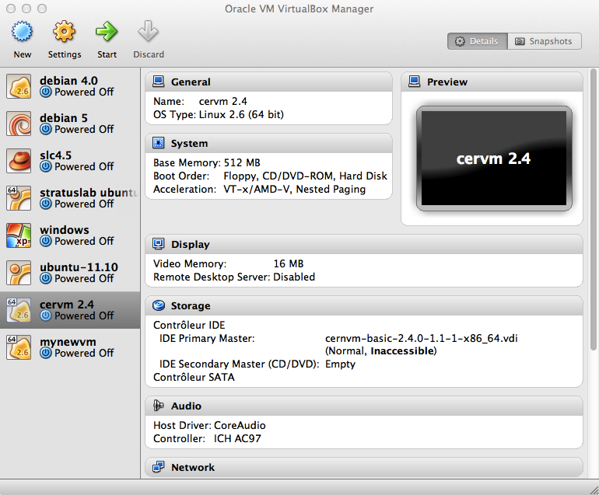Figure 8: the new VM is installed

Running the VM
Depending on what is in the contextualization script, the boot process may be long. This mainly depends on your CPU power.

Running the installedvirtual machine named “mynewvm” looks like:

$> ./xwstartvm.sh –-start --name mynewvm

We can check it in the Virtual-Box main window as shown in figure 9.

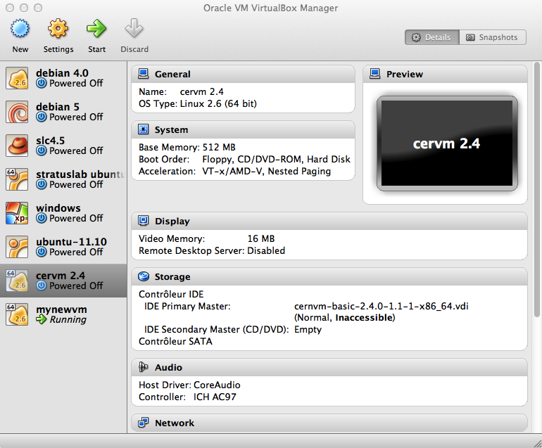Figure 9: the new VM is running

Connecting to the running VM
For security reasons, your are not allowed to connect as “root”. You can only connect as “vmuser”, a non privileged user in the VM.

Linux and Mac OS X
If the used bootable media has ”openssh-server” installed and started, we can connect to our VM since we provided a contextualization that has installed our public key. There may be a warning message complaining about the authenticity of the host as shown below:

$> ssh -p 2022 -i .ssh/id_rsa vmuser@localhost
The authenticity of host '[localhost]:2022 ([127.0.0.1]:2022)' can't be established.
RSA key fingerprint is d0:df:f1:a2:e6:b4:56:99:01:eb:e9:32:81:94:8f:05.
Are you sure you want to continue connecting (yes/no)? yes
Warning: Permanently added '[localhost]:2022' (RSA) to the list of known hosts.
Welcome to SL55 LiveCD
[vmuser@livecd_sl55_v1 ~]# uname -a
Linux livecd_sl55_v1.localdomain 2.6.18-238.12.1.el5 #1 SMP Tue May 31 13:24:21 EDT 2011 i686 i686 i386 GNU/Linux
[vmuser@livecd_sl55_v1 ~]# exit

$>

Stopping the VM
At the end, when you want to stop the VM, hit CTRL+C; the script displays:

^CVen 30 sep 2011 11:43:41 CEST: fatal

- * !!!!!!!!!!!!!!!!!!!!!!!!!!!!!!!!!!!!!!!!!! * -
Error: Ctrl+C
- * !!!!!!!!!!!!!!!!!!!!!!!!!!!!!!!!!!!!!!!!!! * -
Ven 30 sep 2011 11:43:44 CEST: clean
xwvm1317374864: dettach secondary drive /Users/mboleg/VM/contextfat_createlivecd.vdi
/Users/mboleg/VM/contextfat_createlivecd.vdi: delete
0%...10%...20%...30%...40%...50%...60%...70%...80%...90%...100%
xwvm1317374864: dettach secondary drive xwhd1317374864.vdi
xwhd1317374864.vdi: delete
0%...10%...20%...30%...40%...50%...60%...70%...80%...90%...100%
xwvm1317374864: dettach main drive
xwvm1317374864: unregister

You can also invoke the script providing the “--stop” command line parameter:

$> ./xwstartvm.sh –-stop --name mynewvm

Removing the VM
Uninstalling the installed virtual machine named “mynewvm” looks like:

$> ./xwstartvm.sh –-uninstall --name mynewvm

Provisioning virtual machines
The XtremWeb-HEP middleware includes scripts to create new customized LiveCD. This chapter describes this script that creates and allows the usage of Scientific-Linux (SL) 6 LiveCD that could be used over the XtremWeb-HEP desktop grid.
This work is based on the document “Create your own SL4 and SL5 LiveCD” written by Urs Beyerle which describes the method to create a LiveCD. This method uses the “chroot” operation to create the LiveCD, within a standard SL6 installation.

The resulted LiceCD will be configured as follow:
- X-Window system installed, but no daemon started;
- two users: the privileged user “root” and a non privileged user, “sluser”; both configured with random passwords;
- host and domain names set to“xwhepcd_sl55” and ”localdomain” respectively;
- Sun JDK (required by XtremWeb-HEP components, if any);
- a custom login message.

Creating a new customized LiveCD
The middleware proposes a script to create a new LiveCD:
- ${XWHEP_HOME}/bin/sl_createlivecd.sh
In the middleware source package this script is in:
- ${XWHEP_HOME}/src/script/

This script requires the kickstart file:
- ${XWHEP_HOME}/bin/sl_createlivecd.ks
In the middleware source package this script is in:
- ${XWHEP_HOME}/misc/

You can run this script to create a new LiveCD in any Scientific Linux box (virtualized or not). You need administrator rights to launch the script. All steps executed in this script are detailed in chapter 11.2, including customization.

Generating new customized LiveCD
This section describes how to generate a new LiveCD. This may be useful if contextualization does not fit all expected requirements. We will generate our new LiveCD in this VM using the “sl_createlivecd.sh”.

Expected files:
- authorized_keys containing your public address if you want to be able to connect as root.
- iptables_rules.sh containing iptables firewall rules.

The kickstart file list a set of packages to install. One may also provide some private packages by copying rpm, tar.gz, tar.bz2 or zip file to current working directory. The script automatically installs them in the resulting LiveCD.

Start the script as follow:

# sl_createlivecd.sh

Retrieve the customized LiveCD
Since our contextualization launches the script to create a new LiveCD, we can retrieve that new LiveCD in /mnt/xwscratch/livecd/tmp/:

[vmuser@livecd_sl55_v1 ~]# ls -lh /mnt/xwscratch/livecd/tmp/livecd.iso
-rw-r--r-- 1 root root 304M Sep 30 14:37 /mnt/xwscratch/livecd/tmp/livecd.iso

You should save the new created livecd.iso to a safe place of yours before stopping the VM.
Example:

$> scp -P 2022 -i ~/.ssh/id_rsa vmuser@localhost:/mnt/xwscratch/livecd/tmp/livecd.iso .

Stopping our VM
Stopping the VM unregisters and deletes all objects: VM and its associated disks. The boot media, the contextualization disk are deleted.

At the end, when you want to stop the VM, hit CTRL+C.

Creating a new customized LiveCD step by step
To follow this chapter, Virtual-Box must be installed in you machine.

If you do not have any virtual machine, you must create one as described in chapter 13.

This chapter details all steps of the script introduced in chapter11. The resulted LiveCD will be the one of chapter 11.

In this chapter, we try to be as pedagogical as possible by detailing all steps. Each step is provided with the necessary shell command so that the reader can easily copy/paste commands in a shell terminal. Each command appear in grey boxes.
This chapter concludes with an “optional informations” chapter detailing some advanced technics such as creating ans using incremental archive to ease backward step.

Create directory structure, mount virtual filesystems, configure yum
#
# prepare directory structure
#
LIVE=/scratch/livecd
mkdir -p $LIVE
cd $LIVE
mkdir dev proc sys etc tmp
touch etc/fstab etc/mtab
# mount virtual file system
mount --bind /dev dev
mount null -t proc proc
mount null -t sysfs sys
# prepare yum configuration
cp -a /etc/yum.conf $LIVE/etc
cp -a /etc/yum.repos.d $LIVE/etc/
mkdir -p $LIVE/var/lock/rpm

Install yum (please note the back slash at the end of lines)

#
# install yum
#
yum -y -c $LIVE/etc/yum.conf --installroot=$LIVE install yum rootfiles shadow-utils \
bind-utils gnupg vim-enhanced vixie-cron crontabs passwd which kudzu dhclient \
pciutils eject alsa-utils mkisofs wget kernel grub

Enable shadow passwords

#
# enable shadow passwords
#
cd $LIVE
sed -i "s|\*|x|" etc/passwd
sed -i "s|^root::|root:x:|" etc/passwd
cat etc/passwd | cut -d":" -f 1 | while read u; do echo "$u:*:12345:0:99999:1:::"; done >> etc/shadow
chmod 600 etc/shadow
cp -a etc/group etc/gshadow
sed -i "s|:x:|::|" etc/gshadow
sed -i "s|:[0-9]\+:|::|" etc/gshadow
chmod 600 etc/gshadow

Use yum to install some packages
We use yum to install some packages: keyboard layouts, basic graphical environment (without gdm), openssh client, filesystems, Sun JDK, zip, rdate:

#
# install some packages
#
yum -y -c $LIVE/etc/yum.conf --installroot=$LIVE install kbd system-config-keyboard system-config-display xterm icewm openssh-clients squashfs-tools aufs jdk-1.6.0_24-fcs.i586 zip unzip rdate.i386

You can edit the packages list to fit your requirements.

The following error may occur:
filelists.sqlite.bz2: [Errno -1] Metadata file does not match checksum
Is so, edit $LIVECD/etc/yum.conf and add the following line at the end of the file
http_caching=packages
Then execute "yum -c $LIVE/etc/yum.conf clean metadata".
And retry with the next two steps:

yum -c $LIVE/etc/yum.conf --installroot=$LIVE install kbd system-config-keyboard
80M
yum -c $LIVE/etc/yum.conf --installroot=$LIVE install system-config-display xterm icewm openssh-clients squashfs-tools aufs jdk-1.6.0_24-fcs.i586 zip unzip rdate.i386
70M

Install system configuration files
#
# install system configuration files
#
cp /etc/resolv.conf $LIVE/etc
cp /etc/sysconfig/network $LIVE/etc/sysconfig/
cp /etc/sysconfig/i18n $LIVE/etc/sysconfig/
cp /etc/sysconfig/authconfig $LIVE/etc/sysconfig/
cp /etc/sysconfig/kernel $LIVE/etc/sysconfig/
cp /etc/sysconfig/clock $LIVE/etc/sysconfig/

Enter chroot
#
# enter chroot
#
/usr/sbin/chroot $LIVE
PATH=${PATH}:/sbin

Install the build script
#
# install the build script
#
mkdir /build
cd /build
wget http://www.livecd.ethz.ch/download/build/livecd-3.1.0.tar.gz
tar zxf livecd-3.1.0.tar.gz

Customize the build process
#
# customize the build process
#
kernel=`ls /lib/modules`;sed -i "s/^KERNEL.*/KERNEL=$kernel/g" /build/livecd-3.1.0/livecd.conf
sed -i 's/RUNLEVEL=5/RUNLEVEL=3/g' /build/livecd-3.1.0/livecd.conf
sed -i 's/EXTRA_BOOT_OPTIONS=""/EXTRA_BOOT_OPTIONS="nopasswd kb=us changes=xwlivecd750changes"/g' /build/livecd-3.1.0/livecd.conf

Those commands: replace KERNEL version by the one in /lib/modules (the build script needs to know the correct kernel version which is the name of the directory /lib/modules),
set the following parameters RUNLEVEL=3 (doesn’t start X), EXTRA_BOOT_OPTIONS="nopasswd kb=us changes=xwlivecd750changes” (us keyboard, define changes directory to make changes persistent between reboot thanks to aufs).

Customize some more files
#
# customize continued
#
sed -i 's/SCREEN_DEFAULT="1400x1050"/SCREEN_DEFAULT="800x600"/g' livecd-3.1.0/customize/runlast
for linen in 577 578 579 580 581 582 583 584 585 586 587 588 589 590 591 592 593 596 597 598; do sed -i "$linen s/^/#/" livecd-3.1.0/customize/runlast; done
sed -i '599 s/^/HOSTNAME="mylivecd_sl55_v1.localdomain"/' livecd-3.1.0/customize/runlast
sed -i 's/localhost.localdomain localhost/mylivecd_sl55_v1.localdomain mylivecd_sl55_v1/g' livecd-3.1.0/customize/hosts
echo "mkdir /context
mount /dev/hdb1 /context
if [ -f /context/context.sh ]; then
/context/context.sh
fi

dd if=/dev/urandom count=50|md5sum|passwd --stdin sluser
dd if=/dev/urandom count=50|md5sum|passwd --stdin root

" >> livecd-3.1.0/customize/runlast

Those commands:
- change the default screen size (SCREEN_DEFAULT="800x600");
- set up xwhepcd_sl55_v1.localdomain as hostname and domainname (by commenting the lines where the script tries to detect the hostname and domainname itself, line 577(after ### try to get hostname …) to 593 and 596 to 598(fi of ### define default hostname);
- add our desired hostname and domainname (HOSTNAME="mylivecd_sl55_v1.localdomain"), and change file customize/hosts (127.0.0.1 mylivecd_sl55_v1.localdomain mylivecd_sl55_v1));
- try to mount /dev/hdb1 and run the contextualization script;
- define a random password for root and sluser.

Define a “Message of the day”
#
# message of the day
#
sed -i 's/Welcome to $LIVECD_OS ${LiveCD}/Welcome to $LIVECD_OS ${LiveCD}, launched by XtremWeb-HEP/g' livecd-3.1.0/customize-livecd.sh

Build the new LiveCD
#
# build new LiveCD
#
cd /build/livecd-3.1.0
./build-livecd.sh
exit

If the build script completes successfully it should display: “See /tmp for the ISO image”. Then we exit the chroot.

Optional informations
This chapter details some more informations and tips that may be useful for those whishing to go further.

- Leave chroot:
exit
umount proc
umount dev sys

We do not know why, but the first time one unmount “proc” it uses to display this error: “umount: proc: device is busy”, rebooting the system is the only way we found to resolve this problem.
We needed to unmount proc in order to backup the chroot.
- Enter chroot:

LIVE=/scratch/livecd
cd $LIVE
mount --bind /dev dev
mount null -t proc proc
mount null -t sysfs sys
/usr/sbin/chroot $LIVE
PATH=${PATH}:/sbin

- Backup and restore chroot using incremental tar:
Backup a first step:
To do this, you must not be in the chroot, and the chroot proc must be unmounted.

cd /
tar --create --file=mylivecd.1.tar --listed-incremental=/mylivecd.1.snar /scratch

It should display this:
tar: Removing leading `/' from member names
tar: Removing leading `/' from hard link targets

Backup a second step:
cd /
cp mylivecd.1.snar mylivecd.2.snar
tar --create --file=mylivecd.2.tar --listed-incremental=/mylivecd.2.snar /scratch

It should display this:
tar: Removing leading `/' from member names

Restore the incremental tar:
rm -rf /scratch/
tar --extract --listed-incremental=/dev/null --file mylivecd.1.tar
tar --extract --listed-incremental=/dev/null --file mylivecd.2.tar

- (in chroot) Ajust date and time at boot:
in /etc/rc.local add: /usr/bin/rdate -s ntp.unice.fr and set Paris time zone:
echo "/usr/bin/rdate -s ntp.unice.fr" >> /etc/rc.local
ln -sf /usr/share/zoneinfo/Europe/Paris /etc/localtime

- (in chroot) Prevent SL55 to load for useless features:
chmod -x /etc/cron.daily/rpm
chmod -x /etc/cron.daily/yum-cron
chmod -x /etc/cron.weekly/yum-cron
chkconfig ip6tables off
chkconfig mcstrans off
chkconfig restorecond off

- Shrink the Virtual-Box image:
(This needs to be verified.)
If you do many tests or create many LiveCD, the size of the Virtual-box image will expand rapidly, and won't shrink if you delete the /scratch directory. If it happens, here is a solution to shrink it.
This solution is based on the following document:
http://maketecheasier.com/shrink-your-virtualbox-vm/2009/04/06

Install the “zerofree” program in the VM you want to shrink:
yum install
http://scientificlinux.physik.uni-muenchen.de/mirror/epel/5/i386/zerofree-1.0.1-5.el5.i386.rpm

Change runlevel in /etc/inittab to 1: single user mode
Reboot and umount /
Run zerofree: zerofree /dev/mapper/VolGroup00-Logvol00
Turn off the VM.
VBoxManage clonehd /YourPath/YourVM.vdi /YourPath/YourVM2.vdi
VBoxManage internalcommands sethduuid /YourPath/YourVM2.vdi
Turn On VM2.
Change runlevel in /etc/inittab to 5: X11
VM2 is now shrinked, if it reboots and runs well, then you can delete the former VM.

- (in chroot) Start Icewm after boot:
(This needs to be verified.)
echo "### variable LOCALUSER should be known by runlast,
### default is sluser
STARTSESSION="icewm-session"
LOCALUSER_HOME=$(grep "^${LOCALUSER}:" /etc/passwd | cut -d":" -f6)
### create .xinitrc for LOCALUSER
XINITRC=$LOCALUSER_HOME/.xinitrc
echo "[ -x ~/autostart ] && ~/autostart" > $XINITRC
echo "exec $STARTSESSION" >> $XINITRC
chmod 755 $XINITRC
### link .xsession to .xinitrc
ln -sf .xinitrc $LOCALUSER_HOME/.xsession
" >> livecd-3.1.0/customize/runlast

- (in chroot) Install XtremWeb-HEP worker:
(This needs to be verified.)
yum install xwhep-worker-package

We should desactivate "monitor":
because it use cpu too much and prevents Linux to shut down properly.
/etc/init.d/xtremweb.monitor stop
chkconfig --del xtremweb.monitor
chmod -x /opt/xwhep-worker-x.x/bin/xtremweb.monitor (/etc/rc.d/init.d/xtremweb.monitor is a link to it)

worker configuration:
In /opt/xwhep-worker-x.x/conf/xtremweb.worker.conf:
uncomment activator.class=xtremweb.worker.AlwaysActive
comment activator.class=xtremweb.worker.DateActivator
comment activator.date=* 20-7
verify project is empty otherwise it won’t take public jobs

Create xwhep home directory:

echo "mkdir /home/xwhep
chown -R xwhep.xwhep /home/xwhep
" >> livecd-3.1.0/customize/runlast

Managing containers using the XtremWeb-HEP scripts
This chapter describes the XtremWeb-HEP middleware scripts to create, start, stop and destroy Docker container on demand.
These scripts have been designed to be automatically run on worker side, but can also be run by hand. Running these scripts by hand may be helpful to understand how to deploy and use container over an XtremWeb-HEP deployment.
The middleware proposes two versions of the script that creates, launches and destroys containers; one for Linux and Mac OS X, and one for Windows:
- ${XWHEP_HOME}/bin/xwstartdocker.sh
- ${XWHEP_HOME}/bin/xwstartdocker.bat

The middleware also contains scripts to stop a container:
- ${XWHEP_HOME}/bin/xwstopdocker.sh
- ${XWHEP_HOME}/bin/xwstopdocker.bat

In the middleware source package these scripts are in:
- ${XWHEP_HOME}/src/script/

Creating and running new containers
The xwstartdocker.sh script creates a new Docker container, creating the Docker image on the fly, if necessary. The script requires some parameters and may display error messages on erroneous usage, like:

./xwstartdocker.sh: start
./xwstartdocker.sh FATAL: repository not found

The script accepts some optional command line parameters. The three first detailed here are those that may be used to manage virtual machines over desktop grid, as well as on local host:
- -v. Verbose mode
- -i <Docker image name>. Image name to pull from Docker hub.

Finally, the script has an inline help:

$> ./bin/xwstartvdocker.sh --help

Usage : ./bin/xwstartdocker.sh
...

Installing a new container
Installing a new container named “mynewcontainer” looks like:

$> ./xwstartdocker.sh --name mynewcontainer

The script creates a new container which name is “mynewcontainer” followed the creation date in seconds.

Annexe 1: Virtual-Box usage
In this chapter we introduce the usage of Virtual-Box.

Creating a new VM with Scientific-Linux 5.5
To follow this chapter, Virtual-Box (VB) must be installed in you machine. The reader must also download the first DVD of SL 5.5: SL.55.051810.DVD.i386.disc1.iso.

This chapter details how to create a new virtual machines (VM) inside VB, if needed.
You do not need to read this chapter if you use the scripts proposed by the XtremWeb-HEP middleware as described in chapter Erreur : source de la référence non trouvée.

Create a new virtual machine
Please start VB; the main window is show in figure 10. The left part is a list of existing VM; this list may be empty if you have never created any VM so far. The right part details the selected VM.
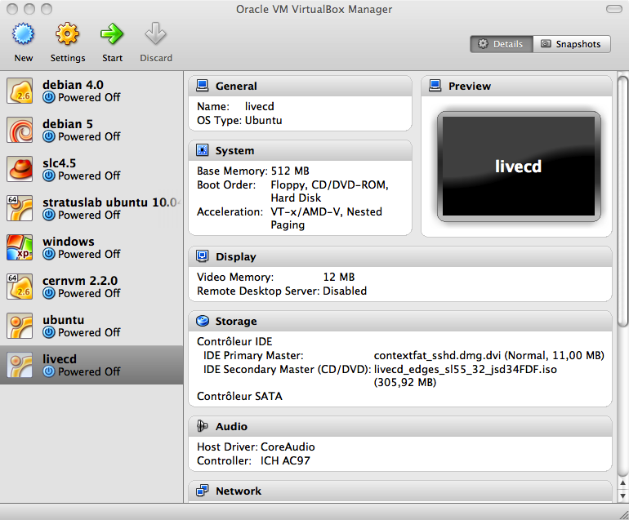Figure 10: Virtual Box main window

Please click on the “New” button in the upper left corner. This opens the first window of the VM wizard as shown in figure 11.
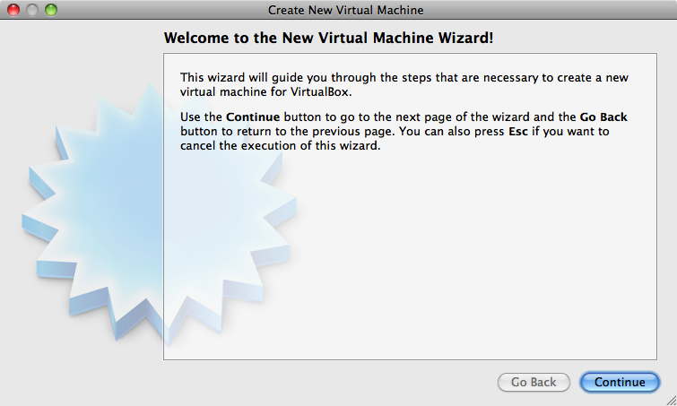Figure 11: Create a new Virtual Machine Wizard

Click “Continue”.

Virtual machine name and OS
In the second wizard window, you must give a new to your new VM and provide the OS type. Let give “SLC55” as name and choose Linux RedHat as shown in figure 12.
The reader should give a name that is not already used by any potentially installed VM.

Figure 12: Create a new VM; give name and OS type
Click “Continue”.

Setting the memory size
In the next wizard window, we give 726Mb of memory as shown in figure 13.
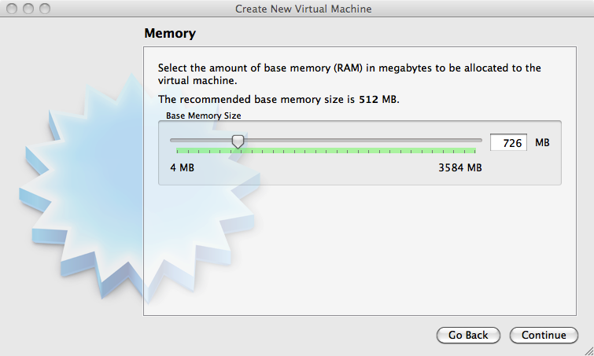Figure 13: Create a new VM; memory size

Click “Continue”.

Setting up the virtual disk
In the next wizard window, we deselect the “Boot Hard Disk” button, as shown in figure 14, so that our VM has no disc for the moment.
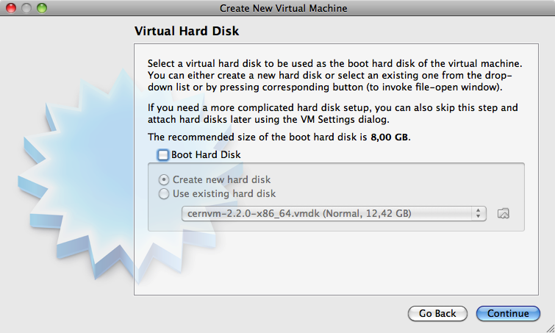Figure 14: Create a new VM; virtual disc

Click “Continue”.

A warning window message then pops up as shown in figure 15. Click “Continue”.

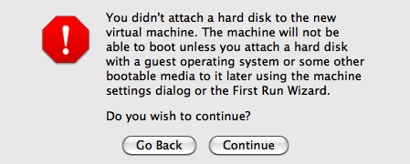Figure 15: Create a new VM; virtual disc warning

Summary
The summary wizard window is finally displayed as shown in figure 16.
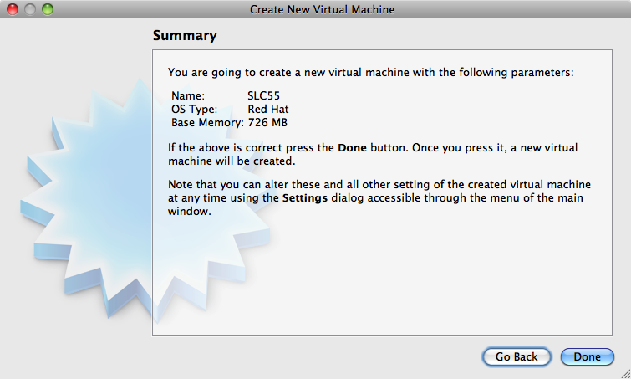Figure 16: Create a new VM; summary
Click “Done.

Your new VM must then be listed in the VB main window.

Prepare media for the new virtual machine
Until now, our new VM has no disc. In this section we attach the downloaded Scientific Linux DVD as main drive and attach a virtual disk (VDI) as secondary drive.

Attach the DVD
In the VB main window, click on the icon of our SLC55 VM; its details must now appear in the right part of the VB main window.
Click on “Storage” to open the “Storage” window.
In the “Storage” window, select the empty DVD drive and select “IDE Primary master” in the drop down list, as shown in figure 17.

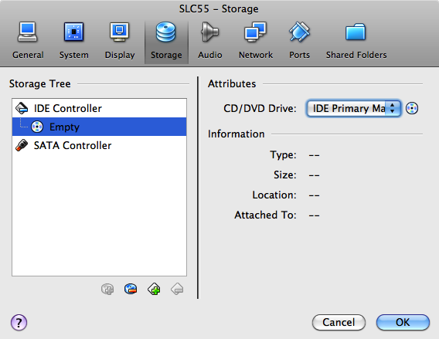Figure 17: Virtual disc main window

To insert a virtual DVD into the virtual drive, we must select the Scientific Linux 5.5 downloaded DVD. Click on the icon as shown in figure 18.
Figure 18: Virtual disc : choose a DVD

This pops up a sub menu as show in figure 19. Please select the “Choose a virtual CD/DVD disk file...” menu item.

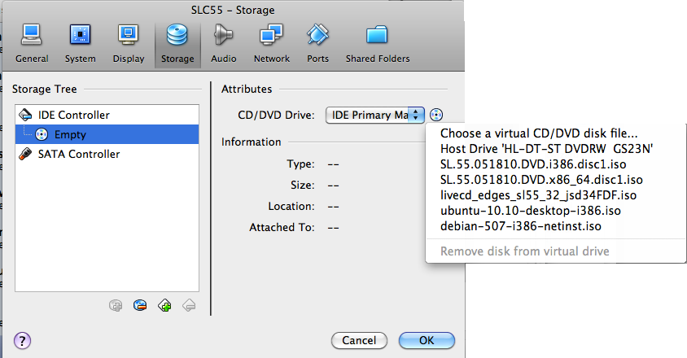Figure 19: Virtual disc: choose a DVD menu

This opens a file selection window; please select the downloaded Scientific Linux DVD as shown in figure 20.

Figure 20: Virtual disc: choose a DVD

Click “Open”. Do not close the “Storage” window.

Create a new hard drive.
If the “Storage” window is not open, open it as describe in chapter 13.2.1.
In the “Storage” window, select “IDE controller” and click on the “+” icon as shown in figure 21.

Figure 21: Virtual disc : create a new virtual disc

This pops up a message window; click on “Create a new disk” as shown in figure 22.

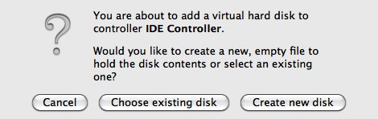Figure 22: Virtual disc: create a new virtual disc

This start a disk wizard, follow the steps and set the new disk size to 40Gb.
Finally, the “Storage” window must look like figure 23.
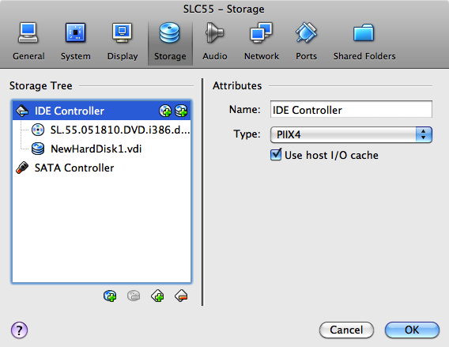Figure 23: Virtual disc : summary

Click “Ok” to close the “Storage” window..

Install Scientific Linux 5.5
Our new VM is ready to install Scientific Linux.

In the VB main window, select our new VM and click “Start”.
This opens a new window; you may have a pop up window as shown in figure 24. Click “Ok”.
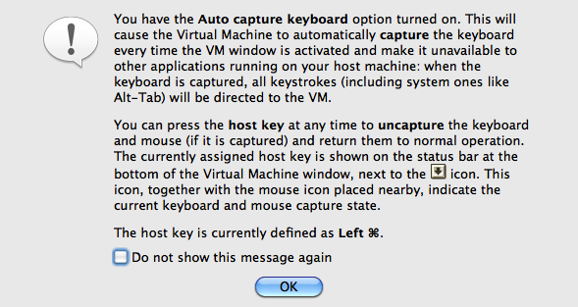Figure 24: Start VM

At boot time, hit the enter key to boot in graphic mode.

Scientific Linux may ask to test the CD media. Use the arrow key to select “Skip”.
Then follow the next steps:
- Click “Next” in the first Scientific Linux window;
- In the language, choose “English”;
- in the keyboard, choose “US internaional”.

The a warning message informs you that the hard drive is to be initialized and that all data will be lost.
Click “yes”.

A partitioning window proposes a list; select “Remove linux partitions on selected drives and create default layout”.
Click “next”.

A warning message asks “You have chosen to remove all Linux partitions...”.
Click “Yes”

A Network Devices window proposes some options; do not change anything.
Click “Next”.

Then select your region in the Region window.
Click “Next”.

A root account window asks you to give a password of your choice.
Enter your password.
Click “Next”.

The next window is dedicated to software installation.
In the proposed list
- keep “GNOME Desktop”;
- deselect “Office and Productivity”.

Click “Next”.

The installation may take a while.

Finally, click “Reboot”, stop the VM and return to VB main page.
Select our VM and click on “Storage”. Select our virtual DVD,click on the icon as shown in figure 18 and select “Remove disk from virtual drive”.
Click “Ok” to close the “Storage” window.

In the VB main window, select our VM and click “Start” to start our VM again. Open a session as “root” and provide your password.
There some steps left to finish the SLC55 installation:
- on the Welcome window, click “Forward”;
- on the Firewall window, select “Disabled” in the list and click “Forward”;
- a warning windows appears, click “Yes”;
- on the SELinux window, select “Disabled” in the list and click “Forward”;
- a warning windows appears, click “Yes”;
- on the date and time, click”forward”;
- on the create user window, create a “testuser”, give and confirm a password;
- click “forward”;
- click “finish” and the “ok”
- the VM reboots again.

Here Scientific Linux is completely installed.

Converting disk image
This chapter introduces some Virtual-Box tips to ease virtual disk image usage. This software comes with the VboxManage (VBM) tool that aims to manage virtual machines and virtual disks.
All tips given in this chapter can be found in the official VB documentation. This chapter assumes that your ${PATH} environment variable is set to use the VBoxManage tool.

Converting to VDI
The VBM tool permits to convert image disk format to VDI. This is useful to use a non VDI disk image into a virtual machine (e.g. to create a contextualization disk).

$> VboxManage convertfromraw <filename> <outputfile>
[--format VDI|VMDK|VHD]
[--variant Standard,Fixed,Split2G,Stream,ESX]

For example, to convert an Apple DMG virtual disk to a VDI one:

$> VboxManage convertfromraw context.dmg context.vdi --format VDI

Converting from VDI
The VBM tool permits to convert image disk format from VDI. This is useful to data from computation inside a virtual machine (e.g. retrieving restults)

$> VBoxManage clonehd <uuid>|<filename> <uuid>|<outputfile>
[--format VDI|VMDK|VHD|RAW|<other>]
[--variant Standard,Fixed,Split2G,Stream,ESX]
[--existing]

For example, to convert a VDI to Apple DMG:

$> VboxManage clonehd context.vdi context.dmg --format RAW

Annexe 2: virtual disk management
This chapter introduces the generation of new virtual disk. This is useful to create contextualization or scratch disks.
The middleware proposes a script that creates a new virtual disk, providing a file or a set of files:
- ${XWHEP_HOME}/bin/xwcontext

In the middleware source package this script is in:
- ${XWHEP_HOME}/src/script/xwcontext

- The middleware does not provide such a script for Windows platform.
- You may need privileged rights to run the script under Linux.

The script requires some parameters and may display error messages on erroneous usage, like:

$> ./xwcontext
[Mar 31 jan 2012 15:01:28 CET] (./xwcontext): start
[Mar 31 jan 2012 15:01:28 CET] (./xwcontext) FATAL: Syntax error (try --help)

The script accepts some optional command line parameter:
- --help: this displays the inline help;
- --source <aFile | aDir>: this is file or the directory to be copied to the virtual disk.
If you provide a single file, it is copied in the new virtual disk; if you provide a directory, the content of the directory is copied, but not the directory itself. More precisely, the content of the directory is copied in the root of the virtual disk.

Finally, the script has an inline help:

$> ./xwcontext --help
Usage: ./xwcontext [--help] --source aFile | aDir
--help: this help
--source aFile or aDir are copied to the virtual disk (VD)
Note that the context of aDir is copied so that if you
call “$> xwcontext myDir”
the resulted VD will not contain a directory named "myDir",
but the content of "myDir"
(this script do cp -R myDir/* CVD)

The rest of the chapter details how to manually create virtual disks.

Mac OS X
The disk utility provided in the /Applications/Utilities directory may be used to create new disk image (.DMG files)
In the GUI, click in the “new image” icon as shown in figure 25. Then follow the instructions.

Figure 25: Create a new image disk

Note that .DMG disk image can not be used “as is” by Virtual-Box. You must convert them to VDI in chapter 13.3.

Windows 7
In the version 7 of the Windows operating system has tools to create and manage virtual hard drive (.VHD file). There are accesses through graphical user interface and command line.

Graphical User Interface
The GUI is embedded in the computer management tool. Open the computer management tool by a right click on your computer icon and select “manage” as shown in figure 26.

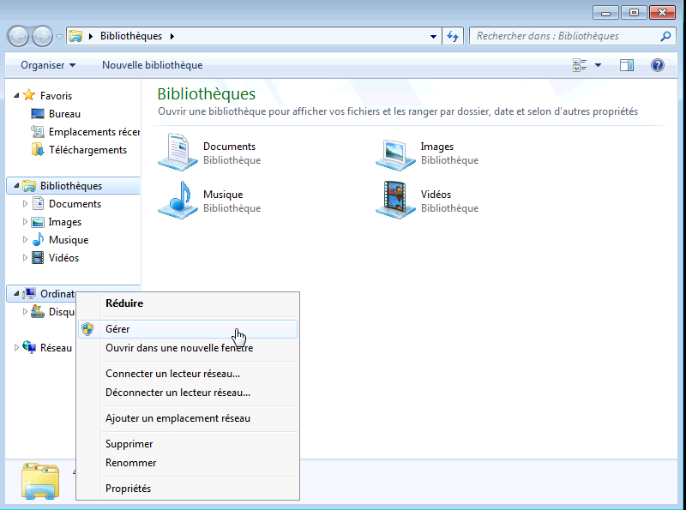Figure 26: Open computer management tool
Open “storage” and click on “disk management”. Then open the “Action” menu and select “Create VHD” item as shown in figure 27, and follow the instructions.

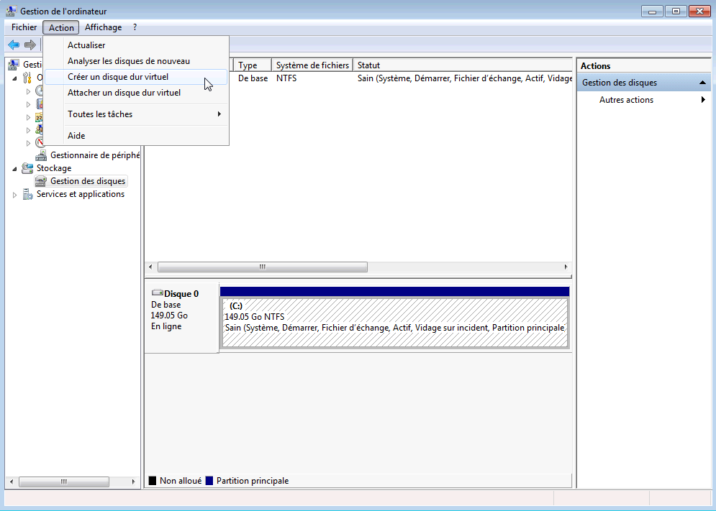Figure 27: Create new virtual disk
Finally your new disk should be listed as shown in figure 28.

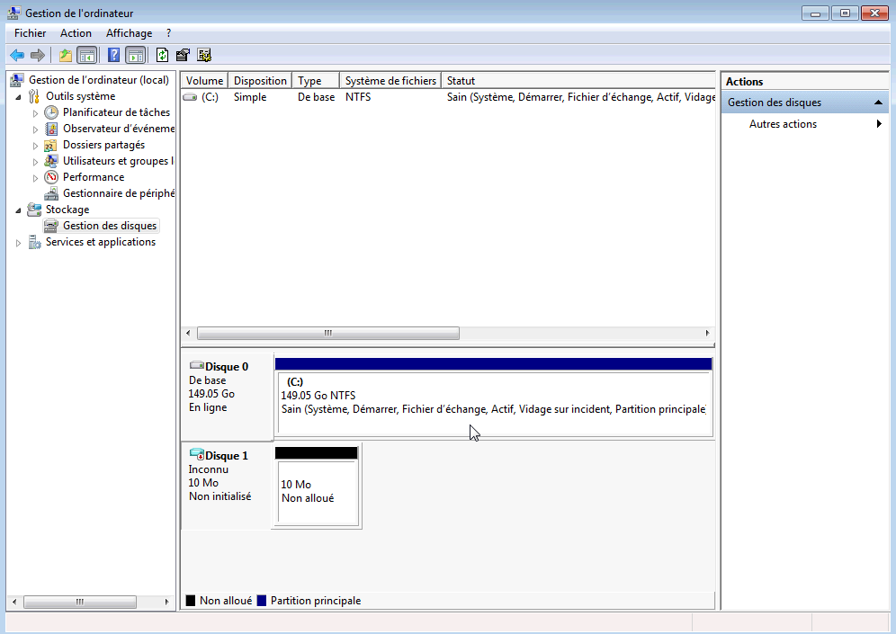Figure 28: The new VHD is created
This disk is still not partitioned; right click on the icon and select “Format Disk” as shown in figure 29 and follow the instructions.

Do not use GTP (GUID Partition Table) partition.
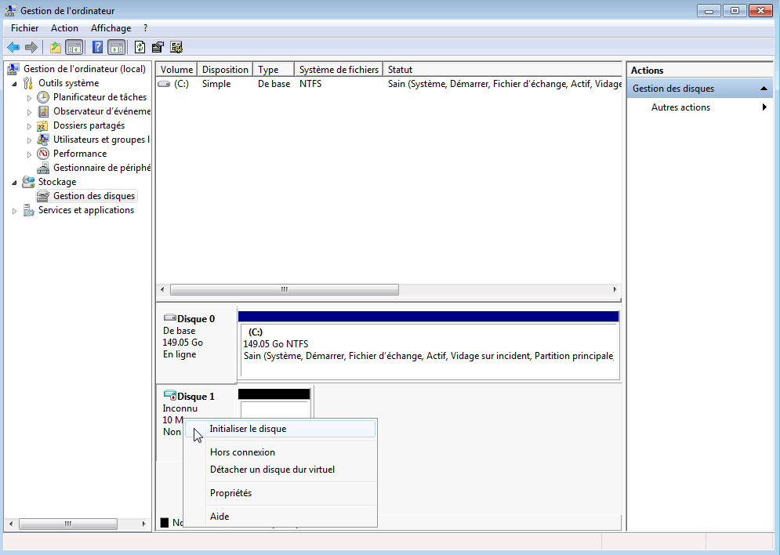Figure 29: Format the new VHD

This disk is still not formatted; right click on the partition and select “New simple volume” as shown in figure 30 and follow the instructions.
You must use FAT32 format.

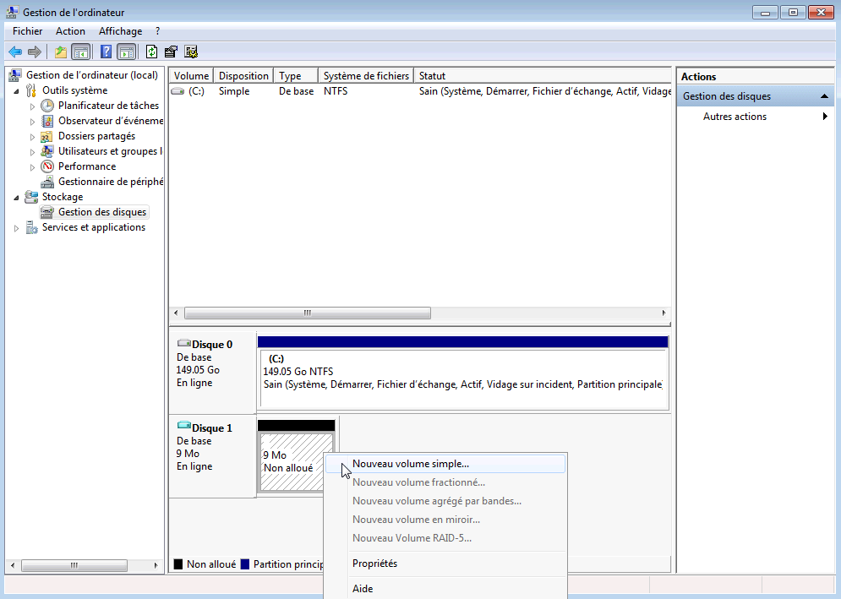Figure 30: New simple volume

Finally, your disk should appear in your file browser as shown in figure 31. In this example we have labeled it “xwcontext”.

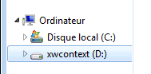Figure 31: VHD shown in file browser

Command line tools
The Windows 7 operating system also proposes command line tool to create and manage Virtual Hard Drive:
- “diskpart”.

The XWHEP middleware proposes a file containing diskpart commands to create a new VHD:
- ${XWHEP_HOME}/bin/diskpart_createvhd.txt

In the middleware source package this script is in:
- ${XWHEP_HOME}/src/script/

The included commands are detailed as follow:
1.a - Create a new 40Mb VHD file in %TMP%\mydisk.vhd; this commands fails if file already exists.

CREATE VDISK FILE="%TMP%\mydisk.vhd" MAXIMUM="40" TYPE="EXPANDABLE"

1.b – Alternatively, you can choose a existing file.

SELECT VDISK FILE="%TMP%\mydisk.vhd"

2. - Attach your VHD

ATTACH VDISK

3. Create partition table

CREATE PARTITION PRIMARY

4. Assign a drive letter; you must choose a free one.

ASSIGN LETTER=X

5. Format the virtual drive.

FORMAT QUICK FS="FAT32" LABEL="XWCONTEXT"

Your disk should appear in your file browser as shown in figure 32.

Figure 32: VHD shown in file browser

6. Copy you files in your VHD.
7. Finally, detach the virtual drive

DETACH VDISK

Note that .VHD disk image can not be used “as is” by Virtual-Box. You must convert them to VDI in chapter 13.3.

Linux
Depending on the Linux flavour and installed tools there are several ways to create virtual disks.

The tools used in this method may necessitate privileged rights.

- First, create a 10Mb zero-filled file called "myvhd.img".
$> dd if=/dev/zero of=myvhd.img bs=1024 count=100000

Another faster way to create a 10Mb zero-filled file called "myvhd.img".
$> fallocate -l 10485760 myvhd.img

- Attach a loopback device to the file.
$> losetup /dev/loop0 myvhd.img

There are up to 8 loopback devices. Use whichever is available. From this point we consider loop0. Please replace if applicable.
- Create a filesystem on it.
$> mkfs -t ext3 -v /dev/loop0

- Mount it somewhere.
$> mkdir /mnt/myvhd
$> mount -t auto /dev/loop0 /mnt/myvhd

- Copy your files in there. For example.
$> cp ~/.ssh/id_rsa.pub /mnt/myvhd/
$> cp $XWHEP_ROOT/bin/context.sh /mnt/myvhd/

- Unmount it.
$> umount /mnt/myvhd
$> losetup -d /dev/loop0

Note that disk images can not be used “as is” by Virtual-Box. You must convert them to VDI in chapter 13.3.

Annexe 3: provisioning electronic keys
This chapter details electronic key management.

Linux and Mac OS X
These OSes are provided with the “ssh-keygen” tool.
You should easily find informations on the web. Here are two examples:

http://wiki.mcs.anl.gov/IT/index.php/SSH_keys:Linux,_MacOS_X,_Cygwin,_and_other_UNIX_variants

http://drupal.org/node/1070130

Windows
This section details the Putty usage. You must install the Putty software to follow this section. It is available at http://www.putty.org.

Import an electronic key pair
This section assumes you already have your key pair.
If you don't, please go to section 15.2.2.
First, open the Putty Key Generator tool. Figure 33 shows this tool icon.

Figure 33: Putty Key Generator icon

Click on “import key” as shown in figure 34.

Figure 34: Putty: import key

You should save you private key as shown in figure 37.
That is all.

Generate a new electronic key pair
If you already have your key pair, you should go to section 15.2.1.
First, open the Putty Key Generator tool. Figure 33 shows this tool icon.
Click on the “generate” button as shown in figure 35 and move you mouse to generate some randomness.

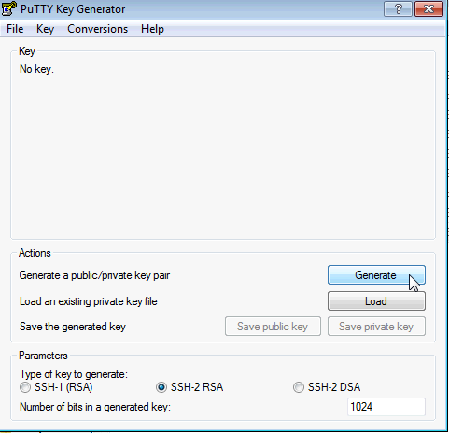Figure 35: Putty: generate a new key

Save you key pair
Export your private key as shown in figure 36.
Let assume you saved it to a file named “privkey”.

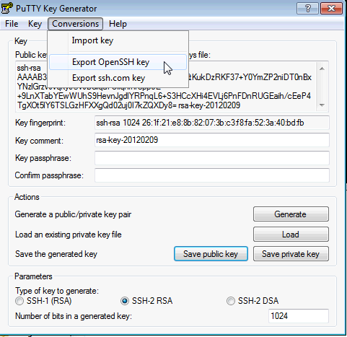Figure 36: Putty: export private key

This may seem redundant, but you should also save your private key in Putty format as shown in figure 37.
Let assume you saved it to a file named “privkey.ppk”.

Figure 37: Putty: save private key

Finally, you must save you public key. To do so copy the public key text as shown in figure 38 to a text file (using “notepad”, for example).
Let assume you saved it to a file named “pubkey”.

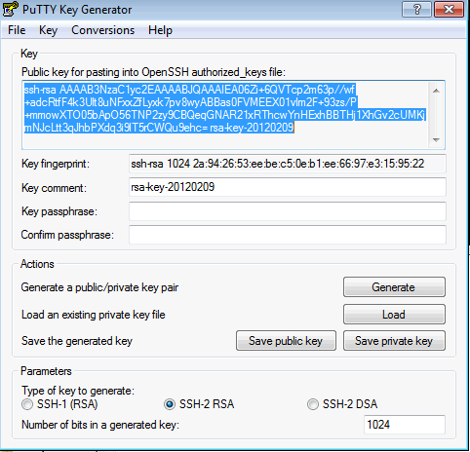Figure 38: Putty: copy public key

List of constants
Please refer to the “XtremWeb-HEP Programmer's Guide”.

XML representations
Please refer to the “XtremWeb-HEP Programmer Guide”.

Job state graph
Please refer to the “XtremWeb-HEP Programmer Guide”.

Client attributes
The client is configurable. It reads its configuration from a text file as explained in chapter 5.3. You should not need to edit or modify your client configuration.
The attributes found in the configuration file can easily be overridden by setting environment variables before using the client.

Introduction
This chapter lists all client attributes. You may modify them in the configuration file or more preferably set environment variables.
One may note that a configuration file may contain some more attributes that are not listed below. This is due to the fact that the middleware stores all attributes value in the config file, even those that are not suitable to a specific part (with empty or default values). The attributes not listed below are not used by the client part of the middleware.

The list is formatted as follow:

property name
Type : property type (e.g. String)
Access : public | auto | restricted | private
public: may be edited
auto: is automatically overridden by the middleware
restricted: should not be edited by the user
private: must not be edited by the user
Default : default value (e.g. null)
Purpose : explanation

Properties list
xtremweb.role
Type : string
Access : private
Default : client
Purpose : this defines the role of an xwhep part

launcher.url
Type : string
Access : private
Purpose : this is url where the worker can find new version of the middleware

dispatcher.servers
Type : String
Access : public
Default : comma separated list of known servers
Purpose : this is a list of xtremweb-hep servers to connect to

data.servers
Type : String
Access : public
Default : dispatcher.servers
Purpose : this is a list of xtremweb-hep data servers to connect to

java.nio
Type : boolean
Access : restricted
Default : true
Purpose : if true, use java new i/o

port.tcp
Type : integer
Access : public
Default : 4321
Purpose : this is the tcp port distributed parts must connect to

port.ssl.tcp
Type : integer
Access : public
Default : 4322
Purpose : this is the secured tcp port distributed parts must connect to

port.udp
Type : integer
Access : public
Default : 4323
Purpose : this is the udp port distributed parts must connect to

port.worker.http
Type : integer
Access : public
Default : 4324
Purpose : this is the port worker are listening for administrative procedures

port.http
Type : integer
Access : public
Default : 80
Purpose : this is the http port distributed parts must connect to

port.https
Type : integer
Access : public
Default : 443
Purpose : this is the secured http port distributed parts must connect to

port.xmlrpc
Type : integer
Access : public
Default : 4327
Purpose : this is the xmrlrpc port distributed parts must connect to

port.sunrpc
Type : integer
Access : public
Default : 4328
Purpose : this is the sun rpc proxy port

port.proxy
Type : integer
Access : public
Default : -1
Purpose : this is the proxy port

proxyname
Type : integer
Access : public
Default : null
Purpose : this is the proxy address

smartsocketshubaddr
Type : string
Access : public
Default : null
Purpose : this is the smartsockets hub virtual address

server.http
Type : boolean
Access : public
Default : false
Purpose : if true, the embedded http server is started

homedir
Type : string
Access : public
Purpose : this is the directory where xwhep part may store objects

path.tmpdir
Type : string
Access : public
Default : system.getproperty(“java.io.tmp”)
Purpose : this is the temporary directory

cachesize
Type : integer
Access : public
Default : 1000
Purpose : this is maximum entry amount the cache may store

sslkeystore
Type : string
Access : public
Purpose : this is the keystore file path

sslkeypassphrase
Type : string
Access : public
Purpose : this is the keystore passphrase

sslkeypassword
Type : string
Access : public
Purpose : this is the keystore password

alive.period
Type : integer
Access : public
Default : 300
Purpose : this is the alive period in second

optimizedisk
Type : boolean
Access : private
Default : true
Purpose : this tells if the middleware should try to optimize disk usage

optimizenetwork
Type : boolean
Access : private
Default : true
Purpose : this tells if the middleware should try to optimize network usage

milstones
Type : string
Access : public
Default : null
Purpose : this is the name of the package to milestone in order to check software efficiency

xtremweb.config
Type : String
Access : restricted
Purpose : this is the path of the configuration file

logger.level
Type : String
Access : public
Default : warn
Purpose : this defines the level of verbosity in the log files, the possible values by ascending order are: error, warn, info, config, debug, finest

sotimeout
Type : long integer
Access : public
Default : 60000
Purpose : this is the socket timeout in milliseconds. Modifying this may lead to connection errors

timeout
Type : integer
Access : public
Default : 15000
Purpose : this defines the delay in milliseconds between two job result requests

mileStones
Type : String
Access : public
Default : null
Purpose : this defines comma separated list of classes to benchmark

xtremweb.cache
Type : string
Access : restricted
Default : temporary directory
Purpose : this defines the directory where the middleware stores local files

commlayer
Type : string
Access : restricted
Purpose : this denifes communication layers

commHhandlers
Type : string
Access : restricted
purpose : comma separated list of colon separated tuples of scheme/handler.
e.g.: “xw:xtremweb.communications.tcpcient,http:org.apache.commons.httpclient.httpclient”

java.nio
Type : boolean
Access : restricted
Default : true
Purpose : if true, use java new i/o

client.loop
Type : integer
Access : public
Default : 60000
Purpose : this defines a loop delay in milliseconds to get job status

x509_user_proxy
Type : string
Access : public
Default : $x509_user_proxy environment variable
Purpose : contains user certificate proxy file path

usercert
Type : string
Access : public
Default : null
Purpose : contains user certificate file path (usually $home/.globus/usercert.pem)

userkey
Type : string
Access : public
Default : null
Purpose : contains user private key file path (usually $home/.globus/userkey.pem)

userkeypassword
Type : string
Access : public
Default : null
Purpose : contains user private key password

login
Type : string
Access : restricted
Default : null
Purpose : this is the login to connect to the xtremweb-hep server

password
Type : string
Access : restricted
Default : null
Purpose : this is the password to connect to xtremweb-hep server

user.uid
Type : unique identifier
Access : auto
Default : null
Purpose : this is the user uid as defined on server side

uid
Type : unique identifier
Access : auto
Default : null
Purpose : this is the client uid as defined on server side

Troubleshooting
You can augment the XWHEP's verbosity by changing the logger.level parameter in the configuration file ( ~/.xtremweb/xtremweb.client.conf ).
The possible values by inverse order of verbosity are: ERROR, WARN, INFO, CONFIG, DEBUG, FINEST.
The middleware makes its best to provide the best information so that you can understand what is going on.

Unknown host exception
When truing to use the client under linux, one may have the following error:

FATAL: java.net.UnknownHostException

This is due to a network misconfiguration of your machine. Your /etc/hosts file certainly contains the following line:

127.0.0.1 localhost.localdomain localhost

Let assume the name of your machine is: yourhostname.
You must:
- correct your configuration in /etc/hosts file by replacing the above line as follow:

127.0.0.1 localhost.localdomain yourhostname

- set the $hostname environment variable (following example using bash interpreter):

export HOSTNAME=yourhostname

Server configuration error
If the server is not configured to validate certificate, the client displays the following error message:

[26/May/2011:14:31:14 +0200] [xtremweb.client.Client_main_1] WARN: java.security.InvalidKeyException: Certificate challenge error: Server config error: server can't validate certificate
[26/May/2011:14:31:14 +0200] [xtremweb.client.Client_main_1] ERROR: java.security.InvalidKeyException: Certificate challenge error: Server config error: server can't validate certificate

One should then contact the server administrator to check its server configuration.

Connection error
This error may occur if you can't contact the XtremWeb-HEP server.
Either because you are not connected, or because the server address is wrong in your configuration file. It may also occur if the server is not running. The error message is displayed like this:

[xtremweb.client.Client_main] ERROR: connection refused

Encryption error
This error may occur if the server certificate has expired, or if the client does not have the expected server certificate.
The error message is displayed like this:

[26/May/2011:14:29:34 +0200] [xtremweb.communications.TCPClient_main_1] WARN: javax.net.ssl.SSLHandshakeException: sun.security.validator.ValidatorException: PKIX path validation failed: java.security.cert.CertPathValidatorException: signature check failed (sun.security.validator.ValidatorException: PKIX path validation failed: java.security.cert.CertPathValidatorException: signature check failed)
[26/May/2011:14:29:34 +0200] [xtremweb.communications.TCPClient_main_1] WARN: Enough messages: closing socket
[26/May/2011:14:29:34 +0200] [xtremweb.client.Client_main_1] ERROR: Encryption error: bad public key
[26/May/2011:14:29:34 +0200] [xtremweb.communications.TCPClient_main_1] WARN: Enough messages: closing socket

X509 certificate errors
Several error types may be encountered.
If your certificate has expired, the client displays the following error message:
[xtremweb.common.XWConfigurator_main] WARN: Can't create X509 proxy: java.security.cert.CertificateExpiredException: NotAfter: Thu May 21 22:10:39

If the certificate password is wrong, the client displays the following error message:
[26/May/2011:14:38:08 +0200] [xtremweb.common.XWConfigurator_main_1] ERROR: Private key error:: java.io.IOException: problem creating RSA private key: java.io.IOException: exception using cipher: javax.crypto.BadPaddingException: pad block corrupted
[26/May/2011:14:38:08 +0200] Fatal: Private key error

Access error

Object not found error
If one try to access an object which is not registered, the client displays an “object not found error”.

$> ./bin/xwdatas cbdc7f9f-d359-48ee-83b7-05c2c6f0315e
[10/Jun/2011:11:00:00 +0200] [xtremweb.client.Client_main_1] WARN: java.io.IOException: Unable to create new Interface from input stream
[10/Jun/2011:11:00:00 +0200] [xtremweb.client.Client_main_1] ERROR: object not found

Access denied error
If one try to access an object which access is not granted, the client displays an “access denied error”.

$> ./bin/xwdatas cbdc7f9f-d359-48ee-83b7-05c2c6f0315e
[10/Jun/2011:11:00:00 +0200] [xtremweb.client.Client_main_1] WARN: java.io.IOException: Unable to create new Interface from input stream
[10/Jun/2011:11:00:00 +0200] [xtremweb.client.Client_main_1] ERROR: object not found

Data upload error
Some error may be reported when trying to upload a data to the server. This may typically happen on server error (e.g. server has local file system error, for any reason: server disk full etc.).

$> ./bin/xwsenddata ~/Mydata/dummy.zip
[09/Jun/2011:17:09:00 +0200] [xtremweb.client.Client_main_1] ERROR: Upload error: javax.net.ssl.SSLException: Connection has been shutdown: javax.net.ssl.SSLException: java.net.SocketException: Broken pipe
[09/Jun/2011:17:09:00 +0200] [xtremweb.common.StreamIO_main_1] WARN: javax.net.ssl.SSLException: Connection has been shutdown: javax.net.ssl.SSLException: java.net.SocketException: Broken pipe (javax.net.ssl.SSLException: java.net.SocketException: Broken pipe)
[09/Jun/2011:17:09:00 +0200] [xtremweb.communications.TCPClient_main_1] WARN: java.io.IOException: Connection has been shutdown: javax.net.ssl.SSLException: java.net.SocketException: Broken pipe
[09/Jun/2011:17:09:00 +0200] [xtremweb.client.Client_main_1] ERROR: Upload error xw://mac-89009.lal.in2p3.fr/6f636b64-a2d5-400e-8f0c-3de9292dcac8

Then if you check that data, you should see its status to datarequest, which means that the server has not been able to store data content:

$> ./bin/xwdatas xw://mac-89009.lal.in2p3.fr/6f636b64-a2d5-400e-8f0c-3de9292dcac8
UID='6f636b64-a2d5-400e-8f0c-3de9292dcac8', NAME='diego_papillon.mov', STATUS='DATAREQUEST'

One should then contact the server administrator to check its server configuration.

Result download error
Some error may be reported when trying to download a result from the server. This may typically happen on server error (e.g. the server has lost the result file, for any reason).

$> ./bin/xwresults
UID='b41f17ab-689d-4c4a-bcd0-4a0246ea8441', STATUS='COMPLETED', COMPLETEDDATE=NULL, LABEL=NULL, ERROR_MSG=NULL
[10/Jun/2011:08:58:22 +0200] [xtremweb.client.Client_main_1] WARN: java.io.IOException: java.io.IOException: file not found
[10/Jun/2011:08:58:22 +0200] [xtremweb.client.Client_main_1] ERROR: object not found

One should then contact the server administrator to check its server configuration.

Contacts
If you need help contact XWHEP team: xtremweb (at) lal.in2p3.fr
The XWHEP website: http://www.xtremweb-hep.org
You can find RPM and Mac OS X packages at this address:
http://www.xtremweb-hep.org/spip.php?article52
Membership request to VO:
https://grid12.lal.in2p3.fr:8443/voms/vo.lal.in2p3.fr/Siblings.do

Third party libraries
jLite library:
http://code.google.com/p/jlite/

Bouncy Castle library:
http://www.bouncycastle.org/

Jetty library:
http://jetty.codehaus.org/jetty/

SmartSockets library:
http://www.cs.vu.nl/ibis/ipl.html

Index
Index lexical
application
application XML representation 25, 71
xwapps 28, 71, 72
xwchmod 28
xwrm 29
xwsendapp 25, 71
Application Programming Interface 57
API 57
bag of tasks 29, 60
Bag of Tasks
bag of tasks XML representation 29
xwchmod 77
xwget 76
xwgetgroup 76
xwgroups 30, 76
xwgroupworks 30
xwremove 76
xwrm 31
xwsendgroup 29, 67, 75, 76
BoT 29, 60
Bouncy Castle 157
Certificate
USERCERT 17
USERKEY 17
USERKEYPASSWORD 17
chroot 95, 99, 101, 102, 103
data
data XML representation 21, 73
xwchmod 22
xwdatas 23, 74
xwdownload 23, 73, 74, 81
xwgetdatas 73
xwrm 23
xwsenddata 21, 72, 73
data driven 21, 24, 73
Debian 15, 16
Docker 105
container 105
dpkg 15, 16
firewall 96
Firewall 126
graphic user interface 19
GUI 19
help 66
HOME 10, 16
HTTPS 49, 57
iptables 96
Jetty 157
jLite 157
job
job XML representation 34, 80
work 31
xwdownload 81
xwget 81
xwgetworks 80
xwremove 82
xwresults 82
xwrm 42, 82
xwsendwork 33, 79, 80
xwstatus 81
xwsubmit 33
xwworks 40, 81
kernel 98, 99, 100
KERNEL 100
Linux 25, 26, 89, 105
LiveCD 95, 97, 101
login 17
Mac OS X 15, 16, 25, 26, 89, 105
memory 115
OAuth 43, 49, 51
OpenId 43, 49, 51
password 17
replication 34, 42
REST interface 57
root 126
RPM 15, 16
Scientific Linux 120, 123, 125, 126
DVD 120, 123
SELinux 127
session
xwchmod 78
xwget 78
xwgetsessions 77
xwremove 78
xwsendsession 31, 77
xwsessions 78
shadow passwords 98
SmartSockets 157
Storage 120, 123, 124
tasks
xwget 83
xwgettasks 83
xwremove 83
xwrm 43, 83
xwtasks 42, 83
TLS 49
URI pass through 34
URL 49, 57
user
user XML representation 43, 44
xwget 84
xwgetusers 84
xwremove 85
xwrm 45, 46, 85
xwsenduser 43, 84
xwusergroups 46
xwusers 44, 84, 85
user group
user group XML representation 45, 85
xwget 86
xwgetusergroups 67, 86
xwremove 86
xwrm 46
xwsendusergroup 45, 85
xwusergroups 46, 86
virtual disk 116, 120
Scientific Linux 120
VDI 120
virtual machine 89, 97
Wall Clock Time 34
web workers 52
Windows 25, 26, 89, 105
workers
xwactivate 47, 67, 88
xwactivatehost 67, 88
xwget 87
xwgethosts 67, 87
xwworkers 47, 87, 88
X509 certificate 16
USERCERT 17, 151
USERKEY 17, 151
USERKEYPASSWORD 17, 151
X509_USER_PROXY 151
XML
application XML representation 25, 71
bag of tasks XML representation 29
data XML representation 21, 73
job XML representation 34, 80
user group XML representation 45, 85
user XML representation 43, 44
xtremweb.client.conf 16, 17, 153
xw 30
xwactivate 47
xwalive 19
xwapps 28
xwchmod 72, 74, 75, 77
xwclean 70
xwconfig 68
xwdatas 23
xwformat 68
xwget 71, 74, 76, 81
xwgetapps 71
xwgetgroup 76
xwgroups 30
xwgroupworks 30
xwgui 20
xwhelp 18, 66
XWHEP_HOME 10, 16, 17, 18
XWHEP_VERSION 10
xwping 20
XWPORTS 35
xwremove 72, 75, 76
xwresults 41, 82
xwrm 24, 29, 31, 42, 43, 45, 46, 72
xwsendapp 25, 70
xwsenduser 43
xwshell 48
xwsubmit 44
xwverbose 68
xwversion 19
xwworkers 47
xwworkscompleted 81
xwworkserror 81
xwworkspending 81
xwworksrunning 81
yum 97, 98, 99, 102, 103
157

We call it “FlyingGrid” because this proposes a known flying object to reach the cloud
We call it “DiggingGrid” because this proposes a step toward Volunteer Grid to dig Big Data
http://code.google.com/p/jlite/
This script name stands for “xtremweb add virtualbox application”
This script name stands for “xtremweb add docker application”
http://jackrabbit.apache.org
https://developer.mozilla.org/en/DOM/FileReader
http://en.wikipedia.org/wiki/Web_worker
http://en.wikipedia.org/wiki/Representational_state_transfer
http://en.wikipedia.org/wiki/Internet_media_type
http://grid.desy.de/vm/hepix/vwg/doc/html/index.shtml
http://en.wikipedia.org/wiki/Secure_Shell
http://www.livecd.ethz.ch/build_sl4_sl5.html
http://fedoraproject.org/wiki/Anaconda/Kickstart
http://ftp2.scientificlinux.org/linux/scientific/55/iso/i386/dvd/SL.55.051810.DVD.i386.disc1.iso
Our screen copies have been done in Windows installed in French; “manage” is denoted as “gérer” in figure 26.

