XtremWeb-HEP 10
“DaringGrid”
Introduction
Version 1.7.0

Table of Contents
1 Introduction 5
1.1 Audience 5
1.2 Software license agreement 5
1.3 Reading conventions 6
1.4 Middleware Versioning 6
1.5 Documentation Versioning 6
1.5.1 Version 1.0.0 7
1.5.2 Version 1.1.0 7
1.5.3 Version 1.2.0 7
1.5.4 Version 1.3.0 7
1.5.5 Version 1.4.0 7
1.5.6 Version 1.5.0 7
1.5.7 Version 1.6.0 7
1.5.8 Version 1.7.0 8
2 Introduction to XtremWeb-HEP (XWHEP) middleware 9
2.1 XWHEP features 9
2.1.1 Volunteer sharing 11
2.1.1.1 Shared application 13
2.1.1.2 Shared library 14
2.1.1.3 Shared data 14
2.1.2 Inter node communication 14
2.1.2.1 Security consideration 15
2.1.3 Wall Clock Time 16
2.1.4 Replication 16
2.1.5 Data driven scheduling 16
2.2 XWHEP architecture 16
3 XWHEP hardware and software requirements 18
4 XWHEP software stack 18
5 XWHEP communication protocols 18
6 Description of the objects managed by XWHEP 19
7 Security considerations for XWHEP 19
7.1 Secure resources of XWHEP 19
7.2 Secured communications of XWHEP 20
7.3 Authentication of XWHEP Server, Client and Worker 20
7.3.1 Using login/password 21
7.3.2 Using X509 certificate 21
7.3.3 Using delegated identity 21
7.3.4 Authentication and identity 21
7.4 XWHEP authorisations 21
7.5 XWHEP ownership 22
7.6 XWHEP access rights 22
7.7 XWHEP logging and bookkeeping 24
7.8 XWHEP confinements 24
7.8.1 XWHEP public confinement 25
7.8.1.1 Access rights for public confinement 26
7.8.1.2 Management of a public confinement 26
7.8.1.3 Resources aggregation within a Public confinement 26
7.8.1.4 Usage of a public confinement 26
7.8.1.5 Behaviour of workers within a public confinement 26
7.8.2 XWHEP group confinement 27
7.8.2.1 Access rights for group confinement 27
7.8.2.2 Management of group confinement 27
7.8.2.3 Resources aggregation within a group confinement 27
7.8.2.4 Usage of a group confinement 28
7.8.2.5 Behaviour of worker within a group confinement 28
7.8.3 XWHEP private confinement 28
7.8.3.1 Access rights for private confinement 28
7.8.3.2 Management of a private confinement 28
7.8.3.3 Resources aggregation within a private confinement 29
7.8.3.4 Usage of a private confinement 29
7.9 Data confidentiality 29
7.10 Data integrity 30
7.11 Data persistence 30
7.12 Result certification 30
8 Virtualization over desktop grid 31
8.1 Introduction 31
8.2 Security considerations 31
8.2.1 Background 31
8.2.2 User rights 31
8.2.3 Connection security 32
8.2.4 Network access 32
8.3 Deployment 32
8.3.1 Installation 33
8.3.2 Registering shared application 33
8.3.3 Proposing shared application 33
8.3.4 Submitting a virtual machine 33
8.4 Contextualization 34
8.4.1 Introduction to contextualization 34
8.4.2 Contextualization structure 35
8.4.3 Create a new contextualization disk 35
8.5 Virtual machines provision 36
9 Container over desktop grid 37
9.1 Introduction 37
9.2 Security considerations 37
9.2.1 Background 37
9.2.2 User rights 37
9.2.3 Connection security 37
9.2.4 Network access 37
9.3 Deployment 38
9.3.1 Installation 38
9.3.2 Registering shared application 39
9.3.3 Proposing shared application 39
9.3.4 Submitting a container 39
10 Bridging XWHEP to other grids 40
10.1 Xtremweb-HEP plugin of the 3G Bridge 40
10.2 XWHEP bridge to gLite 40
10.2.1 Bridging security for XWHEP job submission to gLite 41
10.2.2 Architecture of the XWHEP bridge to gLite 41
10.2.3 Usage of SG resources by the XWHEP bridge 42
11 Offering and billing 44
11.1 Requirements 44
11.2 Specifications 45
11.2.1 Types of Metrics 45
11.2.2 Offering Metrics 45
11.2.3 Billing Metrics 46
12 Contacts for XWHEP 47
13 Third party libraries for XWHEP 47
14 Index 48

Table of Figures
Figure 1: Comparison of Major Grid Middleware Stacks using Cycle Stealing 10
Figure 2: Volunteer sharing 13
Figure 3: Internode communications 15
Figure 4: XWHEP Architecture 17
Figure 5: XWHEP Software Stack 18
Figure 6: XWHEP Access Rights 23
Figure 7: XWHEP Ganglia Monitoring Page 24
Figure 8: XWHEP Confinements 25
Figure 9: LiveCD customization 35
Figure 10: Grid middleware stacks bridged by the 3G Bridge 40
Figure 11: XWHEP Pilot Jobs 42
Figure 12: XWHEP: Snapshots of job running in both DG and SG 43

Introduction
This document is part of the XtremWeb-HEP middleware documentation which contains different documents: , “XtremWeb-HEP Administrator Guide”, “XtremWeb-HEP Resource Provider Guide”, “XtremWeb-HEP Programmer Guide”, “XtremWeb-HEP User Guide”, and this one: “XtremWeb-HEP Introduction”.

The name “XtremWeb-HEP” is shortened as “XWHEP”.
The XtremWeb-HEP version 8 is designated as “FlyingGrid ”
The XtremWeb-HEP version 9 is designated as “DiggingGrid ”

Please note that the documentation versioning is different from the middleware one.
On November 2014, the documentation is made of:
- “XtremWeb-HEP Introduction” 1.5.0;
- “XtremWeb-HEP Programmer Guide” 1.5.0;
- “XtremWeb-HEP Administrator Guide” 1.8.0;
- “XtremWeb-HEP User Guide” 1.10.0;
- “XtremWeb-HEP Resource Provider Guide” 1.5.0.

Audience
Anyone who would like to contribute, use, install or administrate the XtremWeb-HEP middleware should read this document.

This document specifically introduces the XtremWeb-HEP middleware, its services and protocols.

Software license agreement
XtremWeb-HEP (XWHEP) is an open source software provided under the GPL3 license (https://www.gnu.org/licenses/gpl-3.0.en.html).

BECAUSE THE PROGRAM IS LICENSED FREE OF CHARGE, THERE IS NO WARRANTY FOR THE PROGRAM, TO THE EXTENT PERMITTED BY APPLICABLE LAW. EXCEPT WHEN OTHERWISE STATED IN WRITING THE COPYRIGHT HOLDERS AND/OR OTHER PARTIES PROVIDE THE PROGRAM "AS IS" WITHOUT WARRANTY OF ANY KIND, EITHER EXPRESSED OR IMPLIED, INCLUDING, BUT NOT LIMITED TO, THE IMPLIED WARRANTIES OF MERCHANTABILITY AND FITNESS FOR A PARTICULAR PURPOSE. THE ENTIRE RISK AS TO THE QUALITY AND PERFORMANCE OF THE PROGRAM IS WITH YOU. SHOULD THE PROGRAM PROVE DEFECTIVE, YOU ASSUME THE COST OF ALL NECESSARY SERVICING, REPAIR OR CORRECTION.
IN NO EVENT UNLESS REQUIRED BY APPLICABLE LAW OR AGREED TO IN WRITING WILL ANY COPYRIGHT HOLDER, OR ANY OTHER PARTY WHO MAY MODIFY AND/OR REDISTRIBUTE THE PROGRAM AS PERMITTED ABOVE, BE LIABLE TO YOU FOR DAMAGES, INCLUDING ANY GENERAL, SPECIAL, INCIDENTAL OR CONSEQUENTIAL DAMAGES ARISING OUT OF THE USE OR INABILITY TO USE THE PROGRAM (INCLUDING BUT NOT LIMITED TO LOSS OF DATA OR DATA BEING RENDERED INACCURATE OR LOSSES SUSTAINED BY YOU OR THIRD PARTIES OR A FAILURE OF THE PROGRAM TO OPERATE WITH ANY OTHER PROGRAMS), EVEN IF SUCH HOLDER OR OTHER PARTY HAS BEEN ADVISED OF THE POSSIBILITY OF SUCH DAMAGES.

Reading conventions
Code examples appear in grey boxes
$> ./proxy-init.sh desktopgrid.vo.edges-grid.eu
Enter your private key passphrase:
Created VOMS proxy: O=GRID-FR,C=FR,O=CNRS,OU=LAL,CN=Oleg Lodygensky,CN=proxy
Proxy is valid until: Fri Nov 19 21:59:37 2010 CET
Proxy location: /var/folders/0R/0RQqVNNAEpqqeXUidaIL0++++TM/-Tmp-/x509up_u_mboleg

Variables appear in courier font, within '${' and '}', just as “${VARIABLE}”. They should be replaced by their values.

Some variables used in this document:
${XWHEP_VERSION} is the current version of our middleware
${XWHEP_HOME} is the directory where the middleware is installed
${HOME} is the user home directory

Sometimes there are some inputs the reader must provide. These appear in courier font, within '<' and '>', just as “<your input>”.

Middleware Versioning
Middleware versioning is as follows:
- X is the major part of the version
- Y is the minor part of the version
- Z is the micro part of the version

(*) X reports a very important change: for example the communication protocol changes or a major new feature is modified/introduced/removed
When X changes, backward compatibility is not ensured

(*) Y reports an important but not critical change: backward compatibility is ensured

(*) Z reports a minor change: bug correction, documentation changes etc.

In June 2014, the last version of XtremWeb-HEP is 9.0.0.
In this document we refer that version as the current version and refer it as ${XWHEP_VERSION}.

Documentation Versioning
Documentation versioning is as follow
- X is the major part of the version
- Y is the minor part of the version
- Z is the micro part of the version

Version 1.0.0
Date: May 5th , 2011
Authors: O. Lodygensky
Reviewers:
Initial document.

Version 1.1.0
Date: May 25th, 2011
Authors: O. Lodygensky
Reviewers:

- XWHEP 7.5.0 introduces full certificate usage

Version 1.2.0
Date: Sept, 2011
Authors: O. Lodygensky
Reviewers: S. Dadoun, E. URBAH

- XWHEP 7.6.0 introduces uri pass through.

Version 1.3.0
Date: July 17th, 2011
Authors: O. Lodygensky
Reviewers:

- Merging “xwhep intro” and “xwhep extended intro” documents.

Version 1.4.0
Date: January 7th, 2013
Authors: O. Lodygensky
Reviewers:

- Introducing OpenId usage.

Version 1.5.0
Date: June 12th, 2014
Authors: O. Lodygensky, E. Urbah
Reviewers:

- Introducing XWHEP version 9.

Version 1.6.0
Date: January 7th, 2015
Authors: O. Lodygensky
Reviewers:

- Introducing XWHEP 10:
  - OAuth usage;
  - job replication;
  - data driven scheduling.

Version 1.7.0
Date: July 12th, 2017
Authors: O. Lodygensky
Reviewers:

- Introducing XWHEP 10.6.0:
  - Docker container management

Introduction to XtremWeb-HEP (XWHEP) middleware

XWHEP features

XtremWeb-HEP (XWHEP) is based on XtremWeb by INRIA. It is a middleware permitting to deploy a distributed data processing infrastructure (computing grid). XWHEP belongs to the so called “Cycle Stealing” family that uses idle resources. Like some other grid middleware stacks, XWHEP uses remote resources (PCs, workstations, PDA, servers) connected to Internet, or a pool of resources inside a LAN. Participants of an XWHEP infrastructure cooperate by providing their computing resources, such as processor, memory and/or disk space.

Figure 1 permits to compare the major grid middleware stacks using cycle stealing.

 | Condor | Boinc | XtremWeb-HEP (XWHEP) | XtremWeb by INRIA | OurGrid | XtremWeb-CH
Volunteer resources | ✓ | ✓
Multi OSes | ✓ | ✓
Type | cluster | desktop grid
Deployment | per domain | global
Firewall bypassing | ✗ | ✓
Shared FS | ✓ | ✗
Authentication | delegated | included
Authorization | delegated | ✗ | ✓ | ✗ | ✓
OpenId, OAuth | ✗ | ✗ | ✓ | ✗ | ✗ | ✗
X509 | ✗ | ✗ | ✓ | ✗ | ✓
Sandbox | ? | ? | ✓ | ✓ | ✓
Data | ✓ | ✓ | ✓ | ✗ | ✗
Multi users | ✓ | ✗ | ✓ | ✓ | ✓
Multi applications | ✓ | ✗ | ✓ | ✓ | ✓
Volunteer experience | ✓ | ✓ | ✗ | ✗ | ✗
Large deployment | ✓ | ✓ | ✗ | ✗ | ✗
Inter node communication | ✗ | ✗ | ✓ | ✗ | ✗ | ✓
Job replication | ✗ | ✓ | ✓ | ✗ | ✗ | ✗
Data driven scheduler | ✗ | ✗ | ✓ | ✗ | ✗ | ✗
Offering and Billing | ✗ | ✗ | ✓ | ✗ | ✗ | ✗

Figure 1: Comparison of Major Grid Middleware Stacks using Cycle Stealing

XWHEP is a lightweight grid middleware written in Java language. Its a Free Software (GPL), Open Source and non-profit software to explore scientific issues and applications of Global Computing and Peer to Peer distributed systems.
The XWHEP middleware allows to setup and run Distributed Systems. Such project infrastructure may be based on a community of participants. For example, XWHEP allows a High School, a University or a Company to setup and run a Global Computing or Peer to Peer distributed system for either a specific application or a range of applications.

Since XtremWeb-HEP version 8 some new paradigms have been introduced:
- volunteer sharing;
- inter node communication;

Since XtremWeb-HEP version 9 a new paradigm has been introduced:
- offering and billing.

Since XtremWeb-HEP version 10.0.0 two new paradigms have been introduced:
- job replication;
- data driven scheduler.

Volunteer sharing
The new “volunteer sharings” paradigm has been introduced since XtremWeb-HEP middleware, version 8. We designated versions 8+ as “FlyingGrid”. Versions 8 and following keep all functionalities implemented in previous versions. Volunteer sharings are implemented through new services and protocols.
The architecture remains the same. Desktop grids intend to aggregate distributed volunteer computing resources (known as “worker” in XWHEP) and distribute tasks on demand. According to a local activation policy, the worker connects to the centralized server, downloads task (binary code and their associated data) and executes the downloaded binary code. This mode is known as the “pool” mode.
By introducing the “volunteer sharing” paradigm, the worker still work following the pool mode mechanism but can also propose some objects to share: data, applications and library.
This shared objects must still be registered on server side. But objects registered as voluntary sharing are not downloaded by the worker since that last is supposed to have a local copy. A volunteer sharing will never be downloaded. This clearly means that volunteer resources which do not have this object will never be asked to use it. For example if the shared object is an application, volunteer resources which have this application installed could be selected to compute jobs referring this application; but volunteer resources which do not have this application installed -and/or do not declare it as a sharing- will never be selected to run jobs referring this application.
One must note that all security paradigms introduced in previous versions are still applied, even to shared objects: authentication, authorization, confinement, logging and bookkeeping, as well as access rights. They all apply to shared object since that last must still be registered on server to be usable on a deployment.

In this version, we denote non shared objects as “deployable”.
A deployable object is an object distributed volunteer resources must download.
This was this only object type in previous versions.
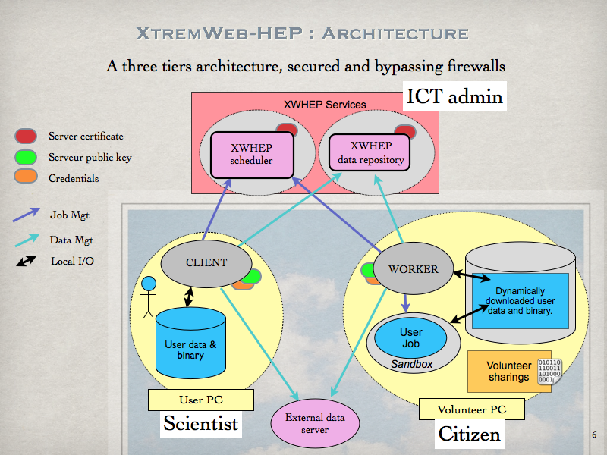Figure 2: Volunteer sharing
Figure 2 shows the architecture of this version, including volunteer sharing. This is still a three tiers architecture with centralized services that ensure the deployment coherency, distributed clients to use and manage the platform, and workers to aggregate volunteer resources.
Compared to the architecture described in the “XtremWeb-HEP Introduction” documentation, we can see the new “volunteer sharing” paradigm on worker side. This represents any object (data, application, library) the worker wishes to propose to the deployment. If the required conditions are met (mainly the security issues), this volunteer sharing may be proposed to users.
It is the volunteer resource owner responsibility to propose or deny volunteer sharing from its resource.

Shared application
Shared application is an application for which the binary will never be downloaded by workers. It must be an application type known by the middleware which uses it to select a volunteer resource. That last presenting a “SHAREDAPPS” field may be selected to compute applications having the matching “TYPE”.Shared application usage has some requirements:
- the application must be registered on server;
- the application type must be greater than ApplicationType.SHARED. Please refer to the “XtremWeb-HEP user guide”;
- the application must be provided with ”launchscriptshuri” and ”unloadscriptshuri”. Please refer to the “XtremWeb-HEP user guide”.

Shared library
Shared library may be referred by registered application. It is a free text the scheduler uses to select a volunteer resource. That last presenting a “SHAREDPACKAGES” field may be selected to compute applications having the matching “NEEDEDPACKAGES”. Shared library usage has some requirements:
- the application must be registered on server;
- the application field “NEEDEDPACKAGES” must be set. Please refer to the “XtremWeb-HEP user guide”.

Shared data
Shared data may be referred by registered data. It is a free text the scheduler uses to select a volunteer resource. That last presenting a “SHAREDDATAS” field may be selected to compute data having the matching “PACKAGE”. Shared data usage has some requirements:
- the data must be registered on server;
- the data field “WORKUID” must be set to select the work -or any of its replica- to launch when a volunteer resource presents a shared data;
- the data field “PACKAGE” must be set. Please refer to the “XtremWeb-HEP user guide”.

Inter node communication
In this version, distributed nodes can now be interconnected. More precisely, applications and jobs run over a deployment may be able to communicate.
This new functionality is manageable by the volunteer resource owner who can switch it on or off.

The distributed parts of the middleware themselves do not gain any new communication facilities: the client cannot connect to any worker and worker cannot communicate to each others.
But client and worker can now create communication tunnels on demand so that jobs running on volunteer resources may have a chance to communicate to applications running on the client side. Jobs running on volunteer resources can also initiate communications to one another. Finally, jobs running on volunteer resources may also be reachable from application running on client side.

Let explain all that by examples. Suppose we have two applications: JackRabbit , which is a standalone version of Apache entirely written in Java language; and wget , which is a non-interactive command line tool for file retrieving over the internet.
We can easily access files from JackRabbit on our desktop grid, in different ways:
- run Jackrabbit on client side and deploy wget over volunteer resources. This could be useful when deploying jobs over XWHEP that need a specific data repository;
- deploy Jackrabbit on volunteer resources and run wget on client side to retrieve data. This could be useful if we want a free hosted data repository;
- deploy Jackrabbit and wget jobs on volunteer resources. This could be useful for a fully distributed data repository solution.

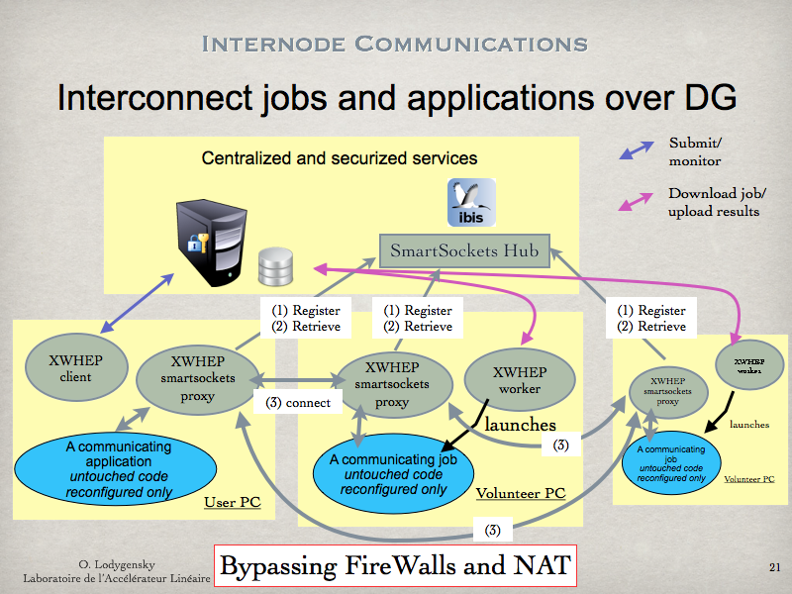Figure 3: Internode communications

All this is achieved using the SmartSockets library. Figure 3 shows the communication architecture. Along the well known centralised XWHEP services, a new centralised service is introduced: the SmartSockets hub which must be installed in a centralised, secured and public server. The XWHEP distributed parts (client and worker) now included a so called “SmartSocket proxy” which is in charge of creating tunnels on demand so that jobs running on volunteer resources may be reachable and can reach other running jobs or applications.
The communication process is as follow: (1) the SmartSocket proxy register on the SmartSocket hub, on client as well as volunteer resource side; (2) the SmartSocket proxy may retrieve on demand distributed communication ends through the SmartSockets hub. Finally, (3) node to node communications may take place.

Security consideration
The middleware is supposed to be run and managed by a non privileged user: it has no chance to use privileged ports (ports lower than 1024).

By the way, even if the middleware has been installed and configured to be run under a privileged account (which is a very bad idea and under the responsibility of the one who do that) the middleware has been written to cowardly refuse to use privileged port.

Port under 1024 are not allowed; if a job has a listening port defined under 1024, this job is not run and its status set to error.

Wall Clock Time
Since XWHEP 8.2.0, the system introduces the notion of “Wall clock time”. This Wall Clock Time being a computation time limit.
Jobs are automatically stopped when their computation time reaches this limit. Their status are set to error.

Replication
Since XWHEP 10.0.0, the system introduces the notion of “job replication”, being a set of copies of computation. Jobs are automatically run several times until a user defined limit. Job replication if made of two parameters: the total amount of expected replicas and the replica set size. That last defines the amount of job to run simultaneously. When a replica computation is completed, a new replica is automatically pushed in the scheduler queue if and only if the replica has completed correctly. This replication process ends as it reach the total amount of expected replicas.
One may note that replication is a new scheduling behaviour added to the scheduler.

Data driven scheduling
Since XWHEP 10.0.0, the system introduces the notion of “data driven scheduling”, being an automatic computation of shared data. This is done by associating a data with a work. When a volunteer resource presents a shared data, the scheduler selects any work -or work replica- associated to a data that is related to the presented shared data.
One may note that data drive is a new scheduling behaviour added to the scheduler.

XWHEP architecture
The XWHEP architecture contains three parts, as shown in figure 4:
- one or a group of several Servers is installed and maintained by system administrators to host centralized XWHEP Services such as the 'Scheduler' and the 'Result Collector';
- distributed parts deployed over the internet:
  - XWHEP Workers are installed by citizens on their PCs to propose their computing resources to be aggregated within an XWHEP infrastructure;
  - XWHEP Clients are installed by XWHEP users (scientists, for example) on their PCs to interact with the infrastructure. The XWHEP client permits users to manage the Servers and use the distributed resources (submit jobs, retrieve results...).

This architecture corresponds to most of well known Global Computing Projects:
- The XWHEP central services permit the XWHEP administrator to manage registered applications.
- An XWHEP Client prepares data that are needed to successfully compute jobs. These data may be stored in the XWHEP infrastructure or in any repository as soon as the data can be described by an URI and are accessible through the network. There is no limit on data size, but data exceeding a few hundred mega-bytes may take very long to download or upload.
- An authorized XWHEP Client registers the application on the XWHEP infrastructure.
- A Client prepares jobs (units of work) containing the reference of a registered application, optional parameters, optional references to additional files.
- Finally, the Client submits the prepared jobs to the XWHEP Scheduler.
- Independently, XWHEP Workers contact the XWHEP Scheduler to get jobs suitable for their architecture.
- In response, the Scheduler sends a suitable job description to a Worker.
- For each file referenced by the job which is not present in the local cache of the Worker yet, the Worker fetches the file from the XWHEP Data Repository or from an External Data Server.
- As soon as a job has finished on Worker side, the Worker contacts the XWHEP Result Collector to send the results.

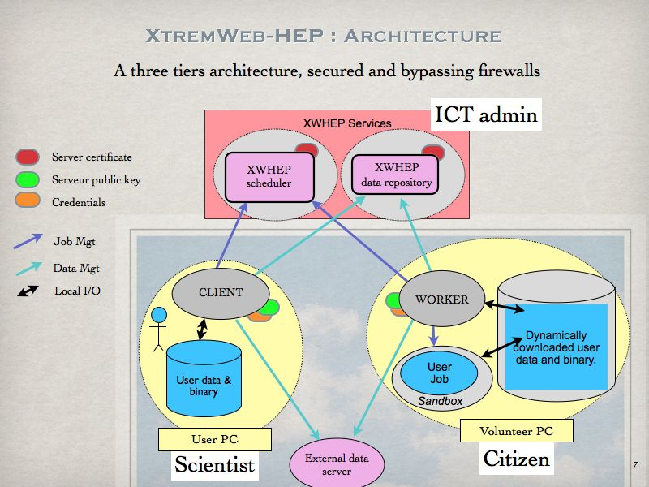Figure 4: XWHEP Architecture

XWHEP hardware and software requirements
The XWHEP middleware, written in Java 1.6 computing language, is highly portable.

To run any component of the middleware, you need:
- a machine running Windows, or Linux or Mac OS X
- java runtime environment 1.6 or above

XWHEP software stack
The middleware is composed of different parts: the centralized server; the distributed client, worker, monitor and bridges. These parts can be layered in four slices as shown in figure 5:
- the “OS layer”, at the bottom;
- the “service layer” on top of the OS layer;
- the “middleware layer” containing distributed parts as the client, the worker and the monitoring tools;
- finally the “application layer” containing the user application submitted as jobs and running on top the the worker.

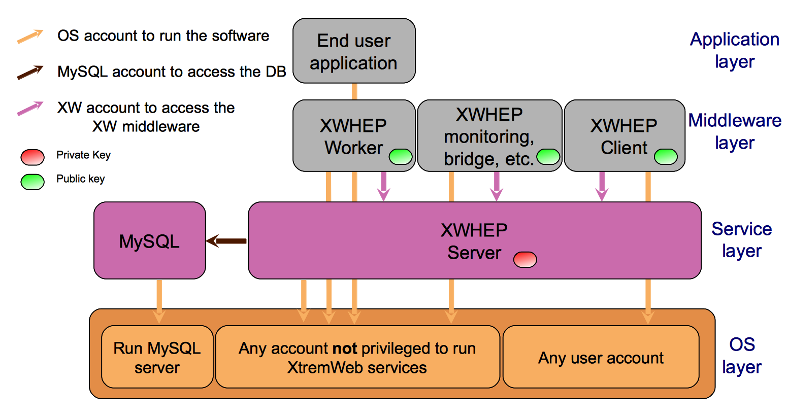Figure 5: XWHEP Software Stack

XWHEP communication protocols
Since the platform is distributed, communications are a key point of the XWHEP middleware. The XWHEP middleware tries to be communication protocol agnostic by allowing different low level protocol as well as several high level ones. Developers may implement their own protocols by extending CommServer and CommClient abstract classes. (Please refer to the “XtremWeb Programmer Guide”). The middleware designs low level protocols as “communication layer” and high level ones as “communication handlers”.

The XWHEP middleware provides two communication layers: UDP and TCP, as well as three communication handlers described by their URI scheme: HTTP, ATTIC and the XWHEP middleware own one: XW.
That last has been introduced to follow the desktop grid requirements and implements a high level of security (see chapter 7).

Description of the objects managed by XWHEP
For the description of the objects managed by XWHEP, please refer to the “XtremWeb-HEP Programmer Guide”.

Security considerations for XWHEP
The middleware ensures security at different levels. In this chapter we detail security in the client-server interaction. Security services and protocols in this context can be introduced as follows :

7 Security considerations for XWHEP 19
7.1 Secure resources of XWHEP 19
7.2 Secured communications of XWHEP 20
7.3 Authentication of XWHEP Server, Client and Worker 20
7.4 XWHEP authorisations 21
7.5 XWHEP ownership 22
7.6 XWHEP access rights 22
7.7 XWHEP logging and bookkeeping 24
7.8 XWHEP confinements 24
7.9 Data confidentiality 29
7.10 Data integrity 30
7.11 Data persistence 30
7.12 Result certification 30

Secure resources of XWHEP
Each part of the middleware must access to some different components. It must be clearly understood that these accesses need to pass different security barriers. The different accounts need to present “credentials” to pass these security barriers.
This section details credential considerations that the middleware installation packages automatically manage at installation time.

This may sound obvious, but each part of the middleware needs to run on some computing resource. To do so, an account is used on that computing resource. Since the server and the worker parts run as “daemon” (a program that runs indefinitely in the background, and not under the direct control of a user), the middleware does not install these parts under privileged account for security reasons, but needs a non privileged user account. The client part is under the responsibility of the user who uses it, and runs under the user account on the user machine. This access type is shown as orange arrows in figure 5, labelled “OS account to run the software”.
The middleware needs a database (DB) where it stores all objects. A DB account is then necessary to connect to the DB server. One may note here that the XWHEP server comes with an embedded DB engine; even with that embedded engine, an account is still necessary. This access type is shown as a brown arrow in figure 5, labelled “MySQL account to access the DB”.
The middleware itself introduces a new account type needed to access the platform: register applications and data, submit jobs etc. When connecting to a XWHEP service, distributed parts must present valid credentials (usually an X509 certificate). These credentials permit to determine if that connection is authorized and what actions are permitted. This access type is shown as purple arrows in figure 5, labelled “XW account to access the XW middleware”.

Finally, the volunteer resources that run the end user jobs may also be secured by the usage of “sandboxing” technology. This is described in the “XtremWeb-HEP Resource Provider Guide”.

Secured communications of XWHEP
As sensitive data may be transferred over the network, the XWHEP middleware systematically ensures communications privacy by using TLS encryption. This ensures security by using encryption and by identifying communicating entities.

Authentication of XWHEP Server, Client and Worker
Server authentication is implemented by the usage of an electronic key pair: the server private key (shown in red in figure 4) is securely stored on server side, and the server public key (shown in green in figure 4) is enclosed inside the installation packages of the client and worker.
This permits to certify the server identity: distributed XWHEP components establish a session with a Server only if this server proves that it owns the private key corresponding to the public key.
On the other side, the server doesn't accept connection without receiving its own public key.

Being connected to the server is not sufficient to execute a command on server side. Each Client must present valid credentials so that the server can securely identify who is connecting.
In XWHEP, different credential types are accepted by the server:
- login/password
- X509 certificate
- OpenId identity
- OAuth identity

Using login/password
Login/password is a key pair that uniquely defines an identity. Such identities must be inserted by the XWHEP administrator.
It is the administrator responsibility to securely send login/password pair to whom it may concern.

Using X509 certificate
The XWHEP middleware is able to use X509 certificates. This is an IETF standard ensuring certificate owner identity. It is out of scope to detail certificate in this document.
The middleware authenticates the communication initiator presenting an X509 certificate by verifying the certificate authority (CA) that signed the certificate.

It is the XWHEP administrator responsibility to manage its list of trusted CA certificates.

Using delegated identity
As found on wikipedia: “OpenID is an open standard that describes how users can be authenticated in a decentralized manner, eliminating the need for services to provide their own ad hoc systems and allowing users to consolidate their digital identities.”

The XWHEP middleware is able to delegate authentication to distributed OpenId or OAuth servers. It is out of scope to detail delegated authentication in this document.
The middleware delegates the authentication process to known servers only. On successful authentication, the middleware checks if the user is allowed to use its deployment. Please refer to the “XtremWeb-HEP administrator guide” for more details on delegated authentication using OpenId or OAuth.

It is the XWHEP administrator responsibility to manage its list of trusted servers as well as users allowed to authenticate in its platform using their remote identity.

Authentication and identity
The authentication process, if successful, defines an identity. This identity is used on server side to execute commands sent by the distributed component (client, worker). An identity has several attributes: first name, last name, email etc.
An identity has also some critical attributes involved in security: credentials (login and password, X509 certificate, delegated identity), user group membership and authorisation.

The XWHEP middleware manages user groups. Any user may belong to at most one user group. User groups aim to confine accesses so that members of the group are allowed to access objects defined within the group. These objects confined in a group are not accessible by users who don't belong to the user group.

XWHEP authorisations
Being authenticated by the server is not sufficient to execute a command on server side. Each authenticated entity has a usage level called “user rights”, that defines authorization.
Authorization allows or denies execution of requested action.

Authorizations are defined as enumerations from least to most privileged. Please refer to the “XtremWeb-HEP Programmer's Guide”.
The super_user authorization allows all access rights on all XWHEP objects.. In the XWHEP middleware, we call “administrator” an identity associated to a super_user authorization.
The standard_user authorization allows to do actions such as insert_job, insert_data etc.

The general case is as follow: user rights R allow to perform an action A if and only if:
0 < A <= R

The only one specific case is: worker_user. Presenting credentials associated with this user rights, each XWHEP worker can:
- never list anything (list_app, list_data etc.)
- never insert anything (insert_app, insert_data etc.)
- never delete anything (delete_app, delete_data etc.)
- ask for a pending job
- send a heartbeat signal
- retrieve an application by providing the application unique identifier (UID)
- download data
- upload result for the job it has computed (this is checked by the server)

XWHEP ownership
In XWHEP, each object has an owner. By default, the owner has full access to his/her objects.
Any user may have access to an object he/she does not own, if this object permits it.
For example, any user belonging to a user group may have access to an object owned by a member of the same user group, if this object permits group access.
Accesses are defined by object access rights presented in next chapter.

XWHEP access rights
Being allowed to execute a command on server is not sufficient to execute this command on an object managed by the server.
All objects (applications, data, jobs etc.) have associated access rights. XWHEP implements this “a la” linux file system access rights. Access rights allow or deny access to the object it is associated with.
XWHEP assigns Read, Write and Execute access rights separately for:
- the owner of the object;
- members of the group the owner belongs to (if any);
- others.

Access rights of an object can by modified by its owner or by an XWHEP administrator.
But it is never possible to increase access rights, except for administrator.

There is one exception where access rights are fully bypassed so that access is always allowed: an XWHEP administrator is always allowed to access (read, write, execute) any object. This exception permits to modify access rights in any manner (even increasing).
Access rights are defined in figure 6:

U_{R} U_{W} U_{E} G_{R} G_{W} G_{E} O_{R} O_{W} O_{E}

Where

U_{R} = User (owner) read access rights
U_{W} = User (owner) write access rights
U_{E} = User (owner) execute access rights, if applicable
G_{R} = Group read access rights
G_{W} = Group write access rights
G_{E} = Group execute access rights, if applicable
O_{R} = Other read access rightss
O_{W} = Other write access rights
O_{E} = Other execute access rights, if applicable

Examples in octal notation:

755 defines
- full accesses for the owner;
- read and execute accesses to the owner group, if any;
- read and execute accesses to others.

750 defines
- full accesses for the owner;
- read and execute accesses to the owner group, if any;
- no access to others.

700 defines
- full accesses for the owner;
- no access to the owner group, if any;
- no access to others.

Figure 6: XWHEP Access Rights

XWHEP logging and bookkeeping
The middleware proposes protocols, services and tools to post analyse events. This may especially be useful in case of errors or unconsidered utilization of the middleware.
As detailed in previous sections, users have associated credential defining their identity and authorisations. All actions executed through the middleware are logged with informations such as the date, the user credential and the action itself. The middleware comes with necessary tools to post analyse actions occurred in a deployment.
The middleware also proposes to use Ganglia as the realtime monitoring system. Ganglia is a cluster and grid monitoring system; it comes with a web interface to easily display realtime monitoring.
Figure 7 shows some ganglia statistics generated by the middleware Ganglia plugin.
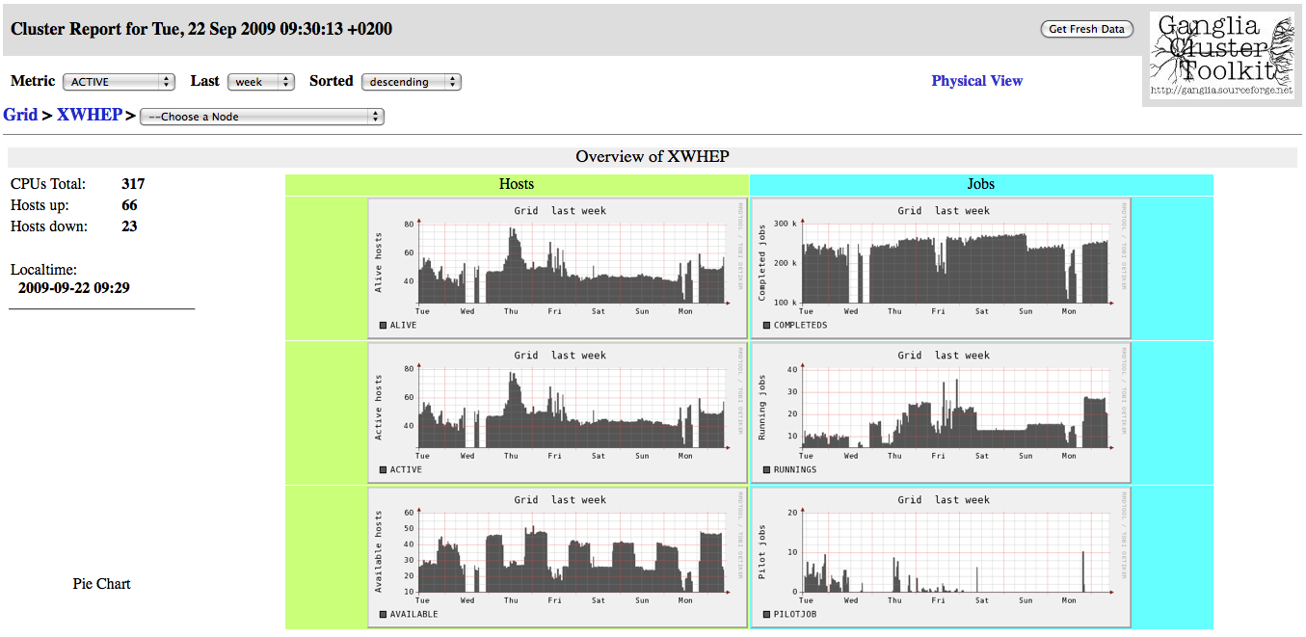Figure 7: XWHEP Ganglia Monitoring Page

XWHEP confinements
Since XWHEP assigns an authorisation to each identity and access rights to each object, XWHEP effectively confines all objects it manages. Inside XWHEP, a combined setup of authorisations and access rights is call a confinement.

All applications, all data, all jobs are confined. But also all users, all clients and all workers.

Confinements aim to restrict accesses so that distributed entities (clients and workers) are allowed or denied to access (read, write, execute) confined objects.
The XWHEP middleware helps to define as many confinements as possible combinations of authorizations and access rights.

In this chapter, we present the three major confinements:
- public
- group
- private

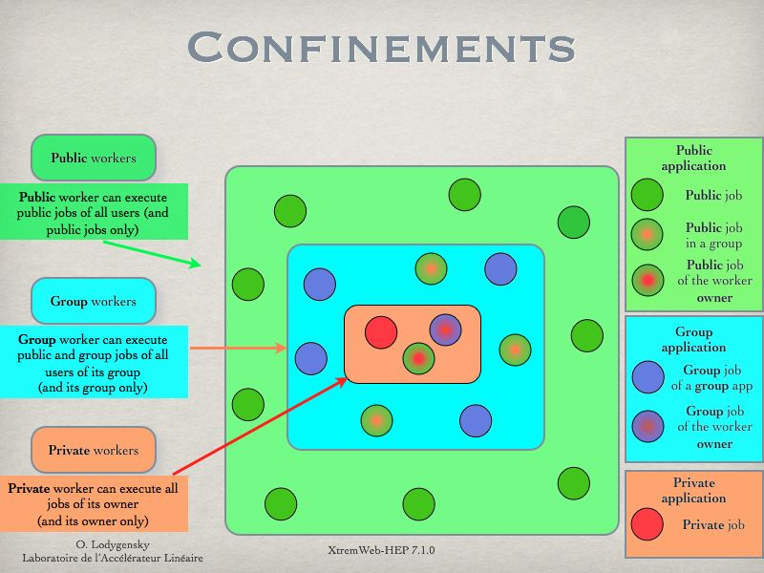
Figure 8: XWHEP Confinements
Confinement paradigms are shown in figure 8 representing the three majors confinement levels : public, group and private.
Following sub chapters detail these confinements.

XWHEP public confinement
This is the default confinement. It is shown in green in figure 8. In a public confinement, everything is public, all distributed entities (workers, clients) have read and execute accesses to public objects. The write access, if set, is reserved to the owner only.
A public confinement is made of public objects:
- public applications;
- public jobs;
- public data;
- public workers;
- public clients;
- public users.

Access rights for public confinement
Public access rights are defined to allow owner full accesses, group read and execute accesses as well as read and execute accesses to others.
The octal value of the public access rights is: 755.

Management of a public confinement
The XWHEP administrator is the only user allowed to manage a public confinement. Administrator authorization is the only one that permits to insert, delete and modify public users, public workers and public applications.

Resources aggregation within a Public confinement
The XWHEP administrator is the only user allowed to perform resource aggregation in a public confinement. To do so, the administrator must create an identity associated with worker_user authorization.

This identity must not belong to any user group.

It is then the administrator responsibility to prepare worker installation packages that will install worker with this identity. All deployed workers will then connect to the server and present this identity.
Such workers will be automatically public. There is no way to modify this. Public workers execute public jobs only.

Usage of a public confinement
Any user can read and execute public objects.
Users who don't have administrator authorization can not modify public objects they don't own.
Users can send public data.
Users can submit jobs referring public applications.

Public applications must refer public data only.
Jobs referring public application are automatically public.
There is no way to modify this.
Public jobs must also refer public data only.

Behaviour of workers within a public confinement
All workers are allowed to access all public objects.
Worker confinement depends on the identity a worker presents when it connects to the XWHEP server. A worker is public if this identity is associated with worker_user authorization and does not belong to any user group.
Public workers are not allowed to access non public objects (group and private objects).
This is why jobs referring public application are automatically public and must refer public data only.

XWHEP group confinement
This confinement confines accesses within a group of users only. By default all entities defined within a user group have read and execute accesses to group objects.
A group confinement is made of group objects:
- group applications;
- group jobs;
- group data;
- group workers;
- group clients;
- group users.

Access rights for group confinement
Group access rights are defined to allow owner full accesses, group read and execute accesses and to deny accesses to others.
The octal value of the group access rights is: 750.

Management of group confinement
The XWHEP administrator is the only user allowed to create a group confinement. The administrator should delegate group management to a group administrator. A group administrator is an identity defined in a user group and associated to advanced_user authorization.
A group administrator is allowed to insert, delete and modify group objects (users, workers , applications....).

Resources aggregation within a group confinement
The group administrator is allowed to manage resources aggregation in a group confinement. To do so the group administrator must create an identity within its group and associated with worker_user authorization.
It is then the group administrator responsibility to prepare worker installation packages that will install a group worker with this identity. All deployed workers will then connect to the server and present this identity.

Such workers will be automatically group workers.
There is no way to modify this.
Group workers can execute any public jobs.
Group workers may also be restricted to execute public jobs owned by members of its group.
Group workers can execute group jobs owned by members of its group.
(this includes group and public jobs)

Usage of a group confinement
Any member of the group can read and execute group objects. Others can't.
Users who are not administrator of the group can not modify group objects they don't own.
Users can send group data.
Users can submit jobs referring group applications.

Group applications must refer public data or data of its group only.
Jobs referring group application are automatically group jobs.
There is no way to modify this.
Group jobs may refer any public data and data of the group.

Behaviour of worker within a group confinement
Public workers are not allowed to access group objects.
Worker confinement depends on the identity a worker presents when it connects to the XWHEP server. A worker is a group worker if this identity is associated with worker_user authorization and belongs to a user group.
Group workers are allowed to access public objects and objects defined in the group.
Group workers are not allowed to access private objects or objects defined in other groups.
This is why jobs referring group application are automatically group jobs and must refer data accessible within the group (public data and data defined in the group).

XWHEP private confinement
This confinement confines accesses to a single user only. All entities defined as private deny accesses to all users but the owner.
A private confinement is made of private objects:
- private applications;
- private jobs;
- private data;
- private workers.

Access rights for private confinement
Private access rights are defined to allow owner full accesses and to deny accesses to all others.
The octal value of the private access rights is: 700.

Management of a private confinement
Any user can manage its own private confinement.

Resources aggregation within a private confinement
Any user is allowed to manage its own private resource aggregation.
A resource is private when its presents owner credentials not associated to worker_user authorization (belonging or not belonging to any user group).
It is then the user responsibility to prepare worker installation packages that will install a private worker with its own identity. All deployed workers will then connect to the server and present this identity.
Such workers will be automatically private workers.
There is no way to modify this.
Private workers execute jobs owned by its owner only.
(this includes private and group and public jobs)

Usage of a private confinement
The owner is the only user allowed to access his/her private objects.
Users can create private data.
Users can submit jobs referring private applications.

Private applications must refer data accessible by the application owner.
Jobs referring private application are automatically private jobs.
There is no way to modify this.
Private jobs may refer any data accessible by its owner.

Data confidentiality
Data may circulate over the network, from client to server, from server to workers, and back. Communication are secured as described in chapter 7.2.
The middleware enforces data confidentiality according to the authorization and access rights mechanisms described above. The confinement ensures that:
- private objects are sent to private clients and workers only;
- group objects are sent to group clients and workers only;
- public objects are freely accessible.

XWHEP provides absolutely no guarantee as soon as an object is sent to a distributed entity.

It is the user responsibility to properly use confinement mechanisms to ensure confidentiality and restricted access to sensitive data.
X509 certificates are automatically private data. This ensures that this very sensitive data will never be downloaded by any one but the owner. The middleware is written in such a way that workers can never access certificates.

Data integrity
The middleware ensures data integrity by checking data size and MD5 checksum on each access. It is the responsibility of the XWHEP administrator to ensure integrity of data stored on server side.

Data persistence

The XWHEP middleware does not propose anything on this field.

It is the end user responsibility to ensure persistence of his/her data. For example by using BitDiew P2P storage or EGI Storage Elements.
The administrator may remove any data from the server without any formal notification to the data owner.
It is the administrator responsibility to avoid removing any data that may lead to some problems regarding registered applications and submitted jobs.

Result certification

The XWHEP middleware does not propose anything on this field.

It is the end user responsibility to verify the results of his/her jobs.

Virtualization over desktop grid
This chapter introduces development, deployment and usage of virtual machines (VM) over the XtremWeb-HEP desktop grid.

To follow this chapter, Virtual-Box (VB) must be installed in your machine. You do not need to create any new VM in VB since the middleware provides scripts to manage VMs: create, start, stop and destroy VMs on demand. Provided scripts do not alter or modify in any manner neither VB itself, nor any existing VM nor virtual disk image (VDI).

The reader should have a minimal understandings on shell languages. This chapter introduces the necessary usage of Virtual-Box (VB) for creating and launching a new virtual machine inside VB.
All instructions in this document are based on Scientific-Linux (SL).

Introduction
This chapter is structured as follow: chapter8.2 details security regarding the usage of virtual machines over a desktop grid; chapter8.3 describes the envisioned usage of virtual machine over desktop grid. Chapter8.4 introduces the contextualization mechanisms.

Security considerations
This chapter describes our “Virtualization Validation Procedure (VVP)”.

The XWHEP server aggregates volunteer resources to remotely launch virtual machines by providing bootable virtual drive (VD), which must be validated following our “Virtualization Validation Procedure”. On another hand VD submitters sign a “Conformance Certificate” that engages their responsibility.
The VVP is conceptually similar to the “EDGeS DSA2.1-Application Validation Procedures”. This procedure, describing a best effort work, is under administrators responsibility. It consists on checking the points described in next subsections.

Background
Embedded OSes used to launch virtual machines must not contain erroneous or malicious softwares or configurations.
They should specifically be based on a recent version containing last software releases with all known bug fixes and security corrections.

User rights
There must be no way to connect as privileged user.
Non privileged users must not be able to gain any privilege; they must specifically not be allowed to use the “sudo” tool.

Connection security
Embedded OSes must contain and run the “sshd” service (or similar one). Connection to virtual machines must systematically use TLS encryption.
Connections should be challenged using end user certificate.

Network access
Internet access may be allowed from the virtual machine.

Access to local area network (LAN) must not be allowed.

Blocking access to LAN may be done using the “iptables” tools.
The following iptables rules may be used to do so:

*filter

# Input
-P INPUT ACCEPT
# Output
-P OUTPUT ACCEPT
# Routage
-P FORWARD ACCEPT

# Communication allowed on loopback
-A OUTPUT -o lo -j ACCEPT

# Output allowed on established incoming connections
-A OUTPUT -m state --state RELATED,ESTABLISHED -j ACCEPT

# Allow a given port range on output
-A OUTPUT -p tcp --dport 4000:4100 -j ACCEPT

# Deny access to LAN
-A OUTPUT --destination 10.0.0.0/8 -j REJECT
-A OUTPUT --destination 172.16.0.0/12 -j REJECT
-A OUTPUT --destination 192.168.0.0/24 -j REJECT

COMMIT

One may note that these rules still allow accesses to LAN through some ports (4000 to 4100 in our example).

These ports may be used to communicate with the XtremWeb-HEP middleware and should not be used until further notification.

Deployment
This chapter details the envisioned solutions proposed within XtremWeb-HEP 8 (XWHEP8) to deploy and use virtual machines over desktop grid.
Deploying and using virtual machines over a desktop grid raises major questions: how to deploy and use a hypervisor needed to manage VM on volunteer resources running desktop Linux, Apple Mac OS X or Microsoft Windows? What about the bandwidth usage to download virtual disks used as bootable media to launch the VM? And how to propose an easy solution to deploy customized VM to the end user?

Next sections show that using Virtual-Box as a volunteer shared application solves the first problem of deploying and using an hypervisor on volunteer resource: we do not need to deploy the hypervisor, we use the one shared by volunteer resources. Section 8.3.4 details our solution to the bandwidth bottleneck. Section 8.4 introduces contextualization, our solution to ease the VM management and usage.

Installation
Using the volunteer sharing technology still necessitates to register shared objects since the XWHEP middleware implements the “pull mode” paradigm where distributed parts are not reachable. This clearly means that, in XWHEP, objects must be registered on server side. This is true for shared objects too: they must be registered on the server in order to be usable over the deployment.
On another hand, registering objects, even shared ones, allows the middleware to apply security mechanisms as described in the “XtremWeb-HEP Introduction” document. This includes authorization, authentication, confinement access rights, logging and bookkeeping.

Registering shared application
In XWHEP, registering application is necessary to allow users to submit jobs that must refer to application. Registering shared applications is detailed in the “XtremWeb-HEP Extended User Guide” document.

Proposing shared application
In XWHEP 8, shared application may be proposed by volunteer resource owners. It is the XWHEP deployment administrator responsibility to encourage them to install the desired application on their volunteer resource and to propose it as a volunteer shared application in the platform.
The volunteer resources can propose whatever they want. Registered shared applications only will be taken in account.
Sharing applications is detailed in the “XtremWeb-HEP Extended Resource Provider Guide” document.

Submitting a virtual machine
In XWHEP 8, submitting jobs is detailed in the “XtremWeb-HEP Extended User Guide” document. This includes job submission referring shared application.
To the end user, there is no difference between submitting jobs referring shared application and submitting jobs referring “deployable” application. This is transparent to the user who is submitting jobs. Please refer to section2.1.1introducing “shared” versus “deployable” objects.
The difference lies on the volunteer resource side and on the fact that the volunteer resources download no binary for shared applications, since the application is supposed to be preinstalled.

In the context of submitting virtual machines to our desktop grid, where users submit jobs referring a shared hypervisor, there is still the problem of the bandwidth usage since submitting virtual machines requires to transfer virtual disks images (VDI) to boot the VM. And VDI may be several giga bytes. And transferring giga bytes over a DG is just inconceivable.

To solve this problem we have decided to encourage the usage of LiveCD since they are a few hundreds mega bytes only. We propose LiveCD with a size about 350Mb on our website.
But LiveCD contains a predetermined operating system that may not fit all end user needs. We propose a solution to modify the OS burnt in the LiveCD: the contextualization introduced in next section.
Section8.4 describes contextualization mechanisms which are certainly enough for the majority of cases. Please refer to the “XWHEP-User-Guide” document to see how to dynamically create and launch a virtual machine, as well as how to create a new contextualizable LiveCD to fit specific requirements that could not be covered by contextualization only.

Contextualization
A LiveCD contains a full operation system (OS) perennially stored in the media that cannot be modified in any manner. When used as a bootable media for a virtual machine, all modifications are lost if the VM is stopped. On next usage, the OS is still as it was originally when the LiveCD has been created.
It is very likely that an OS burnt on a LiveCD does not fit all possible usages, nor some end user requirements.
We introduce “contextualization” in order to easily permit the usage of a LiveCD for a large field of use cases and requirements.

Introduction to contextualization
We propose LiveCD containing customization mechanisms that permit to modify the embedded OS on the fly. To do so, our LiveCD contains a script run at the end of the boot process, which tries to mount two devices:
- one on /scratch to propose some working spaces where the user can run computation;
- another one on /conxtext. If this device is correctly mounted, the script /context/context.sh is executed, if it exists.

If any these devices do not exist, it is not mounted and the LiveCD continue its boot process.
The script /context/context.sh can contain anything (its content is not checked). It is executed without any administrator privilege. It may contains commands to install the end user public key so that the user will be able to connect to its VM using ssh; or it can contain command to install some specific packages or libraries. Etc.

The contextualization script is run without any privileged rights. Hence there are a lot of things that are not allowed. If your script needs privileged rights, you should not use contextualization. In this case, you must create your own LiveCD as described in the “XWHEP-User-Guide” document.

Figure 9 shows the contextualization environment.
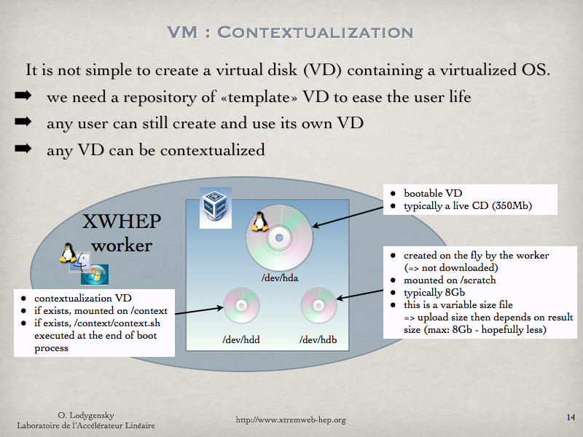Figure 9: LiveCD customization

Contextualization structure
The customization is done by providing a virtual disk (VD) to our script. This VD must contains a script named ”context.sh” in its root (outside any directory). The middleware proposes an example of this script in:
- ${XWHEP_HOME}/bin/context.sh

In the middleware source package this script is in:
- ${XWHEP_HOME}/src/script/

If available, this script is run at the end of the boot process. It may contain any command, keeping in mind that it is run without any administrator privilege.

Create a new contextualization disk
Please refer to the “XWHEP-User-Guide” document.

Virtual machines provision
Virtual disk images are available on different web sites, such as:
- ubuntu : https://cloud-images.ubuntu.com;
- bitnami : https://bitnami.com;
- cernvm : http://cernvm.cern.ch.

Container over desktop grid
This chapter introduces development, deployment and usage of container over the XtremWeb-HEP desktop grid.
To follow this chapter, Docker must be installed in your machine. You do not need to create any new container since the middleware provides scripts to manage them: create, start, stop and destroy containers on demand. Provided scripts do not alter or modify in any manner neither Docker itself, nor any existing container, nor disk image .

The reader should have a minimal understandings on shell languages. This chapter introduces the necessary usage of Docker for creating and launching a new container.

Introduction
This chapter is structured as follow: chapter9.2 details security regarding the usage of container over a desktop grid; chapter9.3 describes the envisioned usage of containers over desktop grid.

Security considerations
This chapter describes our “Docker Validation Procedure (DVP)”.

The XWHEP server aggregates volunteer resources to remotely launch container by providing either a Dockerfile or a Docker image, which must be validated following our “Docker Validation Procedure”. On another hand, image submitters sign a “Conformance Certificate” that engages their responsibility.
The DVP is conceptually similar to the “EDGeS DSA2.1-Application Validation Procedures”. This procedure, describing a best effort work, is under deployments administrator responsibility; it consists on checking the points described in next subsections.

Background
Embedded OSes used to launch container must not contain erroneous or malicious softwares or configurations. They should specifically be based on a recent version containing last software releases with all known bug fixes and security corrections.

User rights
There must be no way to connect as privileged user. Non privileged users must not be able to gain any privilege; they must specifically not be allowed to use the “sudo” tool.

Connection security
Embedded OSes must contain and run the “sshd” service (or similar one). Connection to virtual machines must systematically use TLS encryption. Connections should be challenged using end user certificate.

Network access
Internet access may be allowed from the virtual machine. Access to local area network (LAN) must not be allowed.
Blocking access to LAN may be done using the “iptables” tools.
The following iptables rules may be used to do so:

*filter

# Input
-P INPUT ACCEPT
# Output
-P OUTPUT ACCEPT
# Routage
-P FORWARD ACCEPT

# Communication allowed on loopback
-A OUTPUT -o lo -j ACCEPT

# Output allowed on established incoming connections
-A OUTPUT -m state --state RELATED,ESTABLISHED -j ACCEPT

# Allow a given port range on output
-A OUTPUT -p tcp --dport 4000:4100 -j ACCEPT

# Deny access to LAN
-A OUTPUT --destination 10.0.0.0/8 -j REJECT
-A OUTPUT --destination 172.16.0.0/12 -j REJECT
-A OUTPUT --destination 192.168.0.0/24 -j REJECT

COMMIT

One may note that these rules still allow accesses to LAN through some ports (4000 to 4100 in our example).
These ports may be used to communicate with the XtremWeb-HEP middleware and should not be used until further notification.

Deployment
This chapter details the envisioned solutions proposed within XtremWeb-HEP 10.6.0 (XWHEP10.6) to deploy and use container over desktop grid.
Deploying and using containers over a desktop grid raises major questions: how to deploy and use Docker to manage containers on volunteer resources running desktop Linux, Apple Mac OS X or Microsoft Windows? What about the bandwidth usage to download virtual disks used as bootable media to launch the container? And how to propose an easy solution to deploy customized container to the end user?
Next sections show that using Docker as a volunteer shared application solves the first problem of deploying and using it on volunteer resources: we do not need to deploy Docker; we use the one shared by volunteer resources.

Installation
Using the volunteer sharing technology still necessitates to register shared objects since the XWHEP middleware implements the “pull mode” paradigm where distributed parts are not reachable. This clearly means that, in XWHEP, objects must be registered on server side. This is true for shared objects too: they must be registered on the server in order to be usable over the deployment. On another hand, registering objects, even shared ones, allows the middleware to apply security mechanisms as described in chapter 7. This includes authorization, authentication, confinement access rights, logging and bookkeeping.

Registering shared application
In XWHEP, registering application is necessary to allow users to submit jobs that must refer to application. Registering shared applications is detailed in the “XtremWeb-HEP Extended User Guide” document.

Proposing shared application
Since XWHEP 8, shared application may be proposed by volunteer resource owners. It is the XWHEP deployment administrator responsibility to encourage them to install the desired application on their volunteer resource and to propose it as a volunteer shared application in the platform. Sharing applications is detailed in the “XtremWeb-HEP Extended Resource Provider Guide” document.

Submitting a container
Since XWHEP 8, submitting jobs is detailed in the “XtremWeb-HEP Extended User Guide” document. This includes job submission referring shared application.
To the end user, there is no difference between submitting jobs referring shared application and submitting jobs referring “deployable” application. This is transparent to the user who is submitting jobs. Please refer to section2.1.1introducing “shared” versus “deployable” objects.
The difference lies on the volunteer resource side and on the fact that the volunteer resources download no binary for shared applications, since the application is supposed to be preinstalled.
In the context of submitting containers to our desktop grid, where users submit jobs referring a shared Docker, there is still the problem of the bandwidth usage since submitting containers requires to transfer Docker images to start the container. This is out of the control of the middleware.

Bridging XWHEP to other grids
There are various computing grids, also known as “Distributed Computing Infrastructure” (DCI). Currently, these various grids are powered by different incompatible grid middleware stacks, and users of one grid have extreme difficulty to get access to resources managed by other grids.

An important grid type is the “Service Grid” (SG) aggregating geographically distributed cluster-like resources as a coordinated federation of independently managed computing sites. Inside Service Grids, the job servers do not wait that computing resources pull waiting jobs, but the job servers broker incoming jobs and push them to computing resources assessed as adequate. The most notable SG middleware stacks are Globus, gLite, ARC, Unicore, Naregi and Genesis.

Xtremweb-HEP plugin of the 3G Bridge
In order to bridge these various grids powered by different middleware stacks, the EDGeS and EDGI projects funded by the European Commission have designed, implemented and put in production a “Generic Grid to Grid Bridge”, shortened as “3G Bridge” and shown in Figure 10.

The XWHEP team has contributed with the “Xtremweb-HEP plugin of the 3G Bridge”. An infrastructure using this plugin currently permits users of gLite, ARC and Unicore to transparently take advantage of resources managed by desktop grids powered by XWHEP.

Figure 10: Grid middleware stacks bridged by the 3G Bridge

XWHEP bridge to gLite

XWHEP allows users to use not only volunteer, but also gLite “Service Grid” (SG) resources aggregating and using cluster-like resources, by proposing an innovative resource sharing technology: The XWHEP bridge aggregates SG resources in a Desktop Grid (DG) deployment by submitting to the SG a pilot job (PJ) containing an XWHEP worker. XWHEP implements the DG to gLite bridge so that, under certain circumstances, jobs submitted to an XWHEP scheduler can be run by both types of resource.

Bridging security for XWHEP job submission to gLite
The main concern of the XWHEP bridge is security. The XWHEP bridge must conform to SG security requirements, as well as logging and bookkeeping. To achieve these goals, XWHEP introduces unique DG features: authorization and access rights. These must be understood as those well known in clustering environment. Any user willing to use the platform must have valid credentials which define and ensure its identity as well as its authorizations. Those last allow (or deny) possible actions. For example, an user may be allowed to submit jobs, but not permitted to insert applications etc. If the possibility of an action relies on user authorizations, the success of an action depends on object access rights. All these are described in chapter 7.

The security in SG is ensured by X509 certificates which must be signed by a known certificate authority (CA). These certificates are very sensitive data which must be securely kept by owner. They are designed with a long term life time (generally twelve months) and must definitely never be duplicated. They are secured by a password the owner must be the only one to know. As grids delegate credentials to services, grid users can generate a short life time X509 certificate (generally twelve hours) known as X509 proxy (or simply proxy). User delegation to grid services may be performed by migrating proxy; this is considered as an acceptable compromise since communications are always encrypted ensuring proxy integrity and point to point authentication. On another hand, if a proxy was to be maliciously used, its short life time would then limit the misusage.

Following these concepts, XWHEP can use X509 proxy, as any SG service since communications are encrypted and services authentication ensured by the usage of keys pair. An DG user can connect using such a proxy. The proxy is then safely transferred and copied in XWHEP data repository which ensures its integrity. The usage of this proxy being confined to the owner only thanks to XWHEP AR as explained above: in XWHEP, proxy is a private data, defined with a private access. This especially ensures that the proxy will never be sent to any volunteer computing resource. Finally logging and bookkeeping are ensured on both grids (DG and SG) since the same X509 proxy is used.

An user submitting a job to XWHEP using a proxy gains a potential access to an SG resource. The resource that will finally run the job is still unpredictable. It depends of resources usage. The job will be sent to the first available one, which may be a DG one, as well as an SG one. To ensure its security and integrity, X509 proxy will never be downloaded by any XWHEP resource, neither a volunteer one, nor a pilot job one.

Architecture of the XWHEP bridge to gLite
The XWHEP bridge is the only distributed part of XWHEP that uses the X509 proxy. It is a daemon (a program that loops for ever) that must be run on a machine where both XWHEP and SG client middleware are installed. Grid administrators must ensure the security and the integrity of the XWHEP bridge, since it performs some critical actions.
The XWHEP bridge periodically looks for XWHEP jobs submitted with a valid X509 proxy. For each job, the XWHEP bridge downloads the proxy and uses it to perform SG actions necessary to start a pilot job.
If the proxy is not valid, SG actions fail. The XWHEP bridge does not consider this as an error since the job has then no chance to be computed on any SG resources, but only on DG ones (and the XWHEP bridge does not have to report this as an error since it does not manage DG itself).
If the proxy is valid, the XWHEP bridge will monitor the pilot job and report status until completion or error. To ensure the pilot job will compute proxy owner job, the XWHEP bridge configures it as a private resource : an XWHEP resource that can only compute job for a given user.

Figure 11 shows the overall infrastructure: XWHEP and SG and the XWHEP bridge.

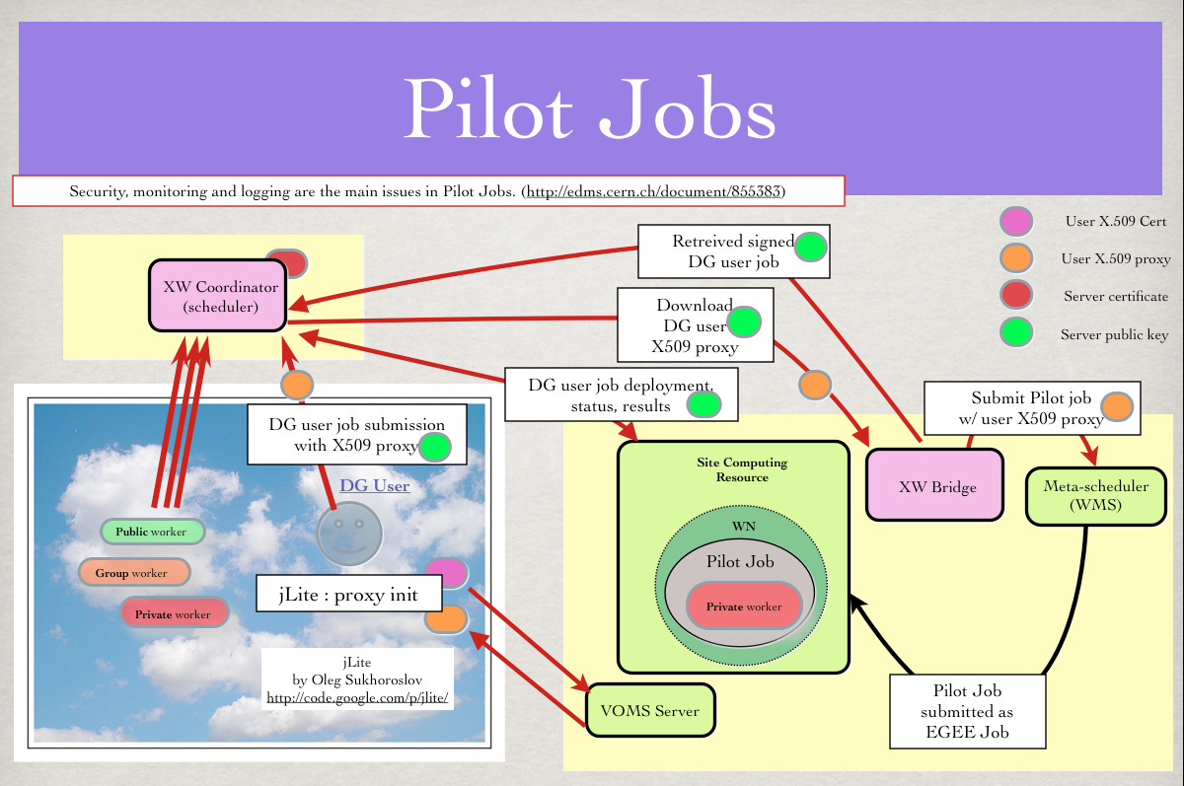Figure 11: XWHEP Pilot Jobs

Usage of SG resources by the XWHEP bridge
One can easily understand that there may be a resource overbooking. Since there are delays in the submission path, it may happen that the XWHEP bridge submits a pilot job that will start up after all jobs have been computed by other resources. Our experience shows that gLite resources are effectively used at an average rate of 75% by our XWHEP bridge. Figure 12 shows resources usage:
- The blue line shows the amount of jobs submitted with an X509 proxy, hence able to be computed by any gLite resources.
- The green line shows the total amount of completed jobs, independently of their submission type (with or without X509 proxy), hence computed by XWHEP and gLite resources.
- The red line shows job failures (data unavailable etc).

This figure also shows two different bar types : a black and a blue one.
- The black bar shows the amount of connected gLite resources. These resources are allocated when the XWHEP-->gLite bridge has found XWHEP jobs submitted with X509 proxy. When such a job is found, the XWHEP bridge downloads the end user proxy and uses it to submit an XWHEP pilot job to gLite (a pilot job being an XWHEP worker that will connect to the XWHEP server and request an XWHEP job to compute).
- The blue bar shows the amount of job effectively computed by gLite resources.
Figure 12: XWHEP: Snapshots of job running in both DG and SG

Offering and billing
Since XWHEP version 9, the middleware contains all necessary services and protocols to propose offering and billing mechanisms.

Requirements
The Offering and Billing module for XtremWeb-HEP should be flexible, and should provision :
- several Customers, Tariff plans, Taxes and Metrics,
- several Contracts : each Contract associates a unique Customer and a unique Tariff plan,
- the history of details for Customers, Tariff plans and Taxes.

Each Customer keeps its Contracts, even if the Customer details (name, address, VAT number, XtremWeb-HEP account, balance...) evolves.
The Customer details keeps, for each Customer, its details with their validity period :
- At any one time, each Customer is described by exactly 1 Customer property list,
- The Customer details keeps the start date of each Customer property list.

In case of evolution, we have to establish a new Customer property list, with a given start date.
A Tariff plan is a stable commercial name for a Tariff subscribed to by a Customer for a Contract, even if the fares and rates may evolve :
- At any one time, each Contract is associated to exactly 1 Tariff plan,
- From time to time, a Customer may voluntarily choose another Tariff plan for a Contract,
- The tariff plan should contain the SLA items for which there is no associated metric, in particular the maximum number of simultaneous tasks.

The Tariff details keeps, for each Tariff plan, its details with their validity period :
- At any one time, a Tariff plan is implemented simultaneously for all its associated contracts by exactly 1 Tariff list,
- As a consequence, at any one time, each Contract is associated to exactly 1 Tariff list,
- A Tariff list takes into account several Metrics,
- A Tariff defines, for each Metric :
  - an immutable package fare for a certain amount of resources and/or
  - an immutable proportional fare for usage beyond the package.
- The Tariff details keeps the start date of each Tariff.

In case of fare and/or rate evolution for a Tariff plan, we have to establish a new Tariff list, with a given start date. Each Tax keeps its name, even if the Tax details (level, rate) evolves. The Tax details keeps, for each Tax, its details with their validity period :
- At any one time, the legal taxes are implemented by exactly 1 Taxes list,
- Each Tax has a level : For example, it is often needed to apply local taxes on the price excluding tax, and then VAT on the sum,
- The Tax details keeps the start date of each Tax list.

In case of tax evolution, we have to establish a new Tax list, with a given start date. Each Contract keeps the start and end dates of each Tariff plan subscribed by each Customer.
For each Metric, we have to :
- define the list of applicable taxes,
- define the standard duration of a measurement,
- make measurements for contiguous periods of time,
- store each measurement with its start time and the duration of the associated period of time.

This permits, at any one time, to reproducibly calculate the bill for a Contract with the fares and taxes which were applicable at the time of resource usage.

Specifications

Types of Metrics
- The 'apps' and 'works' tables should both contain Offering Metrics, whose value is known before any task run,
- The 'works' table should also contain Billing Metrics, whose value is known after the end of the work.

Offering Metrics
These metrics specify resource characteristics required by the application (independently of any specific work), or by the work (with higher values). For example, an application may require 512 MB RAM, and a specific work processing much data may require 3.000 MB RAM.
- minMemory : Minimum amount of RAM per core (in MB),
- minCPUSpeed : Minimum CPU speed (in MHz),
- minFreeMassStorage : Minimum free mass storage (in GB),
- maxWallClockTime : Maximum wall clock time (in seconds) only for works,
- apps.minFreeMassStorage is calculated using the sum of 'datas.size' of following pointers :
- defaultStdinURI : STDIN if not provided by the work,
- baseDirinURI : Input files which are always sent with the work,
- defaultDirinURI : Additional input files if not provided by the work,
- max of 'datas.size' of all binary URIs,
- max of 'datas.size' of all library URIs.

works.minFreeMassStorage has a minimum value calculated using 'datas.size' of pointers from the 'apps' table and 'datas.size' of following pointers:
- stdinURI : overrides 'apps.defaultStdinURI',
- dirinURI : overrides 'apps.defaultDirinURI'.

This metric may be provided by the submitter of the work in order to reserve storage space also for output files.

Billing Metrics
These metrics provide real resource consumption the work :
- status : Depending on work status and SLA, the work will be billed or not,
- resultURI : Its 'datas.size' is the global size of all output files,
- (compenddate – compstartdate) : Wall clock duration of the work.

Contacts for XWHEP
If you need help, you can contact the XWHEP team: xtremweb (at) lal.in2p3.fr

XWHEP website: http://www.xtremweb-hep.org

You can find RPM and Mac OS X packages at this address:
http://www.xtremweb-hep.org/spip.php?article52

Search page for Virtual Organizations managing SG members for access to SG resources :
http://operations-portal.egi.eu/vo

Example of server permitting to request VO membership:
https://grid12.lal.in2p3.fr:8443/voms/vo.lal.in2p3.fr/Siblings.do

Third party libraries for XWHEP
jLite library:
http://code.google.com/p/jlite/

Bouncy Castle library:
http://www.bouncycastle.org/

Jetty library:
http://jetty.codehaus.org/jetty/

SmartSockets library:
http://www.cs.vu.nl/ibis/ipl.html

Index

account 19, 20
Boinc 10
Bouncy Castle 47
certificate 7, 20, 21, 29, 41
Client 16
Condor 10
Conformance Certificate 31, 37
container 37, 38, 39
credentials 19
data driven 10, 11, 16
database 20
deployable 12
Docker 37
image 39
Docker Validation Procedure 37
Ganglia 24
gLite 41, 42, 43
HOME 6
hypervisor 32
Jetty 47
jLite 47
LiveCD 34
local area network 32, 37
login 20
MD5 checksum 30
OAuth 10, 20, 21
offering and billing 10, 11
OpenId 10, 20, 21
OurGrid 10
password 20
replication 10, 11, 16
Result Collector 16
sandboxing 20
Scheduler 16
security 19, 20, 21
SmartSockets 15, 47
TLS 20, 32, 37
VDI 31
virtual disk 33
VDI 33
virtual machine 31, 32, 33
Virtualization Validation Procedure 31
Wall Clock Time 16
Worker 16
X509 10, 20, 21, 29, 41, 42, 43
X509 certificate 20, 21, 29
X509 proxy 41, 42, 43
XWHEP_HOME 6
XWHEP_VERSION 6

We call it “FlyingGrid” because this proposes a known flying object to reach the cloud
We call it “DiggingGrid” because this proposes a step toward Volunteer Grid to dig Big Data
http://www.xtremweb.net
http://www.oracle.com/technetwork/java/index.html
http://www.flyinggrid.org
Object registration is detailed in the user guide documentation.
http://jackrabbit.apache.org
http://www.gnu.org/s/wget/
http://www.cs.vu.nl/ibis/smartsockets.html
To reduce bandwidth usage, the worker manages a local cache in least recently used (LRU) mode. Each time the computer is restarted, the worker automatically cleans this local cache. This ensures that the worker does not use to much local disk space, but the worker may then sometimes need to download the same file from run to run.
http://www.atticfs.org/
http://en.wikipedia.org/wiki/OpenID
“write” includes “modify” and “delete”.
http://ganglia.sourceforge.net/
http://www.bitdew.net/
http://en.wikipedia.org/wiki/Virtual_disk_image
http://www.virtualbox.org
http://www.scientificlinux.org
http://en.wikipedia.org/wiki/sudo
http://en.wikipedia.org/wiki/Hypervisor
http://en.wikipedia.org/wiki/Live_CD
https://docs.docker.com/glossary/?term=image
http://www.docker.com
http://en.wikipedia.org/wiki/sudo

