XtremWeb-HEP 9
“DiggingGrid”
Resource Provider Guide
Version 1.5.0

Table of Contents
1 Introduction 3
1.1 Audience 3
1.2 Software license agreement 4
1.3 Reading conventions 4
1.4 Middleware Versioning 4
1.5 Documentation Versioning 5
1.5.1 Version 1.0.0 5
1.5.2 Version 1.1.0 5
1.5.3 Version 1.2.0 5
1.5.4 Version 1.3.0 6
1.5.5 Version 1.4.0 6
2 Introduction to XtremWeb-HEP middleware 6
3 XtremWeb-HEP hardware and software requirements 6
4 XtremWeb-HEP availability 6
5 Security considerations for XtremWeb-HEP 8
5.1 Secure XtremWeb-HEP volunteer resources 8
5.1.1 Usage of a new user account inside the volunteer resource 8
5.1.2 Volunteer resource usage 8
5.2 XtremWeb-HEP secured communications 9
5.3 Authentication of XtremWeb-HEP Server and Worker 9
5.4 Authorizations managed by XtremWeb-HEP 10
6 The XtremWeb-HEP worker 11
6.1 Installation of the XtremWeb-HEP worker 11
6.1.1 Installation of the worker on Linux RPM 11
6.1.2 Installation of the worker on Linux Debian 11
6.1.3 Installation of the worker on Mac OS X 11
6.1.4 Installation of the worker on MS-Windows 12
6.2 Configuration of the XtremWeb-HEP worker 12
6.2.1 Activation policy 12
6.2.2 Configuration page 13
6.3 Usage of the XtremWeb-HEP worker 14
6.3.1 Starting the XtremWeb-HEP worker 15
6.3.1.1 Starting the worker on Linux 15
6.3.1.2 Starting the worker on Mac OS X 15
6.3.1.3 Starting the worker on MS-Windows 15
6.3.2 Stopping the XtremWeb-HEP worker 16
6.3.2.1 Stopping the worker on Linux 16
6.3.2.2 Stopping the worker on Mac OS X 16
6.3.2.3 Stopping the worker on MS-Windows 16
6.3.3 Restarting the XtremWeb-HEP worker 17
6.3.3.1 Restarting the worker on Linux 17
6.3.3.2 Restarting the worker on Mac OS X 17
6.3.3.3 Restarting the worker on MS-Windows 17
6.4 Removing the XtremWeb-HEP worker 18
6.4.1 Removing the worker on Linux RPM 18
6.4.2 Removing the worker on Linux Debian 18
6.4.3 Removing the worker on Mac OS X 18
6.4.4 Removing the worker on Microsoft Windows 18
6.5 Logging the Xtremweb-HEP worker 19
6.5.1 Logging on Linux and Apple Mac OS X 19
6.5.2 Logging on Microsoft Windows 19
7 Attributes of the XtremWeb-HEP Worker 20
7.1 Introduction to attributes of the XtremWeb-HEP Worker 20
7.2 Properties list of the XtremWeb-HEP Worker 20
8 Contacts for XtremWeb-HEP 29
9 Third party libraries for XtremWeb-HEP 29
10 Index 30

Table of Figures
Figure 1: The worker configuration page 14
Figure 2: Microsoft Windows: Computer manager window 15
Figure 3: Start the worker NT service 16
Figure 4: Stop the worker NT service 17
Figure 5: Uninstall the Worker from Windows 19

Introduction

This document is part of the XtremWeb-HEP middleware documentation which contains different documents: “XtremWeb-HEP Introduction”, “XtremWeb-HEP User Guide”, “XtremWeb-HEP Administrator Guide”, “XtremWeb-HEP Programmer Guide” and this one, “XtremWeb-HEP Resource Provider Guide”.

The name “XtremWeb-HEP” is shortened as “XWHEP”.
The XtremWeb-HEP version 8 is designated as “FlyingGrid ”
The XtremWeb-HEP version 9 is designated as “DiggingGrid ”

Please note that the documentation versioning is different from the middleware one.
On Novembre 2014, the documentation is made of:
- “XtremWeb-HEP Introduction” 1.5.0;
- “XtremWeb-HEP Programmer Guide” 1.5.0;
- “XtremWeb-HEP Administrator Guide” 1.8.0;
- “XtremWeb-HEP User Guide” 1.10.0;
- “XtremWeb-HEP Resource Provider Guide” 1.5.0.

Audience

Anyone (such as a volunteer) who would like to contribute by providing CPU resources to the XtremWeb-HEP middleware should read this document.

The reader is invited to first read the “XtremWeb-HEP Introduction” document.

This document specifically introduces the 'worker' component of the XtremWeb-HEP middleware, and details its installation and management.

With this document, as resource provider of an XtremWeb-HEP deployment, the reader will learn to manage an XtremWeb-HEP worker.

Software license agreement

XtremWeb-HEP (XWHEP) is an open source software provided under the GPL2 license (http://www.gnu.org/licenses/gpl-2.0.html).

BECAUSE THE PROGRAM IS LICENSED FREE OF CHARGE, THERE IS NO WARRANTY FOR THE PROGRAM, TO THE EXTENT PERMITTED BY APPLICABLE LAW. EXCEPT WHEN OTHERWISE STATED IN WRITING THE COPYRIGHT HOLDERS AND/OR OTHER PARTIES PROVIDE THE PROGRAM "AS IS" WITHOUT WARRANTY OF ANY KIND, EITHER EXPRESSED OR IMPLIED, INCLUDING, BUT NOT LIMITED TO, THE IMPLIED WARRANTIES OF MERCHANTABILITY AND FITNESS FOR A PARTICULAR PURPOSE. THE ENTIRE RISK AS TO THE QUALITY AND PERFORMANCE OF THE PROGRAM IS WITH YOU. SHOULD THE PROGRAM PROVE DEFECTIVE, YOU ASSUME THE COST OF ALL NECESSARY SERVICING, REPAIR OR CORRECTION.

IN NO EVENT UNLESS REQUIRED BY APPLICABLE LAW OR AGREED TO IN WRITING WILL ANY COPYRIGHT HOLDER, OR ANY OTHER PARTY WHO MAY MODIFY AND/OR REDISTRIBUTE THE PROGRAM AS PERMITTED ABOVE, BE LIABLE TO YOU FOR DAMAGES, INCLUDING ANY GENERAL, SPECIAL, INCIDENTAL OR CONSEQUENTIAL DAMAGES ARISING OUT OF THE USE OR INABILITY TO USE THE PROGRAM (INCLUDING BUT NOT LIMITED TO LOSS OF DATA OR DATA BEING RENDERED INACCURATE OR LOSSES SUSTAINED BY YOU OR THIRD PARTIES OR A FAILURE OF THE PROGRAM TO OPERATE WITH ANY OTHER PROGRAMS), EVEN IF SUCH HOLDER OR OTHER PARTY HAS BEEN ADVISED OF THE POSSIBILITY OF SUCH DAMAGES.

Reading conventions

Code examples appear in grey boxes
$> ./proxy-init.sh desktopgrid.vo.edges-grid.eu
Enter your private key passphrase:
Created VOMS proxy: O=GRID-FR,C=FR,O=CNRS,OU=LAL,CN=Oleg Lodygensky,CN=proxy
Proxy is valid until: Fri Nov 19 21:59:37 2010 CET
Proxy location: /var/folders/0R/0RQqVNNAEpqqeXUidaIL0++++TM/-Tmp-/x509up_u_mboleg

Variables appear in courier font, within '${' and '}', just as “${VARIABLE}”. They should be replaced by their values.

Some variables used in this document:
${XWHEP_VERSION} is the current version of our middleware
${XWHEP_HOME} is the directory where the middleware is installed
${HOME} is the user home directory

Sometimes there are some inputs the reader must provide. These appear in courier font, within '<' and '>', just as “<your input>”.

Middleware Versioning

Middleware versioning is as follow
- X is the major part of the version
- Y is the minor part of the version
- Z is the micro part of the version

(*) X reports a very important change: for example the communication protocol changes or a major new feature is modified/introduced/removed
When X changes, backward compatibility is not ensured

(*) Y reports an important but not critical change: backward compatibility is ensured

(*) Z reports a minor change: bug correction, documentation changes etc.

In June 2013, the last version of XtremWeb-HEP is 8.2.2.
In this document we refer that version as the current version and refer it as ${XWHEP_VERSION}.

Documentation Versioning

Documentation versioning is as follows:
- X is the major part of the version
- Y is the minor part of the version
- Z is the micro part of the version

Version 1.0.0

Date: Sept, 2011
Authors: O. Lodygensky
Reviewers: E. URBAH

Initial document.

Version 1.1.0

Date: July 17th, 2012
Authors: O. Lodygensky
Reviewers:

Merging with the “extended resource provider”.

Version 1.2.0

Date: December 3rd, 2012
Authors: O. Lodygensky
Reviewers:

Introducing new configuration variable: forcenewuid.

Version 1.3.0
Date: October 16th, 2013
Authors: O. Lodygensky
Reviewers:

- Introducing the smartsocketshubaddr configuration variable

Version 1.4.0
Date: June 18th, 2014
Authors: O. Lodygensky
Reviewers:

- Introducing XWHEP version 9.

Version 1.5.0
Date: November 11th, 2014
Authors: O. Lodygensky
Reviewers:

- Introducing new configuration variables.

Introduction to XtremWeb-HEP middleware

The XtremWeb-HEP (XWHEP) middleware is introduced in the “XtremWeb-HEP Introduction” document. The reader is invited to refer to that document.

The current document presents the worker part of the XWHEP middleware. This XWHEP worker provides CPU power to a given XWHEP server. Deploying that worker, the XWHEP infrastructure can propose aggregated CPU from volunteer resources to compute end users jobs. Next chapters detail the installation, configuration and usage of the worker provided by an XWHEP server.

XtremWeb-HEP hardware and software requirements

The XWHEP middleware, written in Java 1.6 computing language, is highly portable.

To run the worker component of the middleware, you need:
- an internet connected machine running Linux, MS-Windows or Mac OS X
- java runtime environment 1.6 or above

XtremWeb-HEP availability

The XWHEP middleware is available as “source” and “binary” distributions.

Security considerations for XtremWeb-HEP

The middleware ensures security at different levels. In this chapter, we detail security in the worker-server interaction, where the middleware must ensure there is no malicious usage of the platform that could endanger the aggregated volunteer resources.

Securing volunteer resources involves mechanisms securing both sides:
- ensure the integrity of volunteer resources against potentially malicious or erroneous codes;
- avoid intrusion inside the XWHEP server from unknown and untrusted volunteer resources that the XWHEP server has aggregated.

Secure XtremWeb-HEP volunteer resources

Securing volunteer resource first consists on ensuring their integrity.

Usage of a new user account inside the volunteer resource

The different components of the XWHEP middleware run on distributed computing resources. To do so, a local account is used on each computer. The worker component runs as “daemon”, a program that runs indefinitely in the background, and not under the direct control of a user. For security reasons, the installation package of the XWHEP worker does not install this worker under privileged user account, but under a non privileged user account.
This account is automatically created by the installation package of the XWHEP worker.

Volunteer resource usage

The XWHEP server aggregates volunteer resources to execute binary codes.
These codes are inserted into the XWHEP server by a so called “Application Validation Procedure” and application submitters sign a “Conformance Certificate” that engages their responsibility.

This engagement being not perfectly satisfying, the middleware still has to protect volunteer resources against not only malicious but also erroneous codes. This is done by using “sandboxing ” technology.

The installer of the XWHEP worker for Apple Mac OS X installer is the only one that automatically configures the worker to use sandboxing. Please refer to chapter 7.
On other platforms, the volunteer resource owner may edit the configuration of its worker and set its preferred sandboxing technology.

The volunteer resource owner may also accept to run only Java codes and refuse binary codes by setting the “acceptbin” configuration variable to false. Please see chapter 7.

XtremWeb-HEP secured communications

As sensitive data may be transferred in the network, the XWHEP middleware systematically ensures communications privacy by using TLS encryption. This ensures security by using encryption and by identifying communicating entities.

Authentication of XtremWeb-HEP Server and Worker

Each part of the XWHEP middleware must access to some different components. It must be clearly understood that these accesses need to pass different security barriers. The different accounts need to present “credentials” to pass these security barriers.
The middleware itself introduces a new account type needed to access the platform: register applications and data, submit jobs etc. When connecting to an XWHEP service, distributed parts must present valid credentials (usually an X509 certificate). These credentials permit to determine if that connection is authorized and what actions are permitted.

Server authentication is implemented by the usage of an electronic key pair: the server private key is securely stored on server side, and the server public key is enclosed inside the installation package of the worker.
This permits to certify the server identity: distributed XWHEP components establish a session with a Server only if this server proves that it owns the private key corresponding to the public key.
On the other side, the server doesn't accept connection without receiving its own public key.

Being connected to the server is not sufficient for a worker to execute a request on server side. Each worker must present valid credentials so that the server can securely identify who is connecting.
In XWHEP, two credential types are accepted by the server:
- login/password
- X509 certificate

The worker, which runs on a volunteer resource, doesn't use certificate but login/password only. Login and password are stored in the worker configuration file.
The fact that workers are distributed with their login and password on unknown and untrusted resources could be seen as a security hole.
This is solved as explained in next section.

Authorizations managed by XtremWeb-HEP

Being authenticated by the server is not sufficient for a worker to execute a request on server side. Each authenticated entity has an usage level called “user rights” that defines authorization.
Authorization allows or denies execution of requested action.

It is the administrator responsibility to ensure that credentials associated to the login and password distributed to workers have the user rights: worker_user.

Presenting an identity associated with this user rights, one can:
- never list anything (list_app, list_data etc.)
- never insert anything (insert_app, insert_data etc.)
- never delete anything (delete_app, delete_data etc.)
- ask for a pending job
- send a heartbeat signal
- retrieve and download objects by providing their unique identifier (UID)
- upload result for the job it has computed (this is checked by the server)

This strictly limits possible actions when a distributed part presents login and password as found from the worker configuration file.

Hence downloading and installing a worker on a resource does not give full access to the resource, but only permits to provide CPU power.

The XtremWeb-HEP worker

This chapter details the XWHEP worker installation and configuration.

Installation of the XtremWeb-HEP worker

This section details how to install the XWHEP worker for different platforms.
You need administrator rights to install the worker package.

- You should definitely not install more than one worker in a single machine.

- You must not copy an installed worker from one machine to another one.
Please use only the installation package.

Installation of the worker on Linux RPM

To install the worker on a platform using RPM, please use the command:

$> rpm -i xwhep-worker-${XWHEP_VERSION}-1.noarch.rpm

This installs:
- /etc/init.d/xtremweb.worker
- /opt/xwhep-worker-${XWHEP_VERSION}

Installation of the worker on Linux Debian

To install the worker on a Debian platform, please use the command:

$> dpkg -i xwhep-worker-${XWHEP_VERSION}.deb

This installs:
- /etc/init.d/xtremweb.worker
- /opt/xwhep-worker-${XWHEP_VERSION}

Installation of the worker on Mac OS X

To install the worker on a Mac OS X platform, the easiest way is to double click on the package and follow the instructions. You can also use the command:

$> sudo installer -pkg xwhep-worker-${XWHEP_VERSION}.mpkg -target /

This installs:
- /Applications/xwhep.worker/
- /Library/LaucnDaemons/fr.in2p3.lal.xwhep.worker.plist
- /private/etc/xwhep.worker/
- /usr/local/bin/xwhep.worker/xtremweb.worker

Installation of the worker on MS-Windows

To install the worker on an MS-Windows platform, the easiest way is to double click on the package and follow the instructions.

This installs:
- c:\Program Files\CNRS\XtremWeb Worker\

Configuration of the XtremWeb-HEP worker

Running the XWHEP worker requires a configuration file. The worker installation package has installed a default one containing all necessary configuration attributes.
This default configuration file can be found there:
${XWHEP_HOME}/conf/xtremweb.worker.conf

The worker configuration file content is detailed in chapter 7.

Activation policy

The worker provides the volunteer resource power accordingly to a local activation policy that the resource owner may customize.

There are two possible activation policies:
- 'always' policy where the volunteer proposes its cpu at any time;
- 'date' policy where the volunteer resource proposes its cpu at predefined spans of time.

The date policy reads scheduled spans from the “activator.date” configuration variable. This variable contains a string determining date/time spans 'a la' crontab. Span may define days of week and hours of day. Several comma separated spans may be provided

Field grammar:
- '*' : every possible values
- <x> : a unic value
- <x-y>: a pair of values separated by an hyphen ('-') defining a span from x to y

Two fields are allowed:

- 1st field defines days of week
- '*' for every day
- '1', 'Sun' or 'Sunday'
- '2', 'Mon' or 'Monday'
- …
- '7', 'Sat' or 'Saturday'

- <N-M> a couple (of integers or Strings) defining days from N to M

- 2nd field defines hours
- '*' every hour
- <N> an integer defining a complete hour (0 <= N <= 23)
- <N-M> a cpair of integers defining hours from N:00 to M:59 (0,0 <= N,M <= 23,23)

Examples:

One span only:

- * * : every days, full day
- * 1 : every days, from 1:00AM to 1:59AM
- * 11-17 : every days, from 11:00AM to 5:59PM
- 1 * : every Sunday, full day
- Thu * : every Thursday, full day
- 2-Thu * : from Monday to Thursday, full day
- 5-2 * : from Thursday to Monday, full day
- Thu-Tue 18-3 : from Thursday to Tuesday, from 6:00PM to 3:59AM

Two spans at a time:

- Thu-Tue 18-3, Sat-Sun *: from Thursday to Tuesday, from 6:00PM to 3:59AM and every week end, full day

Configuration page

The worker comes with an embedded web server run by Jetty to server its configuration page.

The resource owner may access its worker configuration page using a its preferred web browser at: http://localhost:4324/.
This opens the page shown in figure 1. This page may look different since it may have been customized by administrator of the XWHEP platform. The one shown here is the default configuration page.

The upper part has a “Stop the worker now” link where you can click to immediately stops your worker.
This does not uninstall the worker. If you really want to uninstall the worker, please see the chapter 6.4.

The left part shows the “Summary” presenting informations send to the server: the worker UID (its unique identifier) and some information on the hardware (CPU, RAM, OS, ...).
The right part show the “Configuration” where the resource owner may customize its worker:
- Max run: you can set the amount of job to compute. If set, the worker will stop after computing that amount of jobs. You must click “Set max” to change the value.
- Activation policy: this drop down menu contains two items:

Please note the contextual help in the upper part of the page when you change the item

  - Always: to propose your cpu as needed by the platform
  - crontab: you can set hour spans when the worker will have the right to propose your cpu to the platform

Please click in the text area to see the contextual help in the upper part of the page

  - You must click “set activator”

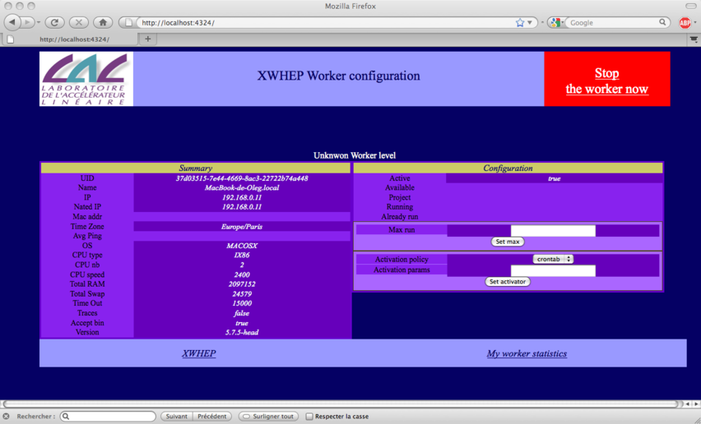Figure 1: The worker configuration page

Usage of the XtremWeb-HEP worker

As soon as the worker package has been installed and configured as described in chapter6.2, the worker is running.
The worker runs as daemon and automatically starts at boot time; administrator privileges are needed to manually stop/start the server.

Starting the XtremWeb-HEP worker

This section gives the command to start the worker for different platforms.

Starting the worker on Linux

On Linux (both RPM or Debian), the command to start the worker is:
$> sudo /etc/init.d/xtremweb.worker start

Starting the worker on Mac OS X

On Apple Mac OS X, the command to start the worker is:
$> sudo /Application/xwhep.worker/bin/start.sh

Starting the worker on MS-Windows

On MS-Windows, you must open the “Computer manager window” as shown in figure 2 (the snapshots are in French, sorry...) to start the worker.

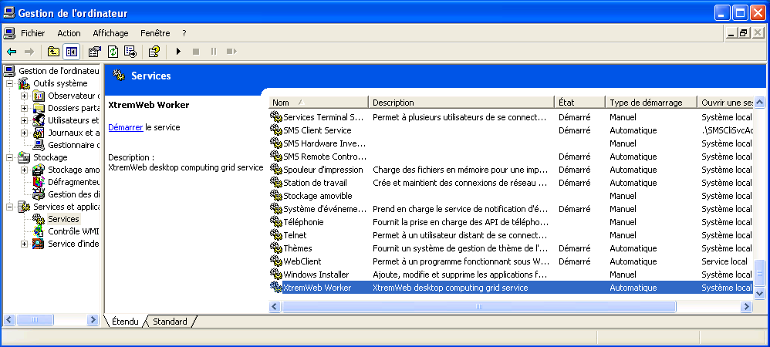Figure 2: Microsoft Windows: Computer manager window
On the left panel, click on “Services and Applications”, then on “Services”.
Then, on the right panel scroll to “XtremWeb Worker”.

If the worker is not started yet, click on “Start the service” as shown in figure 3.

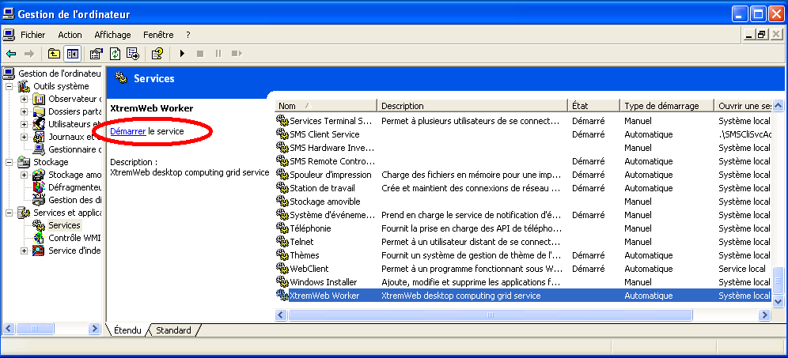Figure 3: Start the worker NT service

Stopping the XtremWeb-HEP worker

This section gives the command to stop the worker for different platforms.

Stopping the worker on Linux

On Linux (both RPM or Debian), the command to stop the worker is:
$> sudo /etc/init.d/xtremweb.worker stop

Stopping the worker on Mac OS X

On Apple Mac OS X, the command to stop the worker is:
$> sudo /Application/xwhep.worker/bin/stop.sh

Stopping the worker on MS-Windows

On MS-Windows, you must open the “Computer manager window” as shown in figure 2 (the snapshots are in French, sorry...) to stop the worker.
On the left panel, click on “Services and Applications”, then on “Services”.
Then, on the right panel scroll to “XtremWeb Worker”.

If the worker is started, click on “Stop the service” as shown in figure 4.

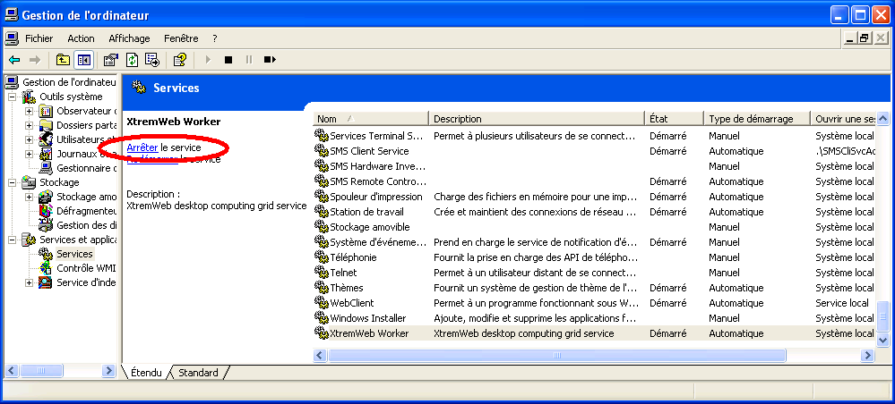Figure 4: Stop the worker NT service

Restarting the XtremWeb-HEP worker

This section gives the command to restart the worker for different platforms.

Restarting the worker on Linux

On Linux (both RPM or Debian), the command to restart the worker is:
$> sudo /etc/init.d/xtremweb.worker restart

Restarting the worker on Mac OS X

On Apple Mac OS X, there is no specific command: you must stop then start the worker as explained above.

Restarting the worker on MS-Windows

On MS-Windows, you must do what is described in section 6.3.2.3, but click “Restart the service” instead of “Stop the service”.

Removing the XtremWeb-HEP worker

This section details how to remove the XWHEP worker from different platforms.
You need administrator rights to remove the worker package.

Removing the worker on Linux RPM

To remove the worker from a platform using RPM, please use the command:

$> rpm -e xwhep-worker-${XWHEP_VERSION}

Removing the worker on Linux Debian

To remove the worker from a Debian platform, please use the command:

$> dpkg -r xwhep-worker-${XWHEP_VERSION}

Removing the worker on Mac OS X

To remove the worker from an Mac OS X platform, please use the command:

$> sudo /Application/xwhep.server/bin/uninstall.sh

Removing the worker on Microsoft Windows

To remove the worker from an MS-Windows platform, please go to the folder:
- c:\Program Files\CNRS\XtremWeb Worker\

Then double-click on “UninstallXWWorker-NT.bat” as shown in figure 5.

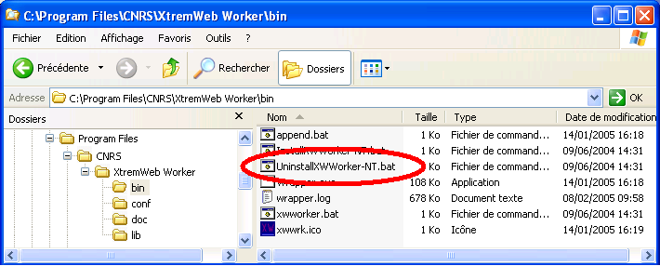Figure 5: Uninstall the Worker from Windows
Finally, delete the “XtremWeb Worker” folder.

Logging the Xtremweb-HEP worker

The middleware writes events on a log file in order to post analyse its behaviour.

Logging on Linux and Apple Mac OS X

The XWHEP worker log file is /var/log/xtremweb.worker-${HOSTNAME}.log.
Where HOSTNAME is the name of the machine where the worker is launched.

Logging on Microsoft Windows

The XWHEP worker log file is
- c:\Program Files\CNRS\XtremWeb Worker\xtremweb.worker-${HOSTNAME}.log.

Where HOSTNAME is the name of the machine where the worker is launched.

Attributes of the XtremWeb-HEP Worker

The XWHEP worker is configurable. It reads its configuration from a text file as explained in chapter 6.2. You should not need to edit or modify your worker configuration.
The attributes found in the configuration file can easily be overridden by setting environment variables.

Introduction to attributes of the XtremWeb-HEP Worker

This chapter lists all worker attributes. You may modify them in the configuration file or more preferably set environment variables.
One may note that a configuration file may contain some more attributes that are not listed below. This is due to the fact that the middleware stores all attribute values in the config file, even those that are not suitable to a specific part (with empty or default values). The attributes not listed below are not used by the worker part of the middleware.
We provide them here mainly as general purpose information and also since it could be useful under certain circumstances.

The list is formatted as follows:

property name
Type : property type (e.g. String)
Access : public | auto | restricted | private
public: may be edited
auto: is automatically overridden by the middleware
restricted: should not be edited by the user
private: must not be edited by the user
Default : default value (e.g. null)
Purpose : explanation
Since : XWHEP version

Properties list of the XtremWeb-HEP Worker

role
Type : string
Access : private
Default : worker
Purpose : this defines the role of an XWHEP component

config
Type : String
Access : restricted
Purpose : this is the path of the configuration file

project
Type : string
Access : public
Default : null
Purpose : this restricts a worker to a group only

launcherurl
Type : string
Access : private
Default : null
Purpose : this is the URL where the worker can find new version of the middleware

dispatchers
Type : String
Access : public
Default : null
Purpose : this is a comma separated list of XWHEP servers to connect to

dataservers
Type : String
Access : public
Default : dispatcher.servers
Purpose : this is a comma separated list of XWHEP servers to connect to

cache
Type : string
Access : restricted
Default : temporary directory
Purpose : this defines the directory where the middleware stores local files

commLayer
Type : string
Access : restricted
Default : null
Purpose : this identifies communication layers

commHandlers
Type : string
Access : restricted
Default : null
purpose : comma separated list of colon separated tuples of scheme/handler.
e.g.: “xw:xtremweb.communications.tcpcient,http:org.apache.commons.httpclient.httpclient”

login
Type : string
Access : restricted
Purpose : this is the login to connect to the XWHEP server

password
Type : string
Access : restricted
Purpose : this is the password to connect to XWHEP server

javanio
Type : boolean
Access : restricted
Default : true
Purpose : if true, use java new i/o

tcpPORT
Type : integer
Access : public
Default : 4321
Purpose : this is the tcp port distributed parts must connect to

tcpsport
Type : integer
Access : public
Default : 4322
Purpose : this is the secured tcp port distributed parts must connect to

udpport
Type : integer
Access : public
Default : 4323
Purpose : this is the udp port distributed parts must connect to

httpworkerport
Type : integer
Access : public
Default : 4324
Purpose : this is the port workers are listening to for administrative procedures

httpport
Type : integer
Access : public
Default : 80
Purpose : this is the http port distributed parts must connect to

httpsport
Type : integer
Access : public
Default : 443
Purpose : this is the secured http port distributed parts must connect to

xmlrpcport
Type : integer
Access : public
Default : 4327
Purpose : this is the xmrlrpc port distributed parts must connect to

sunrpcport
Type : integer
Access : public
Default : 4328
Purpose : this is the sun rpc proxy port

proxyport
Type : integer
Access : public
Default : -1
Purpose : this is the proxy port

proxyserver
Type : integer
Access : public
Default : null
Purpose : this is the proxy address

server.http
Type : boolean
Access : public
Default : false
Purpose : if true, the embedded http server is started

homedir
Type : string
Access : public
Purpose : this is the directory where xwhep part may store objects

tmpdir
Type : string
Access : public
Default : system.getproperty(“java.io.tmp”)
Purpose : this is the temporary directory

cachesize
Type : integer
Access : public
Default : 1000
Purpose : this is maximum entry amount the cache may store

sslkeystore
Type : string
Access : public
Purpose : this is the keystore file path

sslkeypassphrase
Type : string
Access : public
Purpose : this is the keystore passphrase

sslkeypassword
Type : string
Access : public
Purpose : this is the keystore password

optimizedisk
Type : boolean
Access : private
Default : true
Purpose : this tells if the middleware should try to optimize disk usage

optimizenetwork
Type : boolean
Access : private
Default : true
Purpose : this tells if the middleware should try to optimize network usage

milestones
Type : string
Access : public
Default : null
Purpose : this is the name of the package to milestone in order to check software efficiency

loggerlevel
Type : string
Access : public
Default : warn
Purpose : this is the logger level; may be (from the most to the least verbose): “finest”, “debug”, “config”, “info”, “warn” or “error”

uid
Type : unique identifier
Access : auto
Default : null
Purpose : this is the worker uid as defined on server side

forcenewuid
Type : boolean
Access : auto
Default : false
Purpose : this tells if the worker should generate a new uid, overriding the one found from config file, if any. This is especially useful when sharing configuration file in a shared file system, which is common on cloud resources for instance. If this is true, generated uid is not saved in configuration file.

workpoolsize
Type : integer
Access : public
Default : the amount of detected cpu
Purpose : this is the allowed amount of simultaneous jobs;

activatorclass
Type : string
Access : public
Default : xtremweb.worker.alwaysactive
Purpose : this is the class name that implements the activator to detect activation policy; please refer to chapter 6.2.1

activatordate
Type : string
Access : public
Default : null
Purpose : this is used to define spans where the volunteer resource may propose its cpu to compute jobs. This is only used with the dateactivator. please refer to chapter 6.2.1

computingjobs
Type : integer
Access : public
Default : -1
Purpose : how many jobs to computing before stopping the worker. the default value indicates to never stop the worker

timeout
Type : integer
Access : public
Default : 15000
Purpose : this is the timeout to wait between to work requests in milliseconds. this timeout is multiplied by 2 between two unsuccessful requests (workrequest returned no job) up to 4 times so that the maximum delay between two requests is (4 * timeout).
setting less than 10 is a very special case: the so called “real time” case where the worker writes no files to disk. hence if it crashes, it will not be able to recover all informations.

sotimeout
Type : integer
Access : public
Default : 60000
Purpose : this is the socket timeout in milliseconds. Setting it to zero means wait for ever; it is at your own risk, keep in mind that Zero may block the worker for ever.

soretry
Type : integer
Access : public
Default : 50
Purpose : This defines how many times we keep trying on socket timeout. This is forced to default value if less than 1

nooptimeout
Type : integer
Access : public
Default : -1
Purpose : This is the max timeout to wait for a job. If no job received within this time out, the worker stops. This is especially used to deploy workers over Service Grids, so that we don't use a machine for nothing. A value less than one means wait forever

acceptbin
Type : boolean
Access : public
Default : true
Purpose : this tells if the worker accepts to download and execute binary code. If set to false, the worker refuses binary codes (but still accept Java ones).

sandboxenabled
Type : boolean
Access : public
Default : true
Purpose : this tells if the worker should try to use sandboxing to confine job execution

sandboxpath
Type : string
Access : public
Default : “/usr/bin/sandbox-exec”, on mac os x
Purpose : this is the path to the sandbox program

sandboxargs
Type : string
Access : public
Default : “-f /usr/share/sandbox/xgridagentd_task_nobody.sb”, on mac os x
Purpose : this is the sandbox command line argument

sgid
Type : uuid
Access : auto
Default : null
Purpose : this is the service grid unique identifier. This is automatically set by the worker, if available

jobid
Type : uuid
Access : public
Default : null
Purpose : this is the unique identifier of the job this worker must first compute; this is used in the context of “spequlos ” by inria

batchid
Type : uuid
Access : public
Default : null
Purpose : this is the unique identifier of the bag of tasks this worker must first compute; this is used in the context of “spequlos” by inria

incomingconnections
Type : boolean
Access : public
Default : true
Purpose : this allows the usage of SmartSocket to create communication tunnels. This does not modify the volunteer resource firewall configuration in any manner
Since : 8.0.0

sharedapps
Type : comma separated list of application types
Access : public
Default : null
Purpose : this list the volunteer resource shared applications. The worker checks if these applications are the expected ones. This must contains known application typeThis is used by the scheduler.
Since : 8.0.0
See : xtremweb.common.AppType

sharedpackages
Type : comma separated list of library names
Access : public
Default : null
Purpose : this list the volunteer resource shared libraries. This is a free text used by the scheduler.
Since : 8.0.0

shareddatas
Type : comma separated list of data names
Access : public
Default : null
Purpose : this list the volunteer resource shared data. This is a free text used by the scheduler.
Since : 8.0.0

smartsocketshubaddr
Type : string
Access : public
Default : null
Purpose : this is the smartsockets hub virtual address
Since : 8.3.2

smartsocketshubaddr
Type : string
Access : public
Default : null
Purpose : this is the smartsockets hub virtual address
Since : 8.3.2

maxramspace
Type : integer
Access : public
Default : 1 megabyte
Purpose : this is the maximum amount of ram, in kilobytes, that can be used per application and per job. The default value being one megabyte, its integer representation is then 1024 (1024 kilobytes = 1 megabyte).
Since : 9.1.0

maxdiskspace
Type : integer
Access : public
Default : 30 gigabytes
Purpose : this is the maximum amount of disk, in megabytes, that can be used per application and per job. The default value being thirty gigabytes, its integer representation is then 30720 (30720 megabytes = 30 gigabyte).
Since : 9.1.0

Contacts for XtremWeb-HEP

If you need help contact XWHEP team: xtremweb (at) lal.in2p3.fr

XWHEP website: http://www.xtremweb-hep.org

You can find installation packages at this address:
http://www.xtremweb-hep.org/spip.php?article52

Search page for Virtual Organizations managing SG members for access to SG resources :
http://operations-portal.egi.eu/vo

Example of server permitting to request VO membership:
https://grid12.lal.in2p3.fr:8443/voms/vo.lal.in2p3.fr/Siblings.do

Third party libraries for XtremWeb-HEP

jLite library:
http://code.google.com/p/jlite/

Bouncy Castle library:
http://www.bouncycastle.org/

Jetty library:
http://jetty.codehaus.org/jetty/

Index

account 8, 9
Application Validation Procedure 8
bouncycastle 29
certificate 9
Conformance Certificate 8
credentials 9
Debian 11, 15, 16, 17, 18
dpkg 11, 18
HOME 4
http://localhost:4324/ 13
Jetty 29
jLite 29
Linux 6
login 9
Mac OS X 6, 11, 18
MS-Windows 6, 12, 18
password 9
RPM 11, 15, 16, 17, 18
security 8, 9
TLS 9
X509 9
X509 certificate 9
xtremweb.worker.conf 12
XWHEP_HOME 4, 12
XWHEP_VERSION 4

We call it “FlyingGrid” because this proposes a known flying object to reach the cloud
We call it “DiggingGrid” because this proposes a step toward Volunteer Grid to dig Big Data
http://en.wikipedia.org/wiki/Sandbox_%28computer_security%29
http://jetty.codehaus.org/jetty/
http://www.lri.fr/~fedak/index.php?n=Main.SpeQuloS

