XtremWeb-HEP to EGEE bridge

The XtremWeb (XWHEP) is a Desktop Grid (DG) platform that allows users to not only use volunteer but also Service Grid (SG) ressources by proposing an innovative ressource sharing technology introduced as the bridge. An SG ressource aggregated in a DG deployment is known as a pilot job (PJ). As a proof of concept XWHEP implements the DG to EGEE bridge so that DG jobs (jobs submitted to XWHEP scheduler) can be run by both ressources, under certain circumstances.

The main key of the bridge is security. The XWHEP bridge must conform to SG security requirements, as well as logging and bookkeeping.
To achieve these goals XWHEP introduces unique DG features: authorization and access rights. These must be understood as those well known in clustering environment. Any user willing to use the platform must have valid credentials which define and ensure its identity as well as its authorizations. Those last allowing (or denying) possible actions. For example, an user may be allowed to submit jobs, but not permitted to insert applications etc. If the possibility of an action relies on user authorizations, the success of an action depends on object access rights.
In XWHEP, all objects are defined with access rights (AR). These must be seen as Linux file system ones. They are composed of three groups of three fields : read, write and execute fields for the object owner, the group members of the owner (if the owner in defined in an user group) and other users. The default AR is 0x755 which allows full access to the owner, read and execute accesses for group members, and read and execute accesses for other users. Any combination is possible. An AR set to 0x700 denies accesses to all users, but the owner: this defines a private access. An AR set to 0x750 allows full access to the owner, read and execute accesses for group members, but denies accesses to other users (non group members) : this defines a group access.

The security in SG is ensured by X509 certificates which must be signed by a known certificate authority (CA). These certificates are very sensitive datas which must be securely kept by owner. They are designed with a long term life time (generally twelve months) and must definitely never be duplicated. They are secured by a password the owner must be the only one to know. As grids delegate credentials to services, grid users can generate a short life time X509 certificate (generally twelve hours) know as X509 proxy (or simply proxy). User delegation to grid services is done by migrating proxy; this is considered as a good compromise since communications are always encrypted ensuring proxy integrity and point to point authentication. On another hand, if a proxy was to be maliciously used, its short life time would then limit the misusage.

Following these concepts, XWHEP can use X509 proxy, as any SG service since communications are encrypted and services authentication ensured by the usage of keys pair. An DG user can connect using such a proxy. The proxy is then safely transferred and copied in XWHEP data repository which ensures its integrity. The usage of this proxy being confined to the owner only thanks to XWHEP AR as explained above: in XWHEP, proxy is a private data, defined with a private access.
Finally monitoring and bookkeeping are ensured on both grids (DG and SG) since the same X509 proxy is used.

An user submitting a job to XWHEP using a proxy gains a potential access to an SG ressource. The ressource that will finally run the job is still unpredictable. It depends of ressources usage. The job will be sent to the first available one, which may be a DG one, as well as an SG one. To ensure its security and integrity, X509 proxy will never be downloaded by any XWHEP ressource, neither a volunteer one, nor a pilot job one.

The bridge is the only distributed part that uses the X509 proxy. It is a daemon (a program that loops for ever) that must be run on a machine where both XWHEP and SG client middlewares are installed. Grid administrators must ensures the bridge security and integrity since it performs some critical actions.
The bridge periodically look for XWHEP jobs submitted with a valid X09 proxy. For each job, the bridge downloads the proxy and uses it to perform SG actions necessary to start a pilot job. If the proxy is not valid, SG actions fail. The bridge does not consider this as an error since the job has then no chance to be computed on any SG ressources, but only on DG ones (and the bridge does not have to report this as an error since it does not manage DG itself). If the proxy is valid, the bridge will monitor the pilot job and report status until completion or error. To ensure the pilot job will compute proxy owner job, the bridge configures it as a private ressource : an XWHEP ressource that can only compute job for a given user. Next figure shows the full obtained platform : XWHEP and DG and the bridge.
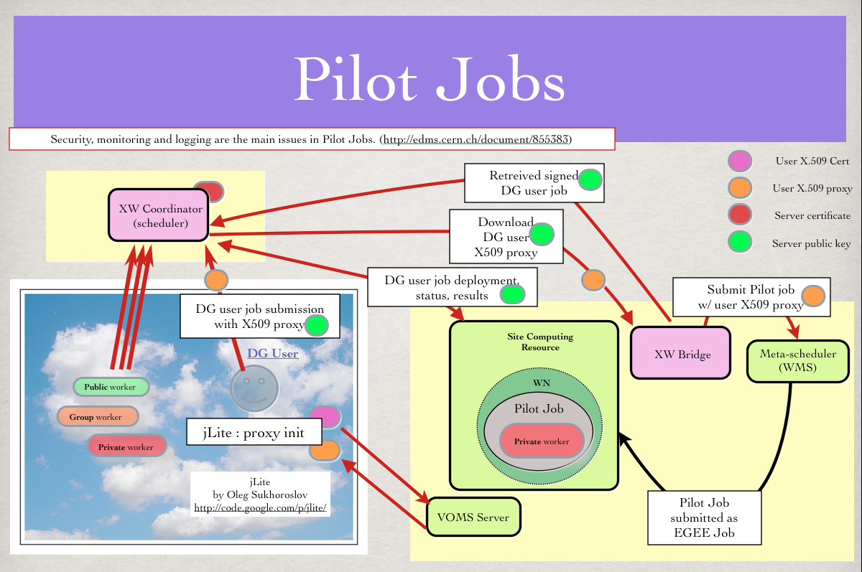

One can easily understand that there may be a ressource overbooking. Since there are delays in the submission path, it may happen that the bridge submit a pilot job that will start up after all jobs having been computed by other ressources. Our experience shows that EGEE ressources are effectively used at an average rate of 75%. Next figure shows ressources usage. The blue line represent the amount of jobs submitted with an X509 proxy -hence able to be computed by any EGEE resources. The green line represents the total amount of completed jobs, independently of their submission type (with or without X509 proxy), hence computed by XWHEP and EGEE resources. The red line represents job failures (data unavailable etc). This figure also shows two different bar types : a black and a blue one. The black one represents the amount of connected EGEE resources.This resources are allocated when the XWHEP->EGEE bridge has found XWHEP jobs submitted with X509 proxy. When such a job is found, the bridge download the end user proxy and uses it to an XWHEP pilot job to EGEE (a pilot job being an XWHEP worker that will connect to the XWHEP server and request an XWHEP job to compute). The blue bar represents the amount of job effectively computed by EGEE resources. We can see two different periods in Figure 1 : before october 2009 and since november 2009. In the first period, we were using the XWHEP->EGEE bridge version V1 ; since the second period, we use the bridge version V2. In first period we can see that the bridge unnecessarily overbooked EGEE resources which were really used in a 10% ratio only, which were just very bad. This was due to the fact that the bridge was designed to try to manage jobs from many XWHEP deployment connecting to all XWHEP server. In the second period, using the bridge V2, the average effective usage of connected EGEE resources is 75%, which is very good. this is due to the fact that the bridge does not connect to XWHEP servers, but directly to the database used by this server ; of course the bridge does not modify the database itself : it only connects to the database in read only mode to ensure that it does not perturb the server. Connecting to the database ensures a better performance rates but does not allow the management of more than one XWHEP server per bridge since database accesses are usually not allowed outside an administrative domain.

