Web Maps Connector Installation/Configuration Instructions

Contents
Web Maps Connector Installation/Configuration Instructions 1
Introduction 3
.Net Run-time environment 3
.NET and Web Proxies 5
Setting Up Source Code 7
Loading code 7
XML Configurations 8
config.xml 8
gui.xml 8
SPECIAL NOTE FOR PNI USERS: 9
Configuring SOC (optional) 9
Web Maps Connector and SIAS 10
Geocoding Style 11
Bing Maps Credentials 11
Restricting Access to Users 12
Users Based on the Windows Login Name 12
Users Based on the Smallworld Authorization User 12
Users Based on the Smallworld Authorization Group 12
Users Based on the Smallworld Authorization Rights Name 12
Clearing All Authorization Information for User access 12
Reporting and Changing Authorization List 12
Known Issues 13
Geocoding 13
Reverse Geocoding 13
Image Information 13
Using the Web Maps Toolbar 13
Using the Web Map Chooser 14
Appendix A – Using the Smallworld Style Load Editor 16

Introduction
These instructions are meant to give an administrator the key steps for installing the Web Maps Connector (WMC) in a CST 4.x SWAF environment. Examples are given with the Cambridge Demonstration Database.

.Net Run-time environment
You will need a .Net environment on the machine that runs the SW_VE_acp.exe ACP.
Review your computer’s Add/Remove Programs list and confirm that a Microsoft .NET Framework with version of at least 3.5 is present. Some installations have successfully run WMC on .NET Framework 3.0, but if you encounter any kind of .Net Security exceptions, please make sure you have .NET framework 3.5 installed on the client machines. Also, in some cases, customers have skipped the 3.5 installation and installed 4.0 instead. This has also caused .Net Security exceptions. If you have any .Net problems, please ensure that 3.5 is installed.
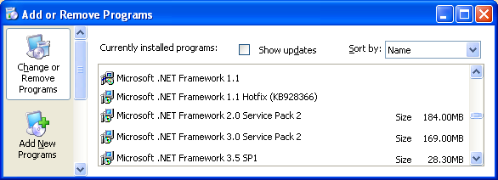

If you need to install a new version, browse to http://msdn.microsoft.com/en-us/netframework/cc378097.aspx

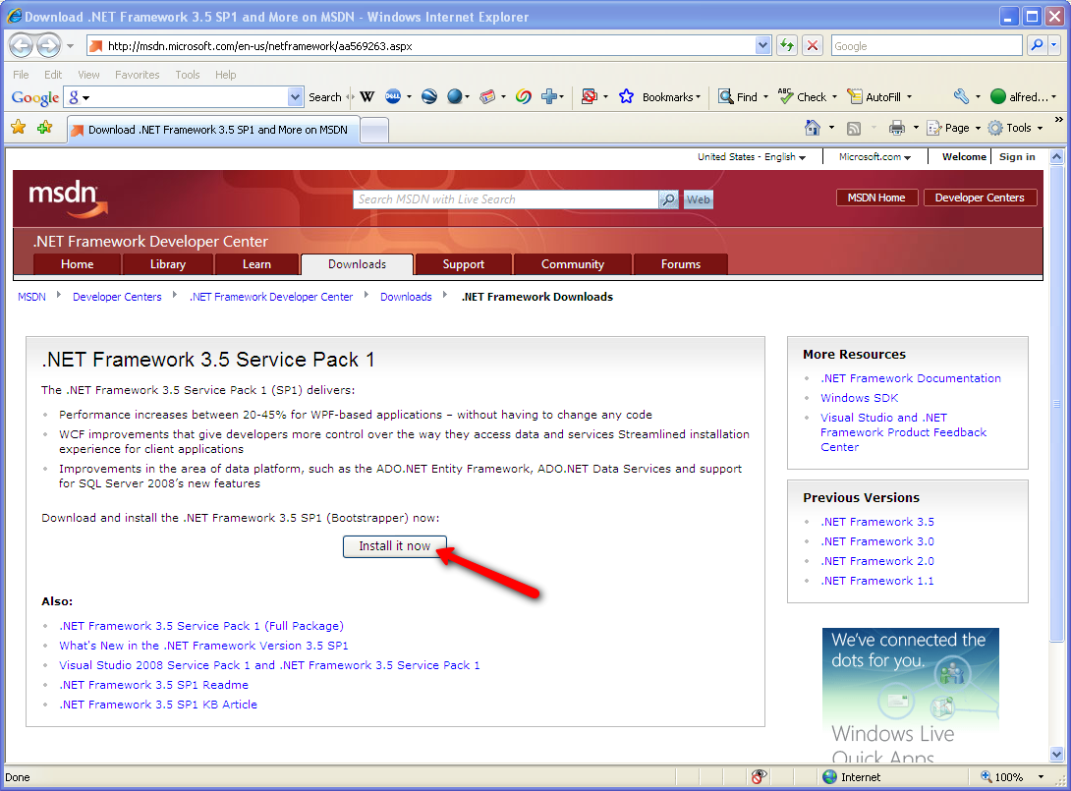

Click to start the install process.
Depending on how up-to-date your Windows OS is, you may also get a message telling you that you need to install Windows Installer 3.1. If you get that message, you can find the Windows Installer 3.1 redistributable at http://www.microsoft.com/downloads/details.aspx?FamilyID=889482fc-5f56-4a38-b838-de776fd4138c&DisplayLang=en
Proceed with installing .NET Framework 3.5 Service Pack 1.

If you forget to install the .Net environment, you will be able to build the WMC code into your image but the first time the WMC code tries to use the SW_VE_acp.exe you will get an error message…
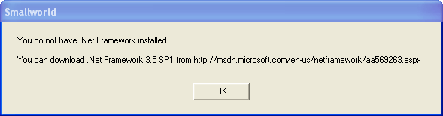
Your default browser will also be automatically started to point to http://msdn.microsoft.com/en-us/netframework/aa569263.aspx and you can proceed with installing the .Net framework.

.NET and Web Proxies
The Web Maps Connector makes use of HTTP Requests to communicate with various Web Services. If you are behind a firewall that uses a Web Proxy you may experience some connectivity problems. The .NET framework attempts to read your web proxy settings from your Internet Explorer connectivity settings. In many cases, this is all that is required and the Web Maps Connector will handle the web proxy without any interaction on your part.
In some cases, however, the .NET framework cannot determine a valid web proxy configuration. In that case you will need to provide some configurations yourself. These changes are persistent and saved in modules\wmc_som\resources\base\bin\SW_VE_acp.exe.config.
To explicitly declare the web proxy server…
MagikSF> if_ve_acp.set_web_proxy_info(“http://<proxy_server_name>:<proxy_server_port>”)
$

If you explicitly set the web proxy info, then the authentication credentials sent to the web proxy server will be the credentials that the current user used to log into their Windows session.
If you do not want to use the user’s default login credentials, you can tell the Web Maps Connector to always prompt the user for web proxy credentials by setting the second argument (optional) to _true.
MagikSF> if_ve_acp.set_web_proxy_info(“http://<proxy_server_name>:<proxy_server_port>”, _true)
$

By setting the secondary argument to _true, the user will be presented with this prompt…

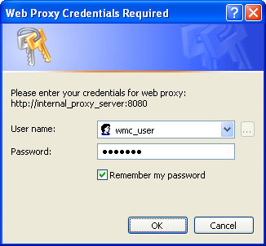
… each time they start the Web Maps Connector ACP. Typically the ACP is only started once per session, so this prompt will not appear very frequently for a given user. These Web Proxy Credentials are not stored anywhere in the Web Maps Connector product. This dialog makes use of the Windows CredUIPromptForCredentials dialog that stores credentials in the Windows Credentials Cache. You can read more about it at http://msdn.microsoft.com/en-us/library/aa375177(VS.85).aspx

To clear the web proxy settings…
MagikSF> if_ve_acp.set_web_proxy_info(_unset)
$

To show the current web proxy settings…
MagikSF> if_ve_acp.get_web_proxy_info()
$

In some cases you may want to set the web proxy setting for a particular user to override the default application web proxy settings….
MagikSF> if_ve_acp.set_web_proxy_info_for_current_user(“http://<proxy_server_name>:<proxy_server_port>”)
$

To clear the user-specific web proxy settings and default back to the application web proxy settings…
MagikSF> if_ve_acp.set_web_proxy_info_for_current_user(_unset)
$

The user-specific settings are stored in the .Net IsolatedStorage file and are not easily accessible by users. They are specific to that user on that machine.

These web proxy changes will take effect the next time SW_VE_acp.exe is started. You can restart the proxy by either killing the “SW_VE_acp.exe” process with Task Manager or by using this command at the Magik prompt:
MagikSF> if_ve_acp.locked_end(_false)
$

Setting Up Source Code
Extract the Web_Maps_Connector product to a folder. For example, I have extracted it to:
C:\projects\Web_Maps_Connector

Modify your build script or environment to recognize the Web_Maps_Connector product. In our example, I modified environment.bat to include the new product path at the end of the SW_PRODUCTS_PATH environment variable.

Loading code
Your build script will need to load module wmc_magik_gui at a minimum. If you are in the Cambridge DB, you may choose to load the wmc_cambridge_example module. If you are using a server-type image (e.g., SIAS), you only need to load the wmc_som module
We have included a sample Cambridge build script that you can use to build the WMC SOM into the Cambridge environment:
- Copy wmc_cambridge_example\source\cambridge_db-source\make_open_swaf_with_wmc.magik into %SMALLWORLD_GIS%\cambridge_db\source
- Start up a swaf closed image with SW_PRODUCTS_PATH aware of the Cambridge_db and Web Maps_Connector products
- MagikSF> load_file("C:\Smallworld41\cambridge_db\source\make_open_swaf_with_wmc.magik")
$
- Restart your image and configure the SOC (see next section)

XML Configurations

config.xml
Add the following plugin definitions in the config.xml for your application.
<plugin name="ve" class_name="ve_swaf_plugin">
<properties>
<!-- Indicates whether a check should be made for updates to this -->
<!-- product each time the plugin is started. (Default=True) -->
<property name="auto_check_for_updates?" value="true"/>

<!-- Indicates whether or not to use the Silverlight interface when -->
<!-- launching Bing Maps in the web browser. (Default=True) -->
<property name="use_bing_maps_silverlight?" value="true"/>
</properties>
</plugin>
<plugin name="wmc_route_finder" class_name="user:wmc_route_finder_plugin" />
<plugin name="wmc_map_chooser" class_name="user:wmc_map_chooser" />
<plugin name="wmc_map_chooser_plugin" class_name="user:wmc_map_chooser_plugin" />
<plugin name="panes" class_name="pane_manager">
<properties>
<!-- list of role names which, when assigned to elements of the gui,
will put them under the control of the pane_manager -->
<property name="role_names" value="editor_manager, object_control, themes, viewers, wmc_map_chooser"/>
</properties>
</plugin>

gui.xml
Add the following toolbar definition in the gui.xml for your application and then remember to add the toolbar to a <dock/> tag (usually found in the same XML file).
<toolbar name="ve">
<action name="wmc_map_chooser_plugin.show_hide_map_chooser"/>
<action name="ve.toggle_dataset"/>
<!-- <action name="ve.road_view"/> -->
<!-- <action name="ve.aerial_view"/> -->
<!-- <action name="ve.label_view?"/> -->
<action name="ve.query"/>
<action name="ve.geocode"/>
<action name="ve.reverse_geocode"/>
<action name="ve.get_metadata"/>
<action name="ve.show_in_web_browser"/>
<action name="ve.show_birds_eye_in_web_browser"/>
<action name="ve.about"/>
<section/>
<action name="wmc_route_finder.activate_dialog"/>
</toolbar>

The Web Map Chooser GUI can be embedded in a tab next to the main map. The following shows how it is done in the Cambridge DB example environment. You will need to make a similar modification in your own gui.xml. The Web Map chooser GUI is discussed in detail at the end of the documentation and is the GUI that is used to toggle between the various vendor maps.

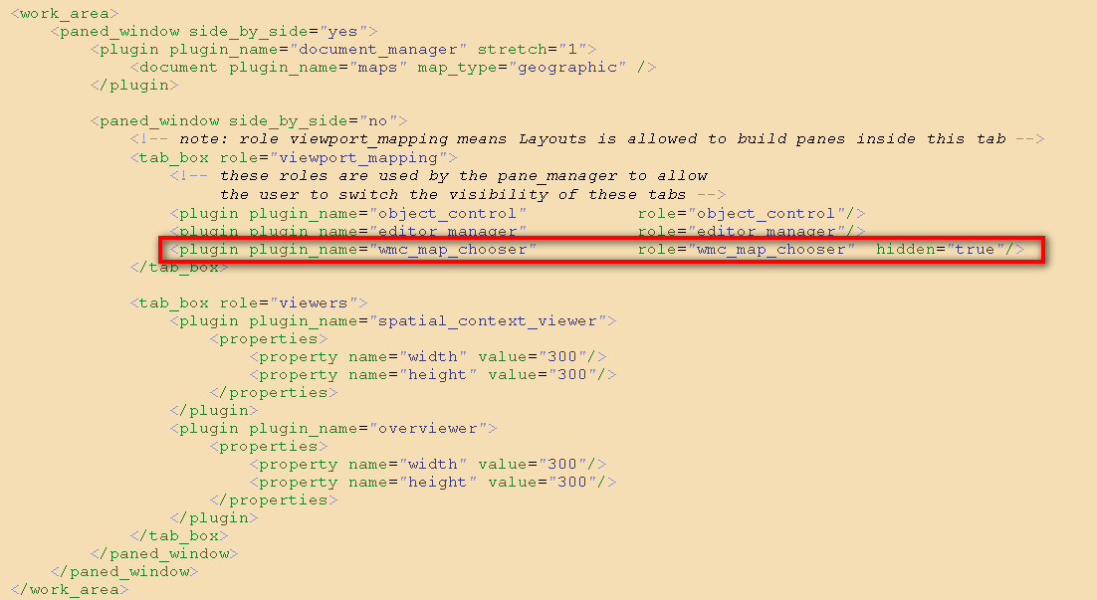

SPECIAL NOTE FOR PNI USERS:
If you are installing this toolbar on the main map of your PNI application, you will need to modify your map_gui.xml (and not your gui.xml) file with the following (slightly different) definition:
<toolbar name="ve">
<action source="application" name="wmc_map_chooser_plugin.show_hide_map_chooser"/>
<action source="application" name="ve.toggle_dataset"/>
<!-- <action name="ve.road_view"/> -->
<!-- <action name="ve.aerial_view"/> -->
<!-- <action name="ve.label_view?"/> -->
<action source="application" name="ve.query"/>
<action source="application" name="ve.geocode"/>
<action source="application" name="ve.reverse_geocode"/>
<action source="application" name="ve.get_metadata"/>
<action source="application" name="ve.show_in_web_browser"/>
<action source="application" name="ve.show_birds_eye_in_web_browser"/>
<action source="application" name="ve.about"/>
<section/>
<action source="application" name="wmc_route_finder.activate_dialog"/>
</toolbar>

Even for PNI, you still need to modify your gui.xml file’s <work_area> section to embed the Web Map chooser GUI tag.

Configuring SOC (optional)
There is no need to explicitly configure a wmc_dataset in the SOC. Each time the user opens the Bing Dataset from the WMC Toolbar a dataset is created and added to the SOC. There is also no need to create ACE settings for the WMC Dataset. Each time the user opens the WMC Dataset from the WMC Toolbar, the current ACE (all display scales) is configured to make the Road/Aerial/Label and geocode_result layers editable and the geocode_result layer will also be visible.

If you do want to create a SOC entry for the Bing Dataset follow these instructions.
The name of the dataset in the SOC Configuration must match the name specified in shared constant bing_dataset.DATASET_NAME. By default, you can name the dataset “bing_dataset”
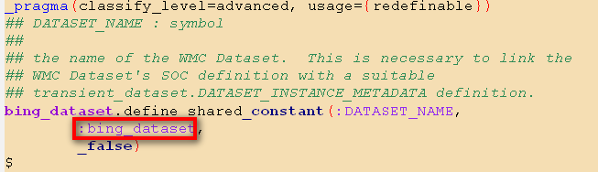
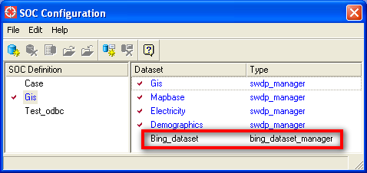

Web Maps Connector and SIAS
Web Maps Connector for SIAS currently only supports the raster imagery tiles from data vendors. There is no out-of-the-box support for other web services like geocoding, reverse geocoding and routing. You are welcome to build your own client interface and SIAS service classes that call the WMC Magik API to enable these additional functions. Here are some steps you can follow to enable WMC raster imagery on SIAS
- Make sure the Web_Maps_Connector product and wmc_som module are loaded into your SIAS image.
- Add “bing_dataset” as a “bing_dataset_manager” entry in your SOC (see section “Configuring SOC (optional)” above for details)
- Make appropriate visibility entries for the bing_dataset geometries for the ACE that you will be using with SIAS.
- In the resources/base/data/server_config.xml file in the service_framework application’s module that you use for your SIAS server.
  - E.g. <dataset name="bing_dataset" mode="readonly" alternative= "|" has_rollforward_checkpoint="false"/>
- Rebuild your SIAS image and test.

Geocoding Style

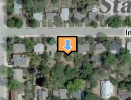
The Bing Geocoding Result styles are in a style dump file found at Web_Maps_Connector\modules\wmc_som\bing_geocode_result.style Use the Smallworld style load editor to import these styles into your style system. (See section “Appendix A – Using the Smallworld Style Load Editor” for details about importing the style)

Bing Maps Credentials
Use the following methods to configure your Bing Maps UserName and Password credentials for your environment.
MagikSF> if_ve_acp.credential_user_name << “AQAAABFdERjHoAwE/Cl+sBAAqAAAABAAAAB.."
$

MagikSF> if_ve_acp.credential_password << "4jjueDsM6kCDPz7nE89zlQQAAAACAAAAAUTtc.."
$

These encrypted credentials will have been provided to you by your iFactor Consulting account representative and are unique to your account.

Restricting Access to Users
In some cases you may want to restrict access to the Bing Maps Connector to certain users. We have provided an API for you to set permissions at various levels based on the Smallworld authorization system and the Windows username. If a user is not authorized to use Bing Maps Connector, she will still see the toolbar on her application but all the functionality will be disabled.
NOTE: The results of the :set_sw_auth_info() and :clear_sw_auth_info() methods shown below are persistent and saved in modules\wmc_som\resources\base\bin\SW_VE_acp.exe.config. If you make any changes to the authorization list using these methods you will want to make sure that you have run these methods on each instance of the above-mentioned SW_VE_acp.exe.config file.

Users Based on the Windows Login Name

MagikSF> if_ve_acp.set_sw_auth_info(:os_username,{“alfred”,”brad”,”chad”})
$

Users Based on the Smallworld Authorization User

MagikSF> if_ve_acp.set_sw_auth_info(:user,{“alfred”,”brad”,”chad”})
$

Users Based on the Smallworld Authorization Group

MagikSF> if_ve_acp.set_sw_auth_info(:group,{“south_region”,”west_region”})
$

Users Based on the Smallworld Authorization Rights Name

MagikSF> if_ve_acp.set_sw_auth_info(:right,{“bing_maps_connector”})
$

Clearing All Authorization Information for User access
To allow all users to access the Bing Maps Connector functionality, you need to clear the authorization information…
MagikSF> if_ve_acp.clear_sw_auth_info()
$

Note that this “cleared” mode is the out-of-the-box setting for Bing Maps Connector.

Reporting and Changing Authorization List
You can use the following API to report to you what is currently set in the Bing Maps Connector authorization list.
MagikSF> if_ve_acp.report_sw_auth_info()
$

If no authorization restrictions exist, your message will be…
No authorization information is defined for the Bing Maps Connector.

If some authorization restrictions do exist, your message will be similar to…
You can modify the following code and run it at the MagikSF prompt to modify your authorization settings:
if_ve_acp.set_sw_auth_info(:os_username,{"alfred","brad","chad"})

As the message states, you can modify the Magik code that is presented and then paste it back into a MagikSF prompt to update the authorization eligibility list. This approach makes it easy to modify an existing list without too much Magik manipulation.

Known Issues

Geocoding
Be sure that you have picked a map view coordinate system that is valid for the area that you want to geocode to.

Reverse Geocoding
Place a trail point. Click the “Reverse Geocode” icon and you will be presented with the address of the nearest street address.

Image Information
This works for aerial imagery only. Road tiles do not have metadata.

Using the Web Maps Toolbar

Show/Hide Web Map Chooser.
Push this button to activate the Web Map Chooser (see the next section for Web Map Chooser)
 | The Web Maps dataset is currently closed. Click this button to open it.
 | The Web Maps dataset is currently open. Click this button to close it.
 | Enter a query in the text box and click the button to launch a geocode request.
 | Place a trail point. Click the “Reverse Geocode” icon and you will be presented with the address of the nearest street address.
 | In Aerial View mode, place a trail point on the map and click this button to show information about the Aerial imagery at this location and zoom scale.
 | Click on this button to launch your default web browser with http://maps.bing.com with the same center point, zoom scale and map type as is visible in your current Smallworld Web Maps Dataset’s map view.
 | Click on this button to launch your default web browser with http://maps.bing.com Bird’s Eye view with the same center point as is visible in your current Smallworld Web Maps Dataset’s map view. If no Bird’s Eye view is visible for your map center point, the web browser will show Road maps.
 | Click on this button to find out how to contact iFactor Consulting and to read the Microsoft Terms of Use and Privacy Policy.
 | Click on this button to launch the Route Finder tool.

Using the Web Map Chooser
The Web Map Chooser is the main graphical interface for selecting which Web Map(s) to render on the map.
When you select the “Show/Hide Web Map Chooser” toggle on the WMC toolbar, the Web Map Chooser will be activated. Depending on which vendor modes your WMC has been licensed for, you will see more or less layer icons in the Web Map Chooser. There are two kinds of Web Maps: 1) an opaque layer (e.g., aerial imagery or Bing Aerial Labeled); and 2) a transparent layer (e.g., iFactor Weather Radar). You can only ever select one opaque layer but you may select multiple transparent layers.
Once you have selected the layer(s) you are interested in seeing, click the “Apply” button on the Web Map Chooser GUI. The main map will refresh.

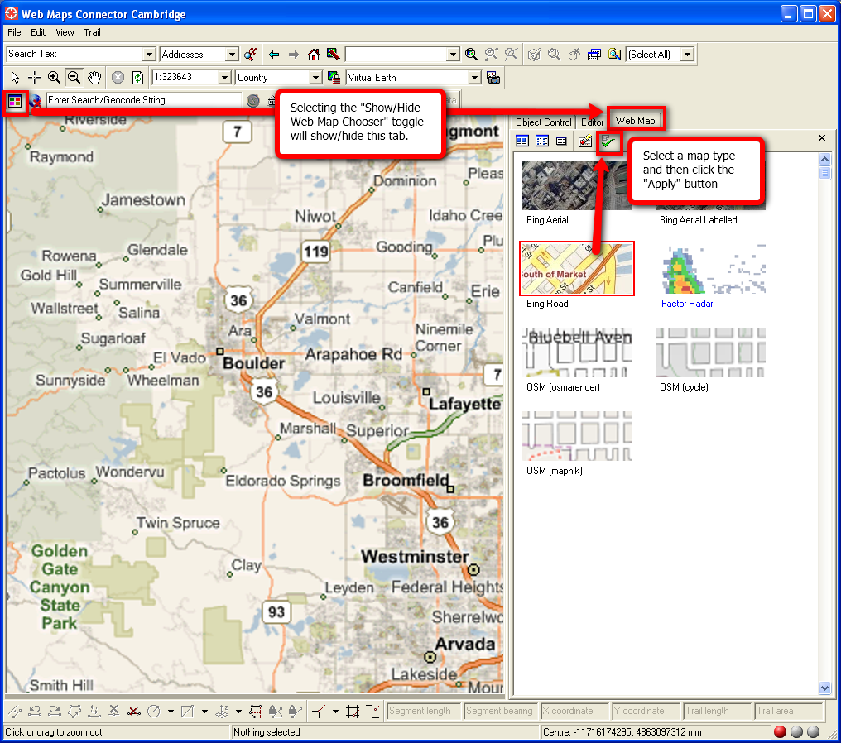

Appendix A – Using the Smallworld Style Load Editor

Temporarily load the following modules…
MagikSF> sw_module_manager.load_module(:style_dump_and_load)
$
MagikSF> sw_module_manager.load_module(:classic_application)
$

Start the application manager…
MagikSF> start_application_manager()
$

Start the Classic Application…
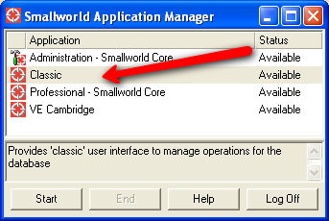
You will see a User Map application like this…
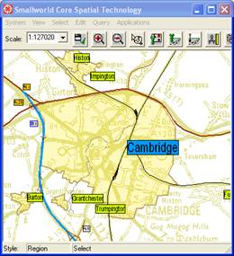

Make the Style View writable…
MagikSF> gis_program_manager.style_view.switch(:write)
$

Start the Style Load Editor…
MagikSF> smallworld_product.application(:gis).start_style_load_editor()
$

… that will look like this:
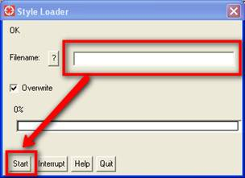

Populate the Filename field with the appropriate style dump file (as per the installation instructions)
Click Start.
The style loading process should not take more than a few seconds.
When the load is complete, commit the Style View…
MagikSF> gis_program_manager.style_view.commit()
$

Switch the Style View back to readonly…
MagikSF> gis_program_manager.style_view.switch(:readonly)
$

The styles are now loaded into your style database. Please review your style system to ensure that the symbology has been loaded correctly into each of your customized display scales and that the orientation/scale is correct at each display scale.
Before you start your administrative application, make sure that your Bing Dataset is toggled on. You can toggle it on from your VE Plugin toolbar…
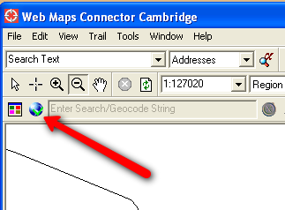

Once the Bing Dataset has been turned on, start your Style Designer from your Administration application and browse to Bing Dataset -> Geocode Result -> Location. Please review that geometry’s styles and make any changes appropriate for the various display scales.

