

**The Experiment Report of**

***Machine Learning***

**College** Software College

**Subject** Software Engineering

**Members**

**Student ID 201530613719**

**E-mail** g2369969039@gmail.com

**Tutor**  Mingkui Tan

**Date submitted** 2017.12.2

**1. Topic:**

LinearRegression& Linear Classification & Gradient Descent

**2. Time:**

2017.12.2 AM 9:00-12:00

**3. Reporter:**

Ziwei Zhang

**4. Purposes:**

* Train a linear regression model to predict house price.
* Train a linear classifier model to classify

**5. Data sets and data analysis:**

* + Linear Regression uses Housing in LIBSVM Data, including 506 samples and each sample has 13 features.
  + Linear classification uses australian in LIBSVM Data, including 690 samples and each sample has 14 features.

**6. Experimental steps:**

* Load and preprocess data
* Implement Linear regression/classification loss function
* Perform gradient check using numerical gradient
* Compare the performation of naive implementation and vertorized implementation of gradient computing.
* Perform Gradient Descent to train a model and visualize the result
* Perform cross-validation to tune hyperparameter

**7. Code:**

Linear Regression: 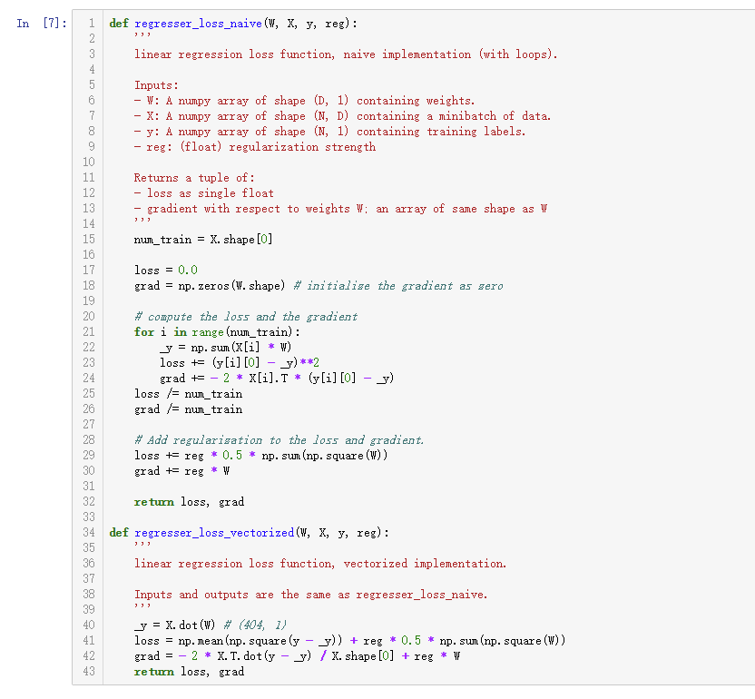

Linear Classification:

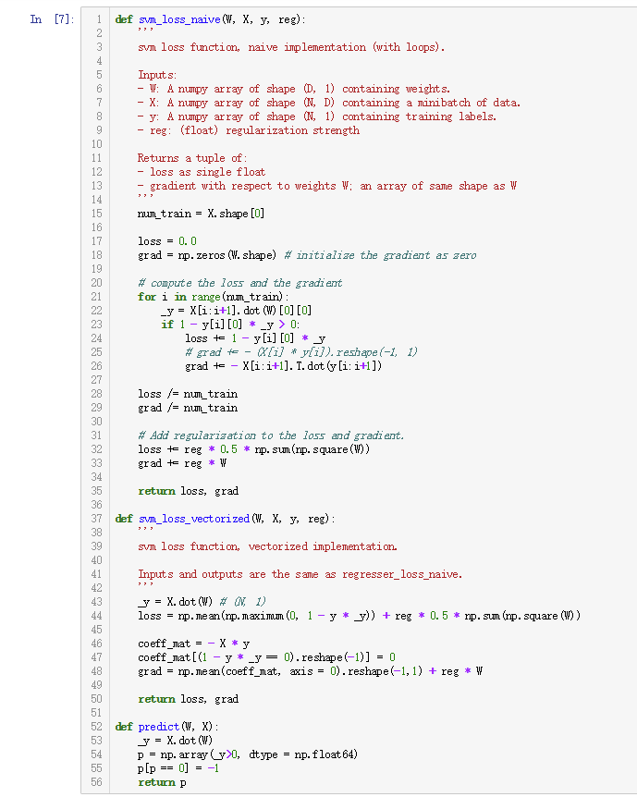

**8. Selection of validation (hold-out, cross-validation, k-folds cross-validation, etc.):**

hold-out

**9. The initialization method of model parameters:**

Zero initialization.

**10. The selected loss function and its derivatives:**

Linear Regression:

Linear Classification:

**11. Experimental results and curve:**

## Hyper-parameter selection (η, epoch, etc.):

Linear Regression:

Learning rage = 0.08

Regularization strength = 1.5e-5

Linear Classification:

Learning rage = 0.0001

Regularization strength = 2

## Assessment Results (based on selected validation):

## Predicted Results (Best Results):

Linear Regression:

Loss = 23.4

Linear Classification:

Accuracy = 0.855

## Loss curve:

Linear Regression:

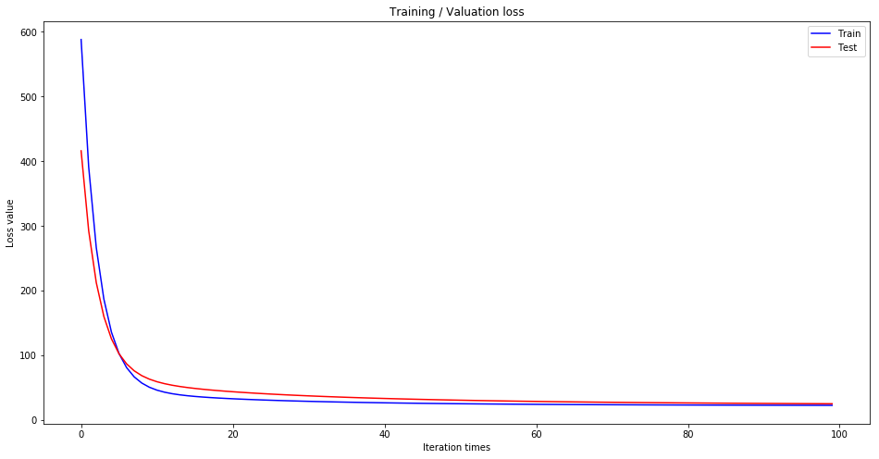

Linear Classification:

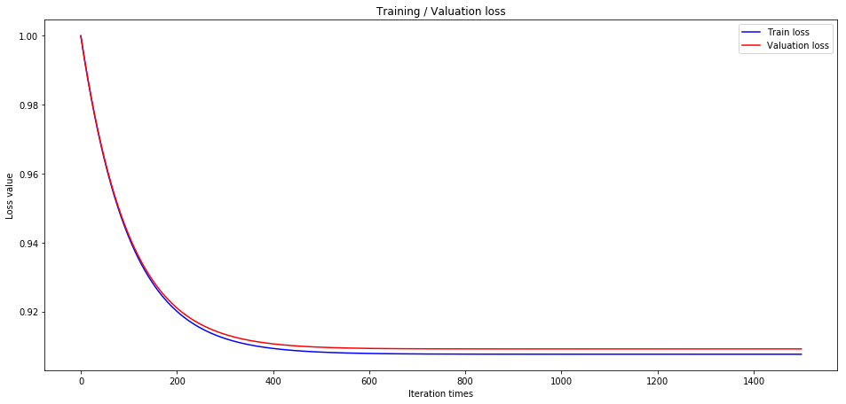

**12. Results analysis:**

Both two model perform well on Houing dataset and Australian dataset.