Homework 6

1. To calculate the total numbers of bits we need to calculate the index and tag.

Index = log 2^(cache size/block size) = log 2^(2\*1024) = 11.

ByteSelect = log 2 ^block size = log 2^16 = 4

Tag = Processor Address Bits – Index – ByteSelect

Tag = 64 -11-4 = 49

Total Num of 32kb cache = 2048 \* (1 + 49 + 128) = 364544 bits

2a. The block size is determined by the offset bits.

Block size = 2^offset bits

Block size = 2^5

Block size = 32 words = 64 bytes

2b. Looking at our index bits we look at 5 bits.

Blocks = 2^4 = 32 blocks

2c. Total Bits / Useful Bits = Tag + Block Size in Bits / Block Size in Bits

= (54 + 512)/512

= 566/512

2d.

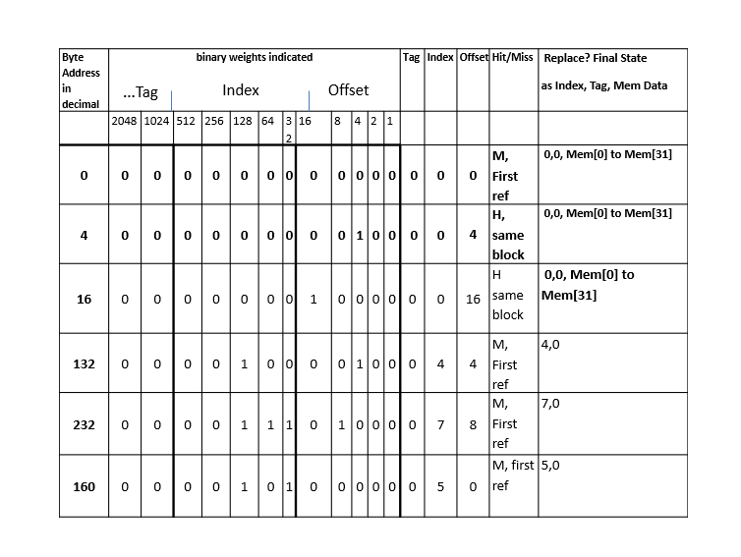

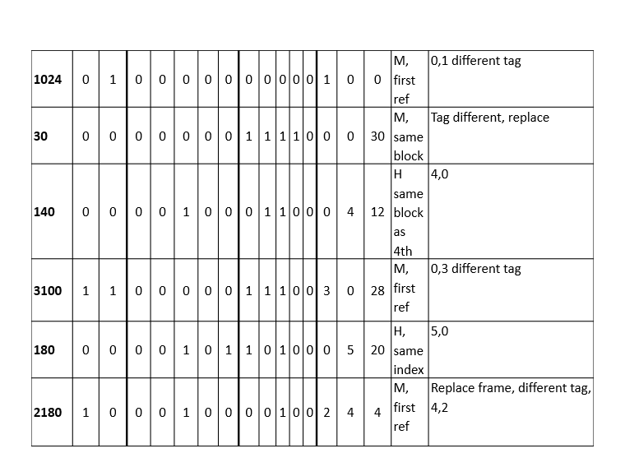

2e. Based on the data from the chart there was 4 hits out of 12 possible.

Hit ratio = 4/12 = 1/3 which is about 33%

2f. List the final state of the cache, with each valid entry represented as <Valid, tag, index, and data>. Data can be shown as say, Mem[128] to Mem [159]

Based on the data from the graph in decimal:

< Yes, 0 , 0 Mem[4]>

<Yes,0,0,Mem[16]>

<Yes,0,4,Mem[140]>

<Yes,0,5,Mem[150]>

404b,

64 blocks 2^6