*Tiny FE Calculator* is a tabbed-type tiny utility; as of June 2019 it is a demo prototype, based on UL 508 A requirements for general use ICPs and NFPA 79 for industrial machinery; other functions/requirements (such as those for industrial machinery) may be implemented.

To launch the app double-click on the program icon; a message windows pops up:

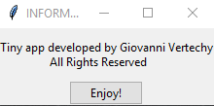

Click the “Enjoy!” button to open the program.

\

Functionality is pretty much self-explanatory:

1. Tab 1: Transformer OCP - it calculates primary and secondary overcurrent protection size of single-phase control transformers. Reference: UL 508 A, par. 42.1.3 (Table 42.2).

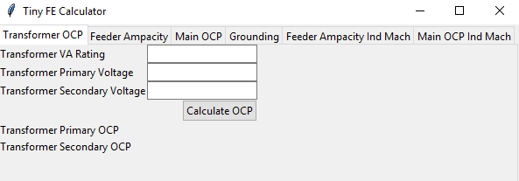

1. Tab 2: Feeder Ampacity - it calculates the ampacity of feeder conductors on the load side of the main (feeder) overcurrent protective device; the “All other Loads” field requires a dash-separated number sequence, such as: 12-45.7-27.2 (no other characters such as commas, spaces, etc. shall be used). Reference: UL 508 A, par. 28.3.3

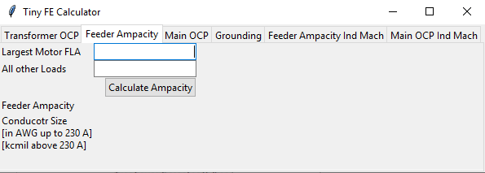

1. Tab 3: Main OCP - it calculates the size of the main (feeder) overcurrent protective device; the “Full load current of all other loads” field requires a dash-separated number sequence, such as: 12-45.7-27.2 (no other characters such as commas, spaces, etc. shall be used). Reference: UL 508 A, par. 32.3.1 (b)

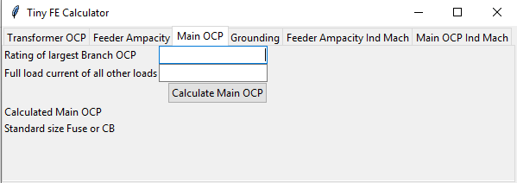

1. Tab 4: Grounding – it determines the minimum grounding conductor size (in AWG or kcmil), based on UL 508 A Tab. 15.1, and NFPA 79 Tab. 8.2.2.3

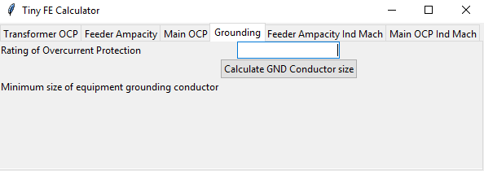

1. Tab 5: Feeder Ampacity Ind Mach - it calculates the ampacity of feeder conductors on the load side of the main (feeder) overcurrent protective device; the “All other Loads” field requires a dash-separated number sequence, such as: 12-45.7-27.2 (no other characters such as commas, spaces, etc. shall be used). Reference: UL 508 A, par. 66.4.1

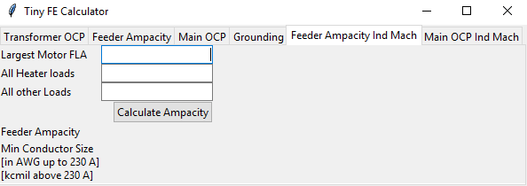

1. Tab 6: Main OCP - it calculates the size of the main (feeder) overcurrent protective device; the “Full load current of all other loads” field requires a dash-separated number sequence, such as: 12-45.7-27.2 (no other characters such as commas, spaces, etc. shall be used). Reference: UL 508 A, par. 32.3.1 (b)

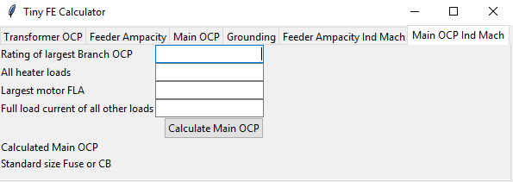

Note: depending on the (largest) branch circuit protection size (such as when the largest branch OCP is close to the largest motor FLA - for example when using self protected combination motor controllers) the calculated Main OCP may be lower than the calculated feeder ampacity; the result is mathematically correct, but determination of main ocp size requires electrical engineering judgement.