C13566933

Gary O’Donoghue

OOP Assignment 1

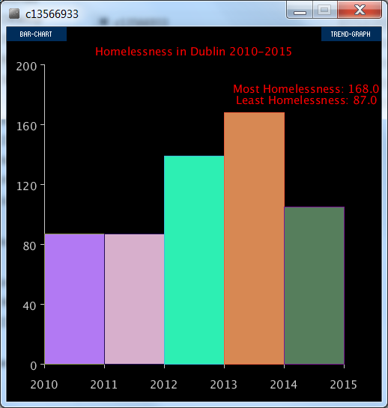

I struggled a lot with bugs but eventually pulled together a piece of working code with help from online tutorials, past labs, online discussions and lecturer’s notes.

I used ControlP5 library to navigate through my graphs. I have the bar chart flashing in different colours relatively slowly. There is also a max homeless and min homeless text above both graphs.

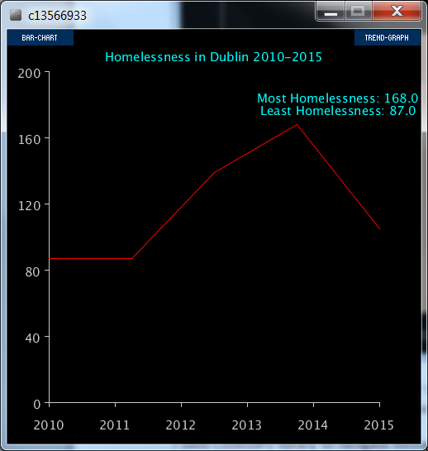

A ‘feature’ with the above graph is that the data changes in the middle of the year points on the X axis. When I tried to change that, I received more errors.