**NAME: ELEZUO ARITH**

**REG. NO.: 20161967135**

**COURSE: CSC 514**

**Section: Login Page**

<section class="cashier-page">

<div class="container">

<div class="title-box">

<p class="legend"> Login </p> <hr>

</div>

<form action="#">

<h3>Cashier Login</h3>

<div class="form-group">

<label for=""> Admin ID :- </label>

<input type="text">

</div>

<div class="form-group">

<label for=""> Password :- </label>

<input type="password">

</div>

<button>Login</button>

</form>

</div>

</section>

**Section: Add Cashier Details**

<section class="cashier-page">

<div class="container">

<div class="title-box">

<p class="legend">Add Cashier Details</p> <hr>

</div>

<form action="#">

<h3>Add Cashier Details</h3>

<div class="form-group">

<label for="">Cashier ID</label>

<input type="text">

</div>

<div class="form-group">

<label for="">Cashier Name</label>

<input type="text">

</div>

<div class="form-group">

<label for="">Mobile Number</label>

<input type="number">

</div>

<div class="form-group">

<label for="">Address</label>

<input type="text">

</div>

<div class="form-group">

<label for="">Email ID</label>

<input type="email">

</div>

<div class="form-group">

<label for="">Password</label>

<input type="password">

</div>

<button>Submit</button>

</form>

</div>

</section>

**Section: Cashier Login Details**

<section class="cashier-page">

<div class="container lg-box">

<div class="title-box">

<p class="legend">Cashier Login Details</p> <hr>

</div>

<form action="#">

<h3>Cashier Login Details</h3>

<div class="form-group">

<label for=""><strong>Cashier ID</strong></label>

<select name="" id="">

<option value="">1001</option>

</select>

</div>

</form>

<div class="table-container">

<table class="responsive-table">

<thead>

<tr>

<th style="width: 40px; border: 1px solid #000;"></th>

<th>cashier_id</th>

<th>login_time</th>

<th>logout_time</th>

<th>number</th>

<th>date</th>

</tr>

</thead>

<tbody>

<tr>

<td></td>

<td>1001</td>

<td>1:42PM</td>

<td>1:45PM</td>

<td>B2</td>

<td>19-Nov-22</td>

</tr>

<tr>

<td></td>

<td>1001</td>

<td>1:42PM</td>

<td>1:45PM</td>

<td>B2</td>

<td>19-Nov-22</td>

</tr>

<tr>

<td></td>

<td>1001</td>

<td>1:42PM</td>

<td>1:45PM</td>

<td>B2</td>

<td>19-Nov-22</td>

</tr>

<tr>

<td></td>

<td>1001</td>

<td>1:42PM</td>

<td>1:45PM</td>

<td>B2</td>

<td>19-Nov-22</td>

</tr>

<tr>

<td></td>

<td>1001</td>

<td>1:42PM</td>

<td>1:45PM</td>

<td>B2</td>

<td>19-Nov-22</td>

</tr>

</tbody>

</table>

</div>

</div>

</section>

**STYLESHEET (CSS)**

/* -- Removing margin and padding for the page -- */

*, *::before, *::after {

font-family: "Inter", sans-serif;

margin: 0;

padding: 0;

}

/* -- Make the body tag span the height of the screen */

body {

box-sizing: border-box;

height: 100vh;

background-color: #a9a9a9;

background: url("bg.jpg") center;

background-size: cover;

backdrop-filter: brightness(70%);

}

/* --- Components --- */

/* -- Set an automatic width for the page -- */

.container {

margin: 10% auto;

padding: 20px;

display: flex;

flex-direction: column;

justify-content: center;

background-color: #fff;

}

/* -- Create a box with an 80% width -- */

.lg-box {

width: 80%;

flex-direction: column;

align-items: center;

}

/* --- Main Styling --- */

/* -- Align the divs to the center -- */

.cashier-page {

display: flex;

justify-content: center;

align-items: center;

}

/* -- Make the form elements stack below each other -- */

.cashier-page form {

font-size: 14px;

padding: 10px;

display: flex;

flex-direction: column;

justify-content: center;

align-items: center;

}

/* -- Give the form a 300px width -- */

.lg-box > form {

width: 300px;

}

/* -- Align contents of the form to the center -- */

.cashier-page form .form-group {

display: flex;

justify-content: center;

align-items: center;

gap: 10px;

width: 100%;

margin-bottom: 20px;

}

/* -- Give each title some margin below them -- */

.cashier-page form h3 {

margin-bottom: 20px;

}

/* -- Space out the label tags from the input tags -- */

.cashier-page form .form-group label {

flex: 0 0 32%;

font-weight: 500;

}

/* -- Adjust the input and select tags accordingly -- */

.cashier-page form .form-group input, select {

padding: 5px;

border: 1px solid #7e7c7c;

border-radius: 2px;

outline: none;

width: 100%;

font-size: 14px;

}

/* -- Adjust the button to desired effect -- */

.cashier-page form button {

padding: 6px 30px;

font-family: inherit;

font-size: 14px;

border: 1px solid #cac7c7;

border-radius: 3px;

}

/* --- Table Section --- */

/* -- Give the table a scroll property -- */

.table-container {

width: 100%;

overflow-y: scroll;

}

/* -- Remove spaces between each cell in the table -- */

table {

border: 2px solid #000;

width: 100%;

border-collapse: collapse;

}

/* -- Give some space inside each cell in the head part of the table -- */

table thead tr th {

text-align: left;

padding: 3px;

font-size: .9rem;

}

/* -- Give the table body a border -- */

table td {

border: 1px solid #000;

padding: 0.3rem;

font-size: .9rem;

font-weight: 500;

}

/* -- Remove the border from the first column of the table body -- */

table tbody tr td:first-child {

border: none;

}

/* -- Create a text at the top of each box -- */

.title-box {

margin-bottom: 2rem;

display: flex;

gap: .5rem;

width: 100%;

align-items: center;

}

.title-box p.legend {

font-weight: 800;

width: 100%;

max-width: max-content;

font-size: .7rem;

}

.title-box hr {

width: 100%;

border: 1px solid #000;

}

**OUTPUT**

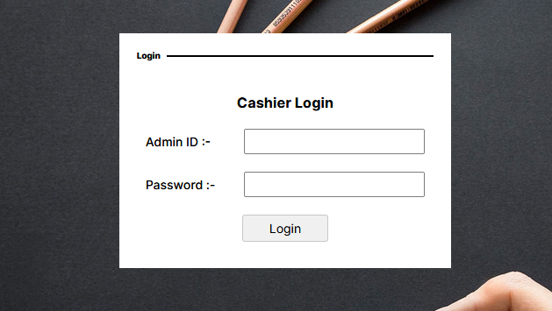

***Output A:*** *Login Page*

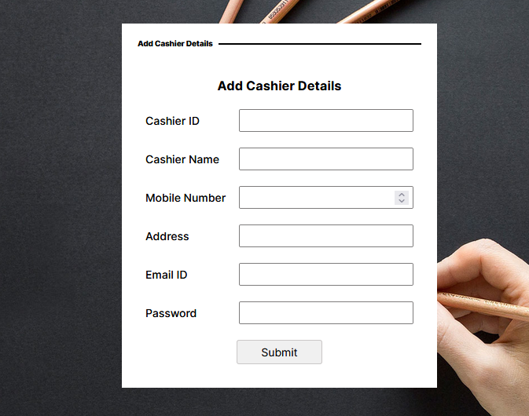

***Output B:*** *Add Cashier Details Page*

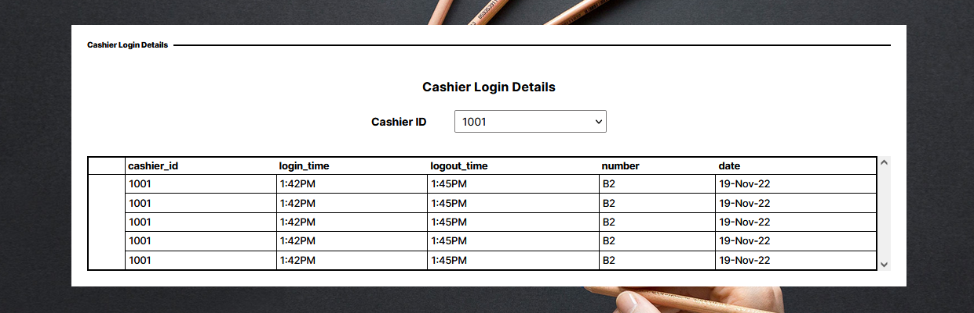

***Output C:*** *Cashier Login Details Page*