LAB REPORT
Name : Maurya Sujeet
Roll No.: 17BCS016

FPIC :
- Using −fpic option usually generates smaller and faster code, but will have platform−dependent limitations, such as the number of globally visible symbols or the size of the code. The linker will tell you whether it fits when you create the shared library.
- When these options are present during compilation, the compiler generates code that accesses symbols through a collection of indirection registers and global offset tables. The primary benefit of PIC code is that the text segment of the resulting library (containing machine instructions) can quickly relocate to any memory address without code patches. This improves program startup time and is important for libraries that large numbers of running processes must share. (PIC lets the operating system relocate libraries to different virtual memory regions without modifying the library instructions.)
- The primary downside to compiling the module as non-PIC is that loading time increases because the dynamic linker must make a large number of code patches when binding symbols.

Differences between Dynamic and Static Libraries.
Static :
- All the code to execute the file is in one executable file, with little to virtually zero compatibility issues.
- Constant load time every time a file is compiled and recompiled.
- Larger in size because the file has to be recompiled every time when adding new code to the executable.(Library function are invoked at compile time.)
- Faster execution.

Dynamic:
- Potential compatibility issues if a library is changed without recompiling the library into memory.
- Dynamic linking load time will be reduced if the shared library code is already present in memory.
- Only one copy of the shared library is kept in memory, making it much faster to compile programs and significantly reducing the size of the executable program.(Library function are invoked at run time.)
- Slower execution time compared to static libraries.
For example:
Size of executable of static library – 13464 bytes
Size of executable of dynamic library – 13288 bytes

MAP VS SHARED MEMORY
Shared Memory :
- Shared memory is memory that may be simultaneously accessed by multiple programs with an intent to provide communication among them.
- Shared memory refers to block of RAM that can be accessed by several different CPU in a multiprocessor computer system.
- Remains available until system is shut down.
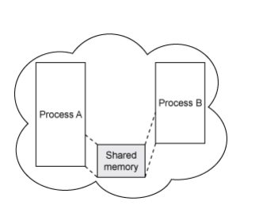

MAP :
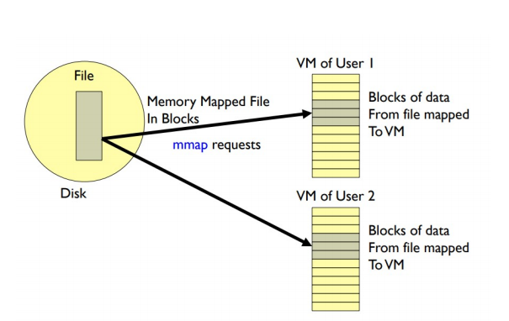

- Map a disk block to a page in memory
- Allows file I/O to be treated as routine memory access.
- File is initially read using demand paging ! i.e., loaded from disk to memory only at the moment it’s needed .
- When needed, a page-sized portion of the file is read from the file system into a physical page of memory .
- Subsequent reads/writes to/from that page are treated as ordinary memory accesses .
- Backed by a file .
- Persists even after programs quit or machine reboots .

Mmap()
- Mmap allows your process to directly access the physical memory stored in the page cache. It does this by mapping the process page table entries to the same page frames found in the disk cache.
- Mmap requires a file descriptor, so we need to open the file first.
- mmap only works on lseekable file descriptors, i.e. "true" files, not pipes or sockets.
- We seek to our desired size and write one byte to ensure that the file is sufficient length (failing to do so causes your program to receive SIGBUS upon trying to access the file). ftruncatewould also work.
- When finished, we call munmap to unmap the file from memory
MAP_SHARED : Shares mapping.Updates to the mapping are visible to other processes mapping the same region.
MAP_PRIVATE : Create a private copy-on-write mapping.Updates to the mapping are not visible to other processes mapping the same file.
Mysync() : mysync() flushes changes made to the in-core copy of a file that was mapped into memory using mmap() back to disk.Without use of this call there is no guarantee that changes are written back before munmap() is called.

