**GROUP 5**

**Sales Representative DB**

Nelson Liang

Victor Li

Udit Manocha

Steven Gonzalez

**Overview**

The purpose of this project is to implement a Relational Database Management System (RDBMS) that will Demonstrate Insertions, Updates and Deletions while expressing constraints to the database. The database will be populated with enough information in order to allow Querying of the database along with the proposed UIDs.

**Project Idea**

Our group has decided to develop a database based on three tables: Employees, Departments, and Customers. The Employee table will consist of 13 attributes of various data types. The attributes are as follows: EmployeeID (Primary Key), FirstName, LastName, JobTitle, BirthDate, HireDate, Address, City, State, Country, ZipCode, Phone, Email, and Department. The second table, Departments, will consist of the four following attributes: DepartName (Primary Key), DepartHead, and the Location. Lastly, the Customers table will consist of the following 11 attributes: CustomerID (Primary Key), FirstName, LastName, Address, City, State, Country, ZipCode, Phone, Email, and SupportRepID.

As a group we have determined that the number of tuples in the Customer table should exceed that of the Employee table. The number of tuples in the Employees table will also exceed that of the Departments table. As such, there can be multiple customers assign to a single Employee, however, no customer may have more than one employee. In addition, each department can have multiple employees, however, employees may not have multiple departments.

**E-R Diagram**

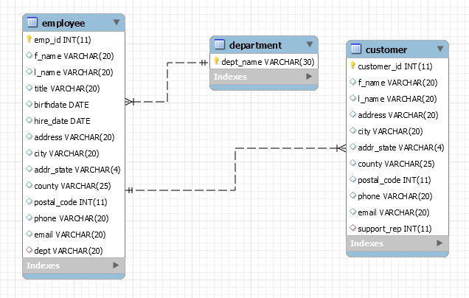

**View**

**Create a View**

/* Find all customers in customer table that are from Utah and create a view with their customer ID and last names */

*CREATE OR REPLACE VIEW v AS*

*SELECT * FROM customer*

*WHERE customer.addr_state = 'Utah';*

**Simple query on the View**

/* select everything from view v */

SELECT * from v

//OUTPUT: SELECT * from v

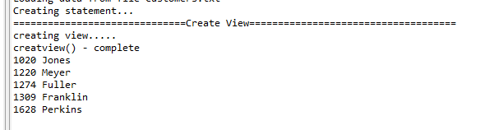

**Inserts**

**INSERT - 1**

INSERT INTO employee

(f_name, l_name, emp_id, title, address, city, addr_state, country, postal_code, phone, email, dept) VALUES ('Steven', 'Gonzalez', 120, 'Software Engineer', '1 Washington Square Hall', 'San Jose', 'California', 'United States', 95023, '1-(831)801-8637', 's.gonzalez0250@yahoo.com', 'Software');

**INSERT - 2**

INSERT INTO project2_db.customer

(`customer_id`, `f_name`, `l_name`, `address`, `city`, `addr_state`, `country`, `postal_code`, `phone`, `email`) VALUES ('1989', 'Peter ', 'Pan', '52127 Del Mar Crossing', 'Arvada', 'Colorado', 'United States', '19160', '1-(201)927-1717', 'wrobertsd123@bluehost.com');

**INSERT - 3**

INSERT into Department

(dept_name, dept_address, dept_city, dept_state, dept_country, dept_lead) VALUES ('electronics', 'Miller Rd', 'Hollister', 'California', 'US', 'Jim Jones');

**INSERT - 4**

INSERT INTO customer

(customer_id,f_name,l_name,address,city,addr_state,country,postal_code,phone,email,support_rep)

VALUES (2000, 'Udit', 'Manocha', 'One Washington Sq', 'San Jose','California', 'United States', 95112, '1-(424)288-0824', ['udit.manocha@sjsu.edu](mailto:'udit.manocha@sjsu.edu)', 56);

//OUTPUT: after execution of insert statements

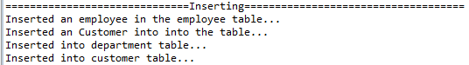

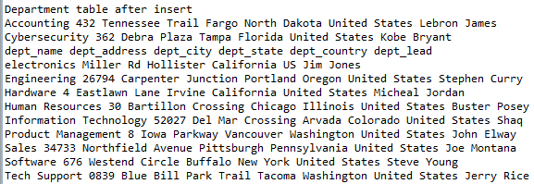

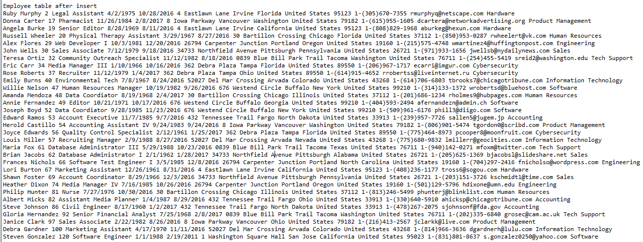

//customer table after insert execution

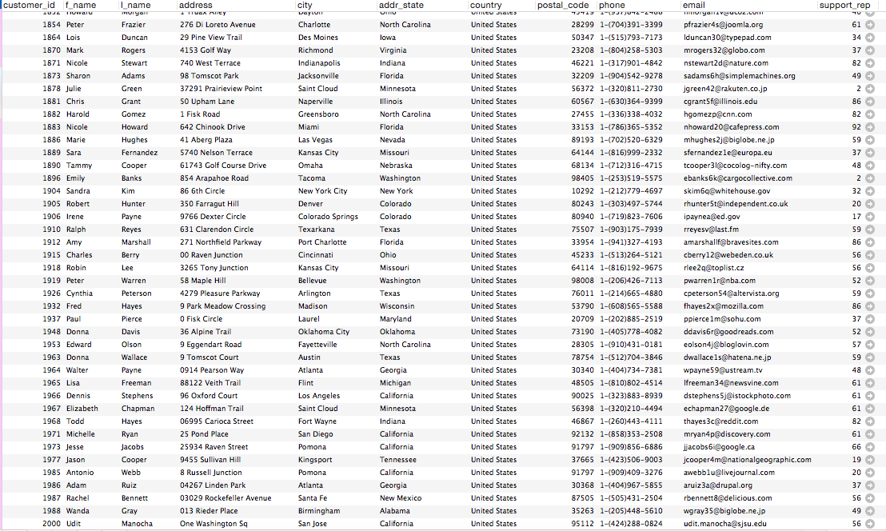

**Updates**

**UPDATE-1**

UPDATE project2_db.customer

SET `address` = '111 Hoffman Trail'

WHERE `customer_id` = '1989';

**UPDATE-2**

UPDATE employee

SET l_name = 'Barrientos'

WHERE f_name = 'Rose';

**UPDATE-3**

UPDATE department

SET dept_lead = 'Babe Ruth'

WHERE dept_name = 'electronics';

**UPDATE-4**

UPDATE customer

SET l_name = 'Sharma'

WHERE customer_id = 2000;

//OUTPUT: after execution of insert

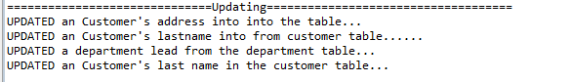

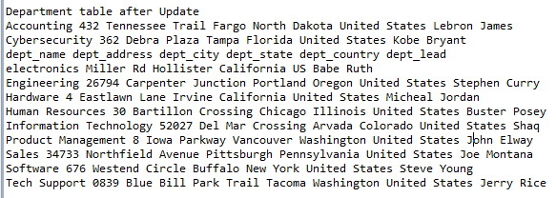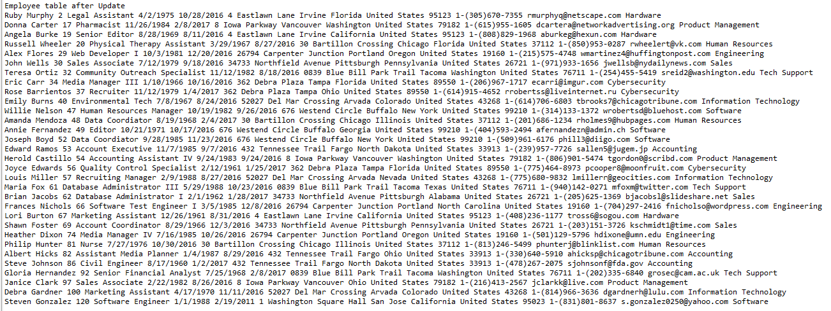

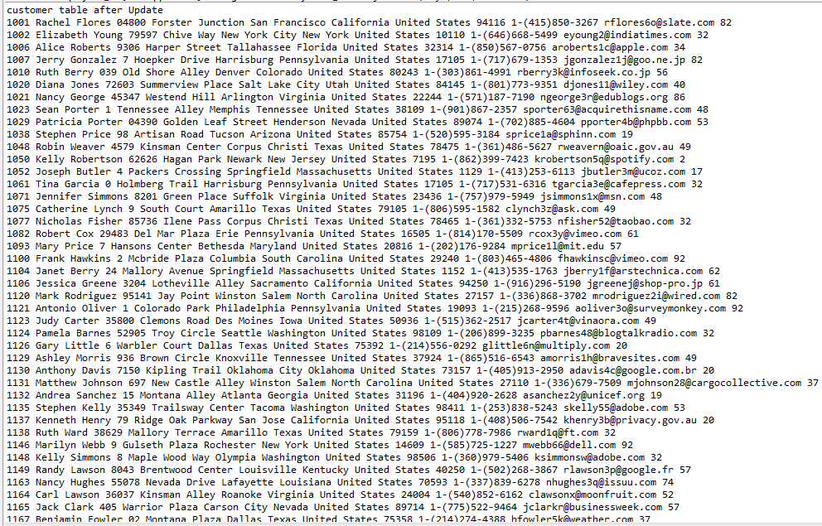

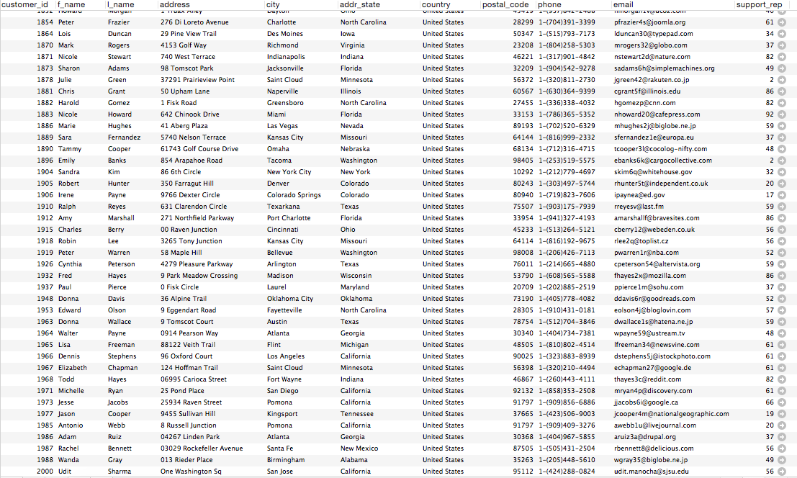

**Deletions**

**DELETE-1**

DELETE FROM employee

WHERE emp_id = 2;

**DELETE-2**

DELETE FROM project2_db.customer

WHERE `customer_id`='1989';

**DELETE-3**

DELETE FROM department

WHERE `dept_name` = 'electronics';

**DELETE-4**

DELETE FROM customer

WHERE customer_id = 1989

//OUTPUT: After execution of delete 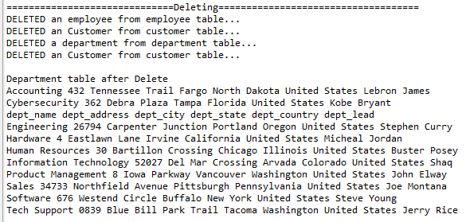

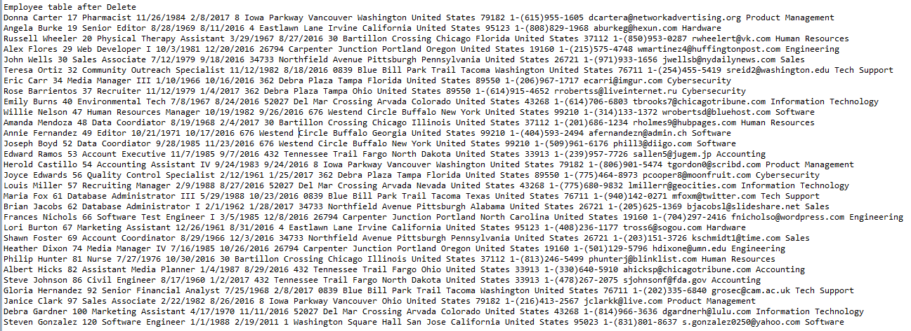

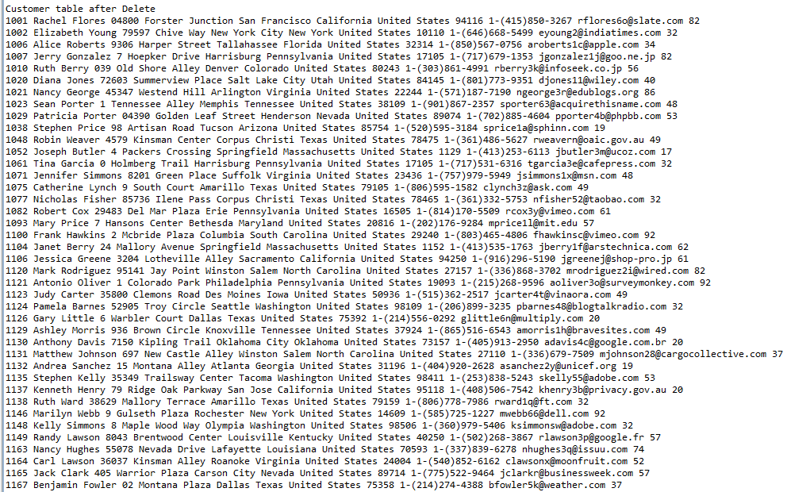

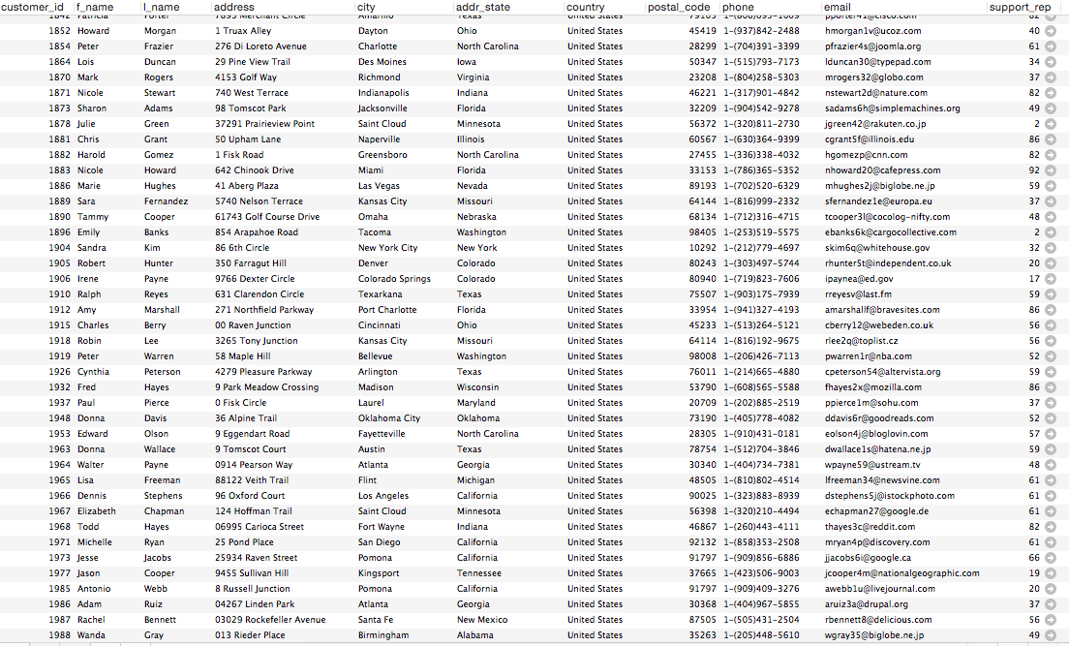

**Aggregation and Nested Queries**

**COUNT – the number of customers each employee has**

SELECT employee.f_name, employee.l_name, support_rep AS rep_id, COUNT(support_rep)

FROM customer JOIN employee

ON customer.support_rep = employee.emp_id

GROUP BY support_rep

ORDER BY support_rep ASC;

OUTPUT: count the number of customers each employee has

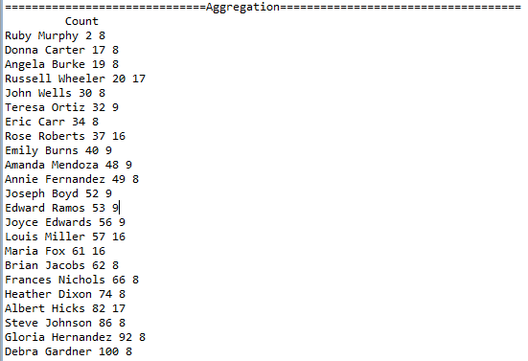

**MIN – find out who has least number of customers get rep_id and their number of customers**

SELECT rep_id, MIN(myCount)

FROM (SELECT support_rep AS rep_id, COUNT(support_rep) AS myCount

FROM customer

GROUP BY support_rep) AS countFunction;

//OUTPUT: sales rep id who has the minimum customer accounts



**MAX – find out who has most customers, get rep_id and number of customers**

SELECT rep_id, MAX(myCount)

FROM (SELECT support_rep AS rep_id, COUNT(support_rep) AS myCount

FROM customer

GROUP BY support_rep) AS countFunction;

//OUTPUT: sales rep id who has the most customer accounts



**AVG – find out the average customers each employee has**

SELECT rep_id, AVG(myCount)

FROM (SELECT support_rep AS rep_id, COUNT(support_rep) AS myCount

FROM customer

GROUP BY support_rep) AS countFunction;

//OUTPUT: average number of customers each employee has



**SUM – count sales rep for each customer to determine how many customers in customer table**

SELECT SUM(myCount)

FROM (SELECT support_rep AS rep_id, COUNT(support_rep) AS myCount

FROM customer

GROUP BY support_rep) AS countFunction;

//OUTPUT: number of customers in the customer table



**/* Select first and last names of all customers whos first name starts with the letter ‘A’ */**

SELECT f_name, l_name from customer

WHERE f_name IN (SELECT f_name FROM customer WHERE f_name LIKE 'A%');

OUTPUT: first and last names of all customers whose first name starts with ‘A’

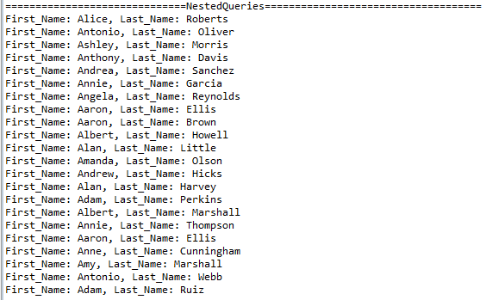

**/* Select first name, last name and employee id of all employees in employee table with even numbered employee ids */**

SELECT f_name, l_name, emp_id FROM employee

WHERE emp_id IN (SELECT emp_id FROM employee WHERE emp_id MOD 2 = 0);

//OUTPUT: first and last names along with employee ids of employees who id number is even

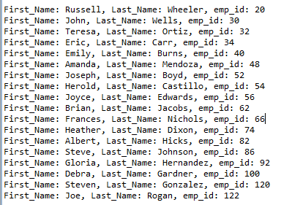

**/* get the department names, address, city, state and department lead of all departments located in California */**

SELECT dept_name, dept_address, dept_city, dept_state, dept_lead

FROM department WHERE dept_state IN (SELECT dept_state FROM department

WHERE dept_state = 'California');

//OUTPUT: department name, address, city, state and dept_lead of deparments located in ‘California’



**Two and Three-Way Join**

**Two-Way Join**

SELECT customer.customer_id, customer.f_name, customer.l_name, employee.emp_id, employee.f_name, employee.l_name

FROM project2_db.`customer` INNER JOIN project2_db.`employee`

ON customer.support_rep = employee.emp_id;

//OUTPUT: Two Way Join – NOTE 🡪 table was so big all of it wasn’t included

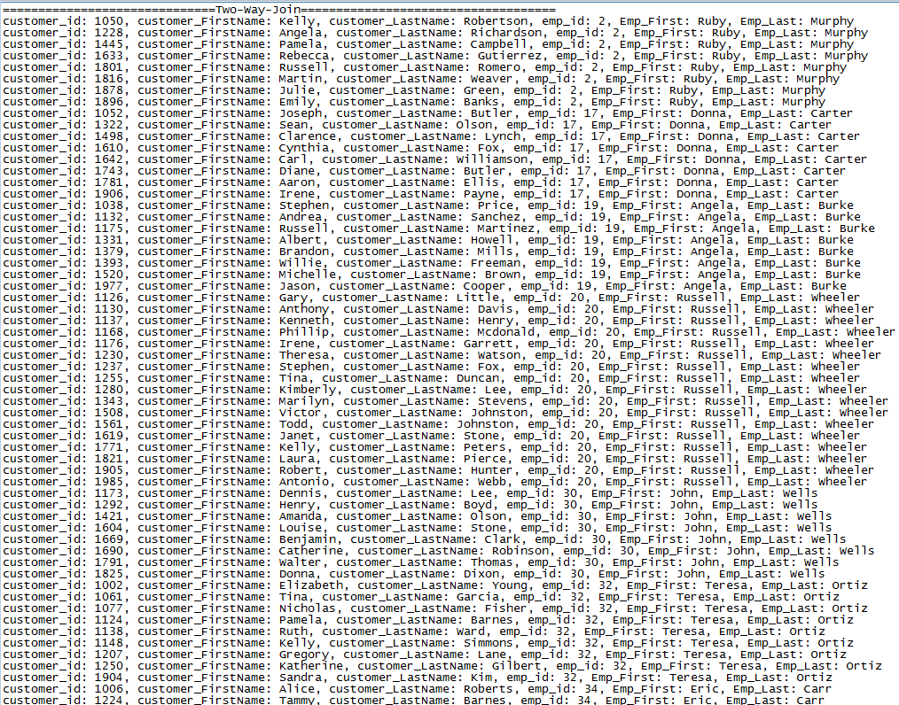

**Three-Way Join**

SELECT customer.f_name, customer.l_name, employee.f_name, employee.l_name, department.dept_name, department.dept_lead

FROM employee

JOIN customer ON employee.emp_id = customer.support_rep

JOIN department ON department.dept_name = employee.dept

ORDER BY dept_name;

//OUTPUT: Three Way Join -- NOTE 🡪 table was so big all of it wasn’t included

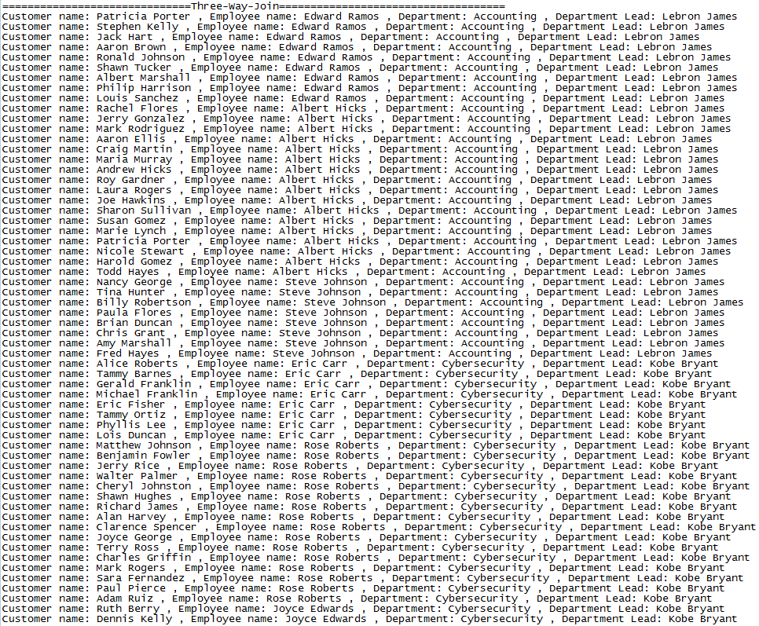

**Transaction**

**Transaction with Constraint Violation**

**public** **static** **void** transactionWithViolation() **throws** SQLException {

**try** {

*conn*.setAutoCommit(**false**); //turn off auto-commit

*statement* = *conn*.createStatement();

*sql* = "INSERT INTO employee (f_name, l_name, emp_id, title, address, city, addr_state, country, postal_code, phone, email, dept) " + "VALUES ('Steven', NULL, 120, NULL, '1 Washington Square Hall', 'San Jose', 'California', 'United States', 95023, '1-(831)801-8637', 's.gonzalez0250@yahoo.com', 'Software');";

*statement*.executeUpdate(*sql*);

//Never reached because first insert statement trips a constraint violation and jumpt to catch block

*sql* = "INSERT INTO employee (f_name, l_name, emp_id, title, address, city, addr_state, country, postal_code, phone, email, dept) " + "VALUES ('Steven', NULL, 122, NULL, '1 Washington Square Hall', 'San Jose', 'California', 'United States', 95023, '1-(831)801-8637', 's.gonzalez0250@yahoo.com', 'Software');";

*statement*.executeUpdate(*sql*);

*conn*.commit(); // never reached

}**catch**(SQLException e) {

//constraint violation... so rollback changes

System.***out***.println("Constraint violation - Columns 'l_name' and 'title' in employee table cannot be NULL. processing Rollback");

System.***out***.println("Processing Rollback");

*conn*.rollback();

System.***out***.println("Rollback complete...");

}

}

//OUTPUT: Transaction with constraint violation

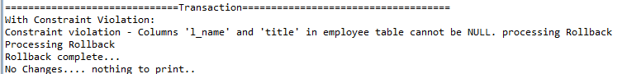

**Transaction No Violation**

**public** **static** **void** transactionNoViolation() **throws** SQLException {

**try** {

*conn*.setAutoCommit(**false**);

*statement* = *conn*.createStatement();

//no violation

*sql* = "INSERT INTO employee (f_name, l_name, emp_id, title, address, city, addr_state, country, postal_code, phone, email, dept) " + "VALUES ('Joe', 'Rogan', 122, 'Engineer', '1 Washington Square Hall', 'San Jose', 'California', 'United States', 95023, '1-(831)801-9999', 'joe111110@yahoo.com', 'Software');";

*statement*.executeUpdate(*sql*);

*conn*.commit(); //changes are committed

System.***out***.println("Successful Transaction commit");

}**catch**(SQLException e) {

//Never reached, no violation in try block

System.***out***.println("Constraint violation - processing Rollback");

*conn*.rollback();

System.***out***.println("Rollback complete...");

}

}

//OUTPUT: Transaction without any violation, successful commit, last entry of the table “Joe Rogan was the tuple added in the transaction”

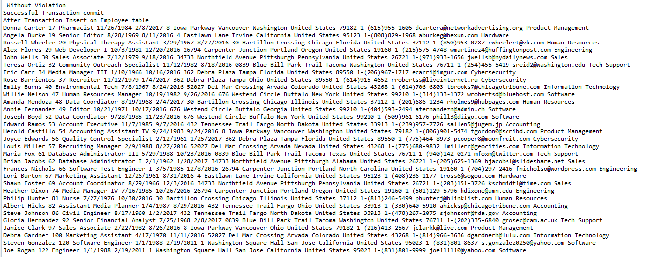

**JDBC – CODE**

**import** java.sql.*;

**public** **class** project2_db {

// JDBC driver name and database URL

**static** **final** String ***JDBC_DRIVER*** = "com.mysql.jdbc.Driver";

**static** **final** String ***DB_URL*** = "jdbc:mysql://localhost/";

// Database credentials

**static** **final** String ***USER*** = "root";

**static** **final** String ***PASS*** = "cs157a"; // insert your MySQL password

**private** **static** Connection *conn* = **null**;

**private** **static** PreparedStatement *preparedStatement* = **null**;

**private** **static** Statement *statement* = **null**;

**private** **static** ResultSet *rs* = **null**;

**private** **static** String *sql* = **null**;

**private** **static** project2_db *db*;

**public** **static** **void** main(String[] args) **throws** SQLException {

*db* = **new** project2_db();

}

**public** project2_db() **throws** SQLException {

**try** {

Class.*forName*(***JDBC_DRIVER***); //Register JDBC Driver

//STEP 3: Open a connection

System.***out***.println("Connecting to a selected database...");

*conn* = DriverManager.*getConnection*(***DB_URL***, ***USER***, ***PASS***);

System.***out***.println("Connected database successfully...");

*createDatabase*();

*createTables*();

*loadIntoTables*();

//STEP 4: Execute a query

System.***out***.println("Creating statement...");

*statement* = *conn*.createStatement();

System.***out***.println("\n==============================Create View====================================");

ResultSet result = *createView*();

*printCustomer*(result);

//createTrigger();

System.***out***.println("\n==============================Two-Way-Join====================================");

*twowayjoin*();

System.***out***.println("\n\n==============================Three-Way-Join====================================");

*threeWayJoin*();

System.***out***.println("\n\n==============================Aggregation====================================");

System.***out***.println("\t Count");

*countAggregate*();

System.***out***.println("\n\t Min");

*minAggregate*();

System.***out***.println("\n\t Max");

*maxAggregate*();

System.***out***.println("\t AVG");

*avgAggregate*();

System.***out***.println("\t SUM");

*sumAggregate*();

System.***out***.println("\n==============================Inserting====================================");

*insert*();

//System.out.println("\n\tInsert2 method:");

//insertTwo();

System.***out***.println("\nDepartment table after insert");

*printDepartmentTable*();

System.***out***.println("\nEmployee table after insert");

*printEmployeeTable*();

System.***out***.println("\nCustomer table after insert");

*printCustomerTable*();

System.***out***.println("\n\n==============================Updating====================================");

*update*();

//System.out.println("\tUpdate2 method");

//updateTwo();

System.***out***.println("\nDepartment table after Update");

*printDepartmentTable*();

System.***out***.println("\nEmployee table after Update");

*printEmployeeTable*();

System.***out***.println("\ncustomer table after Update");

*printCustomerTable*();

System.***out***.println("\n\n==============================Deleting====================================");

*delete*();

//System.out.println("\tDelete2\n");

//deleteTwo();

System.***out***.println("\nDepartment table after Delete");

*printDepartmentTable*();

System.***out***.println("\nEmployee table after Delete");

*printEmployeeTable*();

System.***out***.println("\nCustomer table after Delete");

*printCustomerTable*();

System.***out***.println("\n\n==============================Transaction====================================");

System.***out***.println("With Constraint Violation: ");

*transactionWithViolation*();

System.***out***.println("No Changes.... nothing to print..\n\n Without Violation");

*transactionNoViolation*();

System.***out***.println("After Transaction Insert on Employee table");

*printEmployeeTable*();

System.***out***.println("\n");

System.***out***.println("\n\n==============================NestedQueries====================================");

*nestedQueries*();

*rs*.close();

}**catch**(SQLException se){

//Handle errors for JDBC

se.printStackTrace();

}**catch**(Exception e){

//Handle errors for Class.forName

e.printStackTrace();

}**finally**{

//finally block used to close resources

**try**{

**if**(*statement*!=**null**)

*conn*.close();

}**catch**(SQLException se){

}// do nothing

**try**{

**if**(*conn*!=**null**)

*conn*.close();

}**catch**(SQLException se){

se.printStackTrace();

}//end finally try

}//end try

System.***out***.println("\nGoodbye!");

}

**private** **static** **void** createDatabase() **throws** SQLException {

String queryDrop = "DROP DATABASE IF EXISTS project2_db;";

Statement stmtDrop = *conn*.createStatement();

stmtDrop.execute(queryDrop);

*sql* = "SET foreign_key_checks = 0; ";

*statement* = *conn*.createStatement();

*statement* .execute(*sql*);

System.***out***.println("Creating database..."); // Create a database

String sql = "CREATE DATABASE project2_db;";

*preparedStatement* = *conn*.prepareStatement(sql);

*preparedStatement*.executeUpdate();

System.***out***.println("Database created successfully...");

*conn* = DriverManager.*getConnection*(***DB_URL***+"project2_db", ***USER***, ***PASS***);

}

**private** **static** **void** createTables() **throws** SQLException {

String queryDrop = "DROP TABLE IF EXISTS department";

Statement stmtDrop = *conn*.createStatement();

stmtDrop.execute(queryDrop);

String createTableSQL = "CREATE TABLE department("

+ "dept_name VARCHAR(40) NOT NULL PRIMARY KEY, "

+ "dept_address VARCHAR(30), "

+ "dept_city VARCHAR(40), "

+ "dept_state VARCHAR(40), "

+ "dept_country VARCHAR(40), "

+ "dept_lead VARCHAR(40)) ";

*preparedStatement* = *conn*.prepareStatement(createTableSQL);

*preparedStatement*.executeUpdate();

System.***out***.println("Table called department created successfully...");

queryDrop = "DROP TABLE IF EXISTS employee";

stmtDrop = *conn*.createStatement();

stmtDrop.execute(queryDrop);

createTableSQL = "CREATE TABLE employee( "

+ "f_name VARCHAR(20) NOT NULL, "

+ "l_name VARCHAR(20) NOT NULL, "

+ "emp_id INTEGER NOT NULL PRIMARY KEY, "

+ "title VARCHAR(30) NOT NULL, "

+ "birthdate VARCHAR(10) DEFAULT '1/1/1988', "

+ "hire_date VARCHAR(10) DEFAULT '2/19/2011', "

+ "address VARCHAR(40), "

+ "city VARCHAR(20), "

+ "addr_state VARCHAR(20), "

+ "country VARCHAR(25), "

+ "postal_code INTEGER, "

+ "phone VARCHAR(20), "

+ "email VARCHAR(40), "

+ "dept VARCHAR(35), "

+ "FOREIGN KEY (dept) REFERENCES department(dept_name)); ";

*preparedStatement* = *conn*.prepareStatement(createTableSQL);

*preparedStatement*.executeUpdate();

System.***out***.println("Table called employee created successfully...");

queryDrop = "DROP TABLE IF EXISTS customer";

stmtDrop = *conn*.createStatement();

stmtDrop.execute(queryDrop);

createTableSQL = "CREATE TABLE customer( "

+ "customer_id INTEGER NOT NULL PRIMARY KEY, "

+ "f_name VARCHAR(20), "

+ "l_name VARCHAR(20), "

+ "address VARCHAR(40), "

+ "city VARCHAR(20), "

+ "addr_state VARCHAR(20), "

+ "country VARCHAR(25), "

+ "postal_code INTEGER, "

+ "phone VARCHAR(20), "

+ "email VARCHAR(40), "

+ "support_rep INTEGER, "

+ "FOREIGN KEY (support_rep) REFERENCES employee(emp_id) "

+ "ON UPDATE CASCADE "

+ "ON DELETE CASCADE); ";

*preparedStatement* = *conn*.prepareStatement(createTableSQL);

*preparedStatement*.executeUpdate();

System.***out***.println("Table called customer created successfully...");

}

**public** **static** **void** loadIntoTables() **throws** SQLException {

String path = System.*getProperty*("user.dir").replace("\\", "\\\\") + "/departments.txt";

System.***out***.println("Loading data from file departments.txt");

String loadDataSQL = "LOAD DATA LOCAL INFILE '" + path + "' INTO TABLE department "

+ "LINES TERMINATED BY '\r\n'"; // need to add lines terminated if on windows

*preparedStatement* = *conn*.prepareStatement(loadDataSQL);

*preparedStatement*.execute();

path = System.*getProperty*("user.dir").replace("\\", "\\\\") + "/employees.txt";

System.***out***.println("Loading data from employees.txt");

loadDataSQL = "LOAD DATA LOCAL INFILE '" + path + "' INTO TABLE employee "

+ "LINES TERMINATED BY '\r\n'"; // need to add lines terminated if on windows

*preparedStatement* = *conn*.prepareStatement(loadDataSQL);

*preparedStatement*.execute();

path = System.*getProperty*("user.dir").replace("\\", "\\\\") + "/customers.txt";

System.***out***.println("Loading data from file customers.txt");

loadDataSQL = "LOAD DATA LOCAL INFILE '" + path + "' INTO TABLE customer "

+ "LINES TERMINATED BY '\r\n'"; // need to add lines terminated if on windows

*preparedStatement* = *conn*.prepareStatement(loadDataSQL);

*preparedStatement*.execute();

}

**public** **static** **void** countAggregate() **throws** SQLException {

*sql* = **null**;

*rs* = **null**;

*sql* = "SELECT employee.f_name, employee.l_name, support_rep AS rep_id, COUNT(support_rep) "

+ "FROM customer JOIN employee "

+ "ON customer.support_rep = employee.emp_id "

+ "GROUP BY support_rep "

+ "ORDER BY support_rep ASC; ";

**try** {

*preparedStatement* = *conn*.prepareStatement(*sql*);

*rs* = *preparedStatement*.executeQuery();

**while**(*rs*.next()) {

String f_name = *rs*.getString("f_name");

String l_name = *rs*.getString("l_name");

**int** rep_id = *rs*.getInt("rep_id");

**int** count = *rs*.getInt("COUNT(support_rep)");

System.***out***.println(f_name + " " + l_name + " " + rep_id + " " + count);

}

}**catch**(SQLException e) { e.printStackTrace(); }

}

**public** **static** **void** minAggregate() **throws** SQLException {

*sql* = **null**;

*rs* = **null**;

*sql* = "SELECT rep_id, MIN(myCount) "

+ "FROM (SELECT support_rep AS rep_id, COUNT(support_rep) AS myCount "

+ "FROM customer "

+ "GROUP BY support_rep) AS countFunction; ";

**try** {

*preparedStatement* = *conn*.prepareStatement(*sql*);

*rs* = *preparedStatement*.executeQuery();

**while**(*rs*.next()) {

**int** rep_id = *rs*.getInt("rep_id");

**int** minCount = *rs*.getInt("MIN(myCount)");

System.***out***.println("sales rep MIN(count): " + minCount);

}

}**catch**(SQLException e) { e.printStackTrace(); }

}

**public** **static** **void** maxAggregate() **throws** SQLException {

*sql* = **null**;

*rs* = **null**;

*sql* = "SELECT rep_id, MAX(myCount) "

+ "FROM (SELECT support_rep AS rep_id, COUNT(support_rep) AS myCount "

+ "FROM customer "

+ "GROUP BY support_rep) AS countFunction; ";

**try** {

*preparedStatement* = *conn*.prepareStatement(*sql*);

*rs* = *preparedStatement*.executeQuery();

**while**(*rs*.next()) {

**int** rep_id = *rs*.getInt("rep_id");

**int** maxCount = *rs*.getInt("MAX(myCount)");

System.***out***.println("Sales Rep with the most Customer Contracts, Max(count): " + maxCount + "\n");

}

}**catch** (SQLException e) { e.printStackTrace(); }

}

**public** **static** **void** avgAggregate() **throws** SQLException {

*sql* = **null**;

*rs* = **null**;

*sql* = "SELECT rep_id, AVG(myCount) "

+ "FROM (SELECT support_rep AS rep_id, COUNT(support_rep) AS myCount "

+ "FROM customer "

+ "GROUP BY support_rep) AS countFunction; ";

**try** {

*preparedStatement* = *conn*.prepareStatement(*sql*);

*rs* = *preparedStatement*.executeQuery();

**while**(*rs*.next()) {

**int** rep_id = *rs*.getInt("rep_id");

**int** avgCount = *rs*.getInt("AVG(myCount)");

System.***out***.println("sales_reps have number of average customers , AVG(count): " + avgCount + "\n");

}

}**catch**(SQLException e) { e.printStackTrace(); }

}

**public** **static** **void** sumAggregate() **throws** SQLException {

*sql* = **null**;

*rs* = **null**;

*sql* = "SELECT rep_id, SUM(myCount) "

+ "FROM (SELECT support_rep AS rep_id, COUNT(support_rep) AS myCount "

+ "FROM customer "

+ "GROUP BY support_rep) AS countFunction; ";

**try** {

*preparedStatement* = *conn*.prepareStatement(*sql*);

*rs* = *preparedStatement*.executeQuery();

**while**(*rs*.next()) {

**int** rep_id = *rs*.getInt("rep_id");

**int** sumCount = *rs*.getInt("SUM(myCount)");

System.***out***.println("total customer contracts , SUM(count): " + sumCount + "\n");

}

}**catch**(SQLException e) { e.printStackTrace(); }

}

**public** **static** **void** nestedQueries() {

*sql* = **null**;

**try** {

*sql* = "SELECT f_name, l_name from customer "

+ "WHERE f_name IN (SELECT f_name FROM customer WHERE f_name LIKE 'A%'); ";

*preparedStatement* = *conn*.prepareStatement(*sql*);

*rs* = *preparedStatement*.executeQuery();

**while**(*rs*.next()) {

String f_name = *rs*.getString("f_name");

String l_name = *rs*.getString("l_name");

System.***out***.println("First_Name: " + f_name + ", Last_Name: " + l_name);

}

System.***out***.println("\n");

*sql* = "SELECT f_name, l_name, emp_id FROM employee "

+ "WHERE emp_id IN (SELECT emp_id FROM employee WHERE emp_id MOD 2 = 0);";

*preparedStatement* = *conn*.prepareStatement(*sql*);

*rs* = *preparedStatement*.executeQuery();

**while**(*rs*.next()) {

String f_name = *rs*.getString("f_name");

String l_name = *rs*.getString("l_name");

**int** emp_id = *rs*.getInt("emp_id");

System.***out***.println("First_Name: " + f_name + ", Last_Name: " + l_name + ", emp_id: " + emp_id);

}

System.***out***.println("\n");

*sql* = "SELECT dept_name, dept_address, dept_city, dept_state, dept_lead "

+ "FROM department WHERE dept_state IN (SELECT dept_state FROM department WHERE dept_state = 'California');";

*preparedStatement* = *conn*.prepareStatement(*sql*);

*rs* = *preparedStatement*.executeQuery();

**while**(*rs*.next()) {

String dept_name = *rs*.getString("dept_name");

String dept_address = *rs*.getString("dept_address");

String dept_city = *rs*.getString("dept_city");

String dept_state = *rs*.getString("dept_state");

String dept_lead = *rs*.getString("dept_lead");

System.***out***.println("dept_name: " + dept_name + ", address: " + dept_address + ", city: " + dept_city + ", state: " + dept_state

+ ", dept_lead: " + dept_lead);

}

} **catch**(SQLException e) { e.printStackTrace(); }

}

**public** **static** **void** insert() **throws** SQLException {

*sql* = **null**;

**try**{

//insert 1

*sql* = "INSERT INTO employee (f_name, l_name, emp_id, title, address, city, addr_state, country, postal_code, phone, email, dept) "

+ "VALUES ('Steven', 'Gonzalez', 120, 'Software Engineer', '1 Washington Square Hall', 'San Jose', 'California', 'United States', 95023, '1-(831)801-8637', 's.gonzalez0250@yahoo.com', 'Software'); ";

*statement*.executeUpdate(*sql*);

System.***out***.println("Inserted an employee in the employee table...");

//insert 2

*sql* = "INSERT INTO project2_db.customer (`customer_id`, `f_name`, `l_name`, `address`, `city`, `addr_state`, `country`, `postal_code`, `phone`, `email`) "

+ "VALUES ('1989', 'Peter ', 'Pan', '52127 Del Mar Crossing', 'Arvada', 'Colorado', 'United States', '19160', '1-(201)927-1717', 'wrobertsd123@bluehost.com');";

*statement*.executeUpdate(*sql*);

//STEP 2: Extract data from result set

System.***out***.println("Inserted an Customer into into the table...");

//insert 3

*sql* = "INSERT into Department (dept_name, dept_address, dept_city, dept_state, dept_country, dept_lead) VALUES ('electronics', 'Miller Rd', 'Hollister', 'California', 'US', 'Jim Jones');";

*statement*.executeUpdate(*sql*);

System.***out***.println("Inserted into department table... ");

//insert 4

*statement* = *conn*.createStatement();

*statement*.executeUpdate("INSERT INTO customer(customer_id,f_name,l_name,address,city,addr_state,country,postal_code,phone,email,support_rep)" + "VALUES (1302,'Udit','Manocha','One Washington Sq', 'San Jose','California','United States',95112,'1-(424)288-0824','udit.manocha@sjsu.edu',56)");

System.***out***.println("Inserted into customer table... ");

}**catch** (SQLException e) {e.printStackTrace();}

}

**public** **static** **void** update() **throws** SQLException {

*sql* = **null**;

**try** {

//update 1

*sql* = "UPDATE project2_db.customer SET `address`='111 Hoffman Trail' WHERE `customer_id`='1989';";

*statement*.executeUpdate(*sql*);

System.***out***.println("UPDATED an Customer's address into into the table...");

//update 2

*sql* = "UPDATE employee SET l_name = 'Barrientos' where f_name = 'Rose'; ";

*statement*.executeUpdate(*sql*);

System.***out***.println("UPDATED an Customer's lastname into from customer table......");

//update 3

*sql* = "UPDATE department SET dept_lead = 'Babe Ruth' WHERE dept_name = 'electronics' ";

*statement*.executeUpdate(*sql*);

System.***out***.println("UPDATED a department lead from the department table...");

//update 4

*statement* = *conn*.createStatement();

*statement*.executeUpdate("UPDATE customer SET l_name = 'Sharma' WHERE customer_id = 1989");

System.***out***.println("UPDATED an Customer's last name in the customer table...");

} **catch**(SQLException e) { e.printStackTrace(); }

}

**public** **static** **void** delete() **throws** SQLException {

*sql* = **null**;

**try** {

//delete 1

*sql* = "DELETE FROM employee WHERE emp_id = 2; " ;

*statement*.executeUpdate(*sql*);

System.***out***.println("DELETED an employee from employee table...");

//delete 2

*sql* = "DELETE FROM project2_db.customer WHERE `customer_id`='1989';";

*statement*.executeUpdate(*sql*);

//STEP 2: Extract data from result set

System.***out***.println("DELETED an Customer from customer table...");

//delete 3

*sql* = "DELETE FROM department WHERE `dept_name` = 'electronics';";

*statement*.executeUpdate(*sql*);

System.***out***.println("DELETED a department from department table...");

//delete 4

*statement* = *conn*.createStatement();

*statement*.executeUpdate("DELETE FROM customer WHERE customer_id = 1971");

System.***out***.println("DELETED an Customer from customer table...");

} **catch**(SQLException e) { e.printStackTrace(); }

}

**public** **static** **void** twowayjoin() **throws** SQLException {

//STEP 1: Execute a query

**try**{

*sql* = "SELECT customer.customer_id, customer.f_name, customer.l_name, employee.emp_id, employee.f_name, employee.l_name "

+ "FROM project2_db.`customer` INNER JOIN project2_db.`employee` ON customer.support_rep = employee.emp_id;";

*rs* = *statement*.executeQuery(*sql*);

//STEP 2: Extract data from result set

**while**(*rs*.next()){

//Retrieve by column name

**int** cus_id = *rs*.getInt("customer.customer_id");

String cus_first = *rs*.getString("customer.f_name");

String cus_last = *rs*.getString("customer.l_name");

**int** emp_id = *rs*.getInt("employee.emp_id");

String emp_first = *rs*.getString("employee.f_name");

String emp_last = *rs*.getString("employee.l_name");

//Display values

System.***out***.print("customer_id: " + cus_id);

System.***out***.print(", customer_FirstName: " + cus_first);

System.***out***.print(", customer_LastName: " + cus_last);

System.***out***.print(", emp_id: " + emp_id);

System.***out***.print(", Emp_First: " + emp_first);

System.***out***.println(", Emp_Last: " + emp_last);

}

}**catch**(SQLException se) { se.printStackTrace(); }

}

**public** **static** **void** threeWayJoin() **throws** SQLException {

*sql* = **null**;

*rs* = **null**;

**try** {

*sql* = "SELECT customer.f_name, customer.l_name, employee.f_name, employee.l_name, department.dept_name, department.dept_lead "

+ "FROM employee "

+ "JOIN customer ON employee.emp_id = customer.support_rep "

+ "JOIN department ON department.dept_name = employee.dept "

+ "ORDER BY dept_name; ";

*rs* = *statement*.executeQuery(*sql*);

**while**(*rs*.next()){

String c_f_name = *rs*.getString("customer.f_name");

String c_l_name = *rs*.getString("customer.l_name");

String e_f_name = *rs*.getString("employee.f_name");

String e_l_name = *rs*.getString("employee.l_name");

String dept_name = *rs*.getString("department.dept_name");

String dept_lead = *rs*.getString("department.dept_lead");

System.***out***.println("Customer name: " + c_f_name + " " + c_l_name

+ " , Employee name: " + e_f_name + " " + e_l_name

+ " , Department: " + dept_name + " , Department Lead: " + dept_lead);

}

}**catch**(SQLException e) {

e.printStackTrace();

}

}

**public** **static** **void** transactionWithViolation() **throws** SQLException {

**try** {

*conn*.setAutoCommit(**false**); //turn off auto-commit

*statement* = *conn*.createStatement();

*sql* = "INSERT INTO employee (f_name, l_name, emp_id, title, address, city, addr_state, country, postal_code, phone, email, dept) "

+ "VALUES ('Steven', NULL, 120, NULL, '1 Washington Square Hall', 'San Jose', 'California', 'United States', 95023, '1-(831)801-8637', 's.gonzalez0250@yahoo.com', 'Software');";

*statement*.executeUpdate(*sql*);

//Never reached because first insert statement trips a constraint violation and jumpt to catch block

*sql* = "INSERT INTO employee (f_name, l_name, emp_id, title, address, city, addr_state, country, postal_code, phone, email, dept) "

+ "VALUES ('Steven', NULL, 122, NULL, '1 Washington Square Hall', 'San Jose', 'California', 'United States', 95023, '1-(831)801-8637', 's.gonzalez0250@yahoo.com', 'Software');";

*statement*.executeUpdate(*sql*);

*conn*.commit(); // never reached

}**catch**(SQLException e) {

//constraint violation... so rollback changes

System.***out***.println("Constraint violation - Columns 'l_name' and 'title' in employee table cannot be NULL. processing Rollback");

System.***out***.println("Processing Rollback");

*conn*.rollback();

System.***out***.println("Rollback complete...");

}

}

**public** **static** **void** transactionNoViolation() **throws** SQLException {

**try** {

*conn*.setAutoCommit(**false**);

*statement* = *conn*.createStatement();

*sql* = "INSERT INTO employee (f_name, l_name, emp_id, title, address, city, addr_state, country, postal_code, phone, email, dept) "

+ "VALUES ('Joe', 'Rogan', 122, 'Engineer', '1 Washington Square Hall', 'San Jose', 'California', 'United States', 95023, '1-(831)801-9999', 'joe111110@yahoo.com', 'Software');";

*statement*.executeUpdate(*sql*);

*conn*.commit();

System.***out***.println("Successful Transaction commit");

}**catch**(SQLException e) {

//Never reached, no violation in try block

System.***out***.println("Constraint violation - processing Rollback");

*conn*.rollback();

System.***out***.println("Rollback complete...");

}

}

**public** **static** **void** printCustomerTable() **throws** SQLException {

*rs* = **null**;

**try** {

*statement* = *conn*.createStatement();

*rs* = *statement*.executeQuery("SELECT * from customer; ");

}**catch**(SQLException e) { e.printStackTrace(); }

**while**(*rs*.next()) {

**int** customer_id = *rs*.getInt("customer_id");

String f_name = *rs*.getString("f_name");

String l_name = *rs*.getString("l_name");

String address = *rs*.getString("address");

String city = *rs*.getString("city");

String state = *rs*.getString("addr_state");

String country = *rs*.getString("country");

**int** zipcode = *rs*.getInt("postal_code");

String phone = *rs*.getString("phone");

String email = *rs*.getString("email");

**int** support_rep = *rs*.getInt("support_rep");

System.***out***.println(customer_id + " " + f_name + " " + l_name + " " + address + " "

+ city + " " + state + " " + country + " " + zipcode + " " + phone + " "

+ email + " " + support_rep);

}

}

**public** **static** **void** printEmployeeTable() **throws** SQLException{

*rs* = **null**;

**try** {

*statement* = *conn*.createStatement();

*rs* = *statement*.executeQuery("SELECT * from employee; ");

}**catch**(SQLException e) { e.printStackTrace(); }

**while**(*rs*.next()) {

String f_name = *rs*.getString("f_name");

String l_name = *rs*.getString("l_name");

**int** employee_id = *rs*.getInt("emp_id");

String title = *rs*.getString("title");

String birthdate = *rs*.getString("birthdate");

String hire_date = *rs*.getString("hire_date");

String address = *rs*.getString("address");

String city = *rs*.getString("city");

String state = *rs*.getString("addr_state");

String country = *rs*.getString("country");

**int** zipcode = *rs*.getInt("postal_code");

String phone = *rs*.getString("phone");

String email = *rs*.getString("email");

String department = *rs*.getString("dept");

System.***out***.println(f_name + " " + l_name + " " + employee_id + " " + title + " "

+ birthdate + " " + hire_date + " " + address + " " + city + " " + state + " "

+ country + " " + zipcode + " " + phone + " " + email + " " + department);

}

}

**public** **static** **void** printDepartmentTable() **throws** SQLException {

*rs* = **null**;

**try** {

*statement* = *conn*.createStatement();

*rs* = *statement*.executeQuery("SELECT * from department; ");

}**catch**(SQLException e) { e.printStackTrace(); }

**while**(*rs*.next()) {

String department_name = *rs*.getString("dept_name");

String department_address = *rs*.getString("dept_address");

String department_city = *rs*.getString("dept_city");

String department_state = *rs*.getString("dept_state");

String department_country = *rs*.getString("dept_country");

String department_lead = *rs*.getString("dept_lead");

System.***out***.println(department_name + " " + department_address + " " + department_city + " "

+ department_state + " " + department_country + " " + department_lead);

}

}

**private** **static** **void** printCustomer(ResultSet rs) {

**try** {

**while**(rs.next()) {

System.***out***.print(rs.getString("customer_id") + " " + rs.getString("l_name") + "\n");

}

} **catch** (SQLException e) { e.printStackTrace(); }

}

**private** **static** ResultSet createView() {

System.***out***.println("creating view.....");

ResultSet rs = **null**;

**try** {

*statement* = *conn*.createStatement();

*statement*.executeUpdate("CREATE OR REPLACE VIEW v AS SELECT * FROM customer WHERE customer.addr_state = 'Utah';");

rs = *statement*.executeQuery("SELECT * from v");

System.***out***.println("creatview() - complete");

}

**catch** (SQLException e) { e.printStackTrace(); }

**return** rs;

}

}