Steven Gonzalez

CS157B

Professor Ezzat

MW: 730pm – 845pm

Project 1

1. **Database:**

MySQL – RDBMS

1. **JDBC Driver-Type 4:**

mysql-connector-java 5.1.40

1. **Schema**

/* BEGIN SCHEMA */

DROP DATABASE IF EXISTS oneProjectDB;

CREATE DATABASE oneProjectDB;

USE oneProjectDB;

DROP TABLE IF EXISTS USRealtors;

CREATE TABLE USRealtors(

f_name VARCHAR(20),

l_name VARCHAR(20),

comp_name VARCHAR(45),

street VARCHAR(30),

city VARCHAR(20),

county VARCHAR(30),

c_state VARCHAR(3),

zip INTEGER,

phone VARCHAR(13),

salary INTEGER,

PRIMARY KEY(phone)

);

INSERT INTO USRealtors (f_name, l_name, comp_name, street, city, county, c_state, zip, phone, salary) VALUES("Steven", "Gonzalez", "Google", "170 Miller Rd", "Hollister", "San Benito", "CA", "95111", "831-801-8637", "110");

INSERT INTO USRealtors (f_name, l_name, comp_name, street, city, county, c_state, zip, phone, salary) VALUES("Carly", "Harrell", "Yahoo", "250 San Lorenzo", "Mountain View", "Santa Clara", "CA", "95111", "987-654-3211", "115");

INSERT INTO USRealtors (f_name, l_name, comp_name, street, city, county, c_state, zip, phone, salary) VALUES("Kloe", "Fidone", "Apple", "1 Memorial Dr", "Santa Clara", "Santa Clara", "CA", "95111", "987-321-6544", "100");

INSERT INTO USRealtors (f_name, l_name, comp_name, street, city, county, c_state, zip, phone, salary) VALUES("Cody", "Gosponeditch", "Samsung", "1 Lincon St", "San Jose", "Santa Clara", "CA", "95111", "654-831-9877", "70");

INSERT INTO USRealtors (f_name, l_name, comp_name, street, city, county, c_state, zip, phone, salary) VALUES("Danny","Roye", "Sony", "2 Chappel Ct", "San Francisco", "San Francisco", "CA", "95111", "831-207-0990", "56");

INSERT INTO USRealtors (f_name, l_name, comp_name, street, city, county, c_state, zip, phone, salary) VALUES("Rob", "Baily", "Lenovo", "3 Azul Ct", "Oakland", "Oakland County", "CA", "95111", "831-099-0207", "66");

INSERT INTO USRealtors (f_name, l_name, comp_name, street, city, county, c_state, zip, phone, salary) VALUES("Eddie", "Orozco", "Microsoft", "2 Main St", "Palo Alto", "Santa Clara", "CA", "95111", "408-842-7282", "90");

INSERT INTO USRealtors (f_name, l_name, comp_name, street, city, county, c_state, zip, phone, salary) VALUES("Nick", "Elmore", "McAfee", "77 Santa Clara St", "Los Angeles", "Los Angeles", "CA", "95111", "842-408-0207", "50");

INSERT INTO USRealtors (f_name, l_name, comp_name, street, city, county, c_state, zip, phone, salary) VALUES("Liz", "Barrientos", "Norton", "22 San Fernando St", "Sacramento", "Santa Clara", "CA", "95111", "831-329-0987", "87");

INSERT INTO USRealtors (f_name, l_name, comp_name, street, city, county, c_state, zip, phone, salary) VALUES("Maria", "Guiterez", "PayPal", "33 4th Street", "San Jose", "Santa Clara", "CA", "95111", "831-879-4455", "78");

LOAD DATA LOCAL INFILE 'C:\\Program Files\\MySQL\\MySQL Server 5.7\\bin\\data\\company.txt' INTO TABLE USRealtors;

/* END SCHEMA */

1. **Table population:**

I used INSERT statements in my SCHEMA to insert insert 10 items into the table.

Screenshot after first population of database:

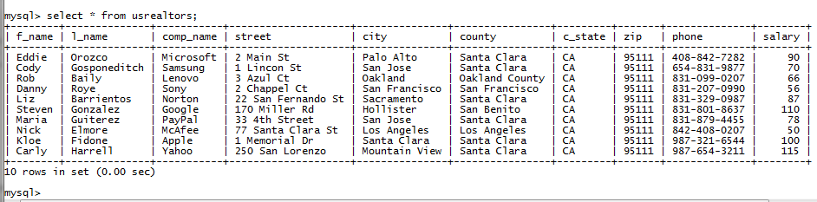

I then used a .txt file filled with data to INSERT most of the data used in my database using the statement In my SCHEMA:

LOAD DATA LOCAL INFILE 'C:\\Program Files\\MySQL\\MySQL Server 5.7\\bin\\data\\company.txt' INTO TABLE USRealtors;

Screenshot after loading .txt file into the database:

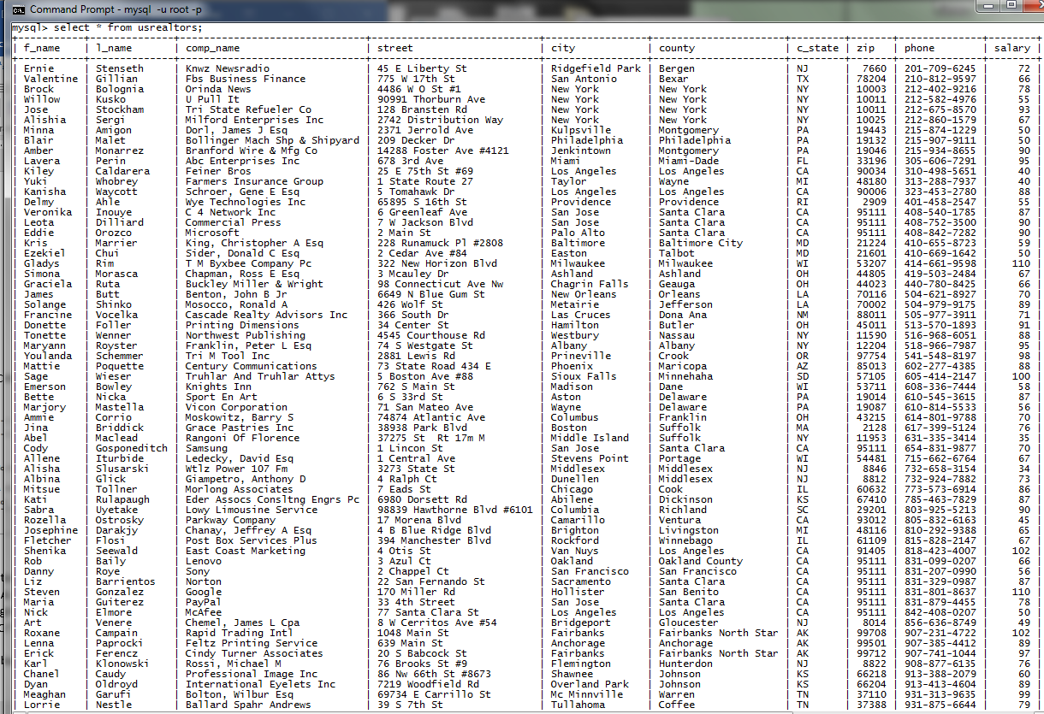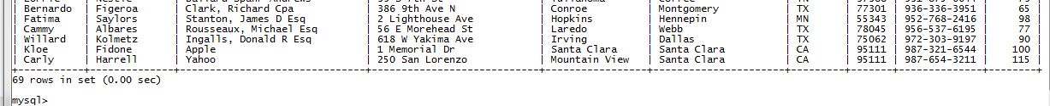

1. **Queries:**
   1. SELECT COUNT(*) as total_realtors

FROM usrealtors;

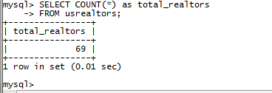

* 1. SELECT f_name, l_name, comp_name, street, city, c_state, zip, phone

FROM usrealtors ORDER BY city ASC;

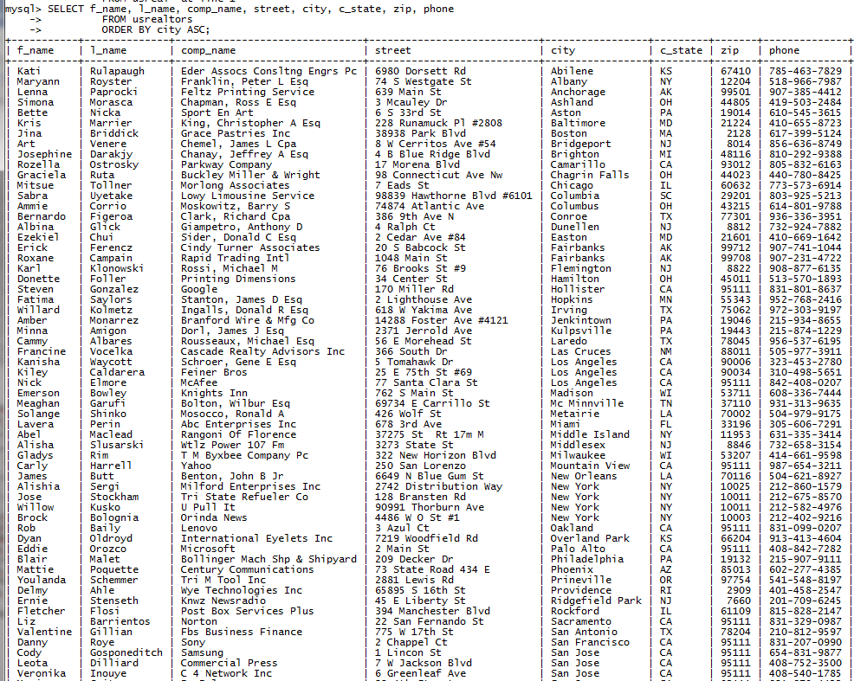

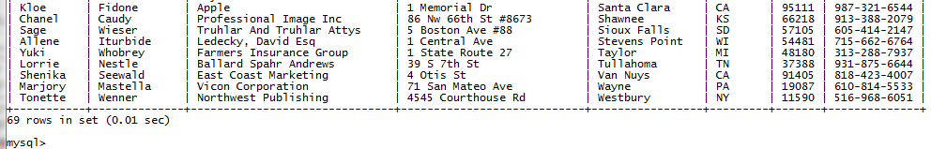

* 1. Select SUM(salary) as total_payout

FROM usrealtors;

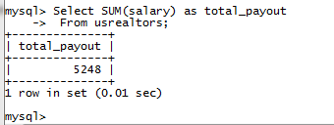

* 1. SELECT f_name, l_name, salary

FROM usrealtors;

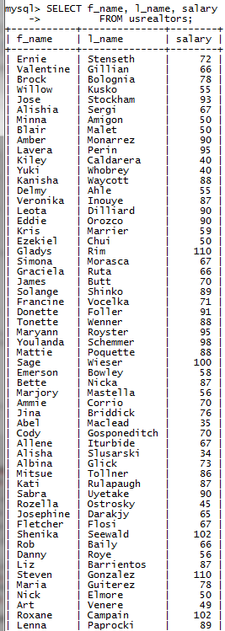 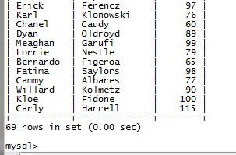

* 1. SELECT MIN(salary), MAX(salary), AVG(salary), city, c_state

FROM usrealtors

GROUP BY city

ORDER by AVG(salary) ASC;

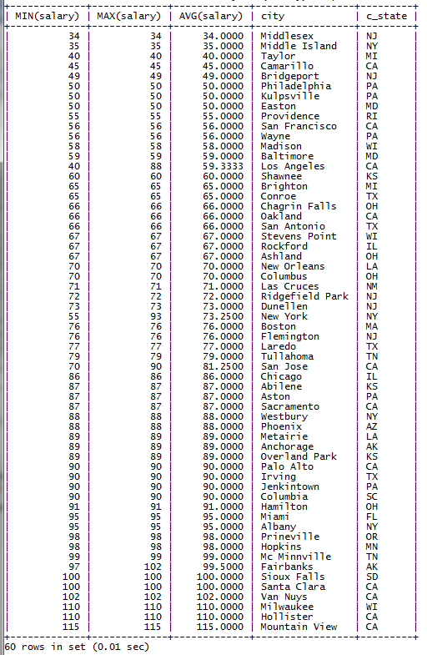

1. **JDBC code I made for my Database**

**import** java.sql.*;

**public** **class** myDB {

// JDBC driver name and database URL

**static** **final** String ***JDBC_DRIVER*** = "com.mysql.jdbc.Driver";

**static** **final** String ***DB_URL*** = "jdbc:mysql://localhost/";

// Database credentials

**static** **final** String ***USER*** = "root";

**static** **final** String ***PASS*** = "cs157a";

**private** **static** Connection *conn* = **null**;

**private** **static** PreparedStatement *preparedStatement* = **null**;

**private** **static** Statement *statement* = **null**;

**private** **static** String[] *f_names* = {"Steven", "Carly", "Kloe", "Cody", "Danny", "Rob", "Eddie", "Nick", "Liz", "Maria" };

**private** **static** String[] *l_names* = {"Gonzalez", "Harrell", "Fidone", "Gosponeditch", "Roye", "Baily", "Orozco", "Elmore", "Barrientos", "Guiterez"};

**private** **static** String[] *comp_name* = {"Google", "Yahoo", "Apple", "Samsung", "Sony", "Lenovo", "Microsoft", "McAfee", "Norton" ,"PayPal"};

**private** **static** String[] *street* = {"170 Miller Rd.", "250 San Lorenzo", "1 Memorial Dr", "1 Lincon St", "2 Chappel Ct", "3 Azul Ct", "2 Main St", "77 Santa Clara St", "22 San Fernando St", "33 4th St"};

**private** **static** String[] *city* = {"Hollister", "Mountain View", "Santa Clara", "San Jose", "San Francisco", "Oakland", "Palo Alto", "Los Angeles", "Sacramento", "San Jose"};

**private** **static** String *county*= "Santa Clara";

**private** **static** String *state* = "CA";

**private** **static** **int** *zip* = 95111;

**private** **static** String[] *number* = {"831-801-8637", "987-654-3211", "987-321-6544", "654-831-9877", "831-207-0990", "831-099-0207", "408-842-7282", "842-408-0207", "831-329-0987", "831-879-4455"};

**private** **static** **int**[] *salaries* = {110, 115, 100, 70, 56, 66, 90, 50, 87, 78};

**public** myDB() **throws** SQLException {

**try** {

Class.*forName*(***JDBC_DRIVER***); //Register JDBC Driver

*createDatabase*();

*createTable*();

*loadIntoTable*();

*prepInsert*();

*getDbCount*();

*getListingsByCity*();

*getPayout*();

*getNamesWithSalaries*();

*getCityMinMaxAvgSalary*();

}

**catch**(SQLException se){se.printStackTrace(); }

**catch**(Exception e){ e.printStackTrace(); }

}

**private** **static** **void** createDatabase() **throws** SQLException {

System.***out***.println("Connecting to database..."); // Open a connection

*conn* = DriverManager.*getConnection*(***DB_URL***, ***USER***, ***PASS***);

String queryDrop = "DROP DATABASE IF EXISTS oneProjectDB;";

Statement stmtDrop = *conn*.createStatement();

stmtDrop.execute(queryDrop);

System.***out***.println("Creating database..."); // Create a database named CS

String sql = "CREATE DATABASE oneProjectDB;";

*preparedStatement* = *conn*.prepareStatement(sql);

*preparedStatement*.executeUpdate();

System.***out***.println("Database created successfully...");

*conn* = DriverManager.*getConnection*(***DB_URL***+"oneProjectDB", ***USER***, ***PASS***);

}

**private** **static** **void** createTable() **throws** SQLException {

String queryDrop = "DROP TABLE IF EXISTS USRealtors";

Statement stmtDrop = *conn*.createStatement();

stmtDrop.execute(queryDrop);

String createTableSQL = "CREATE TABLE USRealtors("

+ "f_name VARCHAR(20), "

+ "l_name VARCHAR(20), "

+ "comp_name VARCHAR(45), "

+ "street VARCHAR(30), "

+ "city VARCHAR(20), "

+ "county VARCHAR(30), "

+ "c_state VARCHAR(3), "

+ "zip INTEGER, "

+ "phone VARCHAR(13), "

+ "salary int, "

+ "PRIMARY KEY(phone));";

*preparedStatement* = *conn*.prepareStatement(createTableSQL);

*preparedStatement*.executeUpdate();

System.***out***.println("Table called USRealtors created successfully...");

}

**public** **static** **void** loadIntoTable() **throws** SQLException {

String path = System.*getProperty*("user.dir").replace("\\", "\\\\") + "/company.txt";

System.***out***.println("Load data from a file company.txt");

String loadDataSQL = "LOAD DATA LOCAL INFILE '" + path + "' INTO TABLE USRealtors "

+ "LINES TERMINATED BY '\r\n'"; // need to add lines terminated if on windows

*preparedStatement* = *conn*.prepareStatement(loadDataSQL);

*preparedStatement*.execute();

}

**public** **static** **void** prepInsert() **throws** SQLException {

**int** i;

**for**(i = 0; i < *f_names*.length; i++) {

*insertIntoTable*(*f_names*[i], *l_names*[i], *comp_name*[i], *street*[i], *city*[i], *county*, *state*, *zip*, *number*[i], *salaries*[i]);

}

System.***out***.println(i + " - Entries Added...");

*printTable*();

}

**public** **static** **void** insertIntoTable(String fname, String lname, String cname, String street, String city, String county, String state, **int** zip, String phone, **int** salary) **throws** SQLException {

String sql = **null**;

sql = "INSERT INTO usrealtors "

+ "(f_name, l_name, comp_name, street, city, county, c_state, zip, phone, salary) VALUES"

+ "(?, ?, ?, ?, ?, ?, ?, ?, ?, ?)";

**try**{

*preparedStatement* = *conn*.prepareStatement(sql);

*preparedStatement*.setString(1, fname);

*preparedStatement*.setString(2, lname);

*preparedStatement*.setString(3, cname);

*preparedStatement*.setString(4, street);

*preparedStatement*.setString(5, city);

*preparedStatement*.setString(6, county);

*preparedStatement*.setString(7, state);

*preparedStatement*.setInt(8, zip);

*preparedStatement*.setString(9, phone);

*preparedStatement*.setInt(10, salary);

*preparedStatement*.executeUpdate();

}**catch** (SQLException e) {e.printStackTrace();}

}

**public** **static** **void** printTable() **throws** SQLException{

ResultSet rs = **null**;

**try** {

Statement statement = *conn*.createStatement();

rs = statement.executeQuery("SELECT * from usrealtors");

}**catch** (SQLException e) {e.printStackTrace();}

**while**(rs.next()) {

String fname = rs.getString("f_name");

String lname = rs.getString("l_name");

String cname = rs.getString("comp_name");

String street = rs.getString("street");

String city = rs.getString("city");

String county = rs.getString("county");

String state = rs.getString("c_state");

**int** zip = rs.getInt("zip");

String phone = rs.getString("phone");

**int** salary = rs.getInt("salary");

System.***out***.println(fname + ", " + lname + ", " + cname + ", " + street + ", " + city + ", " + county + ", " + state + ", " + zip + ", " + phone + ", " + salary + "k");

}

}

**public** **static** **void** getDbCount() **throws** SQLException {

String sql = **null**;

ResultSet rs = **null**;

sql = "SELECT COUNT(*) as total_realtors "

+ "FROM usrealtors; ";

**try** {

*preparedStatement* = *conn*.prepareStatement(sql);

rs = *preparedStatement*.executeQuery();

System.***out***.println();

**while**(rs.next()) {

System.***out***.println("total realtors: " + rs.getInt("total_realtors"));

}

}**catch**(SQLException e) { e.printStackTrace(); }

}

**public** **static** **void** getListingsByCity() **throws** SQLException {

String sql = **null**;

ResultSet rs = **null**;

sql = "SELECT f_name, l_name, comp_name, street, city, c_state, zip, phone "

+ "FROM usrealtors "

+ "ORDER BY city ASC; ";

**try** {

*preparedStatement* = *conn*.prepareStatement(sql);

rs = *preparedStatement*.executeQuery();

System.***out***.println();

**while**(rs.next()) {

String fname = rs.getString("f_name");

String lname = rs.getString("l_name");

String cname = rs.getString("comp_name");

String street = rs.getString("street");

String city = rs.getString("city");

String state = rs.getString("c_state");

**int** zip = rs.getInt("zip");

String phone = rs.getString("phone");

System.***out***.println(fname + ", " + lname + ", " + cname + ", " + street + ", " + city + ", " + state + ", " + zip + ", " + phone);

}

}**catch**(SQLException e) { e.printStackTrace(); }

}

**public** **static** **void** getPayout() **throws** SQLException {

String sql = **null**;

ResultSet rs = **null**;

sql = "SELECT SUM(salary) as total_payout "

+ "FROM usrealtors; ";

**try** {

*preparedStatement* = *conn*.prepareStatement(sql);

rs = *preparedStatement*.executeQuery();

System.***out***.println();

**while**(rs.next()) {

System.***out***.println("total Payout: " + rs.getInt("total_payout"));

}

}**catch**(SQLException e) { e.printStackTrace(); }

}

**public** **static** **void** getNamesWithSalaries() **throws** SQLException {

String sql = **null**;

ResultSet rs = **null**;

sql = "SELECT f_name, l_name, salary "

+ "FROM usrealtors "

+ "ORDER BY salary DESC; ";

**try** {

*preparedStatement* = *conn*.prepareStatement(sql);

rs = *preparedStatement*.executeQuery();

System.***out***.println();

**while**(rs.next()) {

System.***out***.println(rs.getString("f_name") + " " + rs.getString("l_name") + ", " + rs.getInt("salary") + "k");

}

}**catch**(SQLException e) { e.printStackTrace(); }

}

**public** **static** **void** getCityMinMaxAvgSalary() **throws** SQLException {

String sql = **null**;

ResultSet rs = **null**;

sql = "SELECT MIN(salary), MAX(salary), AVG(salary), city, c_state "

+ "FROM usrealtors "

+ "GROUP BY city "

+ "ORDER by AVG(salary) ASC; ";

**try** {

*preparedStatement* = *conn*.prepareStatement(sql);

rs = *preparedStatement*.executeQuery();

System.***out***.println();

**while**(rs.next()) {

System.***out***.println("Min: " + rs.getInt("MIN(salary)") + "k, Max: "

+ rs.getInt("MAX(salary)") + ", AVG: " + rs.getInt("AVG(salary)") + "k, "

+ rs.getString("city") + ", " + rs.getString("c_state"));

}

}**catch**(SQLException e) { e.printStackTrace(); }

}

}