教程：<https://blog.csdn.net/m0_60355964/article/details/124735742>

./build报错

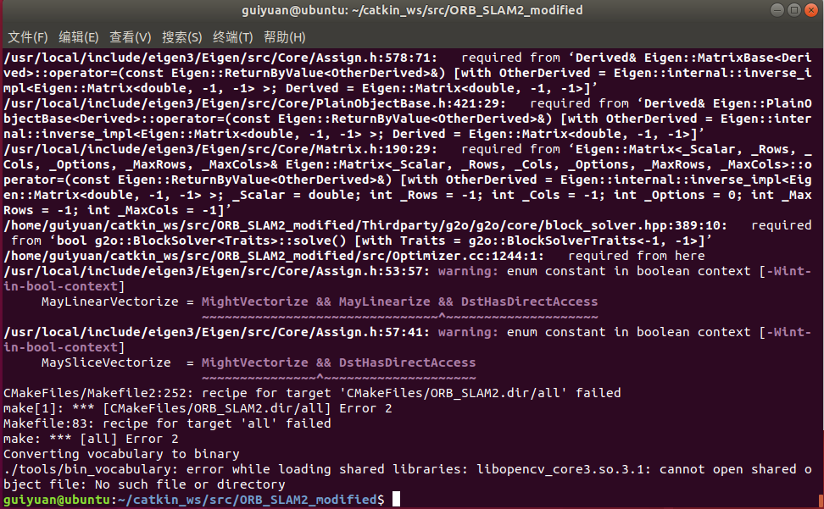

https://blog.csdn.net/m0_60355964/article/details/124735742，参照下图（怀疑这步都不用，就是多build几次）

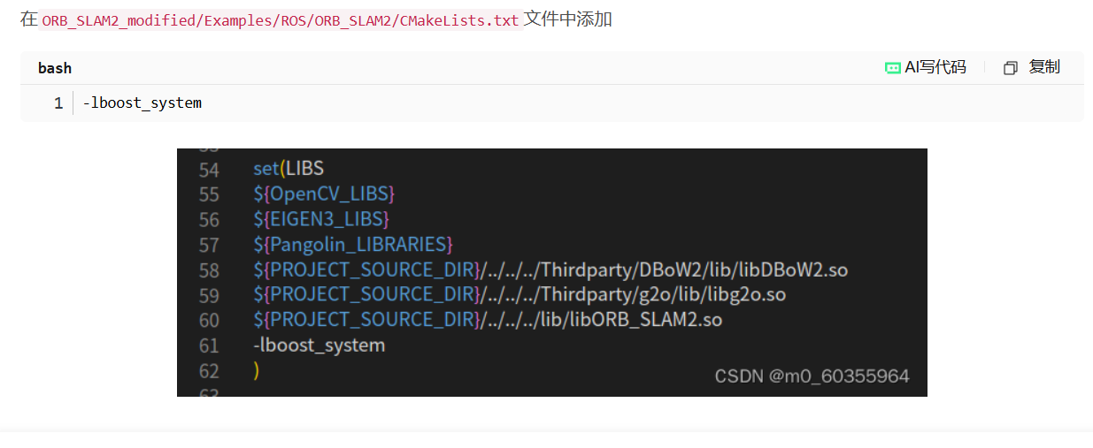

先加了-lboost_system

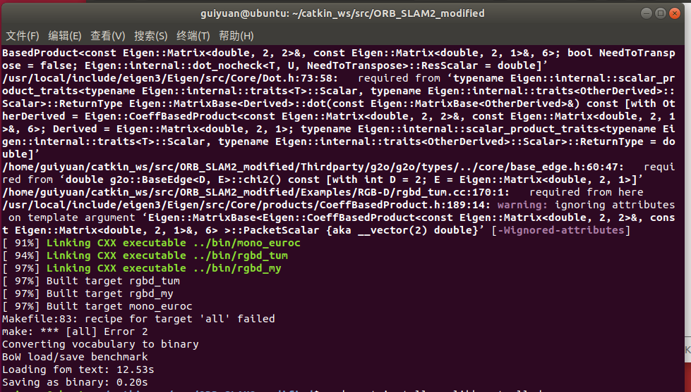

多./build几遍就过了，可能是内存不足。

./build_ros.sh时，看ORBSLAM2构建稠密点云图及小觅相机的使用.html

#roslaunch realsense2_camera rs_camera.launch

roslaunch realsense2_camera rs_rgbd.launch

rosrun ORB_SLAM2 RGBD Vocabulary/ORBvoc.txt Examples/ROS/ORB_SLAM2/MyD435i2.yaml

https://blog.csdn.net/m0_60355964/article/details/124850849?spm=1001.2014.3001.5502

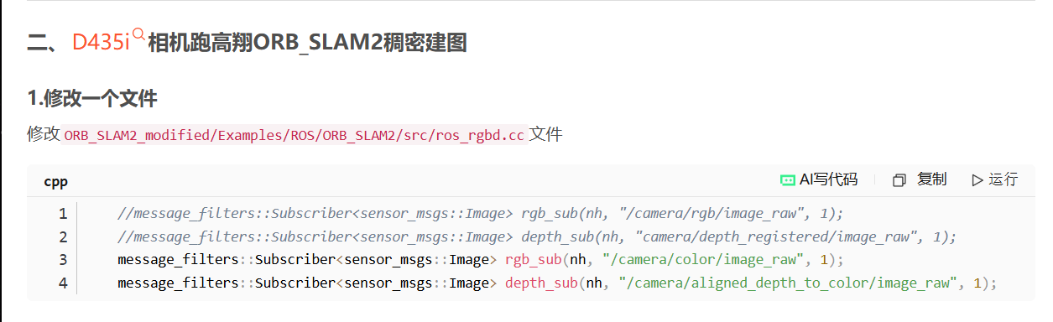

roslaunch realsense2_camera rs_rgbd.launch

rosrun ORB_SLAM2 RGBD Vocabulary/ORBvoc.txt Examples/ROS/ORB_SLAM2/MyD435i2.yaml

（配置用MyD435i2.yaml）

在终端查看pcd文件

pcl_viewer vslam.pcd