**CHAPTER 1**

**INTRODUCTION**

Nowadays, people have smartphones with them all the time. So we thought about why don't we use these to control home appliances of our home. From there we ideated the concept of ***iHALO*** (Intelligent Home Assistant& Lifeline Observer). ***iHALO*** as a home automation system is a simple Android app which you can use to control electrical appliances with voice commands, computer vision or just through bots(chat/SMS) . Using the app, you can control all the appliances like TV, fans, light etc. It’s acts as an artificial intelligence which can be controlled using voice command (given by user). You can give the command to switch on or off the devices (like light, fan etc) as well as you can even manipulate them like fan speed, light intensity. Commands are sent via a Wi-Fi module to Arduino. So there is no need for you to get up to switch on or switch off the device while watching a movie or doing some important work.

We are also using an AR-augmented reality app to control the appliances and manipulate them. If we want to switch on the electrical appliance we just need to focus the camera and it will start it and using a virtual button, we can switch it off. If we want to know the electricity unit consumed by our appliances along with the cost of units we just need to send a text message to the device (Arduino) through our phone. The Arduino would be connected to the network through a Wi-Fi module which would reply with another text message containing the electricity unit and the total cost consumed by the appliances. This will help the user to get update on the electricity bill and they can decide whether to use the appliances on a regular routine or reduce it usage to save electricity.

Our project iHALO, also provides an health monitoring service to the residents in our home specifically could also be used to monitor the health conditions of the old people/patients in our home.

# CHAPTER 2

# SYSTEM ANALYSIS

In this chapter, we will discuss and analyse about the developing process of ***iHalo*** including software requirement specification (SRS) and comparison between existing and proposed system. The functional and non-functional requirements are included in SRS part to provide complete description and overview of system requirement before the developing process is carried out. Besides that, existing vs proposed provides a view of how the proposed system will be more efficient than the existing one.

## 2.1 EXISTING SYSTEM

Most Advanced home automation systems in existence today require a big and expensive change of infrastructure. This means that it often is not feasible to install a home automation system in an existing building. The Home Automation is a wireless home automation system that is supposed to be implemented in existing home environments, without any changes in the existing infrastructure. The existing infra-red (IR) or Blue-tooth remote controls present in the market are in general appliance specific and the same cannot be used interchangeably. Home appliances are the major sources of energy consumption. Demand management is a key for customizing energy use by managing the lighting, cooling, and heating Systems within residential units. On the other hand, the intelligent operation of activities can also facilitate the optimized management and operation of energy.

## 2.2 PROPOSED SYSTEM

iHalo is a personal home automation assistant that would help us to control our electrical home appliances with ease, integrated with augmented reality and intended for the common public and also for the visually challenged and speech-impaired persons. This project aims at developing a Home Automation System prototype which mainly focuses on monitoring and controlling household appliances through the Internet. The system consists of two main parts: A hardware interface module and a software communication module. The Hardware interface module consists of: Arduino 101, Wi-Fi module and relays. The central device is the microprocessor that connects to the Wi-Fi module and receives orders to monitor and control the appliances. The communication between the application and microprocessor is handled by the server, thus managing the users and the appliances. The software communication module uses an Android application as the frontend, which serves as an interface to the user to communicate with the microprocessor. It presents a list of devices with which the user can interact.

The system offers switching functionalities to control the appliances connected to the system, which includes Lights, Fans, Air-conditioners and various other appliances connected to the system. In India, the alternating current supplied to our homes is of 230V. Arduino Board is not capable of withstanding such high Voltages. Thus, Relays are used to convert this high voltage to low voltage i.e. less than 5V. The relay switches have capability to carry a maximum load of 10A at 240V. To enable connectivity with the microcontroller Wi-Fi module is used.

Blind people can control electrical appliances with the help of simple voice commands like “iHalo turn on the Fan” that is by using android app you can give the command to control your room electrical appliances. It can also be used for dumb people with the help of an AR(Augmented Reality) to control the appliances and manipulate them. If we want to switch on the electrical appliance we just need to focus the camera and it will start it using a virtual button and we can switch it off.

iHalo provides Internet connectivity, which allows Internet access and control from the Android Application effectively and efficiently. The Android application is a user friendly interface, which enables the user to view the status of applications at home and control it as per his/her requirement.

## 2.3 PROJECT MODULES

The modules in the project are

* Smart Home Assistant module: To control electrical home appliances
* Health monitoring module: To monitor the health conditions of the old people.

# CHAPTER 3

# REQUIREMENT SPECIFICATIONS

This section describes the software and hardware requirements of the system**.**

## 3.1 HARDWARE REQUIREMENTS

## iHALO HOME ASSISTANCE

* **LDR (Light Dependent Resistor)**: We put this device inside an Energy Meter which is entirely encapsulated with black tape to eliminate sunlight interference. The rate at which the light blinks in the energy meter is used to determine the power consumption.
* **Wi-Fi Module**: Here we use ESP8266 Wi-Fi module to connect our Arduino to the internet and make connection with IoT Cloud like Thingspeak, Blynk.

* **Arduino 101: The** Arduino/Genuino 101 is a learning and development board which contains the Intel® Curie™ Module, designed to integrate the core's low power consumption and high performance with the Arduino's ease-of-use.

* **4 channel 12V 10A relay control board module: A** relay is an electromagnetic switch operated by a relatively small electric current that can turn on or off a much larger electric current. The heart of a relay is an electromagnet (a coil of wire that becomes a temporary magnet when electricity flows through it). You can think of a relay as a kind of electric lever: switch it on with a tiny current and it switches on ("leverages") another appliance using a much bigger current.

* **Jumper Wires:** A jump wire is an electrical wire or group of them in a cable with a connector or pin at each end, which is normally used to interconnect the components of a breadboard or other prototype or test circuit, internally or with other equipment or components, without soldering.

## iHalo Band

We need

* **Infineon DPS310**: The barometric pressure sensors DPS310 offers excellent pressure noise performance and high stability with temperature.

* **Arduino Nano**: The Arduino Nano is a small, complete, and breadboard-friendly board based on the ATmega328; offers the same connectivity and specs of the UNO board in a smaller form factor.

* **Wifi module** : Here we use ESP8266 WiFi module to connect our arduino to the internet and make connection with IoT Cloud like Thingspeak, Blynk.

* **4v LiPo Battery**: For powering up, Arduino Board.

* **Jumper Wires:** A jump wire is an electrical wire or group of them in a cable with a connector or pin at each end, which is normally used to interconnect the components of a breadboard or other prototype or test circuit, internally or with other equipment or components, without soldering.

## 3.2 SOFTWARE REQUIREMENTS

* **Operating system:** Android OS v4.4 and above to execute our iHALO app.
* **Arduino IDE**: The Arduino Board is programmed using the Arduino Software (IDE), the Integrated Development Environment.

* **Android Studio**: Android Studio is the official integrated development environment (IDE) for Google's Android operating system, built on JetBrains IntelliJ IDEA software and designed specifically for Android development. It is a replacement for the Eclipse Android Development Tools (ADT) as primary IDE for native Android application development.

* **IoT Platform:** Blynk is a Platform with iOS and Android apps to control Arduino, Raspberry Pi and the likes over the Internet. It's a digital dashboard where you can build a graphic interface for your project by simply dragging and dropping widgets.

* **AR development Tools**: Unity with Vuforia is a software platform for creating Augmented Reality apps. Developers can easily add advanced computer vision functionality to any application, allowing it to recognize images and objects, and interact with spaces in the real world.

* **Programming Language**: Arduino Board is coded in C language. Android app may be developed in Java or Kotlin language.

# CHAPTER 4

# SYSTEM DESIGN

## 4.1 USE CASE DIAGRAM

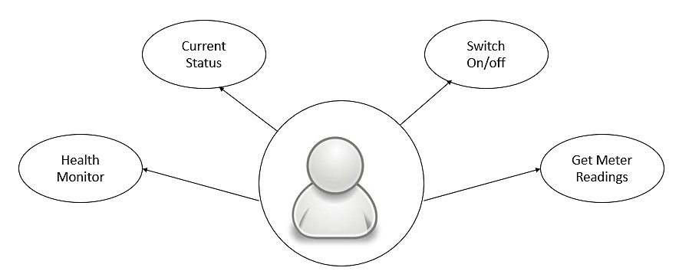

### Figure 4.1: Use case diagram

A use case diagram is a graphic depiction of the interactions among the elements of a system. A use case is a methodology used in system analysis to identify, clarity and organize system requirements. Here the user can monitor his health, current status of home appliances, make devices switch on or off, and even get current meter readings.

## 4.2 DATA FLOW DIAGRAM

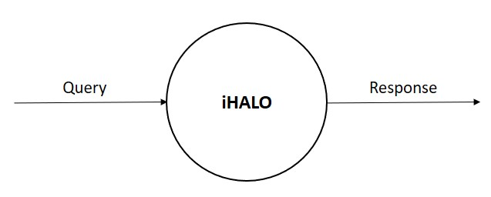

### Figure 4.2: Level 0 DFD

This is the level 0 DFD also known as context level diagram where the whole system is considered as a single unit. The users pass a query in form voice commands, computer vision or through just text. Our system then processes this query, to perform necessary action to be performed. Response may be in form of switching on or off the home appliances or get the status of various devices (including Band).

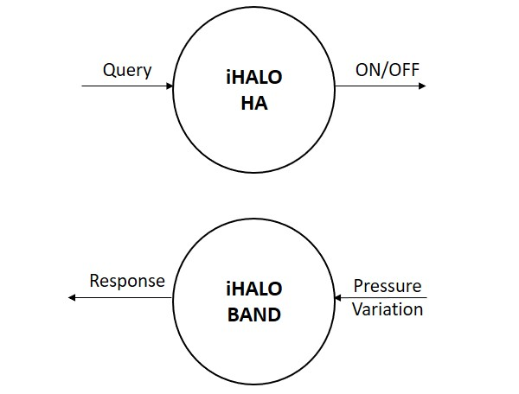

### Figure 4.3: Level 1 DFD

The level 1 DFD describes about the procedures/actions done by the user & the system. Our system is divided into two sub systems. One subsystem is, iHalo as a *Home assistant* where you can give the command to switch on or off the devices (like light, fan etc.) as well as you can even manipulate them like fan speed, light intensity.

Another subsystem is, iHalo as *Health monitor* provides a health monitoring service to the residents in our home specifically could also be used to monitor the health conditions of the old people/patients in our home. Here the input is pressure variations and response is provided by iHalo after analysing the input.

Our band will be able to analyse/detect :

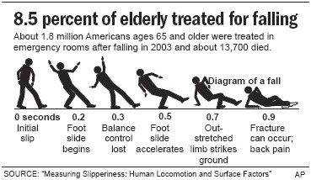

**Fall***–Big drop and constant altitude states that patient has fallen and can't get up*.

Studies show that the biggest issue with elders are of them losing balance and falling down. Often patients are helpless and it's only after sometime that help comes. This could be easily avoided with the Health Band by the detection of a sudden drop in pressure. Once detected a message is automatically sent to relatives, for aid preventing the injury to worsen.



**Exercise** *- Wave like motion depicting a step, this was generated by walking around the room with the band tied on my foot*

For old people it can be rather hard to get them to exercise, or go for a walk even though this will keep them fit and healthy. We figured that a way to motivate them could be by showing them the number of steps taken or in how much time they have walked for, so that they have something to push them to exercise. Once the Health Band detects a "wave" motion it deducts that the patient has begun his/her exercise. Crest to crest or trough to trough marks one cycle. As steps are taken the number of cycles are generated and then displayed.

**Fever** *- Normal body temperature is around 37 degrees Celsius*

This one is pretty straight forward the sensor also gives the temperature. The band being in contact with the arm gives the live temperature of the patient. Any spikes or drops will be alerted again automatically via message to relatives.

**State** - *No change in altitude for a period of time could suggest that the patient is asleep*

Tells the relatives the live state of the patient. For example, if the Health Band detects not much changes of pressure the patient could be sleeping.

## 4.3 BLOCK DIAGRAM

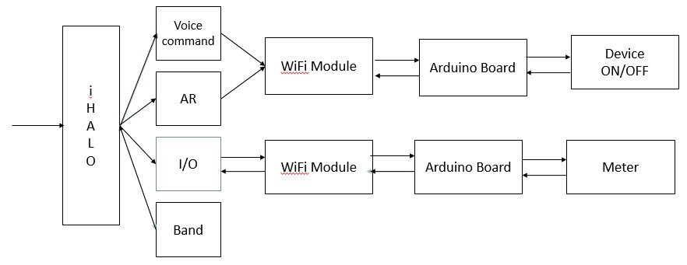

### Figure 4.5: Block diagram of iHALO

**The Digital Energy Meter**

In the energy meter, a **LDR** (Light Dependent Resistor) is used to take the blink speed according to the load. The blink per second value is fed into the Arduino for further calculation units and the value of energy consumed. These are sent to the user via the **GSM** module. The user can then comprehend which appliance is consuming more power and take action accordingly.

**The AR Virtual Assistant**

The AR Virtual Assistant works using an android app which is installed on the user’s android phone. The android app is connected to the Arduino 101 via Wi-Fi which is in turn connected to the relay and hence the electrical appliances. If we want to switch on the electrical appliance we just need to focus the camera and it will start it and using a virtual button, we can switch it off.

**The Voice Assistant**

The Voice Assistant of iHALO works using an android app which is installed on the user’s android phone. The user activates the agent using the wake up command, ‘Listen up iHALO’.

The android app is connected to the Arduino 101 via Wi-Fi which is in turn connected to the relay and hence the electrical appliances.

**The flow of signals is as follows:**

* 1. Voice Input/AR Interface
* 2. Processing on Sensor
* 3. Sending encrypted data to Arduino via Wi-Fi Module.
* 4. Processing on Arduino 101
* 5. Digital signals to relay
* 6. Operate the Device According to the Digital Data.

**Pins connections:**

* Pin 8 -- > Pulse In [Digital Input]
* Pin 6 -- > IN1 -- > Device1 Output
* Pin 4 -- > IN2 -- > Device2 Output
* Pin 5 -- > IN3 -- > Device3

**Connections of Energy meter:**

* Connect the meter to the supply.
* Cover the energy meter with a black tape, preventing the LDR inside the energy meter from outside light.
* Connect the neutral wire directly to the loads and the phase wire to the relay.
* Take the wires from the LDR outside the meter to the counter circuit.
* Now take the output from the counter circuit to the assigned pin 8 pulse pin.
* Connect the TX, RX pin of the Arduino 101 to RX, TX pin of the GSM module.
* Now power up the boards after burning the code.

## 4.4 SEQUENCE DIAGRAM

It is an interaction diagram that shows how object operate with one another and in what order. It is a construct of message sequence chart. It shows the object interaction arranged in time sequence.

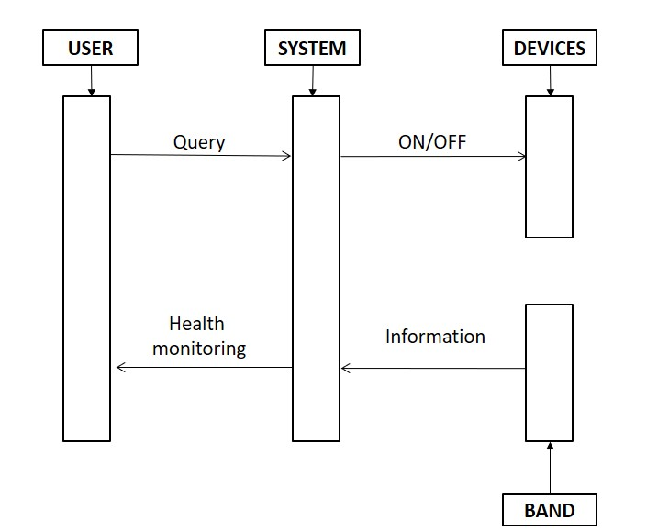

### Figure 4.6: Sequence diagram

Sequence diagrams are a popular dynamic modelling solutions. Dynamic modelling focuses on the interaction occurring within the system. Sequence diagram specially focus on the lifelines of an object and how they communicate with other object to perform a function before lifeline ends. The main three objects of our project are user, system and devices. A sequence diagram shows object interactions arranged in time sequence. It depicts the objects and classes involved in scenario and the sequence of messages exchanged between the objects needed to carry out the functionality of the scenario. Sequence diagrams are typically associated with use case realizations in the logical view of the system under development. Sequence diagrams are sometimes called event diagrams or event scenarios. The user interacts with system by passing query. The system processes the query, and take an action to switch the device on or off. iHALO band monitors the health condition of users. According to the pressure variations from the body, response is provided by iHalo after analysing the input.

# CHAPTER 5

# PROTOTYPE

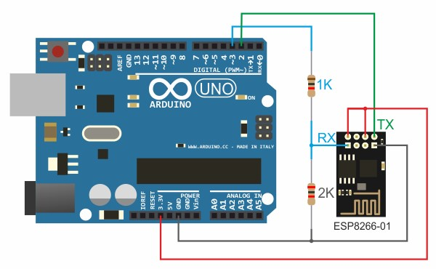

## Figure 5: Prototype schematic

We implemented a cut down version of iHALO, to check whether our proposed system can be made into reality. For this we used an Arduino Board, ESP8266 Wi-Fi module, a LED and resistor (300 ohm). Blynk platform came handy for prototyping. Our objective was to make LED glow when we switch on the button on the Blynk app. The Blynk app sends the request to increase the voltage in D13 pin. As a result, our LED glows. The experiment was success and the output was verified.

# CHAPTER 6

# SAMPLE OUTPUT

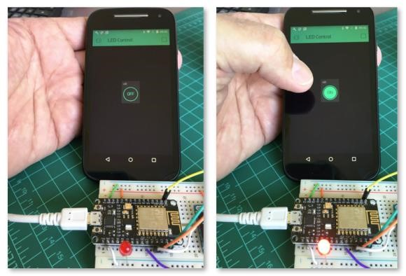

# CHAPTER 7

# CONCLUSION

**iHALO** is an android based home automation system which makes the system more flexible and attractive user interface compared to other home automation systems. Using a simple android app we can control electrical appliances with voice commands or with the help of Augmented Reality. So there is no need for you to get up to switch on or switch off the device while watching a movie or doing some important work. The system comprises of a Wifi module, Arduino board and relay modules. Wifi module is used as the communication channel between android phone and the Arduino Board.

# CHAPTER 8

# FUTURE SCOPE

We are planning to implementing low power Wi-Fi module would be better. Improving our system to report power use of each appliance. Implementing light weight protocol like MQTT would be better. Use of Node Js can decrease our waiting time of response. Our wish is to implement our project in all the possible situation like in offices, industries, schools, cars etc.

# CHAPTER 9

# BIBLIOGRAPHY

[1] “Specialization on Internet of things”.[Online]. Available:https://www.coursera.org/specializations/internet-of-things

[2] “Android App Development ”.[Online]. Available:https://developer.android.com/training/index.html

[3] “Augmented Reality App Development”.[Online]. Available: https://library.vuforia.com/

[4] “Blynk Platform for IoT ”.[Online]. Available: http://docs.blynk.cc/

[5] Fundamentals of software engineering by Rajib mall, PHI Learning