Vetify Product Requirements Document (PRD)
Developer: Aldwin Bernard V. Loreto
Date: June 2026
Version: 1

1. System Overview

1.1 Document Purpose
This document outlines the features, system behavior, and design rules for Vetify. It acts as a clear guide for developers, designers, and project stakeholders to understand how the app works and how it should be built.

1.2 Product Definition
Vetify is a mobile web application built to help pet owners take better care of their animals. It gives owners quick pet care advice through an AI chat assistant, helps them find nearby animal clinics on a map, and offers tools like customized meal planning, daily reminders, and easy-to-read pet anatomy guides.

1.3 Goals and Objectives
- Reduce Panic: Provide pet owners with instant, stress-free access to directions and contact information for local animal clinics during critical, time-sensitive emergencies.
- Simplify Health & Nutrition Advice: Deliver clear, everyday answers to complex pet health and dietary questions through a friendly AI assistant, removing confusing medical jargon so anyone can understand the instructions immediately.
- Promote Proactive Daily Care: Empower pet parents to track daily habits, manage interactive 7-day meal plans, and receive smart, gentle care reminders to maintain their pet's long-term health and well-being.
- Establish a Trusted Professional Network: Create a safe, verified marketplace where pet owners can seamlessly find, review, and connect with licensed veterinary doctors who have passed strict credential audits.
- Ensure Data Privacy and System Safety: Maintain a high standard of platform safety by using automated real-time emergency text scanning alongside data encryption to keep user emails and private chat histories fully confidential.

2. System Roles

2.1 Entities
- Pet Owners / Normal Users : Everyday users who need fast advice, help tracking daily habits, or a quick way to find an emergency clinic.
- Veterinarians (Professionals): Licensed doctors who want to create profiles, display their credentials, and let local pet owners find them.
- System Administrators: Staff members who check veterinarian licenses for safety and look over AI conversation logs to make sure the app gives correct advice.

2.2 Professional Account Approval State
This section defines the operational states for each account type. Developers use these states to restrict UI access (e.g., preventing a Vet from receiving inquiries until their license is fully verified)
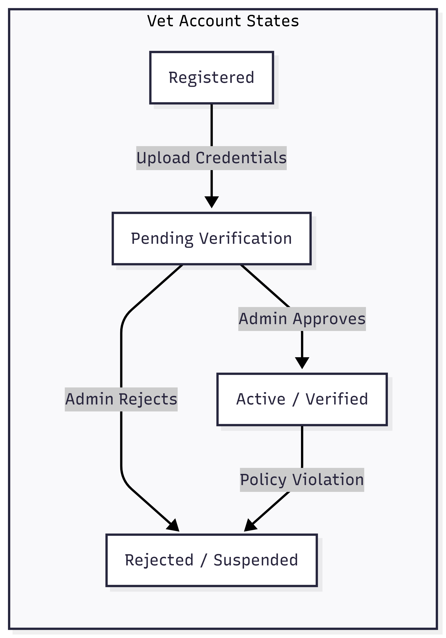

2.3 Access Control & Permissions Matrix (RBAC)
System Feature / Action | Pet Owner | Veterinarian | System Admin
Ask Vetify AI Assistant | ✔ (Create/Read) | ❌ | ✔ (Read Safety Logs)
Create & View Pet Profiles | ✔ (Full Access) | ❌ | ❌
Search Map & Clinic Listings | ✔ (Read) | ❌ | ❌
Manage Clinic & Professional Profile | ❌ | ✔ (Create/Update) | ✔ (Read/Update Status)
Send Direct Hire Inquiries | ✔ (Create) | ❌ | ❌
Receive & Respond to Inquiries | ❌ | ✔ (Read/Update) | ❌
Draft & Publish Blog Posts | ❌ | ✔ (Create/Update) | ✔ (Full Control)
Verify Professional Licenses | ❌ | ❌ | ✔ (Update Verification)
Delete Users or Moderate Logs | ❌ | ❌ | ✔ (Delete)

3. Functional Requirements

3.1 Smart Vet Locator (The Map)
- Purpose: To show users nearby veterinary clinics on an interactive map.
- How it Works:
  - The app asks the user for permission to see their device location (GPS).
  - If allowed, the map centers on the user and drops markers on all nearby animal clinics.
  - Clicking a marker shows a small box with the clinic's name, phone number, distance, and if they are currently open.
  - A "Get Directions" button opens the user's default map app (like Google Maps) to guide them there.
  - If GPS is turned off, a simple search bar lets the user type in their city or postal code manually.

3.2 Vetify AI Assistant (The Chat)
- Purpose: To give instant answers to simple, everyday pet care questions.
- How it Works:
  - The user types a question into the chat screen (e.g., "Can cats eat cheese?").
  - The system checks the message against a list of dangerous words like "bleeding", "choking", or "poison".
  - If the message is safe, the AI writes a friendly, simple response.
  - If a dangerous word is found, the AI stops its normal response. It immediately shows a warning message: "This looks like an emergency. Please contact a professional veterinarian doctor right away."
  - A large button appears directly underneath the warning, taking the user straight to the Vet Locator map.

3.3 Professional Connection Directory
- Purpose: To help users find and look through profiles of real, licensed veterinarians.
- How it Works:
  - Users open the "Contact a Professional" tab to see a list of local vets.
  - Each profile displays the doctor’s photo, full name, specialty (such as dogs, cats, or birds), and years of experience.
  - A green "Verified" badge shows on the profile only after a system admin has manually checked the doctor’s medical license.
  - Users can click a "Send Inquiry" button to type a message directly to the doctor's clinic.

3.4 Interactive Anatomy Guide
- Purpose: To teach pet owners about their pet's body using clear visual diagrams.
- How it Works:
  - The user selects an animal type from a list (Dog, Cat, or Bird).
  - The app displays a basic, simple drawing of that animal's body structure.
  - The drawing has clickable areas (like the heart, stomach, teeth, or joints).
  - When a user taps an area, a small text box opens up to explain what that body part does, common signs of illness to watch out for, and how to keep it healthy.

3.5 Personalized Meal Planner
- Purpose: To create a customized, weekly eating schedule for a pet.
- How it Works:
  - The user fills out a quick form with their pet's details: type of animal, age, weight, energy level, and allergies.
  - The app processes this data and creates a clear 7-day food chart.
The chart shows how much food to give each day, what types of ingredients to focus on (like protein or fiber), and a list of specific ingredients the owner must avoid based on the allergies entered.

3.6 Veterinary Blogs
- Purpose: To share reliable health tips and articles written by verified doctors.
- How it Works:
  - Users can scroll through an article feed on the home screen.
  - Registered, verified vets can write and publish these articles to share updates, safety warnings, and care tips.
  - Users can filter articles by category, such as "Nutrition Tips" or "Safety Guides."

3.7 Smart Care Reminders
- Purpose: To send simple pop-up notifications that remind owners of daily care tasks.
- How it Works:
  - The app sends quiet, friendly notifications to the user's device during the day.
  - Examples include: "Don't forget to refill the water bowl!" or "Time for a quick walk?"
  - Users can open their settings page to turn these reminders on or off, or change the times they receive them.

4. System Diagrams

4.1 Use Case Diagram
Main System Features & User Flows
This diagram maps out how everyday users (Pet Owners) and Veterinary Professionals interact with the core features of the app. It visually links users to their main activities—like chatting with the AI, opening the map, or building a meal plan—and shows how the system connects pet owners to real veterinarians when a professional inquiry is made.
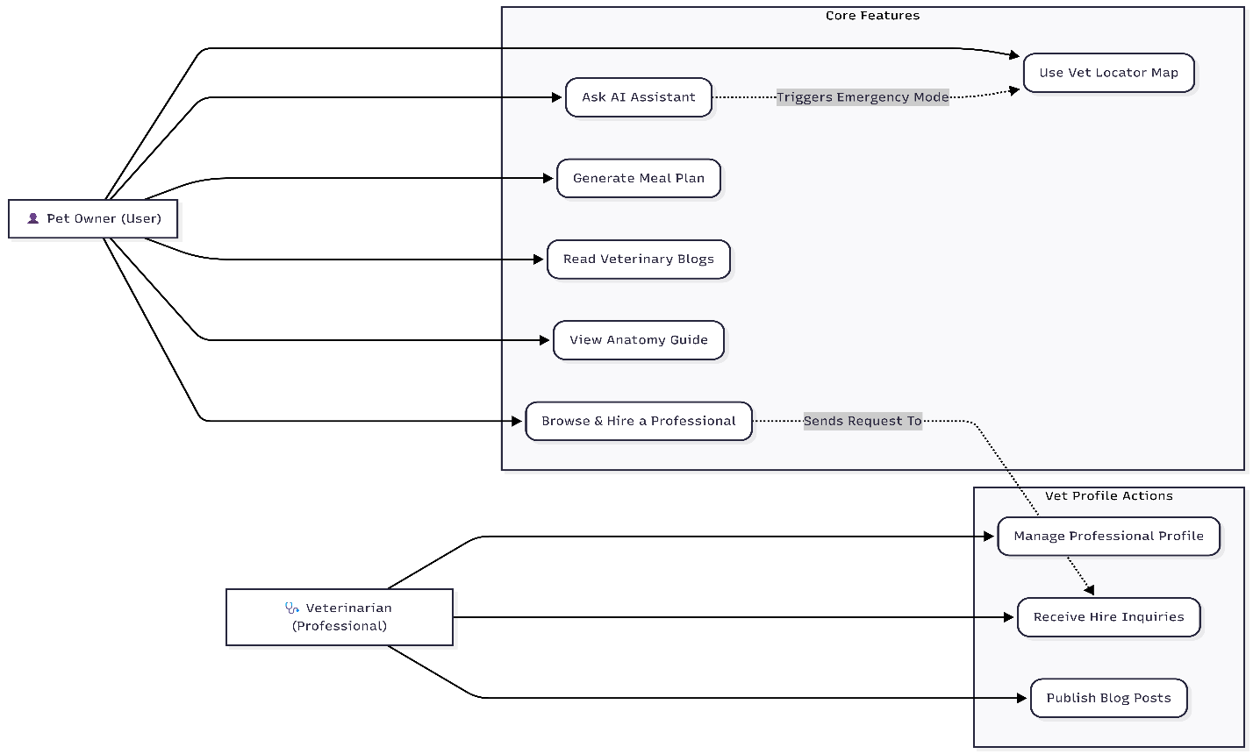

Administrative Backend & CRUD Operations
This diagram focuses entirely behind the scenes, showing how the System Admin manages application data. It uses standard CRUD (Create, Read, Update, Delete) steps to show how admins safely review and approve veterinarian profiles, audit the AI chat logs to keep answers safe, and post or remove system blog content.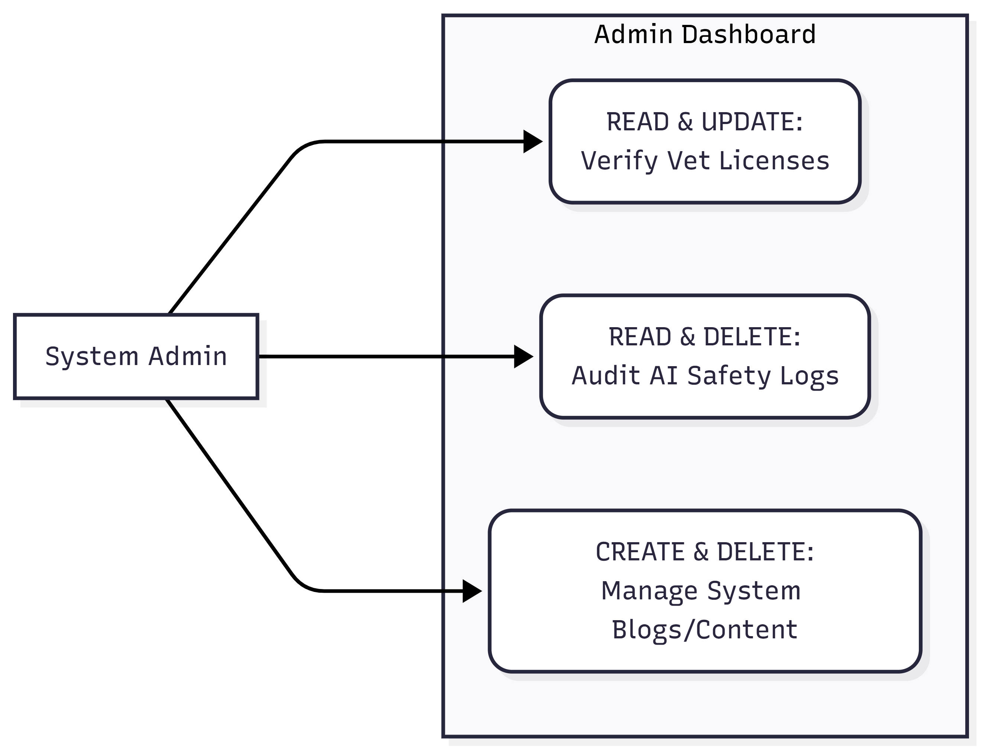

4.2 Architectural Design Diagram
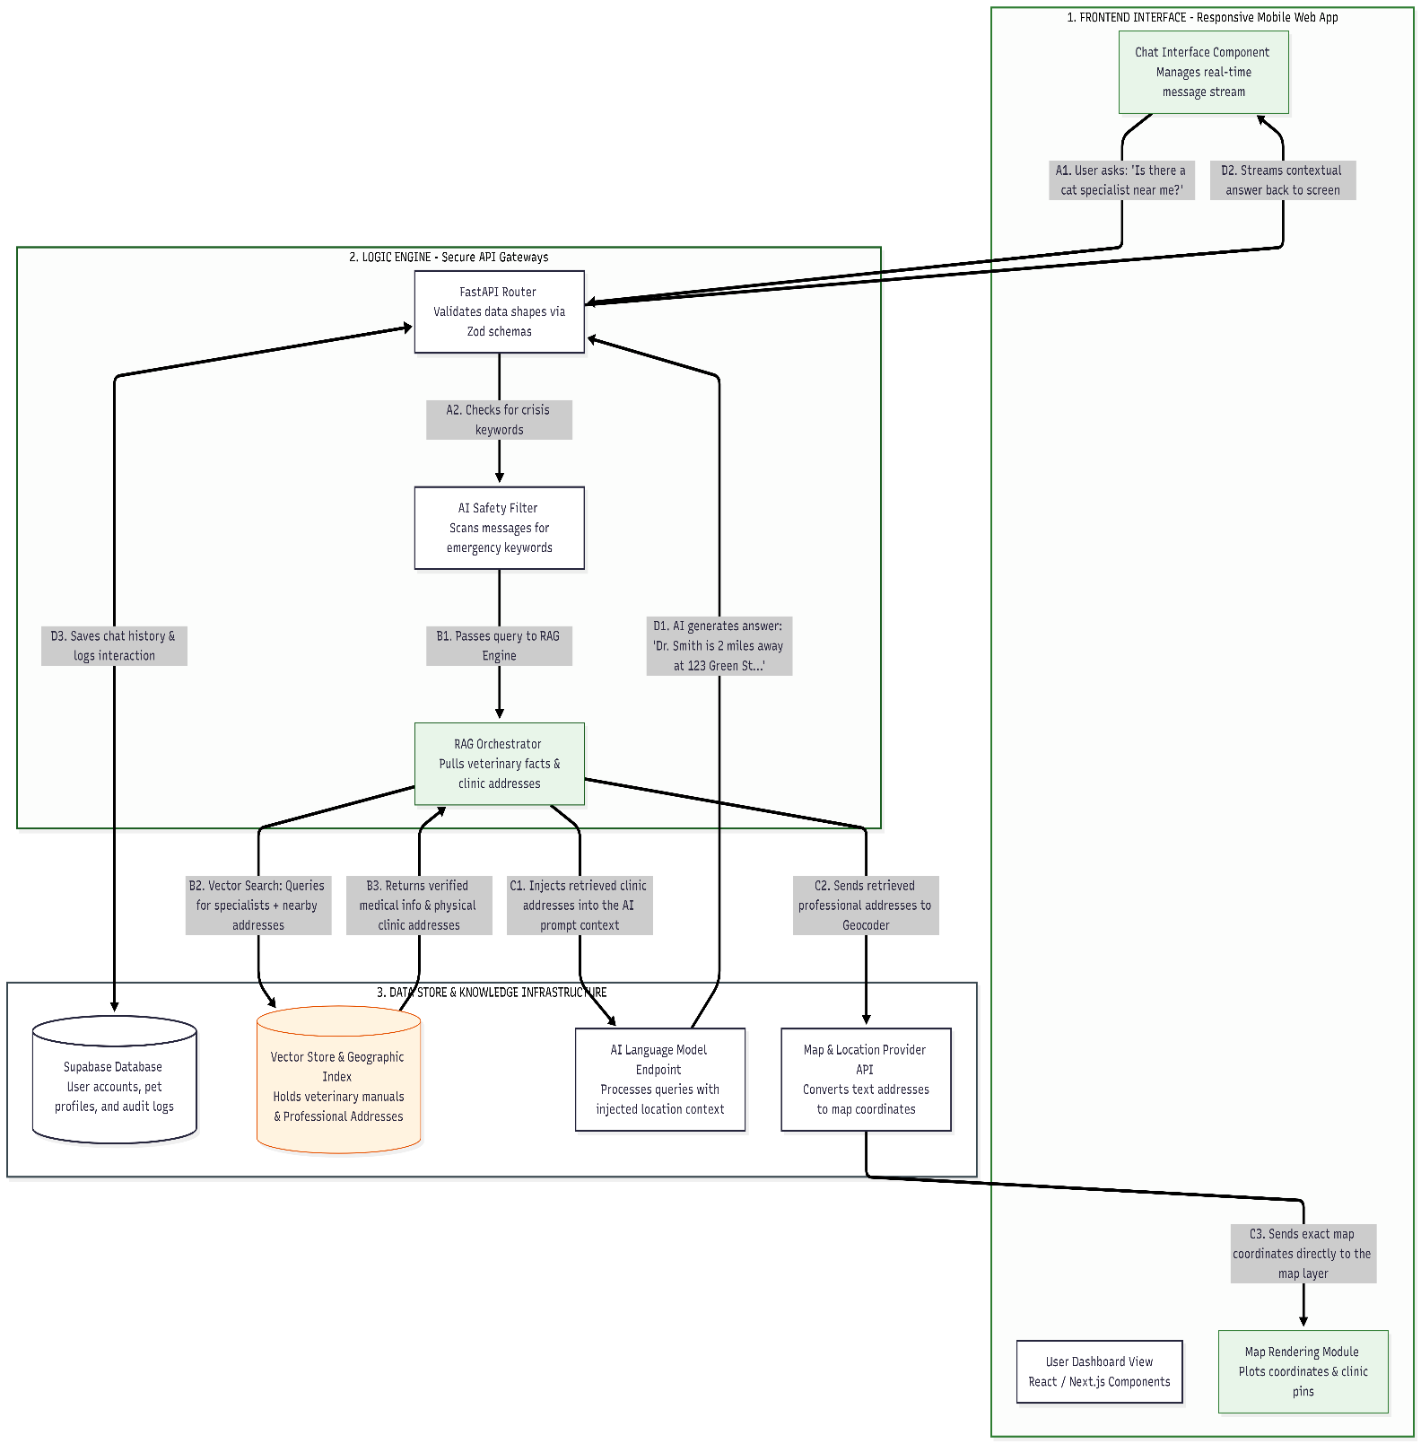
This diagram maps Vetify’s three main layers: The Screen (frontend UI), The Brain (backend safety and logic), and The Memory (databases). It shows how the location-aware AI engine (RAG) matches user queries with verified medical facts and clinic addresses, automatically plotting those physical locations onto the map in real-time.

5. User Experience & Design Guidelines

5.1 Color Palette
- Color Theme: The app uses a calm design style featuring deep forest green and emerald accents to build a sense of safety, health, and trust.
- Tone of Voice: All text must be warm, reassuring, and clear. Avoid complicated medical terms so that anyone can understand the instructions immediately.
- Layout Speed: Key actions must happen fast. A user in a hurry should be able to open the app, find an emergency vet clinic, and see directions in two clicks or fewer from the main dashboard.

5.2 Mobile Responsive Views & Interface Layout
- To ensure a highly responsive, mobile-first experience, the application interface adapts its structure for narrow mobile viewport widths. The visual wireframe layout prioritizes thumb-friendly accessibility, clear horizontal division, and quick action steps.

5.3 Visual Feedback & State Transitions
- Skeleton Loading: Instead of showing a blank screen or a spinning loading wheel (which can make a user think the app has crashed), the app must use animated skeleton screen placeholders while the map pins are loading.
- AI Typing Indicator: The chat interface must show a "typing" animation (three pulsing green dots) within 0.5 seconds of a user submitting a query, letting them know the system is actively processing their request while the RAG engine finishes retrieving facts.

6. MVP Scope & Success Targets

6.1 What is Included in the Minimum Viable Product (MVP)
- The basic AI chat assistant with built-in emergency word safety checks.
- The Vet Locator map and clinic contact list based on device location.
- A basic profile setup for one pet to generate the 7-day meal plan chart.

6.2 Success Metrics
System performance using the SMART framework.
Metric | Specific | Measurable | Achievable | Relevant (R) | Time-bound
Response Speed | Stream the first AI text response tokens. | Appears in < 1.5 seconds during normal peak usage hours. | Uses streaming text response models via FastAPI to cut latency. | Keeps anxious users engaged without thinking the app froze. | Optimized and stress-tested before the Phase 1 MVP release.
Map Loading | Load and render nearby clinic pins using device GPS. | Map fully interactive within 2.0 seconds on 4G connections. | Uses map caching and fetches only nearby clinic coordinates. | Vital for finding immediate care in tight emergency situations. | Tested against slow connection filters prior to deployment.
Safety Accuracy | Scan chat inputs for emergency terms like "poison" or "bleeding". | Catches critical text and flags a warning in ≥ 95% of crisis test cases. | Combines local key-term matching with smart text evaluation pipelines. | Protects pet health by instantly routing emergencies to real vets. | Baseline verified before launch; reviewed weekly post-launch.
Privacy Guardrails | Secure user login details, emails, and private chat text logs. | 100% data encryption at rest (AES-256) and in transit (TLS 1.3). | Enforces strict database privacy rules and secure web pathways. | Builds user trust and protects private text histories. | Built directly into core setup; checked before every release.

