Soil Analyzer Materials and Connection Guide
Prepared 6 November 2026 | One screenless prototype | Simple buying and connection guide
This guide puts the parts, two connection pictures, and buying links in one place. The names and IDs in the pictures match the purchase tables. Parts marked “alternative” replace another part; you do not need to buy both.

Can I use the cheaper DFRobot pH kit
Yes, the original DFRobot SEN0161 can be used for a calibrated prototype, with a stable 5 V supply and a suitable connection to the ESP32 analog input. Your listing matches the original SEN0161 specifications. Ask the seller to confirm that model. Your stated price is about PHP 2,000; it has not been confirmed at checkout.
The kit already includes the electrode, pH signal board and analog cable. Do not buy another pH conversion board. The remaining issue is the signal voltage going into the ESP32. The original kit’s supplied description does not state a guaranteed maximum output voltage. Have the builder check it and add an analog voltage divider or other input circuit when needed. A common digital 5 V/3.3 V logic-level board is not a substitute for an analog input circuit.
The newer SEN0161-V2 is easier to connect: DFRobot states a 3.3–5.5 V supply and 0–3.0 V analog output. It still needs calibration. Neither kit is a probe for pushing straight into dry soil: use the soil–water sample method agreed in the paper. Buffers and proper probe-care solution are separate if not included. [S1–S2]

Is one battery enough and how long will it last
One genuine 18650 cell rated about 3,000–3,500 mAh can be the starting battery. It must supply the whole system’s current, including converter losses and Wi-Fi bursts. Its voltage is about 3.6/3.7 V normally and 4.2 V when full. The final NPK probe and the measured current decide whether one cell is enough.
Battery-only example | If average current measured at the battery is | Estimated time
3,500 mAh cell; assume 80% usable capacity | 100 mA | about 28 hours
Same assumed battery | 250 mA | about 11 hours
Same assumed battery | 500 mA | about 5.6 hours
Calculation: time in hours = 3,500 × 0.80 ÷ average battery current in mA. These are examples, not tested runtime. Battery-side current includes converters and all parts. A 5 V-side current cannot be used in this formula. Solar charging is excluded. The M35A datasheet lists 3,450 mAh typical; shops may round this to 3,500. [S7] Two matched cells in a correctly built 1S parallel pack can roughly double capacity; a series holder needs a different charger.

Connection flow with a breadboard
The same power and data paths are used in both versions. Option A power parts are shown. Sensor names and IDs match the tables that follow.
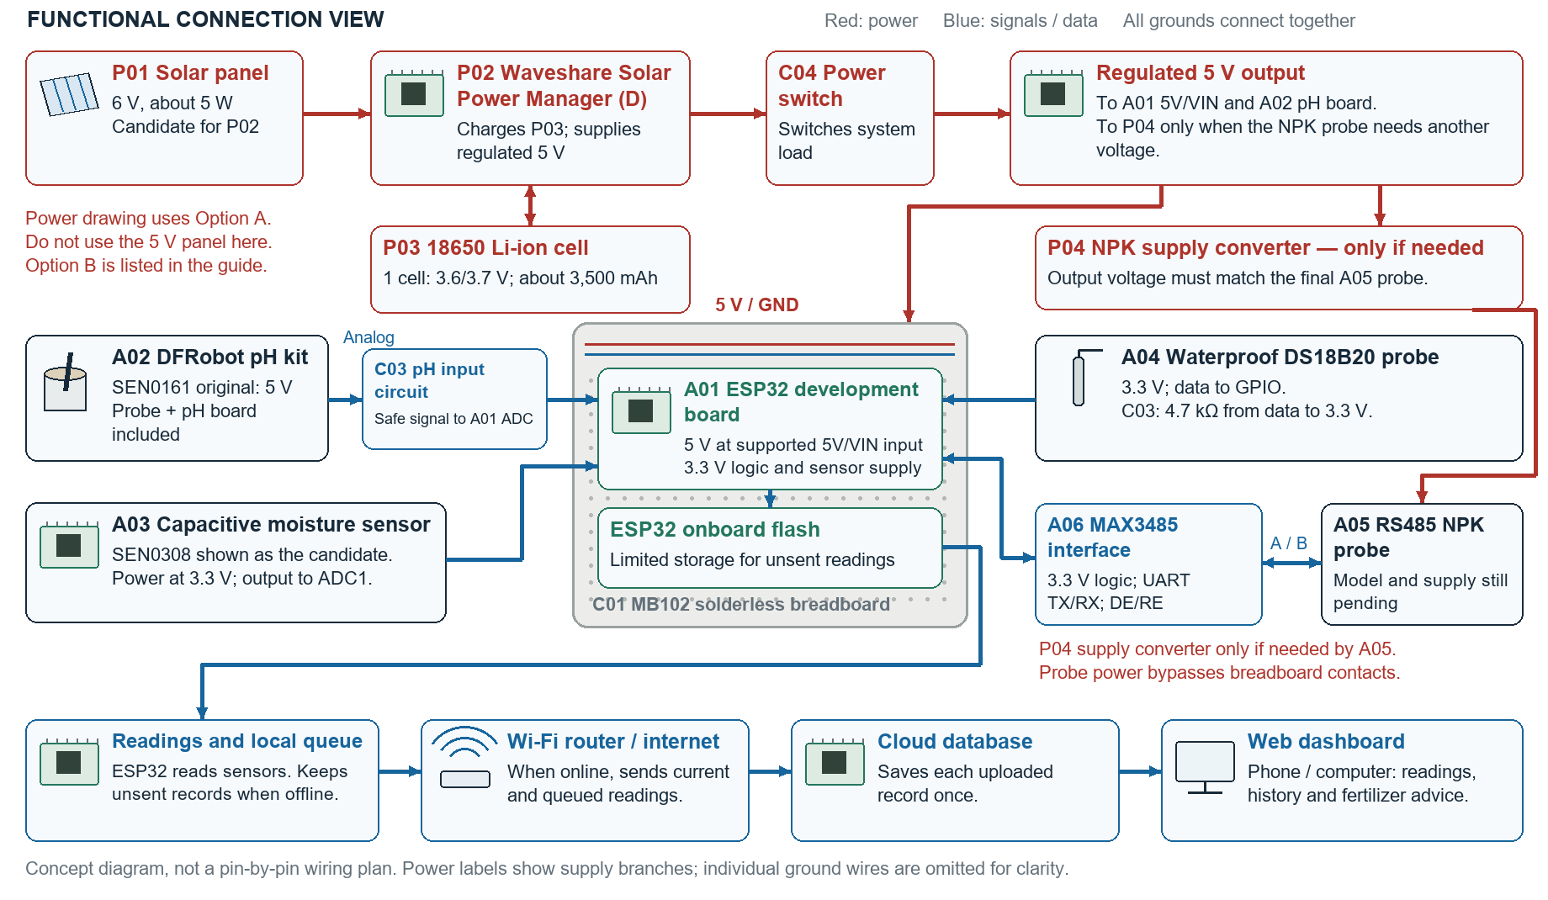
The MB102 holds jumper-wire connections for testing. Charging and high-current power wires go directly to rated connectors, not through the breadboard rails.

Connection flow without a breadboard
The same power and data paths are used in both versions. Option A power parts are shown. Sensor names and IDs match the tables that follow.
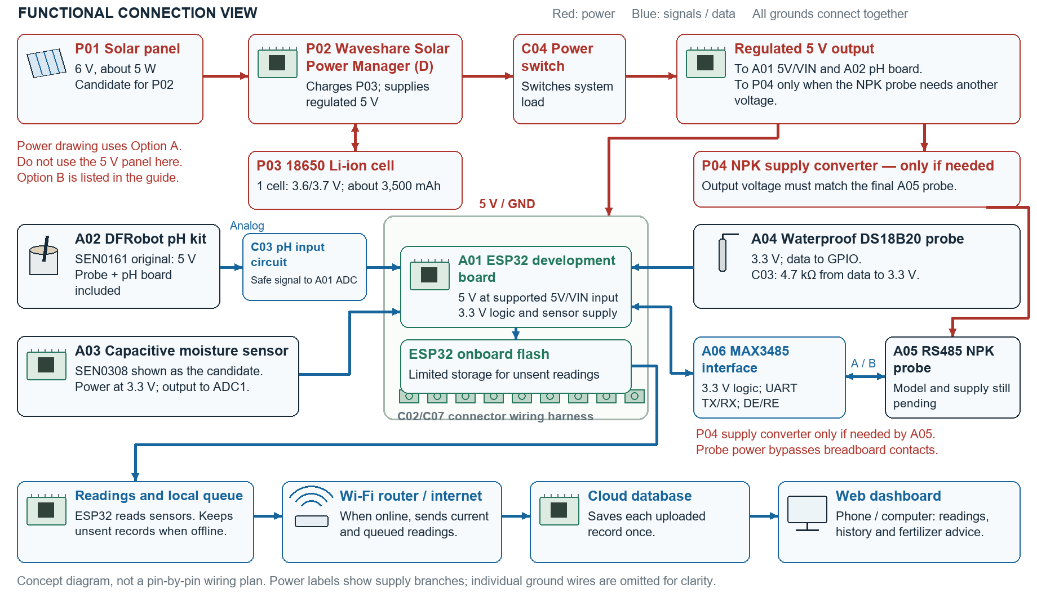
Replace the MB102 with a secured connector wiring harness and insulated soldered joints where needed. Mount the boards on standoffs. This version does not add a perfboard or a custom PCB.

Controller and sensor purchase list
Direct listing = a candidate product page. Search link = a way to find the item; no exact seller or variant is selected. Listings can change, and a model name in a title does not prove the delivered part is genuine. Most listings below were collected on 5 November; the added pH listing was supplied by you. Check price, stock, variant and inclusions before buying.
ID and exact name used in pictures | Qty | Simple purpose | Shopee link | What to check
A01 ESP32 development board | 1 | Reads sensors; stores unsent readings; uses Wi-Fi. | Direct listing | Confirm board model, pin map, flash size and supported 5 V input.
A02 DFRobot pH kit — SEN0161 original | 1 kit | Measures the pH of a prepared liquid sample. | Your cheaper listing | 5 V supply. Probe, pH board and analog cable included. Analog input circuit may be needed.
A02 Alternative pH kit — SEN0161-V2 | 1 kit | Same job; 0–3.0 V output is simpler for ESP32. | MakerLab V2 listing | Confirm SEN0161-V2, full kit and buffer inclusions. Replaces the original kit; do not buy both.
A03 Capacitive moisture sensor — SEN0308 candidate | 1 | Checks soil moisture after calibration. | Direct listing | SEN0308 differs from the earlier SEN0193. At 3.3 V it has 0–2.9 V output per DFRobot. [S3]
A04 Waterproof DS18B20 probe | 1 | Measures soil temperature. | Direct listing | Three-wire version; correct cable. Use a 4.7 kΩ data pull-up to 3.3 V.
A05 RS485 NPK probe — provisional | 1 | Provides NPK-related readings for testing. | Candidate listing | Exact model, supply, current and Modbus register map still needed. Lab comparison must establish what its readings mean.
A06 MAX3485 3.3 V RS485 interface | 1 | Lets the ESP32 talk to the NPK probe. | Direct listing | Complete 3.3 V module. Match TX/RX and DE/RE control; 3.3 V logic on the ESP32 side.
Earlier alternatives: SEN0193 moisture sensor and generic PH-4502C + E201-C pH kit remain alternatives only. A different sensor needs its own wiring, calibration and description. Generic automatic-direction RS485 modules are candidates only after the supply and output logic levels are verified.
SEN0193 moisture sensor — search
PH-4502C + E201-C kit — search
Automatic-direction RS485 module — search

Power purchase list and matching options
Option A is used in both pictures because the Waveshare board already manages charging and produces regulated 5 V. It replaces a separate solar charger and 5 V boost board. The 6 V, 5 W panel is a starting candidate, not a promise of all-day operation. Size the panel after measuring the load. [S4]
ID and part | Qty | Simple purpose | Shopee link | Match before buying
P01 Solar panel — 6 V, about 5 W | 1 | Collects energy from sunlight. | 6 V / 5 W candidate | For Option A. Confirm actual output and open-circuit voltage; controller input is 6–24 V.
P02 Waveshare Solar Power Manager (D) | 1 | Charges a one-cell Li-ion battery and provides 5 V. | Direct listing | Select exact D version. Battery sold separately. Confirm charge-current setting is suitable for one cell.
P03 18650 Li-ion cell — about 3,000–3,500 mAh | 1 initially | Stores energy for operation without sun. | M35A search | New genuine cell, suitable current rating. Use the manager’s documented 1S battery connection and protection.
P03 Compatible single-cell holder and battery leads | 1 set | Holds and connects the battery. | Search | Correct size, polarity and current rating. Optional vendor holder may differ; no series pack.
P04 NPK supply converter — conditional | 0 or 1 | Changes supply voltage for the final NPK probe. | Converter search | Only if the probe needs it. Set and measure output before connecting the probe. Check continuous current.
C04 Power switch, rated fuse and holder | 1 set | Turns the load off and protects the wiring. | Fuse search | Fuse value and wire size follow the measured load. Switch shown on the regulated load side.

Option B from the earlier conversation
A regulated 5 V, 3 W panel can feed a CN3065 charger rated for that input. That option needs a suitable battery connection, protection and a separate regulated 5 V output. The exact board must be checked for running the device while charging; a basic CN3065 board does not automatically provide a separate managed system output. Do not mix Option B’s 5 V panel with Option A’s 6–24 V solar input. [S5]
5 V, 3 W panel — Option B only
CN3065 solar Li-ion charger — Option B only
5 V boost converter — search for Option B only
Previously mentioned TP4056 and DFRobot DFR0559 are other charging arrangements, not extra boards to add to Option A. Do not order multiple charger designs together.
DFRobot DFR0559 alternative — search
TP4056 alternative — not a complete solar power system — search

Wiring and assembly materials
Start with the breadboard version. Use the direct wiring version when the circuit works. Both use the same sensors and software. Reuse items you already have.
ID and part | Starting qty | Simple purpose | Shopee link | Selection note
C01 MB102 solderless breadboard, 830 points | 1; 2 if needed | Holds temporary wire connections. | Search | Check ESP32 width and free rows. Not needed in the direct wiring version.
C02 Jumper wires and hookup wire | 1 mixed set | Connects boards and signals. | Search | Buy connector ends needed by the actual boards. Use separate rated wire for power.
C03 Resistors and small parts | 1 set | Includes 4.7 kΩ pull-up and pH input parts. | Search | Builder selects divider/filter values after checking pH output. External ADC only if tests justify it.
C04 DC power switch | 1 | Turns the device load on and off. | Search | Match DC current rating and mounting hole.
C05 Momentary push button | 1 if used | Starts the firmware action assigned to it. | Search | Optional unless the firmware needs a physical control.
C06 USB programming and data cable | 1 | Programs and tests the ESP32. | Search | Match exact board connector. Must carry data.
C07 Terminal blocks and wire connectors | As needed | Makes secure direct wire connections. | Search | Used in the version without a breadboard. Choose wire and current ratings.
C08 Enclosure and removable lid | 1 | Holds and protects the parts. | Search | Choose size after placing real parts. Test any claimed weather protection.
C09 Cable glands and strain relief | Per cable entry | Holds cables at the box entry. | Search | Match cable diameter. Protect the BNC connector and electronic boards.
C10 Standoffs, screws, ties and insulation | 1 set | Mounts boards and covers exposed joints. | Search | Separate bare contacts; secure the battery and power boards.
The starter kit in your earlier screenshot said “without ESP32.” It does not replace A01 or the soil sensors, and its unrelated parts are not required. No OLED/LCD, microSD card, GPS, separate RTC or perfboard is included. The ESP32’s own flash stores a limited number of unsent records.

Calibration and sample preparation materials
These items help you check the readings and care for the probes. Confirm quantities with the testing method and sample count. Search links do not confirm that a product is certified.
ID and item | Starting qty | Simple purpose | Shopee link | Selection note
D01 Dedicated soil–water sample cup | 1 | Holds the prepared pH sample. | Search | Use the same sample-preparation method for device and reference.
D02 Certified pH calibration buffers | 2 points; third if required | Sets the pH sensor using known pH values. | Search | Buy correct values, lot and expiry. Do not assume 6.86 and 7.00 are the same.
D03 Electrode storage solution | 1 bottle | Keeps the pH probe in its proper condition. | Search | Use the probe maker’s specified solution. Do not store in distilled water.
D04 Suitable pH electrode cleaner | As needed | Removes contamination from the probe. | Search | Choose the cleaner specified for the electrode and soil residue.
D05 Distilled or deionized water | About 2–5 L initially | Prepares samples and rinses equipment. | Search | Grade and amount depend on the chosen method.
D06 Wash bottle | 1 | Rinses the probe and containers. | Search | Keep clean; borrow if available.
D07 Beakers, cylinder and stirring tools | 1 set | Measures, mixes and holds samples. | Search | Borrow suitable lab supplies. Do not buy D01 twice.
D08 Soil sample bags, labels and marker | Per sample plus spares | Keeps each sample traceable. | Search | Follow the receiving lab’s packing rules.
D09 Gloves, wipes and waste bags | As needed | Keeps handling and cleanup consistent. | Search | Follow the lab’s sample-handling procedure.
D10 Moisture tins or heat-safe containers | Per test batch | Holds soil for wet and dry weighing. | Search | Use lab-approved containers for the reference method.
D11 Soil sieve | 1 if the method uses it | Prepares soil to a chosen size. | Search | Mesh size must follow the chosen method.
D12 Trowel or auger and mixing tray | 1 set | Collects and mixes soil samples. | Search | Clean between samples. Reuse existing suitable tools.

Equipment to borrow or use in the laboratory
Arrange access before buying. A cheap tester is not automatically a suitable reference for validating this device. Search links are for finding equipment; the lab must confirm the required accuracy and calibration.
Equipment | Qty/access | Simple purpose | Shopee link | Preferred approach
Calibrated reference pH meter and electrode | 1 system | Checks the prototype’s pH readings. | Search | Borrow from the lab or pay for pH testing. Need calibration records.
Calibrated reference thermometer | 1 | Checks the DS18B20 readings. | Search | Borrow or use a lab reference.
Controlled water bath or stable test setup | Per test | Holds a steady temperature for comparison. | Search | Use the setup in the selected test method.
Laboratory drying oven | Shared | Dries soil for reference moisture testing. | Search | Use the university laboratory.
Suitable laboratory balance | Shared | Measures wet and dry soil mass. | Search | Resolution must suit the method; a kitchen scale may not.
Desiccator, desiccant and heat-safe tongs | Shared set | Cools and handles dried samples. | Search | Use the laboratory’s suitable set.
Digital multimeter | 1 | Checks voltage, polarity and continuity. | Search | Freelancer’s or lab’s existing tool.
Current or power meter / logger | 1 suitable setup | Measures power use and battery runtime. | Search | A USB meter reads the 5 V side, not battery-side current.
Regulated bench supply or USB supply | 1 | Powers controlled tests. | Search | Use a supply that can handle current bursts.
Wire cutter, stripper and screwdriver | Shared set | Cuts, strips and tightens connections. | Search | Use the builder’s existing tools.
Soldering tools, heat shrink and enclosure tools | Shared set as needed | Makes permanent joints and mounts parts. | Search | Needed only for the assembly work actually used.

From the power source to the web screen in simple words
Step | What happens
Sunlight and power | P01 solar panel sends power to P02 solar manager. P02 charges P03 battery and gives the system regulated 5 V. The battery supports operation when sunlight is weak or absent.
Power to the device | The load switch turns the electronics on. A01 accepts 5 V only through an input supported by its exact board. Its onboard regulator supplies 3.3 V for the ESP32 and selected low-power sensors.
pH reading | The A02 electrode sits in the prepared soil–water sample. Its included board turns the electrode signal into an analog voltage. C03 keeps that signal within the ESP32 ADC range when needed.
Moisture and temperature readings | A03 sends an analog moisture signal. A04 sends a digital temperature reading. The ESP32 converts or records these using the calibration stored in firmware.
NPK-related readings | A05 uses RS485. A06 translates the RS485 communication to ESP32 serial signals. P04 supplies another voltage only if the chosen NPK probe needs it.
Offline recording | The ESP32 keeps unsent readings in its own flash. Storage is limited. Firmware must track records and handle a full queue without silently losing data.
Online upload | When the server can be reached through Wi-Fi, the ESP32 sends new readings and uploads saved records. A record ID helps the server avoid duplicate records.
Cloud and web dashboard | The cloud database stores the data. The phone or computer web page shows readings, history, connection status and supported fertilizer advice. The web page is the screen.
The breadboard only changes how wires are held. Removing it does not remove the ESP32, sensor interface boards, resistors, ground connections or power conversion. The breadboard is a passive connector and does not change 5 V into 3.3 V.
All non-isolated circuit grounds must be connected as the final wiring plan requires. Use an ADC1 input for analog readings on a classic ESP32 when Wi-Fi is active; confirm this for the exact ESP32 family. Do not connect a 5 V signal directly to an ESP32 GPIO. The exact pin numbers are left open until the real board and NPK probe are selected. [S6]

Existing devices and testing services
Item or service | How it is used | Where to arrange it
Laptop or desktop and USB port | Programs the device, builds the web app and analyzes data. | Use an existing computer; buy only if no access exists.
Phone and a second test browser/device | Checks how the web screen works on different devices. | Use existing or borrowed devices.
Wi-Fi router or phone hotspot and internet | Lets the ESP32 reach the server; used for loss-and-recovery tests. | Existing network. A new router is optional.
Stopwatch or software logger | Times sensor response, upload and recovery. | Existing phone or software.
Independent soil nutrient and pH laboratory tests | Compares readings against suitable reference methods. | University or qualified soil laboratory. These are services, not Shopee parts.
Agronomist/adviser review | Checks supported crops, fertilizer references and advice labels. | Arrange with the adviser or a suitable expert.
Software and hosting | ESP32 firmware; Next.js web app; database; Python, pandas and scikit-learn. | Use the project tools. Record any hosting, domain or data fees separately.
Delivery, sample transport, travel and printing | Covers real project and testing costs. | Budget actual costs; they are not electronic parts.
Before commissioning nutrient tests, agree the soil method, nutrient fraction, units, number of independent samples and repeats with the lab. A listing calling a probe an “NPK sensor” does not establish that its values match the lab method.

Finish the parts selection before ordering
The remaining choices are the exact ESP32 board, original pH kit versus V2, moisture model, final NPK model and its power needs. The pictures use Option A for power and show the original pH kit with an input-conditioning step. They do not change the thesis or firmware automatically. Keep each component’s model, calibration and units in the build record.
Measure the assembled device current during idle, measurement and Wi-Fi upload. Then test battery-only runtime. Increase the battery or panel only if those results show it is needed. A 5 W panel rating is a best-condition rating; the useful daily charge depends on sunlight, placement and losses.

Sources and purchase link notes
Manufacturer documents are the basis for compatibility notes. Shopee pages are buying candidates, not independent proof of performance. No purchase or seller contact has been made. The original pH kit price is the user’s stated price; this guide does not provide a current quoted total.
S1 DFRobot SEN0161 original specifications and pinout
5 V supply; original kit uses an electrode, signal board and analog cable.
S2 DFRobot SEN0161-V2 specifications
3.3–5.5 V supply and 0–3.0 V output. Use the code and calibration for the actual version.
S3 DFRobot SEN0308 specifications
3.3–5.5 V supply and 0–2.9 V analog output.
S4 Waveshare Solar Power Manager D manual
6–24 V solar input, 3.7 V Li-ion battery arrangement and regulated 5 V output. Check the board’s charge-current and battery requirements.
S5 CN3065 manufacturer datasheet
A single-cell Li-ion solar charger. A particular module’s connections and protection must also be checked.
S6 Espressif DevKitC V4 power guide
Board power options are separate. Use one supported power source at a time.
S6 Espressif classic ESP32 ADC documentation
ADC2 is shared with Wi-Fi on classic ESP32; use ADC1 for this design and calibrate for the actual chip.
S7 Molicel M35A manufacturer datasheet
Typical capacity 3,450 mAh, nominal 3.6 V, full-charge voltage 4.2 V. Marketplace authenticity is not verified.
S8 DS18B20 manufacturer datasheet
The three-wire sensor supports 3.3 V operation; its data line uses a pull-up resistor.
Existing project references used to compile the list: docs/COMPLETE_MATERIALS_AND_TESTING_BUDGET.md and docs/SHOPEE_PURCHASING_CHECKLIST.md. This new guide consolidates those lists and the later power discussion. Earlier alternative quotes are not extra items to add to a total.

