HYBRID MULTI-SENSOR SOIL ANALYZER WITH FERTILIZER COMPATIBILITY ADVISOR AND WEB-BASED
MONITORING SYSTEM

ESRAEL N. TUYADANG

THESIS

An undergraduate thesis submitted to the faculty of the Department of
Agricultural and Biosystems Engineering, College of Engineering
Nueva Vizcaya State University, Bayombong, Nueva Vizcaya
In partial fulfillment of the requirements for the degree

BACHELOR OF SCIENCE IN AGRICULTURAL AND BIOSYSTEMS ENGINEERING
(AB Land and Water Resources Engineering)

November 2026
NVSU R&D Form 3
ACCEPTANCE SHEET
The thesis entitled "HYBRID MULTI-SENSOR SOIL ANALYZER WITH FERTILIZER COMPATIBILITY ADVISOR AND WEB-BASED MONITORING SYSTEM”, prepared and submitted by ESRAEL N. TUYADANG in partial fulfillment of the requirements for the degree of BACHELOR OF SCIENCE IN AGRICULTURAL AND BIOSYSTEMS ENGINEERING with specialization in AB Land and Water Resources Engineering is hereby accepted.

JUNE C. QUIPO, MSc GLAIZALYN B. LICTAWA, Ph.D.
Member, Advisory Committee Member, Advisory Committee
________________________ ________________________
Date Date

RHEALYN A. QUIPO, MSc
Chair, Advisory Committee
_______________________
Date

Accepted as partial fulfillment of the requirements for the degree of BACHELOR OF SCIENCE IN AGRICULTURAL AND BIOSYSTEMS ENGINEERING with specialization in AB Land and Water Resources Engineering.

GLAIZALYN B. LICTAWA, Ph.D.
Chair, Department of Agricultural and Biosystem Engineering
______________________
Date

ADORNADO C. VERGARA, Ph.D.
Dean, College of Engineering
______________________
Date

R&D Contribution No.___________ RAMON P. BANGAO JR.
Date: _________ Research MIS Coordinator
TABLE OF CONTENTS
PAGE
ACCEPTANCE SHEET ii
TABLE OF CONTENTS iii
LIST OF FIGURES v
LIST OF TABLES vii
LIST OF APPENDIX FIGURES viii
INTRODUCTION 1
Background of the Study 1
Statement of the Problem 3
Objectives of the Study 5
Significance of the Study 6
Scope and Delimitation 7
Time and Place of the Study 9
Definition of Terms 9
REVIEW OF RELATED LITERATURE AND STUDIES 11
Soil Testing and Soil Fertility Assessment 11
Soil pH Monitoring 12
Soil Moisture Monitoring 12
Soil Temperature Monitoring 13
NPK Monitoring 14
Multi-Parameter Soil Sensing 14
Internet of Things in Smart Agriculture 14
Wireless and Web-Based Monitoring 15
Fertilizer Recommendation and Compatibility 15
Trained Models and Machine Learning in Agricultural Decision Support 16
Solar and Rechargeable Power for Field Devices 17
Web Application Quality Evaluation Using ISO/IEC 25010:2023 17
METHODOLOGY 19
Conceptual Framework 19
Components of the Device 20
System Architecture 31
Principle of Operation 32
Soil Sampling and Sample Allocation 34
Instrumentation 35
Hardware Development 36
Firmware and Data Acquisition 39
Calibration Procedure 40
Calibration and Validation Metrics 41
Repeatability Testing 42
Dataset Preparation and Trained Model Development 44
Fertilizer Compatibility Advisory 45
Web-Based Application Development 46
Web Application Assessment Using ISO/IEC 25010:2023 48
Technical Evaluation Procedure 49
System Integration and Functional Testing 52
Recommendation Validation 53
Simple Cost Analysis 53
Statistical Treatment of Data 55
Ethical and Safety Considerations 60
LITERATURE CITED 61
APPENDIX FIGURES 63
LIST OF FIGURES
FIGURE |  | PAGE
1 | Philippine Soil Test Kit | 11
2 | Low-cost soil-moisture sensor setup | 13
3 | Input–Process–Output framework | 20
4 | Hardware components of the multi-sensor soil analyzer | 21
4a | Solar panel | 22
4b | Solderless breadboard | 22
4c | ESP32 development board | 23
4d | pH interface board | 23
4e | MAX3485 RS485 interface | 24
4f | Charging module | 24
4g | 5 V boost converter | 25
4h | 12 V boost converter | 25
4i | Rechargeable 18650 cells | 26
4j | Battery holder | 26
4k | Power switch | 27
4l | Capacitive soil moisture sensor | 27
4m | DS18B20 temperature probe | 28
4n | RS485 NPK probe | 28
4o | Liquid pH electrode | 29
4p | Soil-water sample cup | 29
4q | Jumper wires and resistors | 30
4r | Push button | 30
5 | System architecture | 32
6 | Hardware and data-acquisition flow | 37
7 | Enclosure arrangement of the multi-sensor soil analyzer | 38
8 | Exposed arrangement of the multi-sensor soil analyzer | 39
9 | Web monitoring and fertilizer advisory workflow | 48
LIST OF TABLES
TABLE |  | PAGE
1 | Instruments, materials, and laboratory services for calibration and testing | 36
2 | Proposed web application evaluation matrix | 49
3 | Five-point agreement scale for the web application evaluation | 51
LIST OF APPENDIX FIGURES
APPENDIX FIGURE |  | PAGE
A1 | Proposed schedule of study from July 2026 to April 2027 | 63

INTRODUCTION

Background of the Study
Proper soil management is important in crop production because soil conditions affect nutrient availability, water supply, root growth, and crop development. Farmers need accurate and timely information about soil conditions to determine whether fertilizers or other soil management practices are needed.
Traditional soil testing provides useful information, but laboratory testing requires sample collection, transportation, preparation, and waiting time. It also requires access to laboratory facilities, which can make frequent soil testing difficult in some areas. One alternative is the Philippine Soil Test Kit, which provides quick field results for pH, organic matter, nitrogen, phosphorus, and potassium. However, according to the Food and Agriculture Organization (n.d.), the kit provides qualitative results and is mainly used for soil fertility monitoring and fertilizer recommendations. It is not intended for scientific research that requires actual nutrient measurements.
Recent developments in smart agriculture have made sensors, microcontrollers, wireless communication, cloud platforms, and data analytics more accessible for agricultural applications. Reviews of agricultural Internet of Things (IoT) systems describe the use of sensors for soil moisture, temperature, pH, nutrients, and other field variables, with data transmitted to software systems for monitoring and decision support (Chamara et al., 2022; Rajak et al., 2023). These systems can reduce the need for repeated manual observation and can make field information available through a digital interface.
Soil pH is important because it affects nutrient availability and fertilizer effectiveness. Soil moisture and temperature also provide information about the conditions around plant roots. Nutrient levels, particularly nitrogen (N), phosphorus (P), and potassium (K), help farmers decide when and how much fertilizer to apply. A multi-sensor system that measures these soil properties in one session can provide more complete information than a sensor that measures only one factor.
Collecting soil measurements alone does not provide direct recommendations. Farmers still need to understand the results and determine which fertilizers are suitable for the current soil conditions. The proposed system addresses this by combining soil sensors with a fertilizer compatibility advisor. It uses a trained model, agricultural rules, and stored reference data to convert sensor measurements into clear and easy to understand recommendations.
The project also includes a web-based monitoring system where users can view current and past soil measurements, monitor sensor readings, check fertilizer recommendations, and store records for future references. Studies on IoT in agriculture show that combining sensors, communication, software, and data processing is a common approach in smart farming (Chamara et al., 2022; Rajak et al., 2023). The device will also store readings locally when there is no internet connection and upload them to the server once the connection is restored.
The system will use a rechargeable battery and solar charging to support field operations. This setup allows the device to operate in areas without a constant electrical supply. Solar charging will serve as an additional power source, but the system will still require external charging when needed.
This study proposes the development of a Hybrid Multi-Sensor Soil Analyzer with Fertilizer Compatibility Advisor and Web-Based Monitoring System. It focuses on developing the device, calibrating and validating the pH, temperature, moisture, and NPK sensors, training and testing a fertilizer compatibility model, integrating the model into a web application, evaluating the web application using ISO/IEC 25010:2023, and recording the development cost.

Statement of the Problem
Farmers often rely on soil testing methods that may be limited in accuracy or accessibility when deciding how much fertilizer to apply. For example, the Philippine Soil Test Kit, is a quick field tool used to check soil pH, organic matter, nitrogen, phosphorus, and potassium. Its results classify nutrient levels as low, medium, or high but do not provide their actual amounts (Food and Agriculture Organization, n.d.). Laboratory testing can provide actual nutrient measurements, but it requires sample collection, transportation, and processing. Farmers must also wait for the results, which makes frequent soil testing less convenient.
Electronic soil sensors were introduced to make soil testing faster and more accessible, but low-cost sensors still have limitations. Estrada et al. (2025) tested portable NPK sensors in Guatemala and Colombia and compared their readings with laboratory results. The sensors showed low accuracy, and their readings were strongly affected by soil moisture. The authors did not recommend those sensors for fertilizer management. These findings show why the proposed NPK probe must be checked against suitable laboratory results before it is used to support fertilizer advice.
Sensor calibration is another concern. Gómez-Astorga et al. (2024) found that the calibration curves of low-cost capacitive moisture sensors differed by up to 30% from the control when biochar and salinity were present in the soil. This finding shows that soil conditions can affect calibration. Other studies also identified calibration, internet access, power supply, and cost as common challenges when using soil sensors in the field (Chamara et al., 2022; Rajak et al., 2023; Sreeram et al., 2026).
Many soil monitoring devices only display sensor readings without providing recommendations. Farmers still need to understand the pH, moisture, temperature, and NPK values to determine which fertilizers are suitable for their soil. This can be difficult for those without agricultural knowledge. Power supply is also a concern, especially for portable devices used in areas without access to electricity. Existing studies discuss calibrated soil sensing, fertilizer recommendations, web-based monitoring, and solar charging, but these features are rarely combined in one low-cost system.
There is a need for a portable soil analyzer that measures pH, temperature, moisture, and NPK levels. Its readings must be calibrated and compared with standard testing methods and calibrated instruments to check their accuracy. The system will also use a trained model to assess whether a listed fertilizer option is suitable for the selected crop and soil condition. Users can view the results through a web application. The web application will be evaluated using ISO/IEC 25010:2023, and the study will record the direct cost of developing the device.
This study aims to develop a Hybrid Multi-Sensor Soil Analyzer with Fertilizer Compatibility Advisor and Web-Based Monitoring System, evaluate the accuracy and consistency of its sensor readings, develop and assess the web application, and estimate the overall development cost.
Existing studies show that soil sensors and IoT systems can measure different agricultural conditions and send data for monitoring and decision-making. These studies also identify common challenges, such as sensor calibration, internet access in rural areas, power supply, cost, and field use (Chamara et al., 2022; Rajak et al., 2023; Sreeram et al., 2026).
This study aims to address these challenges by combining several functions into one prototype. These include multi-parameter soil sensing, calibration using reference measurements, a fertilizer compatibility advisor powered by a trained model, solar charging, rechargeable battery power, and web-based monitoring. The study will also evaluate the web application and determine the direct cost of developing the device.
The main contribution of this study is the integration of these features into one working prototype rather than developing an entirely new sensor or software component.

Objectives of the Study
The general objective of the study is to develop a Hybrid Multi-Sensor Soil Analyzer with Fertilizer Compatibility Advisor and Web-Based Monitoring System. Specifically, the study aims to:
1. Develop a multi-sensor soil analyzer with offline data recording, Wi-Fi synchronization, a fertilizer compatibility advisor, and a web-based monitoring system.
2. Calibrate the pH, temperature, moisture, and NPK sensors using suitable reference methods and instruments, and check their accuracy using independent samples.
3. Train and test a fertilizer compatibility model, integrate it into a web application, and assess the web application using ISO/IEC 25010:2023.
4. Perform simple cost analysis.

Significance of the Study
Farmers and Agricultural Practitioners. The system can provide soil measurements and clear fertilizer recommendations in the field. Its web monitoring feature also allows users to review previous measurements and compare soil conditions over time.
Agricultural and Biosystems Engineering Students. The project demonstrates how sensors, instrumentation, embedded systems, solar power, IoT, and data processing can be combined in an agricultural system.
Researchers. The study can serve as a reference for future research on low-cost soil sensors, fertilizer recommendation systems, web-based monitoring, and sensor calibration.
Agricultural Extension Personnel. The portable system can support field demonstrations and agricultural activities that require quick soil measurements. Its use will depend on the accuracy results obtained during calibration and testing.
Future Developers. The system can be improved by adding more crop types, fertilizer products, communication methods, soil measurements, better models, and larger datasets.
Contribution to the Sustainable Development Goals (SDGs). This study supports SDG 2 (Zero Hunger) by providing a tool that can help users make better decisions about soil management and fertilizer use. Its solar charging feature supports SDG 7 (Affordable and Clean Energy), while the combination of sensors and a web-based advisory system contributes to SDG 9 (Industry, Innovation and Infrastructure). These contributions will depend on the system's actual performance and proper use.

Scope and Delimitation
The study focuses on developing a portable soil analyzer that uses selected electronic sensors to measure soil pH, temperature, moisture, and NPK levels.
The system includes a microcontroller for collecting sensor data (ESP32), onboard storage for saving readings, a rechargeable battery, solar charging, an enclosure, sensor interface boards, Wi-Fi connectivity, a server and database, and a web-based monitoring interface.
The device will store sensor readings in the ESP32's built-in memory when the network or server is unavailable. Once connected to a configured Wi-Fi network and the server becomes accessible, the saved readings will be uploaded automatically. Cloud storage requires internet access, while a local server can be accessed through the same Wi-Fi network.
Offline operation will only support soil measurement and local data storage. The server will handle fertilizer recommendations. The storage capacity and maximum number of records will be determined and tested during development. When the storage becomes full, the device will stop recording new readings while keeping unsent records until they are uploaded.
The users will access the data through a web dashboard using a computer or mobile device. When the device is disconnected, users can still view previously uploaded records if the server is accessible. New readings will only appear on the dashboard after successful synchronization. The dashboard will also display the time of the latest received reading to help users identify whether the data are current or delayed.
The fertilizer compatibility advisor will support one selected crop, a small approved list of fertilizer options, and the soil conditions covered by the study. It will provide a suitability class for each supported fertilizer option. It will not provide fertilizer amounts or application schedules. The results will guide users and will not replace laboratory soil testing or advice from agricultural experts.
The device will be calibrated using standard procedures and calibrated reference instruments. For pH calibration, standard buffer solutions with known pH values will be used following the sensor manufacturer's instructions. Calibration and validation will use soil samples and conditions available to the researchers.
The model dataset will use soil measurements collected by the researchers and suitable public data from Kaggle, if available. Public and local records will be combined only when their measurements, units, nutrient tests, and fertilizer labels match. Records that do not meet these conditions will be excluded. Model performance will depend on the quality, amount, and range of the accepted data.
The web application will be evaluated using the ISO/IEC 25010:2023 product quality model. The evaluation will cover the quality characteristics that apply to the system through technical testing and evaluator ratings. The scope and limitations of each assessment will also be stated (International Organization for Standardization, 2023).
The cost analysis will cover the main hardware, electronic components, fabrication materials, software or service expenses, and other expenses needed to develop the prototype. It will not include a full business feasibility or profitability analysis.

Time and Place of the Study
The study will be conducted from July 2026 to April 2027. The prototype will be developed, calibrated, and tested at Nueva Vizcaya State University, Bayombong, Nueva Vizcaya, subject to laboratory availability and approval. Soil sampling and field testing will take place at selected agricultural sites based on the approved sampling plan. The proposed schedule of activities is shown in Appendix Figure A1.

Definition of Terms
Calibration -The process of comparing sensor outputs with known or reference values and adjusting the system so that its readings better represent the reference measurements.
Compatibility Advisor - The decision-support component that interprets measured soil conditions and provides a fertilizer compatibility or suitability advisory based on the study's trained model and reference rules.
Hybrid - A combination of several sensor types (pH, temperature, moisture, and NPK) and two power sources (rechargeable battery and solar charging) in one device.
Internet of Things (IoT) - A system in which physical devices equipped with sensors, processing, and communication capabilities exchange data through a network.
ISO/IEC 25010:2023 - The international product quality model used as the reference framework for evaluating the web application. Its nine characteristics provide the basis for selecting applicable technical tests and evaluation items
Multi-Sensor Soil Analyzer - The proposed device that combines several sensors to measure soil pH, temperature, moisture, and NPK-related variables.
NPK - The three primary plant nutrients nitrogen (N), phosphorus (P), and potassium (K).
Offline Recording - Saving sensor readings in the device without a connection to the server, subject to the allocated local storage capacity.
Synchronization - Uploading locally stored readings to the server after connectivity is restored and confirming that the records have been saved without duplication.
Trained Model - A computational model developed from training data so that it can classify or predict an advisory output from selected soil measurements.
Web-Based Monitoring System - The online software component used to receive, store, display, and review measurements and advisory outputs.

REVIEW OF RELATED LITERATURE AND STUDIES

Soil Testing and Soil Fertility Assessment
Soil testing provides information about soil conditions that can help guide crop and soil management decisions. Soil pH and nutrient levels are important because they affect nutrient availability and fertilizer use. In the Philippines, rapid field soil testing is used to provide information for fertilizer recommendations. According to the FAO Asia-Pacific knowledge hub, the Philippine Soil Test Kit is a field tool used to measure pH, organic matter, nitrogen (N), phosphorus (P), and potassium (K). Its results are qualitative and are not intended for scientific research that requires actual nutrient measurements (Food and Agriculture Organization, n.d.).
The proposed analyzer follows the same general need for rapid field information but attempts to combine multiple measurements in one device and connect those measurements to a digital monitoring and advisory system. The difference is therefore not simply the presence of a soil sensor; it is the integration of sensing, calibration, model-based interpretation, web monitoring, and portable power. Figure 1 presents the Philippine Soil Test Kit described by the Food and Agriculture Organization.
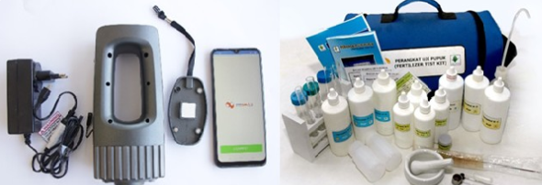
Figure 1. Philippine Soil Test Kit

Soil pH Monitoring
Soil pH describes the acidity or alkalinity of soil and is commonly considered when evaluating nutrient availability and fertilizer management. Because pH can influence the chemical form and availability of nutrients, measuring it alongside other soil variables can provide useful context for interpretation. In the proposed system, pH is one of the core measurements used by the analyzer and will serve as an input to the compatibility advisor.

Soil Moisture Monitoring
Soil moisture is important for crop production because water availability affects plant growth, nutrient movement, and irrigation needs. Recent studies show the increasing use of sensors, IoT, and machine learning for soil moisture monitoring and prediction. They also identify calibration, internet connection, power supply, and cost as common challenges in field use (Sreeram et al., 2026).
The proposed system includes a soil moisture sensor to measure water levels in the soil. The readings will be displayed in the web application together with other soil measurements. Gómez-Astorga et al. (2024) tested and calibrated low-cost capacitive moisture sensors in sandy loam soil with different biochar and salinity levels, as shown in Figure 2. Their results showed calibration differences of up to 30% compared with the control soil, showing the need for soil-specific calibration.
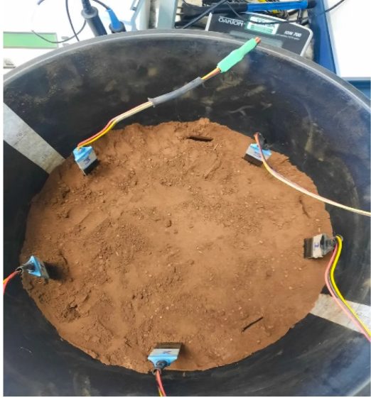
Figure 2. Low-cost soil-moisture sensor setup

Soil Temperature Monitoring
Soil temperature affects the physical and biological processes in the soil. It also influences the conditions around plant roots and soil organisms. Including a temperature sensor in the analyzer provides additional information about soil conditions. The sensor will be calibrated using a suitable reference thermometer or calibrated instrument before testing.

NPK Monitoring
Nitrogen, phosphorus, and potassium are important nutrients needed for crop growth. Studies on IoT and soil sensors identify these nutrients as important measurements for agricultural monitoring systems (Rajak et al., 2023).
Electronic NPK sensors also have limitations related to sensor type, soil conditions, calibration, and interference. Their readings may not always match the actual nutrient levels in the soil. Estrada et al. (2025) compared low-cost NPK sensors with laboratory results and found that the sensors had low accuracy and were strongly affected by soil moisture. Because of these limitations, this study will calibrate the sensors and compare their readings with a reference testing method instead of treating their raw outputs as accurate measurements.

Multi-Parameter Soil Sensing
Measuring several soil properties can provide more information than measuring only one. Studies on agricultural IoT describe systems that combine sensors, processing units, communication technologies, and software to monitor soil and environmental conditions (Chamara et al., 2022; Rajak et al., 2023). By combining pH, moisture, temperature, and NPK measurements, the proposed system can use different soil conditions as inputs for the fertilizer compatibility advisor.

Internet of Things in Smart Agriculture
IoT-based agriculture connects sensors to communication networks, data processing systems, and user applications. Chamara et al. (2022) reviewed agricultural IoT systems based on their sensors, main boards, communication methods, power sources, crops, and applications. Rajak et al. (2023) also discussed the use of IoT and smart sensors to monitor soil moisture, temperature, composition, and nitrogen levels. They also identified challenges such as implementation costs, data security, and limited digital knowledge among farmers. These studies support the design of the proposed system, where a microcontroller collects sensor readings and sends them to a web-based monitoring system.

Wireless and Web-Based Monitoring
Web-based monitoring allows users to view sensor readings through a browser. It usually includes data collection, wireless communication, server processing, database storage, and a dashboard. In the proposed system, users can check current soil measurements and view previous records through the web dashboard.
Offline recording requires local storage and a system for managing saved data when the internet connection is unavailable. Espressif Systems (n.d.-a) explains that non-volatile flash memory can store data even after the device restarts. Its Wi-Fi documentation also describes how devices can handle connection and reconnection events (Espressif Systems, n.d.-b). The proposed system will use these features to temporarily store sensor readings that have not yet been uploaded. The storage capacity, data retention after restart, and recovery of interrupted data transfers will be tested during development.

Fertilizer Recommendation and Compatibility
Fertilizer recommendations depend on several factors, including crop requirements, existing soil nutrient levels, soil pH, and other agricultural conditions. The Philippine Soil Test Kit shows how soil test results can be used to recommend the type and amount of fertilizer needed for a specific crop. Its qualitative results also show the importance of considering the limitations of the testing method when making recommendations (Food and Agriculture Organization, n.d.).
In this study, fertilizer compatibility will mean whether a listed fertilizer option is suitable for the selected crop and measured soil condition. The advisor will use the required soil measurements, selected crop, and fertilizer option to predict a suitability class. Stored reference rules will be used to check the results. The system will provide guidance and will not replace laboratory soil testing or advice from agricultural experts.

Trained Models and Machine Learning in Agricultural Decision Support
Machine learning is increasingly used in agriculture for prediction, classification, monitoring, and decision-making. Studies on smart agriculture discuss the use of machine learning, data mining, deep learning, IoT, and sensor technologies in different agricultural activities (Pandey et al., 2022). A trained model can help analyze several input variables at the same time, provided that the training data are suitable for the intended purpose.
For the proposed system, model development will begin with collecting and preparing the dataset. The dataset will contain selected soil measurements and their corresponding compatibility labels or target outputs. The data will be divided into training and testing sets. The model will be trained using the training set, while the testing set will be used to evaluate its performance on data it has not seen before. This separation helps provide a more reliable evaluation because using the same data for both training and testing can make the model appear more accurate.
The model will be added to the web application after sensor calibration and model validation. This ensures that the model receives measurements using the same units and ranges as the training data. If calibration changes the scale of the sensor readings, the model's input processing must also be adjusted to match.

Solar and Rechargeable Power for Field Devices
Portable agricultural devices need a reliable power source to support sensors, data processing, wireless communication, and data storage. A rechargeable battery can store energy, while a solar panel can recharge it when sunlight is available. The proposed system will use both to support field operations. Power consumption will also be considered when selecting components because sensors and wireless communication require energy to operate.
The reviewed studies support the use of sensors, communication, and decision-support systems in agriculture, but they also show the importance of accurate measurements. Chamara et al. (2022) and Rajak et al. (2023) discuss the design and challenges of agricultural IoT systems. Gómez-Astorga et al. (2024) show the need for soil-specific moisture sensor calibration, while Estrada et al. (2025) report accuracy problems with low-cost NPK sensors. For this reason, the study will evaluate both the overall prototype and the accuracy of its measurements. Fertilizer recommendations will also be limited to the soil conditions and results supported by the calibration and validation process.

Web Application Quality Evaluation Using ISO/IEC 25010:2023
ISO/IEC 25010:2023 provides a product quality model with nine characteristics: functional suitability, performance efficiency, compatibility, interaction capability, reliability, security, maintainability, flexibility, and safety. It serves as a guide for defining and evaluating the quality of software and information technology products (International Organization for Standardization, 2023).
In this study, these characteristics will be used to evaluate the web application through technical tests, test cases, and evaluator ratings. Interaction capability will focus on how easily users can understand and use the application. Flexibility will assess how well the application works in its supported environments and under its intended workload. Safety will focus on warnings and controls that help prevent users from acting on invalid or unsupported recommendations.
The evaluation will follow the ISO/IEC 25010:2023 product quality model but will not be considered an official ISO certification.

METHODOLOGY
This study will use a developmental and experimental research design. The developmental part will focus on designing, assembling, programming, and combining the hardware and software components of the proposed system. The experimental part will focus on calibrating and validating the sensor readings using selected standard methods and calibrated reference instruments.
The study will begin with the approved study plan, component selection, hardware and firmware development, and power system setup. Sensor calibration and initial checks against reference measurements will come before model training. The researchers will then prepare the development data, train the model, develop the web application, and test the connected system. Final independent sensor and model tests will follow model selection. Web application evaluation and development cost analysis will complete the study.
Development and testing will use the available laboratories, workshops, computers, and agricultural facilities of the Agricultural and Biosystems Engineering program at Nueva Vizcaya State University, Bayombong, Nueva Vizcaya. Selected agricultural sites will also be used for soil sample collection and field testing when needed.

Conceptual Framework
The conceptual framework is based on the four specific objectives of the study. Figure 3 shows the input, process, and output for each objective. Its rows group the work by objective and do not show a strict time order.
The first row focuses on developing the integrated soil analyzer. The second covers the calibration and validation of pH, temperature, moisture, and NPK measurements using selected reference methods and instruments. The third covers model training and testing, web application development, and web application evaluation using ISO/IEC 25010:2023. The fourth covers the direct cost of developing the prototype.
Calibration, initial sensor checks, and tests using development data will guide improvements. Calibration equations, model settings, and test procedures will be fixed before the final independent tests. Final test data will not be used to choose the model or adjust its settings.
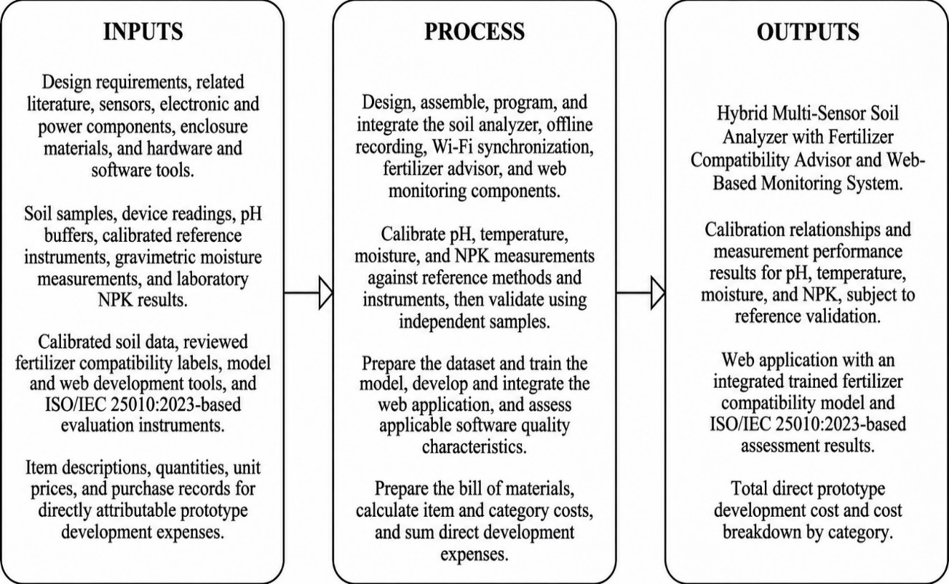
Figure 3. Input–Process–Output framework

Components of the Device
Figure 4 illustrates the proposed sensing, processing, power, and interface components. The drawing serves as a visual inventory for prototype assembly; component ratings and connections will be verified during hardware development. The NPK probe remains provisional, subject to the feasibility and validation procedures described in this study. The 18 illustrated component groups exclude an OLED display; offline storage will use flash already present on the ESP32 board.
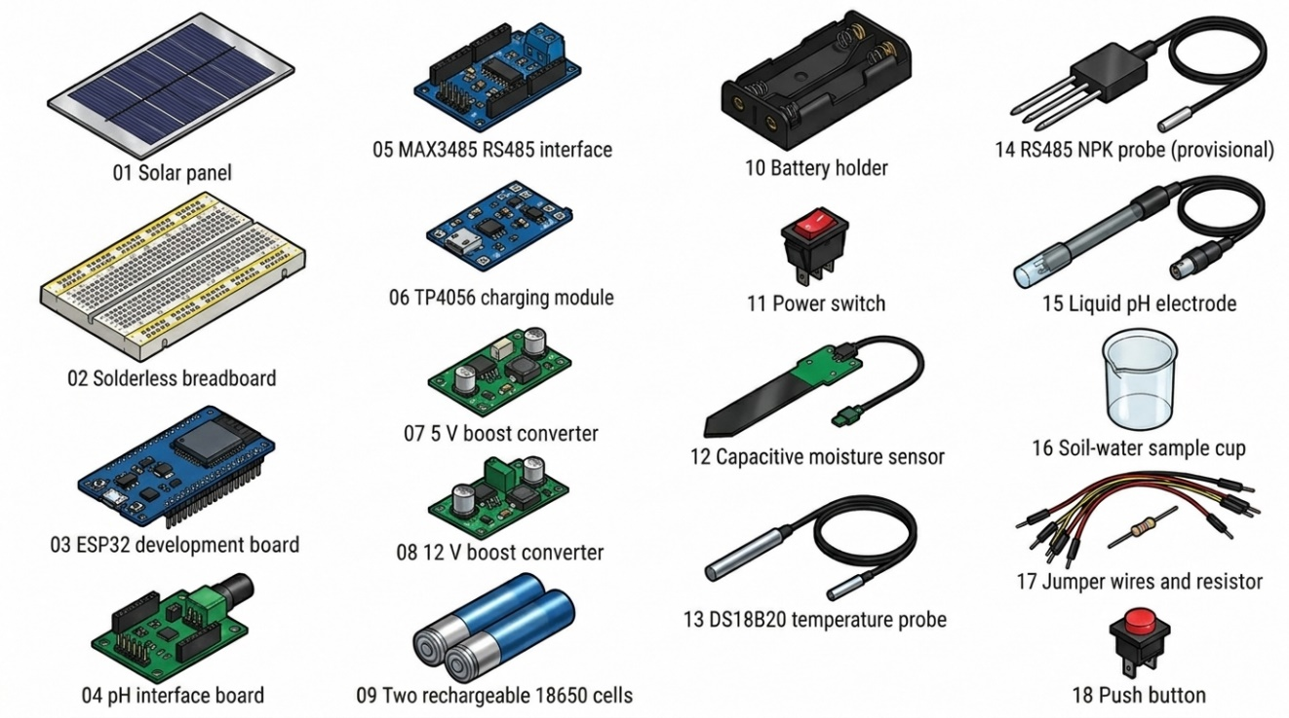
Figure 4: Hardware components of the multi-sensor soil analyzer
Figures 4a to 4r present the individual parts shown in Figure 4 and explain their proposed functions. The numbering in the overview identifies the physical component groups. The drawings illustrate the proposed hardware and do not constitute verified wiring diagrams.
Solar Panel. The solar panel will convert sunlight into electrical energy for the charging circuit. Its output rating and mounting position will be selected based on the battery and charger requirements. It will provide additional charging during suitable field conditions but will not serve as the device's only power source.
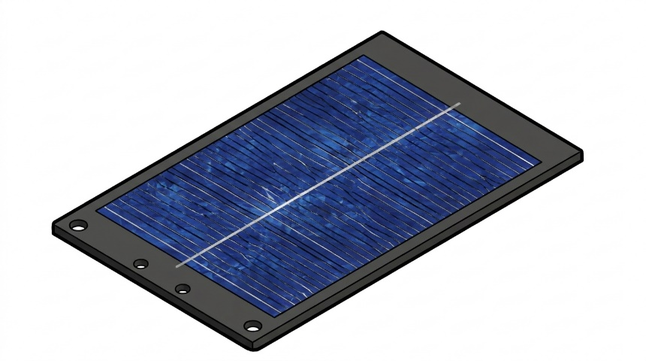
Figure 4a. Solar panel
Solderless Breadboard. The solderless breadboard will be used to connect electronic components during prototype assembly and testing. It will allow easy changes to sensor and controller connections during development. All connections will be checked and secured before field testing.
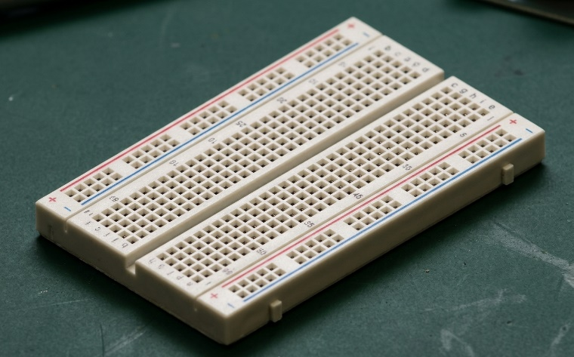
Figure 4b. Solderless breadboard
ESP32 Development Board. The ESP32 will run the firmware, collect sensor readings, apply calibration values, and store unsent data in its flash memory. It will also use its built-in Wi-Fi to upload saved readings to the server. The allocated storage space and maximum number of records will be determined through storage and restart tests.
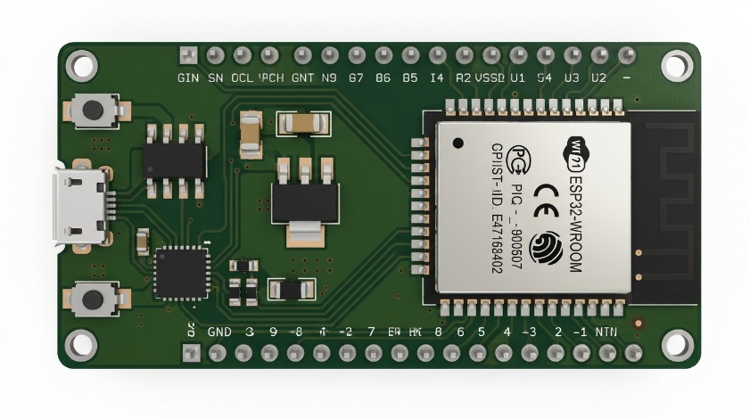
Figure 4c. ESP32 development board
pH Interface Board. The pH interface board will process the signal from the pH electrode and convert it into an analog output that the ESP32 can read. It is separate from the pH electrode, which is responsible for measuring soil acidity or alkalinity. The board's output and power requirements will be checked for compatibility with the ESP32 before calibration (DFRobot, n.d.-b).
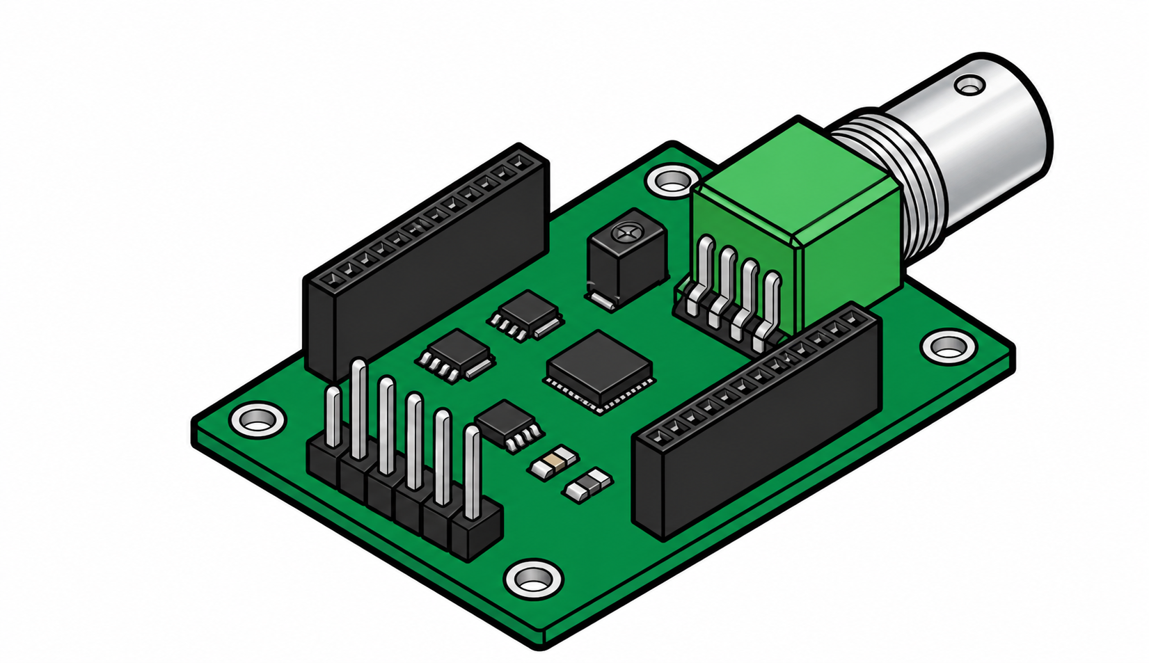
Figure 4d. pH interface board
MAX3485 RS485 Interface. The MAX3485 will connect the ESP32 to a compatible NPK probe through an RS485 communication line. It will handle data transfer between the controller and the probe but will not measure nutrient levels. Its 3.3 V logic and module connections will be checked during assembly (Analog Devices, n.d.-b).
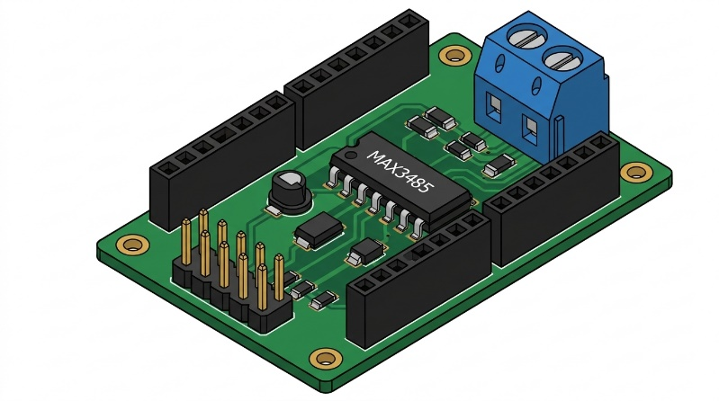
Figure 4e. MAX3485 RS485 interface
Charging Module. The charging module will manage the charging of the selected rechargeable battery. The TP4056 shown in the diagram is a proposed component, and its compatibility with the battery setup, solar input, and required charging current will be checked before use. Battery charging control and battery protection will also be handled as separate requirements.
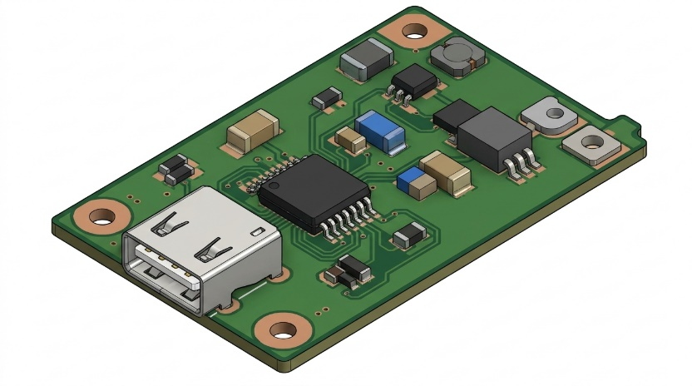
Figure 4f. Charging module (TP4056)
5 V Boost Converter. The 5 V boost converter will increase the battery voltage to a regulated 5 V output if needed by the ESP32 board or other modules. Its current capacity, efficiency, and connection to the correct board input will be checked under normal operating conditions.
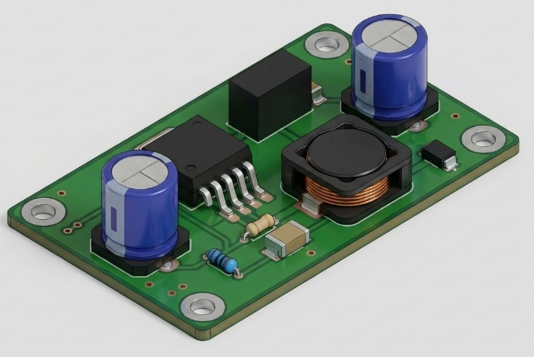
Figure 4g. 5 V boost converter
12 V Boost Converter. The 12 V boost converter will only be used if the selected NPK probe requires a 12 V power supply. The probe's specifications will determine the required voltage and current. This component will only be included if it is needed for the final hardware setup.
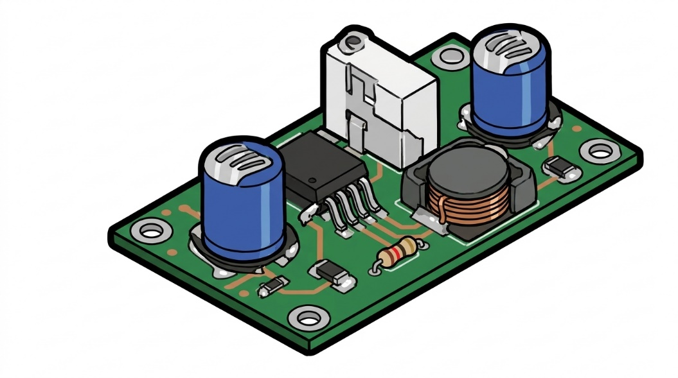
Figure 4h. 12 V boost converter
Rechargeable Battery. The rechargeable 18650 battery cells will store energy to power the device when sunlight or external charging is unavailable. The proposed design includes two cells. Their capacity, connection arrangement, and protection requirements will be determined based on the selected charging module and verified before use.
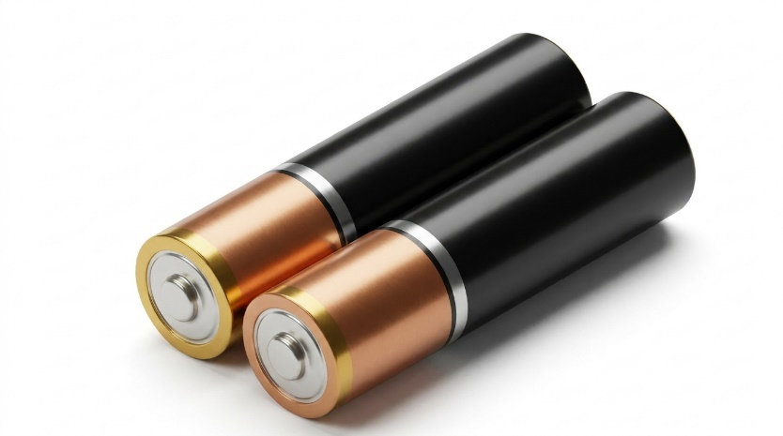
Figure 4i. Rechargeable 18650 Battery
Battery Holder. The battery holder will secure the rechargeable cells and provide their electrical connections. Its wiring will be checked to ensure that the cell arrangement matches the selected charger and protection circuit. The holder itself does not provide battery charging or protection.
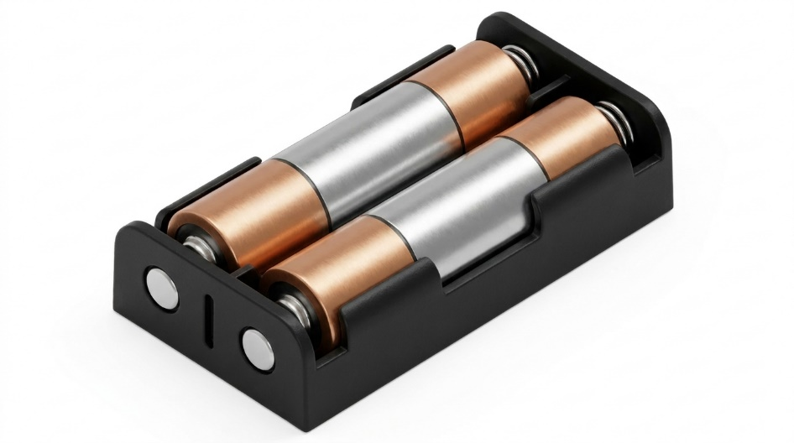
Figure 4j. Battery holder
Power Switch. The power switch will turn the device on or off by connecting or disconnecting the power supply. Its current rating and position will be selected based on the final circuit design. Users will use it to start or end a measurement session.
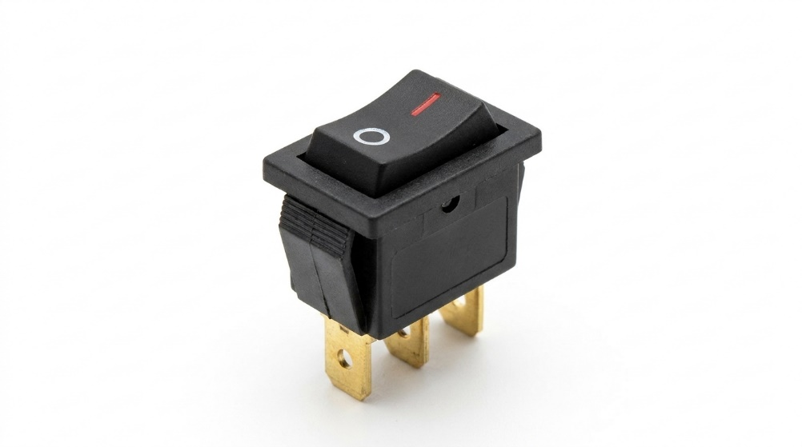
Figure 4k. Power switch
Capacitive Soil Moisture Sensor. The capacitive moisture sensor will measure soil moisture by detecting changes in the soil's dielectric properties and provide an analog signal to the ESP32. The proposed SEN0193 or an equivalent sensor will be calibrated using the selected gravimetric reference method. Raw sensor readings will not be presented as moisture percentages without proper calibration (DFRobot, n.d.-a).
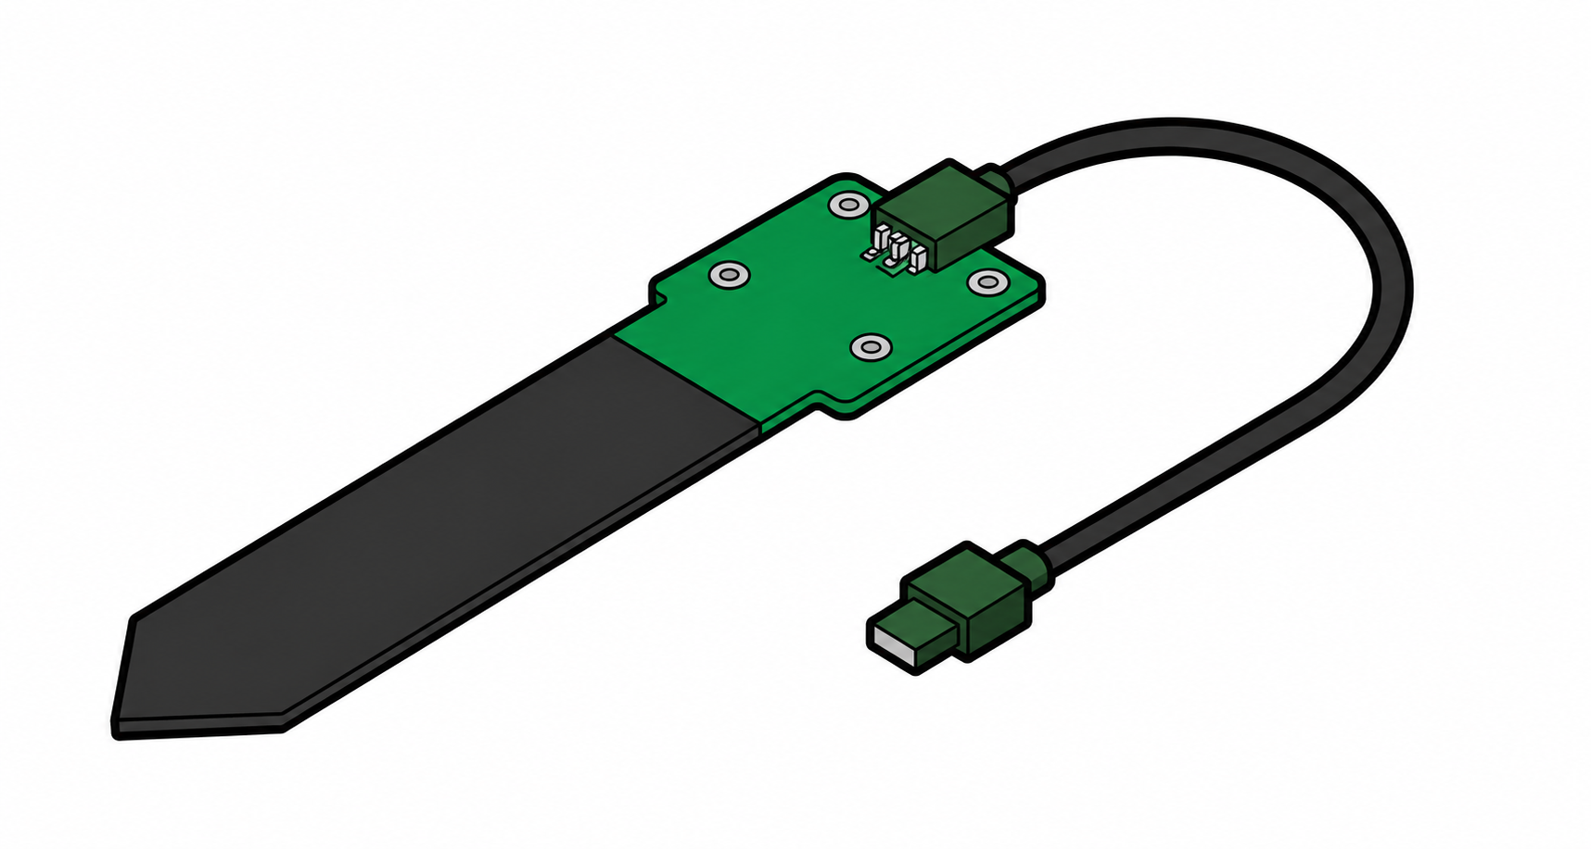
Figure 4l. Capacitive soil moisture sensor (SEN0193)
DS18B20 Temperature Probe. The DS18B20 will measure soil temperature and send digital readings to the ESP32 through its 1-Wire interface. The probe will be tested against a calibrated thermometer within the intended temperature range. Its placement and the time needed for stable readings will follow the testing procedure (Analog Devices, n.d.-a).
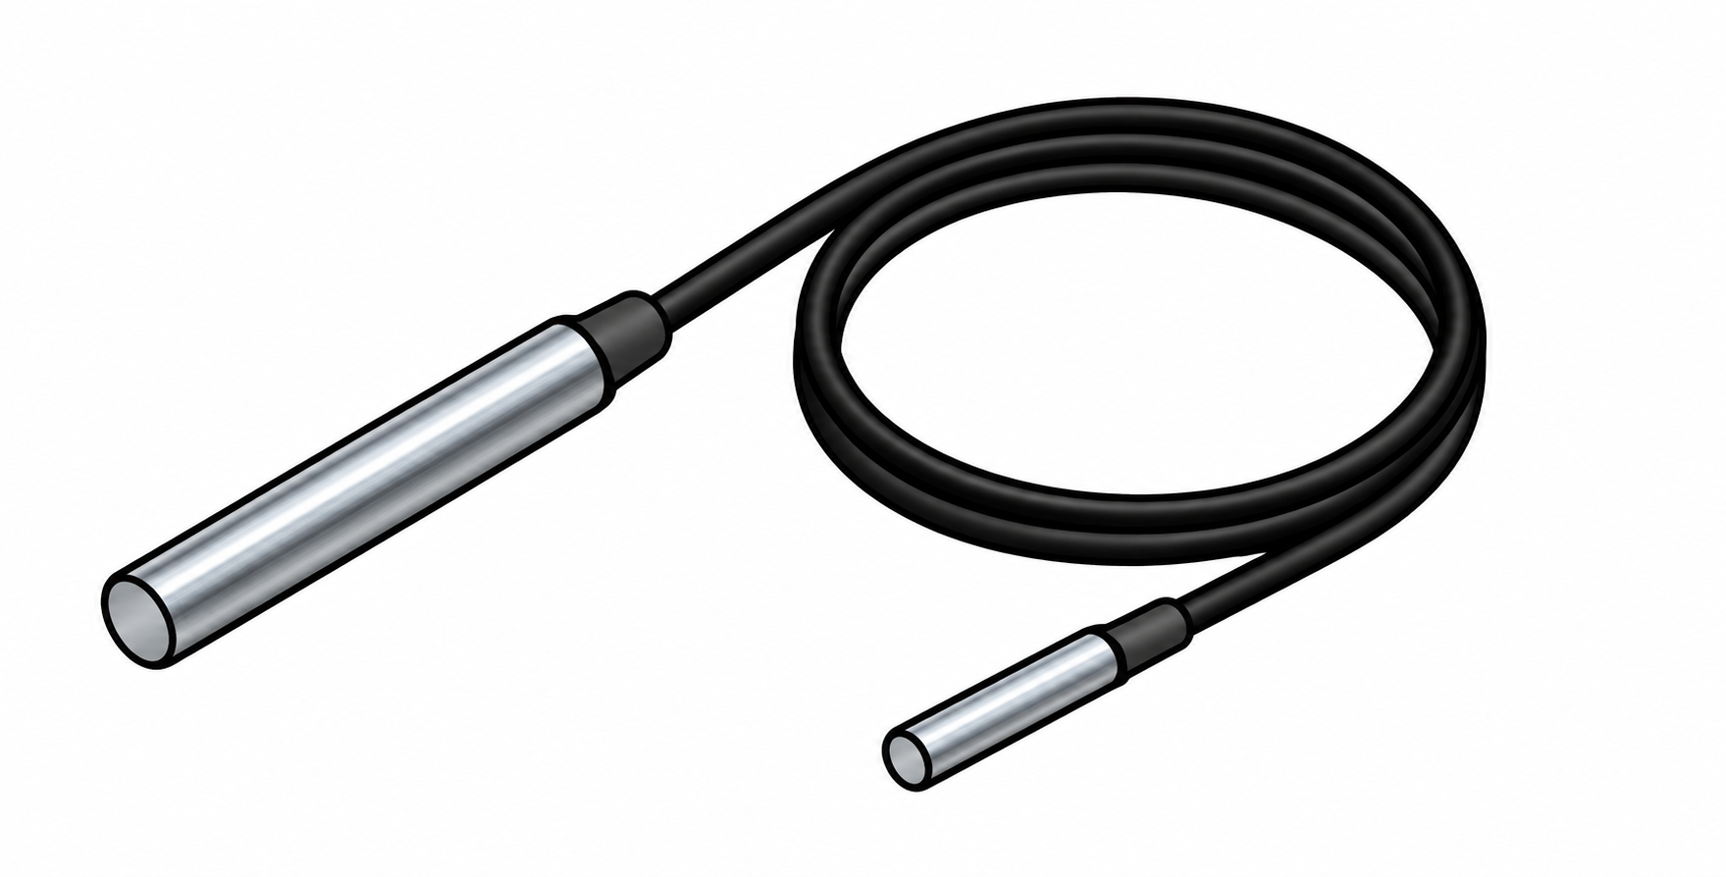
Figure 4m. DS18B20 temperature probe
RS485 NPK Probe. The proposed NPK probe will measure nutrient-related values and send the readings to the ESP32 through an RS485 connection. Its measurement method, units, nutrient types, and power requirements will be identified and documented. It will only be used for recommendations of fertilizer if its readings are validated through comparison with suitable laboratory results.
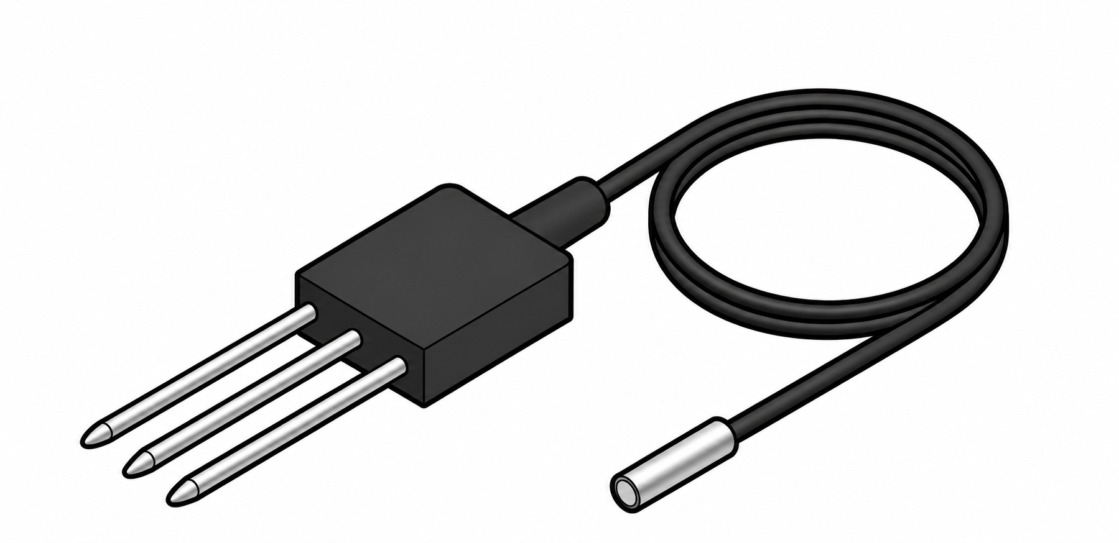
Figure 4n. NPK probe (RS485)
Liquid pH Electrode. The liquid pH electrode will measure the acidity or alkalinity of a prepared soil-water mixture. It will connect to the pH interface board and will not be inserted directly into dry soil. Calibration, cleaning, and storage will follow the recommended procedures for the selected electrode (DFRobot, n.d.-b).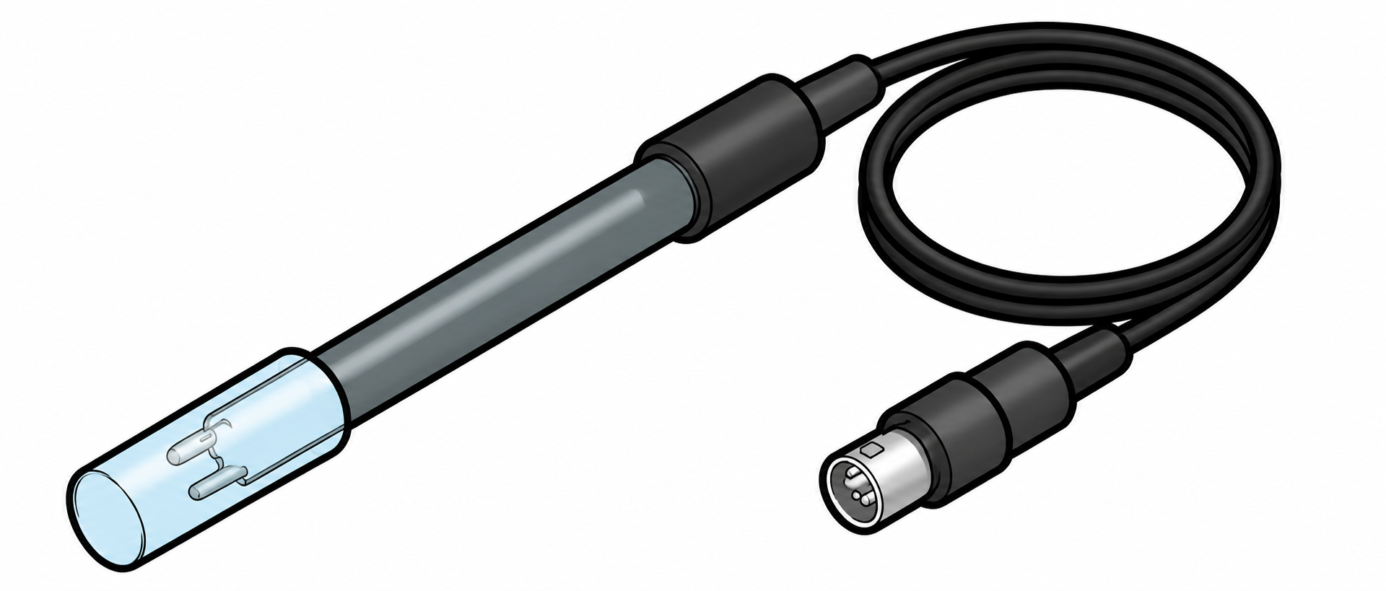
Figure 4o. Liquid pH electrode
Soil-Water Sample Cup. The sample cup will hold the prepared soil-water mixture during pH measurement. Clean containers and consistent preparation methods will help prevent contamination between samples. The cup is only used for sample preparation and does not perform any electronic measurements.
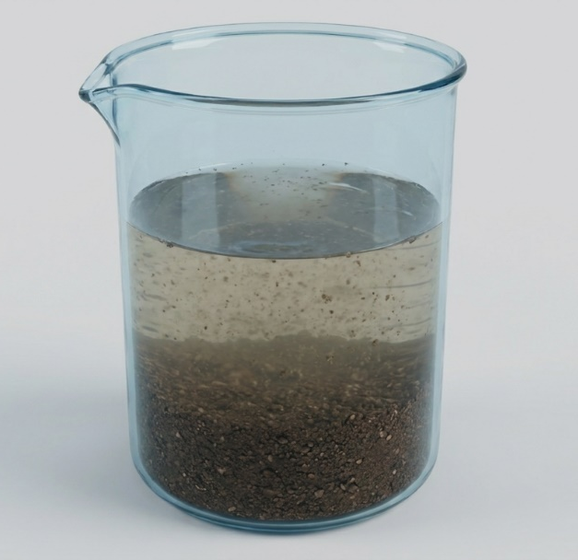
Figure 4p. Soil-water sample cup
Jumper Wires and Resistors. Jumper wires will connect the different parts of the circuit, while resistors will provide the required pull-up and signal-conditioning functions. Their values and placement will depend on the selected components and circuit design. All connections will be secured to prevent accidental disconnection during use.
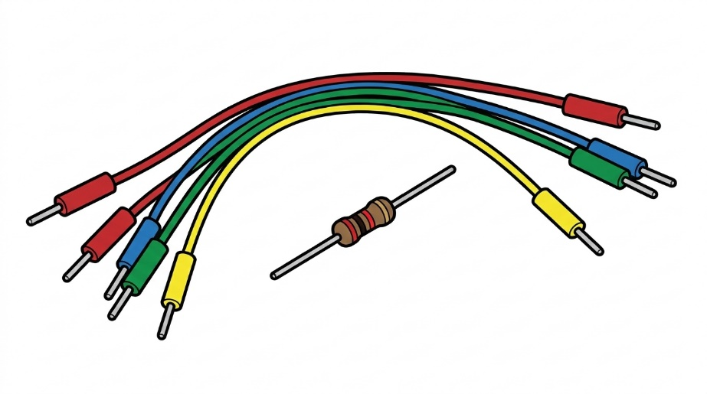
Figure 4q. Jumper wires and resistors
Push Button. The push button will provide a temporary input to the ESP32 if included in the final system design. It may be assigned to start a soil measurement during development. Its function will be tested to ensure that it works as intended. The button is a proposed control and its final function will depend on the firmware implementation.
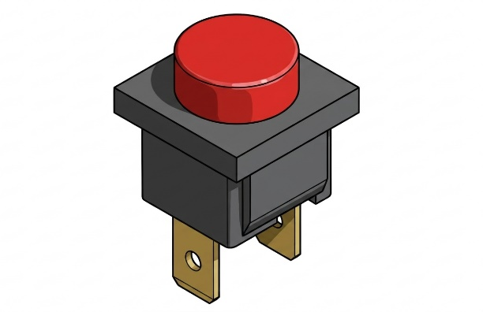
Figure 4r. Push button
Local Data Storage. The ESP32's onboard built-in memory will be used to store sensor readings that have not yet been uploaded. The storage space will be allocated after considering the memory needed by the firmware and other system functions. The maximum number of records will be determined through testing rather than estimated. Saved records are expected to remain available after a device restart, subject to validation of the storage setup (Espressif Systems, n.d.-a). The system will not use a separate microSD module.
Enclosure and Probe Assembly. The enclosure will protect the electronic components, while the probe assembly will hold the sensors in place during soil measurement and field use.
Web Server and Database Platform. Development will initially use an existing computer with a local web server or available institutional hosting to reduce recurring costs. The system will store soil measurements, calibration status, timestamps, and fertilizer recommendations. Internet requirements and hosting costs will also be recorded. The server will confirm successful data uploads and use device and record identifiers to prevent duplicate entries when the same records are uploaded again.
Computer or Mobile Device. A computer or mobile device will be used for programming, accessing the dashboard, and evaluating the system during development and testing. Users will access the web application through a browser, which will serve as the device's main display instead of a built-in screen.

System Architecture
The proposed system will have five main layers: sensing, processing, communication, web application, and decision support.
The sensing layer will contain the pH, temperature, moisture, and NPK sensors. The processing layer will use a microcontroller to collect and prepare the sensor readings. The communication layer will send the data through an available wireless connection. The web application will store and display the measurements, while the decision-support layer will use the trained model and stored reference data to generate fertilizer compatibility recommendations.
Figure 5 shows the proposed system architecture. The processing layer will also store unsent readings in a local queue. Once the network and server are available, the communication layer will upload the saved records automatically. The web application will confirm successfully stored records, display the time when each measurement was taken and received, and show the synchronization status.
Cloud storage will require an internet connection, while a local server can be accessed through an available local Wi-Fi network without public internet access.
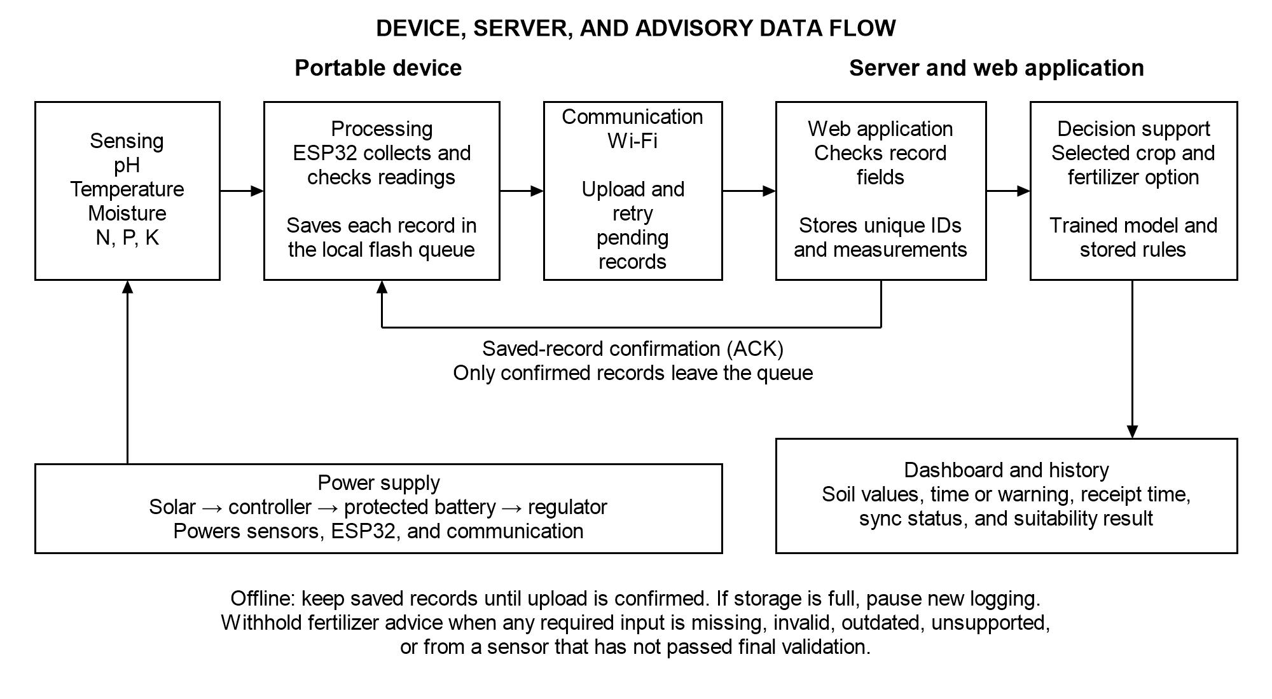
Figure 5. System architecture

Principle of Operation
Before each measurement session, the operator will charge the battery, check the connections, and make sure the sensor calibration records are updated. Each soil sample will be assigned a unique identifier. The operator will prepare the soil-water mixture for pH measurement and the required soil samples for moisture, temperature, and NPK testing, following the documented sampling procedure.
When the power switch is turned on, the battery will supply power to the ESP32 and to the connected sensor modules. The firmware will initialize the sensors, load the stored calibration values, and retrieve saved records from the ESP32's flash memory. The solar panel will provide additional charging when sunlight is available and the charging circuit supports it. The device's operating time will depend on the actual battery performance.
The operator will place the moisture and temperature probes into the prepared soil. The NPK probe will be checked during development and will support fertilizer advice only after passing validation. The liquid pH electrode will be placed in a separately prepared soil-water mixture. Once the readings become stable under the defined procedure, the ESP32 will collect data through the analog, 1-Wire, and RS485 interfaces used by the selected sensors.
The ESP32 will convert the sensor outputs using the assigned calibration values and check for missing, invalid, or out-of-range readings. Each measurement will be linked to its sample identifier, record identifier, calibration status, and time of collection. A time status indicator will identify readings collected before the device clock is synchronized. The completed record will first be saved to the allocated flash memory before the device attempts to upload it.
When the Wi-Fi network and server are available, the device will automatically upload the saved records. The server will check and store each record while preventing duplicate entries using the device and record identifiers. It will then send a confirmation to the device. Only records with successful upload confirmation will be removed from the local queue. If the connection is interrupted, unsent records will remain in the flash memory and will be uploaded again once the connection is restored. If the storage becomes full, the device will stop saving new readings while keeping the pending records.
The server will process uploaded measurements using the trained fertilizer compatibility model and stored reference rules. The web dashboard will display the soil measurements, collection time or time warning, compatibility results, and any limitations. Fertilizer advice will be withheld if any required input is missing, invalid, outdated, outside the supported range, or from a sensor that has not passed final validation. This includes N, P, and K readings. Monitoring and record storage can continue while advice is withheld. Offline readings will appear on the dashboard after successful upload.
At the end of the session, the operator will check the latest synchronization status, turn off the device, and clean and store the probes according to their handling requirements. Saved records that have not yet been uploaded are expected to remain available when the device is turned on again, subject to restart and interrupted-write testing. The soil-water mixture and remaining soil samples will be handled according to the laboratory procedures.

Soil Sampling and Sample Allocation
Before the main sample collection, the researchers and adviser will approve a sampling plan. It will state the selected crop, fertilizer options, locations, soil conditions, sampling depth, sample counts, collection method, sample amount, transport, and preparation steps. The sample counts will be based on initial tests, the planned comparisons, laboratory capacity, and budget. The researchers will confirm laboratory access and suitable N, P, and K reference tests before collecting the main samples.
The plan will assign separate samples to calibration, model development, and final independent testing. It will state the number of independent samples and records needed for each group and fertilizer class. Final test samples will be kept separate from calibration and model development. The crop, fertilizer list, sample counts, and test limits have not yet been set and will be approved before the main data collection.
Each soil sample will be assigned a unique ID linked to its collection location, date, sampling depth, and preparation details. Portions of the same mixed soil sample will be used for both device measurements and reference measurements when applicable. Calibration and final validation samples will be separated before developing the calibration equations. Repeated readings and portions taken from the same soil sample will remain in the same dataset group to avoid counting them as separate independent samples.

Instrumentation
Table 1 lists the instruments, materials, and laboratory services needed for calibration and system testing. Reference instruments, drying equipment, and laboratory testing services will be accessed through the university or partner laboratories, subject to their approval. Before testing, the researchers will record the final instrument models, calibration status, testing methods, measurement ranges, detection limits, and measurement uncertainties. The NPK reference test must measure the same type of nutrient content and use the same units as the sensor output. Total nutrient content and extractable or available nutrient content will be treated as different measurements.
Table 1. Instruments, materials, and laboratory services for calibration and testing
Instrument, material, or service | Use and information to record
Standard pH 4.00 and 7.00 buffer solutions | Calibrate the pH sensor. Record buffer lot, expiry, temperature, and calibration date. Use other buffers only if the selected procedure requires them.
Calibrated pH meter | Compare device and reference pH readings using the same soil-water preparation method. Record paired readings and the reference meter's calibration status.
Calibrated thermometer | Compare readings with the temperature probe under the same test conditions. Record paired temperatures, stabilization time, and thermometer calibration status.
Drying oven, balance, moisture tins, and desiccator | Determine moisture from wet and dry soil masses. Record container mass, drying temperature and duration, and whether results use a mass or volume basis.
Soil core sampler of known volume, if volumetric moisture is reported | Measure soil bulk density from dry mass and known sample volume before converting moisture from a mass basis to a volume basis.
Soil trowel, bags, labels, sieve, clean cups, measuring cylinder, and preparation water | Collect and prepare samples. Use the water type and soil-to-water ratio required by the selected pH method. Record sample ID, site, depth, soil mass, and water volume.
Laboratory N, P, and K testing service | Compare probe readings with laboratory results for paired soil samples. Record nutrient forms, test methods, units, detection limits, and soil moisture conditions.
Digital multimeter and suitable current or power meter | Measure supply voltage and operating current during battery and charging tests. Record the device load and test conditions.
Computer or mobile device, Wi-Fi network, browser tools, timer, and evaluation forms | Log repeated sensor readings and battery runtime. Test the dashboard and delayed uploads. Record task times, record IDs, connection conditions, and evaluator responses.

Hardware Development
The hardware will be assembled in a modular design so that individual sensors can be replaced or recalibrated without changing the entire system. Each sensor interface will be connected to the microcontroller based on its electrical requirements. Power connections will be separated from sensor signal wires as much as possible to reduce electrical interference. Figure 6 shows the proposed hardware and data collection process.
The enclosure will protect the electronic components during field use. The temperature, moisture, and compatible NPK probes will be placed in prepared soil samples or field soil using consistent placement procedures and depth. The pH electrode will measure a separately prepared soil-water mixture. The physical design will focus on portability, easy access to the charging system, simple cleaning, and sensor replacement. The enclosure will not include an OLED or LCD screen because the web application will serve as the main display.
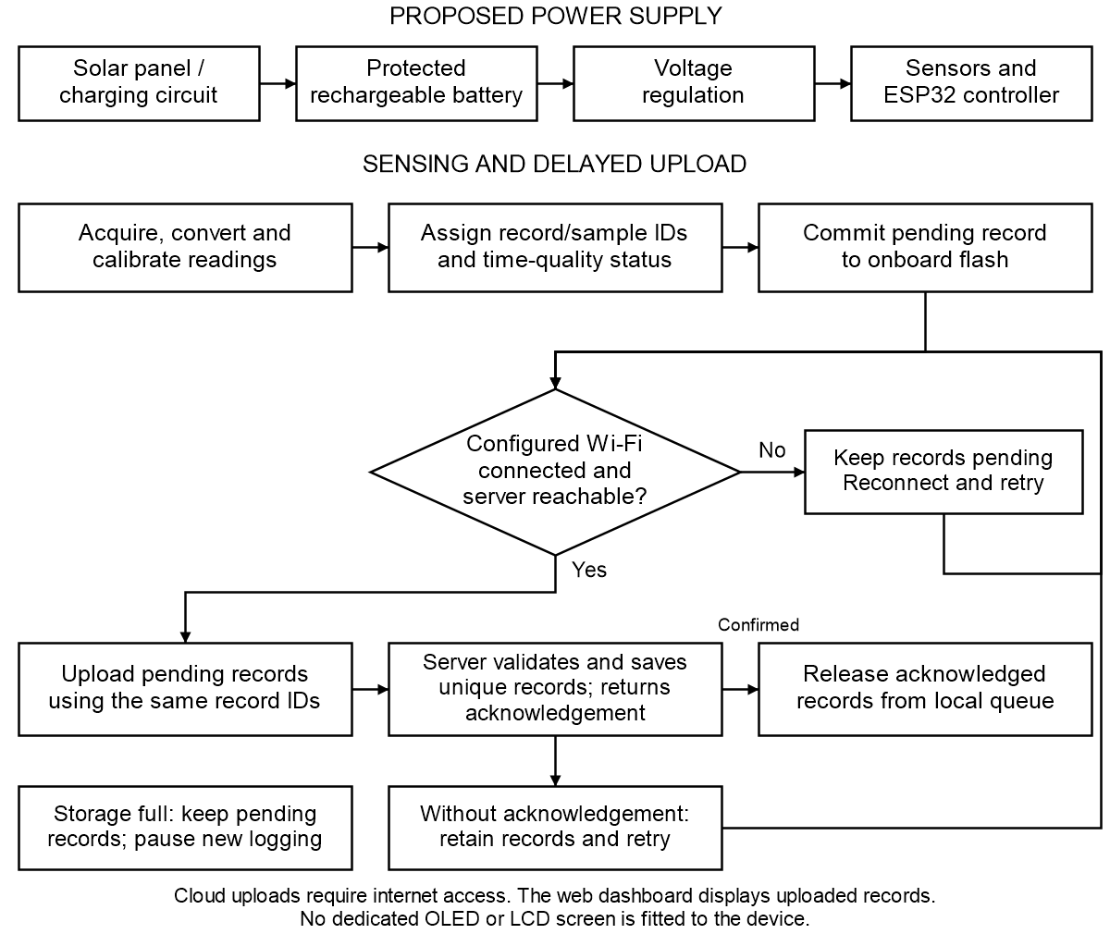
Figure 6. Hardware and data-acquisition flow
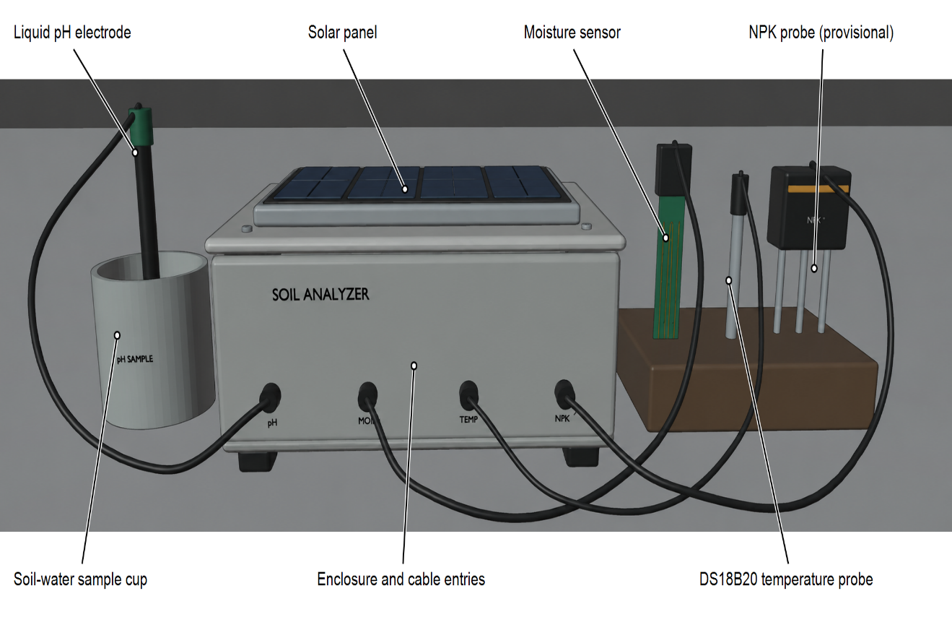
Figures 7 and 8 show the proposed enclosure and breadboard arrangements without a built-in screen. These designs show the planned placement of the solar panel, power modules, controller, and sensor connections. The web application will display the uploaded measurements. The pH electrode will use a separate sample cup for the prepared soil-water mixture. The final dimensions, wiring, and power connections will be determined and checked during prototype assembly.

Figure 7. Enclosure arrangement of the multi-sensor soil analyzer
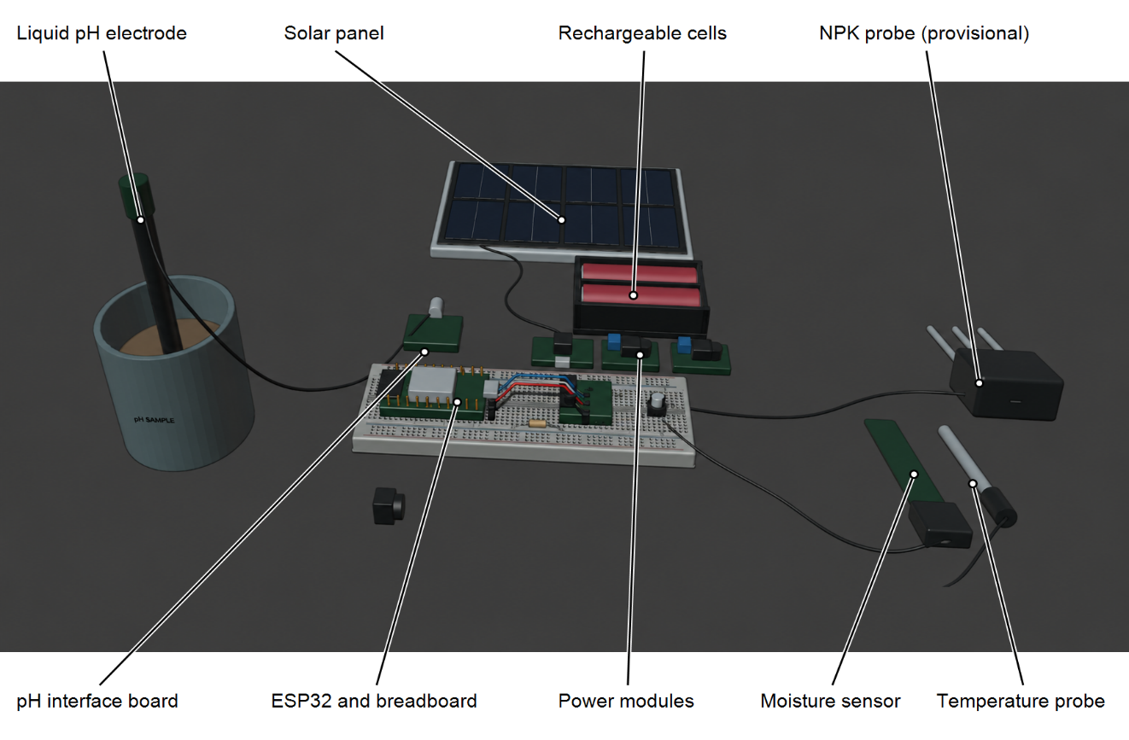
Figure 8. Exposed arrangement of the multi-sensor soil analyzer

Firmware and Data Acquisition
The firmware will initialize the sensors, collect readings, process the data, apply calibration values, and save each measurement to the ESP32's flash memory before attempting to upload it. Each record will contain a unique identifier, sample identifier, sensor readings, calibration status, and measurement time when the device clock is available. A time status indicator will identify readings collected before clock synchronization. The server will also record the time it receives each record separately from the actual measurement time.
The firmware will connect to the configured Wi-Fi network and upload saved records when the server becomes available. Records will remain stored in flash memory during internet interruptions, server errors, or unconfirmed uploads. The device will reuse the same record identifiers when retrying uploads to prevent duplicate entries. Records will only be removed from local storage after the server confirms successful saving. If the storage becomes full, the device will stop recording new readings while keeping pending records. The dashboard will show the storage status once communication is restored. The system will not require a separate hardware clock or built-in display.
To ensure consistent measurements, the researchers will follow a fixed testing procedure. This will include sample preparation, probe cleaning, stabilization time, measurement depth, number of readings, and recording intervals. All procedures will be documented and followed during calibration and validation.

Calibration Procedure
Calibration and initial checks against reference measurements will be completed before local readings are used for model development. These early checks will guide development and will not replace final independent validation. The pH electrode will be calibrated using fresh buffers, usually pH 4.00 and 7.00, following the manufacturer's instructions. Soil pH readings will be compared with a calibrated pH meter using the same soil-water preparation method. Temperature readings will be compared with a calibrated thermometer. Moisture calibration will use oven-drying measurements. NPK readings will be compared with laboratory results from the same soil samples. Calibration equations will be made only when the initial data show a reliable relationship and will be fixed before final validation.
For pH calibration, the researcher will record the buffer values, calibration date, temperature, soil-water preparation, stabilization time, and reference pH readings. Differences between the sensor and reference meter will be reported in pH units. The correction will also be tested using separate soil samples.
For temperature calibration, sensor readings will be compared with a calibrated thermometer or temperature reference across the expected operating range. Differences between the readings will be measured, and corrections will be applied when supported by the results.
For moisture calibration, the wet and dry soil weights, drying conditions, and moisture measurement basis will be recorded. The sensor will be tested at different moisture levels to establish its calibration relationship. If the results will be reported as volumetric moisture, soil bulk density will also be measured instead of directly converting gravimetric moisture percentages.
For NPK calibration, the nutrient types, extraction methods, units, and detection limits will be identified before sensor readings are compared with laboratory results. Soil preparation will follow a consistent procedure, and moisture conditions will be recorded. If the readings do not show a reliable relationship with laboratory results, the limitation will be reported. All fertilizer suitability advice will remain unavailable unless every required sensor input passes final validation.

Calibration and Validation Metrics
Final sensor validation will follow calibration and model selection. It will use independent soil samples that were not used for calibration or model development. Device readings will be compared with calibrated reference instruments and laboratory results from the same samples. Each sample will be measured at least three times, and its repeated readings will be summarized before comparison. The independent sample counts will follow the approved sampling plan.
Measurement performance will be evaluated using absolute error, Mean Absolute Error (MAE), Root Mean Square Error (RMSE), bias, Coefficient of Determination (R²), and Pearson correlation when applicable. Percentage error and Mean Absolute Percentage Error (MAPE) will only be used for suitable ratio-scale measurements with nonzero reference values. They will not be used for pH or temperature readings in Celsius.
Before the main data collection, the adviser will approve an acceptance plan for each parameter. It will state the measurement range, reference method, units, allowable error, and the source or reason for each limit. A proposed limit will be clearly identified if no suitable published limit is available. Error and bias will be used to judge measurement agreement because correlation alone does not show accuracy. The formulas are given in the Statistical Treatment of Data section. Sensor accuracy and model classification accuracy will be assessed separately.

Repeatability Testing
Repeatability will be tested using at least ten consecutive readings from the same soil sample under the same operating conditions. Tests will also be performed at different points within the measurement range. The mean, standard deviation, and variance will be reported for each parameter. Standard deviation will be expressed in pH units for pH readings and degrees Celsius for temperature readings. The coefficient of variation (CV) will only be used for suitable ratio-scale measurements with a nonzero mean.
Repeated readings will be used to assess measurement consistency and will not be treated as separate soil samples. The same operator, device, sample preparation, location, and measurement procedure will be maintained during each short testing period. Each test will follow the documented cleaning, probe placement, and stabilization procedures. Tests using a stationary probe will be reported separately (Joint Committee for Guides in Metrology, 2012).
For one sample under a specific test condition, let x_{j} represent the jth reading, $m$represent the number of readings (at least ten), and $\overline{x }$represent the mean. The mean and repeatability standard deviation will be calculated using the following formulas:
$$\overline{x} = \frac{Σ_{j = 1}^{m}{x_{j}}}{m} (1)$$
$$s_{r} = \sqrt{\frac{Σ_{j = 1}^{m}{{(x_{j} - \overline{x})}^{2}}}{m - 1}} (2)$$
The repeatability variance is represented by $s_{r}^{2}$. Standard deviation will be reported using the original measurement unit for each parameter and test condition. Results from different moisture levels or temperatures will be analyzed separately and will not be combined into one repeatability standard deviation.
$$r_{95} ≈ 2.8 s_{r} (3)$$
The approximate 95% repeatability limit, $r_{95}$, represents the absolute difference expected to include approximately 95% of pairs of individual readings when measurement errors are independent, approximately normal, and have similar variance. It is not a confidence interval for the mean or a measure of accuracy percentage. This formula follows the FAO soil-laboratory quality guidance in Section 7.5.2.2 and is not attributed to a PAES clause (van Reeuwijk, 1998).
$$CV (\%) = 100 \frac{s_{r}}{\overline{x}} (4)$$
The CV will only be calculated for suitable positive ratio-scale measurements with a mean sufficiently above zero. It will not be used for pH, temperature in Celsius, or uncalibrated sensor readings (National Institute of Standards and Technology, n.d.-b). The exact PAES number, edition, and applicable clause for repeatability will be confirmed with the adviser before final testing. No PAES compliance or acceptance threshold is claimed in this study.

Dataset Preparation and Trained Model Development
The model dataset will use local soil measurements and suitable public data from Kaggle, if available. For each public dataset, the researchers will record its title, original source, link, version, and terms of use. Public and local records will be combined only when their input measurements, units, nutrient tests, and fertilizer labels match. Records that do not meet these conditions will be excluded, and the reason will be reported.
The model will assess whether a listed fertilizer option is suitable for the selected crop and measured soil condition. Its required inputs will be pH, soil temperature, soil moisture, N, P, K, the selected crop, and the fertilizer option. Each record will link these inputs to an expected suitability class. A qualified agriculture professional will review the class definitions and labels using the selected agricultural references. Local readings may be used for model development after calibration and initial reference checks. Fertilizer advice from the completed system will be released only after the required sensors and model pass final independent testing. Unclear labels will be reviewed before training.
The researchers will record how missing values, repeated records, and unusually high or low readings are handled. Data will be divided into development and final test groups before training. Readings and fertilizer records from the same soil sample or collection group will stay together. Independent local samples for final testing will not be used to fit calibration equations, train the model, or choose model settings. The planned sample counts and records for each class will be approved before the main data collection.
A Decision Tree classifier will be used first because its decisions are easy to follow. Its results will be compared with the results from the study's reference rules. Random Forest or Support Vector Machine models may also be tested if there are enough samples in each class. Data cleaning and model settings will be based on the development data only. If enough independent groups are available, the model will be checked using different training and validation groups within the development data.
The final test data will be used only after the model and testing method have been selected. Accuracy, precision, recall, F1-score, and a confusion matrix will be reported with the number of independent test samples and records in each class. Scores based on labels created from rules will be described as agreement with those rules. A qualified agriculture professional will also assign expected labels to selected final test cases before seeing the model results. The findings will be limited to the selected crop, fertilizer options, and soil conditions tested.

Fertilizer Compatibility Advisory
The advisory will focus on one locally relevant crop and a small approved list of fertilizer options. These choices have not yet been made. Before the main data collection and labeling, the adviser and a qualified agriculture professional will approve the crop, fertilizer list, nutrient interpretation, references, suitability classes, and decision rules. Each class will have a written definition and an example. The researchers will record how unclear labels are reviewed and resolved.
The advisory will require pH, soil temperature, soil moisture, validated N, P, and K readings, the selected crop, and the fertilizer option. The trained model will predict a suitability class. The application will explain the result in simple language and show the soil values used. The result will cover suitability only and will not give fertilizer amounts or application schedules.
The system will withhold fertilizer advice if a required input is missing, invalid, outdated, outside the supported range, or from a sensor that has not passed final validation. It will also withhold advice when the available data do not support a reliable prediction. The application will explain the reason in simple language. Supported ranges, rules for outdated readings, and model acceptance limits will be approved before final testing. The advisory will guide users and will not replace professional advice or laboratory soil analysis.

Web-Based Application Development
The web application will include the following main functions: user access or basic session control, dashboard, current sensor readings, historical records, fertilizer compatibility advisory, model output, and system information. The application will connect to the database through an appropriate API or server-side connection. The dashboard will display the latest received records, measurement times or time-quality information, server receipt times, and the device's last contact time. Measurements recorded while offline will appear after they are uploaded. The interface will distinguish delayed or outdated records from current measurements.
The dashboard will show the latest uploaded pH, temperature, moisture, and validated NPK-related readings. Measurement times or time-quality indicators and last-update information will help users identify whether the readings are recent or were uploaded after a delay.
The historical records section will retrieve uploaded measurements using their unique identifiers, measurement times or time-quality indicators, and server receipt times. It will also include records uploaded after an offline period to maintain their connection to the original soil sample.
The advisory section will display the fertilizer compatibility class generated by the model, along with the soil values used to produce the result. Missing, invalid, outdated, or unsupported inputs will trigger the defined limitation message instead of an unsupported recommendation.
Data management functions will handle the storage and retrieval of measurement and advisory records. The server will check required fields and use unique record identifiers to prevent duplicate entries when uploads are retried.
The system status section will display the device's last contact time, latest reported synchronization status, number of pending records, and storage condition. If a status update was received before the device disconnected, its original update time will be retained. It will not be presented as a live status report.
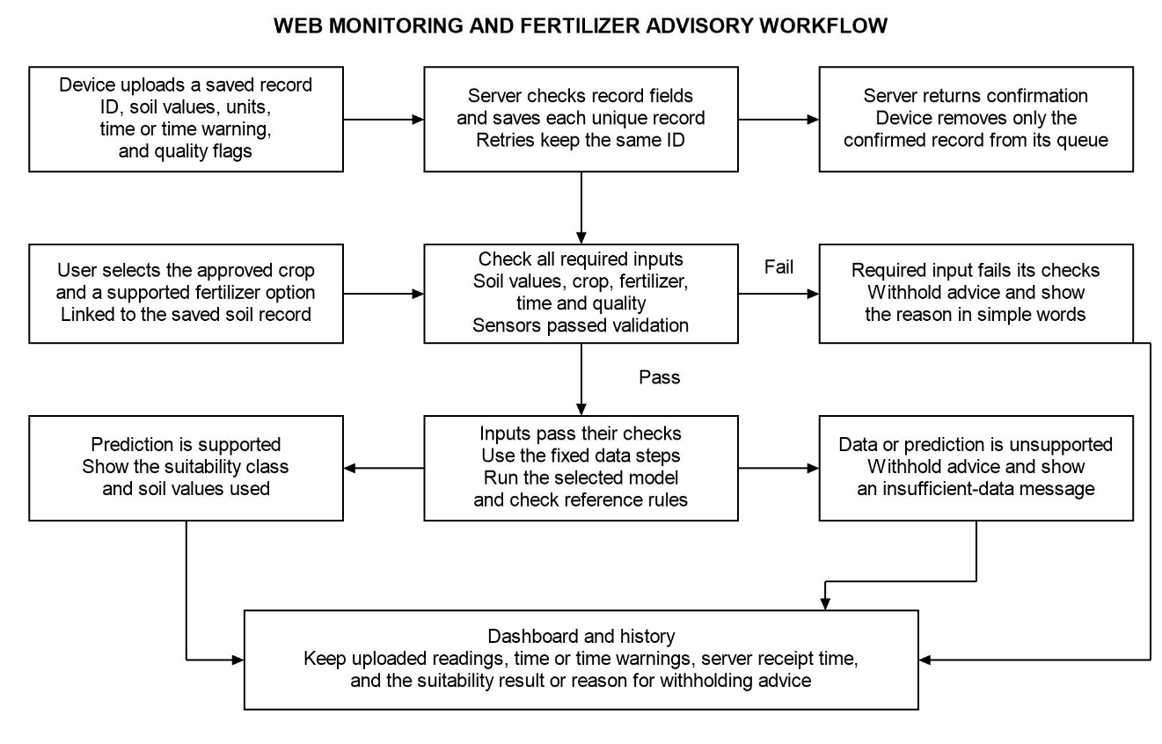
Figure 9. Web monitoring and fertilizer advisory workflow

Web Application Assessment Using ISO/IEC 25010:2023
The evaluators will include faculty members in Agricultural and Biosystems Engineering, information technology professionals, and potential end-users. Purposive sampling will be used to select evaluators based on the criteria relevant to their assigned roles. The number of evaluators, eligibility requirements, and final evaluation tools will be prepared before recruitment and submitted for adviser approval.
This study will use a researcher-prepared evaluation questionnaire and technical test checklist based on the ISO/IEC 25010:2023 product quality model. The assessment will cover functional suitability, performance efficiency, compatibility, interaction capability, reliability, security, maintainability, flexibility, and safety. Each characteristic will be evaluated using procedures appropriate for the prototype. Respondents will rate only the items they can observe and that are relevant to their assigned roles.
The mean rating for each characteristic and the overall mean will be calculated using the approved rating scale. The questionnaire will be reviewed for clarity and, if required by the research panel, undergo content validation before it is administered.

Technical Evaluation Procedure
The researcher will use the following procedure to assess the selected quality characteristics. This procedure is intended for the study and is not an ISO certification process. Before testing, the adviser will approve the selected characteristics, evaluator groups, task instructions, test data, operating conditions, and acceptance thresholds. The same application version and anonymized or sample test records will be used to give all evaluators similar testing conditions.
Each participant will receive an orientation and complete the tasks assigned to them. These tasks will include opening the dashboard, checking a current reading and its timestamp, retrieving a historical record, requesting a fertilizer compatibility advisory, and identifying an invalid reading or outdated connection. The researcher will record task completion, errors, assistance needed, time taken, and participant ratings. Participants may choose not to participate or withdraw at any time. Their identifying information will be kept separate from their responses. Table 2 presents the procedure and evidence used to assess each quality characteristic.
Table 2. Proposed web application evaluation matrix
Characteristic | Procedure and Evidence
Functional Suitability | Check the system requirements against the prepared test cases. Compare displayed sensor readings, stored records, and model results with the expected values. Record successful tests and any errors found.
Performance Efficiency | Measure page loading time, data refresh time, and fertilizer advisory response time through repeated tests. Record the device, browser, internet connection, data volume, and number of users during testing.
Compatibility | Test the main features using selected desktop and mobile browsers. Check whether data is properly transferred between the sensor device, web application, database, and trained model.
Interaction Capability | Observe how participants use the system. Record completed tasks, navigation errors, requests for assistance, and their understanding of measurement units and advisory limitations. Collect their ratings after testing.
Reliability | Test the system under different connection conditions by disconnecting and reconnecting Wi-Fi and interrupting server access. Check whether measurements are stored offline and successfully uploaded after reconnection. Also test upload retries, duplicate prevention, storage limits, and recovery after interruptions.
Security | Test input validation, protected pages, user sessions, and access permissions where implemented. Use a controlled testing environment and avoid using actual sensitive information.
Maintainability | Ask qualified technical reviewers to examine the code structure, configuration, documentation, and system logs. Check how easily small changes can be made to the application.
Flexibility | Test the application in supported environments and different screen sizes. Check its ability to handle the planned data volume and number of users. Record the required configurations and deployment procedures.
Safety | Test the system using missing, invalid, outdated, or unsupported sensor readings. Check whether the application displays appropriate warnings and prevents unreliable fertilizer recommendations.
Technical reviewers will assess characteristics related to the system's code and configuration, while end-users will evaluate only the features they can directly observe and use. Items that are not relevant to a respondent will be marked as not applicable and excluded from the calculation. Technical test results will also be presented separately from participant ratings.
Respondents will use the five-point scale in Table 3 to rate each statement.
Table 3. Five-point agreement scale for the web application evaluation
Rating | Interpretation
5 | Strongly Agree
4 | Agree
3 | Neither Agree nor Disagree
2 | Disagree
1 | Strongly Disagree
The questionnaire items will focus on observable system behavior and will be reviewed to ensure that they are clear and relevant to the study. The questionnaire will also undergo pilot testing before the final evaluation.
The mean score for each questionnaire item will be calculated using the following formula:
$$\overline{x}=\frac{\sum{\left(f×s\right)}}{N}$$Where:
- $f$= Frequency of each response
- $s$= Assigned rating score
- $N$= Total number of valid responses
The mean for each quality characteristic will be calculated using the valid responses from its corresponding questionnaire items. If an overall mean is calculated, the researchers will specify how the scores are weighted and which responses are excluded. The interpretation ranges for the ratings will also be approved before data collection.
The evaluation results will be used to assess the system's quality based on the selected characteristics. These results will not be presented as proof of ISO certification or compliance.

System Integration and Functional Testing
The researchers will connect the sensors, firmware, server, database, web application, and selected model. Test records with known values will be used to check sample IDs, units, saved readings, dashboard displays, history, and suitability results. Missing, invalid, outdated, and unsupported inputs will also be tested to confirm that the application withholds advice and shows the correct reason.
Offline tests will include Wi-Fi loss, an unavailable server, a restart after a record is saved, and interrupted uploads before and after server confirmation. A power interruption during a local write will also be tested. The researchers will compare local records with server records using unique IDs and values. Missing records, incomplete writes, and duplicate records will be reported separately. A reading interrupted before it is fully saved will not be counted as a safely stored record.
The researchers will measure usable queue capacity, record size, logging interval, and the time needed to upload saved records after reconnection. A full-queue test will check that new logging pauses and existing records remain safe. Tests will also check measurement time flags, unknown collection times, server receipt times, and saved status updates. A saved status report will retain its original time.
Power tests will record battery runtime under a stated sensing and upload workload, from the chosen starting charge to the defined low-battery cutoff. Voltage, current, solar conditions, and charging behavior will be recorded. Test conditions and cutoff limits will be approved before testing. Any fault found during development will be corrected before the calibration equations, model, and procedures are fixed for final independent testing.

Recommendation Validation
Recommendation validation will use the final independent samples set aside in the sampling plan. These samples will not be used for calibration, model training, or model selection. Before seeing the model results, qualified agriculture professionals will assign expected labels using the approved references and decision rules. The predictions will be compared with these labels using a confusion matrix, accuracy, precision, recall, and F1-score. Agreement with labels based on rules will be reported as agreement with those rules. The reviewers will also check selected results for agricultural use. These tests will not establish crop yield benefits or fertilizer application rates.

Simple Cost Analysis
The total cost of prototype development will be estimated by adding the direct costs of hardware, sensors, electronic components, enclosure materials, power components, fabrication, software or hosting expenses used for the prototype, and other directly related expenses. The proposed design will not include a separate display or microSD hardware. Local data storage will use the selected ESP32 board and its allocated onboard flash memory.
Each item will be recorded with its description, quantity, unit price, and supporting purchase record. The cost of each item will be calculated using Equation 5.
$$C_{i} = q_{i} × p_{i} (5)$$
In Equation 5, $C_{i}$represents the item cost in Philippine pesos, $q_{i}$represents the quantity purchased, and $p_{i }$represents the unit price. Each expense will be assigned to only one category to avoid double counting. The total direct development cost will be calculated using Equation 6.
$$C_{total} = Σ_{i = 1}^{n}{C_{i}} = C_{H} + C_{S} + C_{F} + C_{O} (6)$$
In this equation, n represents the total number of costed items. $C_{H}$represents hardware and electronic components, $C_{S }$represents software and services, $C_{F}$represents fabrication and enclosure materials not already included under hardware, and $C_{O }$represents other directly related expenses. The analysis will focus on the cost of developing the prototype. It will not be presented as a complete economic feasibility analysis because additional data on production, maintenance, labor, depreciation, and benefits would be needed.
The cost contribution of each subsystem will also be calculated. Items will be grouped into sensing, power, communication, processing, enclosure, and web infrastructure. Each item will belong to only one subsystem to avoid double counting. Equation 7 will be used to identify the largest contributors to the documented development cost.
$$P_{s} = 100 × \frac{C_{s}}{C_{total}} (7)$$
In Equation 7, $P_{s}$represents the percentage contribution of subsystem s, while $C_{s}$represents its total direct cost. The percentage will only be calculated when the total development cost is greater than zero. Borrowed reference instruments will be listed separately and will not be assigned a purchase cost since no purchase was made.
Borrowed or donated instruments and components will be listed separately from actual cash expenses. When available, their estimated replacement values will also be reported. This will help distinguish the researcher's actual out-of-pocket expenses from the resources needed to reproduce the prototype. Planned budget allocations will be kept separate from actual expenses.

Statistical Treatment of Data
Descriptive statistics will be used to summarize sensor measurements and repeatability results. The mean, standard deviation, minimum, maximum, and variance will be reported separately for each parameter and test condition. The coefficient of variation will only be included for suitable ratio-scale measurements with a nonzero mean.
The agreement between the developed device and reference measurements will be evaluated using absolute error, Mean Absolute Error (MAE), Root Mean Square Error (RMSE), bias, Pearson correlation, and the coefficient of determination, when applicable. Relative error and Mean Absolute Percentage Error (MAPE) will only be used for suitable ratio-scale measurements with nonzero reference values. They will not be used for pH or temperature readings in Celsius.
The trained fertilizer compatibility model will be evaluated using classification accuracy, precision, recall, and F1-score for each class, along with a confusion matrix. These measures will describe the model's performance on independent test samples with documented expected labels.
The web application assessment will be summarized using item means, characteristic means, valid response counts, and descriptive interpretations. Any overall mean will include a clear explanation of its weighting and excluded responses. Technical test results will be presented separately from respondent ratings.
A two-sided paired-sample t-test at a 0.05 significance level may also be used to examine the mean difference between device and reference measurements, subject to adviser approval and the statistical assumptions discussed below.
For each sensor parameter, let $d_{i }$represent the calibrated device reading for independent sample i, $y_{i}$represent its corresponding reference reading, and $n$represent the number of valid paired samples. Let $\overline{d}$and $\overline{y}$represent their respective means. Repeated readings will first be summarized for each independent sample. Each parameter will be evaluated separately using matching units and measurement methods.
$$e_{i} = d_{i} - y_{i}; {AE}_{i} = |d_{i} - y_{i}| (8)$$
$$MAE = \frac{Σ_{i = 1}^{n}{|d_{i} - y_{i}|}}{n} (9)$$
$$RMSE = \sqrt{\frac{Σ_{i = 1}^{n}{{(d_{i} - y_{i})}^{2}}}{n}} (10)$$
$$Bias = \frac{Σ_{i = 1}^{n}{(d_{i} - y_{i})}}{n} (11)$$
AE represents absolute error, while MAE represents the average of the absolute differences between device readings and reference measurements. Root Mean Square Error (RMSE) gives greater weight to larger errors. Lower MAE and RMSE values indicate smaller measurement errors, with zero being the ideal value. Positive bias indicates that the device tends to give higher readings than the reference, while negative bias indicates lower readings. Errors will be reported in the appropriate units, such as pH units, degrees Celsius, moisture percentage points based on the stated measurement method, or matching nutrient units (scikit-learn developers, n.d.).
$$R^{2} = 1 - \frac{Σ_{i = 1}^{n}{{(d_{i} - y_{i})}^{2}}}{Σ_{i = 1}^{n}{{(y_{i} - \overline{y})}^{2}}} (12)$$
For independent validation, R² represents the coefficient of determination, where the reference measurements are the observed values and the device readings are the predicted values. A value of 1 indicates a perfect prediction, while 0 means the predictions perform the same as using the mean of the reference values. Negative values indicate worse performance in terms of squared error. R² cannot be calculated when all reference values are identical and should not be interpreted as percentage accuracy. The R² from calibration fitting will be reported separately from the R² obtained during independent validation (scikit-learn developers, n.d.).
$$r = \frac{Σ_{i = 1}^{n}{(d_{i} - \overline{d})(y_{i} - \overline{y})}}{\sqrt{Σ_{i = 1}^{n}{{(d_{i} - \overline{d})}^{2}} Σ_{i = 1}^{n}{{(y_{i} - \overline{y})}^{2}}}} (13)$$
Pearson's correlation coefficient (r) measures the strength and direction of the linear relationship between paired readings. Its value ranges from −1 to +1 and cannot be calculated when one set of readings has a constant value. It will be used together with error and bias measurements because a high correlation does not always mean that the readings are accurate. For example, two sets of readings may have a strong correlation but still show a consistent difference. The square of Pearson's r will not automatically be used as a replacement for Equation 12 (SciPy developers, n.d.).
$${RE}_{i} = \frac{d_{i} - y_{i}}{y_{i}}; {APE}_{i} = 100 \frac{|d_{i} - y_{i}|}{|y_{i}|} (14)$$
$$MAPE (\%) = \frac{Σ_{i = 1}^{n}{{APE}_{i}}}{n} (15)$$
RE represents relative error, while APE represents absolute percentage error. Percentage error and Mean Absolute Percentage Error (MAPE) will only be used for suitable ratio-scale measurements with nonzero reference values. The handling of values close to zero and measurements below detection limits will also be documented. MAPE will not be used for pH or temperature readings in Celsius. The value obtained by subtracting MAPE from 100 will not be presented as a general measure of sensor accuracy.
$$Percentage within tolerance = 100 \frac{N_{tol}}{n} (16)$$
If a percentage summary of sensor performance is needed, Nₜₒₗ will represent the number of valid paired readings that meet the condition |dᵢ − yᵢ| ≤ Tᵢ. Here, Tᵢ is the allowable error set in advance for each parameter and measurement range. The selected tolerance, its source or practical justification, and the number of readings that meet it will be reported. This is a researcher-defined measure and not a verified PAES requirement. Measurement accuracy will mainly be described using the reported errors, bias, and repeatability results (Joint Committee for Guides in Metrology, 2012).
$$Classification accuracy (\%) = 100 \frac{C}{N} (17)$$
For model evaluation, N represents the total number of independent test cases, while C represents the number of correctly classified cases. A prediction is considered correct when it matches the documented expected fertilizer compatibility class. Classification accuracy is different from sensor measurement accuracy and does not, by itself, prove that the model is effective for agricultural use.
$${Precision}_{k} = \frac{{TP}_{k}}{{TP}_{k} + {FP}_{k}}; {Recall}_{k} = \frac{{TP}_{k}}{{TP}_{k} + {FN}_{k}} (18)$$
$${F1}_{k} = \frac{2 {TP}_{k}}{2 {TP}_{k} + {FP}_{k} + {FN}_{k}} (19)$$
For each class k, compared with all other classes, TPₖ represents the number of correct predictions for class k. FPₖ represents the number of cases from other classes that were incorrectly predicted as class k. FNₖ represents the number of cases belonging to class k that were predicted as another class.
Precision, recall, and F1-score will be reported for each class, together with the number of samples in each class. If a calculation has a zero denominator, the result will be marked as undefined, and the method used to handle it will be stated. The confusion matrix will present the expected classes in rows and the predicted classes in columns. RMSE and R² will not be used for numerical codes assigned to classification labels because these codes do not represent actual numerical measurements (scikit-learn developers, n.d.)
$$t = \frac{\overline{e}}{\frac{s_{e}}{\sqrt{n}}}; df = n - 1 (20)$$
For the optional two-sided paired-sample t-test, $\overline{e}$represents the mean difference between paired measurements, while $s_{e}$represents the sample standard deviation of those differences. The test will require independent pairs and an appropriate distribution of paired differences. The proposed significance level is 0.05. A result that is not statistically significant will not be considered proof that the measurements are equivalent or that individual errors are acceptable (National Institute of Standards and Technology, n.d.-a).
Calibration equations will be developed using calibration data only. Final accuracy results will be based on independent soil samples. Repeated readings from the same sample will not be counted as separate independent samples. Training and testing datasets will be separated by soil sample or collection group to prevent data leakage. Correlation and R² will be reported together with error and bias measurements because a high correlation alone does not prove that the device measurements agree with the reference results. A paired t-test result that is not statistically significant will also not be interpreted as proof of measurement equivalence.

Ethical and Safety Considerations
The prototype will follow the electrical, equipment, and soil-handling procedures of the laboratory and field sites. All electrical connections will be properly insulated and protected. The battery, solar panel, and charging components will be selected and operated according to their specifications. The study will clearly state the limitations of the measurements and will not present unvalidated fertilizer recommendations as guaranteed agricultural advice.

LITERATURE CITED
Analog Devices. (n.d.-a). DS18B20: Programmable resolution 1-Wire digital thermometer. https://www.analog.com/en/products/ds18b20.html
Analog Devices. (n.d.-b). MAX3485: 3.3 V powered RS-485/RS-422 transceiver. https://www.analog.com/en/products/max3485.html
Chamara, N., Islam, M. D., Bai, G., Shi, Y., & Ge, Y. (2022). Ag-IoT for crop and environment monitoring: Past, present, and future. Agricultural Systems, 203, Article 103497. https://doi.org/10.1016/j.agsy.2022.103497
DFRobot. (n.d.-a). Gravity capacitive soil moisture sensor SEN0193. https://wiki.dfrobot.com/sen0193/
DFRobot. (n.d.-b). Gravity laboratory grade analog pH sensor kit SEN0161-V2. https://wiki.dfrobot.com/sen0161-v2/
Espressif Systems. (n.d.-a). Non-volatile storage library. ESP-IDF Programming Guide. https://docs.espressif.com/projects/esp-idf/en/stable/esp32/api-reference/storage/nvs_flash.html
Espressif Systems. (n.d.-b). Station scenarios. ESP-IDF Programming Guide. https://docs.espressif.com/projects/esp-idf/en/stable/esp32/api-guides/wifi-driver/station-scenarios.html
Estrada, O., Ramos, G., Lizarazo, M., & Jimenez, D. (2025). Digital transformation accelerator. Technical report of the probe: Low-cost portable soil fertility sensors: Myth or reality? Alliance of Bioversity International and CIAT. https://alliancebioversityciat.org/publications-data/digital-transformation-accelerator-technical-report-probe-low-cost-portable-soil
Food and Agriculture Organization. (n.d.). Asia-Pacific knowledge hub on sustainable soil and land management: Soil test kit. https://www.fao.org/asiapacific/work-in-the-region/regional-priorities/faorap-regional-priority-two/soil-management/capacity-building-and-knowledge-exchange/asia-pacific-knowledge-hub-on-sustainable-soil-and-land-management/en
Gómez-Astorga, M. J., Villagra-Mendoza, K., Masís-Meléndez, F., Ruíz-Barquero, A., & Rimolo-Donadio, R. (2024). Calibration of low-cost moisture sensors in a biochar-amended sandy loam soil with different salinity levels. Sensors, 24(18), Article 5958. https://doi.org/10.3390/s24185958
International Organization for Standardization. (2023). Systems and software engineering: Systems and software Quality Requirements and Evaluation (SQuaRE): Product quality model (ISO/IEC Standard No. 25010:2023). https://www.iso.org/standard/78176.html
Joint Committee for Guides in Metrology. (2012). International vocabulary of metrology: Basic and general concepts and associated terms (VIM) (3rd ed., JCGM 200:2012). Bureau International des Poids et Mesures. https://www.bipm.org/documents/20126/2071204/JCGM_200_2012.pdf
National Institute of Standards and Technology. (n.d.-a). Analysis of paired observations. NIST/SEMATECH e-Handbook of Statistical Methods. https://www.itl.nist.gov/div898/handbook/prc/section3/prc311.htm
National Institute of Standards and Technology. (n.d.-b). Coefficient of variation. Dataplot Reference Manual. https://www.itl.nist.gov/div898/software/dataplot/refman2/auxillar/coefvari.htm
Pandey, C., Sethy, P. K., Behera, S. K., Vishwakarma, J., & Tande, V. (2022). Smart agriculture: Technological advancements on agriculture: A systematical review. In R. C. Poonia, V. Singh, & S. R. Nayak (Eds.), Deep learning for sustainable agriculture (pp. 1–56). Academic Press. https://doi.org/10.1016/B978-0-323-85214-2.00002-1
Rajak, P., Ganguly, A., Adhikary, S., & Bhattacharya, S. (2023). Internet of Things and smart sensors in agriculture: Scopes and challenges. Journal of Agriculture and Food Research, 14, Article 100776. https://doi.org/10.1016/j.jafr.2023.100776
scikit-learn developers. (n.d.). Metrics and scoring: Quantifying the quality of predictions. Scikit-learn documentation. https://scikit-learn.org/stable/modules/model_evaluation.html
SciPy developers. (n.d.). scipy.stats.pearsonr. SciPy documentation. https://docs.scipy.org/doc/scipy/reference/generated/scipy.stats.pearsonr.html
Sreeram, R., Adithya Krishna, S., Kumar, A. S., Remya, S., & Cho, Y. Y. (2026). Soil moisture monitoring technologies in smart agriculture: A comprehensive review. Farming System, 4(2), Article 100189. https://doi.org/10.1016/j.farsys.2025.100189
van Reeuwijk, L. P. (1998). Guidelines for quality management in soil and plant laboratories (FAO Soils Bulletin No. 74). Food and Agriculture Organization of the United Nations. https://www.fao.org/4/w7295e/w7295e00.htm

APPENDIX FIGURES
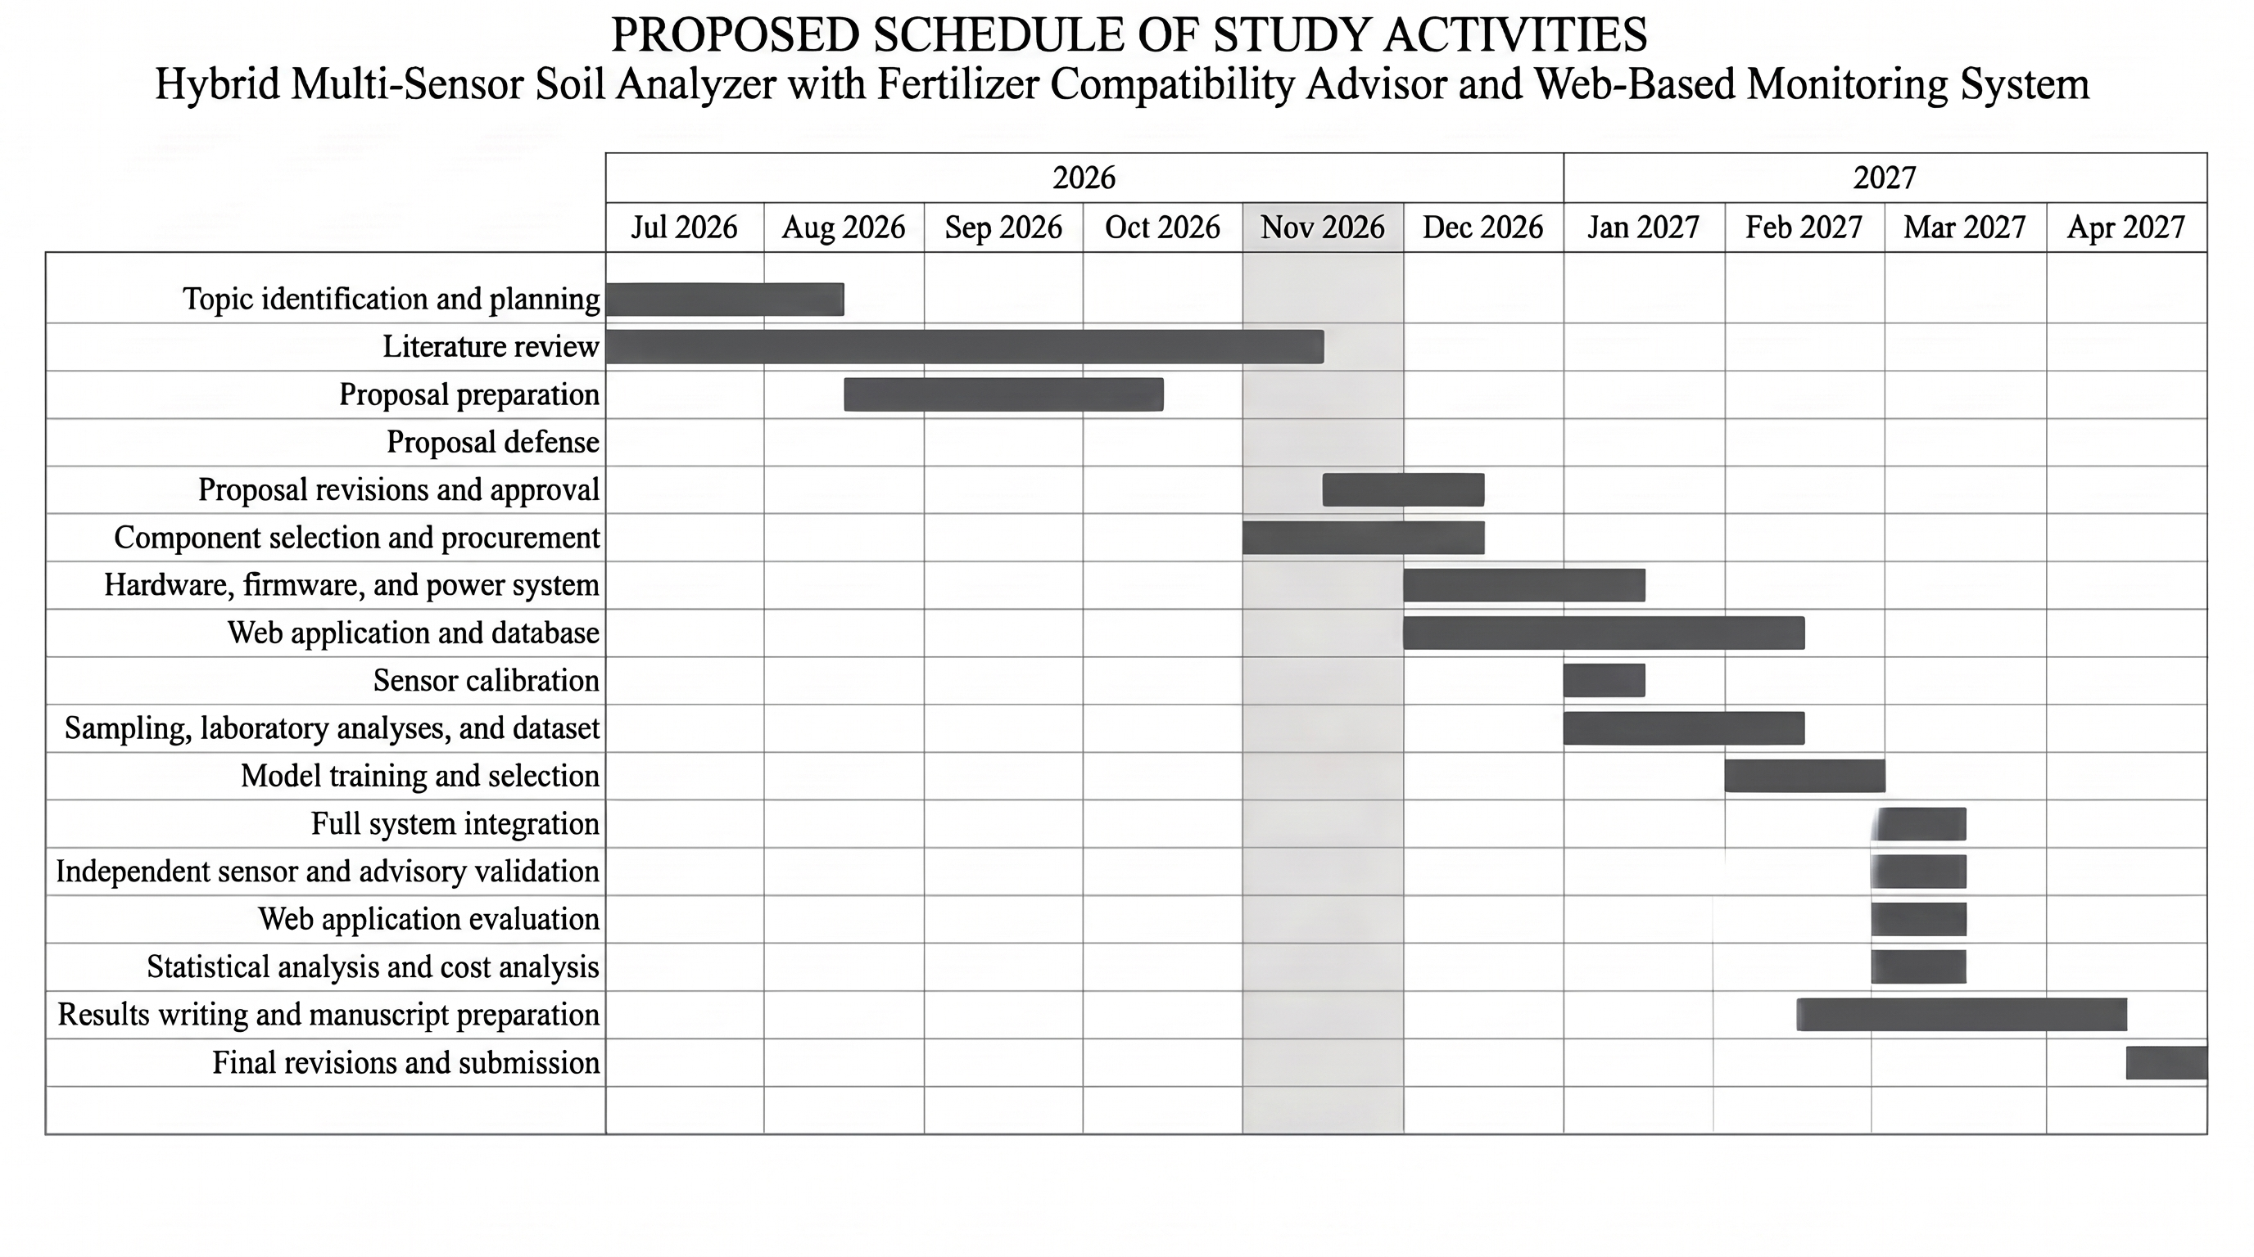
Appendix Figure A1. Proposed schedule of study from July 2026 to April 2027

