HYBRID MULTI-SENSOR SOIL ANALYZER
WITH FERTILIZER COMPATIBILITY ADVISOR
AND WEB-BASED MONITORING SYSTEM
ESRAEL N. TUYADANG
THESIS
An undergraduate thesis submitted to the faculty of the Department of Agricultural and Biosystems Engineering, College of Engineering, Nueva Vizcaya State University, Bayombong, Nueva Vizcaya, in partial fulfillment of the requirements for the degree
BACHELOR OF SCIENCE IN AGRICULTURAL AND BIOSYSTEMS
ENGINEERING
November 2026
NVSU RDD FORM NO. 3

ACCEPTANCE SHEET
This thesis attached hereto, entitled “HYBRID MULTI-SENSOR SOIL ANALYZER WITH FERTILIZER COMPATIBILITY ADVISOR AND WEB-BASED MONITORING SYSTEM”, prepared and submitted by ESRAEL N. TUYADANG in partial fulfillment of the requirements for the degree of BACHELOR OF SCIENCE IN AGRICULTURAL AND BIOSYSTEMS ENGINEERING is hereby accepted.
_________________________ ___________________________
Member, Advisory Committee Member, Advisory Committee
________________ ________________
Date Date
___________________________
Chair, Advisory Committee
________________
Date
Accepted as partial fulfillment of the requirements for the degree of BACHELOR OF SCIENCE IN AGRICULTURAL AND BIOSYSTEMS ENGINEERING
____________________________
Department Chair
___________________
Date
____________________________
Dean, College of Engineering
____________________
Date
RDD Index Contribution No.: __________ ________________________
Date: ______________________ Research MIS Coordinator
TABLE OF CONTENTS
PAGE
TITLE PAGE i
ACCEPTANCE SHEET ii
TABLE OF CONTENTS iii
LIST OF FIGURES v
LIST OF TABLES vi
INTRODUCTION 1
Background of the Study 1
Statement of the Problem 3
Objectives of the Study 5
Significance of the Study 6
Scope and Delimitation 7
Time and Place of the Study 8
Definition of Terms 9
REVIEW OF RELATED LITERATURE AND STUDIES 11
Soil Testing and Soil Fertility Assessment 11
Soil pH Monitoring 12
Soil Moisture Monitoring 12
Soil Temperature Monitoring 13
NPK Monitoring 14
Multi-Parameter Soil Sensing 14
Internet of Things in Smart Agriculture 14
Wireless and Web-Based Monitoring 15
Fertilizer Recommendation and Compatibility 15
Trained Models and Machine Learning in Agricultural Decision Support 16
Solar and Rechargeable Power for Field Devices 17
Web Application Quality Evaluation Using ISO/IEC 25010:2023 18
METHODOLOGY 19
Conceptual Framework 19
Components of the Device 21
System Architecture 29
Principle of Operation 30
Soil Sampling and Sample Allocation 32
Instrumentation 32
Hardware Development 33
Firmware and Data Acquisition 36
Calibration Procedure 37
Calibration and Validation Metrics 38
Repeatability Testing 39
Dataset Preparation and Trained Model Development 41
Fertilizer Compatibility Advisory 41
Web-Based Application Development 42
Web Application Assessment Using ISO/IEC 25010:2023 44
Technical Evaluation Procedure 45
System Integration and Functional Testing 47
Recommendation Validation 48
Simple Cost Analysis 49
Statistical Treatment of Data 50
Ethical and Safety Considerations 54
LITERATURE CITED 55
APPENDIX FIGURES 57
LIST OF FIGURES
PAGE
Figure 1. Philippine Soil Test Kit described by the Food and Agriculture Organization 11
Figure 2. Low-cost soil-moisture sensor setup reported by Gómez-Astorga et al. (2024) 13
Figure 3. Input–Process–Output framework of the proposed study 20
Figure 4. Proposed hardware components of the multi-sensor soil analyzer 21
Figure 4a. Solar panel 22
Figure 4b. Solderless breadboard 22
Figure 4c. ESP32 development board 22
Figure 4d. pH interface board 23
Figure 4e. MAX3485 RS485 interface 23
Figure 4f. Charging module 24
Figure 4g. 5 V boost converter 24
Figure 4h. 12 V boost converter 24
Figure 4i. Rechargeable 18650 cells 25
Figure 4j. Battery holder 25
Figure 4k. Power switch 25
Figure 4l. Capacitive soil moisture sensor 26
Figure 4m. DS18B20 temperature probe 26
Figure 4n. RS485 NPK probe 26
Figure 4o. Liquid pH electrode 27
Figure 4p. Soil-water sample cup 27
Figure 4q. Jumper wires and resistors 27
Figure 4r. Push button 28
Figure 5. Proposed system architecture of the multi-sensor soil analyzer 30
Figure 6. Proposed hardware and data-acquisition flow 34
Figure 7. Proposed enclosure arrangement of the multi-sensor soil analyzer 35
Figure 8. Proposed exposed arrangement of the multi-sensor soil analyzer 36
Figure 9. Proposed web monitoring and fertilizer advisory workflow 44
Appendix Figure A1. Proposed schedule of study from July 2026 to April 2027 57
LIST OF TABLES
PAGE
Table 1. Proposed laboratory instruments and measurement records 33
Table 2. Proposed web application evaluation matrix 46

INTRODUCTION

Background of the Study
Effective soil management is important in crop production because soil conditions directly affect nutrient availability, water management, root development, and the ability of crops to obtain the nutrients they need. Farmers and agricultural practitioners therefore need timely information about soil properties before deciding whether fertilizer or other soil-management practices are necessary.
Traditional soil testing can provide useful information, but laboratory-based testing may require sample collection, transportation, preparation, waiting time, and access to laboratory facilities. In field situations, these requirements may make frequent testing less convenient. The Philippine Soil Test Kit is one example of a rapid field-oriented approach, but the Food and Agriculture Organization notes that the kit provides qualitative results for pH, organic matter, nitrogen, phosphorus, and potassium and is intended mainly for fertility monitoring and fertilizer recommendation rather than scientific research requiring actual nutrient quantities (Food and Agriculture Organization, n.d.).
Recent developments in smart agriculture have made sensors, microcontrollers, wireless communication, cloud platforms, and data analytics more accessible for agricultural applications. Reviews of agricultural Internet of Things (IoT) systems describe the use of sensors for soil moisture, temperature, pH, nutrients, and other field variables, with data transmitted to software systems for monitoring and decision support (Chamara et al., 2022; Rajak et al., 2023). Such systems can reduce the need for repeated manual observation and can make field information available through a digital interface.
Soil pH is an important soil property because it affects nutrient availability and the effectiveness of fertilizer management. Soil moisture and temperature are also useful measurements because they describe important physical and environmental conditions in the root zone. Nutrient information, particularly nitrogen (N), phosphorus (P), and potassium (K), can further support decisions concerning fertilizer application. A multi-sensor system that gathers these variables in one measurement session can therefore provide a more complete picture than a single-parameter sensor.
However, collecting measurements alone does not automatically provide a practical recommendation. Farmers or users still need to interpret the measured values and determine whether a fertilizer is compatible with the current soil condition. This creates an opportunity to combine sensing with a fertilizer compatibility advisor. The proposed system is designed to use a trained model together with defined agricultural decision rules and stored reference information to transform sensor measurements into an understandable advisory output.
The project further incorporates a web-based monitoring system. A web interface can allow users to view current and historical measurements, monitor sensor readings, inspect advisory results, and store records for later comparison. IoT research shows that combining sensing, communication, software, and data processing is a common architecture for smart agriculture (Chamara et al., 2022; Rajak et al., 2023). To accommodate interrupted connectivity, the proposed device will retain unsent readings locally and upload them when access to the server is restored.
Power availability is another consideration for field use. The proposed analyzer will therefore use both rechargeable energy storage and solar charging. This arrangement is intended to support portable operation and reduce dependence on a continuous external electrical supply. The solar component is not intended to make the system completely independent of all external charging under every condition; rather, it provides an additional renewable charging source for field operation.
With these considerations, this study proposes the development of a Hybrid Multi-Sensor Soil Analyzer with Fertilizer Compatibility Advisor and Web-Based Monitoring System. The study focuses on device development, calibration and independent validation of pH, temperature, moisture, and NPK-related measurements, integration of a trained model into a web application, assessment using the ISO/IEC 25010:2023 product quality model, and a simple cost analysis.

Statement of the Problem
Farmers still decide how much fertilizer to use with methods that are either not very exact or hard to get. The Philippine Soil Test Kit, for example, is a quick tool used in the field to check pH, organic matter, nitrogen, phosphorus, and potassium. But its results only tell if a nutrient is low, medium, or high. They do not give the real amount of each nutrient (Food and Agriculture Organization, n.d.). Laboratory tests can give real amounts, but samples must be collected, brought to the lab, and tested, and the farmer has to wait for the results. This makes frequent testing hard for farmers.
Electronic soil sensors were developed to address this problem, but the low-cost sensors available today also have limitations. Estrada et al. (2025) tested commercial low-cost portable NPK sensors in Guatemala and Colombia and compared their readings with laboratory analyses. The sensors showed low accuracy and their readings depended strongly on soil moisture, so the authors did not recommend them for fertilizer management. Calibration is also a concern. Gómez-Astorga et al. (2024) reported that the calibration curves of low-cost capacitive moisture sensors deviated by up to 30% from those of the control soil when biochar and salinity were present, and concluded that specific and continuous calibration is required. Other studies likewise report that calibration, internet connection, power supply, and cost remain problems when sensors are used in the field (Chamara et al., 2022; Rajak et al., 2023; Sreeram et al., 2026).
Another problem is that many devices only show sensor readings. The farmer still has to understand the pH, moisture, temperature, and NPK values and decide if a fertilizer fits the soil, which is hard for those without training in agriculture. Field devices also need power, and a portable device that cannot be recharged in the field is hard to use. In the literature reviewed for this study, calibrated sensing, fertilizer advice, web-based record keeping, and solar charging are generally reported separately rather than combined in one low-cost prototype.
Because of these gaps, there is a need for a portable soil analyzer that measures pH, temperature, moisture, and NPK, and whose readings are calibrated and checked against standard methods and calibrated instruments. The readings should also be connected to a trained model that gives fertilizer advice, shown through a web-based monitoring system that is evaluated using ISO/IEC 25010:2023. The cost of making the device should also be known to see if it is affordable. This study therefore aims to develop a Hybrid Multi-Sensor Soil Analyzer with Fertilizer Compatibility Advisor and Web-Based Monitoring System, to check how accurate and consistent its readings are, to build and evaluate the web application, and to estimate the cost of development.
Existing research shows that soil sensors and IoT systems can measure multiple agricultural variables and transmit information for monitoring and decision support, while reviews continue to identify challenges in sensor calibration, rural connectivity, energy requirements, cost, and field deployment (Chamara et al., 2022; Rajak et al., 2023; Sreeram et al., 2026). The research gap addressed by the present study is the integration of several functions in one undergraduate agricultural engineering prototype: multi-parameter soil sensing, calibration against reference measurements, a fertilizer compatibility advisor using a trained model, solar and rechargeable power, and web-based monitoring. The project further explicitly evaluates the web application and documents the direct development cost. The intended contribution is therefore an integrated prototype rather than a claim that any one sensor or software component is entirely new.

Objectives of the Study
The general objective of the study is to develop a Hybrid Multi-Sensor Soil Analyzer with Fertilizer Compatibility Advisor and Web-Based Monitoring System.
Specifically, the study aims to:
1. Develop a multi-sensor soil analyzer with offline data recording, Wi-Fi synchronization, a fertilizer compatibility advisor, and a web-based monitoring system.
2. Calibrate the device based on standard method and calibrated instrument in determining pH, temperature, moisture, and NPK.
3. Develop a web-based application that integrates the trained model and assess it according to ISO/IEC 25010:2023.
4. Perform simple cost analysis.

Significance of the Study
Farmers and Agricultural Practitioners. The system may provide field-level soil information and a more understandable fertilizer compatibility advisory. The web monitoring feature may also help users review previous measurements instead of relying only on a single field observation.
Agricultural and Biosystems Engineering Students. The project can demonstrate the application of sensors, instrumentation, embedded systems, renewable-energy support, IoT, data processing, and agricultural decision support in one prototype.
Researchers. The study may serve as a basis for improving low-cost soil sensing, model-based fertilizer advisory systems, web-based monitoring, and field validation procedures.
Agricultural Extension Personnel. A portable monitoring system may support demonstrations and field activities where rapid soil measurements are useful, subject to the accuracy limitations established through calibration.
Future Developers. The modular design can be improved by adding more crops, fertilizer products, communication methods, additional soil properties, improved models, or larger datasets.
Contribution to the Sustainable Development Goals (SDGs). The study supports SDG 2 (Zero Hunger) by developing a tool that may help users make more informed soil and fertilizer-management decisions. Its solar-charging feature relates to SDG 7 (Affordable and Clean Energy), while the integration of sensors and a web-based advisory system supports SDG 9 (Industry, Innovation and Infrastructure). These contributions are potential applications of the prototype and will depend on its validated performance and appropriate use.

Scope and Delimitation
The study covers the design and development of a portable multi-sensor soil analyzer capable of measuring pH, soil temperature, soil moisture, and NPK-related readings using selected electronic sensors.
The system includes a microcontroller-based acquisition unit, limited onboard non-volatile storage, rechargeable battery, solar charging component, enclosure, sensor interface boards, Wi-Fi communication, a server/database platform, and a web-based monitoring interface.
The device will support offline recording of sensor readings in an allocated area of the ESP32 board's onboard non-volatile flash memory. Saved readings will be queued and uploaded automatically after connection to a configured Wi-Fi network and restoration of access to the selected server. Cloud upload will require internet access; a local server may be reached over the same local Wi-Fi network. Offline operation is limited to sensing and local recording; fertilizer advisories will be generated by the server. Storage capacity and the maximum retained record count will be established and tested during development. If storage becomes full, new local logging will pause while pending records are retained until synchronization.
The prototype will not include a dedicated OLED or LCD screen. A browser-based dashboard on a computer or mobile device will serve as the user display. During device disconnection, users may view previously uploaded records when the server is accessible; newly recorded readings will appear only after successful synchronization. The dashboard will identify the time of the latest received reading so that delayed data are not presented as live measurements.
The fertilizer compatibility advisor is limited to the crops, soil-condition ranges, fertilizer references, and training data defined by the researchers. The advisory output is a decision-support recommendation and does not replace laboratory soil analysis or professional agronomic advice.
The device will be calibrated using selected standard procedures and/or calibrated reference instruments. Calibration and validation will be conducted using soil samples and conditions accessible to the researchers.
The trained model will be developed from the dataset collected or assembled for the study. Model performance will depend on the quality, quantity, representativeness, and labeling of the dataset.
The web application will be assessed using the ISO/IEC 25010:2023 product quality model. The evaluation will cover the characteristics applicable to the prototype through technical tests and evaluator ratings, with the scope and limitations of each assessment reported explicitly (International Organization for Standardization, 2023).
The cost analysis will cover the direct development costs of major hardware, electronic components, fabrication materials, software or service expenses incurred for the prototype, and other directly related development costs. It is not a full commercial feasibility or profitability study.

Time and Place of the Study
The study will be conducted from July 2026 to April 2027. Prototype development, calibration, and laboratory testing will be conducted at Nueva Vizcaya State University, Bayombong, Nueva Vizcaya, subject to laboratory access and permission. Soil sampling and field testing will be conducted at accessible agricultural sites selected through the sampling plan and approved before collection. The proposed schedule of activities is presented in Appendix Figure A1.

Definition of Terms
Calibration -The process of comparing sensor outputs with known or reference values and adjusting the system so that its readings better represent the reference measurements.
Compatibility Advisor - The decision-support component that interprets measured soil conditions and provides a fertilizer compatibility or suitability advisory based on the study's trained model and reference rules.
Hybrid - A combination of several sensor types (pH, temperature, moisture, and NPK) and two power sources (rechargeable battery and solar charging) in one device.
Internet of Things (IoT) - A system in which physical devices equipped with sensors, processing, and communication capabilities exchange data through a network.
Multi-Sensor Soil Analyzer - The proposed device that combines several sensors to measure soil pH, temperature, moisture, and NPK-related variables.
NPK - The three primary plant nutrients nitrogen (N), phosphorus (P), and potassium (K).
Offline Recording - Saving sensor readings in the device without a connection to the server, subject to the allocated local storage capacity.
Synchronization - Uploading locally stored readings to the server after connectivity is restored and confirming that the records have been saved without duplication.
Trained Model - A computational model developed from training data so that it can classify or predict an advisory output from selected soil measurements.
Web-Based Monitoring System - The online software component used to receive, store, display, and review measurements and advisory outputs.
ISO/IEC 25010:2023 - The international product quality model used as the reference framework for evaluating the web application. Its nine characteristics provide the basis for selecting applicable technical tests and evaluation items.

REVIEW OF RELATED LITERATURE AND STUDIES

Soil Testing and Soil Fertility Assessment
Soil testing is used to obtain information about soil properties that can guide crop and soil-management decisions. Soil pH and nutrient status are particularly important because they affect nutrient availability and fertilizer decisions. In the Philippines, rapid field soil testing has been used to provide qualitative information that can support fertilizer recommendations. The FAO Asia-Pacific knowledge hub describes the Philippine Soil Test Kit as a rapid field tool for pH, organic matter, N, P, and K, while also noting that its results are qualitative and are not intended for scientific research requiring actual nutrient amounts (Food and Agriculture Organization, n.d.).
The proposed analyzer follows the same general need for rapid field information but attempts to combine multiple measurements in one device and connect those measurements to a digital monitoring and advisory system. The difference is therefore not simply the presence of a soil sensor; it is the integration of sensing, calibration, model-based interpretation, web monitoring, and portable power. Figure 1 presents the Philippine Soil Test Kit described by the Food and Agriculture Organization.
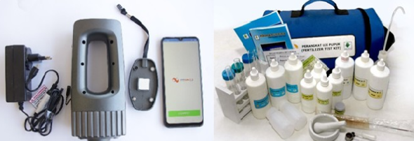
Figure 1. Philippine Soil Test Kit described by the Food and Agriculture Organization

Soil pH Monitoring
Soil pH describes the acidity or alkalinity of soil and is commonly considered when evaluating nutrient availability and fertilizer management. Because pH can influence the chemical form and availability of nutrients, measuring it alongside other soil variables can provide useful context for interpretation. In the proposed system, pH is one of the core measurements used by the analyzer and may also serve as an input to the compatibility advisor.

Soil Moisture Monitoring
Soil moisture is an important variable for crop production because water availability affects plant growth, nutrient movement, and irrigation decisions. Recent reviews describe the increasing use of sensor technologies, IoT, and machine learning for soil-moisture monitoring and prediction, while also identifying calibration, connectivity, energy, and cost as practical challenges in field deployment (Sreeram et al., 2026). The developed system includes soil moisture sensing so that the web application can present moisture information together with the other measured variables. Gómez-Astorga et al. (2024) calibrated low-cost capacitive moisture sensors in a biochar-amended sandy loam soil at different salinity levels, as shown in Figure 2, and found calibration curves deviating by up to 30% from the control soil, which indicates why soil-specific calibration is needed.
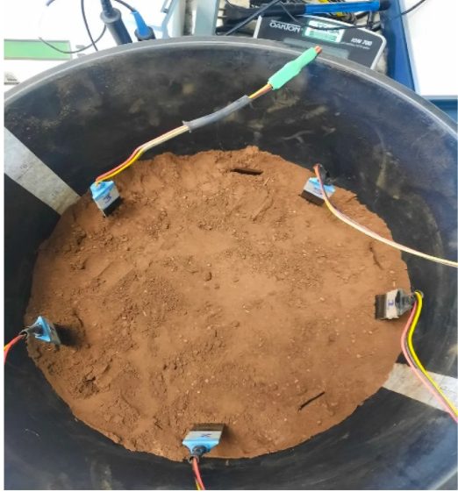
Figure 2. Low-cost soil-moisture sensor setup reported by Gómez-Astorga et al. (2024)

Soil Temperature Monitoring
Soil temperature affects biological and physical processes in the soil and can change the environment experienced by plant roots and soil organisms. Including temperature in a multi-sensor analyzer provides additional context for interpreting soil measurements. The sensor will be calibrated against a suitable reference thermometer or calibrated instrument before validation.

NPK Monitoring
Nitrogen, phosphorus, and potassium are among the major nutrients required for crop production. IoT and sensor reviews identify soil nutrients such as nitrogen and other soil properties as important targets for agricultural sensing systems (Rajak et al., 2023). However, electronic NPK sensors can have limitations associated with sensor type, soil condition, calibration, interference, and the relationship between sensor response and actual nutrient concentration. Estrada et al. (2025) compared commercial low-cost NPK sensors with laboratory analyses and reported low accuracy and strong sensitivity to soil moisture. For this reason, the present study includes calibration and comparison against a reference method rather than treating raw sensor output as automatically accurate.

Multi-Parameter Soil Sensing
A multi-parameter approach can provide more information than measuring a single soil variable. Agricultural IoT reviews describe systems that combine sensors, processing units, communication technologies, and software for monitoring environmental and soil conditions (Chamara et al., 2022; Rajak et al., 2023). Combining pH, moisture, temperature, and NPK-related measurements can allow the proposed advisory component to consider several soil conditions at the same time.

Internet of Things in Smart Agriculture
IoT-based agriculture generally connects physical sensing devices with communication networks, data processing, and user-facing applications. Chamara et al. (2022) reviewed Ag-IoT systems according to sensors, main boards, communication protocols, power supplies, crops, and applications. Rajak et al. (2023) likewise discussed IoT and smart sensors for monitoring moisture, temperature, soil composition, and nitrogen content, together with limitations such as implementation cost, data security, and limited digital knowledge among farmers. These studies support the architecture of the proposed project, in which sensor measurements are collected by a microcontroller and transferred to a web-based monitoring environment.

Wireless and Web-Based Monitoring
Web-based monitoring can convert sensor measurements into records that users can view through a browser. Such a system may include data acquisition, wireless transmission, server-side processing, database storage, and a dashboard. The main benefit for the proposed project is that the user can inspect current measurements and historical records through the browser-based dashboard.
Offline recording requires a storage mechanism and application logic in addition to wireless transmission. Espressif Systems (n.d.-a) documents non-volatile flash storage that can retain written values across restarts, while its Wi-Fi guidance describes application handling of connection and reconnection events (Espressif Systems, n.d.-b). The proposed prototype will use these capabilities for a limited queue of unsent measurements. The available capacity, retention after restart, and recovery during interrupted writes and uploads will be verified during development.

Fertilizer Recommendation and Compatibility
Fertilizer recommendation is not simply a matter of selecting a fertilizer product. It depends on crop requirements, existing soil nutrient conditions, soil pH, and other agronomic factors. The Philippine Soil Test Kit example illustrates how field soil-test results can be interpreted to recommend the kind and amount of fertilizer for a particular crop, while its qualitative nature also shows why interpretation should be connected to the limitations of the measurement method (Food and Agriculture Organization, n.d.).
In the proposed study, compatibility is treated as a decision-support problem. The advisor will use selected soil variables and the training dataset to produce a compatibility classification or advisory output. Reference rules and database constraints may be retained as safety and consistency checks. The model will not be presented as a substitute for laboratory analysis.

Trained Models and Machine Learning in Agricultural Decision Support
Machine learning has increasingly been used in smart agriculture for prediction, classification, monitoring, and decision support. Reviews of smart agriculture describe the use of machine learning, data mining, deep learning, IoT, and sensing technologies across agricultural operations (Pandey et al., 2022). A trained model can be useful when multiple input variables need to be considered together and the available training data represent the target decision.
For the proposed project, the model-development process begins with data collection and cleaning. The dataset will contain selected sensor variables and the corresponding compatibility label or target output. Data will be divided into training and testing portions, and the selected model will be trained only on the training portion. The test portion will then be used to evaluate generalization. This separation is important because testing a model using the same observations used for training can give an overly optimistic estimate of performance.
The model will be integrated into the web application after calibration and model validation. This order is important because the model should receive measurements expressed in the same units and ranges used during training. If sensor calibration changes the scale of the raw readings, the model input-processing procedure must also be updated accordingly.

Solar and Rechargeable Power for Field Devices
Portable agricultural electronics require a power source that can support sensing, processing, communication, and data storage. A rechargeable battery can provide stored energy while a solar panel can replenish the battery during suitable conditions. The proposed system will combine these two approaches to support field operation. Power consumption should be considered during component selection because wireless transmission and sensor operation can contribute substantially to energy demand.
Taken together, the reviewed studies support integrating sensing, communication, and decision support, while identifying measurement validity as a central limitation. Chamara et al. (2022) and Rajak et al. (2023) describe the architecture and deployment challenges of agricultural IoT systems. Gómez-Astorga et al. (2024) demonstrate the importance of soil-specific moisture calibration, while Estrada et al. (2025) question the accuracy of low-cost NPK readings. The present study will therefore evaluate both the integrated prototype and the validity of its measurements, with fertilizer advisories restricted to the conditions supported by calibration and validation.

Web Application Quality Evaluation Using ISO/IEC 25010:2023
ISO/IEC 25010:2023 defines a product quality model with nine characteristics: functional suitability, performance efficiency, compatibility, interaction capability, reliability, security, maintainability, flexibility, and safety. It provides a framework for specifying and evaluating the quality of information and communication technology products (International Organization for Standardization, 2023). In this study, the characteristics will be translated into observable tasks, technical test cases, and evaluator ratings suited to the web application.
The evaluation will use the terminology of the 2023 product quality model throughout the instrument and technical evaluation matrix. Interaction capability will address whether users can understand and operate the application, flexibility will address adaptation to the supported operating environments and intended load, and safety will address warnings and controls that reduce the risk of acting on invalid or unsupported advisory outputs. The assessment will not be presented as ISO certification.

METHODOLOGY
This study will use a developmental and experimental research design. The developmental component will be used to design, assemble, program, and integrate the hardware and software components of the proposed system. The experimental component will be used to calibrate and validate the sensor measurements against selected standard methods and calibrated reference instruments. The study will proceed through the following major stages: requirements identification; component selection; hardware and enclosure development; firmware development; solar and rechargeable power integration; calibration; data collection; trained-model development; web application development; system integration; validation; web application quality assessment; and cost analysis.
The development and testing activities will be conducted using available laboratory, workshop, computer, and agricultural field resources associated with the Agricultural and Biosystems Engineering program at Nueva Vizcaya State University, Bayombong, Nueva Vizcaya, with selected agricultural field locations used for soil-sample collection and field testing as appropriate.

Conceptual Framework
The study follows an Input–Process–Output (IPO) framework. Inputs include the soil samples and preparation supplies; the proposed analyzer hardware; calibration and reference materials, including a calibrated pH meter and pH buffers, calibrated thermometer, gravimetric moisture equipment, and laboratory nitrogen, phosphorus, and potassium analyses; labeled training and test data with documented fertilizer references; and the software, connectivity, and evaluation tools needed for system testing. The process comprises system design and assembly, sensor calibration, paired measurement and data collection, dataset preparation and model training, web application and database integration, offline recording and Wi-Fi synchronization, independent validation and repeatability testing, software quality assessment, and direct development cost analysis. The primary output is the system named in the study title: the Hybrid Multi-Sensor Soil Analyzer with Fertilizer Compatibility Advisor and Web-Based Monitoring System. Supporting outputs include the developed prototype and web application, trained compatibility advisor, calibrated and validated measurement results, software quality evaluation results, and documented direct development cost.
Feedback from calibration, model testing, and web application evaluation will be used to identify parts of the prototype that require adjustment before final testing.
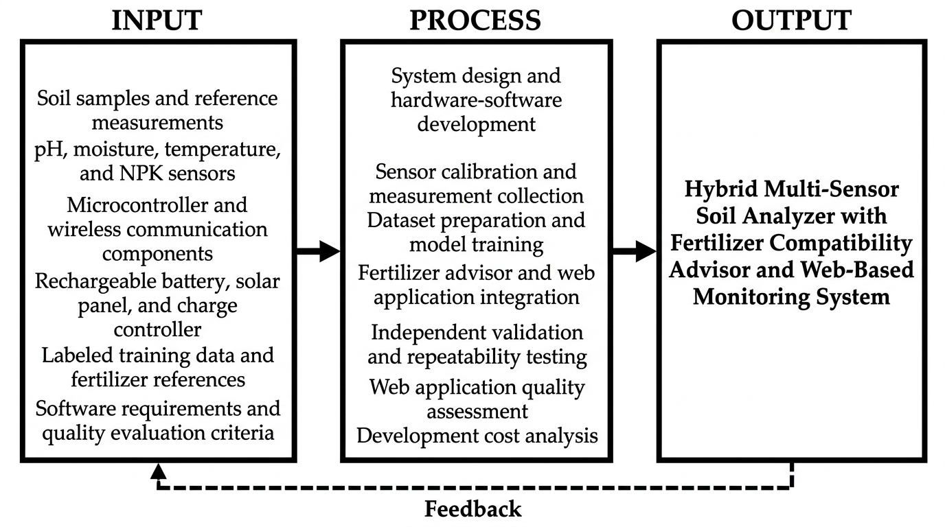
Figure 3. Input–Process–Output framework of the proposed study

Components of the Device
The proposed device will consist of the following components.
Figure 4 illustrates the proposed sensing, processing, power, and interface components. The drawing serves as a visual inventory for prototype assembly; component ratings and connections will be verified during hardware development. The NPK probe remains provisional, subject to the feasibility and validation procedures described in this study. The 18 illustrated component groups exclude an OLED display; offline storage will use flash already present on the ESP32 board.
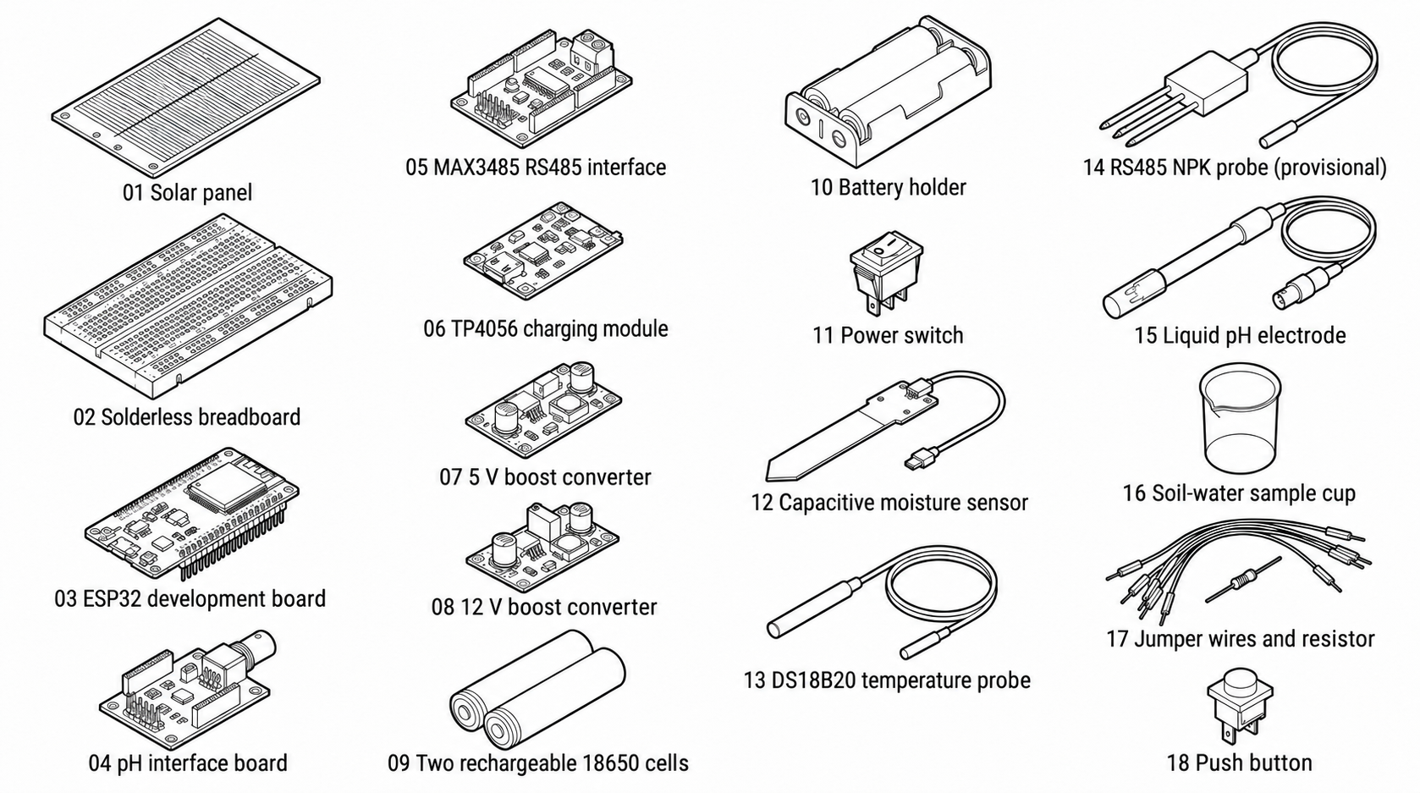
Figure 4. Proposed hardware components of the multi-sensor soil analyzer
Figures 4a to 4r present the individual parts shown in Figure 4 and explain their proposed functions. The numbering in the overview identifies the physical component groups. The drawings illustrate the proposed hardware and do not constitute verified wiring diagrams.
Solar panel. The solar panel will convert available sunlight into electrical energy for the charging circuit. Its output and mounting position will be selected to suit the final battery and charger. It will supplement charging during suitable field conditions without establishing continuous solar-powered operation.
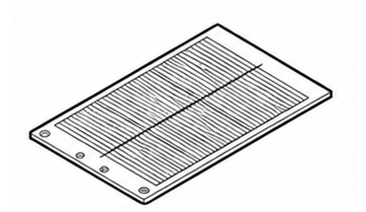
Figure 4a. Solar panel
Solderless breadboard. The solderless breadboard will provide reusable connection points for prototype assembly and troubleshooting. It will support changes to the sensor and controller connections during development. Final connections will be secured and inspected before field handling.
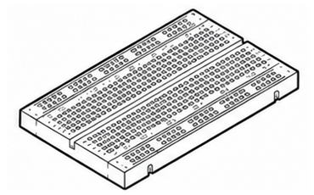
Figure 4b. Solderless breadboard
ESP32 development board. The ESP32 will run the acquisition firmware, read the sensors, apply calibration parameters, maintain the bounded flash queue, and synchronize records over its built-in Wi-Fi connection. Flash allocation and the retained record count will be established through storage and restart tests.
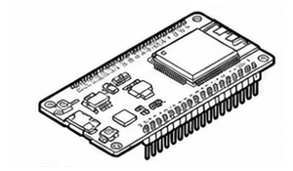
Figure 4c. ESP32 development board
pH interface board. The pH interface board will condition the electrode signal and provide an analog output for the controller. It performs a different function from the liquid electrode. The selected interface output and supply will be checked for compatibility with the ESP32 inputs before calibration (DFRobot, n.d.-b).
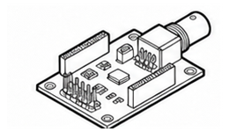
Figure 4d. pH interface board
MAX3485 RS485 interface. The MAX3485 interface will translate the controller serial signals to the RS485 bus used by a compatible NPK probe. It will transfer measurement data rather than measure nutrients. Its 3.3 V logic interface and the selected module connections will be verified during assembly (Analog Devices, n.d.-b).
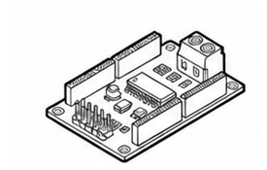
Figure 4e. MAX3485 RS485 interface
Charging module. The charging module will control charging of the selected rechargeable battery arrangement. The TP4056 shown in the drawing is a draft component, and its suitability for the battery wiring, solar input, charging current, and operation while charging remains to be confirmed. Charger control and battery protection will be treated as separate requirements.
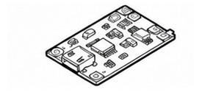
Figure 4f. Charging module
5 V boost converter. A 5 V boost converter will raise the battery output to a regulated 5 V supply if required by the selected development board or interface modules. Its current capability, efficiency, and connection to the correct board input will be checked under the intended operating load.
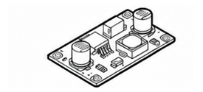
Figure 4g. 5 V boost converter
12 V boost converter. A 12 V boost converter will be included only if required by the selected NPK probe. The probe specification will determine the required supply voltage and current. This converter is conditional and will not be included solely because it appears in the conceptual drawing.
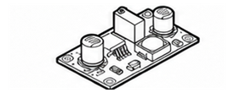
Figure 4h. 12 V boost converter
Rechargeable 18650 cells. The rechargeable cells will store energy for portable operation when sunlight or external charging is unavailable. The drawing shows two cells as a proposed quantity. Their capacity, series or parallel arrangement, matching, and protection will be selected together with the charger and verified before use.
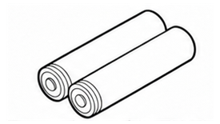
Figure 4i. Rechargeable 18650 cells
Battery holder. The battery holder will provide mechanical support and electrical contacts for the selected cells. Its wiring determines the cell arrangement, so it will be checked against the charger and protection design. The holder itself does not charge or protect the cells.
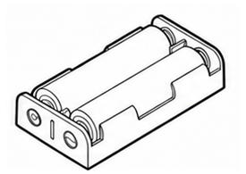
Figure 4j. Battery holder
Power switch. The power switch will connect or disconnect the device supply according to the final wiring. Its current rating and accessible position will be selected for the completed power circuit. The operator will use it to start and end a measurement session.
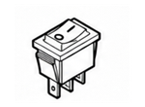
Figure 4k. Power switch
Capacitive soil moisture sensor. The capacitive moisture sensor will provide an analog signal related to the dielectric properties around its sensing area. The proposed SEN0193 or equivalent will be calibrated against the stated gravimetric reference procedure. Raw readings will not be reported as moisture percentages without the fitted relationship (DFRobot, n.d.-a).
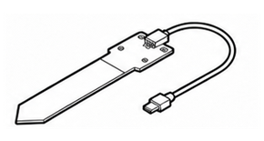
Figure 4l. Capacitive soil moisture sensor
DS18B20 temperature probe. The DS18B20 will measure soil temperature and transmit digital readings through its 1-Wire interface. The selected probe assembly will be checked against a calibrated thermometer across the intended range. Probe placement and stabilization will follow the measurement procedure (Analog Devices, n.d.-a).
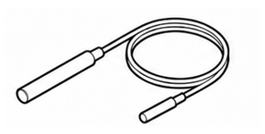
Figure 4m. DS18B20 temperature probe
RS485 NPK probe. The provisional NPK probe will report nutrient-related readings through its supported communication protocol. Its measurement principle, units, nutrient fractions, and supply requirements will be documented. It will enter the nutrient-dependent advisory workflow only if comparison with suitable laboratory measurements supports that use.
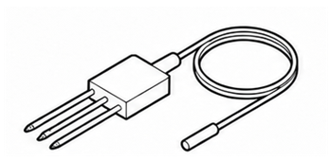
Figure 4n. RS485 NPK probe
Liquid pH electrode. The liquid pH electrode will respond to the acidity or alkalinity of the prepared soil-water suspension. It will connect to the pH interface board and will not be inserted directly into dry soil. Calibration, rinsing, and storage will follow the selected electrode procedure (DFRobot, n.d.-b).
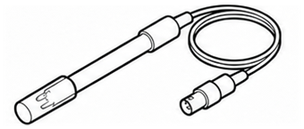
Figure 4o. Liquid pH electrode
Soil-water sample cup. The sample cup will hold the separately prepared suspension during pH measurement. Clean containers and a consistent preparation procedure will reduce carry-over between samples. The cup is a sampling accessory and performs no electronic measurement.
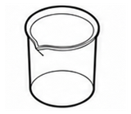
Figure 4p. Soil-water sample cup
Jumper wires and resistors. Jumper wires will connect the prototype circuit points, and resistors will provide the required pull-up or other designed signal-conditioning functions. Their values and placement will follow the selected component interfaces. Connections will be secured to limit accidental separation during handling.
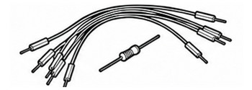
Figure 4q. Jumper wires and resistors
Push button. The push button will provide a momentary local input to the ESP32 if included in the final firmware workflow. A measurement-request action may be assigned during development and checked in functional testing. The drawing identifies the proposed control without claiming that this action is already implemented.
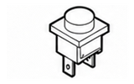
Figure 4r. Push button
Local data storage. An allocated area of the ESP32 board's onboard flash will hold pending sensor records. The flash allocation will be selected after accounting for firmware and other required data; the retained record count will be measured rather than assumed. Successfully committed records are intended to survive a device restart, subject to validation of the storage implementation (Espressif Systems, n.d.-a). No separate microSD module is proposed.
Enclosure and probe assembly. The enclosure and probe assembly will protect the electronics and allow safe sensor placement during field handling.
Web server and database platform. Development will initially use an existing computer and a local web server or available institutional hosting to reduce recurring expenses. The system will store measurements, calibration status, timestamps, and advisory records. Internet access requirements and any deployment or hosting costs will be documented. The server will acknowledge saved records and use device and record identifiers to prevent duplicate entries when uploads are repeated.
Computer or mobile device. A computer or mobile device will be used for programming, accessing the dashboard, and conducting the evaluation during development and testing. Its browser will provide the operating display through the web interface, replacing a dedicated screen on the analyzer.

System Architecture
The proposed system will consist of five main layers: sensing, processing, communication, web application, and decision support. The sensing layer will contain pH, temperature, moisture, and NPK-related sensors. The processing layer will contain the microcontroller that reads and preprocesses the sensor values. The communication layer will send the measurements through an available wireless connection. The web application will store and display the measurements. The decision-support layer will use the trained model and reference information to generate the fertilizer compatibility advisory. Figure 5 presents the proposed system architecture. The processing layer will maintain the local queue, and the communication layer will upload pending records when the configured network and server are reachable. The web layer will acknowledge stored records, distinguish acquisition time from receipt time, and show synchronization status. A cloud deployment will require internet access; a reachable local server will not require a public internet connection.
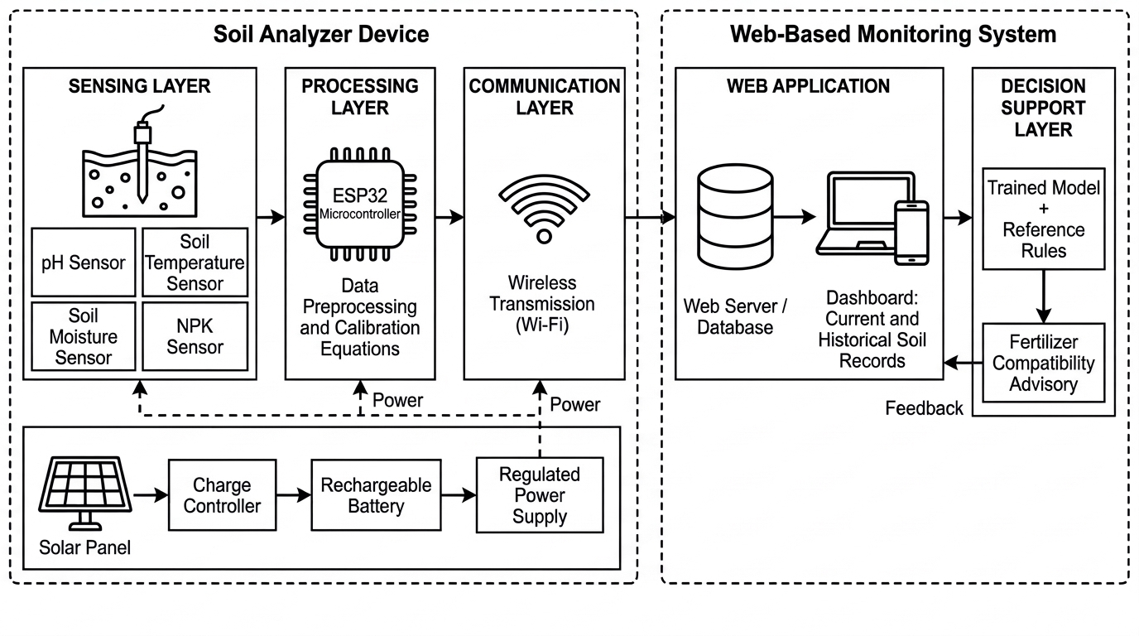
Figure 5. Proposed system architecture of the multi-sensor soil analyzer

Principle of Operation
Before a measurement session, the operator will charge the battery, inspect the connections, and confirm that the sensor calibration records are current. Each soil sample will be assigned an identifier. The operator will prepare the soil-water suspension for pH measurement and the corresponding soil portion for moisture, temperature, and any validated NPK measurement using the documented sampling procedure.
When the power switch is turned on, the battery and regulated supply rails will energize the ESP32 and connected sensor interfaces. The firmware will initialize the sensors, load the fixed calibration parameters, and recover committed records from the onboard flash queue. The solar panel will supplement charging when suitable sunlight and the selected charging circuit permit. Portable operation will remain subject to the measured battery runtime.
The operator will place the moisture and temperature probes, and the NPK probe if accepted after feasibility testing, in the prepared soil using the established depth and placement procedure. The liquid pH electrode will be placed in the separately prepared soil-water suspension. After the documented stabilization criterion is reached, the firmware will acquire the readings through the analog, 1-Wire, and RS485 interfaces used by the selected sensors.
The ESP32 will convert the sensor outputs using the applicable calibration equations and check for missing, out-of-range, or invalid values. It will associate each measurement with the sample identifier, persistent record identifier, calibration status, and acquisition time when available. A time-quality flag will identify measurements acquired before clock synchronization. The completed record will be committed to the allocated non-volatile flash queue before transmission is attempted.
When the configured Wi-Fi network and server are reachable, the device will upload the queued records. The server will validate and store each record, prevent duplicate entries by checking its device and record identifiers, and return an acknowledgement. Only acknowledged records will be released from the local queue. During a connection failure, pending records will remain in flash for later retry. If the queue becomes full, new local logging will pause while pending records are preserved.
The server will pass eligible uploaded measurements to the trained fertilizer compatibility model and apply the documented reference rules and validity checks. The browser dashboard will display the stored soil values, their time information, the advisory class, and any limitations. Nutrient-dependent advice will be withheld when the NPK inputs have not been validated or the record cannot support a prediction. Newly collected offline data will become available on the dashboard after successful upload.
At the end of the session, the operator will check the most recently reported synchronization status, turn off the device, and clean and store the probes according to their handling requirements. Pending committed records are intended to be recovered at the next start, subject to the restart and interrupted-write tests. The pH suspension and soil residues will be handled using the laboratory procedure.

Soil Sampling and Sample Allocation
Before collection, a sampling plan will specify the approved sites, target crop, soil-condition ranges, sampling depth, number of independent samples, collection procedure, sample mass, and transport and preparation requirements. The sample count will be justified using pilot variability, the intended precision of the performance estimates, laboratory capacity, and available funding. Laboratory access and the availability of suitable N, P, and K reference analyses will be confirmed before the main collection begins.
Each independent soil sample will receive a unique identifier linked to its collection site, date, depth, and preparation record. Portions from the same homogenized sample will be used for paired device and reference measurements where the methods permit. Calibration and final validation samples will be separated before equations are fitted. Repeated readings and portions from the same sample will remain in the same model-development partition and will not be counted as additional independent samples.

Instrumentation
The proposed laboratory and field instruments are listed in Table 1. Reference instruments, drying equipment, and analytical services will be accessed through available university or partner laboratories where permission is granted. Final instrument models, calibration status, methods, measurement ranges, detection limits, and uncertainties will be recorded before testing. The NPK reference method must quantify the same measurand and units as the sensor output; total nutrient content and extractable or available nutrient content will not be treated as interchangeable.
Table 1. Proposed laboratory instruments and measurement records
Instrument or material | Purpose and required record
Calibrated pH meter; pH 4.00, 7.00 and 10.00 buffers | Reference pH checks; record buffer lot, temperature, calibration date, and selected soil preparation procedure.
Calibrated reference thermometer | Paired soil-temperature readings; record range, resolution, and calibration status.
Drying oven; balance; moisture tins; desiccator | Gravimetric moisture reference; document wet and dry mass, drying conditions, and moisture basis.
Soil auger or trowel; sample bags; labels; sieve; clean containers | Collect, identify, homogenize, and prepare paired samples; record site, depth, and preparation.
Laboratory N, P and K analyses | Qualified laboratory using documented methods; retain analytical reports, units, extraction basis, and detection limits.
Digital multimeter and suitable current or power meter | Check regulated supply, battery voltage, and operating power; record instrument range and measured operating mode.
Computer; browser tools; stopwatch or timing logger | Record task results, response times, browser conditions, and evaluation evidence.

Hardware Development
The hardware will be assembled in a modular arrangement so that individual sensors can be replaced or recalibrated without redesigning the entire system. Sensor interfaces will be connected to the microcontroller according to their electrical requirements. Power regulation will be separated from sensor signal wiring as much as practical to reduce electrical interference. Figure 6 shows the proposed hardware and data-acquisition flow.
The enclosure will protect the electronic components during field handling. The temperature, moisture, and compatible NPK probes will be placed in prepared samples or field soil using a consistent procedure and depth. The proposed liquid-electrode pH system will measure a separately prepared soil-water suspension. The physical design will prioritize portability, safe access to the charging system, ease of cleaning, and replacement of sensors. The enclosure will not contain an OLED or LCD screen; the web interface will provide the user display.
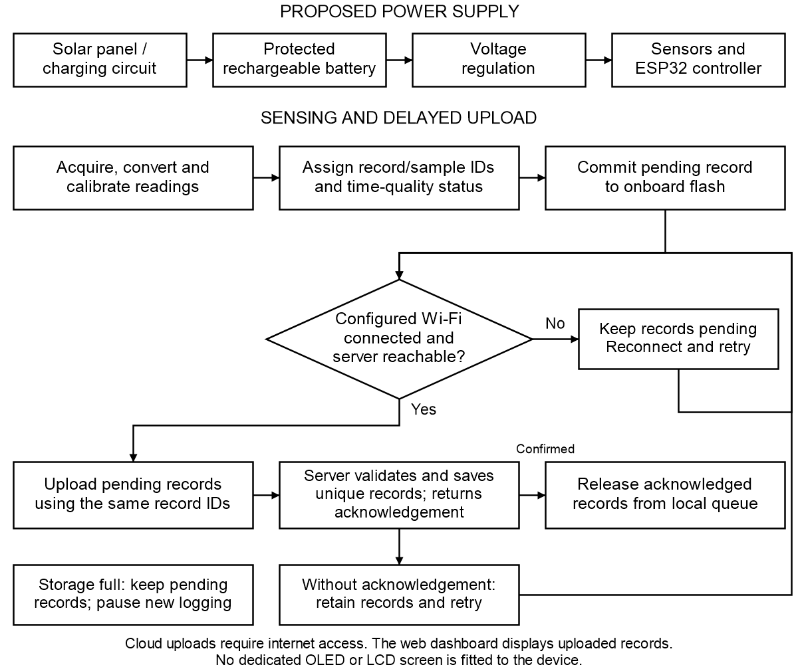
Figure 6. Proposed hardware and data-acquisition flow
Figures 7 and 8 show the proposed enclosure arrangement and the exposed breadboard arrangement without a dedicated screen. These conceptual views illustrate the solar panel, power modules, controller, and sensor connections. The web interface will display uploaded measurements. The pH electrode is shown with a separate sample cup for a prepared soil-water suspension. Final dimensions, wiring, and power connections will be determined and verified during prototype assembly.
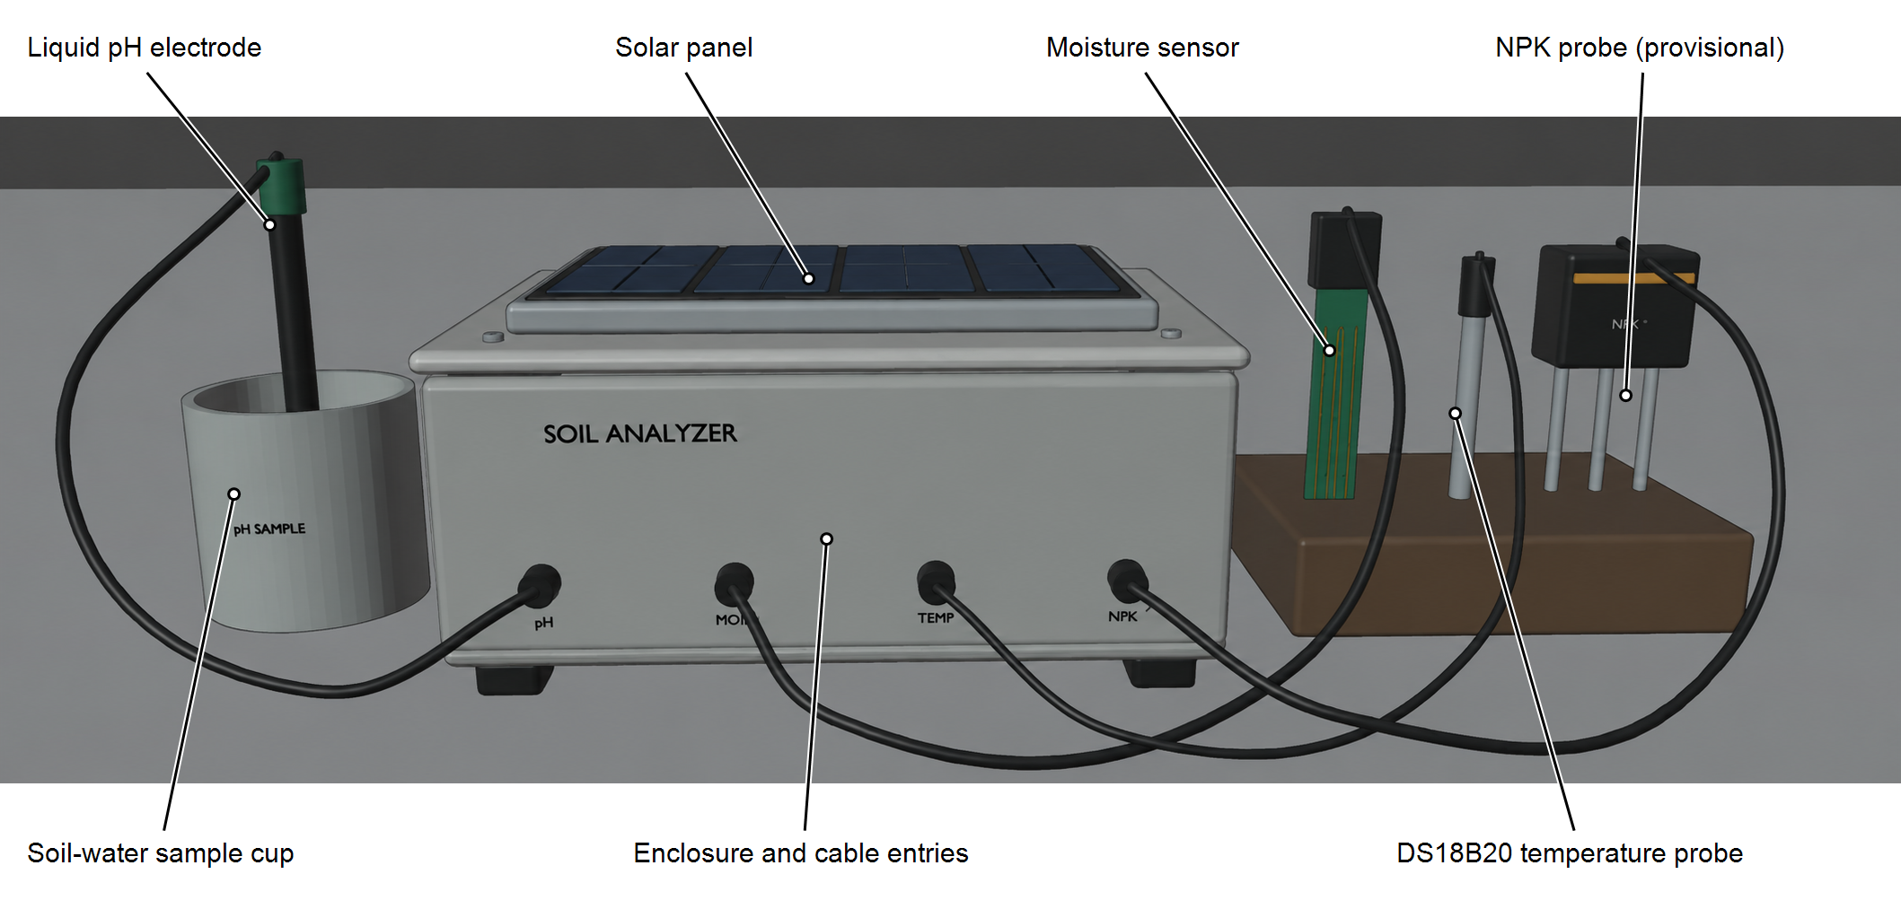
Figure 7. Proposed enclosure arrangement of the multi-sensor soil analyzer
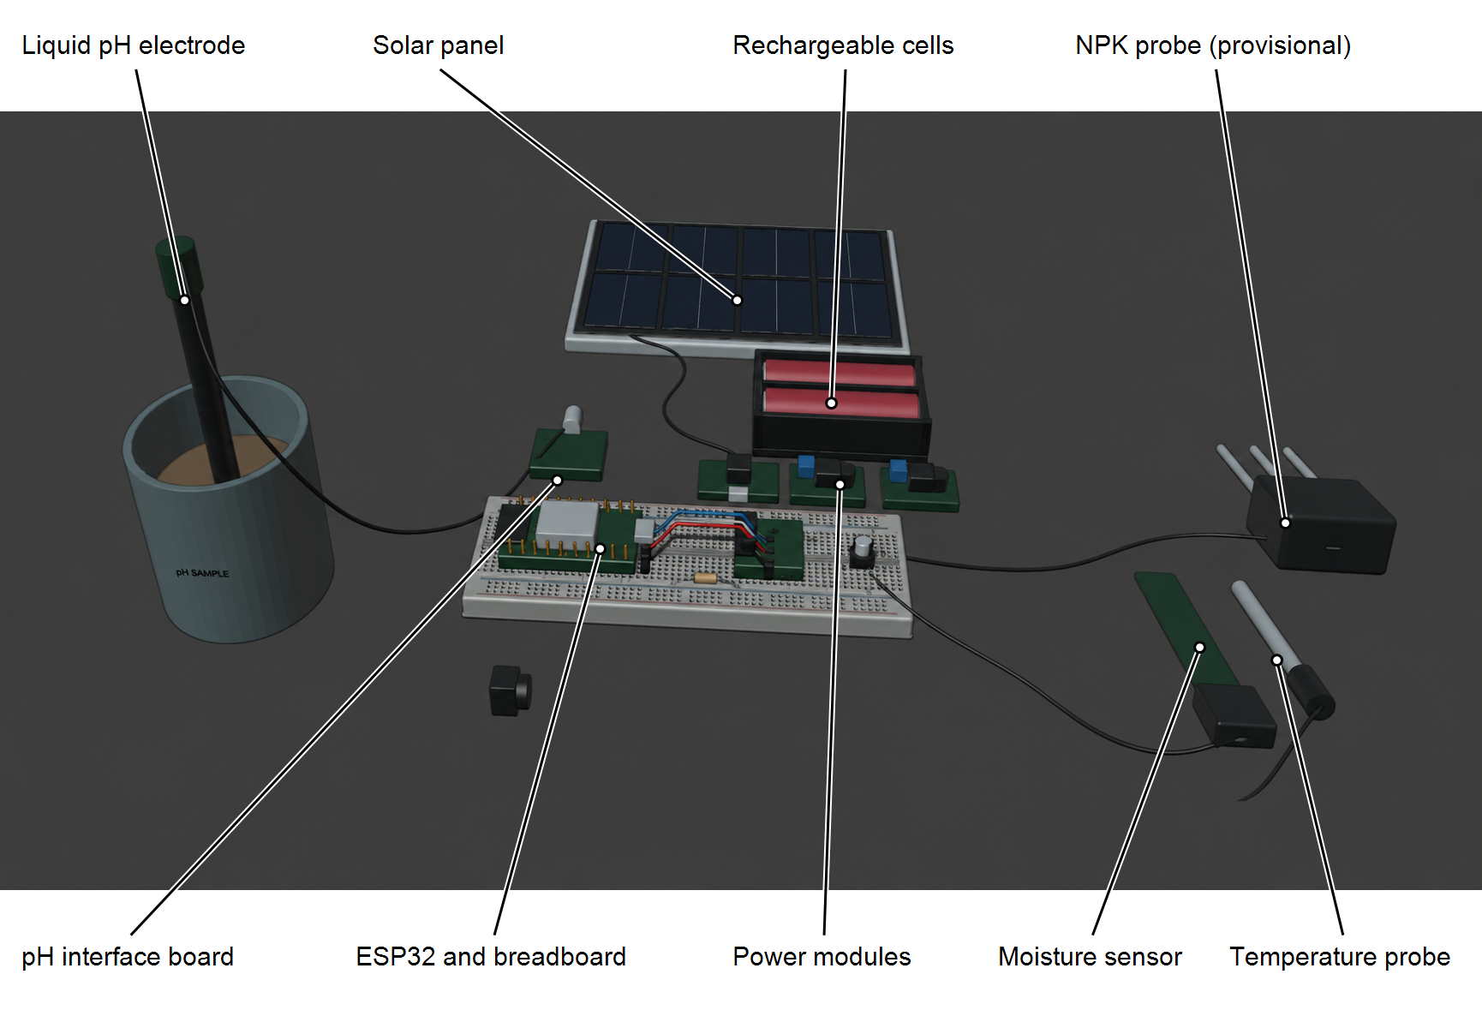
Figure 8. Proposed exposed arrangement of the multi-sensor soil analyzer

Firmware and Data Acquisition
The firmware will initialize the sensors, acquire readings, perform required conversion or preprocessing, apply calibration equations or correction factors, and commit each measurement record to a bounded queue in onboard non-volatile flash before attempting upload. Each record will include a persistent identifier, sample identifier, sensor values, calibration status, and measurement time when a valid clock is available. A time-quality flag will identify readings collected before clock synchronization; the server will record receipt time separately rather than treating upload time as measurement time.
The firmware will connect to a configured Wi-Fi network and attempt synchronization when the server is reachable. Pending records will remain in flash during network outages, server failures, and unconfirmed uploads. The same record identifiers will be reused on retry, and records will be released from the local queue only after the server confirms successful storage. If the allocated queue becomes full, pending records will be retained and further local logging will pause; the dashboard will report the storage condition when communication resumes. No separate hardware clock or local display is assumed.
To support repeatable measurements, the researchers will establish a fixed measurement procedure, including sample preparation, probe cleaning, stabilization time, measurement depth, number of readings, and recording interval. These conditions will be documented and applied consistently during calibration and validation.

Calibration Procedure
Calibration will be completed before final validation and before sensor measurements are used to construct the final model dataset. The pH electrode will be calibrated using fresh buffer solutions spanning the intended range, ordinarily pH 4.00 and 7.00, with an additional check where appropriate. Soil pH will then be compared with a calibrated meter using the same soil-water preparation. Temperature readings will be compared with a calibrated thermometer across the expected range. Moisture calibration will use gravimetric oven-drying measurements under a documented laboratory procedure. NPK outputs will be compared with matched laboratory analyses of the same independent samples. Calibration equations will be fitted only where the pilot data support a valid relationship and will be fixed before final validation.
For pH calibration, the researcher will record the buffer values, calibration date, temperature, soil-water preparation, stabilization criterion, and paired reference pH. Differences will be reported in pH units, and the fitted correction will be checked using separate samples.
For temperature calibration, sensor readings will be compared with a calibrated thermometer or temperature reference across the expected operating range. The difference will be determined, and a correction will be applied when supported by the calibration observations.
For moisture calibration, wet and dry soil masses, drying conditions, and the moisture basis will be recorded. The sensor relationship will be fitted over several moisture levels. If volumetric moisture is reported, the required bulk density will be measured instead of directly equating gravimetric and volumetric percentages.
For NPK calibration, nutrient fractions, extraction methods, units, and detection limits will be confirmed before sensor and laboratory results are compared. Sample preparation will be standardized, and moisture conditions will be recorded. If a valid relationship cannot be established, the limitation will be reported and nutrient-dependent advisories will be withheld.

Calibration and Validation Metrics
Validation shall be conducted using independent soil samples that were not utilized during calibration. Sensor readings obtained from the developed device shall be compared with measurements obtained from calibrated reference instruments and laboratory-based analyses. At least three replications shall be performed for each sample to minimize random measurement error.
Measurement performance will be described using absolute error, Mean Absolute Error (MAE), Root Mean Square Error (RMSE), bias, Coefficient of Determination (R²), and Pearson correlation where appropriate. Percentage error and Mean Absolute Percentage Error (MAPE) will be used only for ratio-scale quantities with nonzero reference values, and will not be primary pH or Celsius-temperature error measures. Before final validation, a parameter-specific acceptance plan will record the measurement range, reference method, units, allowable error, and its source or practical justification. Where no applicable published limit exists, any researcher-proposed threshold will be identified and approved before testing. Agreement will be judged using error and bias rather than correlation alone. The formulas, symbols, and interpretation of these measures are specified under Statistical Treatment of Data. Measurement accuracy will be assessed separately from the classification accuracy of the fertilizer compatibility model.

Repeatability Testing
Repeatability will be assessed using at least ten consecutive measurements from the same sample under identical operating conditions, with checks at different points in the measurement range. The mean, standard deviation, and variance will be reported for each parameter. Standard deviation in pH units and degrees Celsius will be used for pH and temperature, respectively. The coefficient of variation (CV) will be reported only for suitable ratio-scale measurements with a nonzero mean. Repeated readings will characterize measurement consistency and will not be counted as independent soil samples. The same operator, device, preparation, location, and measurement procedure will be maintained over a short interval. Each cycle will use the documented cleaning, placement, and stabilization procedure; tests with a stationary probe will be identified separately (Joint Committee for Guides in Metrology, 2012).
For one sample and test condition, let xⱼ denote repeat reading j, m the number of readings (at least ten), and x̄ the mean. The mean and repeatability standard deviation will be calculated as follows:
$$\overline{x} = \frac{Σ_{j = 1}^{m}{x_{j}}}{m} (1)$$
$$s_{r} = \sqrt{\frac{Σ_{j = 1}^{m}{{(x_{j} - \overline{x})}^{2}}}{m - 1}} (2)$$
Repeatability variance is sᵣ². Standard deviation will be reported in the original measurement units for each parameter and test condition. Results from deliberately different moisture levels or temperatures will not be combined into one repeatability standard deviation.
$$r_{95} ≈ 2.8 s_{r} (3)$$
The approximate 95% repeatability limit, r₉₅, describes the absolute difference expected to contain approximately 95% of pairs of individual results under independent, approximately normal repeatability errors with comparable variance. It is not a confidence interval for the mean or an accuracy percentage. This expression follows FAO soil-laboratory quality guidance, section 7.5.2.2; it is not attributed to a PAES clause (van Reeuwijk, 1998).
$$CV (\%) = 100 \frac{s_{r}}{\overline{x}} (4)$$
CV will be calculated only for suitable positive ratio-scale quantities with a mean sufficiently above zero. It will not be used for pH, Celsius temperature, or an arbitrary uncalibrated sensor scale (National Institute of Standards and Technology, n.d.-b). The exact PAES number, edition, and applicable clause intended for repeatability will be confirmed with the adviser before final testing; no PAES compliance or PAES acceptance threshold is claimed here.

Dataset Preparation and Trained Model Development
A Decision Tree classifier will serve as an interpretable initial model and will be compared with the documented reference-rule baseline. Random Forest or Support Vector Machine classifiers may be evaluated if the number and distribution of independent labeled samples permit a meaningful comparison. Model complexity will be limited according to the available data, and a small prototype dataset will not be presented as evidence of broad agronomic generalization.
The dataset will combine calibrated soil measurements with fertilizer compatibility labels supported by documented agricultural references and professional review. Missing values, duplicates, and outliers will be handled using recorded procedures. Data will be partitioned by independent soil sample or collection group before model fitting. Preprocessing parameters will be learned from training observations only. Grouped cross-validation within the development data will guide model selection where the sample count permits, while the final test set will remain untouched until the model and decision criteria are fixed. Accuracy, per-class precision, recall, F1-score, and a confusion matrix will be reported with the number of independent test samples and class counts.

Fertilizer Compatibility Advisory
The initial advisory scope will be restricted to one locally relevant crop and a small, explicitly listed set of fertilizer options. Before labeling begins, a qualified agriculture professional will review the crop choice, nutrient interpretation, fertilizer references, output classes, and decision criteria. Each class will have a written definition and a worked example linking measured inputs to the expected output. Where expert judgment is used, the review procedure and resolution of ambiguous labels will be documented.
The advisory component will receive calibrated soil variables and, where applicable, the selected crop or fertilizer category. The trained model will return the predicted compatibility class or advisory. The application will display the output in simple language and should also display the relevant measured values so that the user can see the basis of the recommendation.
Where the training dataset does not contain enough information to support a reliable prediction, the system should display an appropriate limitation or insufficient-data message instead of presenting a false level of certainty. The advisory is intended as decision support and not as a replacement for professional fertilizer recommendations or laboratory analysis.

Web-Based Application Development
The web application will contain at least the following functional areas: user access or basic session control if required; dashboard; current sensor readings; historical records; fertilizer compatibility advisory; model output; and system information. The application will communicate with the database through an appropriate application programming interface or server-side connection. The dashboard will serve as the user display and will show the latest received records, their acquisition or time-quality information, server receipt times, and the device last-contact time. Newly recorded offline measurements will become visible after upload; the interface will distinguish delayed or stale records from current measurements.
The dashboard will display the latest uploaded pH, temperature, moisture, and validated NPK-related readings. Measurement times or time-quality flags and last-update information will help users distinguish recent measurements from delayed uploads.
The historical-records area will retrieve uploaded measurements using their unique identifiers, measurement times or time-quality flags, and server receipt times. It will include records uploaded after an offline period so that delayed transmission does not remove the link to the original sample.
The advisory area will show the model-generated fertilizer compatibility class with the supporting soil values. Missing, invalid, stale, or unsupported inputs will trigger the defined limitation message instead of an unsupported recommendation.
Data-management functions will provide controlled storage and retrieval of measurement and advisory records. The server will validate the required fields and use persistent record identifiers to prevent duplicate entries during upload retries.
The system-status area will display the device last-contact time and the latest reported synchronization condition, pending-record count, and storage condition. A status received before a disconnection will retain its update time and will not be presented as a live report.
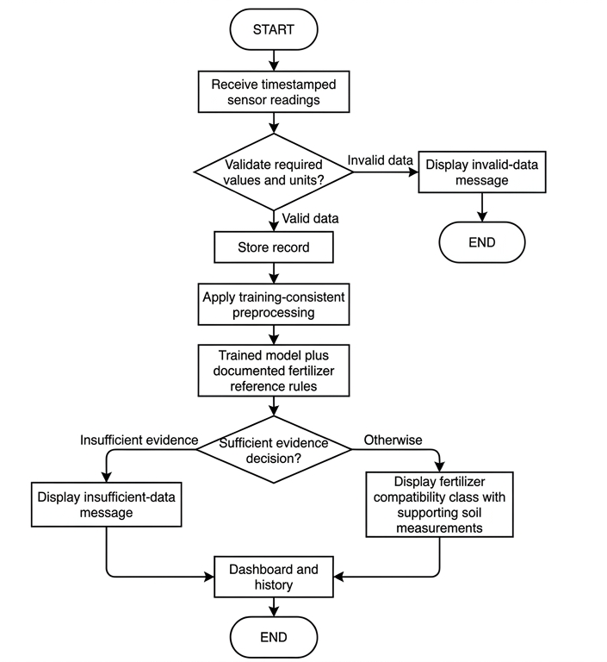
Figure 9. Proposed web monitoring and fertilizer advisory workflow

Web Application Assessment Using ISO/IEC 25010:2023
The proposed evaluators will include Agricultural and Biosystems Engineering faculty members, information technology professionals, and potential end-users. Purposive sampling will be used to select evaluators suited to the criteria assigned to them. The number of evaluators, eligibility requirements, and final instrument will be established before recruitment and submitted for adviser approval.
This study will use a researcher-prepared evaluation questionnaire and technical test checklist based on the ISO/IEC 25010:2023 product quality model. The assessment will address functional suitability, performance efficiency, compatibility, interaction capability, reliability, security, maintainability, flexibility, and safety, using procedures appropriate to the prototype. Respondents will rate only the observable items relevant to their assigned evaluator role.
The mean rating for each characteristic and the overall mean will be computed using the approved rating interpretation. The questionnaire should be reviewed for clarity and, if required by the research panel, subjected to content validation before administration.

Technical Evaluation Procedure
The following procedure is proposed by the researcher to operationalize the selected quality characteristics. It is not an ISO certification procedure. Before testing, the adviser will approve the selected characteristics, evaluator groups, task scripts, test data, operating conditions, and acceptance thresholds. A fixed application version and anonymized or synthetic test records will be used so that each evaluator encounters comparable conditions.
Each participant will receive an orientation and complete assigned tasks: open the dashboard, inspect a current reading and timestamp, retrieve a historical record, request a fertilizer compatibility advisory, and recognize an invalid reading or stale connection. The researcher will record task completion, errors, assistance required, elapsed time, and the participant’s rating. Participants may decline or withdraw; identifying details will be separated from response records. Table 2 summarizes the procedure and evidence used for each quality characteristic.
Table 2. Proposed web application evaluation matrix
Characteristic | Procedure and evidence
Functional suitability | Run a requirements-to-test-case checklist; compare displayed readings, stored records, and model outputs against prepared expected values. Record pass/fail and discrepancies.
Performance efficiency | Measure page loading, data refresh, and advisory response time over repeated trials. Log trial count, device, browser, connection, data volume, and concurrent load.
Compatibility | Repeat core tasks on the selected desktop and mobile browsers; check data exchange between acquisition unit, application interface, database, and model.
Interaction capability | Observe task completion, navigation errors, help requests, and comprehension of units and advisory limitations. Obtain end-user ratings after task completion.
Reliability | Disconnect and restore Wi-Fi; separately interrupt server access while Wi-Fi remains connected. Record measurements offline, restart after committed writes, interrupt and retry uploads, and fill the allocated queue. Compare device and server record identifiers to check retention, duplicate prevention, acknowledgements, queue-full handling, and time-quality flags.
Security | In an authorized test environment, check input validation, protected routes, session handling, and permissions where implemented; do not use real sensitive records.
Maintainability | Have qualified technical reviewers inspect code organization, configuration, documentation, logs, and the effort required for a controlled small change.
Flexibility | Check installation and configuration in the supported environment, adaptation to selected desktop and mobile displays, and behavior at the planned data volume and concurrent load. Record dependencies and deployment steps.
Safety | Submit invalid, stale, missing, or unsupported measurements. Verify clear warnings, withheld nutrient-dependent advisories, and recovery without presenting misleading recommendations.
Technical reviewers will evaluate code- and configuration-dependent characteristics; end-users will evaluate only characteristics they can observe. A characteristic that cannot be assessed by a respondent will be marked not applicable and excluded from that respondent’s denominator. Technical test results will be reported separately from perception ratings.
A proposed five-point agreement scale will be used: 5 strongly agree, 4 agree, 3 neither agree nor disagree, 2 disagree, and 1 strongly disagree. Questionnaire items will describe observable behavior, be reviewed for content and clarity, and be pilot-tested before final administration. The mean item score will equal Σ(frequency × score)/number of valid responses. Characteristic means will be computed from valid item responses; any overall mean will state its weighting and exclusions. Rating bands, if required, will be approved before data collection. No score will be described as proof of ISO compliance.

System Integration and Functional Testing
After individual components have been tested, the hardware, firmware, web application, database, and trained model will be integrated. Functional tests will verify whether sensor data are acquired, transmitted, stored, displayed, and passed to the model correctly. The system will also be tested for common failure conditions such as temporary loss of connectivity, missing readings, and invalid input values. The battery runtime and the charging behavior of the solar panel and charge controller will also be recorded using the multimeter and power meter listed in Table 1 to verify that the power subsystem supports field operation.
Offline recording and synchronization will be tested using known sets of measurement records within the allocated capacity. Tests will cover loss and restoration of Wi-Fi, Wi-Fi with an unreachable server, restart after committed writes, power interruption during a write, and connection failure before or after server acknowledgement. The number and identity of locally committed records will be compared with the unique records stored on the server. Any losses, incomplete writes, duplicates, or failed uploads will be reported.
The maximum retained record count, record size, sampling interval, synchronization time, and queue-full behavior will be measured. These results will define the demonstrated offline recording duration. Records without a valid acquisition time will be checked for an explicit time-quality flag, and delayed records will be checked for correct display on the web interface. Fertilizer recommendations and web monitoring will be evaluated on uploaded data; autonomous offline advisory generation is outside the scope.

Recommendation Validation
A set of test samples not used for model training will be used to validate the fertilizer compatibility output. The model prediction will be compared with the expected label determined from the study's reference dataset and decision criteria. A confusion matrix and classification metrics will be used to describe the model's performance. To check agronomic reasonableness and to guard against the model merely reproducing the labeling rules, a subset of the predicted advisories will also be reviewed by qualified agriculture professionals.

Simple Cost Analysis
The total prototype development cost will be estimated by summing the direct costs of hardware, sensors, electronic components, enclosure materials, power components, fabrication, software or hosting expenses incurred for the prototype, and other directly attributable expenses. The proposed configuration will exclude a dedicated display and separate microSD hardware; local recording will use the selected ESP32 board and its allocated onboard flash.
Each directly attributable item will be recorded with its description, quantity, unit price, and supporting purchase record. The cost of item i will be calculated using Equation 5.
$$C_{i} = q_{i} × p_{i} (5)$$
In Equation 5, Cᵢ is the item cost in Philippine pesos, qᵢ is the quantity purchased, and pᵢ is the unit price. Each expense will be assigned to one category to avoid double counting. The total direct development cost will be computed using Equation 6.
$$C_{total} = Σ_{i = 1}^{n}{C_{i}} = C_{H} + C_{S} + C_{F} + C_{O} (6)$$
Here, n is the number of costed items. C_{H} represents hardware and electronic components, C_{S} represents software and services, C_{F} represents fabrication and enclosure materials not already included in hardware, and C_{O} represents other directly attributable expenses. The analysis will describe prototype development cost. It will not be presented as a full economic feasibility analysis without the additional production, maintenance, labor, depreciation, and benefit data needed for that purpose.
The share of each subsystem in the total cost will also be calculated. Items will be grouped consistently into sensing, power, communication, processing, enclosure, and web infrastructure, and each item will belong to only one subsystem. Equation 7 will identify the largest contributors to the documented development cost.
$$P_{s} = 100 × \frac{C_{s}}{C_{total}} (7)$$
In Equation 7, P_{s} is the percentage contribution of subsystem s and C_{s} is its summed direct cost. The percentage will be calculated only when total cost is greater than zero. Borrowed reference instruments will be listed separately rather than assigned a purchase cost that was not incurred.
Borrowed or donated instruments and components will be identified separately from cash expenditures. Where available, their estimated replacement values will be stated to distinguish the student’s out-of-pocket development cost from the resources needed to reproduce the prototype. Planned budget allocations will not be reported as actual expenditure.

Statistical Treatment of Data
Descriptive statistics will summarize the sensor measurements and repeatability results. The mean, standard deviation, minimum, maximum, and variance will be reported separately for each parameter and test condition. The coefficient of variation will be added only for suitable ratio-scale quantities with a nonzero mean.
Agreement between calibrated device results and reference measurements will be evaluated using absolute error, MAE, RMSE, bias, Pearson correlation, and the coefficient of determination, as appropriate. Relative error and MAPE will be limited to suitable ratio-scale quantities with nonzero reference values and will not be used for pH or Celsius temperature.
The trained fertilizer compatibility model will be evaluated using classification accuracy, per-class precision, recall, F1-score, and a confusion matrix. These measures will describe performance on independent held-out test cases with documented expected labels.
The web application assessment will be summarized using item and characteristic means, valid-response counts, and descriptive interpretations. Any overall mean will state its weighting and exclusions. Technical test outcomes will be reported separately from respondent ratings.
An optional two-sided paired-sample t-test at the 0.05 level of significance may be used to examine the mean difference between device and reference results, subject to adviser approval and the statistical assumptions described below.
For each sensor parameter, let dᵢ be the calibrated device result for independent sample i, yᵢ its paired reference result, n the number of valid independent pairs, and d̄ and ȳ their respective means. Replicate readings will first be summarized at the independent-sample level. Each parameter will be evaluated separately in matched units and on a matched measurement basis.
$$e_{i} = d_{i} - y_{i}; {AE}_{i} = |d_{i} - y_{i}| (8)$$
$$MAE = \frac{Σ_{i = 1}^{n}{|d_{i} - y_{i}|}}{n} (9)$$
$$RMSE = \sqrt{\frac{Σ_{i = 1}^{n}{{(d_{i} - y_{i})}^{2}}}{n}} (10)$$
$$Bias = \frac{Σ_{i = 1}^{n}{(d_{i} - y_{i})}}{n} (11)$$
AE is absolute error. MAE is the average absolute difference, while Root Mean Square Error (RMSE) gives larger errors greater weight. Lower MAE and RMSE indicate smaller errors; zero is ideal. Positive bias indicates average over-reading and negative bias indicates average under-reading. Errors will be reported in pH units, degrees Celsius, moisture percentage points on the stated basis, or the matched nutrient units (scikit-learn developers, n.d.).
$$R^{2} = 1 - \frac{Σ_{i = 1}^{n}{{(d_{i} - y_{i})}^{2}}}{Σ_{i = 1}^{n}{{(y_{i} - \overline{y})}^{2}}} (12)$$
For independent validation, R² is the coefficient of determination with reference results as observed values and device results as predictions. A value of 1 indicates perfect prediction, 0 matches a prediction of the reference mean, and negative values indicate worse squared-error performance. It is undefined when all reference values are identical and does not represent percentage accuracy. Calibration-fit R² will be distinguished from independent-validation R² (scikit-learn developers, n.d.).
$$r = \frac{Σ_{i = 1}^{n}{(d_{i} - \overline{d})(y_{i} - \overline{y})}}{\sqrt{Σ_{i = 1}^{n}{{(d_{i} - \overline{d})}^{2}} Σ_{i = 1}^{n}{{(y_{i} - \overline{y})}^{2}}}} (13)$$
Pearson r describes linear association between paired readings, from −1 to +1, and is undefined for a constant input. It will supplement error and bias because high correlation can coexist with a systematic offset. Pearson r squared will not automatically be substituted for Equation 12 (SciPy developers, n.d.).
$${RE}_{i} = \frac{d_{i} - y_{i}}{y_{i}}; {APE}_{i} = 100 \frac{|d_{i} - y_{i}|}{|y_{i}|} (14)$$
$$MAPE (\%) = \frac{Σ_{i = 1}^{n}{{APE}_{i}}}{n} (15)$$
RE is relative error and APE is absolute percentage error. Percentage errors and MAPE will be restricted to suitable ratio-scale quantities with nonzero reference values; the treatment of near-zero values and detection limits will be documented. MAPE will not be used for pH or Celsius temperature. The quantity 100 minus MAPE will not be presented as a universal sensor accuracy measure.
$$Percentage within tolerance = 100 \frac{N_{tol}}{n} (16)$$
If a percentage summary of sensor performance is required, Nₜₒₗ will count valid pairs satisfying |dᵢ − yᵢ| ≤ Tᵢ, where Tᵢ is the pre-established allowable error for the parameter and measurement range. The tolerance, source or practical justification, and counts will be stated. This is a researcher-defined summary rather than a verified PAES requirement. Measurement accuracy will otherwise be described through the reported errors, bias, and repeatability (Joint Committee for Guides in Metrology, 2012).
$$Classification accuracy (\%) = 100 \frac{C}{N} (17)$$
For model evaluation, N is the number of independent held-out test cases and C is the number classified correctly. A correct prediction matches the documented expected fertilizer compatibility class. This classification accuracy is distinct from sensor measurement accuracy and does not itself demonstrate agronomic effectiveness.
$${Precision}_{k} = \frac{{TP}_{k}}{{TP}_{k} + {FP}_{k}}; {Recall}_{k} = \frac{{TP}_{k}}{{TP}_{k} + {FN}_{k}} (18)$$
$${F1}_{k} = \frac{2 {TP}_{k}}{2 {TP}_{k} + {FP}_{k} + {FN}_{k}} (19)$$
For each class k against all other classes, TPₖ counts correct predictions of k, FPₖ counts other cases incorrectly predicted as k, and FNₖ counts cases of k predicted as another class. Precision, recall, and F1 will be reported per class with class counts; zero denominators will be marked undefined and their handling stated. The confusion matrix will use expected classes as rows and predicted classes as columns. RMSE and R² will not be applied to arbitrary numerical class codes (scikit-learn developers, n.d.).
$$t = \frac{\overline{e}}{\frac{s_{e}}{\sqrt{n}}}; df = n - 1 (20)$$
For the optional two-sided paired t-test of zero mean difference, ē is the mean paired error and sₑ is the sample standard deviation of those errors. Independent pairs and an appropriate distribution of paired differences will be required. The proposed significance level is 0.05. A nonsignificant result will not establish equivalence or acceptable individual errors (National Institute of Standards and Technology, n.d.-a).
Calibration equations will be fitted using calibration observations only. Final accuracy estimates will use independent samples; replicate readings from the same sample will not be treated as independent soil samples. Training and test partitions will be separated by soil sample or collection group to prevent data leakage. Correlation and R² will be reported alongside error and bias because high correlation alone does not demonstrate measurement agreement. A nonsignificant paired t-test will not be interpreted as proof of equivalence.

Ethical and Safety Considerations
The prototype will follow the laboratory and field site's electrical, equipment, and soil-handling procedures. Connections will be insulated and protected. The battery, solar panel, and charging components will be selected and operated within their specifications. The study will report measurement limitations and will not present unvalidated fertilizer recommendations as guaranteed agronomic advice.

LITERATURE CITED
Analog Devices. (n.d.-a). DS18B20: Programmable resolution 1-Wire digital thermometer. https://www.analog.com/en/products/ds18b20.html
Analog Devices. (n.d.-b). MAX3485: 3.3 V powered RS-485/RS-422 transceiver. https://www.analog.com/en/products/max3485.html
Chamara, N., Islam, M. D., Bai, G., Shi, Y., & Ge, Y. (2022). Ag-IoT for crop and environment monitoring: Past, present, and future. Agricultural Systems, 203, Article 103497. https://doi.org/10.1016/j.agsy.2022.103497
DFRobot. (n.d.-a). Gravity capacitive soil moisture sensor SEN0193. https://wiki.dfrobot.com/sen0193/
DFRobot. (n.d.-b). Gravity laboratory grade analog pH sensor kit SEN0161-V2. https://wiki.dfrobot.com/sen0161-v2/
Espressif Systems. (n.d.-a). Non-volatile storage library. ESP-IDF Programming Guide. https://docs.espressif.com/projects/esp-idf/en/stable/esp32/api-reference/storage/nvs_flash.html
Espressif Systems. (n.d.-b). Station scenarios. ESP-IDF Programming Guide. https://docs.espressif.com/projects/esp-idf/en/stable/esp32/api-guides/wifi-driver/station-scenarios.html
Estrada, O., Ramos, G., Lizarazo, M., & Jimenez, D. (2025). Digital transformation accelerator. Technical report of the probe: Low-cost portable soil fertility sensors: Myth or reality? Alliance of Bioversity International and CIAT. https://alliancebioversityciat.org/publications-data/digital-transformation-accelerator-technical-report-probe-low-cost-portable-soil
Food and Agriculture Organization. (n.d.). Asia-Pacific knowledge hub on sustainable soil and land management: Soil test kit. https://www.fao.org/asiapacific/work-in-the-region/regional-priorities/faorap-regional-priority-two/soil-management/capacity-building-and-knowledge-exchange/asia-pacific-knowledge-hub-on-sustainable-soil-and-land-management/en
Gómez-Astorga, M. J., Villagra-Mendoza, K., Masís-Meléndez, F., Ruíz-Barquero, A., & Rimolo-Donadio, R. (2024). Calibration of low-cost moisture sensors in a biochar-amended sandy loam soil with different salinity levels. Sensors, 24(18), Article 5958. https://doi.org/10.3390/s24185958
International Organization for Standardization. (2023). Systems and software engineering: Systems and software Quality Requirements and Evaluation (SQuaRE): Product quality model (ISO/IEC Standard No. 25010:2023). https://www.iso.org/standard/78176.html
Joint Committee for Guides in Metrology. (2012). International vocabulary of metrology: Basic and general concepts and associated terms (VIM) (3rd ed., JCGM 200:2012). Bureau International des Poids et Mesures. https://www.bipm.org/documents/20126/2071204/JCGM_200_2012.pdf
National Institute of Standards and Technology. (n.d.-a). Analysis of paired observations. NIST/SEMATECH e-Handbook of Statistical Methods. https://www.itl.nist.gov/div898/handbook/prc/section3/prc311.htm
National Institute of Standards and Technology. (n.d.-b). Coefficient of variation. Dataplot Reference Manual. https://www.itl.nist.gov/div898/software/dataplot/refman2/auxillar/coefvari.htm
Pandey, C., Sethy, P. K., Behera, S. K., Vishwakarma, J., & Tande, V. (2022). Smart agriculture: Technological advancements on agriculture: A systematical review. In R. C. Poonia, V. Singh, & S. R. Nayak (Eds.), Deep learning for sustainable agriculture (pp. 1–56). Academic Press. https://doi.org/10.1016/B978-0-323-85214-2.00002-1
Rajak, P., Ganguly, A., Adhikary, S., & Bhattacharya, S. (2023). Internet of Things and smart sensors in agriculture: Scopes and challenges. Journal of Agriculture and Food Research, 14, Article 100776. https://doi.org/10.1016/j.jafr.2023.100776
scikit-learn developers. (n.d.). Metrics and scoring: Quantifying the quality of predictions. Scikit-learn documentation. https://scikit-learn.org/stable/modules/model_evaluation.html
SciPy developers. (n.d.). scipy.stats.pearsonr. SciPy documentation. https://docs.scipy.org/doc/scipy/reference/generated/scipy.stats.pearsonr.html
Sreeram, R., Adithya Krishna, S., Kumar, A. S., Remya, S., & Cho, Y. Y. (2026). Soil moisture monitoring technologies in smart agriculture: A comprehensive review. Farming System, 4(2), Article 100189. https://doi.org/10.1016/j.farsys.2025.100189
van Reeuwijk, L. P. (1998). Guidelines for quality management in soil and plant laboratories (FAO Soils Bulletin No. 74). Food and Agriculture Organization of the United Nations. https://www.fao.org/4/w7295e/w7295e00.htm

APPENDIX FIGURES
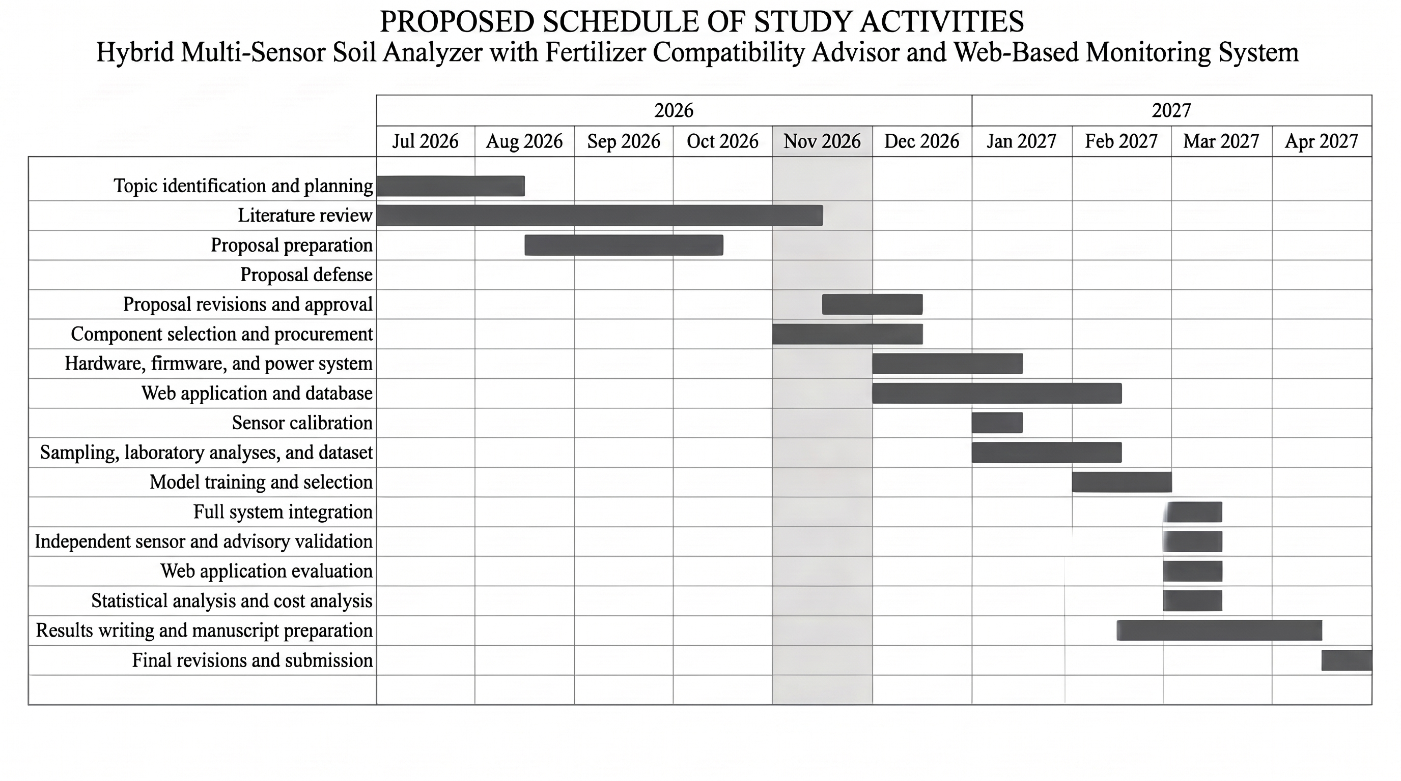
Appendix Figure A1. Proposed schedule of study from July 2026 to April 2027

