Introduction
The rapid advancement of technology has increased the demand for data centers around the world. New data centers have been built across the world in recent years. Many of those regions are already experiencing high levels of water stress, as the cooling systems that these facilities depend on require large amounts of water (Bloomberg, 2025). This growth is a challenge to the world's resources and land spaces, as data centers use limited resources such as land, power, and water.
In the Philippines, the proposed Pax Silica development in New Clark City, Capas, Tarlac, provides a local context for discussing infrastructure growth and resource demand. According to the Philippine Information Agency, the Bases Conversion and Development Authority (BCDA) describes the proposed development as a location for semiconductor and advanced manufacturing facilities. Public concerns have been raised about its possible effects on communities and the environment. BCDA has stated that the development will have planned water supply systems and dedicated electricity generation facilities (Reparejo, 2026). These statements describe proposed arrangements rather than measured results from an operating project.
The proposed Pax Silica development provides a local context for studying infrastructure growth and resource demand. In this study, that context is used to create a simplified simulation involving limited water and electricity supplies. Beyond the context of Tarlac, this spatially uneven development introduces a significant computational problem: how to efficiently model and simulate environments where resource demands are highly concentrated rather than evenly distributed.
From a computer science perspective, representing infrastructure and other objects across a simulated map involves spatial data management. A quadtree provides one way to organize objects according to their positions. An early form of this structure was described by Finkel and Bentley . In the capacity-based version proposed for this study, a map area is divided into four smaller cells when the number of objects it contains exceeds a set capacity. Subdivision continues where necessary until a defined stopping limit is reached (Mishraa, 2020). This creates smaller cells in crowded areas while allowing less crowded areas to remain in larger cells. Such organization can support searches within selected parts of the map. This study will compare the quadtree with a uniform grid-based approach to evaluate their processing time, memory use, and frames per second under the same test conditions.
Simulation games provide an interactive way to represent decisions and their consequences. Huang et al. (2025), for example, developed a serious game about a drinking-water contamination emergency that allowed participants to practice communication and decision-making. Maxim and Arnedo-Moreno (2025) reviewed serious-game design frameworks and identified common elements such as clear objectives, prototyping, testing, and repeated improvement. For Pocket Silica, the game will provide an interactive setting for representing infrastructure growth, water and electricity demand, and NPC protest responses. Its evaluation will focus on computational performance and whether the simulation follows its defined rules. Any claim that the game improves players’ understanding would require a separate evaluation.
This study, Pocket Silica, applies a quadtree-based spatial data structure to simulate infrastructure growth and its increasing demand for limited water and electricity. The simulation is presented through an interactive mobile game prototype.

Review of Related Literatures
Quadtree as a Spatial Data Structure
A quadtree is a tree structure that splits a two-dimensional space into four smaller parts whenever that space holds too much data. Instead of treating every part of a map the same way, a quadtree gives more detail to busy areas and leaves quiet areas alone. This idea is still being used and improved today. Zhou, Lin, Liu, Zheng, Li, and Zhang (2024) used a quadtree based method to plan where ocean sensors should be placed, so that fewer sensors could still gather useful data across a wide area. Their work shows that a quadtree can still solve real, modern problems that involve spreading limited resources across an uneven space, which is close to what this study aims to do with infrastructure and demand for water and electricity.

Quadtree Applications in Game Development
Game developers also use quadtrees to keep games running smoothly. A 2023 article from Game Developer explains that quadtrees let a game check only the objects near each other instead of checking every object on the map, which saves a lot of processing power as a game world grows bigger. Pinwheel Studio (2025) describes a similar method called cell-based culling, where nearby objects are grouped into cells, and the game only checks whether something changed within that cell instead of checking each object one by one. This is close to how this study plans to use a quadtree, since checking a whole cell at once instead of every data center on the map is exactly what keeps the simulation fast.

Serious Games for Water and Energy Resource Management
Games built around resource problems are not new, and several recent studies show how useful they can be, both for water and for energy. Huang, Ashcraft, and Mo (2025) built a serious game about a drinking water contamination crisis, where players had to act fast and communicate clearly to solve the problem before it spread. Their results showed that quick, honest communication helped players solve the crisis faster. McGiven, Poland, Reinking, and Müller (2025) created a game called Thirsty Earth, where players manage irrigation water under a changing climate. One important detail from their game is that water becomes more expensive as more players draw from the same source, which mirrors the idea of a shared resource getting strained as demand grows, a pattern that applies just as easily to electricity as it does to water. Wamucii and colleagues (2024) also built a game to help communities talk about water conflict in a river basin in Kenya and found that playing the game changed how people viewed the causes of water shortage in their area. These studies focus mainly on water, but the same lesson carries over to electricity, since both are limited resources that infrastructure growth competes for. This shows games are a strong way to help people understand resource problems, whether the resource being modeled is water, power, or both at once.

Realism in Serious Game Design
A game can only teach people the right lessons if it behaves close enough to how the real system works. Maxim and Arnedo Moreno (2025) reviewed many serious game design frameworks and found that most of them still try to balance two things that often pull against each other, how real the simulation feels and how enjoyable the game stays to play. Their review found that a realistic prototype, meaning one that closely copies real-world behavior, is often treated as an important step in building a serious game properly. This supports the idea that a simulation like the one in this study needs to behave correctly, not just look good, in order to be trusted as a learning tool.

Research Gap
The reviewed literature discusses quadtree applications and games involving resource management. However, the reviewed studies do not provide the specific comparison proposed in this study: a quadtree and a uniform grid performing the same spatial operations in a mobile simulation involving water and electricity. Pocket Silica will examine this comparison under identical test conditions and check whether both implementations produce the expected results.

Synthesis
The reviewed literature provides a basis for using spatial data structures and interactive simulations to represent resource-related problems. Pocket Silica brings these ideas together in a mobile prototype that models infrastructure growth and demand for water and electricity. The study will compare a quadtree-based implementation with a uniform grid-based implementation and verify their calculations using predefined test scenarios. The proposed Pax Silica development provides contextual background rather than a basis for predicting actual environmental outcomes.

Objectives
This study aims to design, develop, and evaluate a quadtree-based spatial simulation algorithm, implemented in a mobile game prototype called Pocket Silica, that models infrastructure growth and conflicts over limited water resources. Water resource conflict is the focus of the study, while electricity is included only as a supporting game mechanic. The proposed Pax Silica development in Tarlac serves as the contextual background. Specifically, the objectives of the study are as follows:
- To design a quadtree-based spatial data structure that organizes infrastructure entities and supports the spatial operations required by the simulation.
- To implement the quadtree-based algorithm in a mobile game prototype that models infrastructure growth, water demand, and shortages caused by limited water supply.
- To compare the quadtree-based simulation with a uniform grid-based approach in terms of processing time, frames per second (FPS), and memory use under the same test conditions.
- To verify that the simulation correctly applies the intended rules for infrastructure growth, water supply and demand, water shortages, and NPC protest responses to water shortages.

Conceptual Framework
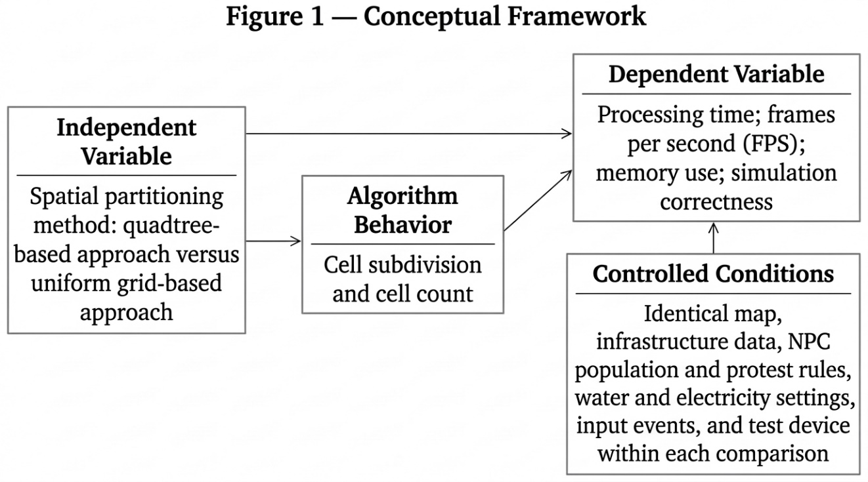
Figure 1: Conceptual Framework
Figure 1 shows the planned comparison between the quadtree-based and uniform grid-based approaches. The independent variable is the spatial partitioning method. The measured outcomes are processing time, frames per second (FPS), memory use, and simulation correctness. Both approaches will use identical conditions within each test scenario, including the map, infrastructure data, NPC population and protest rules, resource settings, input events, and test device. Cell subdivision and cell count will provide additional observations about how the spatial structures operate. Correctness will be checked using predefined cases with expected results for infrastructure growth, resource calculations, and NPC protest responses.

Paradigm of the Study
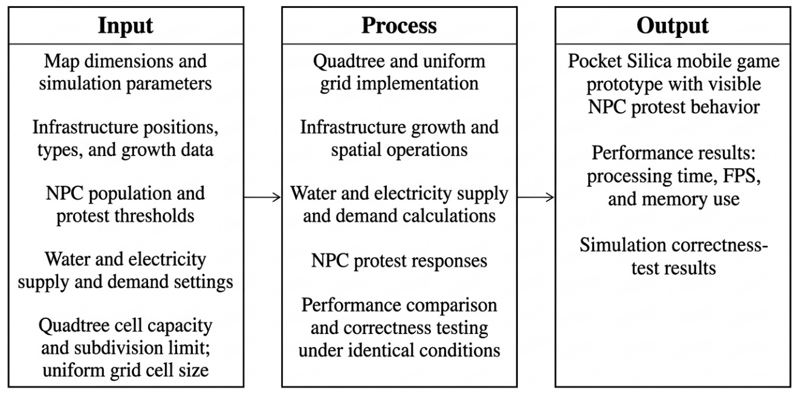
Figure 2: Paradigm of the Study (IPO Chart)
Figure 2 presents the study through the Input, Process, and Output (IPO) model. The inputs include map dimensions, infrastructure data, NPC population, protest thresholds, water and electricity settings, and the configuration of each spatial structure. The process includes implementing the quadtree and uniform grid, running infrastructure growth and spatial operations, calculating resource supply and demand, and updating NPC protest responses. Both implementations will be compared under identical test conditions, and their outputs will be checked against predefined expected results. The outputs are the Pocket Silica mobile game prototype, performance results for processing time, FPS, and memory use, and simulation correctness-test results.

Scope and Delimitation
This study focuses on the design, development, and evaluation of a quadtree-based spatial simulation algorithm implemented in a mobile game prototype called Pocket Silica. The simulation represents infrastructure growth and its increasing demand for two limited resources: water and electricity. Water resource conflict is the focus of the study, while electricity is included only as a supporting game mechanic. It also includes NPCs that protest when either resource reaches a defined low-supply threshold. The proposed Pax Silica development in Tarlac provides a contextual background. The study covers the quadtree’s design, including subdivision when a cell’s entity count exceeds its capacity, subject to a stopping limit. It also covers implementation in the prototype and comparison with a uniform grid-based approach using processing time, frames per second (FPS), and memory use. Predefined test scenarios will check whether infrastructure growth, resource calculations, and NPC protest responses follow the intended rules. Publicly reported information will provide background, while any estimated values used in the simulation will be documented as model assumptions.
The study will not collect field measurements of water availability, electricity supply, land conditions, or actual infrastructure demand in Tarlac. The prototype will not include multiplayer features or in-app purchases. Player enjoyment, engagement, and learning outcomes will not be evaluated because the study focuses on computational performance and simulation correctness. The simulation will not predict the actual environmental effects of Pax Silica or provide policy recommendations on whether the project should proceed. Performance testing will be limited to the development and testing devices available to the researcher, and conclusions will apply to the configurations and scenarios tested.

Significance of the Study
This study will be useful to different groups, from the wider community down to the people who will use it directly.
To government and planning agencies, this study may provide a simple visual example of how infrastructure growth and limited water and electricity supplies interact under defined simulation rules. It does not replace environmental assessments or engineering studies.
To the academic community, this study will provide an example of applying a quadtree to a mobile simulation involving infrastructure growth, water, electricity, and NPC protest responses. Its comparison with a uniform grid-based approach will provide evidence about the performance of the two implementations under the same test conditions. The documented methods and results may also serve as a reference for related computer science research.
To game developers, this study offers a working example of how a quadtree can be built into a simulation game. Developers who want to make games about growth, resources, or strategy may use this as a simple reference.
To students taking up Computer Science, this study can serve as a guide for future thesis work that combines algorithms with real-world issues. It shows that a technical topic like data structures can still be built around a story that people care about.
To players, the prototype may provide an interactive way to observe how infrastructure growth affects water and electricity demand within the simulation. Whether it improves understanding would require a separate evaluation.
To future researchers, this study leaves room for more work. Someone else can take the same idea and improve the algorithm, add more realistic data, or test it on a bigger scale.
Definition of Terms
Quadtree - A hierarchical spatial data structure that recursively partitions a two-dimensional region into four equal quadrants whenever the number of entities within that region exceeds a predefined maximum capacity, continuing until each resulting cell falls within capacity or a minimum cell size is reached.
Spatial Simulation - A computational model that represents the state and behavior of entities distributed across a two-dimensional space over time.
Resource Conflict - A simulated condition in which demand for water or electricity exceeds the available supply, leaving some demand unmet.
Cell Capacity - The entity-count threshold used to determine when a quadtree cell should subdivide, subject to the defined stopping limit.
Baseline Grid-Based Approach - A uniform spatial partitioning method, used for comparison purposes, in which the simulated space is divided into equally sized cells regardless of entity density or distribution.
Resource Demand — The amount of water or electricity an entity requires during a simulation step.
Resource Shortage — The portion of water or electricity demand that the available supply cannot meet.
Non-Player Character (NPC) — A character controlled by the simulation that responds through protests when water or electricity reaches a defined low-supply threshold.

Research Methodologies
Research Design
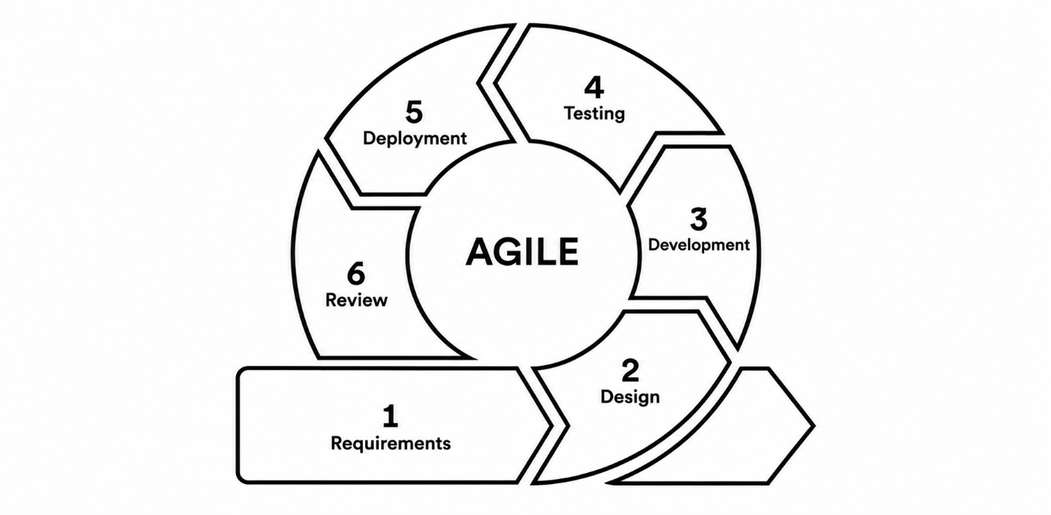
Figure 3: Research Design (Agile Methodology)
This study will develop a mobile simulation prototype and evaluate it through controlled computational experiments. A quadtree-based implementation and a uniform grid-based implementation will be tested using identical maps, infrastructure data, NPC settings, water and electricity rules, and input events within each test scenario. Their processing time, frames per second (FPS), and memory use will be compared. Separate correctness tests will check spatial operations, infrastructure growth, resource calculations, and NPC protest responses against predefined expected results.
Agile will guide the development of Pocket Silica through repeated cycles of planning, design, implementation, testing, and review. This approach will allow the spatial data structures, simulation rules, and mobile interface to be developed and checked in manageable parts. Feedback and test results from each cycle will guide improvements in the next cycle.

Requirements. The researcher will identify the functions required for the prototype, including the quadtree, uniform grid baseline, infrastructure growth, water and electricity calculations, NPC protest behavior, and performance recording. Each function will have a defined expected behavior that can be checked during testing.
Design. The researcher will plan how entities are represented and organized on the map, which spatial operations both implementations will perform, and how the quadtree will subdivide cells. The design will also define infrastructure growth, resource demand and supply calculations, simulation updates, and NPC protest behavior. This will include the resource thresholds that trigger protests and the conditions under which protests end. Both implementations will use the same simulation rules.

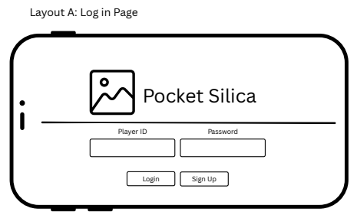

Figure 4: Login Screen

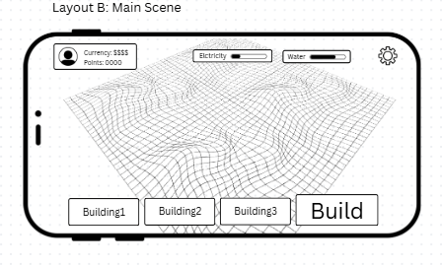
Figure 5: Main Screen
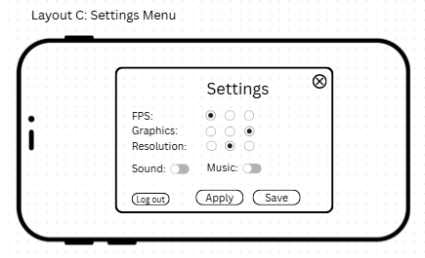

Figure 6: Settings View

Development (Sprints). The prototype will be developed through short, repeated sprints. Each sprint will focus on a working part of the system, such as the spatial data structures, infrastructure growth, resource calculations, NPC protest responses, performance recording, or mobile interface. The functions completed during each sprint will be tested before being integrated with the rest of the prototype.
Testing. The researcher will use predefined scenarios with known expected results to check whether the prototype follows its rules. Tests will cover entity placement, spatial operations, cell subdivision, infrastructure growth, water consumption, electricity supply and demand, and NPC protest responses. Protest tests will check the defined triggering thresholds and ending conditions. Failed tests will be investigated, corrected, and repeated. Performance tests will compare both implementations under identical conditions using processing time, FPS, and memory use.
Deployment. After the required functions have been implemented and checked, a working version of Pocket Silica will be prepared for the planned performance tests and technical evaluation. The build and settings used for the recorded tests will be identified so that the results can be traced to the version evaluated.
Review. At the end of each sprint, the researcher will examine the completed functions, test results, and remaining problems. Adviser feedback may also guide revisions. The findings will be used to identify corrections and plan the next sprint.
Agile is suitable for this study because it allows the algorithm and prototype to be checked throughout development. Repeated testing and review will help identify problems early and support improvements before the final evaluation.

Research Environment
The study will be conducted using a personal computer or laptop for developing and testing Pocket Silica. The prototype will be developed using Unity version 6.6 and C#. Performance testing will be conducted on the installed Android application using a Xiaomi POCO X7 Pro running Android 16, with a Dimensity 8400 processor and 8 GB of RAM. The test platform will be identified as an installed mobile application to ensure that the performance results accurately describe the environment tested.
Both the quadtree-based and uniform grid-based implementations will be tested using the same device, build configuration, graphics settings, and measurement procedure within each comparison. Processing time, frames per second (FPS), and memory use will be recorded. Testing will be limited to the available devices, and conclusions will apply to the configurations and scenarios evaluated.

Respondents of the Study
The study will involve 50 technical evaluators with relevant experience in Computer Science, Information Technology, software development, algorithms, or game development. They will be selected based on their ability to review the prototype’s required functions and provide relevant technical feedback.
The evaluators will review the finished Pocket Silica prototype using an evaluation checklist. Their review will cover infrastructure growth, water and electricity behavior, NPC protest responses, and other required functions. Their feedback will support the technical evaluation, while computational performance and simulation correctness will also be assessed through recorded measurements and predefined tests.

Research Instrument
The study will use a performance testing tool, a correctness-test record, and an evaluation checklist.
The performance testing tool, Unity Profiler, will record processing time, FPS, and memory use for both implementations. Processing time will be measured in milliseconds for the defined simulation operation or update. FPS will be recorded during the measured run, while memory use will be reported according to the selected tool’s measurement definition. The same measurement procedure will be used for both implementations.
The correctness-test record will contain each test scenario, its initial conditions, expected output, actual output, and pass or fail result. It will cover spatial operations, infrastructure growth, water and electricity calculations, and NPC protest responses.
The evaluation checklist will contain items based on the study’s objectives and required functions. Evaluators will indicate whether the functions behave as expected and may provide written comments. The checklist will be reviewed by the adviser for clarity and relevance before it is used.

Data Gathering Procedure
Data will be gathered in two stages. In the first stage, the researcher will conduct correctness tests and performance tests on both implementations. Correctness tests will use predefined scenarios with known expected results, including resource calculations, spatial operations, and NPC responses at the defined protest thresholds. Expected and actual outputs will be recorded. Identified errors will be corrected and the affected tests repeated.
Performance testing will use the same maps, infrastructure data, NPC settings, resource rules, and input events for both implementations. For each scenario, each implementation will be tested in 20 runs, with each measured run lasting 60 seconds. Initial loading will be excluded from the measured interval. Processing time, FPS, and memory use will be saved together with implementation, scenario, device, and build information. Interruptions and repeated runs will be documented.
In the second stage, the researcher will explain the evaluation tasks to the technical evaluators and obtain their consent. The evaluators will review the working prototype, complete the checklist, and provide comments or suggestions. Their responses will be organized using participant codes.

Data Treatment
Performance results will be grouped by implementation and test scenario. The mean, or average, processing time, FPS, and memory use will be calculated across repeated runs. The standard deviation will describe how much the measurements vary between runs. Tables and graphs will present the differences between the two implementations under the tested conditions. Processing time, FPS, and memory use will be interpreted separately because an improvement in one measure may involve a cost in another.
Correctness test results will be summarized using the number of passed and failed cases. Differences between expected and actual outputs will be explained, including errors involving resource calculations, spatial operations, and NPC protest behavior. Corrections and retest outcomes will also be documented.
Evaluation checklist responses will be summarized using frequency counts for each response option. Written comments will be grouped according to recurring issues and suggestions. The discussion will relate these findings to the study’s objectives and acknowledge the limits of the tested devices, scenarios, and evaluator group.

Ethical Considerations
Participation in the technical evaluation will be voluntary. Before the evaluation, participants will receive an explanation of the study’s purpose, the tasks involved, the expected time required, and how their responses will be used. They may decline or stop participating without penalty. Any institutional approval required for the evaluation will be obtained before data collection.
Only information necessary for the evaluation will be collected. Participant codes will be used in the analysis, and identifying details will be excluded from reported results. Evaluation records will be stored securely, with access limited to authorized research personnel.
All sources used in the paper will be acknowledged accurately. Reported information about Pax Silica will be distinguished from the assumptions and fictional events used in Pocket Silica. Performance results, failed tests, and evaluator feedback will be reported honestly.

References
Background, Global and Local Context
ASTIG.ph. (2026, July 25).
Pax Silica is coming to the Philippines: What the 4,000-acre AI hub really means.
https://astig.ph/pax-silica-philippines-4000-acre-ai-hub/
GMA News Online. (2026).
BCDA: No data centers in Pax Silica Tarlac site, only semiconductor manufacturing hubs.
https://www.gmanetwork.com/news/money/economy/997585/pax-silica-bcda-no-data-centers-tarlac/story/
Inquirer.net. (2026, July 31).
Pax Silica brings promise, but at what cost? https://newsinfo.inquirer.net/2274123/pax-silica-brings-promise-but-at-what-cost
Inquirer.net. (2026).
Pax Silica site development eyed in 3 to 5 years. https://business.inquirer.net/604771/pax-silica-site-development-eyed-in-3-to-5-years
International Energy Agency. (2025).
Data centre electricity use surged in 2025, even with tightening bottlenecks driving a scramble for solutions.
https://www.iea.org/news/data-centre-electricity-use-surged-in-2025-even-with-tightening-bottlenecks-driving-a-scramble-for-solutions
Nicoletti, L., Ma, M., & Bass, D. (2025, May 8).
The AI boom is draining water from the areas that need it most. Bloomberg. https://www.bloomberg.com/graphics/2025-ai-impacts-data-centers-water-data/
Philippine News Agency. (2026).
Pax Silica AI hub to start development in 3 to 5 years. https://www.pna.gov.ph/articles/1281392
Philstar.com. (2026, July 27).
Scientists' group debunks claims on Pax Silica project. https://www.philstar.com/headlines/2026/07/27/2545030/scientists-group-debunks-claims-pax-silica-project
Reparejo, A. J. R. (2026, August 10).
BCDA clarifies misconceptions on Pax Silica project in New Clark City
https://pia.gov.ph/news/bcda-clarifies-misconceptions-on-pax-silica-project-in-new-clark-city/
Tech Pilipinas. (2026).
BCDA: No data centers in Pax Silica Tarlac site, only chip plants. https://techpilipinas.com/bcda-no-data-centers-pax-silica-tarlac-site-only-chip-plants

Quadtree and Spatial Data Structures
Game Developer. (2023, December 9).
Quadtree in Unity.
https://www.gamedeveloper.com/programming/quadtree-in-unity
Pinwheel Studio. (2025, September 25).
How to do cell-based culling using quadtree in Unity C#, part 1. https://www.pinwheel.studio/post/how-to-do-cell-based-culling-using-quadtree-in-unity-c-part-1
Zhou, Y., Lin, P., Liu, H., Zheng, W., Li, X., & Zhang, W. (2024).
Fast and flexible spatial sampling methods based on the Quadtree algorithm for ocean monitoring. Frontiers in Marine Science, 11. https://doi.org/10.3389/fmars.2024.1365366

Realism in Serious Game Design
Maxim, R. I., & Arnedo Moreno, J. (2025).
Identifying key principles and commonalities in digital serious game design frameworks: Scoping review. JMIR Serious Games, 13, e54075. https://doi.org/10.2196/54075

Serious Games for Water Resource Management
Huang, J., Ashcraft, C. M., & Mo, W. (2025).
Gamifying water crisis management: A serious game for drinking water contamination emergency response. PLOS ONE, 20(4), e0321210. https://doi.org/10.1371/journal.pone.0321210
McGiven, L., Poland, K., Reinking, C., & Müller, M. F. (2025).
Thirsty Earth: A game-based approach to interdisciplinary water resource education. Hydrology and Earth System Sciences, 29, 2961–2980. https://hess.copernicus.org/articles/29/2961/2025/
Wamucii, C. N., et al. (2024).
Guiding community discussions on human water challenges by serious gaming in the upper Ewaso Ngiro River basin, Kenya. Hydrology and Earth System Sciences, 28, 3495–3512.
https://hess.copernicus.org/articles/28/3495/2024/

