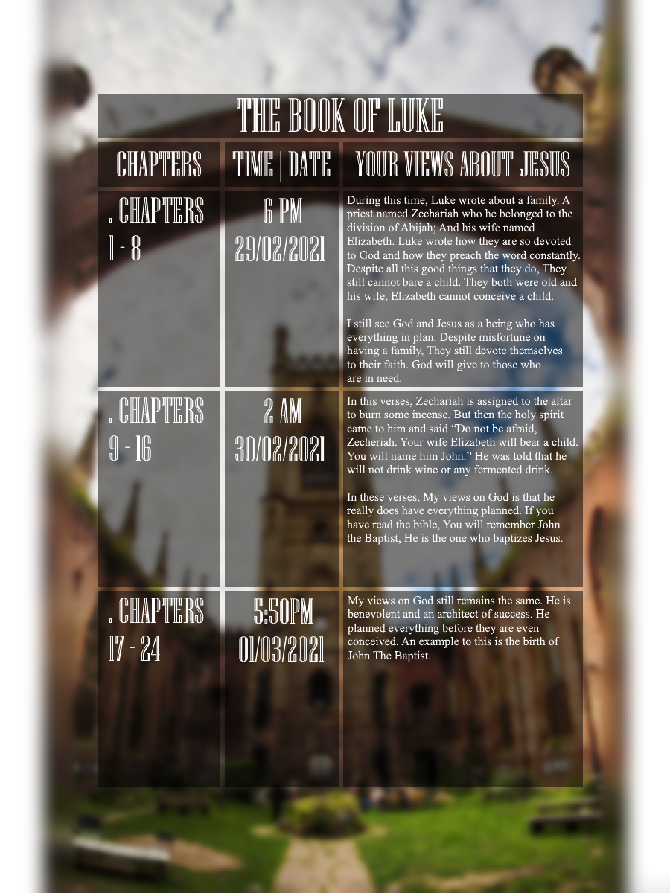

**My Experience**

Soriano, Juan Carlos V. – CS-IT1

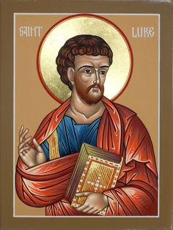 My experience upon reading the Book of Luke gave me insights on how marvellous God’s plan really is. It goes to show that even though we are not yet conceived we already have a destined plan set among us. I might be something else tomorrow, But it’s all in the plan of God. Just like the story of John The Baptist, It was God’s plan for John The Baptist to baptize Jesus to formally introduce him to Christianity. The story goes that John The Baptist was born from a family that is religious. Even though they devote themselves to the religion, They still couldn’t bare a child. The husband name was “Zecheriah” and his wifes’ name is “Elizabeth”. Both of them love each other and the Lord. But still, They couldn’t bare a child.

With the Grace of God they were able to conceive a child even though they are infertile; The Holy spirit then blessed the family by the will of God. Like I said on the first paragraph, God has a plan for everyone. It’s at this point how I got to connect all the dots. At first, I thought the child that was going to be born was Apostle John, But when I read even more, I found out that it was John the Baptist, The same John that baptized Jesus.

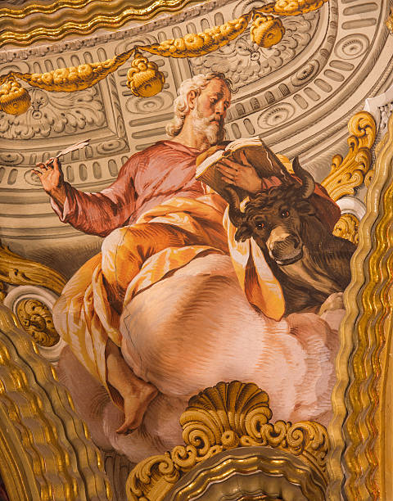 My take away from the entire book will be split into two parts. What I think Luke wanted the people to know after reading this and what can you do after reading the Book of Luke. Firstly what I think Luke wanted the people to know after reading the Gospel of Luke. Luke essentially wrote about the story of Zecheriah. It was wrote here that God has planned everything before we even know what can happen. Zechariah and Elizabeth even at the young age, They couldn’t bare a child; Elizabeth was infertile. But with the Grace of God they were given a son, The Child’s name is John; John The Baptist. He was then told that he will become mute while Elizabeth is conceiving their child, Only when the child is born, He will get his voice back. With all the events that happened here, I believe that Luke wants us to believe in blind faith. We must trust in the voice of God. Believe in his plans and trust in your faith.

Secondly, What can you do after reading the Book of Luke. I think what we could do after reading the Book of Luke is by believing in your faith. Trust in the process, Trust with God’s plan “Behold, God is my salvation; I will trust, and will not be afraid; for the LORD GOD is my strength and my song, and he has become my salvation. -Isaiah 26:3-4