Assignment 3

1

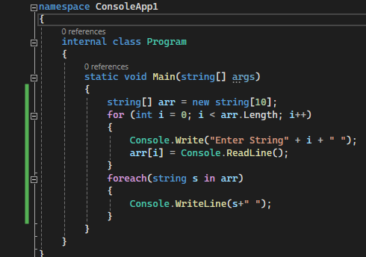

2

