**ILIAS Plugin**

**CtrlMainMenu**

|  |  |
| --- | --- |
| Document version date: | 8..August 2014 |
| Document version number: | 1.3 |
| Document author | Martin Studer, studer + raimann ag  Fabian Schmid, studer + raimann ag |
| Plugin Version: | 2.3 and above |

**Document History**

|  |  |
| --- | --- |
| Version 1.0, 01.12.2013 | created |
| Version 1.1, 11.07.2014 | Updated Installation-Guide with git |
| Version 1.3 | New Entry-Types |

**Table of contents**

1 Introduction 4

2 Installation 5

2.1 Create the Plugin Directory 5

2.2 Get the Plugin from SVN 5

3 Configuration (ILIAS 4.3) 6

3.1 Navigate to the Plugin Administration 6

3.2 Create the Database Tables 6

3.3 Activate the Plugin 7

3.4 Configure the Plugin 7

3.5 Configure the links Desktop and Repository 8

3.6 Add additional Entries 9

4 Additional Entries 10

4.1 Overview 10

4.2 ilCtrl 11

4.3 URL 12

4.4 DropDown 12

4.5 Ref-ID 13

4.6 Last Visited 13

# Introduction

The CtrlMainMenu-Plugin gives you the possibility to customize the Main Menu of ILIAS by configuration.

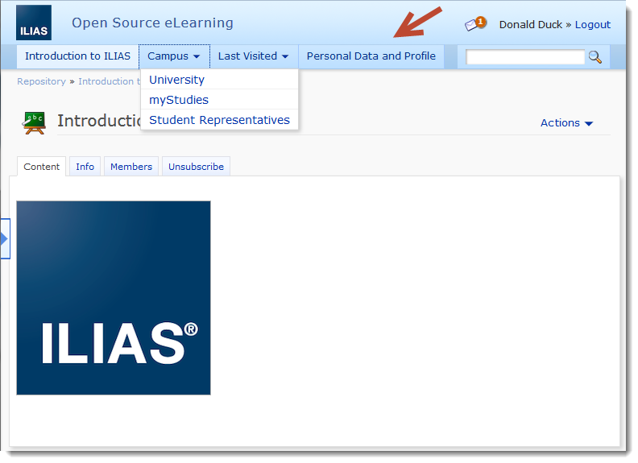

|  |  |
| --- | --- |
| ILIAS Version | 4.4 and above |
| Pricing Model | Free of charge |
| Download | <http://www.ilias.de/docu/goto_docu_wiki_1357_CtrlMainMenu_Plugin.html> |
| Paid Support | <http://studer-raimann.ch/dienstleistungen/support.html> |
| Feature Requests | <http://www.ilias.de/docu/goto_docu_wiki_1357_CtrlMainMenu_Plugin.html> |
| Bug Tracker | <http://www.ilias.de/mantis> |

**Please register your Institution at the following wiki page. So you let us know that you use this plugin and we will publish the Plugin also for 4.5, 4.6 and further.**

<http://www.ilias.de/docu/goto_docu_wiki_1357_CtrlMainMenu_Plugin.html>

# Installation

## Create the Plugin Directory

[ILIAS-WWW]/Customizing/global/plugins/Services/UIComponent/UserInterfaceHook

## Get the Plugin from GitHub

The project can be found on github: https://github.com/studer-raimann/CtrlMainMenu

git clone <https://github.com/studer-raimann/CtrlMainMenu.git> CtrlMainMenu

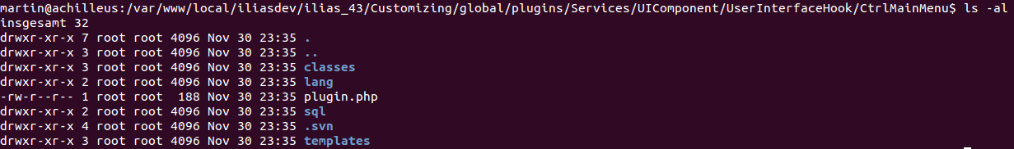Abbildung 1: Example Directory Structure

# Configuration (ILIAS 4.3)

## Navigate to the Plugin Administration

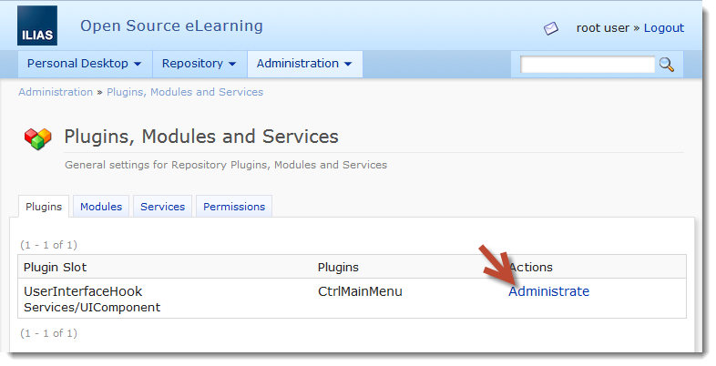

## Create the Database Tables

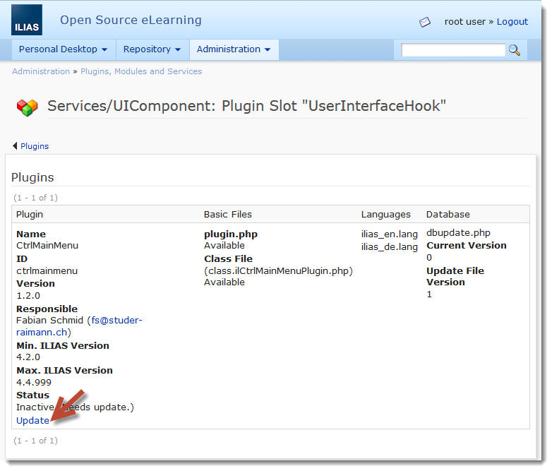

## Activate the Plugin

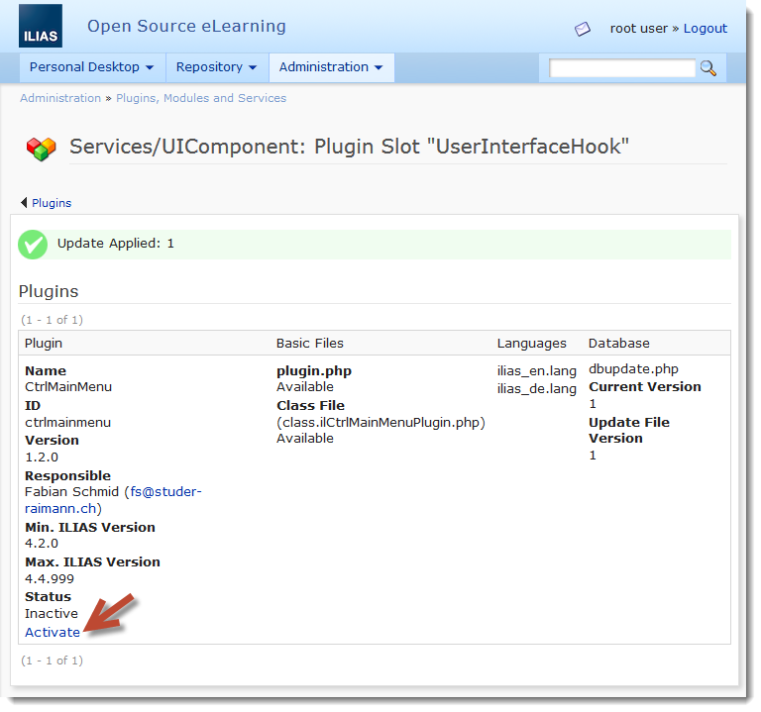

## Configure the Plugin

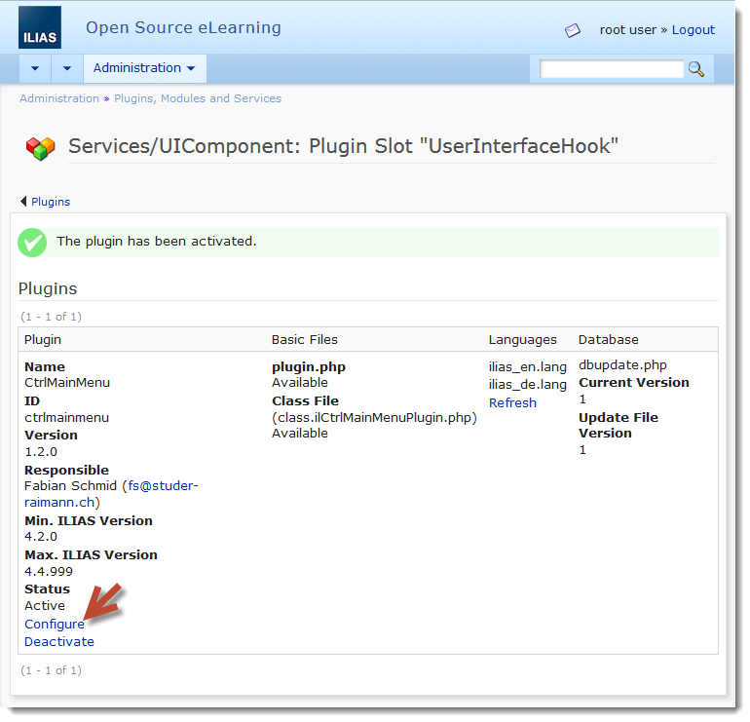

## Configure the links Desktop and Repository

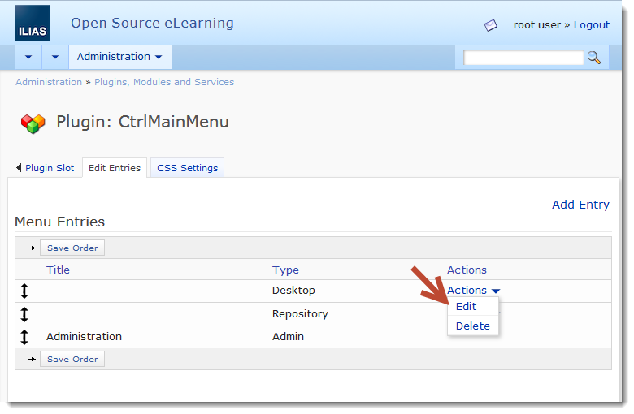

### Choose the Access Type and the Titles

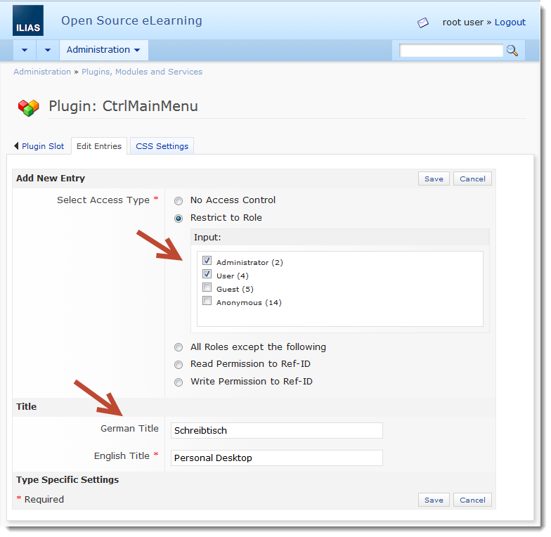

## Add additional Entries

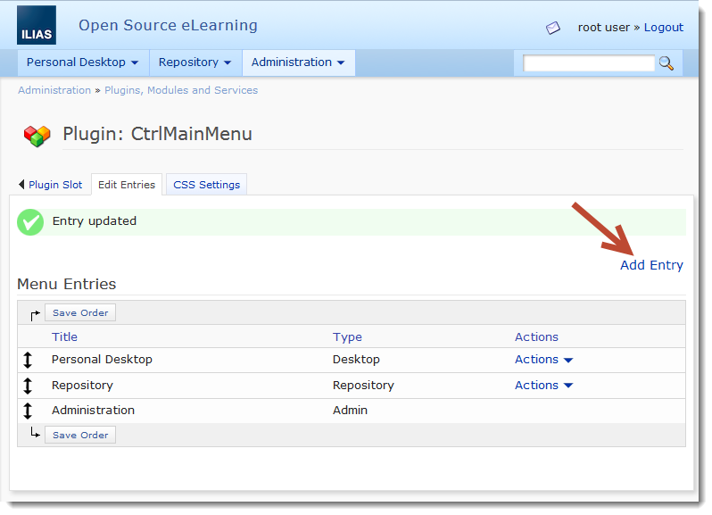

# Global Settings

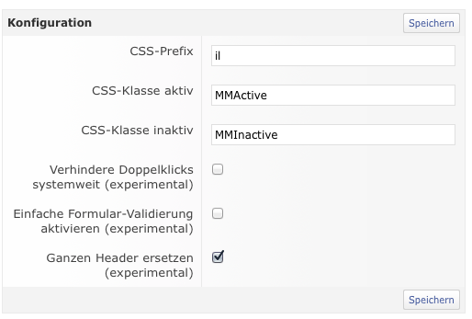

|  |  |
| --- | --- |
|  |  |
| CSS-Prefix | It’s easier to customize a ILIAS-Menu with own css-Prefixes. An example can be activeatd by setting to „fb“. |
| CSS active-Class | Class of an active Entry |
| CSS inactive-Class | Class of an inactive Entry |
| Prevent double-clicks globally | An experimental implementation of a overlay to prevent double-clicks in ILIAS. |
| Simple Form-Validation | An experimental implementation of a Form-Validator |
| Replace full header | You can replace the full ILIAS-Header with the Ctrl-Main-menu-Plugin which allows e left and a right MainMenu (e.g. in following Screenshot) |

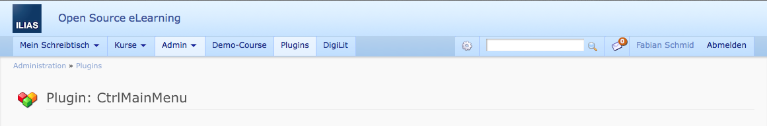

# Set Permissions of an Entry

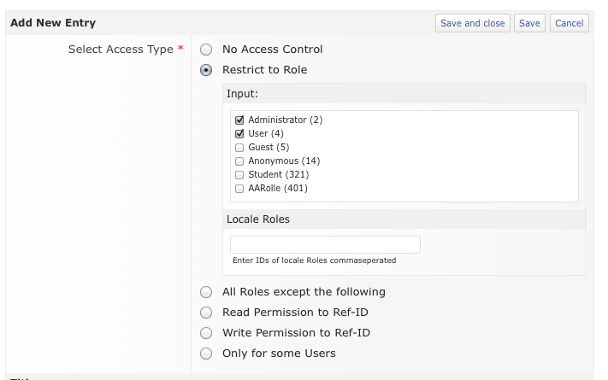

You can restrict Entries with the following settings:

|  |  |
| --- | --- |
|  |  |
| No access control | The entry is always visible |
| restrict to role | Choose one or more global roles, which see the entry. Local roles can be added comma-separated |
| All roles except the following | All roles except oft he chosen will see the entry |
| Read-Permission to ref-id | Only users with read-permission on e ref-id can see the entry |
| Write-Permission to ref-id | Only users with write-permission on e ref-id can see the entry |
| Only for some users | Add user-ids comma-separated which can see the entry. |

# Additional Entries

## Overview

You can add the following entry types

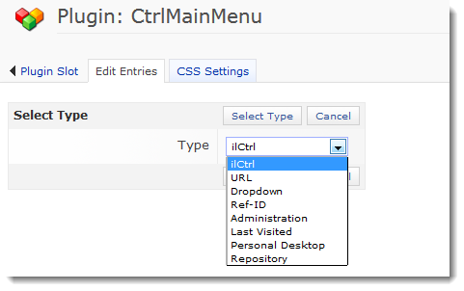

## ilCtrl

Link to a specific GUI of ILIAS e.g. Personal Data and Profile

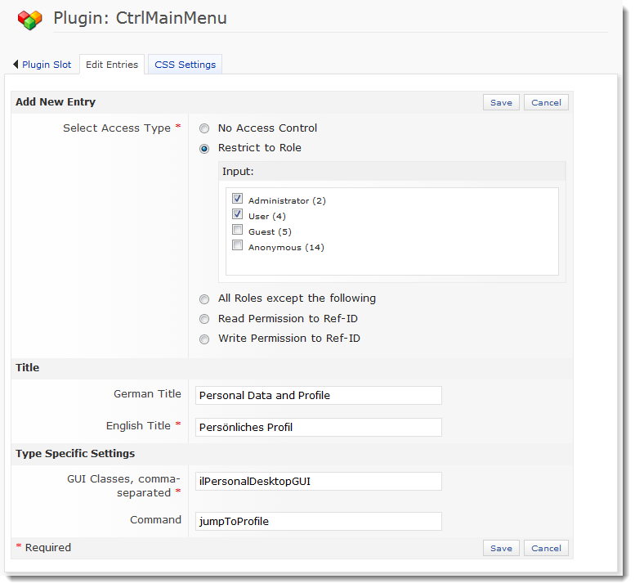

**ilCtrl Use Case**This is a good solution for ILIAS-Installations without a “Personal Desktop”

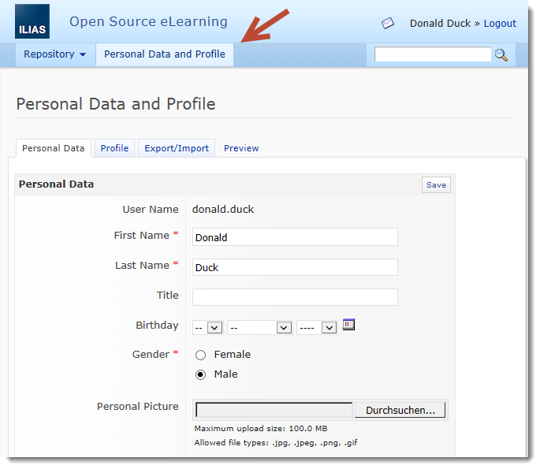

## URL

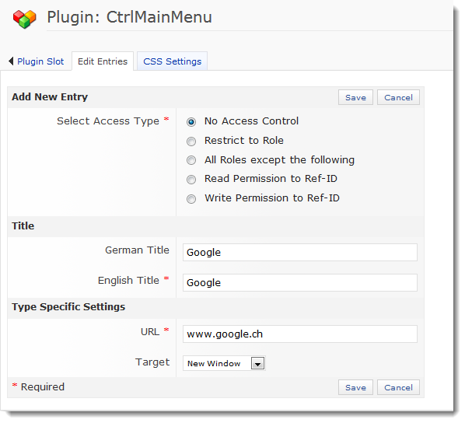

## DropDown

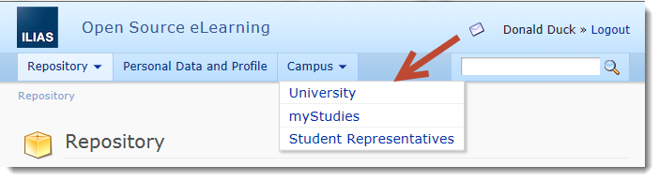

## Ref-ID

You have the possibility to link to any ILIAS Repository Object by Ref-ID.

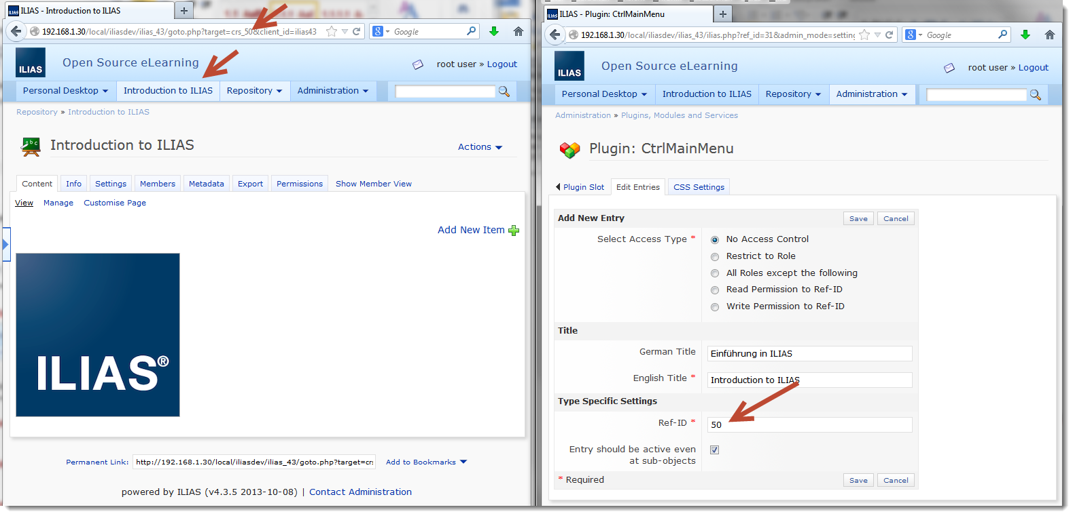

## Last Visited

The Last Visited Menu as you know it from ILIAS 4.2.

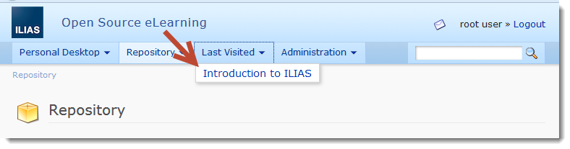

## User-Settings

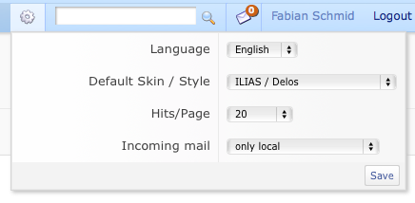

## Quick-Search

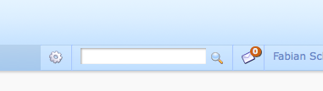

## Mail-Status

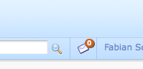

## Authentification

