3.2.8 Authentication/Manage Account Information

Introduction/Purpose of this feature

3.2.8.1 Domain Model

3.2.8.1.1 Activity Diagram

Not applicable.

3.2.8.1.2 Class Diagram

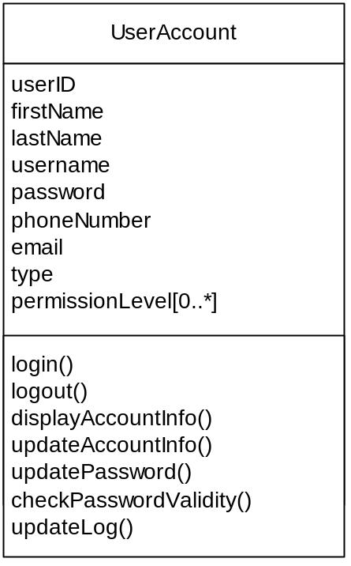
Figure 1 - Authentication/Manage Account Information – Class diagram

3.2.8.2 Use Case Model

The following figure provides the Authentication/Manage Account Information use case diagram.

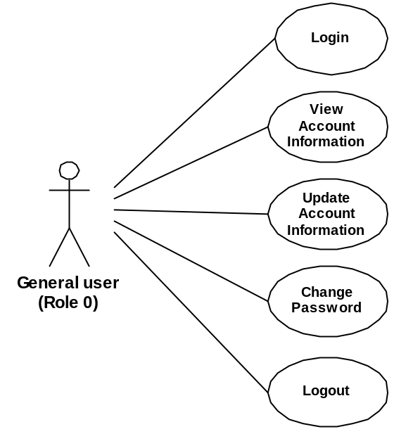
Figure 2 - Authentication/Manage Account Information – Use case diagram

The following paragraphs provide the detailed description for each use case.

3.2.8.2.1 Login

Role: General users (Role 0);
Pre-condition: Unauthenticated session;
Steps:
- The user selects the Login button accessible from the IUfA UUIS Home page;
- The system displays the Login page;
- The user provides username, password, and string of displayed image (CAPTCHA);
- The user selects the Submit button;
- The system, if the provided information is incomplete or erroneous, displays an error message to the user:
  - The user selects the Return button; and
  - The system displays the Login page with blank fields;
- The system fetch user permission level and displays IUfA UUIS main page with menus corresponding to user permission level;
- The system:
  - Creates a new log record to the database;
  - Assigns the log entry a unique identification number (logID);
  - Registers the user ID, and login date;
Post-conditions:
- Authenticated session; and
- A new log entry is stored in the database;
Exceptions:
- The user cancels the login by selecting the Cancel button from the Login page:
- The system displays the IUfA Home page; and
- The system does not store any updated information;
- A database error is encountered:
- The system displays an error message;
- Invalid username, password and/or string (CAPTCHA):
- The system displays an error message.

3.2.8.2.2 View Account Information

Role: General users (Role 0);
Pre-condition: Authenticated session;
Steps:
- The user selects the View account button under the MyProfile tab (accessible from all system pages);
- The system displays the View Account Information page with:
- Username
- First name;
- Last name;
- E-mail;
- Phone number;
- Type;
- Permission level;
Post-conditions: The system displays the View Account Information page;
Exceptions:
- A database error is encountered:
- The system displays an error message.

3.2.8.2.3 Update Account Information

Role: General users (Role 0);
Pre-condition: Authenticated session;
Steps:
- The user selects the Update account button under the MyProfile tab (accessible from all system pages);
- The system displays the Update Account Information page with:
- Un-editable fields:
    - Username;
    - Permission Level;
    - Type
- Editable fields (all mandatory);
    - First name;
    - Last name;
    - E-mail;
    - Phone number;
- The user edits/updates the above fields as applicable;
- The user selects the Submit button;
- The system, if any of the above fields are incomplete, displays a message indicating the missing information and request the user to provide it:
  - The user selects the Return button; and
  - The system displays the Update Account Information page with current information;
- The system displays a message with the user provided information and requesting the user to confirm the submission:
  - The user selects the Confirm button; or
  - The user selects the Return button;
    - The system displays the Update Account Information page with current information;
- The system updates the User database entry with the applicable changes;
Post-conditions:
- The system displays the View Account Information page with updated information; and
- The updated user information is stored in the database;
Exceptions:
- The user cancels the update by selecting the Cancel button from the Update Account Information page:
  - The system displays the View Account Information page; and
  - The system does not store any updated information;
- A database error is encountered:
- The system displays an error message.

3.2.8.2.4 Change Password

Role: General users (Role 0);
Pre-condition: Authenticated session;
Steps:
- The user selects the Change Password button under the MyProfile tab (accessible from all system pages);
- The system displays the Change Password page that requests the user to confirm old password once, and to enter new password twice;
- The user enters the appropriate information and select the Submit button;
- The system, if the provided information is incomplete or erroneous, displays an error message to the user:
  - The user selects the Return button; and
  - The system displays the Change Password page with blank fields;
- The system:
  - Validates the old and new password;
  - Updates the User database entry with the new password;
  - Displays a confirmation message to the user that password has been successfully changed;
    - The user selects the Return button;
Post-conditions:
- The system displays the Password Successfully Changed page; and
- The updated user password is stored in the database;
Exceptions:
- The user cancels the update by selecting the Cancel button from the Change Password page:
  - The system displays the Change Password page with blank fields; and
  - The system does not store any updated information;
- Invalid old or new passwords are entered:
  - The system displays the an error message;
- A database error is encountered:
- The system displays an error message.

3.2.8.2.5 Logout

Role: General users (Role 0);
Pre-condition: Authenticated session;
Steps:
- The user selects the Logout button accessible from all system pages;
- The system displays a message requesting the user to confirm the logout:
  - The user selects the Confirm button; or
  - The user selects the Return button;
    - The system displays the original system page from which the Logout button was accessed);
- The system updates the log database entry with the logout date;
- The system displays the IUfA UUIS Home page.
Post-conditions:
- Unauthenticated session; and
- The logout date is stored in the database;
Exceptions:
- A database error is encountered:
- The system displays an error message.

3.2.8.3 Functional Requirements

TBD

3.2.8.4 Data Dictionary

The following figure provides the Authentication/Manage Account Information E/R diagram.

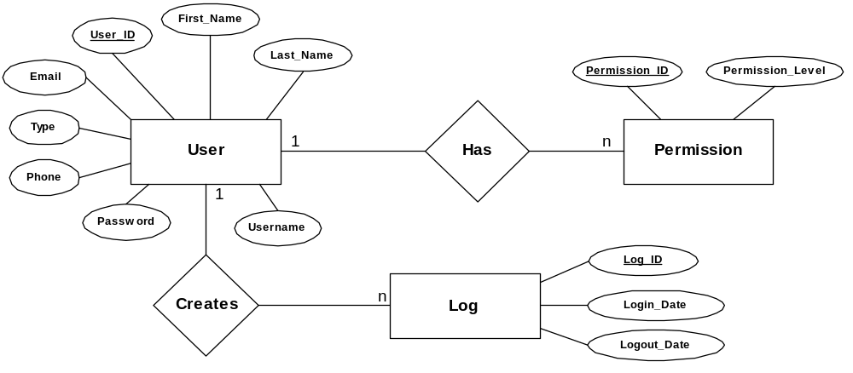
Figure 3 - Authentication/Manage Account Information – E/R diagram

Table 1 – Entity User – Data dictionary
field | type | null | default | comment
User_ID (PK) | int | No |  | Auto increment
Type | int | No
Username | varChar(15) | No
Password | varChar(15) | No
First_Name | varChar(30) | No
Last_Name | varChar(30) | No
Email | varChar(50) | No
Phone | varChar(12) | No

Table 2 – Entity Permission – Data dictionary
field | type | null | default | comment
Permission_ID (PK) | int | No |  | Auto increment
User_ID | int | No |  | Foreign Key to User table
Permission_Level | int | No | 0

Table 3 – Entity Log – Data dictionary
field | type | null | default | comment
Log_ID (PK) | int | No |  | Auto increment
User_ID | int | No |  | Foreign Key to User table
Login_Date | date | No |  | Timestamp
Logout_Date | date | Yes | Null | Timestamp

