Mathias Creutz and Krista Lagus. 2005. Unsupervised Morpheme Segmentation and
Morphology Induction from Text Corpora Using Morfessor 1.0. Publications in Computer
and Information Science, Report A81, Helsinki University of Technology, March. URL:
http://www.cis.hut.fi/projects/morpho/

Innovation in this version of the paper
- Frequent morpheme combinations have a life in the lexicon
- Thus they have some of their own meaning
- But they are also decomposed
- Thus they are still compositional

Ideal balance of cranberry morphemes

History:

De Marken 1996
- Composition: joystick= joy+stick
- Perturbation: introduce changes to give it a new identity
  - Like the class hierarchy where subclasses can modify behavior of super classes (ie joystick is a subclass of joy and stick and modifies their behavior/meaning)

Morfessor
- MDL compression technique

Morfessor Categories ML
- Categories (Prefix,Stem,Suffix,nonmorph, word boundary)
- Remedies shortcomings of Baseline and Linguistica
- Words are represented as HMM:s
  - 3 latent morph categories(pre, stem, suff, noise)
  - Categories/states emit morphs and probabilities
  - Context sensitivity because of transition probabilities between states
  - Some transitions are impossible (ie prefix to suffix)
Morfessor Categories MAP (Maximum a posteriori framework)
- Categories (Prefix, Stem, Suffix, nonmorph, wordboundary)
- Same as Categories ML except algorithm which are basically similar (Chen 1996) but this one is supposed to be more elegant,
- “Likelihood of category membership follows from the usage parameters through prior probability distributions.”
- Uses frequency information
- Uses “meaning” as words in that context
- Uses length of morph (longer, more likely to be a morph)
- Inspiration from de Marcken 1996
  - But can keep track of which level of segmentation is the desired one for an appearance of word in a context

In distinguishable from linguistica for English

Both Morfessor Categories performs better on Finnish, better than the baseline and better than linguistica.

Their future:
- Internal sound change morphemes
- More/better meaning features
- Continuous latent representations

My contribution:
- Max F-score is still ~70% English, ~65% Finnish
  - Allomorphy “each word has two stems, a weak grade stem in which the final glottal stop assimilates (used for the partitive singular), and strong grade vowel stem to which most case suffixes are applied.” “If the syllable context calls for a weak consonant, the '-mp-' becomes '-mm-'.”Wikipedia: Finish Grammar
  - Categories (Prefix,Stem,Suffix,nonmorph, wordboundary)
  - Template (root, aspect, tense, modals, person, number agreement)
  - Find inflection then derivation?
  - Finding contrastive features, minimal pairs etc
  - If find 3/200 words with same ending assume its above chance, and call it a suffix. Esp, if the words have some root somewehere + junk that we don’t know yet.
  - Keep 1 topic per word list to boost the repetition of roots and introduce semantic context in a wayward manner
- “Producing a reasonably good initial segmentation was observed to be important, apparently due to the greedy nature of the Morfessor Categories MAP search algorithm.” Creutz & Lagus 2009?
  - Bootstrapping
  - Longest words first
  - Paradigm, three words in a row, with minimal changes. = minimal pairs/sets

- Changed their initial sort which removed frequency information and sorted the words alphabetically. I still let it remove the frequency but I made it sort in reverse order

$(ZCAT) $< | sed 's/^[0-9]*/1/' | sort -u | gzip > $@  TMPS += traindata.nowcounts.gz | $(ZCAT) $< | sed 's/^[0-9]*/1/' | sort -u | rev | sort |rev | gzip > $@  TMPS += traindata.nowcounts.gz
22/278 more words were segmented
1/278 words changed segmentation
2/278 words lost segmentation
  Count STM | 277
  Count SUFF | 55
  Count STM | 277
  Count SUFF | 81

Words were more segmentation were found or changed
Malil+lugu
malillugu/STM |  | malil/STM | lugu/SUFF
 |  | follow | ‘future’
Nuna+minik
nunaminik/STM |  | nuna/STM | minik/SUFF
 |  | land | 3sg.possess
Uqausi+vini+nginnik
uqausi/STM | vininginnik/SUFF | uqausi/STM | vini/SUFF | nginnik/SUFF
 |  | language | past | 3pl.possess
Inuusiliriji+nginnik
inuusiliri/STM | jinginnik/SUFF | inuusiliriji/STM | nginnik/SUFF
 |  | Experienced worker | 3pl.possessive
Inuusir+mik
Inuu+sir+mik
inuusirmik/STM |  | inuu/STM | sirmik/SUFF
 |  | Be alive | Habit+unspec
Words where segmentation was lost
Avatiliri+nirmik
avatiliri/STM | nirmik/SUFF | avatilirinirmik/STM
limits+change | abstract noun+ 3pl.gen relfexive

Loss functions
    - Did I get it right
    - Are points near center of cluster
    - Hard to compute

So instead
- Want to minimize error on test data, even though we never saw it
- Likelihood
- Posterior

Learning theory (branch of math and comp sci)

Tracking and understanding the algorithm using a mini corpus of words which appeared 2 times in the larger inuk magazine issues 104.
- Used my modified by rhyming order input
- Edited morphesor.1.0.pl to output some variables in the viterbi to track it
- Edited the morphessor1.0.pl and the morphessormakefile to add comments of what it was doing and what the values meant
- Used the creutz2005 pdf with 27pages to understand algorithm. Also used the output sorted by time stamp of the run on my above mini corpus.
- Could continue to add debug lines in morphessor saying what it is doing to track it, but I have to read the pdf to understand it so its find the cycle im going through to understand it.

It first produced baseline.i
- It found mik!
  - 1 inuusilirinir + mik
  - 1 avatilirinir + mik
  - 1 uqau + sirmik
  - 1 inuu + sirmik
- But then it found sirmik, so it took the superset as a morpheme and abandoned mik
- But this principle wont work for languages that have frequent trains of suffixes.
- This supposed to be counter balanced by the common morpheme length which is defaulted at 7 (which is the wrong assumption for Inuktitut). If the morpheme length was lower at 4, then maybe mik would stay as a suffix.
  - But didn’t use the gammadist for suffix length (for the first iteration) “The effect of using a gamma pdf instead of the implicit exponential prior of Section 3.5.3 is usually beneficial for rather small data sizes (up to tens of thousands of words), but the difference diminishes for larger data sizes.” (cruetz 2005:13)
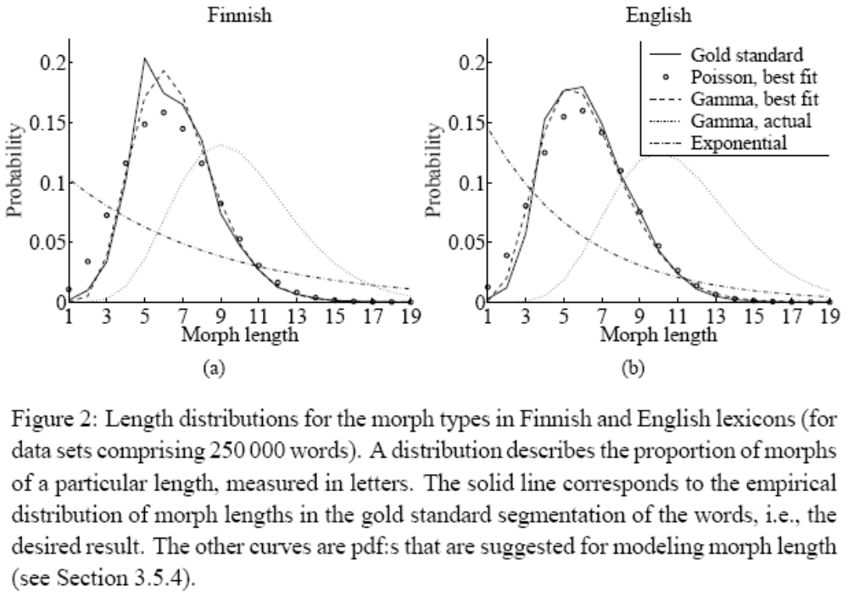(cruetz 2005:13)
  - I can obtain this by taking the list of morphemes that I do have + the roots that I have and plotting a histogram of their lengths to see the distribution for Inuktitut.

- An alternative to changing the common morpheme length to a lower value would be to go through and align words containing suprasuffixes to get a template. Then using a template after finishing all morphessor work to identify smaller suffixes in a safer way.
  - I think this is what the publication was talking about, interms of having longer supramorphemes in the lexicon, but with internal structure as well

- It didn’t find sanik or nik because none/few of them had common roots
  - 1 ikajurtaujjutiksanik
  - 1 ikajuqutiksanik
  - 1 katimaji + rjuanik
  - 1 nuna + minik

Next it did the viterbi on the data, I tried to read the code, didn’t understand it, so looke dit up in the perl prolog tutorial. Then started to read the baseline.probs then started to read the manual.

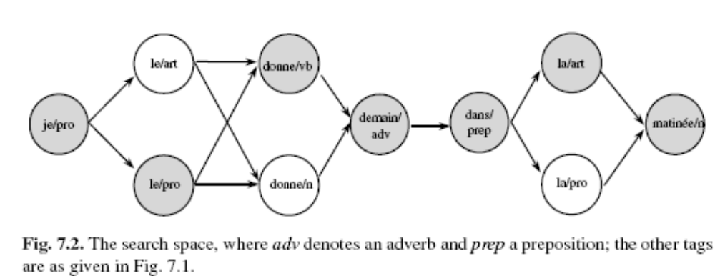(perl prolog tutorial p166)

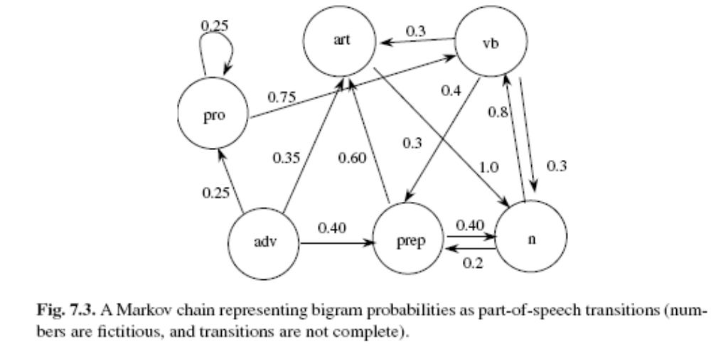
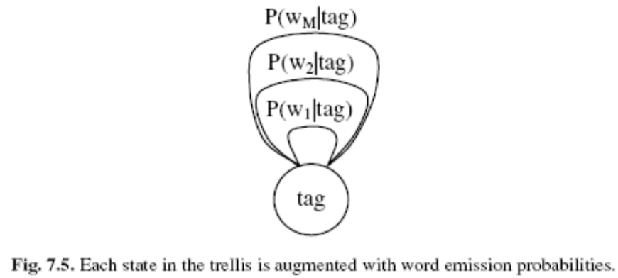

Viterbi trellis of states:
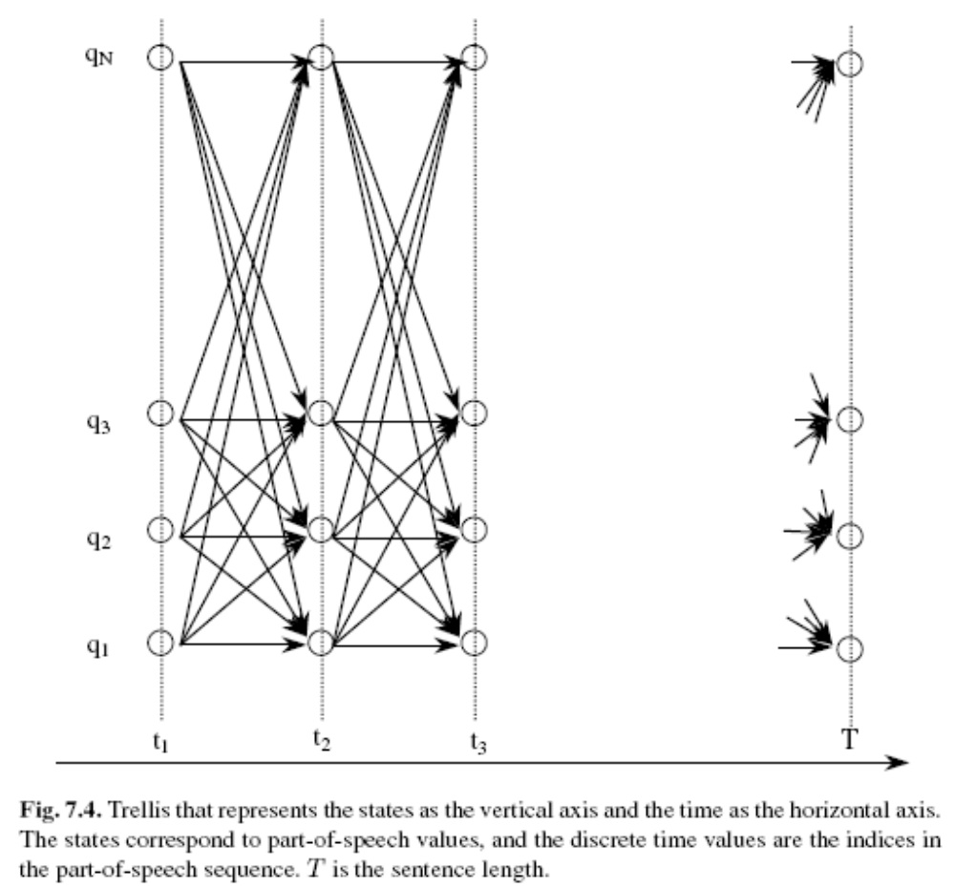

Part 4 search algorithm
- Each word starts as a morph
- Probabilities are replaced with negative logs (base 2) of the probaibility of the morpheme.
- The data structure has each word has a binary branching tree
- Data structure: binany branching tree (each node has its count in the corpus)
- Resplit on every word (random order) to try every split
  - Split that yields the lowest code length is selected

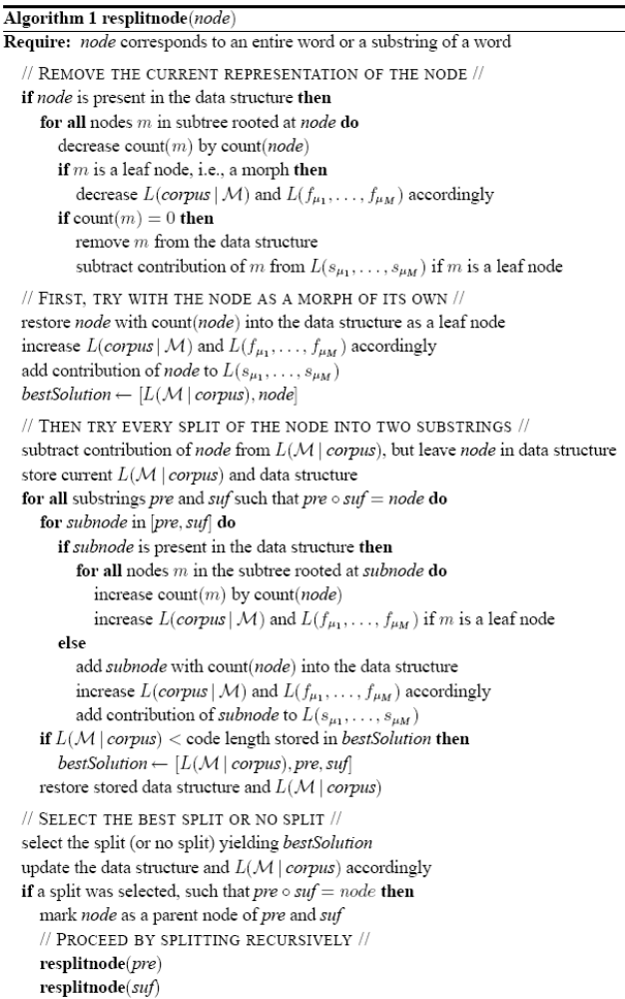
- Continues until code length doesn’t change significantly
- Chose random instead of ordered by length
  - Could choose ordered by length
  - Then random within same length words

Could consider length to be determined as a syllable ( or onset, nucleus, coda) rather than a letter…?

Experiment with vocabulary vs corpus
- “splitting is less common in the word token approach. If word tokens are used as data, common word forms tend to be added to the morph lexicon as entries of their own, regardless of whether a sensible morph segmentation could be found for them. This solution is of course the optimal one if one wishes to code a large corpus (instead of a vocabulary).”
- This doesn’t mean that using a corpus is not useful, it just means that the encoding algorithm does compression, not lexicon building…?
- But compression is exactly right, just need to have tags on the word to say if it’s a “phonological word (cluster of sounds)”, syntactic word or semantic word (with meaning), or syntactic structure (non-local dependencies +concordances)

Local dependencies= a morpheme, non-local dependanceis = an idiom, syntax, meaning. If the model could do non-local dependanceis and local dependencies as a subcomponent it would be a more genereal model (but maybe not restrained enough to get a reasonable accuracy)

