Unified University Inventory System (UUIS)



Assignment 2

Copyright COMP5541 Team III © 2010

Revision History

Revision | Date | Comments
1.0 | 2010-02-20 | Draft
1.1 | 2010-02-20 | Added non-functional requirements
1.2 | 2010-02-23 | Added functional requirements and data dictionary

Table of Content

1. Domain Model 1
2. Behavioral Model 1
3. Use Case Model 3
3.1 Browse/Search Software Inventory 3
3.2 Check Account Status 4
3.3 Checkout Media Software item 5
3.4 Update Software Media Item Status 6
3.5 Report Problems 7
4. Functional Requirements 9
5. Non-Functional Requirements 12
6. Data Dictionary 15

List of Figures

Figure 1 – Software web-based borrowing system – Domain Logic 1
Figure 2 – Software web-based borrowing system – Behavioral Model 1
Figure 3 – Software web-based borrowing system – Use Case Diagram 3

List of Tables

Table 1 - License Table 15
Table 2 – License_Type Table 15
Table 3 – Soft_Purpose Table 15
Table 4 – Software Table 15
Table 5 – Vendor Table 15
Table 6 – Version Table 16
Table 7 – Software_Cat Table 16
Table 8 – Asset Table 16
Table 9 – Check_Out Table 16
Table 10 – Check_In Table 16
Table 11 – Quantity Table 16
Table 12 – User Table 17
Table 13 – User_Type Table 17
Table 14 – User_Account Table 17
Table 15 – History Table 17

- Domain Model

The following figure illustrates how various objects of the software media web-based borrowing system communicate with each other.

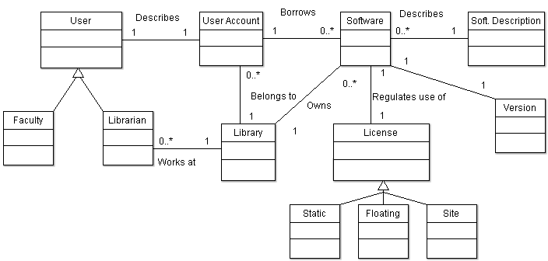

Figure 1 – Software web-based borrowing system – Domain Logic

- Behavioral Model

The following figure illustrates the behavioral model applicable to the software media web-based borrowing system in the context of the IUfA UUIS.
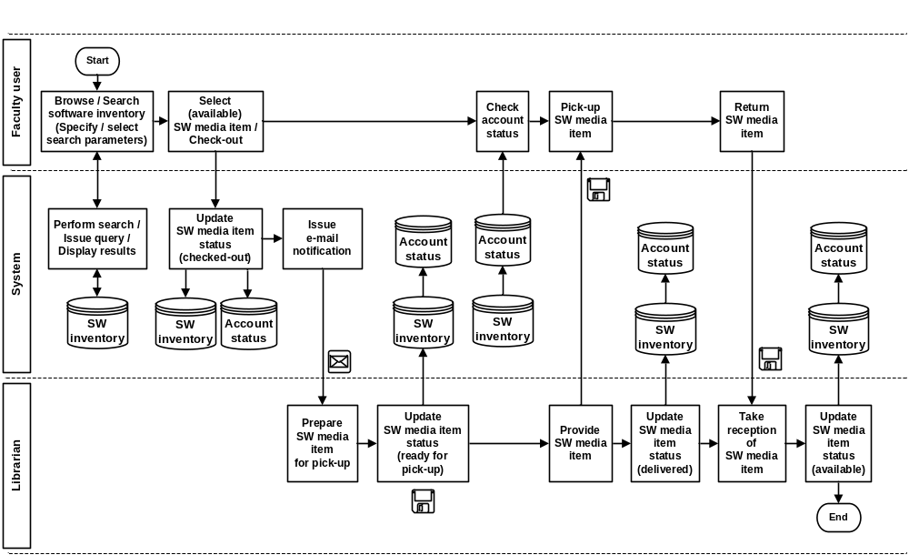
Figure 2 – Software web-based borrowing system – Behavioral Model

All Faculty users of the IUfA UUIS have the capability to browse and search software inventory. A user performs a software inventory search by specifying and selecting search parameters.
Faculty users proceed in checking out a currently available software media item by selecting it from the search results and triggering a “check-out” function. As a result, the system will update the software inventory to indicate that the software media item has been checked-out and will issue an e-mail notification to the Librarian.
The Librarian will prepare the software media item for pick-up and will indicate, in the software inventory, that it is ready.
Faculty users can check their account status which provides information on the current status of software media items checked-out under their account (checked-out or ready for pick-up) as well software media items currently in their possession (with due date).
Upon finding out that the checked-out software inventory item is ready, the Faculty user will proceed to the help desk where the software media item will be delivered to him. The Librarian will update the software inventory to indicate that the software media item has been delivered.
Faculty users will return software media items to the help desk. The Librarian will update the software inventory to indicate that the software media item is available.

- Use Case Model

The following figure provides the Software Management use case diagram.

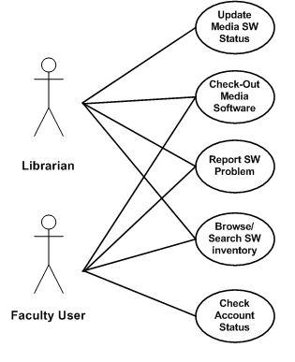
Figure 3 – Software web-based borrowing system – Use Case Diagram

The following paragraphs provide the detailed description for each use case.

- Browse/Search Software Inventory
Role: Faculty users and Librarian;
Pre-condition: Authenticated session;
Steps:
- The user selects the Search Software Media button from Home page;
- The system displays the Search Software Media page;
- The user provides the following (all optional) search information:
- Software Media ID(s) – drop-down list with software media ID from the system;
- Users ID – numerical;
- Software name search string – long text;
- Software version – short text;
- Software vendor – long text;
- Software serial number – numerical;
- Due date – date;
- System requirements – drop-down list with the system requirements (e.g. operating system type); and
- Availability;
- The user selects the Search button;
- The system builds the query based on the selected parameters and issues it to the database to perform;
- The system displays the Search results page with the list of software media items returned by the query with:
  - Software media item ID;
  - Name;
  - Status (checked-out, ready for pick-up, delivered or available);
Post-condition: The system displays the Search results page;
Exceptions:
- The user cancels the search by selecting the Return button from the Search Software Media page:
  - The system displays the Home page;
- The user triggers a modified search by selecting the Modify search button from the Search results page:
  - The system displays the Search Software Media page with the last input value for all search information fields;
- The user triggers a new search by selecting the New search button from the Search results page:
  - The system displays the Search Software page with all search information fields cleared;
- The user clears all search information fields by selecting the Clear search parameters button from the Search Software Media page:
  - The system displays the Search Software Media page with all search information fields cleared;
- The query does not return any result:
  - The system displays a “No results found” message;
- A database error is encountered:
  - The system displays an error message.

- Check Account Status
Role: Faculty users;
Pre-condition: Authenticated session;
Steps:
- The user selects the Account Status button from the Home page;
- The system displays the Account Status page with the following information for each software media items under the user account:
- Software media item ID;
- Software media item name;
- License number (if applicable);
- Status (Checked out, Ready for pickup, Delivered);
- Checkout date and time (if applicable);
- Pick-up date and time (if applicable); and
- Due date (if applicable);
Post-conditions: The system displays the Account Status page;
Exceptions:
- The user returns to the Home page by selecting the Return button from the Account Status page;
- A database error is encountered:
- The system displays an error message.

- Checkout Media Software item
Role: Faculty users;
Pre-condition: Authenticated session;
Steps:
- The user selects a specific software media item from the Search results page;
- The user selects the Check-out button from the Search results page;
- The system displays the following information:
- User first name;
- User last name;
- User ID;
- User e-mail address;
- Software media item name;
- Software media item description;
- Software media item ID;
- Software media item license type (static, site, floating); and
- Expected delivery date;
- The system requests the user to confirm the check-out request:
  - The user selects the Confirm button; or
  - The user selects the Return button;
- The system displays the Search results page with last up-to-date information;
- The system displays the text message “Check-out request successfully submitted”.
Post-condition:
- The system display the Search Software Media page with all search information fields cleared;
- The software media item record in the software inventory is updated with status Checked-out and date; and
- An e-mail notification is issued to the Librarian.
Exceptions:
- The user cancels the checkout operation by selecting the Cancel button from the Software request page:
- The system displays the Home page; and
- The system does not store any information associated with the cancelled checkout media software operation;
- A database error is encountered:
- The system displays an error message.

- Update Software Media Item Status
Role: Librarian;
Pre-condition: Authenticated session;
Steps:
- The user selects a specific software media item from the Search results page;
- The user selects the Update Software media item status button from the Search results page;
- The system displays the Update Software media item status page with:
- Un-editable fields:
    - Software media item ID;
    - Software media item name;
    - Software media item description;
- Editable fields:
    - Status – drop-down list (Ready for pick-up, Delivered, Available);
- The user selects a software media item status value;
- The user selects the Submit button;
- The system displays a message with the user provided information and requesting the user to confirm the submission:
  - The user selects the Confirm button; or
  - The user selects the Return button;
    - The system displays the Update Software media item status page with current information;
Post-condition:
- The system display the Search Software Media page with all search information fields cleared; and
- The software media item record in the software inventory is updated with new status and date;
Exceptions:
- The user cancels the update by selecting the Cancel button from the Update Software media item status page:
  - The system display the Search Software Media page with all search information fields cleared; and
  - The system does not store any updated information;
- A database error is encountered:
- The system displays an error message.

- Report Problems
Role: Faculty users and Librarian;
Pre-condition: Authenticated session;
Steps:
- The user selects the Report problem button under the Problem tab (accessible from all system pages);
- The system displays the Report problem page;
- The user provides the following information:
- Title – short text (mandatory field);
- Description – long text (mandatory field);
- Category – radio button with choices Physical asset, Software or Facility; and
- Physical asset serial number – drop-down list with the system inventory of physical assets;
- SW license number – drop-down list with the system inventory of SW licenses;
- Room number – drop-down list with the system inventory of facility rooms;
- The user selects the Submit button;
- The system, if one or more mandatory field is missing, displays a message indicating the missing information and requesting the user to provide it:
  - The user selects the Return button; and
  - The system displays the Report problem page with current information;
- The system displays a message with the user provided information and requesting the user to confirm the submission:
  - The user selects the Confirm button; or
  - The user selects the Return button;
    - The system displays the Report problem page with current information;
- The system:
  - Assigns the reported problem a unique identification number (problem ID);
  - Sets the problem status to Reported;
  - Adds the problem report to the database including problem ID, originator, user provided information, status and time;
  - Displays a message to the user with the problem ID;
    - The user selects the Return button;
  - Issues a problem report notification to the originator and the Problem tracking coordinator with problem ID, status and time;
Post-conditions:
- The system displays the system page from which the Problem tab was accessed;
- The new problem report is stored in the database; and
- A problem report notification is routed to the originator and the Problem tracking coordinator;
Exceptions:
- The user cancels the request by selecting the Cancel button from the Report problem page:
  - The system displays the original system page (from which the Problem tab was accessed); and
  - The system does not store any information associated with the cancelled problem report;
- A database error is encountered:
  - The system displays an error message.

- Functional Requirements

Note: Throughout this section, “system” specifically refers, unless otherwise noted, to the IUfA UUIS software media web-based borrowing system.

Browse/Search Software Inventory
- The system shall allow a user to browse the software inventory.
- The system shall allow a user to search the software inventory.
- The system shall assist a user, through structured dialogs, to specify search criteria, including user ID, SW ID, name, version, vendor, serial number, due date, system requirements and availability.
- The system shall allow a user to clear search criteria.
- The system shall display the results of a software inventory search.
- The system shall, upon returning no results for a software inventory search, display a message to the user.
- The system shall allow a user to cancel a software inventory search.
- The system shall allow a user to modify the search criteria of a previously executed software inventory search.

Check Account Status
- The system shall allow a user to view the current status of the software media web-based borrowing system related information under his account.
- The system shall display information applicable to each software media item under the user account, including ID, name, license number, status, checkout date, pick-up date and due date.

Checkout Software Media item
- The system shall allow a user to checkout a selected software media item.
- The system shall display information applicable to the software media item to checkout, including ID, name, description, license type and expected delivery date.
- The system shall, prior to proceeding with the checkout operation, request a confirmation from the user.
- The system shall allow a user to cancel a checkout operation.
- The system shall, upon performing the checkout operation, modify the software media item record in the software inventory to reflect its checked-out state including date and time of modification.
- The system shall, upon successfully completing the checkout operation, display a message to the user.
- The system shall, upon successfully completing the checkout operation, issue an e-mail notification to the system Librarian.

Update Software Media Item Status
- The system shall allow the system Librarian to modify a software media item record in the software inventory to reflect its current state including Ready for pick-up, Delivered and Available.
- The system shall display information applicable to the software media item record to modify, including ID, name and description.
- The system shall, prior to proceeding with the record modification operation, request a confirmation from the system Librarian.
- The system shall allow the system Librarian to cancel a record modification operation.
- The system shall, following confirmation from the system librarian, modify the software media item record in the software inventory to reflect its new state including date and time of modification.

Report Problems
- The system shall allow users to report software media items related problems.
- The system shall assist a user, through structured dialogs, to describe the reported problem, including title, description and license number.
- The system shall, prior to proceeding with the submit problem operation, display the problem related information including title, description and license number (if applicable) and request a confirmation from the user.
- The system shall, in the event where no title and/or description are provided, display a message to the user and withhold from performing the submit problem operation.
- The system shall allow a user to cancel a submit problem operation.
- The system shall, upon performing the submit problem operation, create and store a problem report record with unique identification number, originator, title, description, license number (if applicable), date and time of reporting.
- The system shall, upon successfully completing the submit problem operation, display a message to the user including unique identification number and date and time of reporting.
- The system shall, upon successfully completing the report problem operation, issue an e-mail notification to the user and the Problem tracking coordinator including unique identification number and date and time of reporting.

- Non-Functional Requirements

Multilingual-support
[N-F Req.1] The system shall be bilingual (English / French)
[N-F Req.2] The system shall allow for upgrades to any number of languages

Backup (Functionality limited to select IT Users)
Frequency
[N-F Req.3] System shall allow user to adjust automatic backup frequency
[N-F Req.4] System shall user to perform a manual backup
Storage location
[N-F Req.5] Default setup has both on-site and remote backup
[N-F Req.6] System shall allow user to create a default location for remote and default location on-site backup
[N-F Req.7] System shall allow user to select any location (Can be a remote location, Can be on any media ie.tape backup, removable devices, etc)
Scale/scope
[N-F Req.8] System shall allow user to select what information is backed up
[N-F Req.9] Backup stores entire database once, then only stores changes
[N-F Req.10] Backup can re-save entire database as an option
Auto-backup
[N-F Req.11] System shall allow user to set auto-backup features in one screen
Server Hardware Issues

Minimum system requirements
[N-F Req.12] RAM
[N-F Req.13] CPU Clock Speed

Network Architecture
[N-F Req.14] System shall be a distributed architecture
[N-F Req.15] System shall use a broadband connection

Server OS Characteristics
Software compatibility
[N-F Req.16] System shall be OS independent
OS Updates – Automatic or manual
[N-F Req.17] System shall allow only manual OS updates by select IT users

Client Hardware and Software Characteristics
Browsers Supported
[N-F Req.18] System shall function on top 10 browsers as determined by Google Trends
[N-F Req.19] System shall allow mobile device browsers

Performance Issues (dependant on hardware and network speed)
Query Speed
[N-F Req.20] System shall display all queries within 1 second
Write Speed
[N-F Req.21] System shall register new entries within 10 second of pressing submit button

Concurrency
# of concurrent users supported by the system
[N-F Req.22] System should allow 200 concurrent users
Synchronization
[N-F Req.23] System shall allow simultaneous reading and writing to the database
[N-F Req.24] System shall support atomic transactions

Security
Remote access
[N-F Req.25] System shall allow users to access software library remotely
User authentication
[N-F Req.26] Username and password login
[N-F Req.27] Password must be 8 or more alpha-numeric characters
Ensuring permissions
[N-F Req.28] System will strictly respect permissions with each action taken
Denial of Service attack
[N-F Req.29] System shall require a Captcha entry for each query after 5 queries in 30 seconds
[N-F Req.30] System shall require a Captcha entry for each login attempt after 5 login attempts in 30 seconds

Device Support
Supporting Barcode reader
[N-F Req.31] System shall be able to interface with barcode reader model XYZ

System Crashes
Recovery procedure
[N-F Req.32] System shall automatically alert IT department upon system crash
[N-F Req.33] Alert will be as an email, and a SMS to the IT department head's cell phone
[N-F Req.34] System shall display a page to users when the system crashes

Error Handling
Database Connection Failure
[N-F Req.35] System shall, upon encountering a database error, display an error message to the user.
[N-F Req.36] System shall display Temporary service interruption message (hide database reasons)
[N-F Req.37] System shall automatically alert IT department upon system crash
[N-F Req.38] Alert will be as an email, and as a SMS to the IT department head's cell phone
Too Many Users
[N-F Req.39] System shall display a Please wait, system is experienceing high load
[N-F Req.40] If user unable to log in after 2 minutes due to high load the system shall display, Please try again later message

Software License Expiry Alerts
Automatic reminders
[N-F Req.41] System shall allow users to shedule reminders/alerts for software license return dates or expiry dates
[N-F Req.42] System shall notify Librarian 1 month in advance if licenses are to expire to allow for action to renew license

- Data Dictionary

Table 1 - License Table
Column Name | Data Type | Description
License_ID | Integer | Unique value created at each new entry
Serial_Key (PK) | Varchar(30) | Serial number of for the software
Type_ID (PK) | Integer | Foreign Key to License Type Table
Purpose_ID (PK) | Integer | Foreign Key to Soft_Purpose Table
Soft_ID (PK) | Integer | Foreign key to Software Table
Ver_ID (PK) | Integer | Foreign Key to Version Table
Req_ID | Integer | Foreign Key to Requisition Table
Po_ID | Integer | Foreign Key to Purchase Order
ASSET_ID | Integer | Foreign Key to Asset Table
Expir_Date | Date | Expiry Date of the License

Table 2 – License_Type Table
Column Name | Data Type | Description
Type_ID (PK) | Integer | Primary Key for each new type
Type_Name | Varchar(3) | Static, Floating, Site etc..

Table 3 – Soft_Purpose Table
Column Name | Data Type | Description
Purpose_ID (PK) | Integer | Unique value created at each new entry
Purpose | Varchar(30) | i.e. Teaching, Research

Table 4 – Software Table
Column Name | Data Type | Description
Software_ID (PK) | Integer | Unique value created at each new entry
Soft_Name | Varchar(30) | Serial number of for the software
Vend_ID | Integer | Foreign Key to Vendor table.
Cat_ID | Integer | Foreign Key to software category table.
Description | Blob | General Description of the software.

Table 5 – Vendor Table
Column Name | Data Type | Description
Vendor_ID (PK) | Integer | Unique value created at each new entry
Vendor_Name | Varchar(30) | Names of the Vendors

Table 6 – Version Table
Column Name | Data Type | Description
Ver_ID (PK) | Integer | Unique value created at each new entry
Version | Varchar(30) | Version Number of Software
Requirements | Blob | Minimum requirements necessary to run the software
Soft_ID | Integer | Foreign Key to software table.
Description | Integer | General Description of the software.

Table 7 – Software_Cat Table
Column Name | Data Type | Description
Cat_ID (PK) | Integer | Unique value created at each new entry
Cat_Name | Varchar(30) | Category of software: Web Browser, Photo Editing

Table 8 – Asset Table
Column Name | Data Type | Description
Asset_ID (PK) | Integer | Unique value created at each new entry
Asset_Type | Varchar(30) | Furniture, Software etc…

Table 9 – Check_Out Table
Column Name | Data Type | Description
Co_ID (PK) | Integer | Unique value created at each new entry
License_ID | Integer | Foreign Key to License table.
Date_Out | Date | Check ou Date
Due_Date | Date | Due Date of software return
User_ID | Integer | Foreign Key to user table.
Quant_Out | Integer | Number of licenses checked out by user

Table 10 – Check_In Table
Column Name | Data Type | Description
Ci_ID (PK) | Integer | Unique value created at each new entry
Co_ID | Integer | Foreign Key to Check out table
Date_Returned | Date | Date software returned

Table 11 – Quantity Table
Column Name | Data Type | Description
Q_ID (PK) | Integer | Unique value created at each new entry
License_ID | Integer | Foreign Key to Check out table
Quantity | Integer | Number of licenses bought
Out | integer | Quantity of Licenses Checked out

Table 12 – User Table
Column Name | Data Type | Description
User_ID (PK) | Integer | Unique value created at each new entry
UserName | Varchar(30) | Unique username used by user to login
Email | Varchar(30) | Email of User
Fname | Text | First Name of User
Lname | Text | Last Name of User

Table 13 – User_Type Table
Column Name | Data Type | Description
User_Type_ID(PK) | Integer | Unique value created at each new entry
U_Type_Name | Text | User type: Teacher, Faculty, etc…

Table 14 – User_Account Table
Column Name | Data Type | Description
User_Acc_ID (PK) | Integer | Unique value created at each new entry
Username | Varchar(30) | Foreign Key to user table
User_Type_ID | Integer | Foreign Key to User_Type table
Password | Varchar(30) | MD5 encrypted user password

Table 15 – History Table
Column Name | Data Type | Description
Hist_ID (PK) | Integer | Unique value created at each new entry
Ci_ID | Integer | Foreign Key to Check in table
Username | Varchar(30) | Foreign Key to usertable

