Unified University Inventory System (UUIS)



Developers User Guide

Copyright COMP5541 Team III © 2010

Revision History

Revision | Date | Comments
0 |  | First revision
1 |  | Added Subversion Instructions
2 |  | Added JSP Database Example

Table of Content

General 1
References 2
Architecture Description 3
Eclipse Release 3.5.1 Installation Procedures 4
Eclipse Documentation 5
Tomcat 6.0.24 Installation Procedures 6
Tomcat Start, Stop, and Restarting Procedures 10
Tomcat Documentation 11
MySQL 5.1.43 Installation Procedures 12
MySQL Start, Stop, and Restarting Procedures 17
MySQL Documentation 18
Subversion Client v1.6.9 Installation Procedures 19
Subversion Client Procedures 22
Subversion Documentation 23
Example 1 – Java Servlet with Eclipse 24
Example 2 - Java Server pages & JavaBeans database connectivity 38

List of Figures

Figure 1 - UUIS Architecture 3
Figure 2 - Eclipse Workspace Launcher 4
Figure 3 - Eclipse Platform 4
Figure 4 - Apache Tomcat Welcome Setup Wizard 6
Figure 5 - Apache Tomcat License Agreement 6
Figure 6 - Apache Tomcat Choose Components 7
Figure 7 - Apache Tomcat Choose Install Location 7
Figure 8 - Apache Tomcat Configuration 8
Figure 9 - Apache Tomcat Java Virtual Machine 8
Figure 10 - Apache Tomcat Complete Installation Message 9
Figure 11 - Apache Tomcat Start Page 9
Figure 12 - Starting Tomcat from a Console Window 10
Figure 13 - Apache Tomcat 6.0 Documentation 11
Figure 14 - Apache Tomcat Servlets and JSP Examples 11
Figure 15 - MySQL Welcome Setup Wizard 12
Figure 16 - MySQL Setup Type 13
Figure 17 - MySQL Ready to Install 13
Figure 18 - MySQL Complete Installation Message 14
Figure 19 - MySQL Server Instance Configuration 14
Figure 20 - MySQL Server Windows Options 15
Figure 21 - MySQL Security Options 15
Figure 22 - MySQL Configuration Ready to Execute 16
Figure 23 - MySQL Complete Configuration Message 16
Figure 24 - Successful login to MySQL 17
Figure 25 – Subversion.apache.org – Windows package 19
Figure 26 - Subversion Welcome Setup Wizard 19
Figure 27 - Subversion Install Location 20
Figure 28 - Subversion Automatic Updates configuration 20
Figure 29 - Subversion Extend your Collabnet Subversion and experience 21
Figure 25 - Dynamic Web Project (step 1) 24
Figure 26 - Dynamic Web Project (step 2) 25
Figure 27 - Dynamic Web Project (step 3) 26
Figure 28 - Dynamic Web Project (step 4) 27
Figure 29 - Dynamic Web Project (step 5) 28
Figure 30 - Dynamic Web Project (step 6) 28
Figure 31 - Dynamic Web Project (step 7) 29
Figure 32 – Java Server Page (step 1) 29
Figure 33 – Java Server Page (step 2) 30
Figure 34 - Java Servlet (step 1) 31
Figure 35 - Java Servlet (step 2) 32
Figure 36 - Java Servlet (step 3) 32
Figure 37 - Java Servlet (step 4) 33
Figure 38 – WebAppExample folder organization 35
Figure 39 - Starting Tomcat 36
Figure 40 - A Web Application Example – JSP page 36
Figure 41 –Tomcat Console Print Out 37
Figure 42 - A Web Application Example – Servlet page 37
Figure 43 – Eclipse-> Source->Format 39
Figure 44 - A Web Application Example – Book Entry Form 44
Figure 45 - A Web Application Example – Book List 44

General

This document is intended for use by the developers of the Unified University Inventory System (UUIS). It is a step by step installation procedure of the UUIS workbench on Windows and X OS, which includes Eclipse, Tomcat, Subversion and MySQL. This document also provides a complete example of a start-up project.

Note that you need to be administrator on your computer to install the UUIS workbench.

References

[1] Holzner, S. (2004). Eclipse. O’Reilly.

[2] Brittain, J. (2007). Tomcat The Definitive Guide. O’Reilly.

[3] Collins-Sussman, B. (2004). Version Control with Subversion. O’Reilly.

[4] W. Perry, B. (2004). Java Servlet & JSP Cookbook. O’Reilly.

[5] E. Davis, M. A. Phillips, J. (2007). Learning PHP & MySQL. O’Reilly.

[6] http://www.java-tips.org/java-tutorials/tutorials/introduction-to-java-servlets-with-eclipse.html

Architecture Description

UUIS is a 3-tier solution in which the user interface, the business logic and the data management are developed and maintain as independent modules:

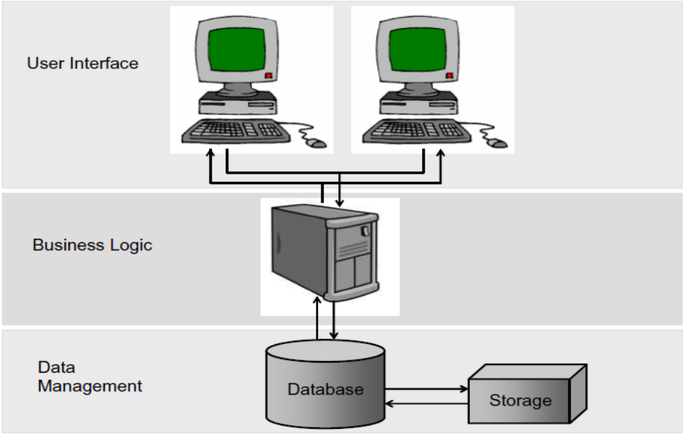
Figure 1 - UUIS Architecture

1. User Interface
Topmost layer of the application. The interface main function is to display information received from other tiers in a user-friendly format.

2. Business Logic
This layer coordinates the application by handling and processing information exchange between the database and the user interface, and by making logical decisions and performing calculations.

3. Data Management
Bottommost layer of the application, the data management consists of a database server that stores all system's data. It keeps data independent from application servers or business logic.

Eclipse Release 3.5.1 Installation Procedures

Navigate to Eclipse web site http://www.eclipse.org/downloads/ and select the download mirror to Eclipse IDE for Java EE Developers (189 MB) . For Windows users, unzip file under C:\Program Files.

Start Eclipse by running the Eclipse executable eclipse.exe that you’ll find under C:\Program Files\eclipse\eclipse.exe. Eclipse will ask you to enter the path to your future workspace directory:

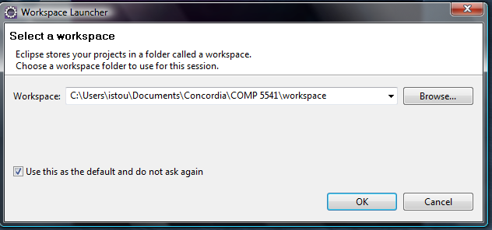
Figure 2 - Eclipse Workspace Launcher

Once you finished accepting the terms, you should see the Eclipse Platform:

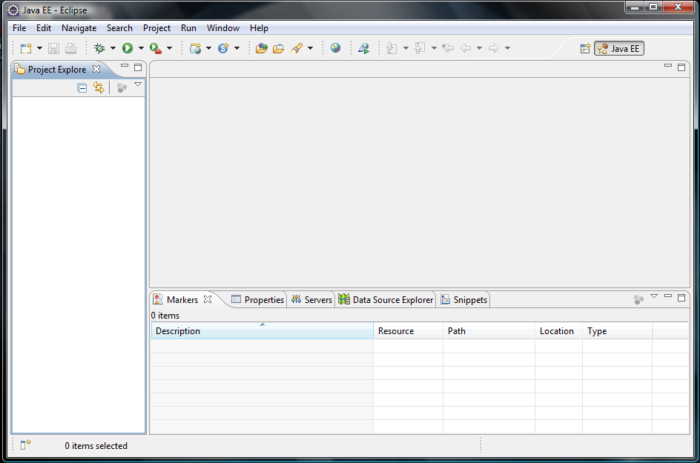
Figure 3 - Eclipse Platform

Eclipse Documentation

Documentation about Eclipse IDE can be found on Eclipse web site:

http://www.eclipse.org/documentation/

Tomcat 6.0.24 Installation Procedures

You can get the Tomcat web server at http://tomcat.apache.org/download-60.cgi. The current release version to install is Tomcat 6.0.24. From the Binary Distributions list, Windows user should select the 32-bit/64-bit Windows Service Installer. Save the executable file anywhere on your disk and double click on apache-tomcat-6.0.24.exe to launch the installation Wizard:

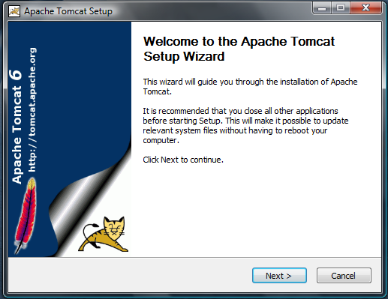
Figure 4 - Apache Tomcat Welcome Setup Wizard

Click Next and accept the License Agreement:

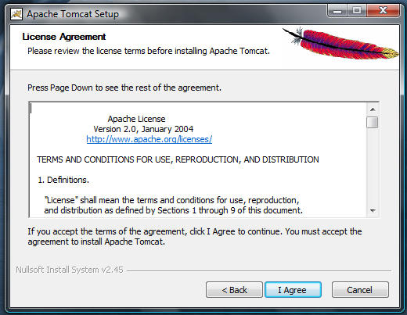
Figure 5 - Apache Tomcat License Agreement
Then, select all components (including Host Manager and Examples):

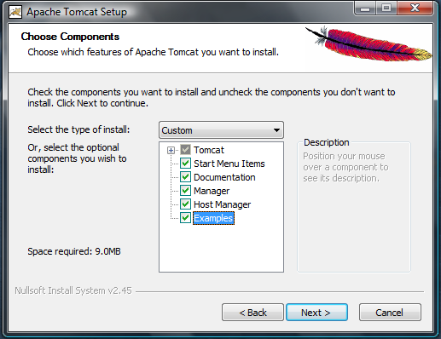
Figure 6 - Apache Tomcat Choose Components

Enter C:\Program Files\Apache Software Foundation\Tomcat 6.0 as the installation location for Tomcat:

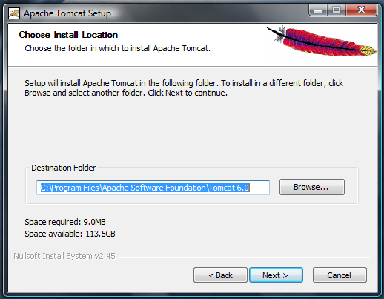
Figure 7 - Apache Tomcat Choose Install Location

Keep Tomcat’s web server port set to 8080 (default). Enter any administrator login username and password (choose something you will remember!); that will be your username and password to log into Tomcat’s Manager webapp:

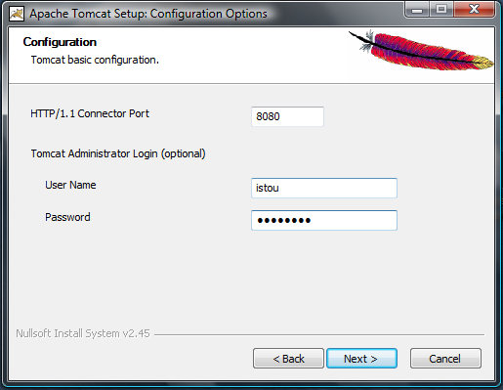
Figure 8 - Apache Tomcat Configuration

Choose C:\Program Files\Java\jre6 as your Java Virtual Machine (should have been installed automatically with Eclipse), and then click Install:

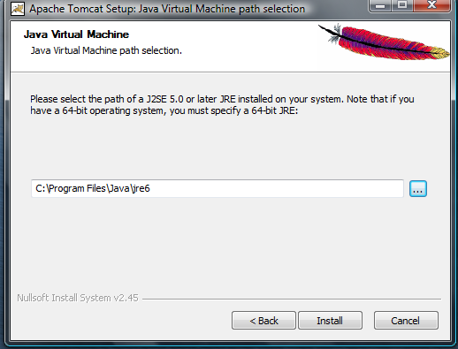
Figure 9 - Apache Tomcat Java Virtual Machine

Once the installation complete normally, you should see the message ‘’Completing the Apache Tomcat Setup Wizard’’:

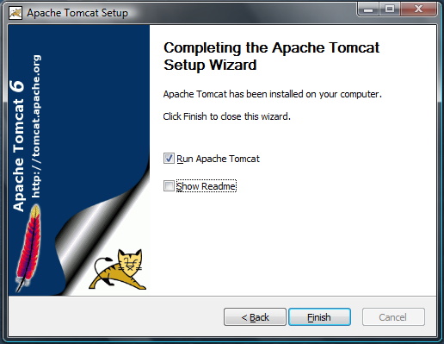
Figure 10 - Apache Tomcat Complete Installation Message

Select Run Apache Tomcat and click Finish. Then, you can confirm that Tomcat was properly installed and ready to use by opening a browser and navigating to Tomcat start page http://localhost:8080:

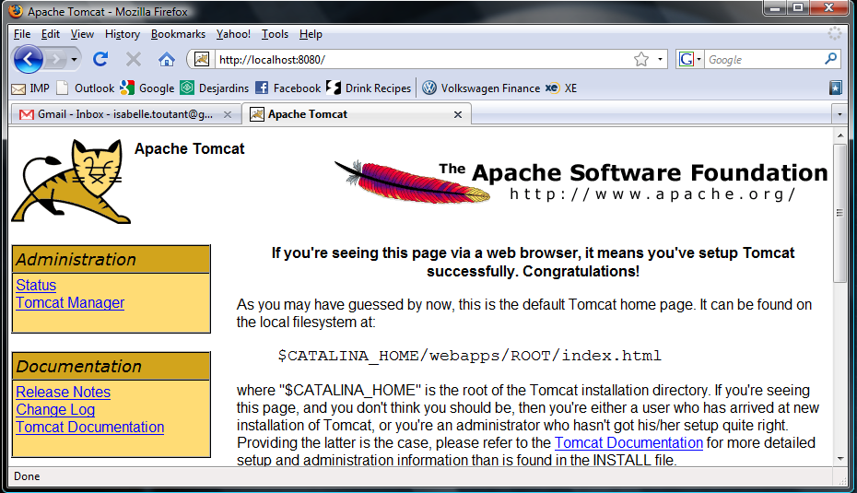
Figure 11 - Apache Tomcat Start Page

Note that the most important directory is the C:\Program Files\Apache Software Foundation\Tomcat 6.0\webapps directory, which is where we will store files to make them accessible to client browser.

Tomcat Start, Stop, and Restarting Procedures

Once you have completed the installation, you should learn how to start up and shut down Tomcat. On Microsoft Windows, Tomcat can be started and stopped from a console window.

Open a console window and change the path to C:\Program Files\Apache Software Foundation\Tomcat 6.0\bin. Then, launch the executable tomcat6.exe. You should see the server information:

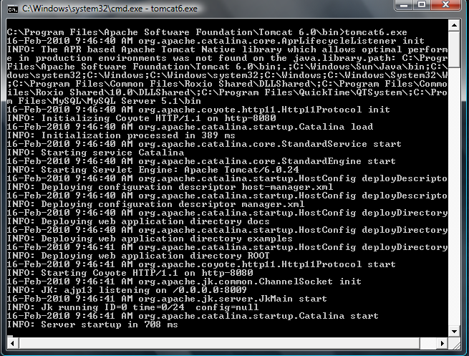
Figure 12 - Starting Tomcat from a Console Window

To shutdown Tomcat from the console window, use Ctrl-C command. If it does not work, find tomcat6.exe process in the Windows task manager and terminate it.

Tomcat Documentation

Documentation about Tomcat can be found on http://localhost:8080/docs/

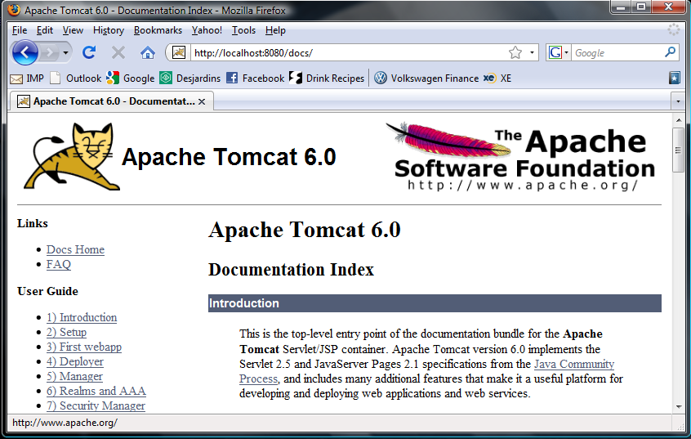
Figure 13 - Apache Tomcat 6.0 Documentation

Several JSP and Servlets examples are available under C:\Program Files\Apache Software Foundation\Tomcat 6.0\webapps\examples directory. They can be run from the http://localhost:8080 page.

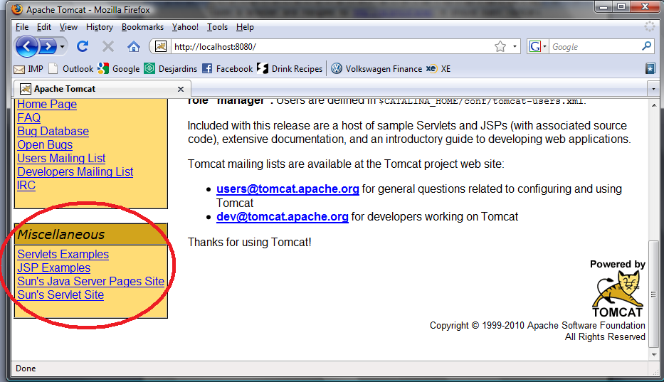
Figure 14 - Apache Tomcat Servlets and JSP Examples

MySQL 5.1.43 Installation Procedures

Navigate to MySQL web site http://www.mysql.com/downloads/mysql/ to download MySQL Community Server 5.1.43. For Windows users, select Windows (x86, 32-bit), MSI Installer (104.9MB).

If it is the first time you have to download from MySQL web site, you will first have to fill your account information to access the download mirror. You will be sent a password that will enable you to log into all of the MySQL web sites, including forums and bugs.

Save the executable file anywhere on your disk, then double click on mysql-5.1.43-win32.exe and select Run to launch the Wizard:

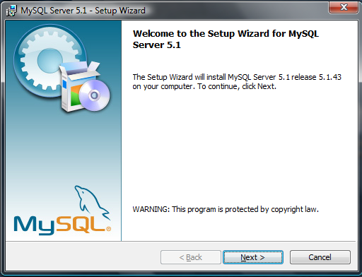
Figure 15 - MySQL Welcome Setup Wizard

Choose the Typical setup type and click Next:

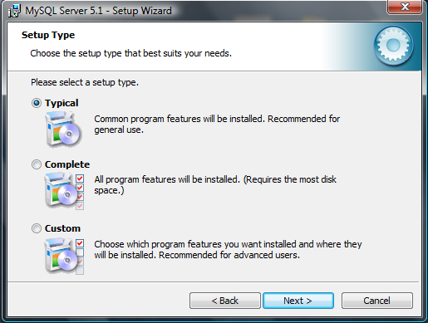
Figure 16 - MySQL Setup Type

Select Install and wait while the setup Wizard install MySQL server 5.1:

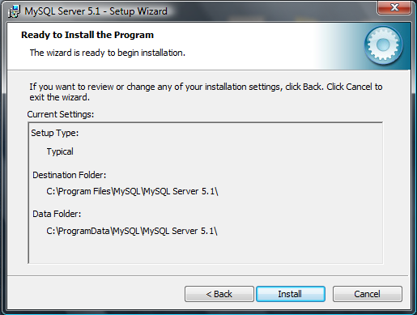
Figure 17 - MySQL Ready to Install

Once the installation complete normally, you should see the message ‘’Wizard Completed’’:

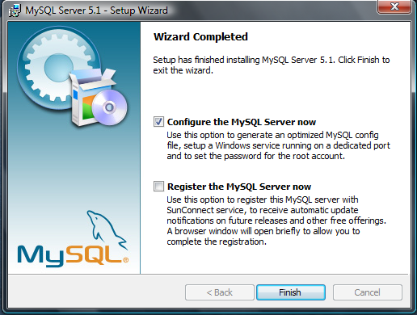
Figure 18 - MySQL Complete Installation Message

Select Configure the MySQL Server now. You should be prompted with the MySQL Server Instance Configuration Wizard. From the Wizard, select Standard Configuration and click Next:

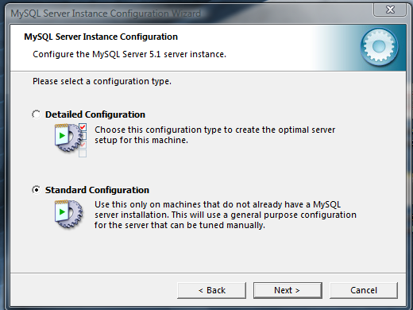
Figure 19 - MySQL Server Instance Configuration

You will need to set the Windows options. Select both Install As Windows Service and Include Bin Directory in Windows PATH and click Next:

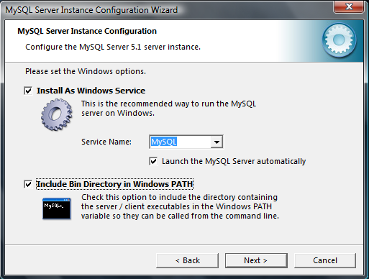
Figure 20 - MySQL Server Windows Options

As security options, enter comp5541 (lowercase) as root password, and click Next:

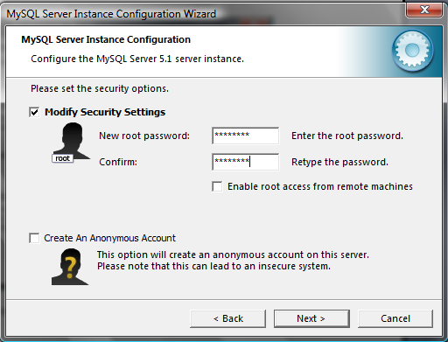
Figure 21 - MySQL Security Options

You have now completed the configuration of the server. Click Execute to launch the final configuration process:

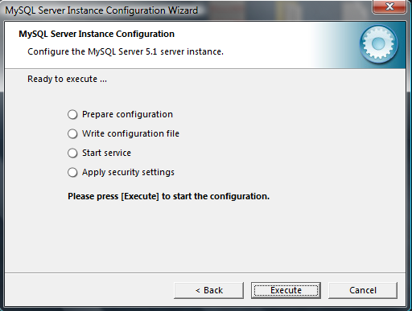
Figure 22 - MySQL Configuration Ready to Execute

Once the configuration is completed, you should see the following messages:

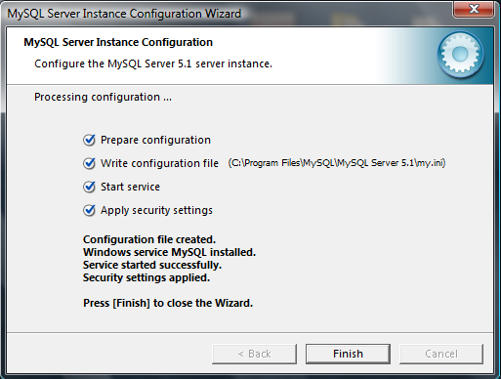
Figure 23 - MySQL Complete Configuration Message

MySQL Start, Stop, and Restarting Procedures

Once you have completed the installation, you should learn how to start up and shut down MySQL. On Microsoft Windows, one way to access the database is by the use of the MySQL Command Line Client that can be found under Start→MySQL→MySQL Server 5.1→MySQL Command Line Client.

Start the MySQL Command Line Client and enter password comp5541. Note that the default user name is root since you’ve installed MySQL on your own computer.

If the password, username and hostname are correct, you should see a banner message like that:

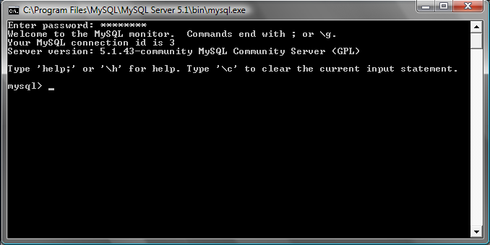
Figure 24 - Successful login to MySQL

To disconnect from the database, type QUIT:

mysql> QUIT
Bye

MySQL Documentation

MySQL 5.1 Reference Manual can be found at: http://dev.mysql.com/doc/refman/5.1/en/index.html

Several MySQL tutorials are also available at:
http://dev.mysql.com/doc/refman/5.1/en/tutorial.html

A complete list of the SQL commands is available at:
http://www.pantz.org/software/mysql/mysqlcommands.html

Subversion Client v1.6.9 Installation Procedures

Navigate to Subversion web site http://subversion.apache.org/packages.html to download the official SVN client is a text-based command-line tool. For Windows users, select CollabNet (certified binaries; maintained by CollabNet)

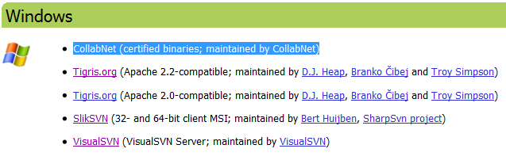
Figure 25 – Subversion.apache.org – Windows package

And from the CollabNet web site, select Dowload of CollabNet Subversion Command-Line Client v1.6.9 (for Windows). If it is the first time you have to download from Collabnet web site, you will first have to register for an account. You will be sent a password that will enable you to access Collabnet download mirror.
Save the executable file anywhere on your disk, then double click on CollabNetSubversion-client-1.6.9-1.win32.exe to launch the installation Wizard:

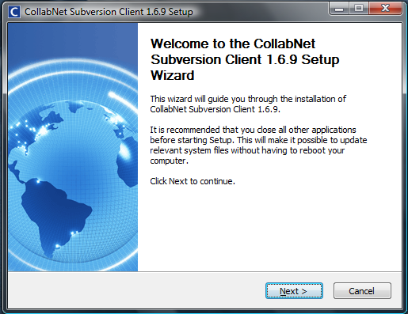
Figure 26 - Subversion Welcome Setup Wizard

Click Next twice and choose the Install location:

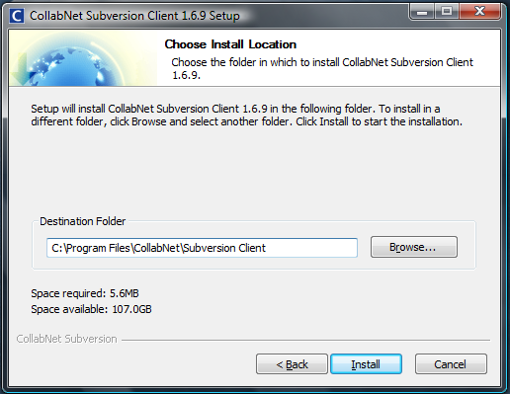
Figure 27 - Subversion Install Location

Click Install:

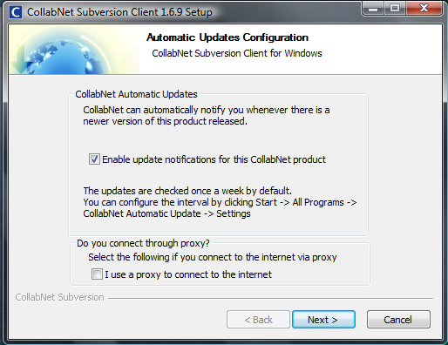
Figure 28 - Subversion Automatic Updates configuration

Uncheck Enable update notifications for this CollabNet product (unless you are planning to use this tool outside the course environment) and click Next.

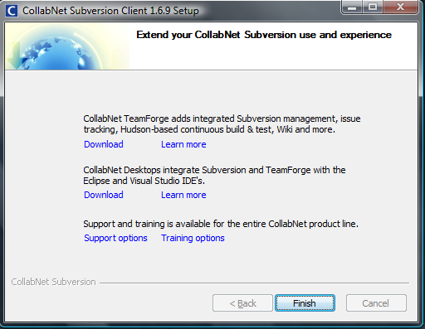
Figure 29 - Subversion Extend your Collabnet Subversion and experience

Finally, click Finish.

Subversion Client Procedures

The CollabNet SVN client is simply used through a command prompt.

To perform a complete checkout of the comp5541t3 view stored on Sourceforge.net repository, open a command prompt; change the path to your COMP5541 working directory and type:

> svn co https://comp5541t3.svn.sourceforge.net/svnroot/comp5541t3
If prompted for authentication, enter your Sourceforge.net username and password.
To get a list of all SVN commands, type:

> svn help

To get help on a specific SVN command, type:

> svn help COMMAND

For further details, refer to Subversion Documentation.

Subversion Documentation

An online version of the O’Reilly book Version Control with Subversion is available at:
http://svnbook.red-bean.com/

Example 1 – Java Servlet with Eclipse

In this example, we will create one dynamic web application that asks the user for first name and surname. Then the system will respond by greeting the user.

1. Creation of a Dynamic Web Project

Start Eclipse. To create our Java Servlet, we first need to create a Dynamic Web Project. Go to File→ New and select Project. A wizard will be prompted to you.

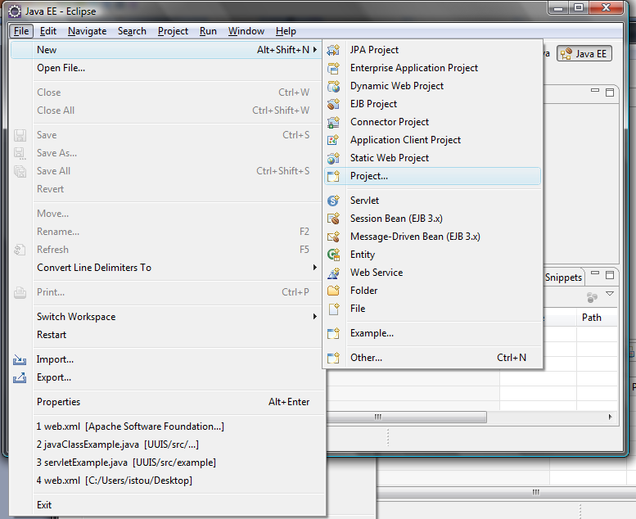
Figure 30 - Dynamic Web Project (step 1)

Go to the Web and choose Dynamic Web Project and press Next.

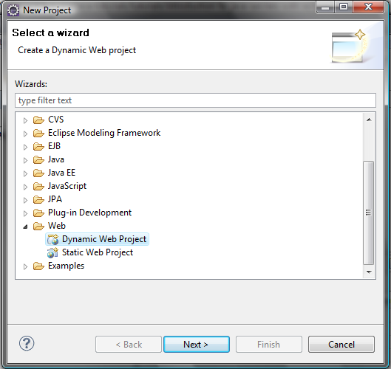
Figure 31 - Dynamic Web Project (step 2)

A wizard will be displayed to you. The wizard is mainly used to configure our Dynamic Web Project. You are allowed to name your Dynamic Web Project with any name that you wish but in this example, we are going to name it ‘WebAppExample’.
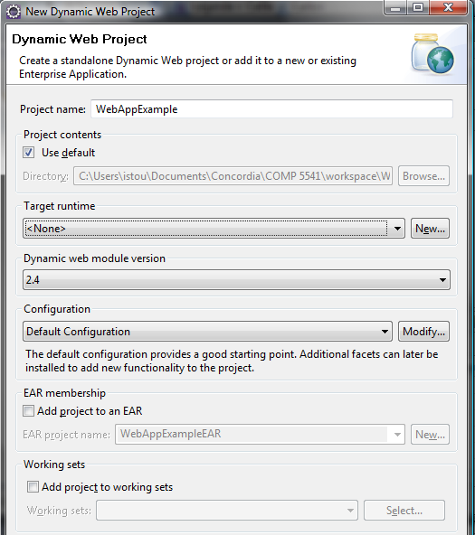
Figure 32 - Dynamic Web Project (step 3)
You then need to provide the Target Runtime, i.e. that you need to identify the server that you would like to use for this Dynamic Web Project; in this case, Apache Tomcat. Click on the New button on the right side of the Target Runtime combo box. A new wizard will be displayed where you are asked to specify which server you wish to use. Select Apache Tomcat v6.0 from the list and click Next.

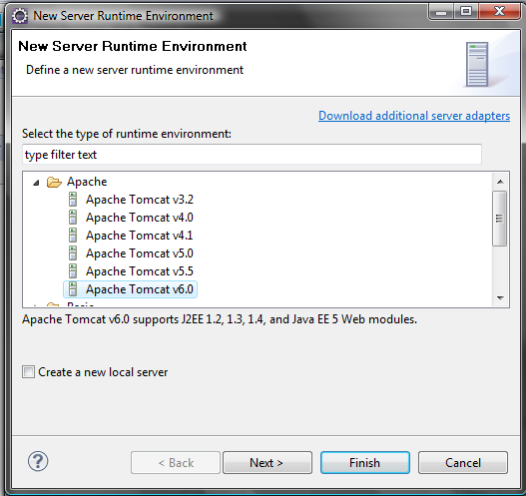
Figure 33 - Dynamic Web Project (step 4)
In the next wizard, we are required to provide the information on where our Apache Tomcat is located, i.e. C:\Program Files\Apache Software Foundation\Tomcat 6.0. Additionally, you also need to provide on what Java Run Time (JRE) you want to use. Choose jre6 and click Finish.
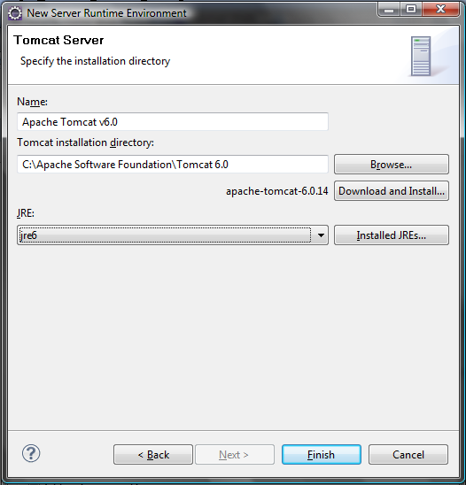
Figure 34 - Dynamic Web Project (step 5)

Back to our Dynamic Web Project configuration, we should have now Apache Tomcat v6.0 as one of the options in the combo box for Target Runtime. Please select the server that you just recently added and click Next twice. Keep default setting of Web Model (i.e. context root set to WebAppExample and Content directory set to WebContent) and click Finish.

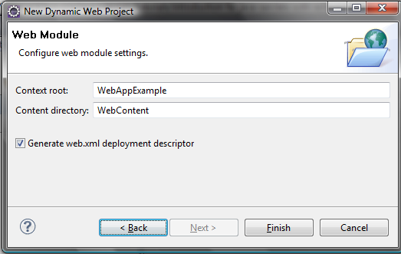
Figure 35 - Dynamic Web Project (step 6)

Your Dynamic Web Project in Eclipse should look like that:

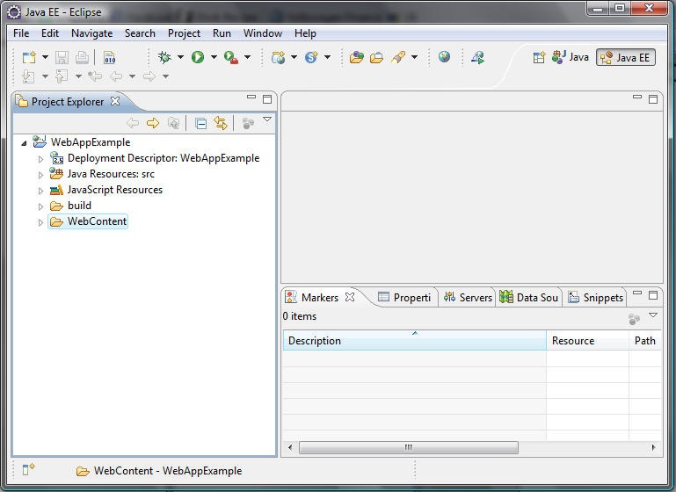

Figure 36 - Dynamic Web Project (step 7)

2. Creation of the JavaServer Page

Now, we need to create a JSP file that we will call index.jsp to allow the user to enter his or her first name and surname. In Eclipse Project Explorer, right click on WebContent, choose New and Other. A wizard is prompted to you to choose what type of files you want to include into your Dynamic Web Project; choose JSP and click Next:

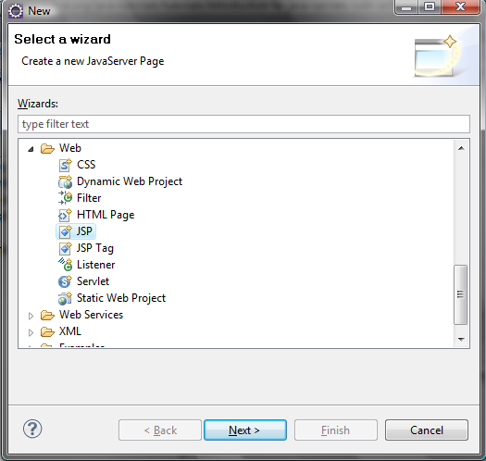
Figure 37 – Java Server Page (step 1)

Name the Java Server Page index.jsp and click Finish.

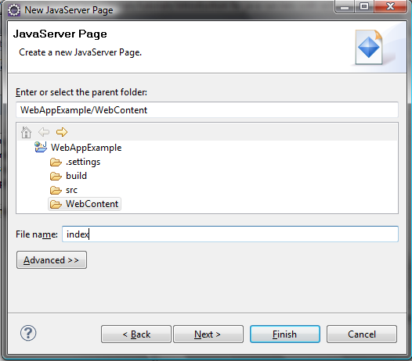
Figure 38 – Java Server Page (step 2)

The content of index.jsp file newly created should look like that:

%@ page language="java" contentType="text/html; charset=ISO-8859-1"
pageEncoding="ISO-8859-1"%>
<!DOCTYPE html PUBLIC "-//W3C//DTD HTML 4.01 Transitional//EN" "http://www.w3.org/TR/html4/loose.dtd">
<html>
<head>
<meta http-equiv="Content-Type" content="text/html; charset=ISO-8859-1">
<title>Insert title here</title>
</head>
<body>

</body>
</html>

Change the title to:

<title>A Web Application Example</title>

And between the <body></body> tags, add the following lines:

<form action="GreetingServlet" method="POST">
First Name: <input type="text" name="firstName" size="20"><br>
Surname: <input type="text" name="surname" size="20">
<br><br>
<input type="submit" value="Submit">
</form>

3. Creation of Java Servlet

Now, we need to create a Java Servlet. In Eclipse Project Explorer, right click on the Java Resources: src folder and choose New and Others. A wizard will be prompted to you to configure your Java Servlet; choose Servlet and click Next:

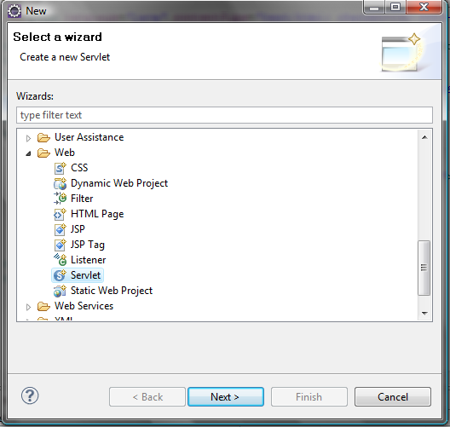
Figure 39 - Java Servlet (step 1)
Next, you have to define the package for your Java Servlet. Normally, we use Package to group a few Java files that has the same functionalities. In this example, we create a package called servlet. The class name is the Java Servlet name; in this case GreetingServlet. Leave other configuration as they are and click Next.
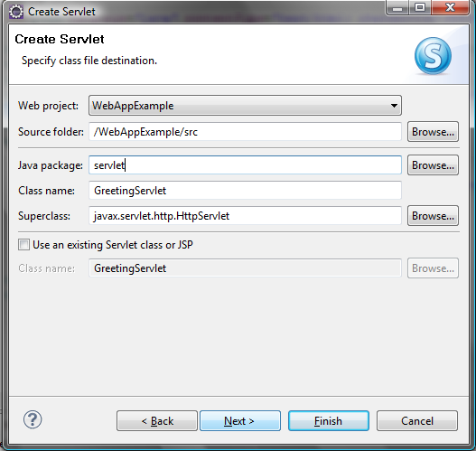
Figure 40 - Java Servlet (step 2)

Provide a description for the Java Servlet, make sure the URL mapping is set to /GreetingServlet (this isused to identify on how the Java Servlet should be called) and click Next:

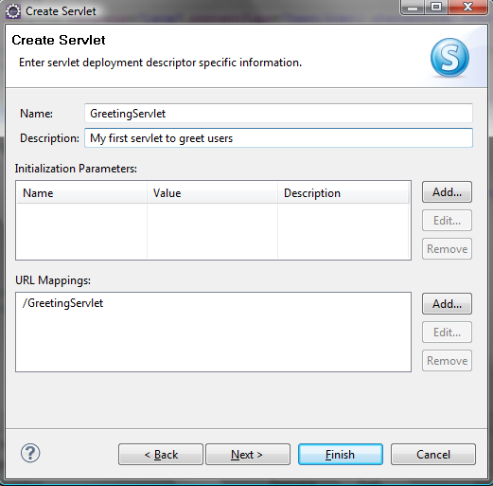
Figure 41 - Java Servlet (step 3)

Finally, you need to set the Java Servlet methods as follow:

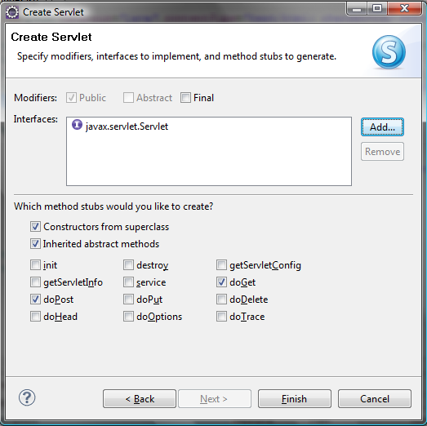
Figure 42 - Java Servlet (step 4)

Once you click Finish, of GreetingServlet.java file should look like that:

package servlet;

import java.io.IOException;
import javax.servlet.Servlet;
import javax.servlet.ServletException;
import javax.servlet.http.HttpServlet;
import javax.servlet.http.HttpServletRequest;
import javax.servlet.http.HttpServletResponse;

/**
* Servlet implementation class GreetingServlet
*/
public class GreetingServlet extends HttpServlet implements Servlet {
private static final long serialVersionUID = 1L;

/**
* @see HttpServlet#HttpServlet()
*/
public GreetingServlet() {
super();
// TODO Auto-generated constructor stub
}

/**
* @see HttpServlet#doGet(HttpServletRequest request,
* HttpServletResponse response)
*/
protected void doGet(HttpServletRequest request,
HttpServletResponse response)
throws ServletException, IOException {
// TODO Auto-generated method stub
}

/**
* @see HttpServlet#doPost(HttpServletRequest request,
* HttpServletResponse response)
*/
protected void doPost(HttpServletRequest request,
HttpServletResponse response)
throws ServletException, IOException {
// TODO Auto-generated method stub
}

}

Add the following to the doPost method (note that will also need to add an import tojava.io.PrintWriter):

protected void doPost(HttpServletRequest request,
HttpServletResponse response)
throws ServletException, IOException {

response.setContentType("text/html;charset=UTF-8");
PrintWriter out = response.getWriter();

String firstName = request.getParameter("firstName").toString();
System.out.println("firstName = " + firstName);

String surname = request.getParameter("surname").toString();
System.out.println("surname = " + surname);

out.println("<html>");
out.println("<head>");
out.println("<title>Servlet GreetingServlet</title>");
out.println("</head>");

out.println("<body>");
out.println("<h1>Servlet GreetingServlet at " + request.getContextPath () + "</h1>");
out.println("<p>Welcome " + firstName + " " + surname + "</p>");
out.println("</body>");
out.println("</html>");

out.close();

}

Build the new code by right clicking on WebAppExample and choosing Build Project.

4. Running the WebAppExample with Tomcat

Now it is time to test the Web Application. Under C:\Program Files\Apache Software Foundation\Tomcat 6.0\webapps, create a new directory called WebAppExample. This new directory must itself have subdirectories (WEB-INF, classes, servlet and lib) organized as follow:

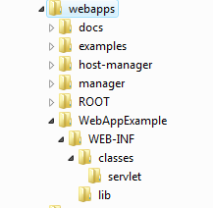
Figure 43 – WebAppExample folder organization

After creating these directories, store index.jsp directly in the \WebAppExample folder, store GreetingServlet.class in the WebAppExample\WEB-INF\classes\servlet folder and finally, store web.xml (taken from workspace\WebAppExample\WebContent\WEB-INF) in the WebAppExample\WEB-INF folder.

Start Tomcat and watch the console carefully. You should see your new web application WebAppExample.
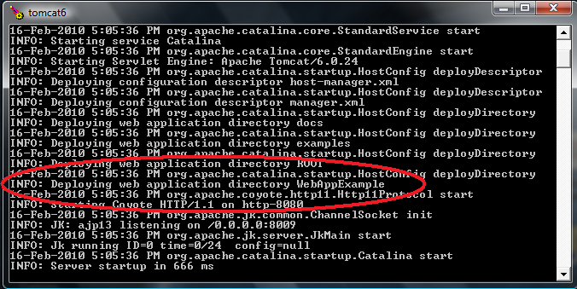
Figure 44 - Starting Tomcat

In your browser, go to http://localhost:8080/WebAppExample/.If it works properly, you should see:

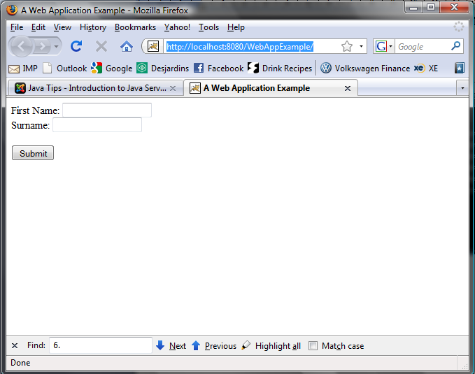
Figure 45 - A Web Application Example – JSP page

Provide your first name and surname and press the Submit button. In your Tomcat console, you should have the result of the System.out.println we put in our doPost method in the GreetingServlet.java code.

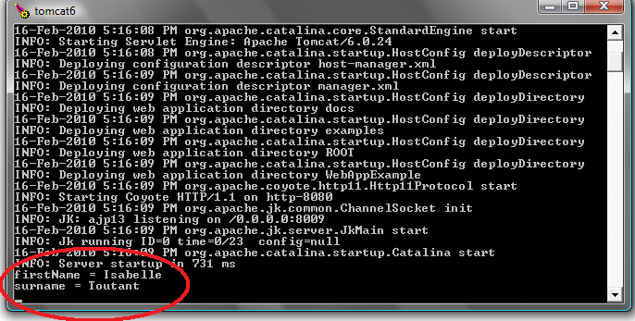
Figure 46 –Tomcat Console Print Out

In your web browser, you should be redirected to the Greeting Servlet page:

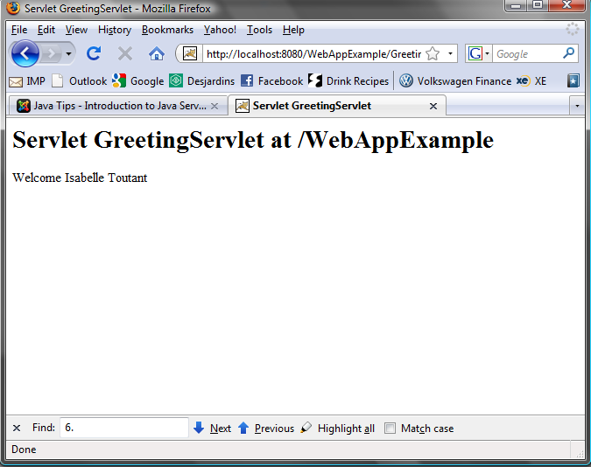
Figure 47 - A Web Application Example – Servlet page

Example 2 - Java Server pages & JavaBeans database connectivity

This is version 2 of the example I had posted a few days earlier, this version works on both MAC and Windows.

The description of assignment 3 mentions using the MVC architecture to develop the search module.

Model–View–Controller (MVC) is a software architecture, currently considered an architectural pattern used in software engineering. The pattern isolates "domain logic" the application logic for the user) from input and presentation (GUI), permitting independent development, testing and maintenance of each1.

To prepare us for the assignment i have remodeled this JSP database tutorial to a JSP and Java Beans tutorial.

This tutorial assumes you have read and followed previous section of the developer user guide.

Step1:

Create a new Dynamic web project in eclipse, name it TestDB.

Step 2:

The first step is to download and install the JDBC MySQL driver:

1. Download the JDBC Driver for MySQL (Connector/J) from:
http://www.mysql.com/products/connector/ (You will need to create an account)

2. Unzip the folder and copy the mysql-connector-java-5.1.12-bin.jar and paste to the

C:\Documents and Settings\[YOURUSER]\workspace\TestDB\WebContent\WEB-INF\lib.

Then, in Eclipse, you right click on the WebContent\WEB-INF\lib and select source>format (as seen on image below)

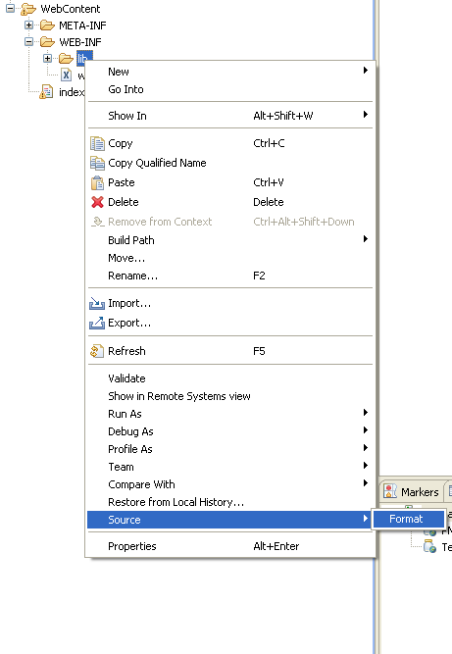

Figure 48 – Eclipse-> Source->Format

You should now see the .jar file in the WebContent\WEB-INF\lib folder.

Step 3:

Create the database and table in MySQL

- Create a database named books:
CREATE DATABASE books;

- Create table name books_details:
CREATE TABLE `books_details`
(
`id` INT( 11 ) NOT NULL AUTO_INCREMENT ,
`book_name` VARCHAR( 100 ) NOT NULL ,
`author` VARCHAR( 100 ) NOT NULL ,
PRIMARY KEY ( `id` )
) TYPE = MYISAM ;

Step 4:

Create Java Bean and JSP page to interact with Database
1. In Eclipse right click Java Ressources: src:
select new>package
Name the package db (keep it in lowercase)

2. Right click the db package you have just created select New > Class,
Name the class Bean (again respect case).

3. Replace any code in the Bean.java with the following:

package db;

import java.sql.*;
import java.io.*;
public class Bean{

//Make sure you are using the right password.
String dbURL = "jdbc:mysql://localhost/books?user=root&password=comp5541";
String dbDriver = "com.mysql.jdbc.Driver";
private Connection dbCon;
public Bean(){
super();
}
public boolean connect() throws ClassNotFoundException,SQLException{
Class.forName(dbDriver);
dbCon = DriverManager.getConnection(dbURL);
return true;
}
public void close() throws SQLException{
dbCon.close();
}
public ResultSet execSQL(String sql) throws SQLException{
Statement s = dbCon.createStatement();
ResultSet r = s.executeQuery(sql);
return (r == null) ? null : r;
}
public int updateSQL(String sql) throws SQLException{
Statement s = dbCon.createStatement();
int r = s.executeUpdate(sql);
return (r == 0) ? 0 : r;
}
}

- Create a JSP page names index.jsp and replace all the code with the following:

Start of code (Don’t copy this line)

<%@ page language="java" import="java.sql.*" %>
<jsp:useBean id="db" scope="request" class="db.Bean" />
<jsp:setProperty name="db" property="*" />
<%!
ResultSet rs = null ;
ResultSetMetaData rsmd = null ;
int numColumns ;
int i;
%>
<%
db.connect();
if(request.getParameter("action") != null){
String bookname=request.getParameter("bookname");
String author=request.getParameter("author");
i = db.updateSQL("insert into books_details(book_name,author) values('"+bookname+"','"+author+"')");
rs = db.execSQL("select * from books_details");
%>
<html>
<body>
<center>
<h2>Books List</h2>
<table border="1" cellspacing="0" cellpadding
="0">
<tr>
<td><b>ID</b></td>
<td><b>Book Name</b></td>
<td><b>Author</b></td>
</tr>
<%
int no=1;
while(rs.next()){
%>
<tr>
<td><%=no%></td>
<td><%=rs.getString("book_name")%></td>
<td> <%=rs.getString("author")%> </td>
</tr>
<%
no++;
}
db.close();
%>
</table>
</center>
</body>
</html>
<%}else{%>
<html>
<head>
<title>Book Entry FormDocument</title>
<script language="javascript">
function validate(objForm){
if(objForm.bookname.value.length==0){
alert("Please enter Book Name!");
objForm.bookname.focus();
return false;
}
if(objForm.author.value.length==0){
alert("Please enter Author name!");
objForm.author.focus();
return false;
}
return true;
}
</script>
</head>
<body>
<center>
<form action="index.jsp" method="post"
name="entry" onSubmit="return
validate(this)">
<input type="hidden" value="list" name="action">
<table border="1" cellpadding="0" cellspacing="0">
<tr>
<td>
<table>
<tr>
<td colspan="2" align="center">
<h2>Book Entry Form</h2></td>
</tr>
<tr>
<td colspan="2">&nbsp;</td>
</tr>
<tr>
<td>Book Name:</td>
<td><input name="bookname" type=
"text" size="50"></td>
</tr>
<tr>
<td>Author:</td><td><input name=
"author" type="text" size="50"></td>
</tr>
<tr>
<td colspan="2" align="center">
<input type="submit" value="Submit"></td>
</tr>
</table>
</td>
</tr>
</table>
</form>
</center>
</body>
</html>
<%}%>

End of code (Don’t copy this line)

Step 5:

Run the application with Eclipse or with Tomcat (as see in Isabelle’s example 1) you show see the following:

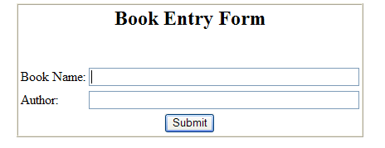
Figure 49 - A Web Application Example – Book Entry Form

Enter Book: 1984
Author: George Orwell
Click Submit

And …
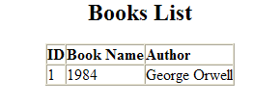

Figure 50 - A Web Application Example – Book List

