v0.03 – 8 March ’10 – D.Z.

Manage Locations

DOMAIN MODEL

Domain Model Diagram
The following figure illustrates the Domain Model applicable to Manage Locations in the context of the IUfA UUIS.
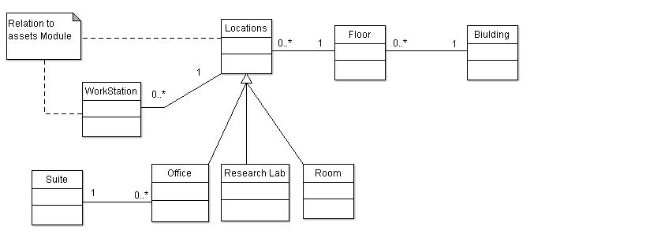
Figure 1 Manage Locations Module – Domain Model

USE CASES

Edit Location
Role: Faculty Admin Users (Role 2 and above);
Pre-condition: Authenticated session, Edit Location privileges;
Steps:
- Admin selects the Edit Location option under the Locations tab (accessible from all system pages);
- The system displays the Edit Location page;
- The system prompts the admin to enter a location number;
- The system displays the current status of the location including:
  - Location Type (Research Lab, Office, or Room)
  - Department Affiliation
  - Faculty Affiliation (if current user is University Admin)
  - User Responsible, if a Research Lab;
  - Available or Unavailable (for construction or other reasons)
- The Admin selects the parameter they wish to edit, from the above list
  - Parameters a, b, c, and d offer a drop down menu to select the new status
  - Parameter d, editing the user responsible, provides a link to the Edit Lab Head page.
Repeat step 4-5 until finished;
- The user selects the Submit button;
- The system logs the transaction;
Post-conditions:
- The system displays the Edit Locations page;
- A location has a new set of parameters;
Exceptions:
- At any time system fails:
  - The system displays an error message.
- At any time, the Admin cancels by selecting the Cancel button:
  - The system displays the Edit Locations page; and
  - The system does not log transaction associated with the cancelled request;

1.2.2 Assign Responsible User to a Lab
Role: Department Admin (Role 1 and above);
Pre-condition: Authenticated session;
Steps:

1. Admin selects the Edit Lab Head option under the Locations tab (accessible from all system pages);
2. The system displays the Edit Lab Head page;
3. The system prompts the admin to enter a location number;
4. Provided the dept admin entered a lab location in their department, the system displays the name and user id of the current person responsible, if any;
5. The admin enters the user id of the new person responsible for the lab;
6. The user selects the Submit button;
7. The system logs the transaction;
Post-condition:
1. The system displays the Edit Lab Head page;
2. The selected lab has a new person responsible for it
Exceptions:
1. At any time system fails:
- The system displays an error message.
2. The admin selects a location that is not in their permission to view
- The system displays a message stating that the current location is not accessible by the admin
3. The admin selects a location that is not designated a research lab
- The system display a message stating that the selected location is not a research lab
1.2.3 Create Building
Role: University Admin (Role 3)
Pre-Conditions: Authenticated session, Create/Remove Location privilege (rare privilege)
Steps:
- Admin selects the Create Building option under the Locations tab (accessible from all system pages);
- System prompts the user to enter their password before proceeding
- System prompts for building information including:
  - address
  - name
- The system searches if the building exists or not
  - If the Building has not yet been entered, the admin selects the Create Building button, and the system saves an unfinished building with no locations or floors
  - If the Building has begun being created but is not yet finished, the admin selects the Floor they wish to work on from a drop down menu of previously entered Floors
  - If the Building has been Completed (see Step 10), and the current User is the supervisor who received the notification then:
    - A Floor is selected from a drop down menu
    - A Location is selected from a drop down menu of all Locations on the selected Floor
    - The Location information is displayed
    - At any point in reviewing the information, the user (supervisor) has access to the Commit Building button, which commits the Building to the database, and allows Physical Assets to be placed within it’s Locations
    - The system logs the transaction;
- System prompts for information on the next lowest floor including:
  - number/name
  - area
- Admin selects either the Create Floor button, or the Save and Exit button.
  - If Create Floor is selected, the system saves an unfinished floor with no locations, but connected to the unfinished building
  - If Save and Exit is selected, the system registers all entered information, logs the transaction and returns to the system Home Page
- System prompts for information on the first location of the floor including:
  - number (required)
  - area (required)
  - type (Research Lab, Office, or Room – Optional)
  - Faculty (optional)
  - Dept (optional)
  - Availability or Occupancy are not prompted. Availability is set to Unavailable by default.
- Admin selects the Create Location button
- System saves a new Location
- System prompts for either a New Location on this Floor, Move to the Next Floor, Save and Exit, or Building Complete
  - If New Location on this Floor is selected, Admin repeats Steps 9-12.
  - If Move to the Next Floor is selected, the Admin repeats Steps 6-7.
  - If Save and Exit is selected, the system registers all entered information
  - If Building Complete is selected, a notification is sent to the user’s supervisor to review the work.
- The system logs the transaction;
Post-Conditions:
- The System Displays the Home Page
- Some information on the building is saved
- If Building Complete was selected, a notification is sent out
- If Commit Building was selected, a new set of locations exists to be used by the system
Exceptions:
- At any time system fails:
  - The system displays an error message

FUNCTIONAL REQUIREMENTS

Edit Location
- (tbd)

Assign Responsible User to a Lab
- (tbd)

Create Building
- (tbd)

