v0.05 – 2 March ’10 – M.D.

Manage Permissions

DOMAIN MODEL

Business logic – workflow
The following figure illustrates the workflow applicable to Manage Permissions in the context of the IUfA UUIS.

Figure 1 Manage Permissions – Workflow

Admin Users (Role 1 and above) of the IUfA UUIS have the capability to grant/revoke permissions.
Following the request to grant or revoke a permission from a Supervisor, the Admin User of each level will be able to:
- Import Users from an existing system;
- Grant/Revoke the requested permission/s to a User;
- Edit Default permissions to a given Role.
- Add new Role.

Domain Model Diagram
The following figure illustrates the domain Model applicable to Manage Permissions in the context of the IUfA UUIS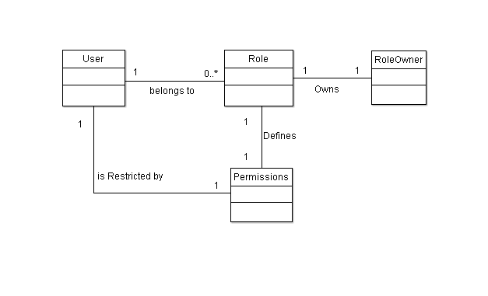
Figure 2 Manage User – Domain Model

USE CASES
The following figure provides the Manage User Permissions use case diagram.

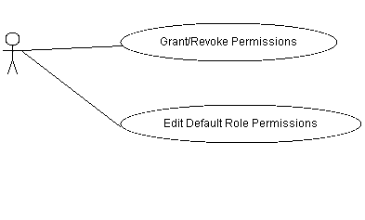
Figure 2 Manage User – Use case diagram

The following paragraphs provide the detailed description for each use case.

Grant/Revoke Permissions
Role: Admin Users (Role 1 and above);
Pre-condition: Authenticated session, Admin privileges;
Steps:
- Admin selects the Security option under the System Administration tab (accessible from all system pages);
- The system displays the Security Administration page;
- The Admin selects the User Permission Tab;
- The Admin searches for target user;
- The system displays the complete set of permissions, and whether they are Granted/Revoked for the selected user;
- The admin selects permission to Grant/Revoke;
Repeat step 3-5 until finish;
- The user selects the Submit button;
- The system logs the transaction;
Post-conditions:
- The system displays the Security Administration page;
- A new set of permissions is Granted/Revoked to a given set of user/s;
Exceptions:
- At any time system fails:
  - The system displays an error message.
- At any time, the Admin cancels by selecting the Cancel button:
  - The system displays the Security Administration page; and
  - The system does not log transaction associated with the cancelled request;

Open Issues:
- Recovery Supported or Not ---- Not specified, needs further study.
- Permissions outside the role (department, Faculty, University), Who grants them? Approval Process?

Edit default Role Permissions
Role: Admin Users (Role 1 and above);
Pre-condition: Authenticated session, Admin privileges;
Steps:
- Admin selects the Security option under the System Administration tab (accessible from all system pages);
- The system displays the Security Administration page;
- The Admin selects the Role Permission Tab;
- The Admin searches for a Role to edit;
- The system displays the complete set of permissions, and whether they are Granted/Revoked for the selected Role;
- The admin selects permission to Grant/Revoke;
Repeat step 3-5 until finish;
- The user selects the Submit button;
- The system logs the transaction;

Post-condition:
- The system displays the Security Administration page;
- A new set of permissions is Granted/Revoked to a given set of user/s;

Exceptions:
- At any time system fails:
  - The system displays an error message.
- At any time, the Admin cancels by selecting the Cancel button:
  - The system displays the Security Administration page; and
  - The system does not log transaction associated with the cancelled request;
Open Issues:
    - Recovery Supported or Not ---- Not specified, needs further study.
    - Permissions outside the role (department, Faculty, University), Who grants them? Approval Process?

FUNCTIONAL REQUIREMENTS

Add User
- The system shall allow Admins to import users from an existing system.

Grant/Revoke Permissions
- The system shall allow Admins to search for users.
- The system shall allow Admins to clear search criteria
- The system shall allow Admis of a given Role, to Grant/Revoke permissions to users belonging to that given Role.
- The system shall log every Transaction involving Permissions for further Audit.
- The system shall allow a Admins to cancel a transaction.
- The system shall allow Admins to Grant/Revoke Admin Privileges to a given user.
- The system shall, upon successfully completing the report problem operation, issue an e-mail notification to the user and the Problem tracking coordinator including unique identification number and date reported.

Edit Default Role Permissions
- The system shall allow Admins to search for Roles.
- The system shall allow Admins of a given Role, to edit the default set of permissions of that given Role
- The system shall log every Transaction involving Permissions for further Audit.
- The system shall allow a Admins to cancel a transaction.

Add New Role
- The system shall allow Admins to search for Roles
- The system shall allow Admins to set the default set of permissions for a new Role.
- The system shall log every Transaction involving Permissions for further Audit.
- The system shall allow a Admins to cancel a transaction.

General/ Miscellaneous
- The system shall allow Admins to print a general user permissions report.
- The system shall allow Admins to print a user permissions report by Roles.
- The system shall allow Admins to print a user permissions report by user.

